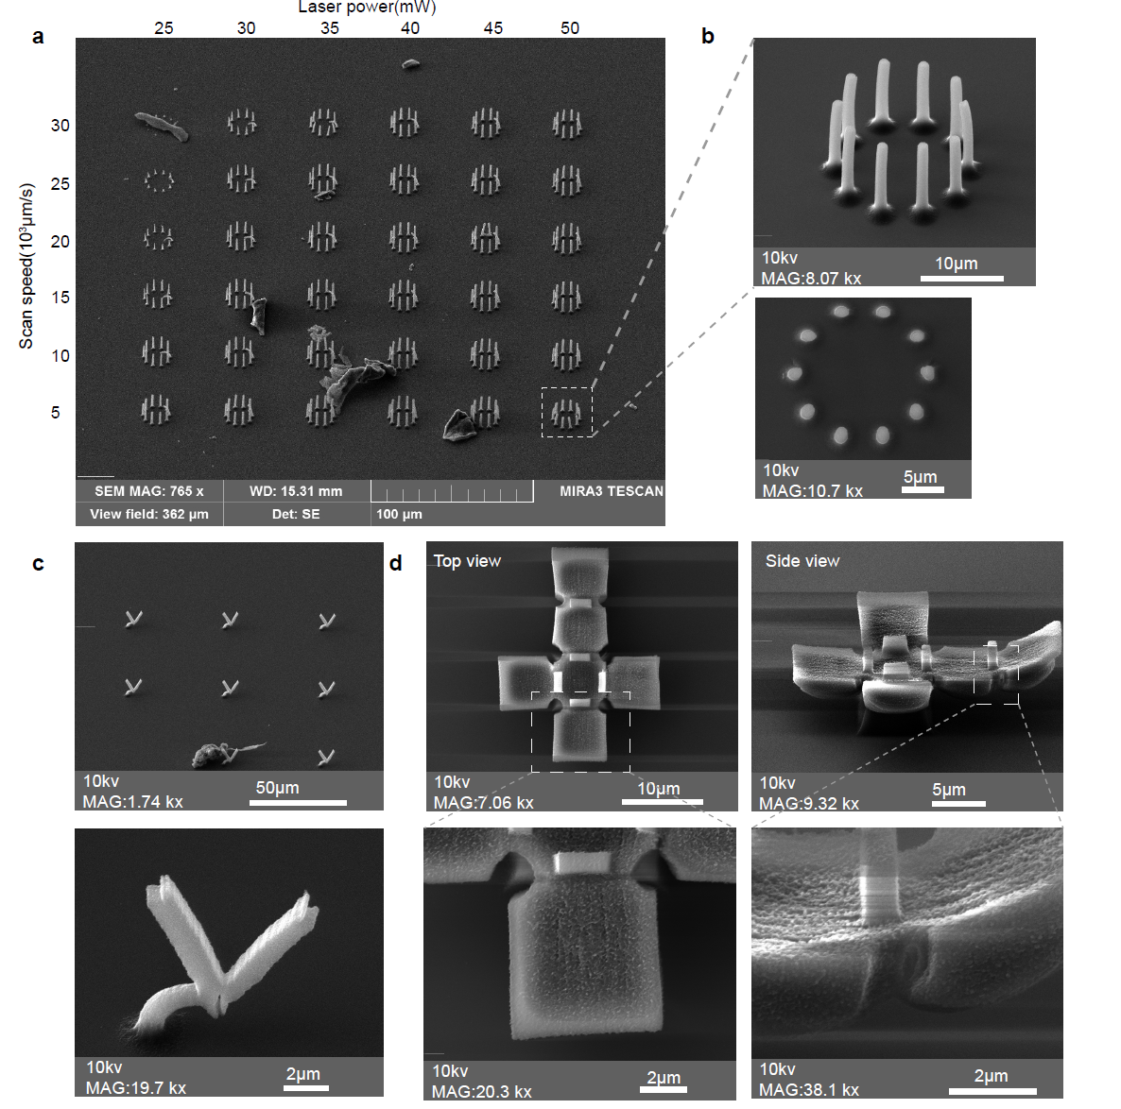
Extended Data Fig. 1 Scanning electron microscope images of 3D BSA microstructures. a.) Overview of the pillar ring array printed with varying laser powers and scan speeds. b.) Side view and top view of pillar ring. c.) Freestanding V units. d.) Self-folding hydrogel cube.

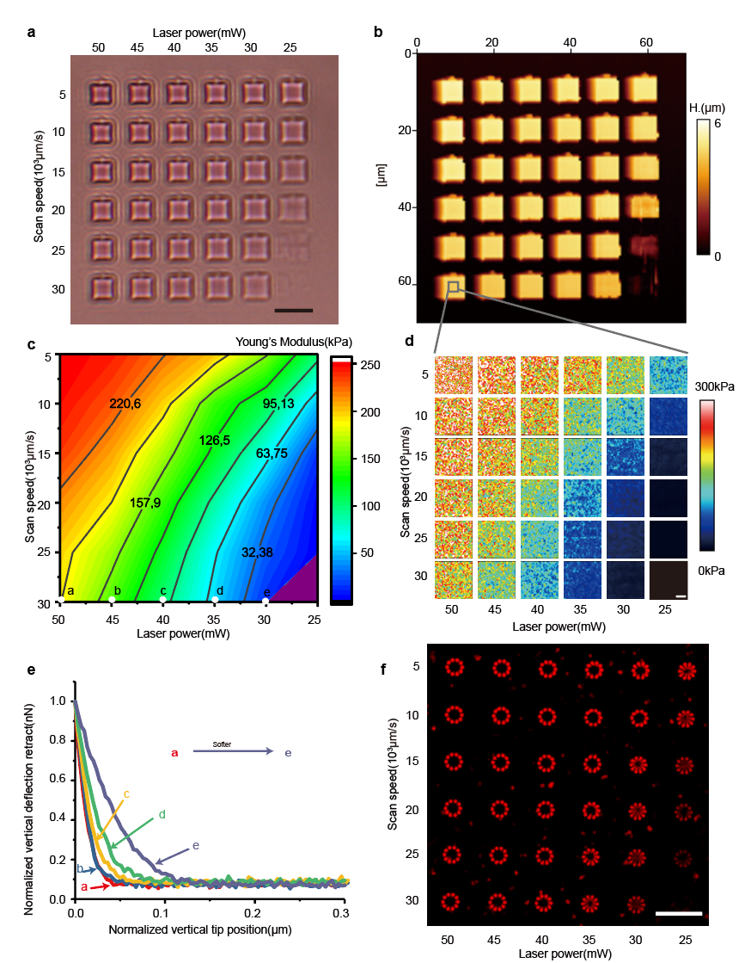
Extended Data Fig. 2. Young’s modulus measurement of the BSA microstructures by the Atomic Force Microscope (AFM). a.) The wide field imaging of BSA hydrogel structure (5x5x5 µm) array fabricated at different laser powers (25 mW-50 mW) and scan speeds (50000-300000 µm/s). Scale bar, 10 µm. b.) AFM imaging of the BSA hydrogel structure array. Color calibration bar represents the height of the microstructures. c.) Young’s modulus map of the hydrogel structures by varying printing parameters. d.) Heatmaps of AFM imaging. Color calibration bar represents the Young’s modulus of the microstructures. e.) Force curve of BSA structures with different elastic properties. f.) Z projection of the deformed pillar rings with different stiffness. Scale bar, 50 µm

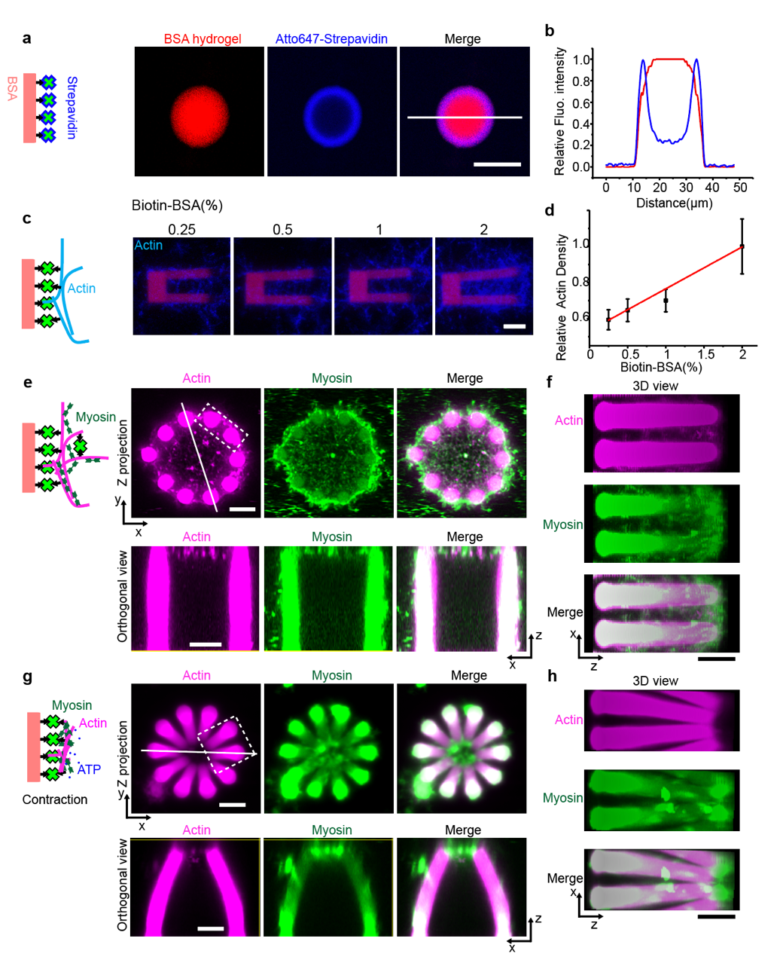
Extended Data Fig. 3. a.) Fluorescence imaging and b.) line plot profile of pillar coated with Atto647-Streptavidin. Scale bar, 20 µm. The structure was fabricated with 1mol% biotin-BSA, and then incubated with 1mg/ml Atto647 labeled streptavidin. The white line in a. represents the position of the line plot profile. c.) Representative fluorescence images of micropillars coated with actin filaments. Structures were printed with varied biotin-BSA fraction from 0.25 mol% to 2 mol%. Scale bar, 5 µm. d.) Plot of relative actin density on pillars determined from the fluorescence intensity of Alexa-647-Phalloidin labeled actin between the two pillars. Data points are shown as mean ± s.d. (n = 8). e-f.) Representative fluorescence images of actin-myosin networks on pillar rings. e.) Projections of z stacks and orthogonal views of the actin network. Actomyosin network mainly formed on the top and surface of the pillar ring. Scale bar, 5 µm. f.) 3D view of the actin network between adjacent pillars. Scale bar, 5 µm. g-h.) Representative fluorescence images of the contracted actin-myosin networks on pillar rings. g.) Z projection of and orthogonal views of the contracted actin-myosin network. Scale bar, 5 µm. h.) 3D view of the contracted actin network between adjacent pillars. Scale bar, 5 µm. Actin networks shown in e-h were crosslinked with 2.25 nM neutravidin. 10 % AlexaFluor-488 labeled myosin was used for the imaging.
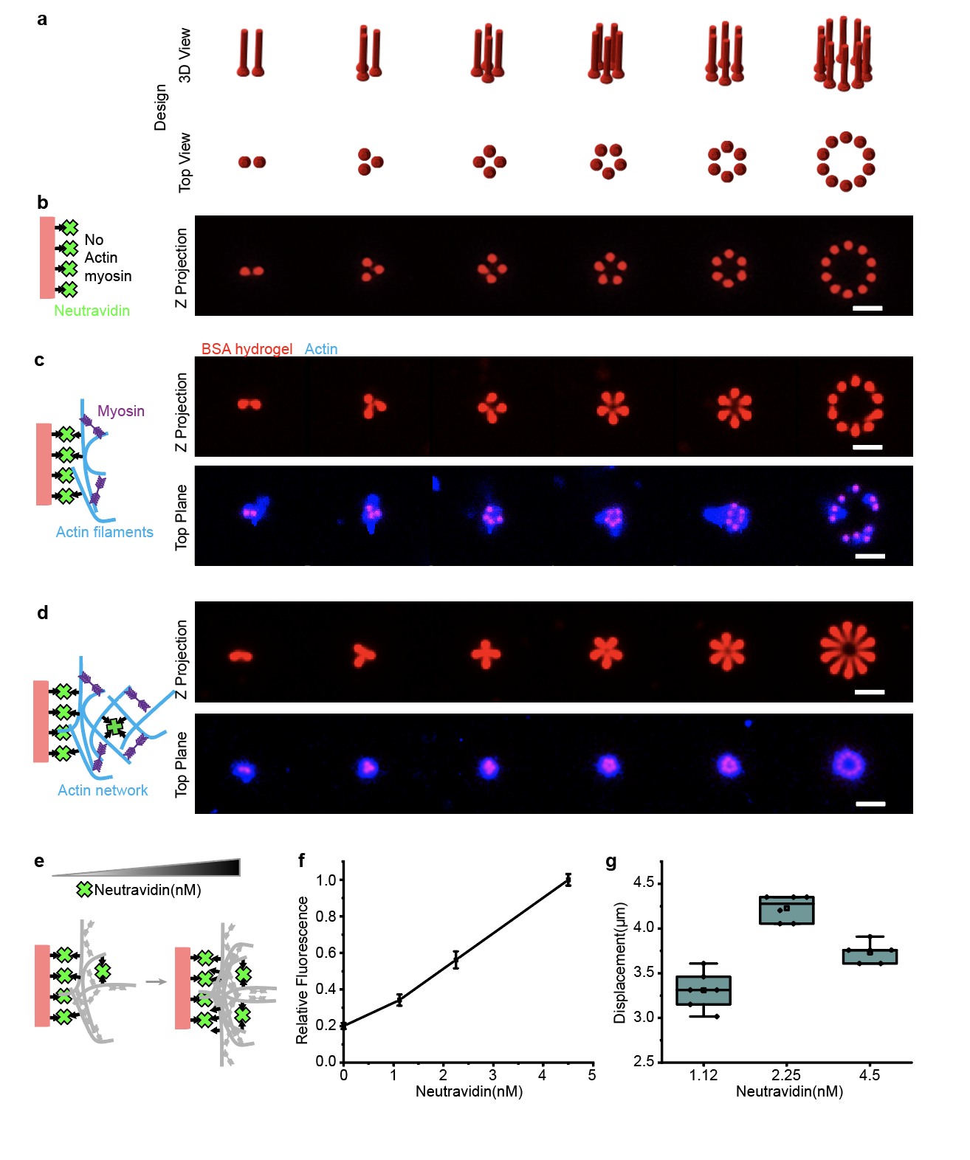
Extended Data Fig. 4. Cross-linked actin networks promote contraction integrity. a.) Schematic designs of pillar rings with different number of pillars. b.) Z projection of pillar rings without actin and myosin network. Scale bar, 10 µm. c.) Contraction of pillar rings coated with actin filaments. Scale bar, 10 µm. Pillar contraction started to differentiate on the ring with 10 pillars. d.) Contractions of pillar rings coated with actin network that was cross-linked by neutravidin (2.25 nM). Scale bar, 10 µm. Compared with the pillar rings coated with the actin filaments, the neutravidin cross-linked actin network could enhance the contraction integrity of pillar rings. e-g.) Neutravidin concentrations influence f.) the actin network density and g.) the contractions of pillar rings. Plot in f. demonstrates the relative fluorescence intensity of Alexa-647-Phalloidin labeled actin networks (inner ring areas) that are crosslinked with different concentration of neutravidin. Data points are shown as mean ± s.d. (n = 6). The concentrations of the cross-linker neutravidin were titrated from 1.12 nM (1:40), 2.25 nM (1:20), to 4.5 nM (1:10) in order to optimize the contractility of actomyosin on the printed microstructures. The densities of actin networks on pillar rings were increased when increasing cross-linker concentrations. However, a reverse trend of pillar displacements was noticed in g. when the neutravidin concentration was increased to 4.5 nM, meaning the contraction was inhibited by the high cross-linking degree (neutravidin: biotin-actin ratio of 1:10 in our system). As such, we chose the 2.25 nM neutravidin concentration for further experiments, as this cross-linking condition best contractility was observed. Box plot in g: lines are median, box limits are quartiles 1 and 3, whiskers are 1.5×interquartile range and points are outliers.

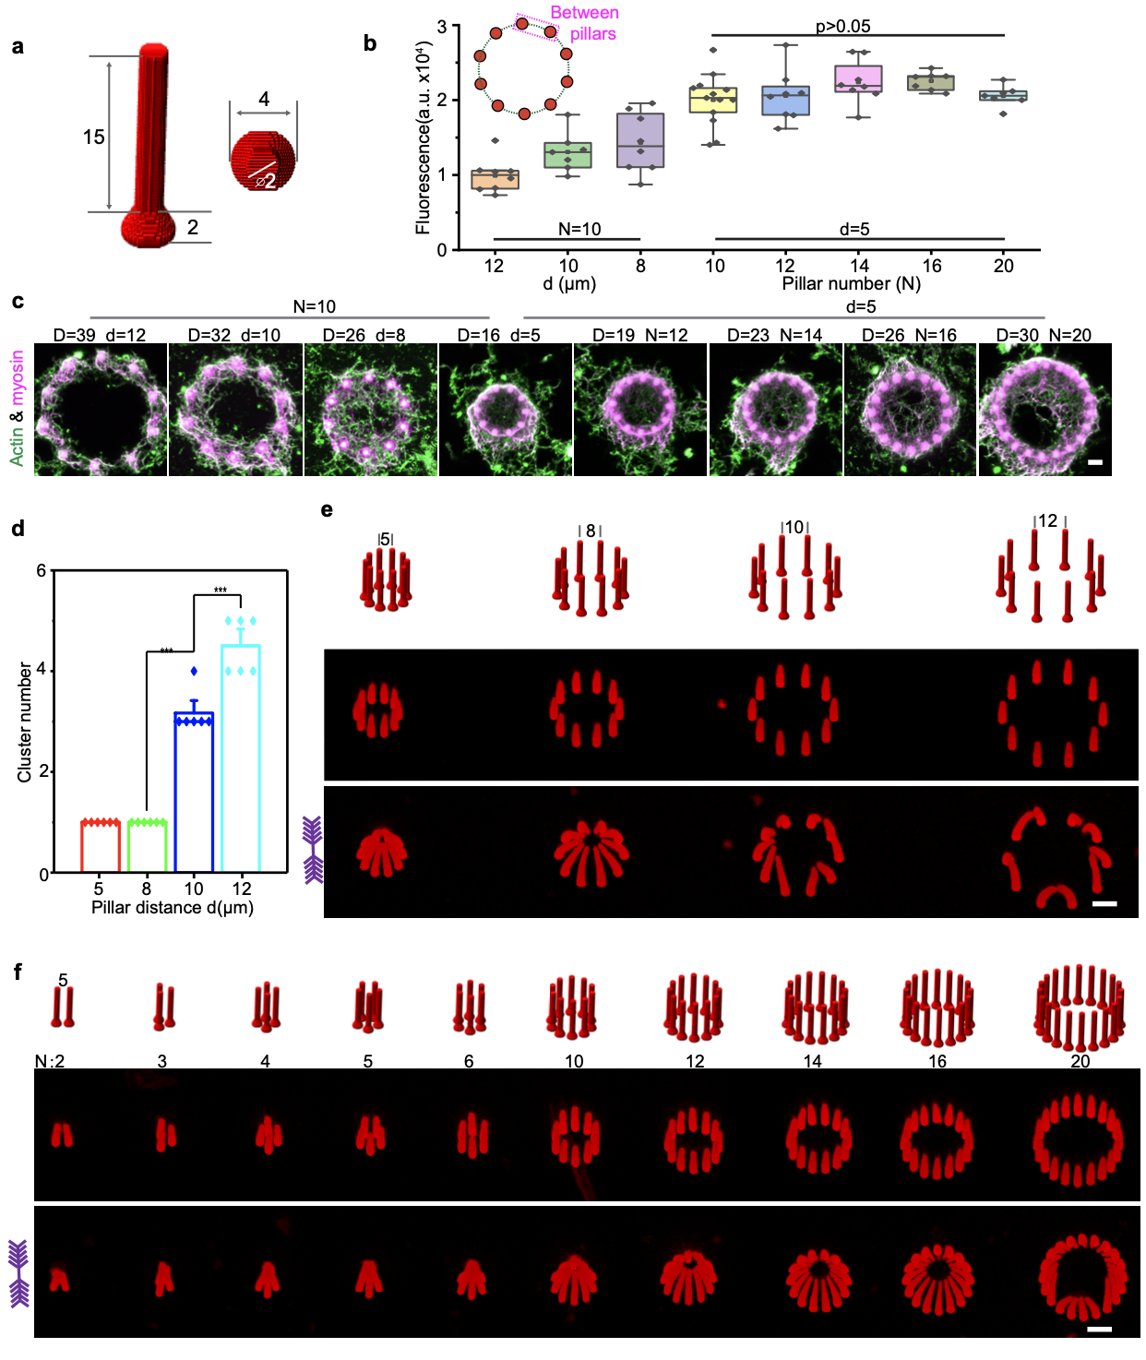
Extended Data Fig. 5. a.) Schematic design of pillar. The dimensions in this figure are given in micrometers. b.) Fluorescence intensity of Alexa-647-Phalloidin labeled actin networks between two adjacent pillars on the pillar rings with different diameters (D, µm) and pillar distances (d, µm). The actin intensity increases with decreasing the adjacent pillar distances. When keeping the adjacent pillar distance constant and increasing the pillar number, the actin density between the adjacent pillars remains roughly constant. p>0.05, Analysis of Variance (ANOVA) one-way statistical test. Box plot in b: lines are median, box limits are quartiles 1 and 3, whiskers are 1.5×interquartile range and points are outliers. c.) Represented images (z-projection) of the actin networks on pillar rings with different sizes and pillar distances. Scale bar, 5 µm. d.) The figure shows pillar clusters number versus pillar distance, which are corresponding to the results in e. ***p<0.0005, Analysis of Variance (ANOVA) one-way statistical test. e.) Representative 3D images of the deformed pillar rings with different pillar distances (N=10). Scale bar, 5 µm. f.) Representative 3D images of the deformed pillar rings with different diameters (d=5 µm). Scale bar, 5 µm. Pillar number was kept constant at 10 in e. Distance of nucleation sites was fixed at 5 µm in f. Printing parameters: laser power, 35mW; scan speed, 30000 μm/s, resulting in Young’s modulus 57 kPa.

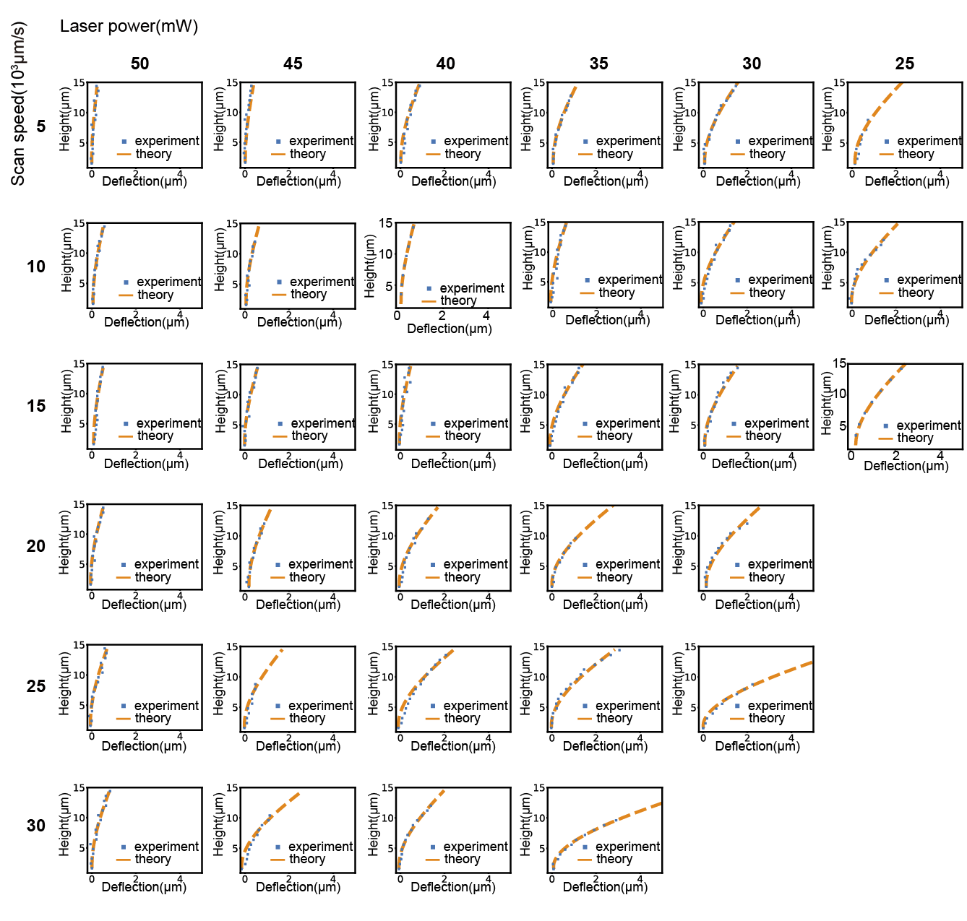
Extended Data Fig. 6. Measured pillar deflection (blue point) and theoretical fitting (orange dash line) of the deformed pillars with different stiffness.

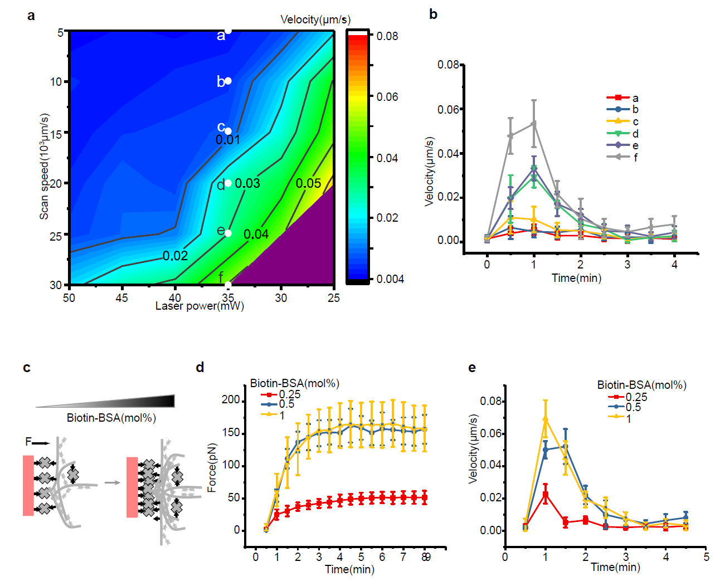
Extended Data Fig. 7. a-b) Stiffness of materials determines the contraction dynamics of pillar rings under active force. a.) The maximal motion velocity map of the pillar rings under active force. b.) Time course of motion velocity during contraction. c-e.) Actin network density influence the contraction dynamics of pillar rings. d.) Dynamics of active force generation on the pillar rings printed with different concentration of Biotin-BSA. e.) Time course of motion velocity during contraction. Data points in b-e are shown as mean ± s.d (n=10). All structures used in d-e were printed with laser power 35 mW and scan speed 30000 μm/s, resulting in Young’s modulus 57 kPa.

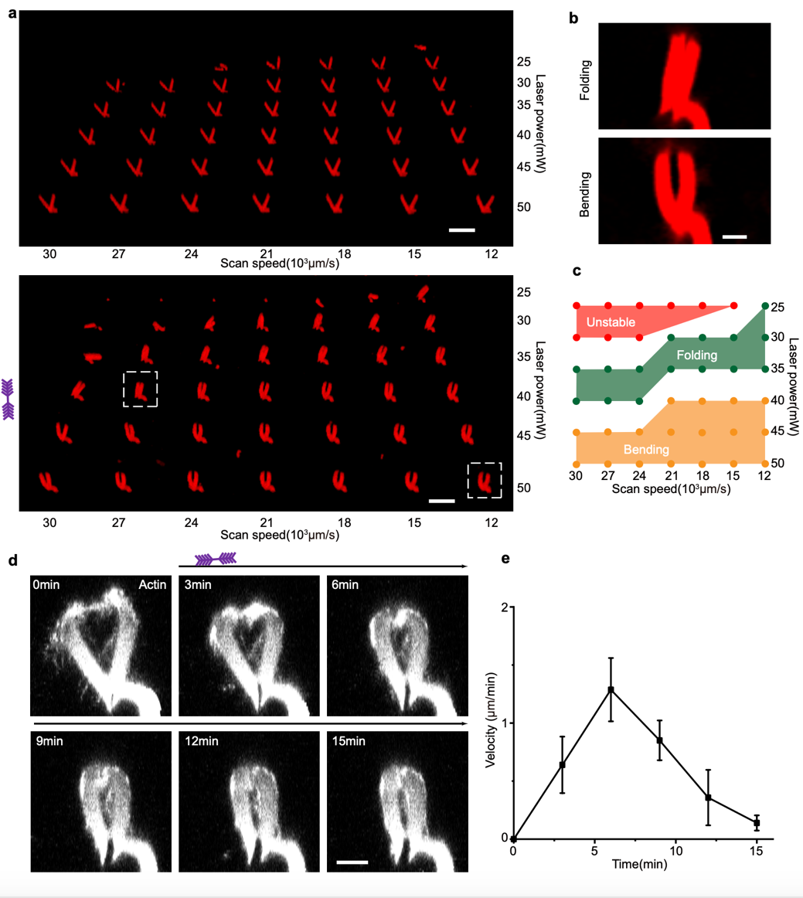
Extended Data Fig. 8. Contraction behaviors of V units depend on the fabrication parameters. a.) Printing of V units with different laser powers (25-50 mW) and scan speeds (120000-300000 µm/s). Scale bar, 20 µm. b.) Folding and bending of V units after deformation. Scale bar, 5 µm. c.) Phase diagram of shape transformation for the V units that was fabricated with different parameters. d-e.) Contraction dynamics of V-hinge follow the dynamic behavior of pillar rings with an initial acceleration phase and a deceleration phase. d.) Dynamics of V hinge. Scale bar, 10 µm. The images illustrate the side view of the structure. Fluorescence signals in d. are from Alexa-647-Phalloidin labeled actin. e.) The tip velocity of V hinge during contraction. Data points in e. are shown as mean ± s.d (n=3). The V unit in d. has a similar design as the structures in a., but the printing size is scaled up by a factor of two in all dimensions.

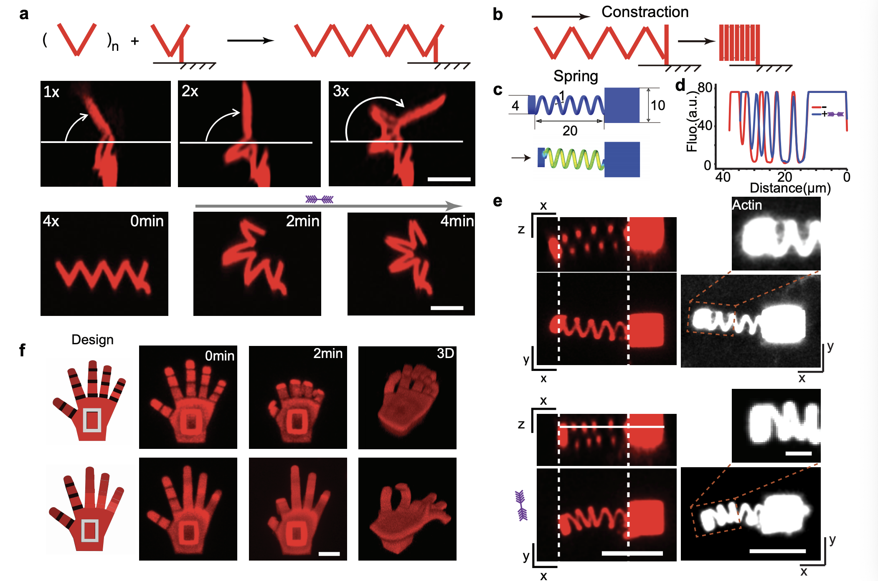
Extended Data Fig. 9. a.) Schematic design and experimental results of V-unit combinations demonstrating complex coiling dynamics under applied active forces. Scale bar, 20 µm. b.) Contraction of hydrogel microstructures. c.) Schematic design and d-e.) experimental results of a contractile protein hydrogel spring. Scale bar, 20 µm. Scale bar (zoom), 5µm. The dimensions in c. are given in micrometers. The line plot in d. represents the spring contraction along its axis before and after trigging (line selection shown in e.). Fluorescence signals of actin networks are from Alexa-647-Phalloidin labeled actin. f.) Anthropomorphic gestures of hydrogel microstructures, grasping and “OK”. Scale bar, 10 µm.
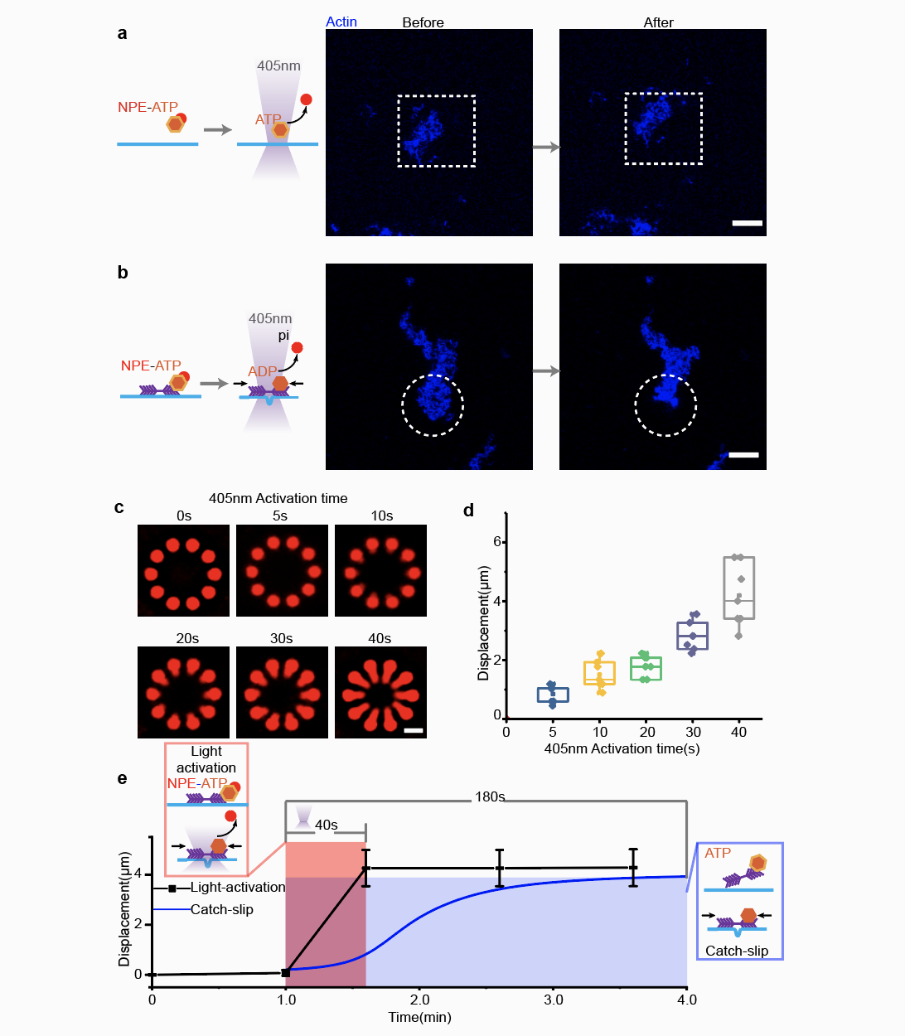
Extended Data Fig. 10. Spatiotemporal control of actin-myosin contraction by UV light. a.) Control experiment of photo-activation on actin network without myosin, demonstrating that the UV laser itself will not induce contraction of actin networks. Scale bar, 20 µm. The dashed square represents the activation region. The region was activated with 30 mW 405 UV laser for 2 min. b.) Spatially activating actomyosin network contraction. Scale bar, 20µm. The dashed circle represents the activation region. 405 nm UV laser could precisely activate the local contraction of the actomyosin network. The region was activated with 30 mW 405 UV laser for 24 s. c.) Representative imaging (Z Projection) and d.) displacement plot (n=7) of pillar rings activated with different periods of 405 nm UV laser. Scale bar, 5 µm. Lines are median, box limits are quartiles 1 and 3, whiskers are 1.5×interquartile range and points are outliers. Red color in c. represents the signal of hydrogel. Actomyosin networks on the structures are not shown. e.) Displacements of pillar ring under light activation. The blue curve represents the simulated active contraction of pillar ring with catch-slip bonds behavior. Data points in e. are shown as mean ± s.d (n=10). Based on the insights from theoretical modeling, the load dependent binding dynamics of myosin enable a large-scale contraction with a peak velocity on time scales much larger than the molecular dynamics of the motor. This informs us that the response time of the system can be optimized by letting motors bind already before initiating the contraction. In this way the initial slow phase can be avoided and the contraction time can be significantly reduced. Experimentally, when the photoactivation in e. was processed after incubating with myofilaments (1 mM NPE-ATP) for 1.5 h, indeed, the light activation with pre-loaded motors can shorten the response time and speed up the active contractions in comparison with the active contraction that rely on the catch-slip bonds.

