Supplementary Materials for

Positive feedback of marine N₂O emissions during past extreme warming

Xiaoxiao Zhao^{1*}, Fanny Monteiro^{2,16}, Kevin W. Becker^{3,4,5}, Lukas Dirksen⁵, Julia Cordes⁵, Julius S. Lipp^{5,6}, Susan J. Carter⁷, Nathan Rochelle-Bates⁸, Emily Hollingsworth⁹, Morgan T. Jones^{10,11}, Bo Pagh Schultz¹², Alexander J. Dickson¹³, Mustafa Kaya¹⁴, Eva Stüeken⁸, Gordon Inglis⁹, Rich Pancost¹⁵, Kai-Uwe Hinrichs^{5,6}, Ann Pearson⁷, Felix J. Elling^{1*}

Corresponding author: xzhao@leibniz.uni-kiel.de, felling@leibniz.uni-kiel.de

Supplementary Text

Nitrification
In addition to enhanced nitrification, changes in MAR_{cren} could be influenced by changes in temperature or organic matter preservation. First, increased temperature during the PETM could have led to higher crenarchaeol abundance relative to other GDGTs, which would reflect archaeal adaptation to higher temperature¹⁻³, potentially resulting in higher MAR_{cren} under constant GDGT production rates. Second, higher preservation of organic matter due to decreased ocean oxygenation during the PETM could have led to enhanced preservation compared to the pre-PETM, inflating MAR_{cren} during the PETM. To evaluate whether changes in MAR_{cren} reflect preservation or temperature change, we normalized GDGT concentrations to TOC (Extended Data Fig. S1). Normalized crenarchaeol concentrations increased during the PETM at sites IODP 302, ODP 959, Fur Formation, Kheu River, and ODP 174 AX Ancora, but showed little or no change at ODP 1172 and IODP 1403. This pattern is identical to what is observed in MAR_{cren} and thus suggests that the increase in MAR_{cren} was not solely driven by improved organic matter preservation. Furthermore, normalized concentrations of GDGT-1, GDGT-2, and GDGT-3 also rose during the PETM. Although these compounds can be produced by a broader range of archaea and are not as specific as crenarchaeol⁴, their primary source in the ocean is the same as for crenarchaeol^{4,5}. The parallel increase of GDGT-1, -2, -3 and crenarchaeol implies that the observed increase in crenarchaeol during the PETM was not driven by temperature increase.

Linear sedimentation rate:
Linear sedimentation rate (LSR) estimates used in this study were compiled from published literature. For most sites, LSRs have been previously described (Supplementary Fig. 5, along with their respective references). Additional details for sites where estimates were derived or recalculated are provided below.
Kheu River:
We defined the PETM carbon isotope excursion (CIE) body between 0 m and 118 m based on δ¹³C_{TOC} data⁶. Assuming a 170 kyr duration for the CIE, the corresponding LSR within the PETM body is estimated at 0.69 cm kyr⁻¹. The LSRs for the pre-PETM and post-PETM intervals were taken from the background sedimentation rates of the Aktumsuk section (0.3 cm kyr⁻¹; ref. ^{7,8}).

Fur Formation:
The PETM CIE body occurs within the Stolleklint Clay. The onset of the CIE is tied to 55.935 Ma, and the recovery begins at 55.765 Ma, assuming a total CIE duration of 170 kyr. The end of the PETM is set at 55.7 Ma⁹. Based on a CIE body thickness of 24.2 m and recovery thickness of 4.53 m¹⁰, the calculated LSRs are 14.24 cm kyr⁻¹ for the CIE body and 6.97 cm kyr⁻¹ for the recovery phase. The pre-PETM LSR is 2.2 cm kyr⁻¹ (ref. ⁹).

Qimugen Formation:
Age constraints are based on microfossil assemblages¹¹. The base of the Lower Member of the Qimugen Formation is correlated with the Selandian–Thanetian boundary (ca. 59.2 Ma), and the onset of the PETM is assigned to ca. 56 Ma¹¹. The LSR within the PETM CIE body is 6 cm kyr⁻¹, while the pre-PETM LSR is 0.82 cm kyr⁻¹ (ref. ¹²).

Nitrogen loss
Nitrogen loss from the water column through denitrification and anammox is closely regulated by oxygen availability. BHT-x, a structural isomer of BHT produced exclusively by marine anammox bacteria such as Ca. Scalindua brodae, has been established as a biomarker for anammox activity¹³⁻¹⁵. Its relative abundance, expressed as the ratio

BHT-x ratio = BHT-x / (BHT + BHT-x)

is used to infer redox conditions, with higher values indicating a stronger contribution of anammox to bacterial biomass and lower oxygen concentrations¹⁶⁻²¹. A BHT-x ratio threshold of ≥0.2 has been suggested to indicate ≤50 µM dissolved [O₂], based on observations from the modern ocean¹⁶. Anammox bacteria typically occur in suboxic transition zones²², requiring both NH₄⁺ and nitrite as substrates, the latter largely derived from ammonia oxidation. Although nitrite can also be produced via other pathways (e.g., sulfur oxidation²³), ammonia oxidation is considered the dominant source in the ocean²⁴⁻²⁶.
BHT-x is generally most abundant in lower suboxic to upper anoxic waters²⁷, consistent with maxima in anammox cell counts²⁸ and nitrite reductase (nirS) gene abundance, a marker gene for anammox²⁹. In our records, BHT-x was detected in the Arctic Ocean, the New Jersey shelf and the Tasman Sea. The high BHT-x ratios (0.13-0.7) in the Arctic Ocean suggest an increase in anammox over the PETM. The consistently low BHT-x ratios (0-0.23) in the New Jersey shelf and Tasman Sea indicate relatively oxic to moderately hypoxic condition, i.e., [O₂] higher than 50 µM. This is consistent with detection of low BHT-x ratios (0–0.2) under moderately oxic conditions in modern marine environments¹⁶, suggesting that oxygen deficiency during the PETM was not sufficient at these sites to support a substantial anammox community. At other sites, BHPs could not be recovered in sufficient quantities to allow BHT-x determination (Extended Data Table 2). This may be due to two factors, 1) the high amounts of sediment available for the three sites mentioned above (20-35 g) compared to much lower amounts (mostly <10 g) available for the other sites, 2) potentially better preservation and low thermal maturity of BHPs at these sites, which represent the oldest marine sediments from which BHTs have been reported so far. For example, at the Kheu River site, relatively high and variable thermal maturity (carbon preference index ≈ 0–3) and reworking of mixed terrigenous and marine organic matter likely promoted degradation of labile bacterial lipids, hindering BHT preservation⁸.
The BHT-x data capture only water column anammox, while no biomarkers are known for the other nitrogen loss processes (denitrification in the water column and sediments, anammox in sediments). It is important to note that the cGENIE framework does not differentiate between water-column denitrification, anammox, sedimentary denitrification, and sedimentary anammox. Here we therefore use the term “nitrogen loss” to describe the combined effect of all anammox and denitrification. Our model simulations highlight the proto-Paratethys, Southern Ocean, and South Atlantic as hotspots of nitrogen loss, broadly overlapping with OMZ development during the PETM (Fig. 2; Extended Data Fig. S2). The simulations also suggest enhanced nitrogen loss in the North Atlantic. However, the persistently low BHT-x ratios in the New Jersey shelf imply that denitrification rather than anammox dominated nitrogen loss processes.

Bulk sediment nitrogen isotopes
Bulk sediment δ¹⁵N reflects the isotopic composition of dissolved inorganic nitrogen (DIN) utilized by primary producers³⁰, integrating nitrogen inputs, losses, and the relative contributions of fixed nitrogen species such as NO₃⁻ and NH₄⁺ (ref. ³⁰). In all studied sites except IODP 1403 and the ODP 1172, δ¹⁵N shows a pronounced negative excursion of 2.5-7‰ magnitude during the PETM. At Kheu River, Fur Fm., and ODP 959, values dropped to negative levels, consistent with OMZ expansion and enhanced NH₄⁺ assimilation. At the Qimugen Fm and ODP174AX Ancora, δ¹⁵N decreased by ~1–2‰, potentially reflecting enhanced N₂ fixation, though further evidence is needed. Consistent with this interpretation, widespread ocean deoxygenation and elevated phosphorus input from intensified weathering and regeneration³¹ would have favored enhanced N₂ fixation. cGENIE simulations suggest a global 106% increase in N₂ fixation rates during the PETM relative to pre-PETM conditions (Extended Data Table 1). At IODP 302, δ¹⁵N decreased modestly from ~3‰ to 1‰ but did not reach negative values, indicating that NH₄⁺ derived from the anoxic zone was not a dominant source of nitrogen to phytoplankton, even though biomarker evidence suggests anoxic conditions (see main text). Consequently, phytoplankton nitrogen demand in the Arctic Ocean (IODP 302) was likely met primarily through N₂ fixation, which introduces nitrogen with δ¹⁵N values near 0-1‰ (ref.³²). This might reflect the strong water-column stratification in the Paleocene-Eocene Arctic Ocean due to high freshwater runoff from the continents^{33,34}, limiting mixing between subsurface and surface water. The situation in the Arctic Ocean was therefore likely similar to the Quaternary Black Sea, where the water column is permanently stratified due to a salinity (density) gradient caused by freshwater input³⁵. Even though the Black Sea contains a large NH₄⁺ reservoir in the anoxic part of the water column³⁶, this NH₄⁺ does seem to be sequestered too deeply to be used by phytoplankton and any NH₄⁺ diffusing upwards is oxidized by abundant nitrifiers in the oxic-anoxic transition zone. This analogy between the Quaternary Black Sea and the PETM Arctic Ocean is corroborated by similar bulk δ¹⁵N values found in the sedimentary record from both sites (0-5‰ during the Holocene, ref. ³⁷ and Fig. 1).

Diagenetic alteration of bulk δ¹⁵N is considered minimal in these settings. High sedimentation rates in marginal environments generally preserve primary δ¹⁵N signals³⁸. Organic matter degradation typically would have driven δ¹⁵N towards more positive values³⁹. This is opposite to the negative excursions observed here, although we cannot exclude some minor overprinting from diagenesis which would result in an overestimation of absolute values (i.e., true values being lower than measured δ¹⁵N values) and/or an underestimation of the magnitude of the excursion. Although the Kheu River samples exhibit relatively higher maturity, which may have affected BHT preservation, the organic matter across all sites is generally thermally immature for bulk geochemical analyses^{8,10,40}, suggesting minimal diagenetic overprint. Elevated C/N ratios at all sites (Supplementary Fig. 3) likely reflect preferential degradation of nitrogen-rich labile compounds, a common feature of ancient black shales^{39,41,42}. Additionally, sulfurization may have enhanced organic carbon preservation, resulting in C/N > 20 (ref. ⁴¹). Strong TOC–TN correlations (p <0.002) across most sites, except IODP 1403 (Supplementary Fig. 4), suggest largely uniform nitrogen sources and a minor contribution from inorganic NH₄⁺ (ref. ⁴¹). In contrast, low TOC content (TOC < 0.2%⁴³) and weak TOC-TN correlations in IODP 1403 indicates substantial oxidation of organic matter, which likely altered its original nitrogen isotopic composition. Therefore, we conclude that the observed δ¹⁵N data are dominantly recording the primary δ¹⁵N values of phytoplankton-derived organic matter at all sites except IODP 1403.

Sensitivity test
In this section, we examined how the marine fixed nitrogen inventory responded during the PETM and how this response depends on ocean phosphate and CO₂ levels in cGENIE. Under PETM-like conditions (~0.75× pre-industrial phosphate), cGENIE simulations indicate that the global fixed nitrogen inventory increased relative to pre-PETM conditions, primarily due to phosphate-driven stimulation of N₂ fixation (Table 1). Unlike Oceanic Anoxic Event 2 (OAE2)⁴⁴, the PETM did not result in a collapse of the marine fixed nitrogen reservoir. Instead, the fixed nitrogen pool continued to grow, likely because oxygen minimum zones were spatially more restricted than during OAE2, constraining global nitrogen loss at relatively low levels (Table 1). Model results show that anoxia expanded to ~1.3% of global ocean volume (10 µM O2 threshold), far smaller than the ~17% estimated for OAE2 (Table 1). Nitrate remained the dominant form of fixed nitrogen globally (Table 1), except in the Para-Tethys where strong deoxygenation and high denitrification losses favored ammonium accumulation (Supplementary Fig. 2).
To investigate the response of fixed nitrogen inventory on variable phosphate levels under an Eocene-like configuration, we conducted sensitivity tests. The results reveal a non-linear response of the fixed nitrogen inventory with elevated phosphate inventory (Supplementary Fig. 2). At moderate phosphate inventory (0.5–1.5× pre-industrial), enhanced N₂ fixation outweighed nitrogen loss, producing a net gain in the nitrogen inventory. Above ~1.5×, the inventory plateaued, and at >2×, accelerated nitrogen removal led to net losses and declining nitrate concentrations. Model experiments further show that global nitrate levels would have peaked at ~1× pre-industrial phosphate, but at >2×, ammonium would have overtaken nitrate as the dominant fixed nitrogen species in an Eocene-like ocean.

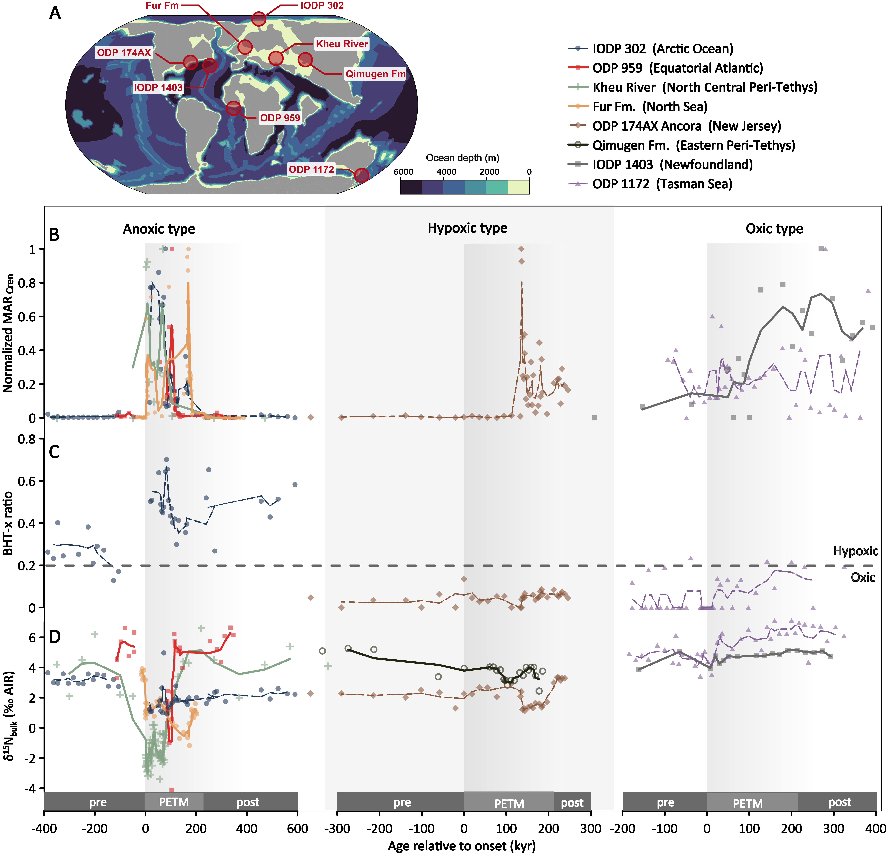

Supplementary Fig. 1. Proxy records indicating changes in the marine nitrogen cycle during the PETM. A, Sampling locations and plate configuration during the late Paleocene (ca. 55 Ma)⁴⁵. B, Normalized Crenarchaeol mass accumulation rate (MAR_{cren}), biomarker of ammonia-oxidizing archaea and a proxy for nitrification, normalized to the maximum value at each site. C, Bacteriohopanetetrol-x (BHT-x) ratio, a biomarker produced by anaerobic ammonium-oxidizing bacteria and a proxy for low O₂ concentrations (BHT-x ratio >0.2 suggests <50 µm O₂). D, Bulk sediment δ¹⁵N (δ¹⁵N_{bulk}). δ¹⁵N_{bulk} data for the Kheu River site are from ref. ⁴²; Sites are grouped into three categories (anoxic, suboxic and oxic) based on integrated assessment of BHT-x ratio, δ1⁵N_{bulk} values and cGENIE-simulated oxygen levels (anoxic: [O₂]<10 μM; hypoxic: 10<[O₂]<60 μM; oxic: [O₂]>60 μM). Solid curves represent 3-point running averages. The grey shadings indicate approximate duration of the event (~170 kyr). Abbreviations: pre: pre-PETM; post: post-PETM.

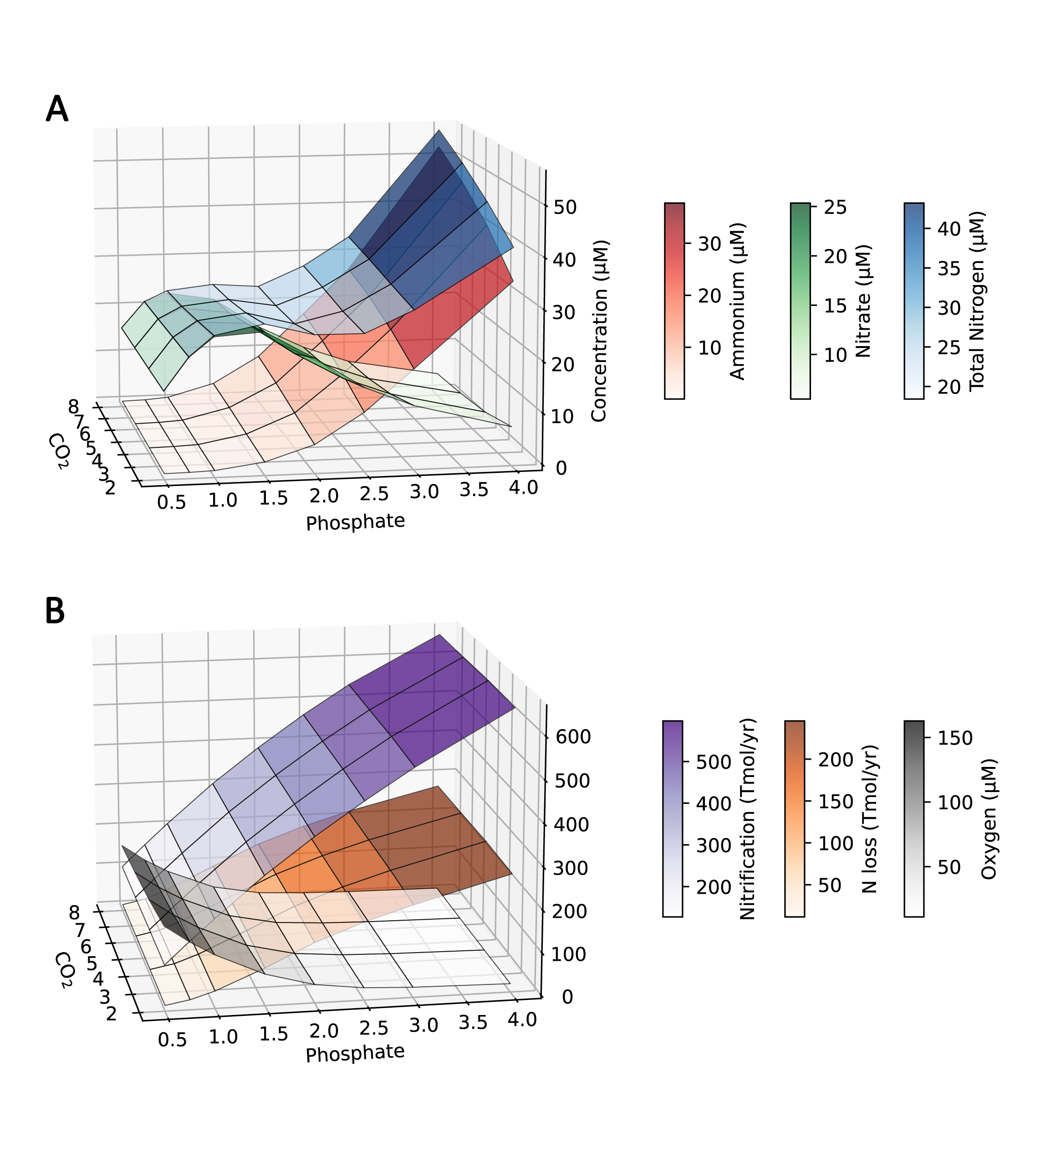

Supplementary Fig. 2. Sensitivity of the marine nitrogen cycle to phosphate and carbon forcing. Modelled response of global biogeochemical fields to varying phosphate and atmospheric CO₂ concentrations. A, Ammonium (red), nitrate (green), and total fixed nitrogen ([NH₄⁺]+[NO₃⁻], in blue) concentrations. Results are shown as surface plots across a parameter space of phosphate supply (x-axis) and CO₂ forcing (y-axis), with shading indicating the magnitude of each variable. B, Nitrification (purple), denitrification (orange), and minimum oxygen concentrations (grey).

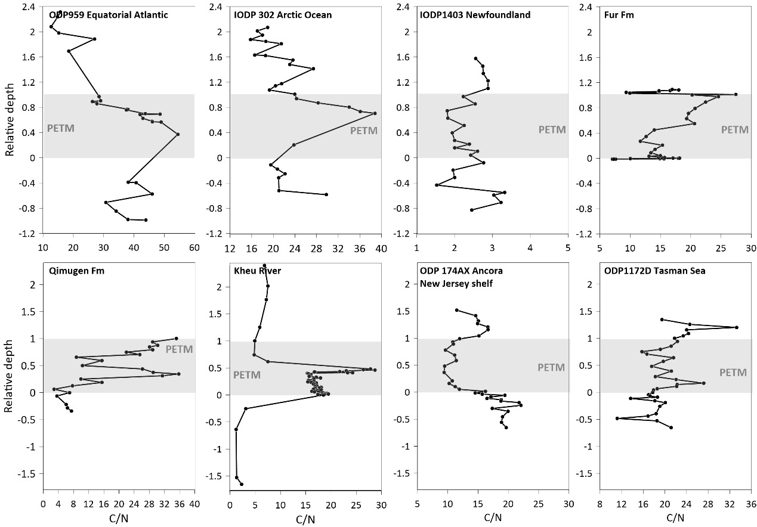

Supplementary Fig. 3. C/N (mol/mol) across globally distributed sites spanning the PETM. The Paleocene–Eocene Thermal Maximum (PETM) interval is highlighted in grey.

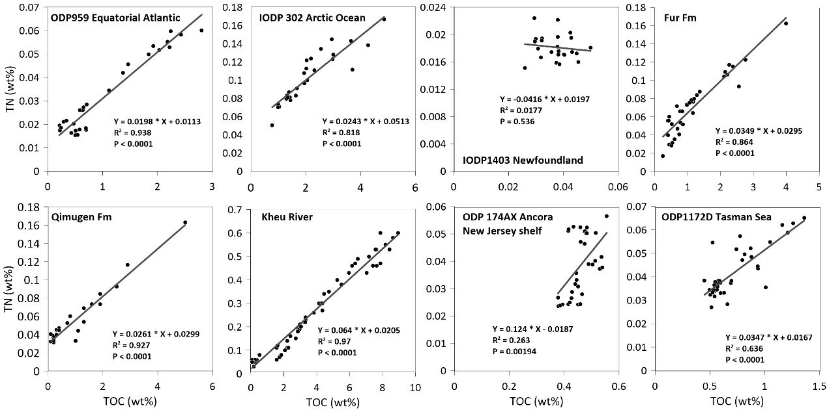

Supplementary Fig. 4. Cross-plots of bulk sediment TOC and TN from eight sites. Black lines indicate least-squares linear regressions.

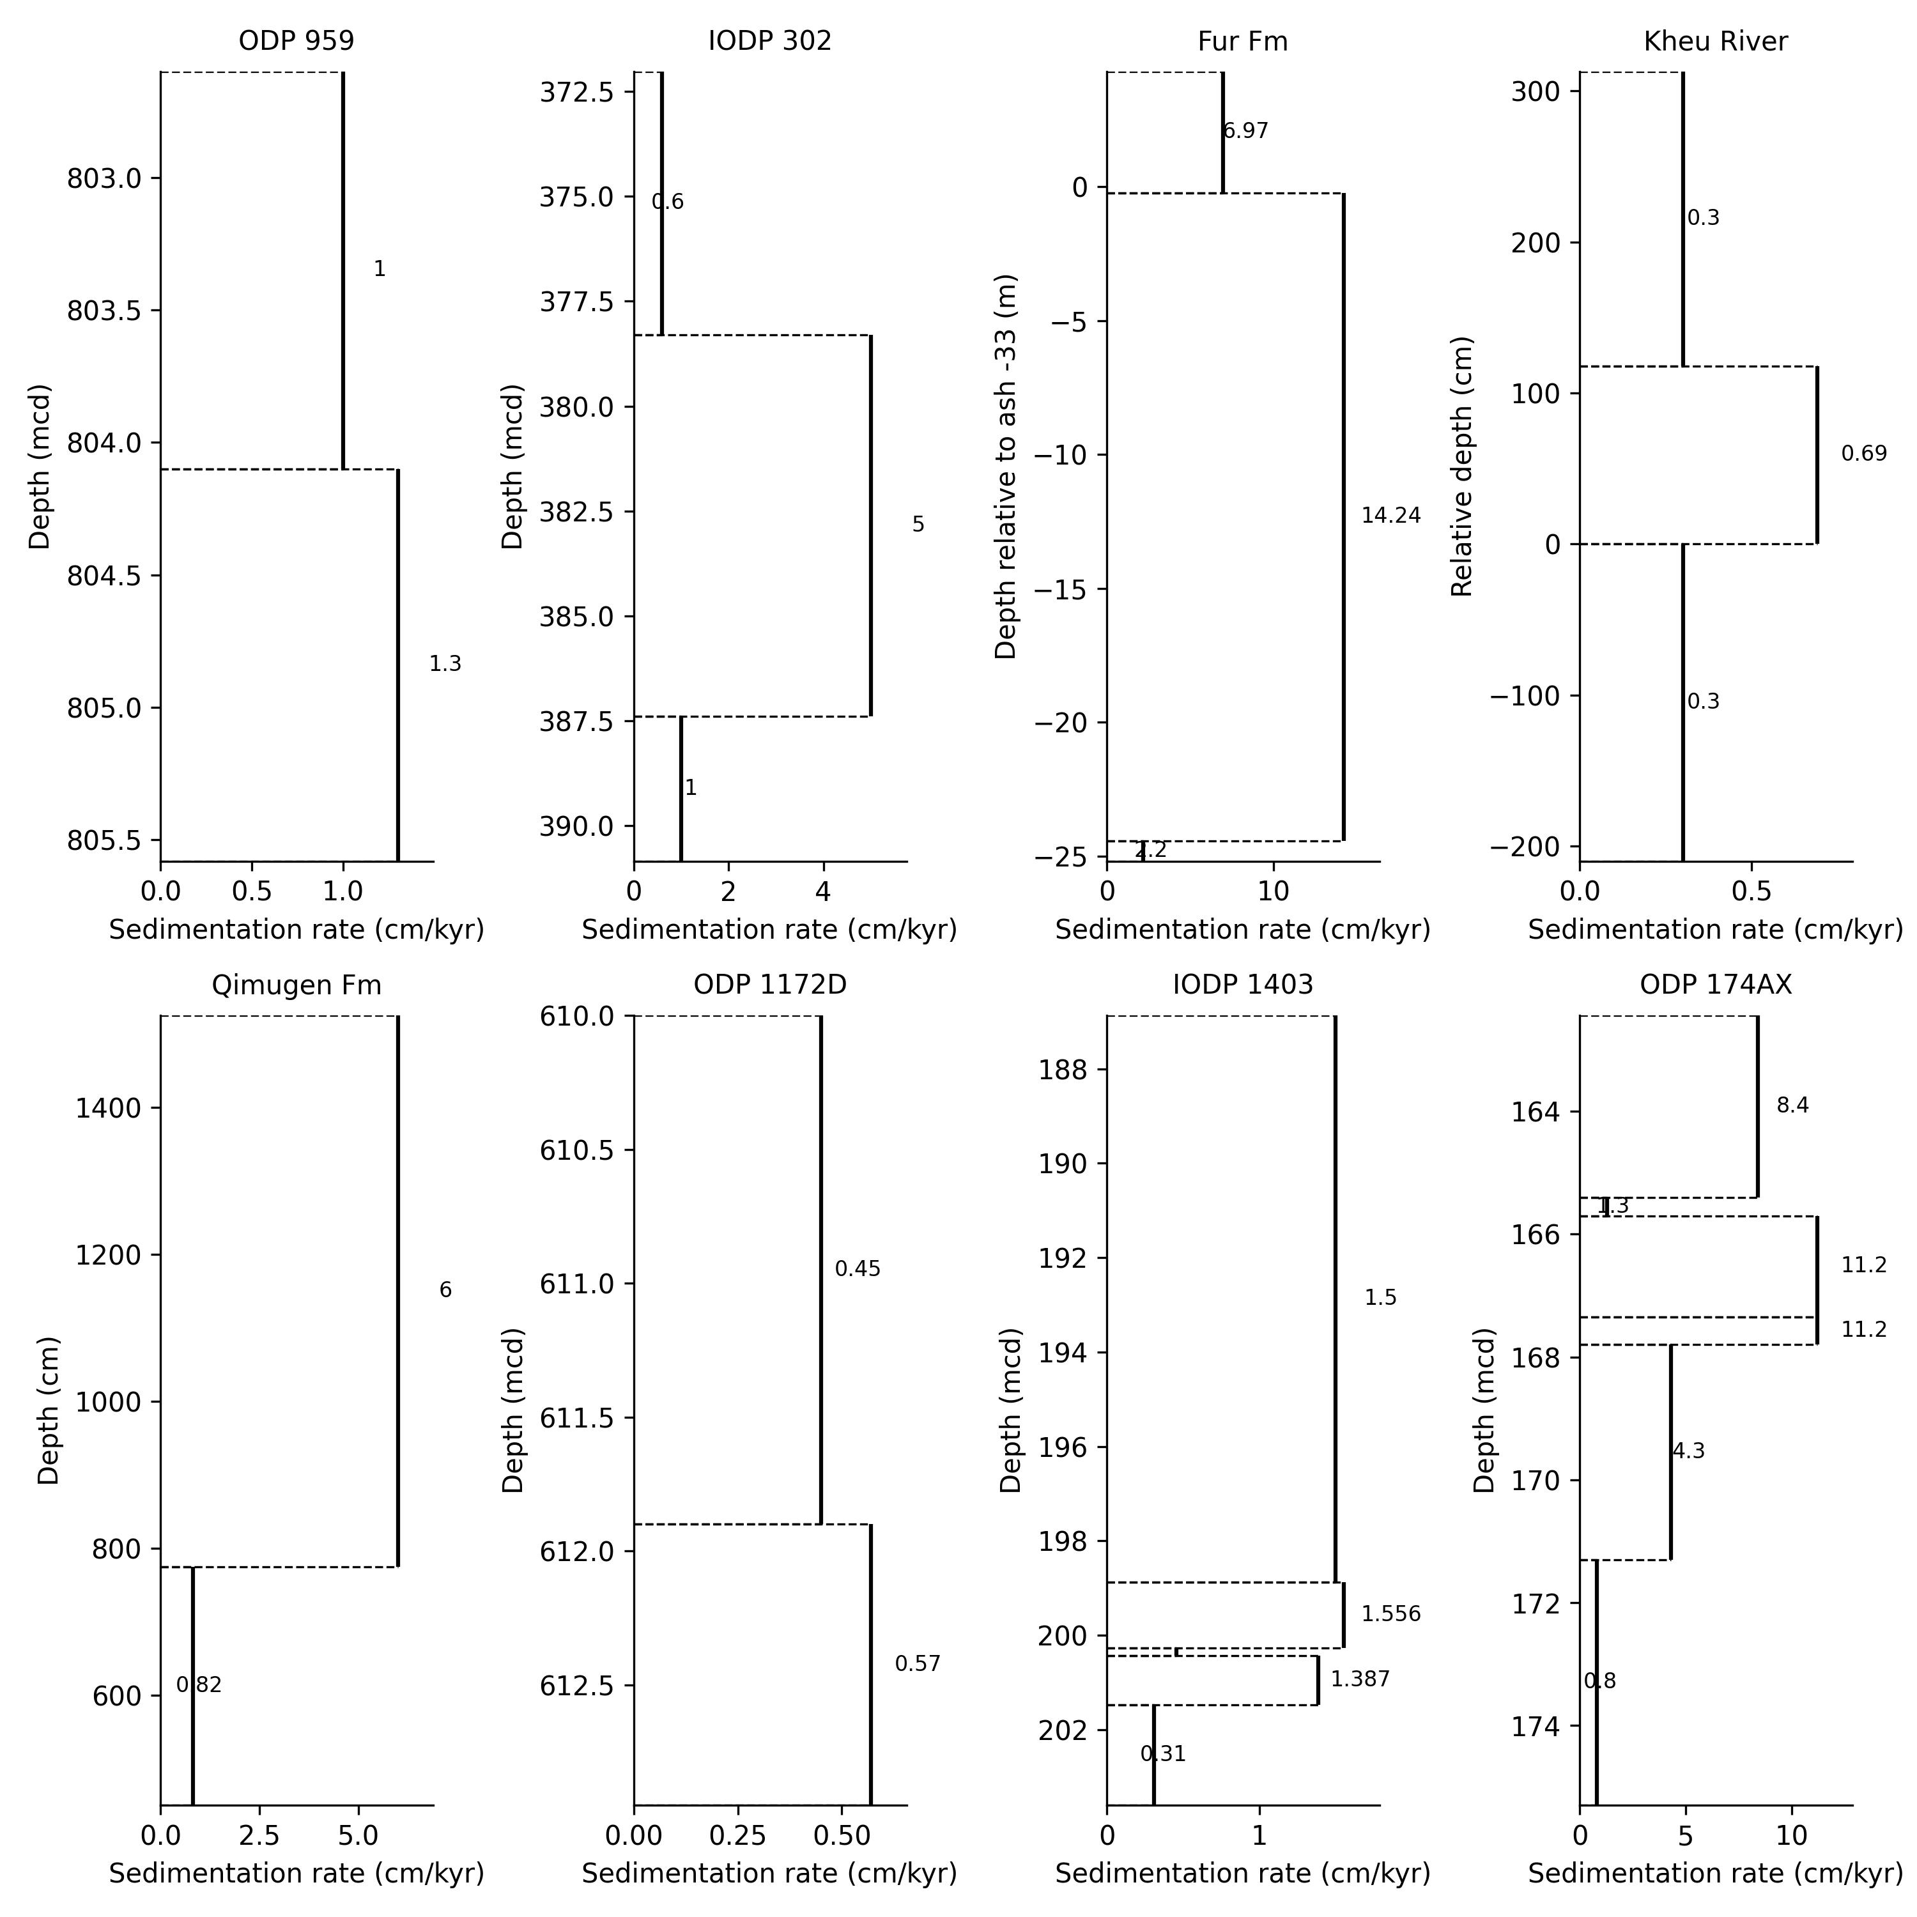

Supplementary Fig. 5. Linear sedimentation rates (LSRs) estimates from this study for Kheu River, Fur Fm, Qimugen Fm, and from previous studies for IODP 302⁴⁶, ODP 1172^{8,47}, ODP174AX Ancora⁸, IODP 1403⁴³, ODP 959⁴⁸.

References

1 Schouten, S., Hopmans, E. C., Schefuß, E. & Damsté, J. S. S. Distributional variations in marine crenarchaeotal membrane lipids: a new tool for reconstructing ancient sea water temperatures? Earth and Planetary Science Letters 204, 265–274 (2002).
2 Elling, F. J., Könneke, M., Mußmann, M., Greve, A. & Hinrichs, K.-U. Influence of temperature, pH, and salinity on membrane lipid composition and TEX₈₆ of marine planktonic thaumarchaeal isolates. Geochimica et Cosmochimica Acta 171, 238–255, doi:10.1016/j.gca.2015.09.004 (2015).
3 Qin, W. et al. Confounding effects of oxygen and temperature on the TEX₈₆ signature of marine Thaumarchaeota. Proceedings of the National Academy of Sciences of the United States of America 112, 10979–10984, doi:10.1073/pnas.1501568112 (2015).
4 Schouten, S. et al. Intact polar and core glycerol dibiphytanyl glycerol tetraether lipids in the Arabian Sea oxygen minimum zone: I. Selective preservation and degradation in the water column and consequences for the TEX₈₆. Geochimica et Cosmochimica Acta 98, 228–243, doi:10.1016/j.gca.2012.05.002 (2012).
5 Pitcher, A., Wuchter, C., Siedenberg, K., Schouten, S. & Sinninghe Damsté, J. S. Crenarchaeol tracks winter blooms of ammonia‐oxidizing Thaumarchaeota in the coastal North Sea. Limnology and Oceanography 56, 2308–2318 (2011).
6 Dickson, A. J. et al. The spread of marine anoxia on the northern Tethys margin during the Paleocene-Eocene Thermal Maximum. Paleoceanography 29, 471–488, doi:10.1002/2014pa002629 (2014).
7 John, C. M. et al. North American continental margin records of the Paleocene‐Eocene thermal maximum: Implications for global carbon and hydrological cycling. Paleoceanography 23 (2008).
8 Hollingsworth, E. H. et al. Spatial and Temporal Patterns in Petrogenic Organic Carbon Mobilization During the Paleocene‐Eocene Thermal Maximum. Paleoceanography and Paleoclimatology 39, doi:10.1029/2023pa004773 (2024).
9 Jones, M. T. et al. New constraints on the absolute age and duration of the Paleocene – Eocene Thermal Maximum (PETM) from ash layer +19 in Denmark. Earth and Planetary Science Letters 671, doi:10.1016/j.epsl.2025.119643 (2025).
10 Stokke, E. W., Jones, M. T., Tierney, J. E., Svensen, H. H. & Whiteside, J. H. Temperature changes across the Paleocene-Eocene Thermal Maximum–a new high-resolution TEX₈₆ temperature record from the Eastern North Sea Basin. Earth and Planetary Science Letters 544, 116388 (2020).
11 Kaya, M. Y. et al. Paleogene evolution and demise of the proto‐Paratethys Sea in Central Asia (Tarim and Tajik basins): Role of intensified tectonic activity at ca. 41 Ma. Basin Research 31, 461–486 (2019).
12 Kaya, M. Y. et al. The Eurasian epicontinental sea was an important carbon sink during the Palaeocene-Eocene thermal maximum. Communications Earth & Environment 3, 124, doi:10.1038/s43247-022-00451-4 (2022).
13 Schwartz-Narbonne, R. et al. A unique bacteriohopanetetrol stereoisomer of marine anammox. Organic Geochemistry 143, doi:10.1016/j.orggeochem.2020.103994 (2020).
14 Rush, D. et al. Anaerobic ammonium-oxidising bacteria: A biological source of the bacteriohopanetetrol stereoisomer in marine sediments. Geochimica et Cosmochimica Acta 140, 50–64, doi:10.1016/j.gca.2014.05.014 (2014).
15 Sáenz, J. P., Wakeham, S. G., Eglinton, T. I. & Summons, R. E. New constraints on the provenance of hopanoids in the marine geologic record: Bacteriohopanepolyols in marine suboxic and anoxic environments. Organic Geochemistry 42, 1351–1362, doi:10.1016/j.orggeochem.2011.08.016 (2011).
16 van Kemenade , Z. R. et al. Bacteriohopanetetrol-x: constraining its application as a lipid biomarker for marine anammox using the water column oxygen gradient of the Benguela upwelling system. Biogeosciences 19, 201–221, doi:10.5194/bg-19-201-2022 (2022).
17 van Kemenade, Z. R. et al. Marine nitrogen cycling dynamics under altering redox conditions: Insights from deposition of sapropels S1 and the ambiguous S2 in the Eastern Mediterranean Sea. Geochimica et Cosmochimica Acta 354, 197–210, doi:10.1016/j.gca.2023.06.018 (2023).
18 Kusch, S. & Rush, D. Revisiting the precursors of the most abundant natural products on Earth: A look back at 30+ years of bacteriohopanepolyol (BHP) research and ahead to new frontiers. Organic Geochemistry 172, 104469, doi:10.1016/j.orggeochem.2022.104469 (2022).
19 Rush, D. et al. Biomarker evidence for the occurrence of anaerobic ammonium oxidation in the eastern Mediterranean Sea during Quaternary and Pliocene sapropel formation. Biogeosciences 16, 2467–2479, doi:10.5194/bg-16-2467-2019 (2019).
20 Elling, F. J. et al. Linking diatom-diazotroph symbioses to nitrogen cycle perturbations and deep-water anoxia: Insights from Mediterranean sapropel events. Earth and Planetary Science Letters 571, 117110, doi:10.1016/j.epsl.2021.117110 (2021).
21 Matys, E. et al. Bacteriohopanepolyols along redox gradients in the Humboldt Current System off northern Chile. Geobiology 15, 844–857 (2017).
22 Kuypers, M. M. et al. Anaerobic ammonium oxidation by anammox bacteria in the Black Sea. Nature 422, 608–611 (2003).
23 Hawley, A. K. et al. Diverse Marinimicrobia bacteria may mediate coupled biogeochemical cycles along eco-thermodynamic gradients. Nature Communications 8, 1507 (2017).
24 Chen, Y. et al. Nitrite cycle indicated by dual isotopes in the northern South China Sea. Journal of Geophysical Research: Biogeosciences 126, e2020JG006129 (2021).
25 Chen, Y. et al. Dual isotopes of nitrite in the Amundsen Sea in summer. Science of the Total Environment 843, 157055 (2022).
26 Peng, X. et al. Ammonia and nitrite oxidation in the Eastern Tropical North Pacific. Global Biogeochemical Cycles 29, 2034–2049 (2015).
27 Kusch, S., Wakeham, S. G. & Sepúlveda, J. Bacteriohopanepolyols across the Black Sea redoxcline trace diverse bacterial metabolisms. Organic Geochemistry 172, doi:10.1016/j.orggeochem.2022.104462 (2022).
28 Lam, P. et al. Linking crenarchaeal and bacterial nitrification to anammox in the Black Sea. Proceedings of the National Academy of Sciences 104, 7104–7109 (2007).
29 Oakley, B. B. et al. Analysis of nitrite reductase (nirK and nirS) genes and cultivation reveal depauperate community of denitrifying bacteria in the Black Sea suboxic zone. Environmental microbiology 9, 118–130 (2007).
30 Galbraith, E. D., Sigman, D. M., Robinson, R. S., Pedersen, T. F. & Capone, D. Nitrogen in past marine environments. Nitrogen in the marine environment 2, 1497–1535 (2008).
31 M. Papadomanolaki, N., K. Lenstra, W., Wolthers, M. & P. Slomp, C. Enhanced phosphorus recycling during past oceanic anoxia amplified by low rates of apatite authigenesis. Science Advances 8, eabn2370, doi:10.1126/sciadv.abn2370 (2022).
32 Rafter, P. A., Bagnell, A., Marconi, D. & DeVries, T. Global trends in marine nitrate N isotopes from observations and a neural network-based climatology. Biogeosciences 16, 2617–2633 (2019).
33 Sluijs, A. et al. Subtropical Arctic Ocean temperatures during the Palaeocene/Eocene thermal maximum. Nature 441, 610–613, doi:10.1038/nature04668 (2006).
34 Pagani, M. et al. Arctic hydrology during global warming at the Palaeocene/Eocene thermal maximum. Nature 442, 671–675 (2006).
35 Stanev, E. V. Black sea dynamics. Oceanography 18, 56–75 (2005).
36 McCarthy, J. J., Yilmaz, A., Coban-Yildiz, Y. & Nevins, J. L. Nitrogen cycling in the offshore waters of the Black Sea. Estuarine, Coastal and Shelf Science 74, 493–514 (2007).
37 Fulton, J. M., Arthur, M. A. & Freeman, K. H. Black Sea nitrogen cycling and the preservation of phytoplankton δ¹⁵N signals during the Holocene. Global Biogeochemical Cycles 26, n/a–n/a, doi:10.1029/2011gb004196 (2012).
38 Robinson, R. S. et al. A review of nitrogen isotopic alteration in marine sediments. Paleoceanography 27, doi:10.1029/2012pa002321 (2012).
39 Freudenthal, T., Wagner, T., Wenzhöfer, F., Zabel, M. & Wefer, G. Early diagenesis of organic matter from sediments of the eastern subtropical Atlantic: evidence from stable nitrogen and carbon isotopes. Geochimica et Cosmochimica Acta 65, 1795–1808 (2001).
40 Fokkema, C. D. et al. Polar amplification of orbital-scale climate variability in the early Eocene greenhouse world. Climate of the Past Discussions 2023, 1–26 (2023).
41 Junium, C. K. & Arthur, M. A. Nitrogen cycling during the Cretaceous, Cenomanian-Turonian Oceanic Anoxic Event II. Geochemistry, Geophysics, Geosystems 8, n/a–n/a, doi:10.1029/2006gc001328 (2007).
42 Junium, C. K., Dickson, A. J. & Uveges, B. T. Perturbation to the nitrogen cycle during rapid Early Eocene global warming. Nat Commun 9, 3186, doi:10.1038/s41467-018-05486-w (2018).
43 Penman, D. E. et al. An abyssal carbonate compensation depth overshoot in the aftermath of the Palaeocene–Eocene Thermal Maximum. Nature Geoscience 9, 575–580 (2016).
44 Naafs, B. D. A. et al. Fundamentally different global marine nitrogen cycling in response to severe ocean deoxygenation. Proceedings of the National Academy of Sciences 116, 24979–24984, doi:10.1073/pnas.1905553116 (2019).
45 Steinig, S. et al. DeepMIP-Eocene-p1: multi-model dataset and interactive web application for Eocene climate research. Scientific Data 11, 970 (2024).
46 Sluijs, A. et al. Arctic late Paleocene–early Eocene paleoenvironments with special emphasis on the Paleocene‐Eocene thermal maximum (Lomonosov Ridge, Integrated Ocean Drilling Program Expedition 302). Paleoceanography 23 (2008).
47 Sluijs, A. et al. Southern ocean warming, sea level and hydrological change during the Paleocene-Eocene thermal maximum. Climate of the Past 7, 47–61 (2011).
48 Frieling, J. et al. Tropical Atlantic climate and ecosystem regime shifts during the Paleocene–Eocene Thermal Maximum. Climate of the Past 14, 39–55 (2018).
49 Herold, N. et al. A suite of early Eocene (~ 55 Ma) climate model boundary conditions. Geoscientific Model Development 7, 2077–2090 (2014).
50 Hollis, C. J. et al. The DeepMIP contribution to PMIP4: Methodologies for selection, compilation and analysis of latest Paleocene and early Eocene climate proxy data, incorporating version 0.1 of the DeepMIP database. Geoscientific Model Development 12, 3149–3206 (2019).
51 Gavrilo, Y. O., Shcherbinina, E. A. & Oberhänsli, H. Paleocene-Eocene boundary events in the northeastern Peri-Tethys. in Causes and consequences of globally warm climates in the early Paleogene (eds Scott L. Wing, Philip D. Gingerich, Birger Schmitz, & Ellen Thomas) (2003).
52 Harris, A. D. et al. Integrated stratigraphic studies of Paleocene–lowermost Eocene sequences, New Jersey Coastal Plain: Evidence for glacioeustatic control. Paleoceanography 25 (2010).
53 Schoon, P. L., Heilmann-Clausen, C., Schultz, B. P., Sinninghe Damsté, J. S. & Schouten, S. Warming and environmental changes in the eastern North Sea Basin during the Palaeocene–Eocene Thermal Maximum as revealed by biomarker lipids. Organic Geochemistry 78, 79–88, doi:10.1016/j.orggeochem.2014.11.003 (2015).
54 Jones, M. T. et al. Tracing North Atlantic volcanism and seaway connectivity across the paleocene–eocene thermal maximum (PETM). Climate of the Past 19, 1623–1652 (2023).
55 Kaya, M. Y. et al. Paleogene evolution and demise of the proto‐Paratethys Sea in Central Asia (Tarim and Tajik basins): Role of intensified tectonic activity at ca. 41 Ma. Basin Research 31, 461–486, doi:10.1111/bre.12330 (2019).

