Changes in Compound Hot-Dry Extremes and Their Exposures under Climate Change
Fuseini Yakubu¹, Jürgen Böhner², Laurens M. Bouwer^{2,3} , Shabeh ul Hasson¹
Affiliations
- HAREME Lab, Institute of Geography, Earth and Society Research Hub, Universität Hamburg, Hamburg, Germany
- Institute of Geography, Earth and Society Research Hub, Universität Hamburg, Hamburg, Germany
- Climate Service Center Germany (GERICS), Helmholtz-Zentrum Hereon, Hamburg, Germany
corresponding author(s): Fuseini Yakubu (fuseini.yakubu@studium.uni-hamburg.de), Shabeh ul Hasson (shabeh.hasson@uni-hamburg.de)

Table S1. Metrics used to validate the performance of the Bias corrections in simulating a similar distribution to the W5E5 v2.0 observational dataset during the historical period from 1979 to 2014 for precipitation and maximum temperature. This was done for the annual and four meteorological seasons: DJF, MAM, JJA, SON.
ID | ESM/Variant Label/Country | Period | Corr |  | Bias |  | MAE |  | RMSE
ID | ESM/Variant Label/Country | Period | pr  (mm/d) | tasmax  (K) | pr  (mm/d) | tasmax  (K) | pr  (mm/d) | tasmax  (K) | pr  (mm/d) | tasmax  (K)
1 | CNRM-CM6-1-HR /r1i1p1f1/  France | Annual | 0.80 | 1.00 | -0.04 | -0.01 | 0.78 | 2.02 | 1.55 | 2.78
1 | CNRM-CM6-1-HR /r1i1p1f1/  France | DJF | 0.80 | 0.99 | -0.03 | -0.02 | 0.74 | 2.16 | 1.57 | 3.03
1 | CNRM-CM6-1-HR /r1i1p1f1/  France | MAM | 0.80 | 1.00 | -0.03 | -0.01 | 0.75 | 2.11 | 1.48 | 2.83
1 | CNRM-CM6-1-HR /r1i1p1f1/  France | JJA | 0.80 | 1.00 | -0.05 | -0.01 | 0.85 | 1.88 | 1.65 | 2.61
1 | CNRM-CM6-1-HR /r1i1p1f1/  France | SON | 0.77 | 1.00 | -0.04 | -0.01 | 0.78 | 1.94 | 1.50 | 2.64
2 | EC-Earth3P-HR /r1i1p2f1/  Sweden | Annual | 0.79 | 0.99 | -0.03 | 0.00 | 0.79 | 2.09 | 1.58 | 2.88
2 | EC-Earth3P-HR /r1i1p2f1/  Sweden | DJF | 0.79 | 0.99 | -0.03 | -0.01 | 0.77 | 2.23 | 1.64 | 3.12
2 | EC-Earth3P-HR /r1i1p2f1/  Sweden | MAM | 0.79 | 1.00 | -0.03 | 0.00 | 0.77 | 2.16 | 1.53 | 2.90
2 | EC-Earth3P-HR /r1i1p2f1/  Sweden | JJA | 0.81 | 1.00 | -0.04 | -0.01 | 0.84 | 2.00 | 1.62 | 2.80
2 | EC-Earth3P-HR /r1i1p2f1/  Sweden | SON | 0.77 | 1.00 | -0.04 | 0.00 | 0.79 | 2.00 | 1.53 | 2.70
3 | HadGEM3-GC31-HM /r1i1p1f2/  United Kingdom | Annual | 0.80 | 1.00 | -0.04 | -0.01 | 0.78 | 2.02 | 1.56 | 2.77
3 | HadGEM3-GC31-HM /r1i1p1f2/  United Kingdom | DJF | 0.79 | 0.99 | -0.04 | 0.01 | 0.76 | 2.20 | 1.62 | 3.06
3 | HadGEM3-GC31-HM /r1i1p1f2/  United Kingdom | MAM | 0.80 | 1.00 | -0.03 | -0.01 | 0.75 | 2.07 | 1.50 | 2.76
3 | HadGEM3-GC31-HM /r1i1p1f2/  United Kingdom | JJA | 0.81 | 1.00 | -0.05 | -0.02 | 0.83 | 1.89 | 1.60 | 2.63
3 | HadGEM3-GC31-HM /r1i1p1f2/  United Kingdom | SON | 0.77 | 1.00 | -0.04 | -0.01 | 0.78 | 1.93 | 1.50 | 2.60
4 | MPI-ESM1-2-XR /r1i1p1f1/  Germany | Annual | 0.78 | 0.99 | -0.04 | -0.01 | 0.81 | 2.18 | 1.63 | 3.01
4 | MPI-ESM1-2-XR /r1i1p1f1/  Germany | DJF | 0.79 | 0.99 | -0.03 | 0.00 | 0.77 | 2.29 | 1.66 | 3.18
4 | MPI-ESM1-2-XR /r1i1p1f1/  Germany | MAM | 0.78 | 0.99 | -0.03 | 0.02 | 0.78 | 2.21 | 1.57 | 2.97
4 | MPI-ESM1-2-XR /r1i1p1f1/  Germany | JJA | 0.79 | 1.00 | -0.05 | -0.01 | 0.88 | 2.18 | 1.70 | 3.10
4 | MPI-ESM1-2-XR /r1i1p1f1/  Germany | SON | 0.76 | 1.00 | -0.04 | 0.01 | 0.81 | 2.05 | 1.60 | 2.79

Table S2. Remaining biases in model after bias correction
No. | Model | (x̄ - x̄) %
No. | Model | Mean (OBs): 22.71 |  | Mean (OBs): 5.92 |  | Mean (OBs): 0.97
No. | Model | 1σ |  | 1.5σ |  | 2σ
No. | Model | Mean (Model) | Bias | Mean (Model) | Bias | Mean (Model) | Bias
1. | CNRM | 27.50 | 4.80 | 8.11 | 2.19 | 1.57 | 0.60
2. | EC-Earth3P | 27.05 | 4.35 | 8.56 | 2.63 | 1.97 | 1.00
3. | HadGEM3 | 25.70 | 2.99 | 7.51 | 1.59 | 1.62 | 0.65
4. | MPI-XR | 26.90 | 4.19 | 8.48 | 2.56 | 2.00 | 1.03

Table S3. Change in compound hot-dry extremes (difference in occurrence in months over 30-year period) between future (2021-2050) and historical (1985-2014) periods
No. | Model | Change in compound hot-dry extremes
No. | Model | Low (1.0σ) |  | Moderate (1.5σ) |  | High (2.0σ)
No. | Model | Min | Max | Min | Max | Min | Max
1. | CNRM | -27 | 116 | -14 | 80 | -7 | 51
2. | EC-Earth3P | -25 | 191 | -15 | 156 | -6 | 103
3. | HadGEM3 | -22 | 241 | -12 | 192 | -8 | 136
4. | MPI-XR | -33 | 270 | -24 | 263 | -16 | 246
5. | ENSEMBLE | -15 | 130 | -6 | 89 | -3 | 69

Table S4. Same as in Table S4, but for hemisphere-specific growing seasons.
No. | Model | Change in compound hot-dry extremes
No. | Model | Low (1.0σ) |  | Moderate (1.5σ) |  | High (2.0σ)
No. | Model | Min | Max | Min | Max | Min | Max
1. | CNRM | -17 | 78 | -9 | 58 | -6 | 31
2. | EC-Earth3P | -19 | 104 | -9 | 74 | -5 | 48
3. | HadGEM3 | -15 | 130 | -8 | 117 | -5 | 100
4. | MPI-XR | -18 | 136 | -12 | 130 | -8 | 121
5. | ENSEMBLE | -8 | 68 | -4 | 45 | -2 | 37

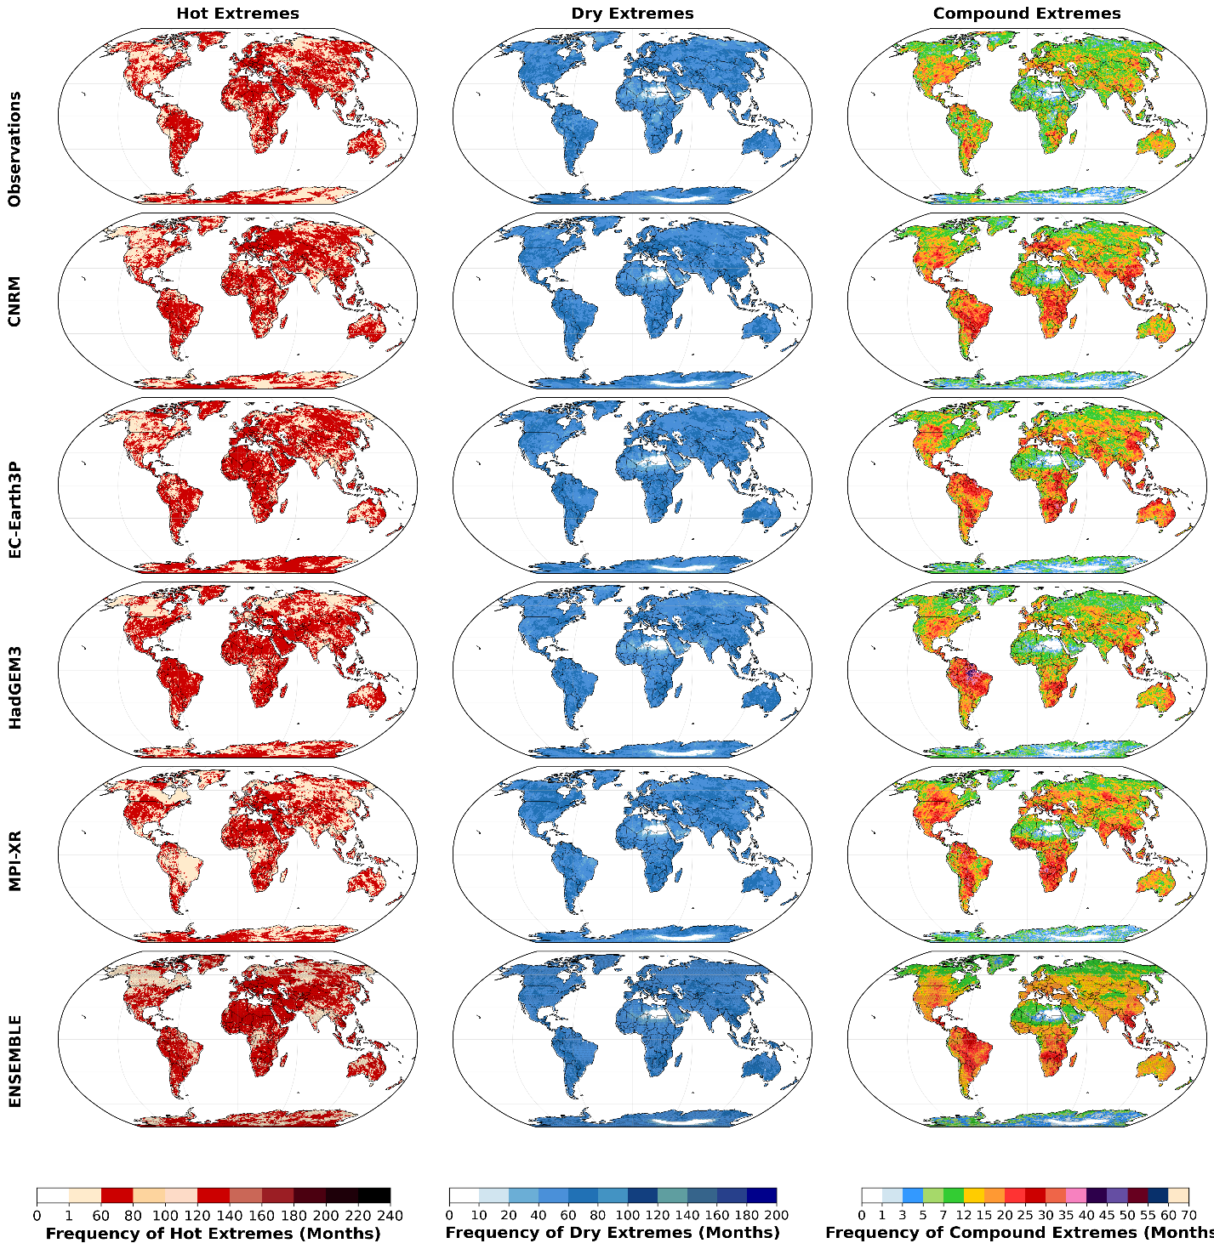
Fig. S1. Global distribution of compound hot, dry, and dry-hot extremes for the historical period (1985-2014) for Low (1.0σ) extremes.
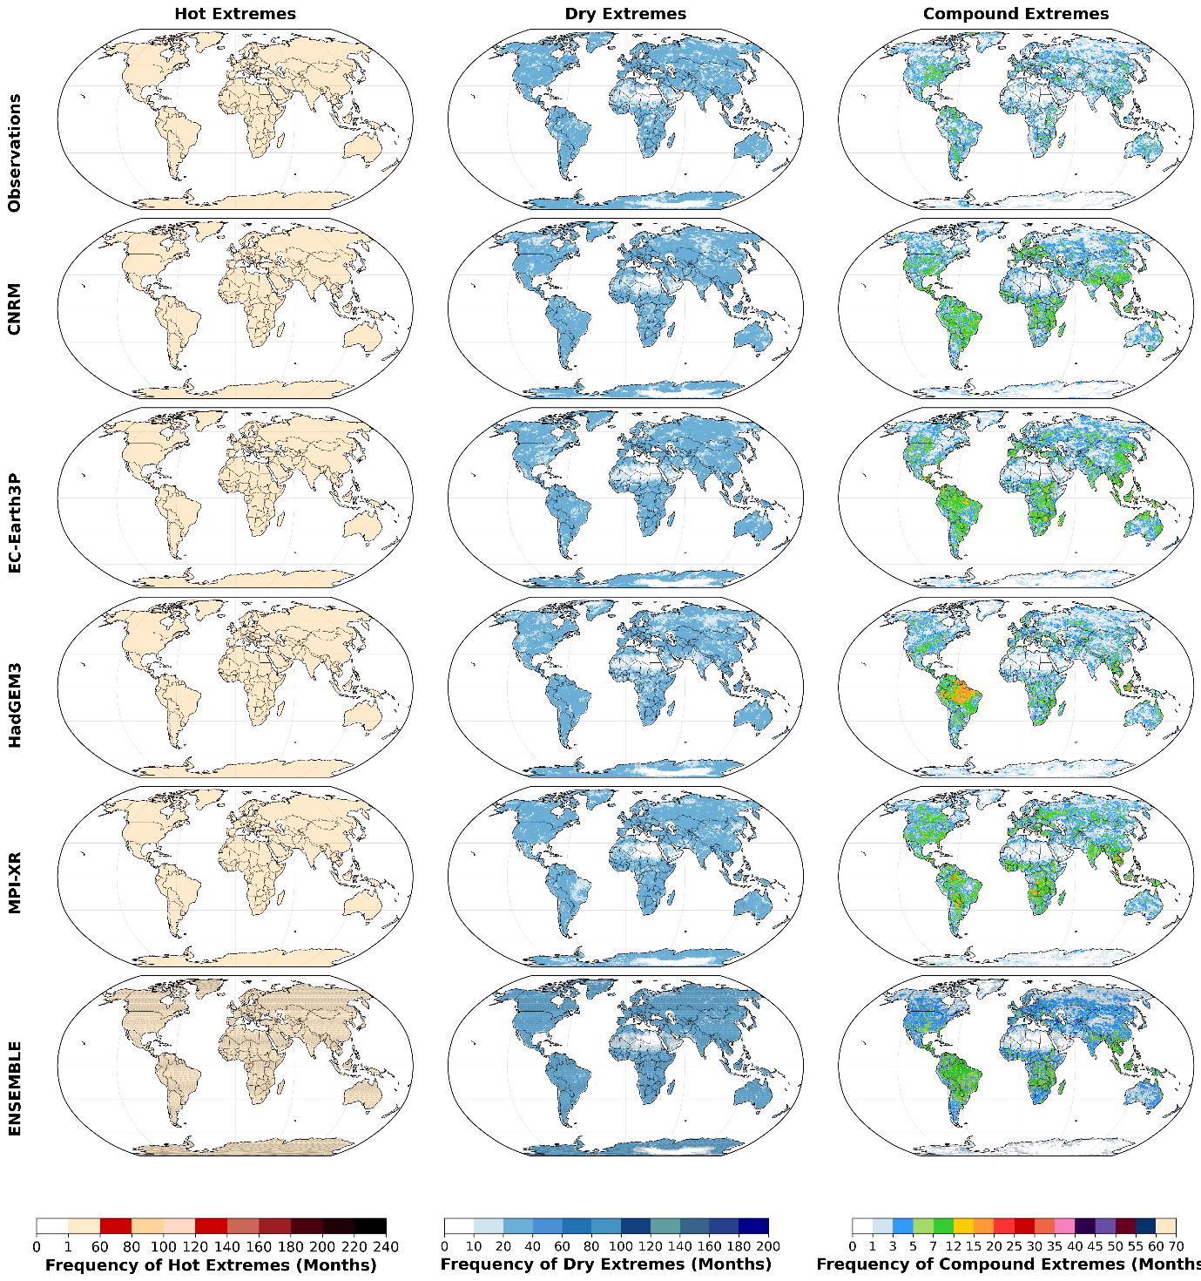
Fig. S2. Same as fig. S1, but for Moderate (1.5σ) extremes.

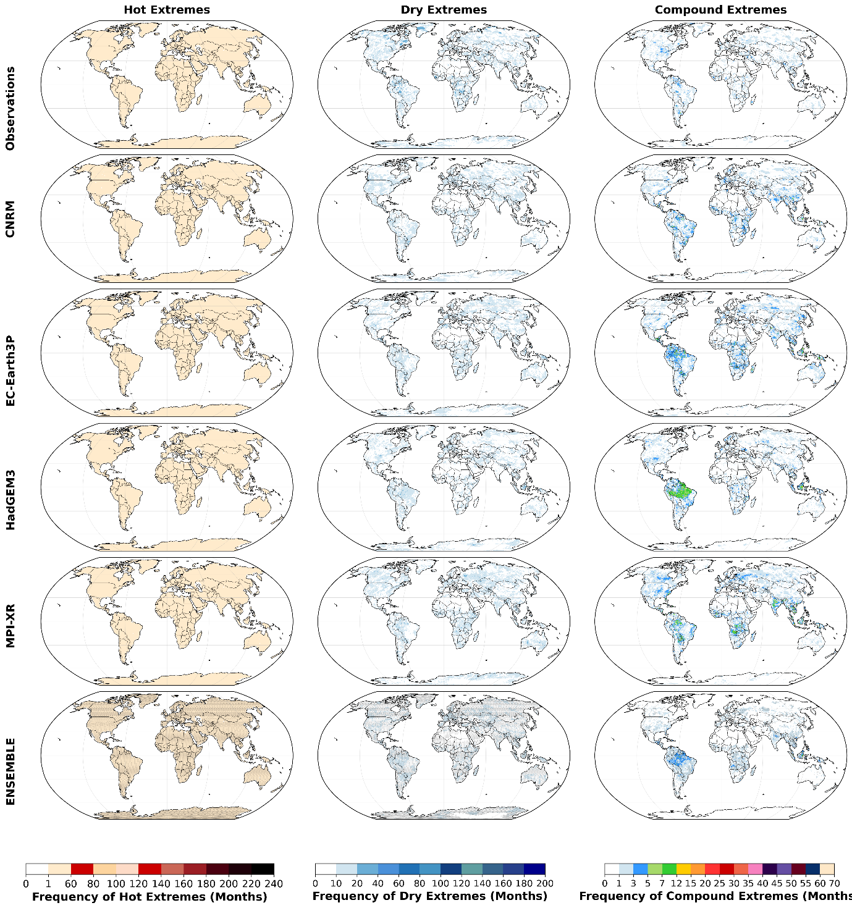
Fig. S3. Same as fig. S1, but for High (2.0σ) extremes.

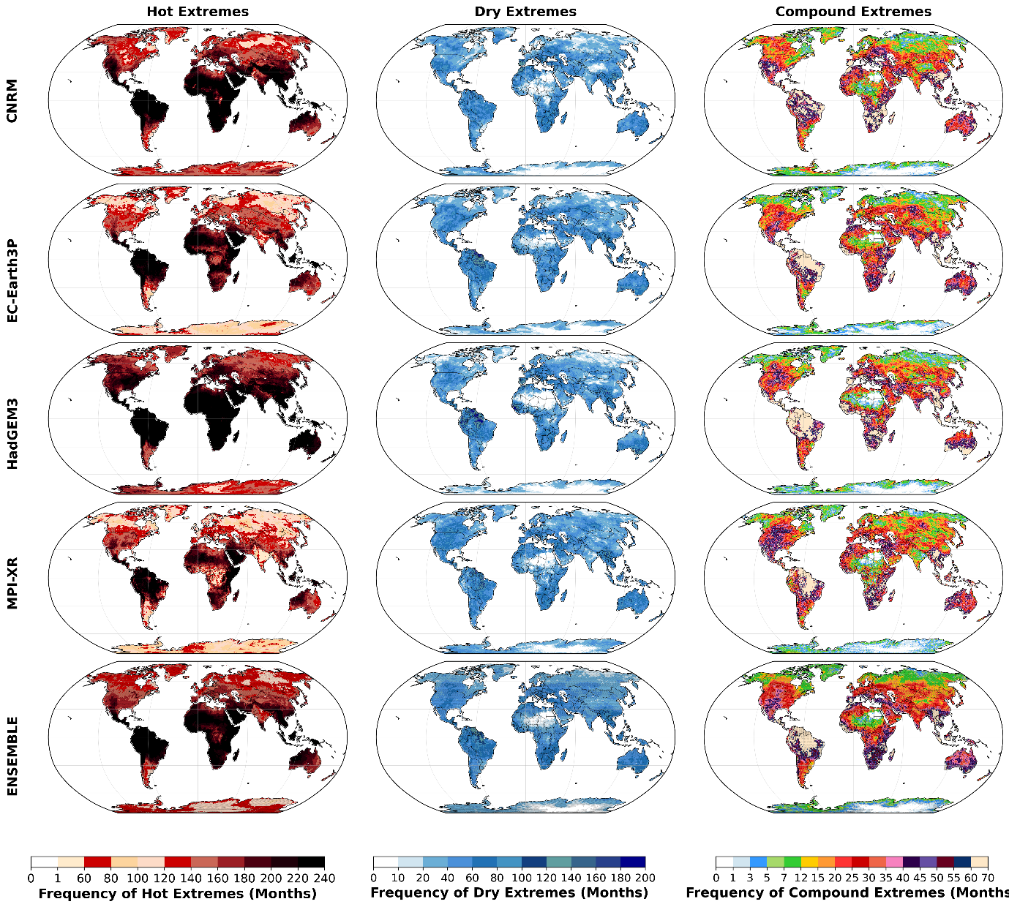
Fig. S4. Same as Fig. S1, but for Low (1.0σ) extremes and future periods (2021-2050).

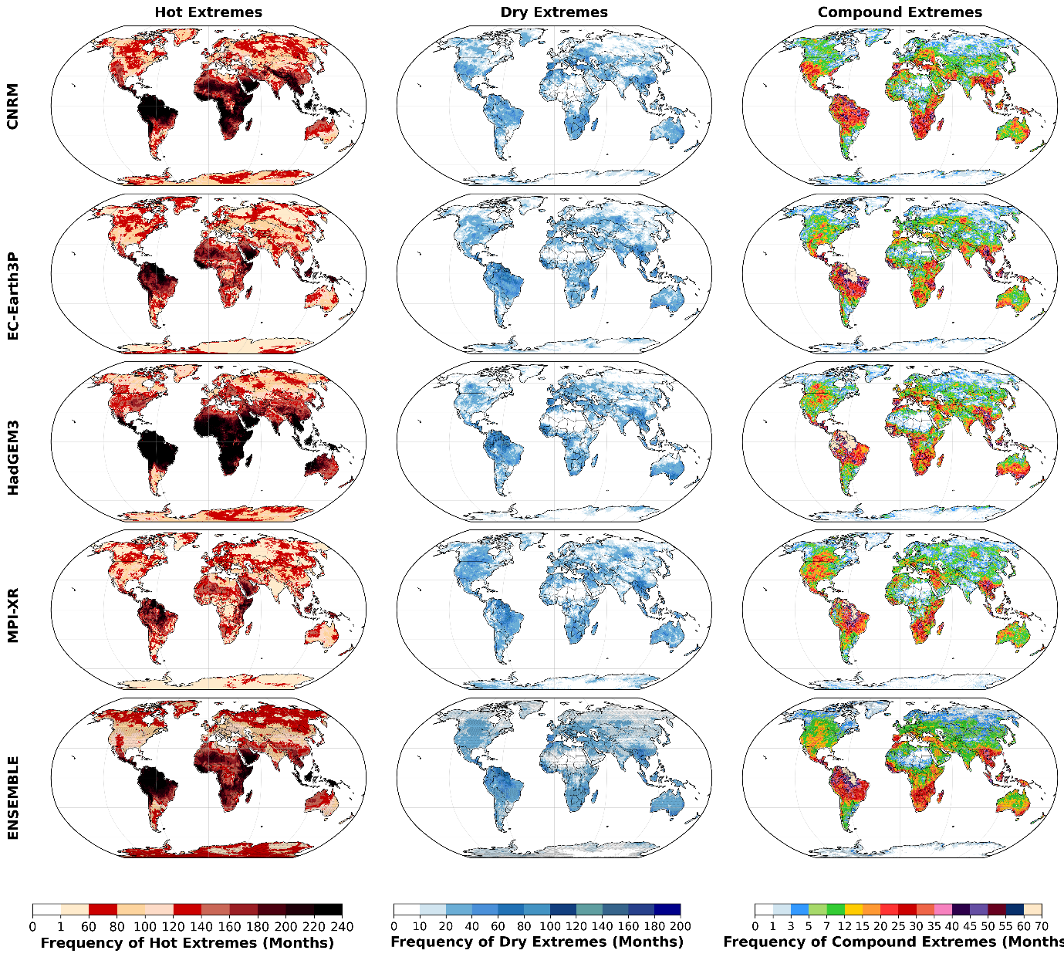
Fig. S5. Same as Fig. S1, but for Moderate (1.5σ) extremes.
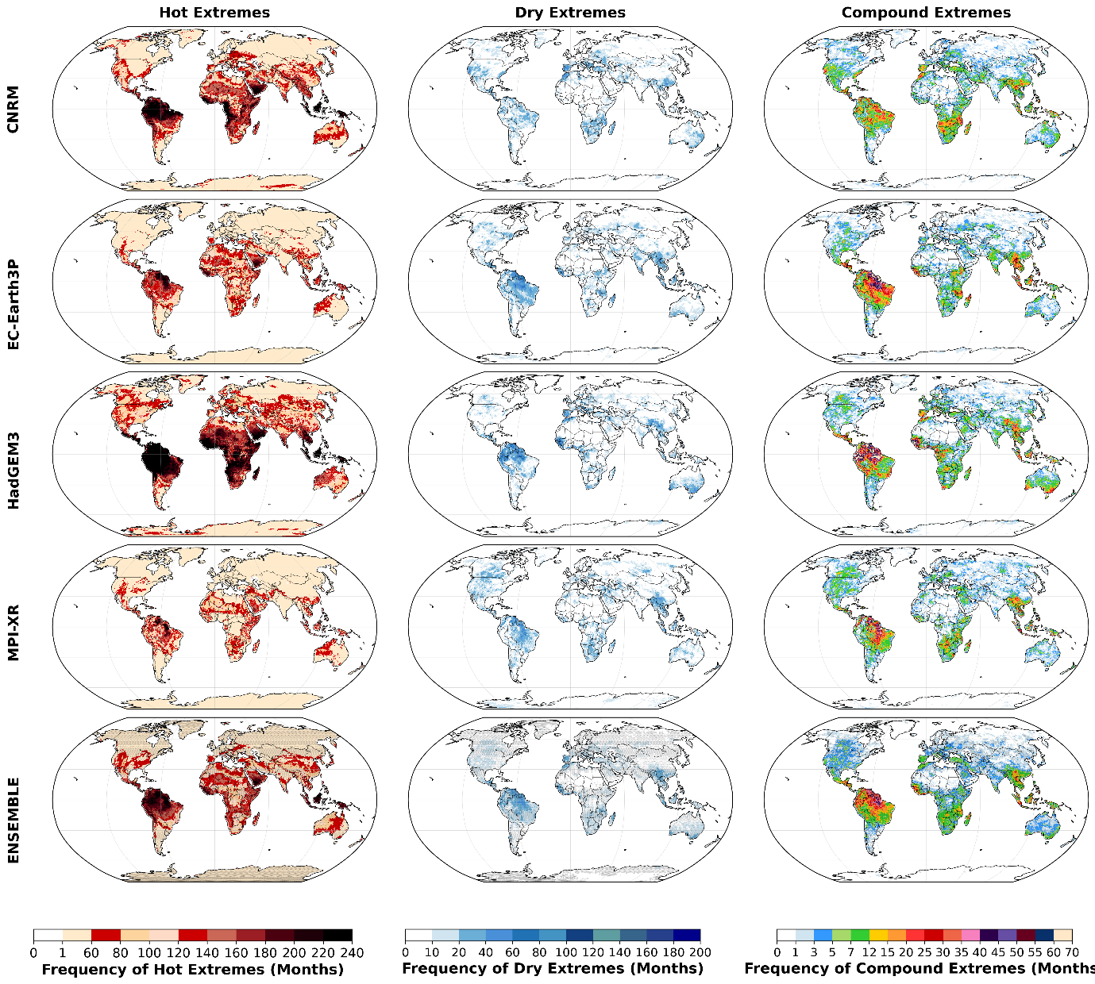
Fig. S6. Same as Fig. S1, but for High (2.0σ) extremes.

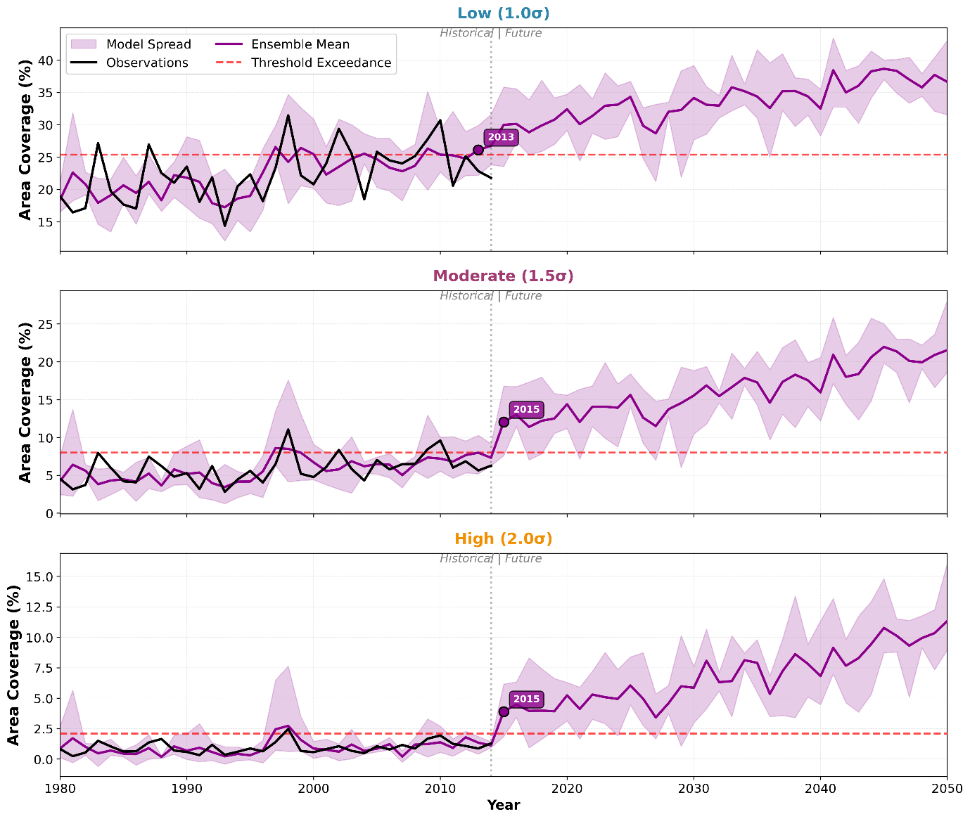
Fig. S7. Temporal evolution of global land area affected by CHDEs (1985-2050) across three intensities, but for the raw model data.

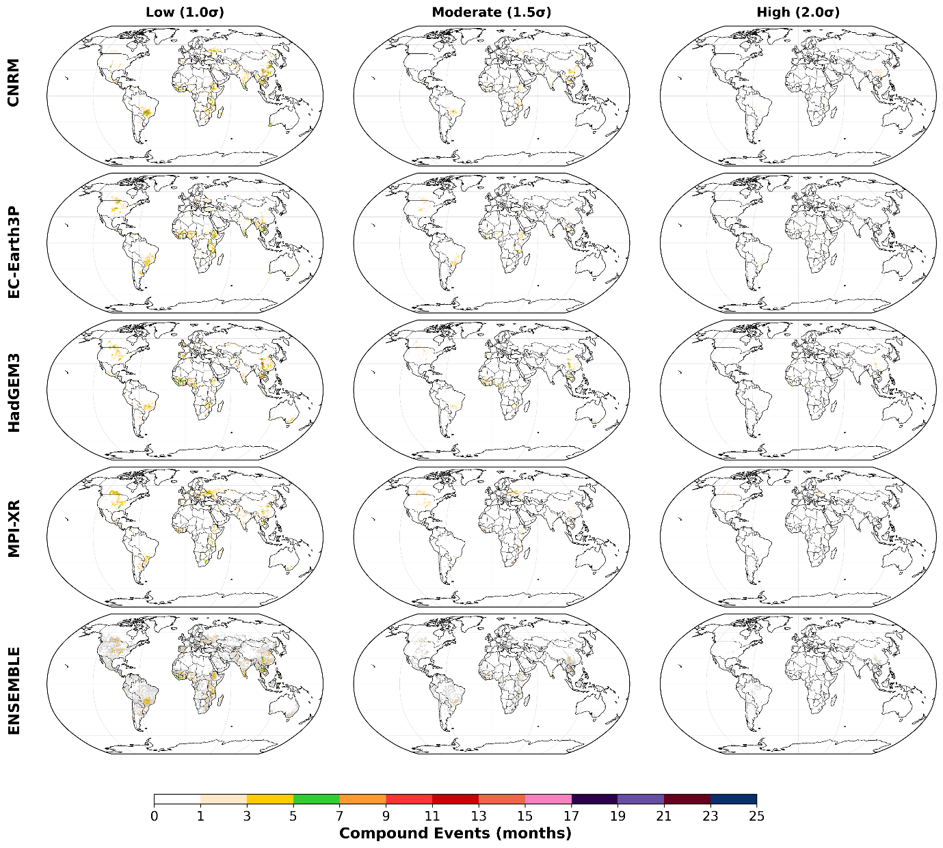
Fig. S8. Distribution of CHDEs during hemisphere-specific growing seasons for 2026-2030. Northern Hemisphere: April-September; Southern Hemisphere: October-March.

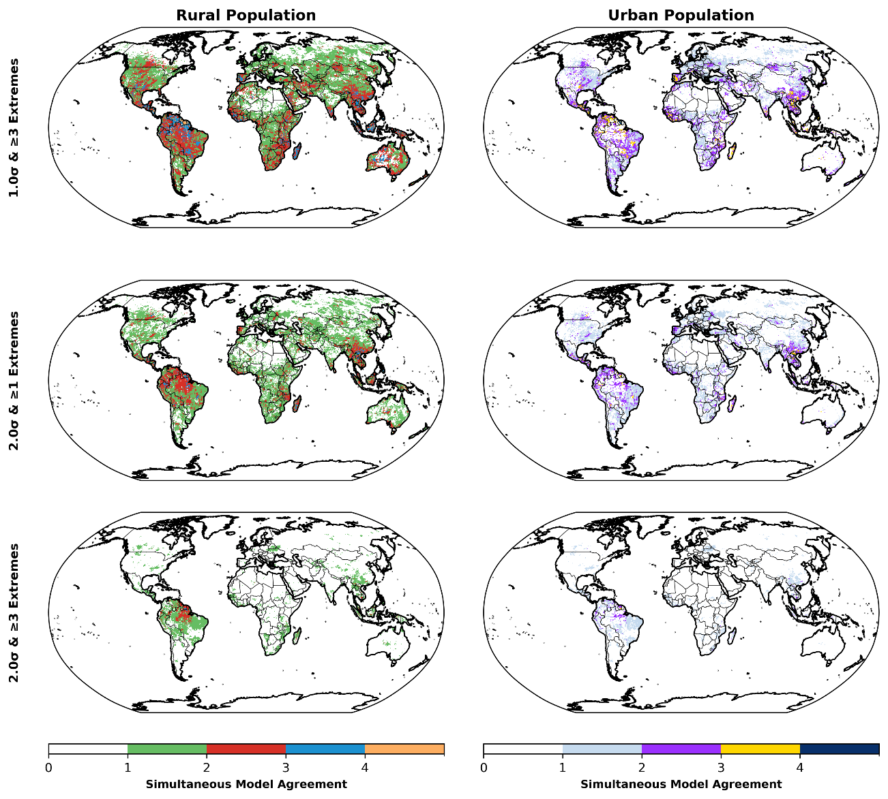
Fig. S9. Spatial distribution of inter-model agreement for population exposure during the period 2026-2030. Left panels show rural populations; right panels show urban populations. Top row: Low intensity with high frequency (1.0σ, ≥3 extremes annually); bottom row: High intensity with high frequency (2.0σ, ≥3 extremes annually). Colour scale indicates number of models agreeing on the same extreme (0-4) at the same grid cell and time, with warmer colours showing higher consensus

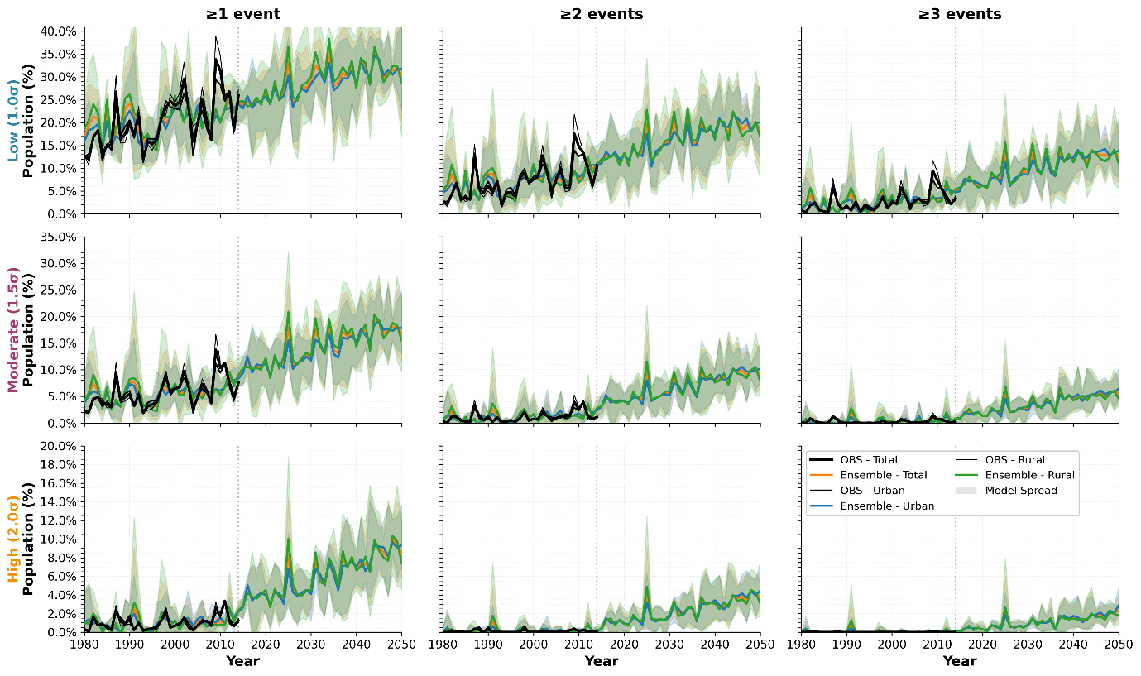
Fig. S10. Increase in global exposure (in %) to CHDEs (1980-2050) organized in a 3×3 panel grid. Baseline period (1985-2014). Rows represent intensities: low (1.0σ), moderate (1.5σ), and high (2.0σ); columns represent extreme frequencies (≥1, ≥2, ≥3 events per year). Each panel shows total (orange), urban (blue), and rural (green) population exposure trajectories, with observations (black) where available and model ensemble spread (shading).

