Bar Chart 1: Visibility of UNAM Repositories through search engines
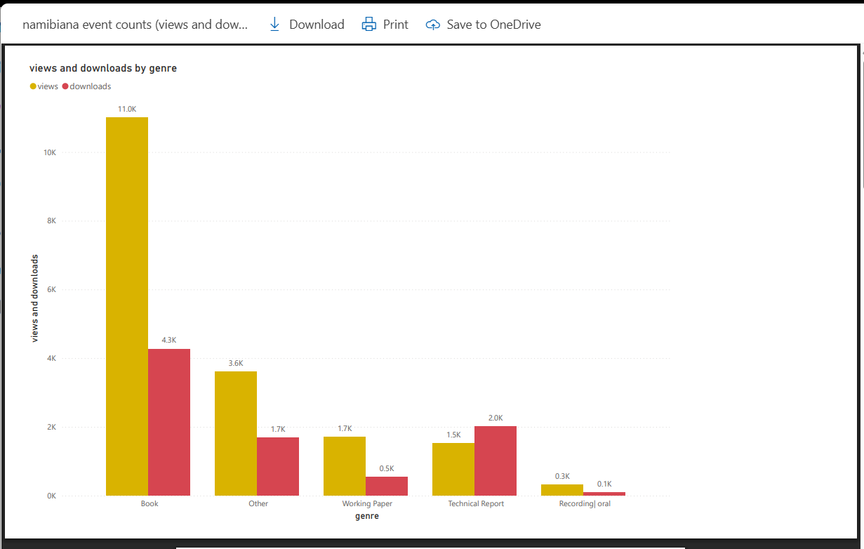
Bar Chart 1: Download statistics from the UNAM Digital Repositories

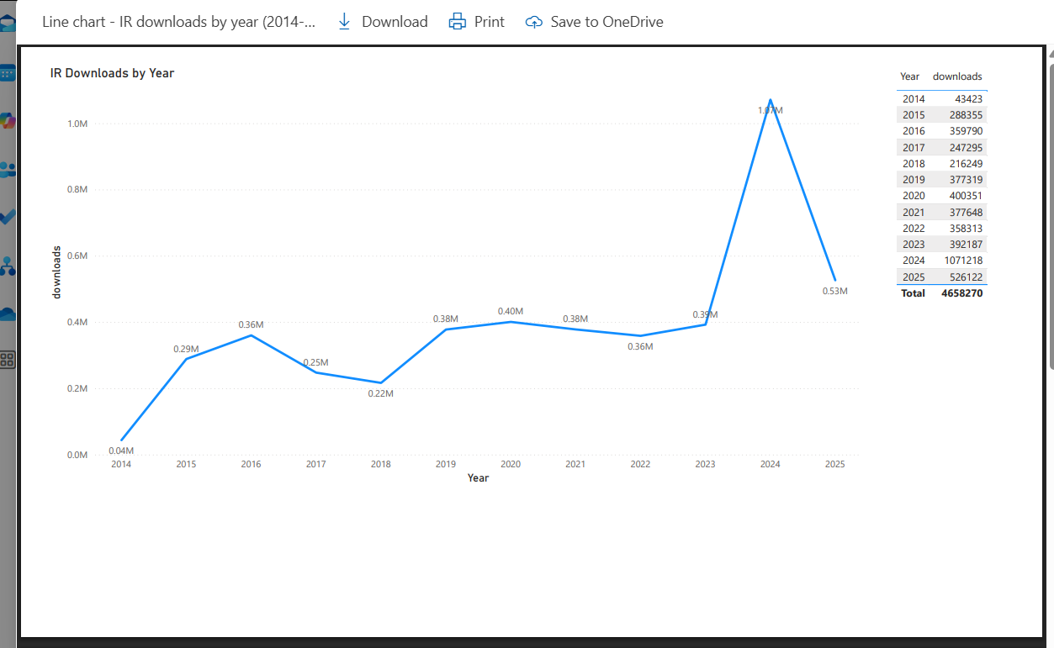
Line chart 1: Download statistics from the UNAM Institutional Repository

