Supplementary Figure 1. Fabrication method and performance characterization of the optical ultrasound source.
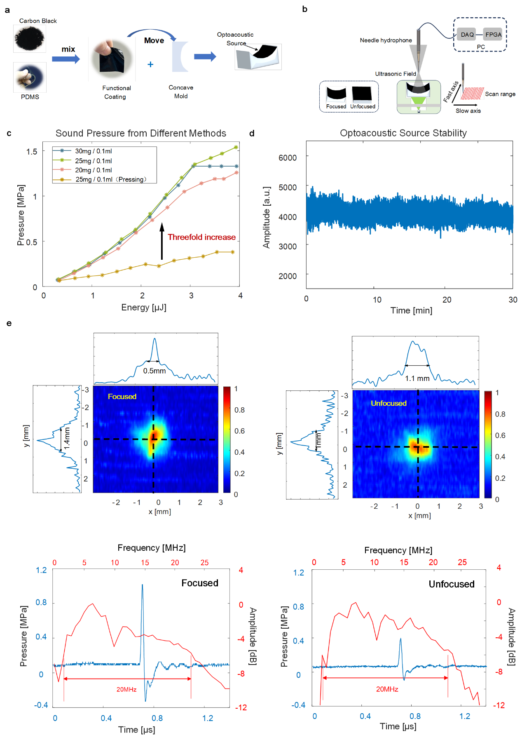
Supplementary Fig 1. (a) Fabrication process of the optical ultrasound source. (b) Acoustic field scanning setup. (c) Comparison of acoustic pressure from different preparation methods. (d) Sound source stability results. (e) Comparison of acoustic field distribution and pressure bandwidth before and after ultrasound focusing.
The fabrication process of the functional coating is illustrated in Supplementary Fig. 1(a). We systematically optimized the performance by adjusting the mixing ratio between carbon powder and PDMS, ultimately determining the optimal composition as carbon powder: PDMS = 25 mg : 0.1 ml. Furthermore, the fabrication methodology was refined to enhance the performance of the acoustic source compared to the previously used in our group: the pressing method was replaced by spin-coating. By controlling the spin speed and duration of the spin coater, the thickness of the coating could be precisely tuned. We first used a low rotation speed of 900 rpm for 15 seconds to evenly spread the coating, followed by a high rotation speed of 5000 rpm for 60 seconds to control the thickness of the coating. The final prepared coating has a thickness between 90 and 100 micrometers. Comparative results (Supplementary Fig. 1(c)) demonstrate that the acoustic source fabricated via spin-coating achieves a threefold enhancement in the generated acoustic pressure amplitude. The stability of the functional coating was evaluated by operating it under maximum laser energy below the damage threshold for 30 minutes. As shown in Supplementary Fig. 1(d), the acoustic pressure amplitude remains relatively stable. To further enhance the signal-to-noise ratio (SNR), the optical ultrasound source was fabricated with a concave surface to achieve line focusing, thereby reducing interference from reflected signals surrounding the blood vessels. Given that the radial artery is typically located approximately 3-5 mm beneath the skin, and our concave acoustic source is positioned 4 mm from the skin, the curvature radius of the concave source was designed to be 7 mm. This design places the focal point roughly at the upper surface of the radial artery, thereby minimizing interference from other tissue signals. The acoustic field profiles of the source, both before and after focusing, were characterized via two-dimensional scanning using a standard hydrophone (Supplementary Fig. 1(b)), with the results presented in Supplementary Fig. 1(e). After focusing, the acoustic pressure increases to three times the original value while maintaining a wide bandwidth of 20 MHz.

Supplementary Figure 2. Working principle of the fiber laser sensor and performance characterization.
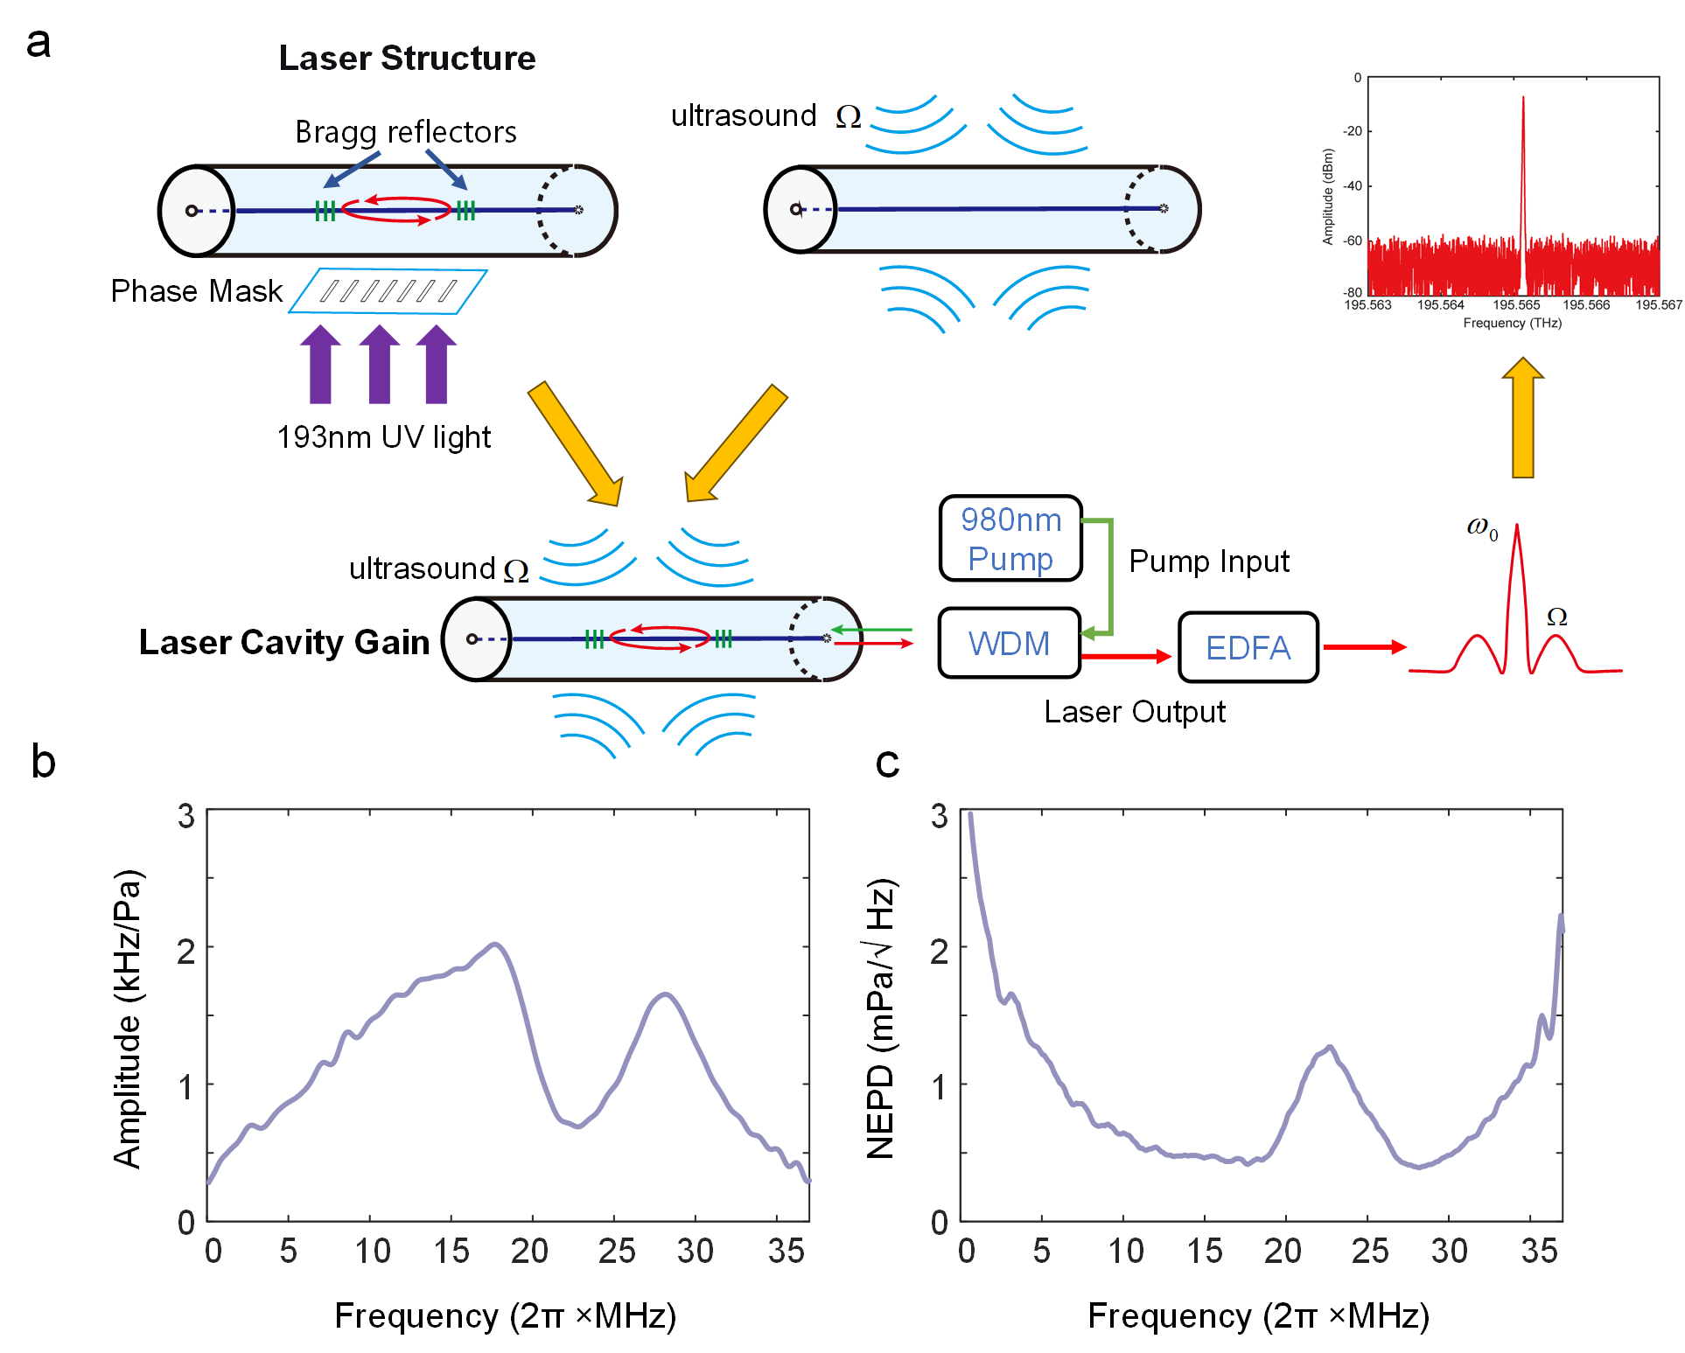
Supplementary Fig 2. (a) Fabrication methods and working principles of fiber laser sensor. (b) Fiber laser sensor's frequency response. (c) Fiber laser sensor's noise-equivalent power spectral density
The sensor employs an erbium-doped fiber with two highly reflective fiber Bragg gratings (FBGs) inscribed by a 193 nm ultraviolet laser and a phase mask. It achieves single-frequency, single-longitudinal-mode operation when dumped at 980 nm. During ultrasound detection, acoustic pressure modulates the fiber's refractive index, shifting the phase of the optical output (Supplementary Fig. 1(a)). The fiber laser cavity significantly enhances this acoustically induced phase variation ${}_{las}\left(Ω\right)$:
$${}_{las}\left(Ω\right)=2π\frac{ω_{0}}{iΩ}∙S_{m}(Ω)P_{i}(Ω) \left(1\right)$$
The ratio $F=ω_{0}/iΩ$ represents the gain factor. With an acoustically induced phase variation reaching approximately ${10}^{-4}$ rad/Pa at 20 MHz, these results indicate that the laser cavity is essential for amplifying the optical phase response."
To demodulate the phase variation, we employed a self-delayed heterodyne detection scheme based on a Mach–Zehnder interferometer. The ultrasound-modulated laser output, expressed as $a(t)=a_{0}exp⁡[iω_{0}t+iΔθ_{las}(t)]$ (1), is split by a 50:50 coupler. One arm incorporates an acousto-optic modulator (AOM) to introduce a frequency shift ($ω_{AOM}=2π×200$ MHz), while the other contains a fiber delay line providing a temporal offset ($τ$). The signals from the two branches are defined as:
$$\begin{aligned}a_{mod}\left(t\right)=\frac{\sqrt{2}}{2}a_{0}\exp\left[iω_{0}t+i{∆θ}_{las}\left(t\right)\right]∙\exp\left(iω_{AOM}t\right)\#\left(2a\right)\end{aligned}$$
$$\begin{aligned}a_{del}\left(t\right)=\frac{\sqrt{2}}{2}a_{0}\exp\left[iω_{0}\left(t-τ\right)+i∆θ_{las}\left(t-τ\right)\right]\#\left(2b\right)\end{aligned}$$
Upon recombination, the heterodyne beat signal detected by the photodetector is$\begin{aligned}a_{b}\left(t\right)=\frac{1}{2}κA_{0}^{2}\exp{\{}i[{∆θ}_{las}(t)-{∆θ}_{las}(t-τ)+ω_{AOM}τ-θ_{Lo}]\} \#\left(3\right)\end{aligned}$
where $θ_{LO}$ is the initial phase and $κ$ is the conversion coefficient. The spectral density $Θ(Ω)$ is derived using the Fourier time-shifting property:
$$\begin{aligned}Θ\left(Ω\right)=\int_{-∞}^{+∞}{∆θ_{b}\left(t\right)}∙e^{-iΩt}dt \\ =\left(1-e^{-iΩτ}\right)Θ_{las}\left(Ω\right)=2\sin\left(\frac{Ωτ}{2}\right)e^{i\frac{π-Ωτ}{2}}Θ_{las}\left(Ω\right) \\ =G\left(Ω\right)∙Θ_{las}\left(Ω\right)=2πF∙{G\left(Ω\right)∙S}_{m}(Ω){∙P}_{i}(Ω) \#\left(4\right)\end{aligned}$$
Based on Equation (4), the transfer function of the self-delayed heterodyne can be defined as $G(Ω)=2\sin\left(\frac{Ωτ}{2}\right)e^{i\frac{π-Ωτ}{2}}$, which introduces an additional sensitivity gain factor of 2 with an optimal value of the product $Ωτ=π$, by controlling the optical length difference between the two arms. The transfer function G also has multiple zeros at integer multiples of the free spectral range (FSR = n/τ, where n is an integer, shown in Figure 3a). Therefore, it is crucial to carefully select a suitable fiber length difference between the two arms to ensure adequate detection bandwidth and coverage of the ultrasonic frequency range. Subsequently, the beat signal is captured by a radiofrequency vector signal transceiver (PXIe-5646R, NI) operating at a sampling rate of 200 MSa/s and directed to an IQ demodulator for phase demodulation. The quadrature (I) and in-phase (Q) components are obtained through Hilbert transformation after filtering out the DC components.
Supplementary Figs. 2(b) and 2(c) illustrate the sensor's frequency response and noise-equivalent power spectral density, respectively. To characterize performance, we first calculated the noise power spectral density (PSD, Hz²/Hz) from measurements taken without applied ultrasound. Next, sensor sensitivity was determined by fixing the source-to-sensor distance at 15 mm and recording the frequency shift induced by ultrasound emission; acoustic pressure was calibrated at the same distance using a standard hydrophone (NH0200, Precision Acoustics). Sensitivity was then defined as the ratio of frequency shift to acoustic pressure. finally, the noise-equivalent pressure spectral density (NEPD) was derived using the relationship $\text{NEPD}=\sqrt{\text{PSD}}/\text{Sensitivity}$. The results, plotted in Supplementary Figure 2(c), demonstrate a broad detection bandwidth of 20 MHz and a noise-equivalent pressure of 0.5 mPa/√Hz, enabling superior signal-to-noise ratio for ultrasound detection.

Supplementary Figure 3. Signal-to-Noise Ratio (SNR) Calculation Method
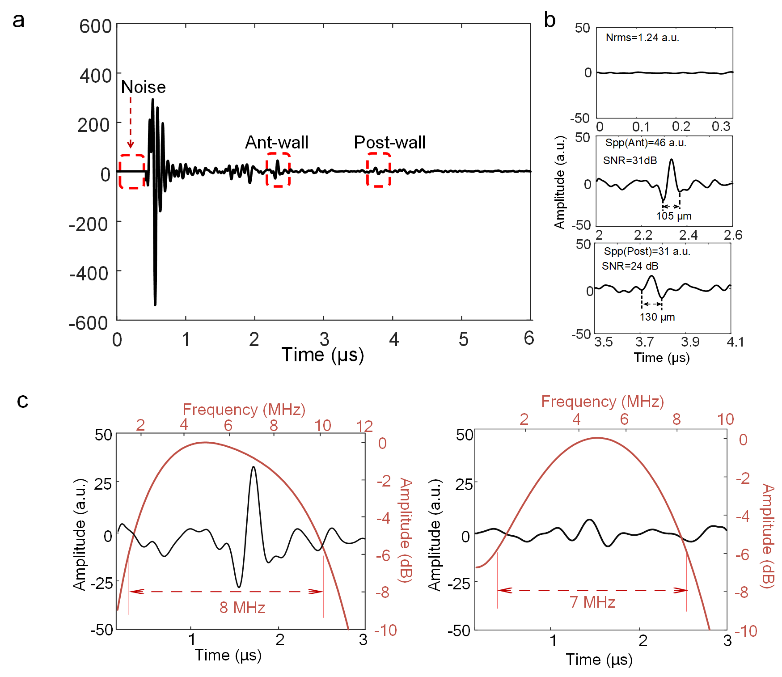
Supplementary Fig 3. (a) An A-line signal encompassing the skin and the anterior/posterior walls of the blood vessel. (b) Signal-to-Noise Ratio (SNR) of the anterior/posterior vascular walls (c) Bandwidth of the anterior/posterior vascular wall signals.
In this study, the signal-to-noise ratio (SNR) was calculated using the following approach: the signal amplitude was defined as its peak-to-peak value, while the noise amplitude was characterized by its root mean square (RMS) value (Supplementary Fig 3(b)). The detailed procedure is outlined below:
- Signal Amplitude Extraction: The signal of interest was locally magnified, and the difference between its maximum and minimum amplitude values was recorded as the peak-to-peak signal $S_{pp}$ (e.g., as labeled in the Supplementary Fig.3: $S_{pp}$ (Ant) = 46 a.u., $S_{pp}$ (Post) = 31 a.u.).
- Noise Amplitude Extraction: A signal-free segment before the arrival of the target signal was selected as the noise reference. The RMS value $N_{\text{RMS}}$ of this segment was computed (e.g., as labeled in the Supplementary Fig.3: $N_{\text{RMS}}=1.24 a.u$.).
- SNR Calculation Formula:
$$\text{SNR (dB)}=20{log⁡}_{10}\left(\frac{S_{pp}}{N_{\text{RMS}}}\right)$$
Calculated Results:
Anterior wall signal: SNR = $20\log_{10}{(46/1.24)}≈31\text{ dB}$
Posterior wall signal: SNR = $20\log_{10}{(31/1.24)}≈24\text{ dB}$
Spectral analysis of the extracted vascular signals reveals that the anterior wall signal yields a bandwidth of 8 MHz, while the posterior wall signal yields a bandwidth of 7 MHz (Supplementary Fig 3(c)).

Supplementary Table 1. Device Bill of Materials
Our entire setup contains no metal parts. A detailed list of materials is provided in Supplementary Table 1.
Supplementary Table 1 Device Bill of Materials
Component | Materials
Optical Ultrasound Source | PDMS
Optical Ultrasound Source | Carbon Powder
Optical Ultrasound Source | Transparent Photopolymer Resin
Fiber Laser Sensor | Silica
Excitation Light Source | Silica
Mold | Resin

Supplementary Table 2. Subjects Information
The age, sex, systolic blood pressure, diastolic blood pressure, and heart rate of the 10 subjects are shown in Supplementary Table 2.
Supplementary Table 2 Subjects Information
Subject | S1 | S2 | S3 | S4 | S5 | S6 | S7 | S8 | S9 | S10
Age | 22 | 23 | 23 | 23 | 24 | 25 | 26 | 28 | 32 | 37
Sex | Female | Male | Male | Female | Female | Male | Male | Male | Male | Male
SBP | 105 | 120 | 124 | 94 | 94 | 124 | 128 | 125 | 126 | 119
DBP | 65 | 83 | 74 | 64 | 71 | 78 | 65 | 64 | 79 | 81
HR | 70 | 77 | 68 | 72 | 70 | 62 | 66 | 60 | 76 | 94

Supplementary Discussion. Safety and Transmission Loss Analysis
The inherent safety of the device in biomedical applications represents one of its core advantages.
Biocompatibility and Tissue Safety ：(Polydimethylsiloxane), carbon powder, optical fibers, and a resin-based housing as its core materials, all of which exhibit excellent biocompatibility, are non-toxic and non-sensitizing. This ensures safe long-term contact with human skin, fundamentally avoiding risks such as infection or thrombosis associated with invasive monitoring (e.g., arterial catheters). Furthermore, the device weighs only 15 grams, preventing any sensation of pressure or discomfort even during extended wear.
Electromagnetic Compatibility and MRI Safety: The all-optical, metal-free design inherently provides immunity to electromagnetic interference. The device will not heat up, displace, or generate artifacts within strong magnetic fields, ensuring patient safety and, critically, causing no interference to the normal operation of MRI equipment. This addresses the significant clinical challenge of interrupted vital sign monitoring for critically ill patients during MRI examinations.
Acoustic Output Safety: The ultrasound waves generated by the system operate at a frequency and acoustic pressure intensity strictly maintained within established biological safety limits.
Electrical Safety: The fully optical system requires no electrical current to be introduced to the human body, completely eliminating the risk of electric shock.
Transmission Loss Analysis：To ensure signal integrity and reliability in complex application scenarios, the system incorporates targeted optimizations to mitigate various transmission losses. Optical Signal Transmission Loss (Sensing Arm): The system employs a high-performance fiber laser ultrasound sensor. This sensor maintains high signal quality and a high signal-to-noise ratio even over an extended transmission distance of 15 meters, ensuring stable signal transmission. Excitation Light Transmission Loss (Excitation Arm): Optical fibers with a core diameter of 400 micrometers are used to enhance coupling efficiency. In wearable applications, fiber routing is carefully planned to avoid excessively small bending radii, minimizing bending losses. This configuration maintains an overall power transfer efficiency of >70% over the 15-meter transmission distance, providing sufficient optical energy for effective ultrasound generation.

