Supporting Information

Supramolecular Janus Eutectic Engineered from Panthenol and Bisabolol Overcomes Transdermal Delivery Paradoxes

Hao WANG¹, Qingsheng TAO², Xiaofeng HE², Kung Chi HSU², Yu GAO², Delphine KEROB³, Wei LIU⁴, Zhenyuan WANG⁵, Nan HUANG², Jiaheng ZHANG¹

¹Sauvage Laboratory for Smart Materials, School of Materials Science and Engineering, Harbin Institute of Technology (Shenzhen), Shenzhen, China, 518055
²L‘Oreal Research & Innovation China, Shanghai 201206, China
³La Roche-Posay Laboratoire Dermatologique, Levallois Perret 92300, La Roche-Posay, France
⁴Department of Dermatology, The General Hospital of Air Force PLA, Beijing 100142, China
⁵Shenzhen Shinehigh Innovation Co., Ltd, Shenzhen 518055, China.

E-mail: zhangjiaheng@hit.edu.cn, frank.huang@loreal.com, wangzhenyuan@shinehigh.cn

Hao WANG, Qingsheng TAO, and Xiaofeng HE contributed equally to this work.

Methods
1. Synthesis of SPB
The D-Panthenol (Hangzhou Xinfu, Zhejiang, China) and α-(-)-bisabolol (Givaudan) were sheared at a stirring rate of 300 rpm at 333k under 10 MPa nitrogen over 6 hours, until no phase separation was perceived. Afterwards, the mixture was sonicated at 20 Hz using ultrasonic processor (300W power) with a 2S on/2S off cycle over 1 hour. Then ethoxydiglycol (Gattefossé SAS) was added, and the above process was repeated to obtain a resultant supramolecular Janus eutectic system.
2. General characterization of SPB
¹H NMR spectra were recorded on a Bruker Avance Neo 400 MHz spectrometer (Faellanden, Switzerland) using deuterated methanol. NOESY was obtained by an Agilent DD2 600 MHz spectrometer. FTIR spectra were recorded using a Thermo Nicolet 380 spectrometer (Madison, WI, USA). The glass transition temperature (Tg) was determined using a Mettler Toledo DSC3 differential scanning calorimeter (Schwerzenbach, Switzerland).
3. Simulations
The density functional theory (DFT) calculations were performed using Gaussian 09 software at the M062X/6-311g(d) level. The interionic interactions of SPB were analyzed by Multiwfn and VMD softwares based on the independent gradient model based on Hirshfeld partition (IGMH) and atoms-in-molecules (AIM) methods¹⁻³.
The molecular dynamic simulations were conducted by GROMACS software⁴. The skin barrier was modeled to a bilayer of ceramide (CER), cholesterol (CHOL), and free fatty acid (FFA) with a molar ratio of 1:1:1⁵. CHARMM36m was employed to generate the topology parameters of AHP-8, CER, CHOL, FFA, MA, and LC⁶. The atomistic coordinates of the molecules were added into a cubic box, which was solvated with the tip3p water model to construct D-panthenol/skin complex with pure water using the membrane builder module in CHARMM-GUI⁶. In the energy minimization step, the conjugate gradient algorithm was utilized to remove irrational intramolecular contacts and converge the maximum force to <100 kJ mol⁻¹ nm⁻¹ . The simulation was conducted in the NPT ensemble, with a pressure of 1.0 bar coupled isotropically with 4.5 × 10⁻⁵ compressibility and a coupling constant of 12.0 ps under the Parrinello-Rahman algorithm. The temperature was set to 298.15 K and coupled with a coupling constant of 1.0 ps under the V-rescale algorithm. The short-range interaction cutoff distance was set to 1.0 nm, and the Particle Mesh Ewald algorithm was utilized to compute the long-range interaction. Finally, a 10 ns run of the constrained simulation was executed with a time step of 2 fs for each system to generate the transdermal process of AHP-8 and calculate the pulling forces.
Molecular docking and molecular dynamic simulations were performed as described previously⁷. In brief, the molecular docking of SPB, D-Panthenol, α-(-)-bisabolol, and mixture to the TRPV1 receptor (PDB ID: 8GF9) was performed using the AutoDock 4.2.6 program, and MD simulations were performed using GROMACS 5.0.2 program based on the optimized structures. After 10 ns, the root-mean-square deviation stabilized, indicating that the system reached equilibrium. Thus, the interactions between the ligands and TRPV1 were analyzed based on the last 10 ns of the MD simulation trajectory.
4. Ex vivo human skin penetration test
A Franz cell diffusion system comprised of TK-12D transdermal absorption diffusion instrument and diffusion cells (Kaikai, Shanghai, China) was employed, with surgically discarded human skin (BioCell, Shaanxi, China) positioned in individual diffusion cells and phosphate buffer saline (PBS) being used as receptor fluid.
With an effective donor chamber surface area of 0.785 cm², a volume of ~100 μL sample, containing ~0.108% of panthenol, was applied topically. Receptor fluid was sampled at 2, 8, and 24 hrs (2 mL with equal volume replacement), while an electromagnetic stirrer was maintained at 300 rpm for each cell at (32 ± 1) °C.
4.1 Raman spectroscopy detection experiment
The confocal Raman spectrometer (inVia reflex, Renishaw, UK) was calibrated by silicon wafer before detection. The quartz gold-plated glass slides with frozen sections were placed on the sample table. Under the microscope, the parts with no separation of the dermis and epidermis, no damage to the skin surface, no folds, and well-defined structures were selected, and their single spectra were measured.
The Raman spectral data set was obtained by scanning the sample with the selected range centered on the point with prominent characteristic peaks and relatively small noise.
4.2 Quantitative analysis experiment
After 24 hr of treatments, panthenol content was extracted from the surface, living skin tissue, and receptor fluid, and thereafter quantified using a high-performance liquid chromatography (HPLC, Agilent, US). In detail, the surface of skin was repeatedly rinsed with 1 mL of PBS, while living skin tissue was removed around the edge of the donor chamber with a sterile scalpel, cut into small pieces, and eventually extracted in 1 mL PBS through ultrasound over a period of 60 mins.
The quantity of panthenol in each compartment was calculated by multiplying volume of extracted solution and corresponding concentrations. Recovery of panthenol for each sample was calculated by dividing the summary of quantity of three compartments with pre-weighted loading dose dividing.
5.Mildness test using RHE models
SkinEthic™ RHE is a commercialized reconstructed epidermis model with well differentiated basal layer, spinous layer, granular layer and horny layer. The present test was carried out on one batch (24ChRHE13) of SkinEthic™ RHE model produced by EpiSkin China.
In order to apply topically, the test actives were diluted in ultrapure water with equal dosage of bisabol, with details laid out in Table S1.
Table S1. Test materials used for topical treatments in SkinEthics® RHE models.
Active tested | Composition and mass ratio | Test dose
SPB | D-panthenol : α-(-)-bisabolol : ethoxydiglycol = 36:40:24 | 2% (total w/w, 0.8% α-(-)-bisabolol)
Simple Mixture | D-panthenol : α-(-)-bisabolol : ethoxydiglycol = 36:40:24 | 2% (total w/w)
α-(-)-Bisabolol | α-(-)-bisabolol : ethoxydiglycol = 40:24 | 1.28% equiv (0.8% α-(-)-bisabolol w/w)
A volume of 32 μL formula (2%) was topically applied on RHE models, followed by 18 hours of incubation at 37°C, 5% CO2 and 95% humidity. Three replicates of RHE tissue models were harvested and subsequently assessed for viability using standard MTT assay⁸. An additional RHE tissue was used for histological morphology assessment.
6. Epidermal wound healing potential evaluation
Human primary keratinocytes and fibroblasts were maintained in corresponding low-calcium (60 μM) growth medium (all from Biocell Biotechnology, Guangdong, China). The cytotoxicity of betaine, SA, and BeSA on human keratinocytes was determined using the MTT assay, as described by a previous study⁹.
Keratinocytes cultured in 6-well-plates were treated with medium containing treatments at a volume of 2 mL per well upon reaching 70-80% confluence. Blank control was treated with normal medium while positive control contained 1 ng/mL epidermal growth factor (EGF, Life Technologies, USA). After 24 hr of incubation. The cells were scratched with pipette tips and refreshed for treatment medium. Microscopy images were taken after another 24 hr incubation and the areas recovered from the scratch was calculated as numerical parameter for comparisons.
7.Anti-irritation potential evaluation
First, 2D keratinocyte tolerance of the bioactives were characterized in 96-well culture plates, with 200 μL of medium containing actives in serial dilutions administered to the cells upon reaching 50-60% confluence. Media was removed after 24 hr of incubation, followed by the addition of MTT working solution (500 μg/mL in fresh medium) and another 4 hr of incubation. Finally, the medium was discarded and cells were dissolved by 150 µL DMSO for OD value measurement at 490 nm.
Then, the actives at the highest non-toxic dose, plus two lower dosages with 2× dilution factors were selected for transient receptor potential V1 (TRPV1) inhibition assay, using intracellular calcium probe method¹⁰. Briefly, the keratinocytes were pre-loaded with the fluorescent probe (need information on the probe from Biocell) through 45 min incubation at 500 μL volume in 24-well plates. Once the probes were preloaded and media was discarded, 500 μL treatments were applied to individual wells with DPBS as blank control (BC), capsaicin (0.05 μM) as triggered control (TC), and trans-4-tert-butylcyclohexanol (25 μM) as positive control (PC) inhibitor. Fluorescence intensity was quantified after 1 hr of reaction, with relative intracellular calcium level (representing activation of TRPV1 channel) and inhibition rate respectively calculated as:
1) Relative intracellular calcium level = $\frac{TC or sample or PC }{NC} ×100\%$
2) Inhibition rate (%) = $\frac{TC - Sample }{TC} ×100\%$
8.Statistical analyses
The Witec data analysis software was used to obtain a clearer spectrum through spectral range selection, removal of cosmic rays, polynomial fitting to remove baselines, and Savitzky-Golay method to smooth the spectrum. For the Raman spectroscopy dataset, univariate analysis was used to extract the compositional information of the experimental samples. The Witec data analysis software completed univariate imaging, that was, Raman spectral imaging. The pseudo-color image reconstruction could be performed by using the comprehensive intensity of the characteristic peak of a substance in the sample scanning spectrum. The intensity of the characteristic peak was related to the brightness of the Raman image color.
Origin software was used to analyze the single-spectral data set, drew the full-layer multi-point Raman scanning spectrum of the skin and reconstruct the Raman pseudo-color map after large-scale scanning, and semi-quantitatively analyzed the characteristic peaks of the substance.
GraphPad Prism software was used to make the graph, and the result was expressed as Mean±SD. Comparison between groups was statistically analyzed by t-test. P<0.05 was considered as significant difference, P<0.01 was considered as extremely significant difference.
All quantitative data were checked for normal distribution and equal variance between treatments, followed by analysis of variance (ANOVA) tests with Dunnett post-hoc comparisons vs. control group, or Tukey comparisons vs. group of interest. Statistically significant differences are highlighted with asterisks (* p<0.05, ** p<0.01, *** p<0.001).
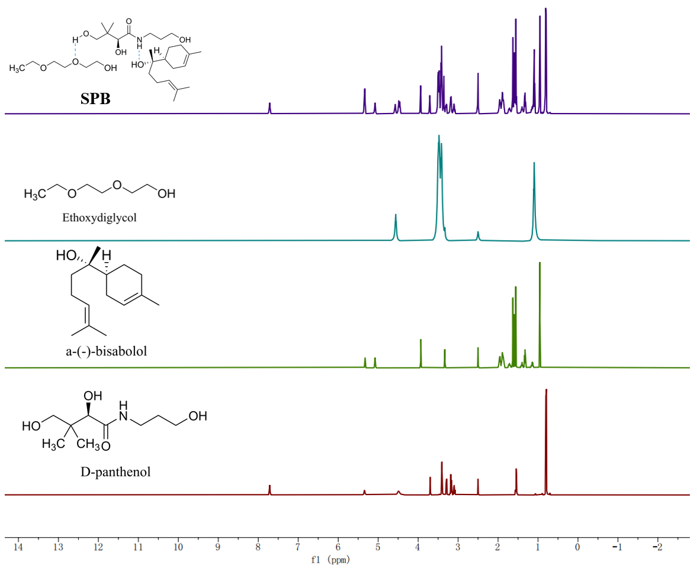
Fig. S1 H¹ NMR of SPB components
Table S2. Stress test (pH) of SPB (48 hr)
Sample | pH | D-Panthenol content/ppm | Retention | α-(-)-Bisabolol content/ppm | Retention
0.2% SPB aqueous solution | Blank control 1 | 723.70 | 100.00% | 744.31 | 100.00%
0.2% SPB aqueous solution | pH=3 | 705.88 | 97.54% | 734.10 | 98.63%
0.2% SPB aqueous solution | pH=4 | 716.34 | 98.98% | 740.97 | 99.55%
0.2% SPB aqueous solution | pH=5 | 719.29 | 99.39% | 741.50 | 99.62%
0.2% SPB aqueous solution | pH=6 | 718.26 | 99.25% | 738.44 | 99.21%
0.2% SPB aqueous solution | pH=8 | 712.07 | 98.39% | 737.74 | 99.12%
0.2% SPB aqueous solution | pH=9 | 696.13 | 96.19% | 743.84 | 99.94%
0.2% SPB aqueous solution | pH=10 | 660.83 | 91.31% | 741.97 | 99.69%
0.2% SPB aqueous solution | pH=11 | 558.43 | 77.16% | 746.30 | 100.27%
0.2% corresponding simple mixed aqueous solution | Blank control 2 | 730.86 | 100.00% | 762.74 | 100.00%
0.2% corresponding simple mixed aqueous solution | pH=3 | 706.04 | 96.60% | 727.54 | 95.39%
0.2% corresponding simple mixed aqueous solution | pH=4 | 713.49 | 97.62% | 742.03 | 97.28%
0.2% corresponding simple mixed aqueous solution | pH=5 | 713.83 | 97.67% | 740.90 | 97.14%
0.2% corresponding simple mixed aqueous solution | pH=6 | 714.21 | 97.72% | 740.93 | 97.14%
0.2% corresponding simple mixed aqueous solution | pH=8 | 709.37 | 97.06% | 745.18 | 97.70%
0.2% corresponding simple mixed aqueous solution | pH=9 | 681.74 | 93.28% | 748.29 | 98.11%
0.2% corresponding simple mixed aqueous solution | pH=10 | 656.60 | 89.84% | 746.11 | 97.82%
0.2% corresponding simple mixed aqueous solution | pH=11 | 513.89 | 70.31% | 745.07 | 97.68%

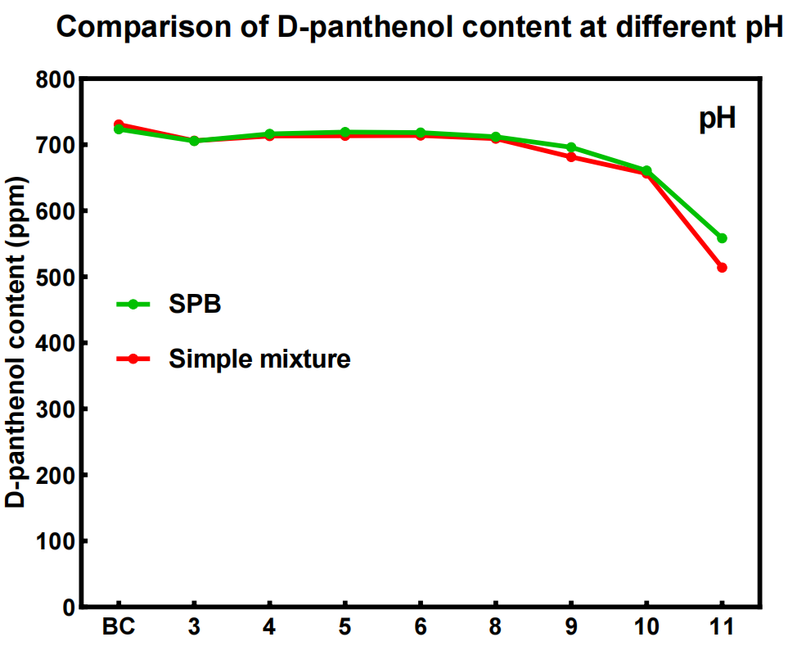
Fig. S2 Stress test (pH) of SPB
Table S3. Stress test (temperature) of SPB (48 hr)
0.2% SPB aqueous solution | pH | D-Panthenol content/ppm | Retention | α-(-)-Bisabolol content/ppm | Retention
0 D | 4℃ | 716.98 | 99.79% | 742.75 | 100.24%
0 D | RT | 718.49 | 100.00% | 740.97 | 100.00%
0 D | 50℃ | 720.97 | 100.35% | 742.66 | 100.23%
5 D | 4℃ | 726.85 | 99.94% | 772.89 | 100.07%
5 D | RT | 727.31 | 100.00% | 772.38 | 100.00%
5 D | 50℃ | 727.53 | 100.03% | 763.74 | 98.88%
10 D | 4℃ | 749.36 | 99.64% | 784.3 | 99.96%
10 D | RT | 752.1 | 100.00% | 784.61 | 100.00%
10 D | 50℃ | 753.45 | 100.18% | 777.97 | 99.15%
30 D | 4℃ | 748.95 | 99.08% | 793.08 | 99.89%
30 D | RT | 755.94 | 100.00% | 793.95 | 100.00%
30 D | 50℃ | 747.87 | 98.93% | 783.06 | 98.63%
Table S4. Stress test (H₂O₂) of SPB (48 hr)
Sample | D-Panthenol content/ppm | Retention | α-(-)-Bisabolol content/ppm | Retention
Blank control | 780.53 | 100.00% | 793.01 | 100.00%
H₂O₂ | 781.58 | 100.13% | 804.59 | 100.13%

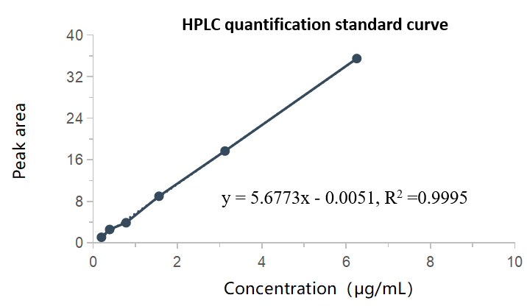
Fig. S3 HPLC quantification standard curve of D-panthenol
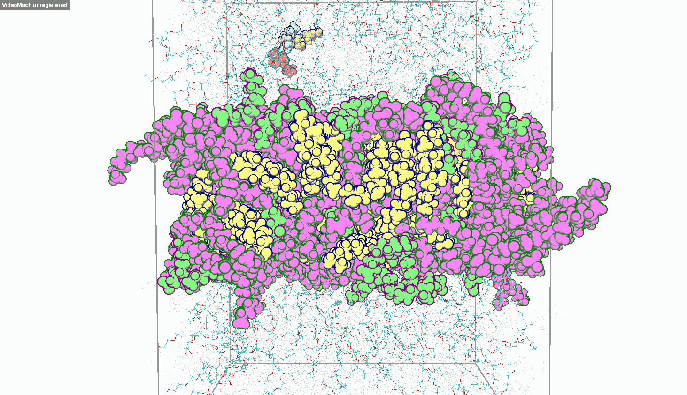
Fig. S4 SPB penetration through lipid bilayers process video

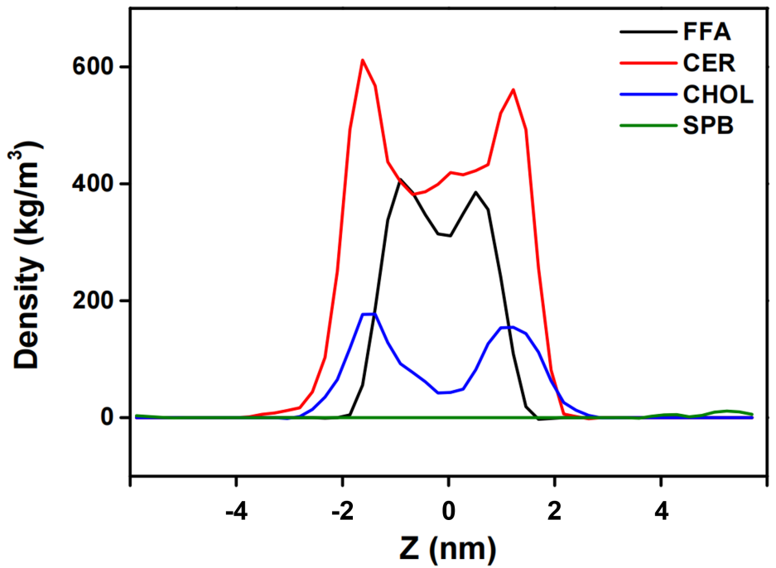
Fig. S5 Molecular density distribution of the system during SPB transmembrane permeation

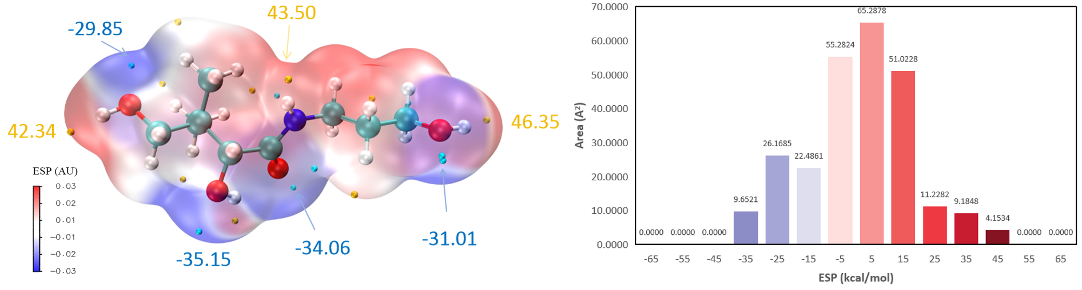
Fig. S6 ESP of D-panthenol

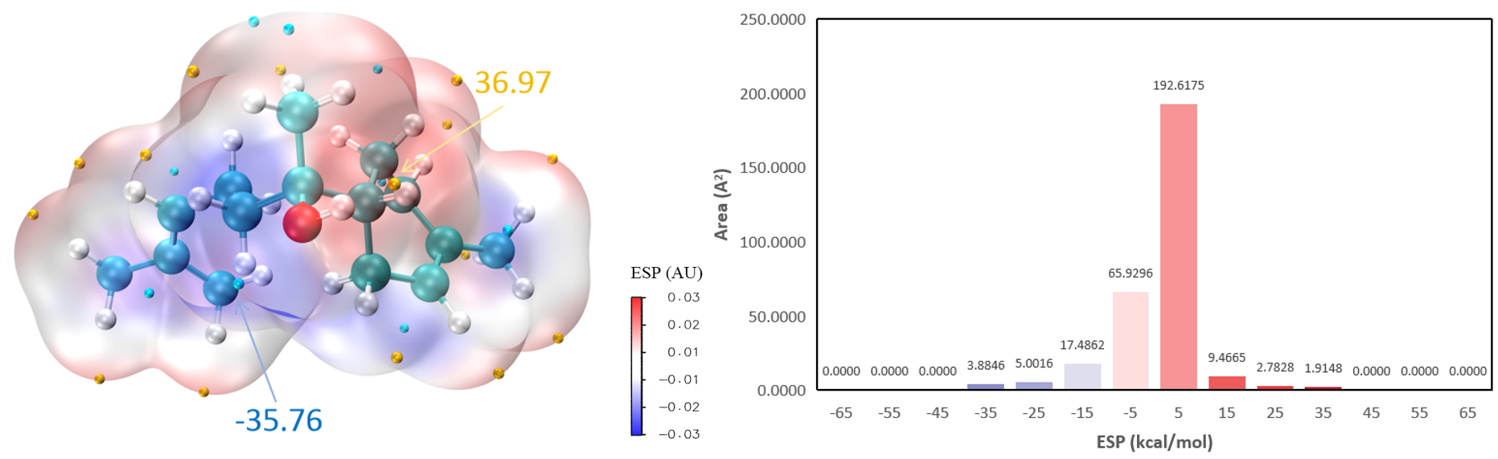
Fig. S7 ESP of α-(-)-Bisabolol

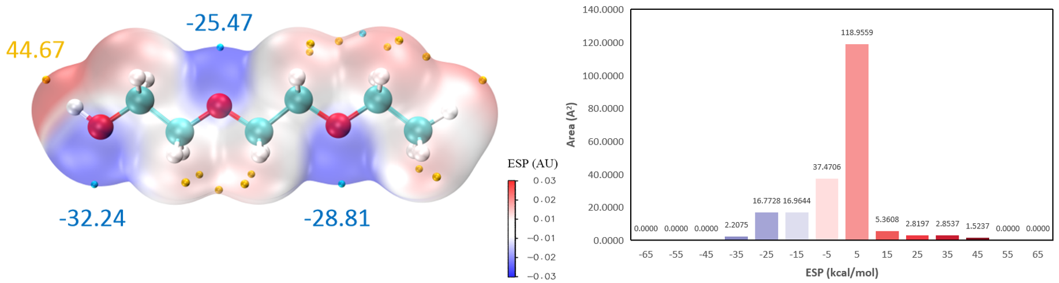
Fig. S8 ESP of Ethoxydiglycol

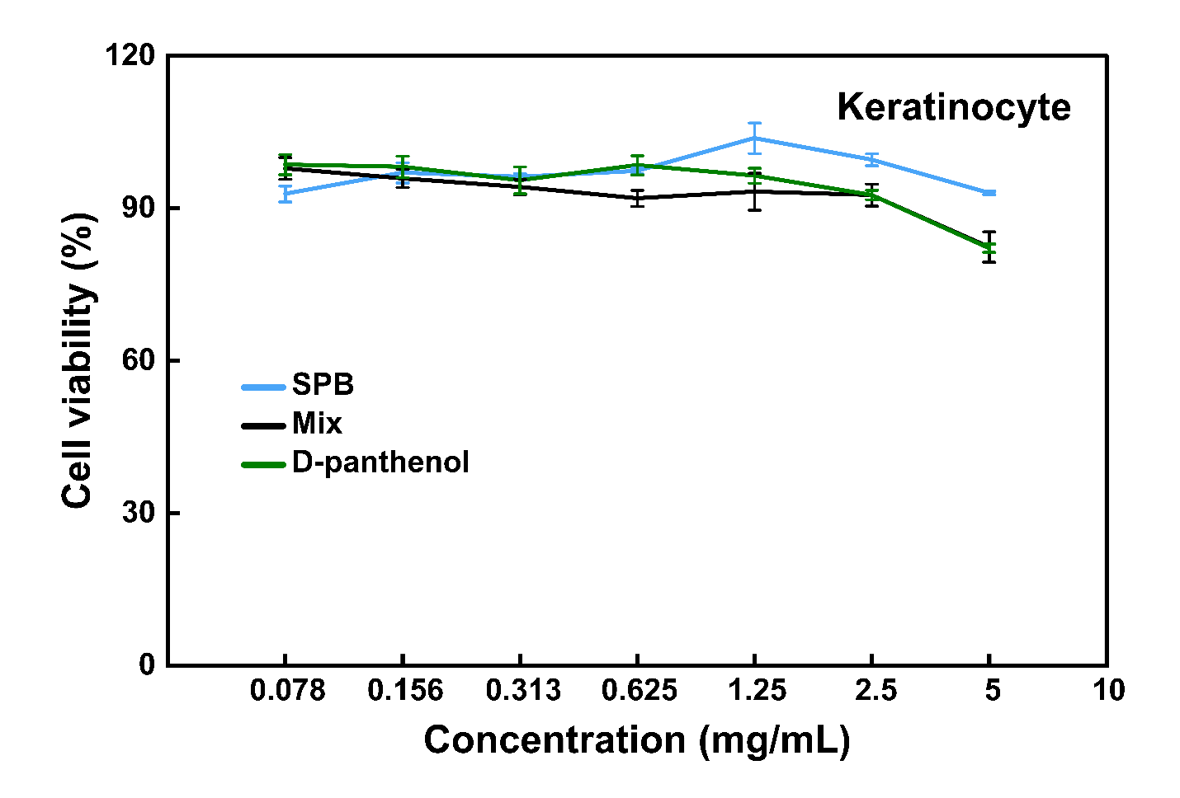
Fig. S9 Keratinocytes viability at different concentrations.
Results are shown as mean ± SD for N=3.
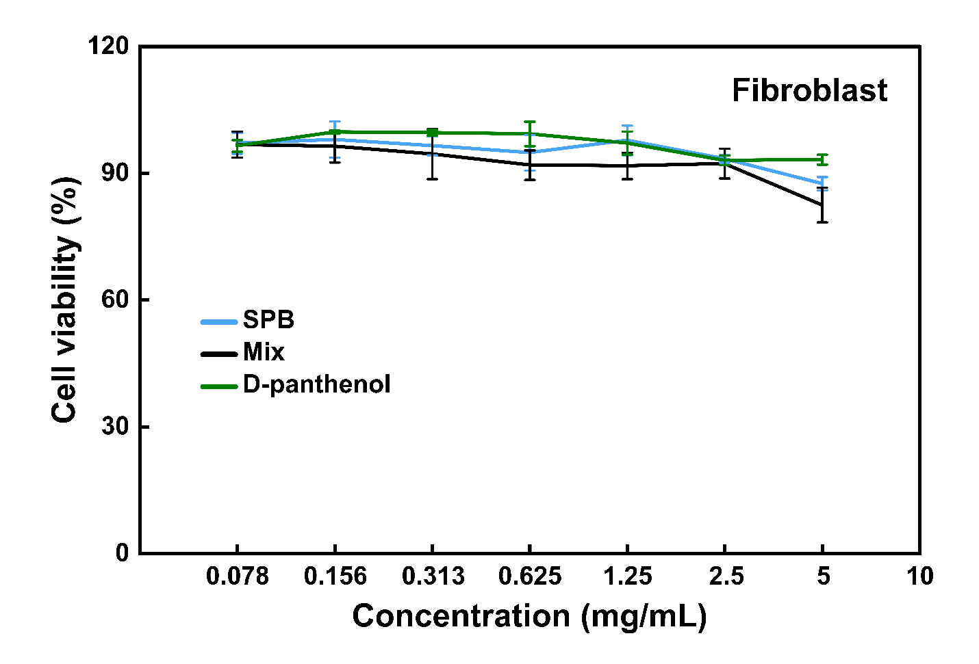
Fig. S10 Fibroblasts viability at different concentrations.
Results are shown as mean ± SD for N=3.
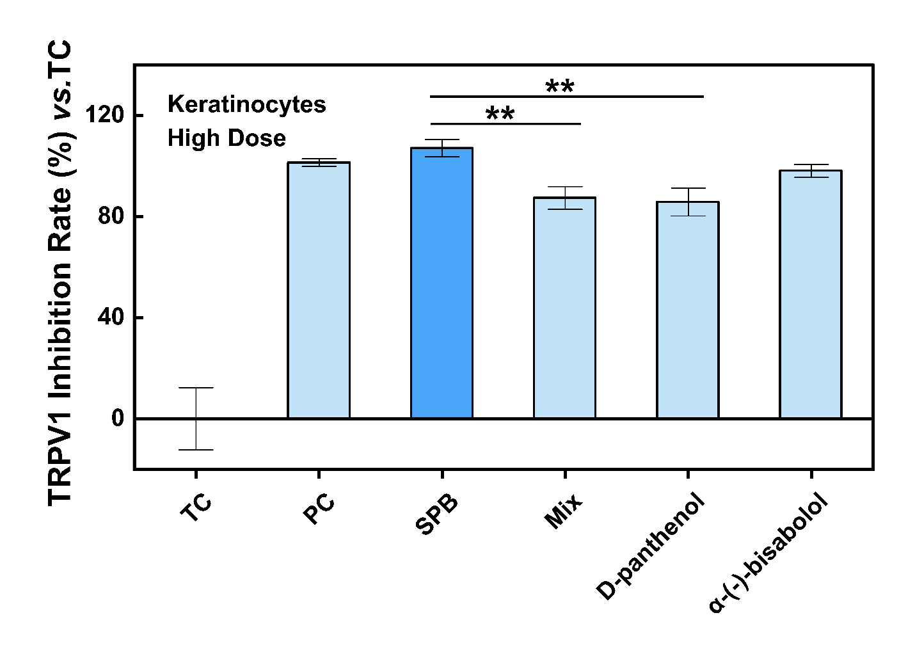
Fig. S11. Anti-irritation potential of high dose bioactives in keratinocytes. Inhibition rate (% vs. TC) of bioactives against capsaicin stimulated calcium influx (* & ** p-value < 0.05 or 0.01 for Tukey post hoc vs. SPB, N=3)
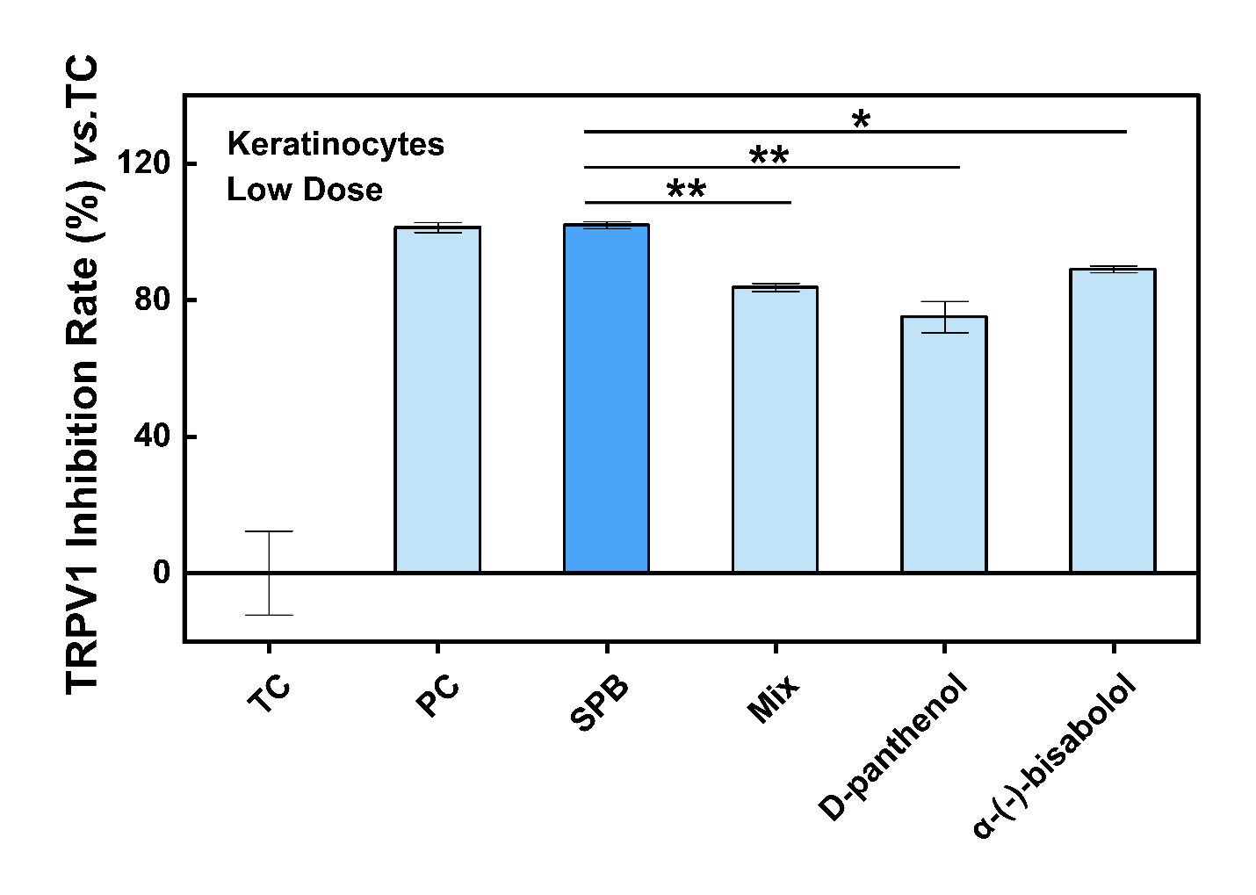
Fig. S12. Anti-irritation potential of low dose bioactives in keratinocytes. Inhibition rate (% vs. TC) of bioactives against capsaicin stimulated calcium influx (* & ** p-value < 0.05 or 0.01 for Tukey post hoc vs. SPB, N=3)
Table S5. Testing doses for TRPV1 inhibition assay in primary human keratinocytes
Groups | Treatments | Dosing concentration |  |  |  | Trigger
Blank control  (BC) | / | / |  |  |  | /
Triggered control (TC) | / | / |  |  |  | Capsaicin  (0.05 μM)
Positive control  (PC) | Trans-4-tert-butylcyclohexanol | 25 μM |  |  |  | Capsaicin  (0.05 μM)
Samples | All as μg/mL | Total | Panthenol | Bisabolol | Ethoxydiglycol | Capsaicin  (0.05 μM)
Samples | SPB | 23.4  11.7 | 8.4  4.2 | 9.4  4.7 | 5.6  2.8 | Capsaicin  (0.05 μM)
Samples | Mixture of D-panthenol +α-(-)-bisabolol | 23.4  11.7 | 8.4  4.2 | 9.4  4.7 | 5.6  2.8 | Capsaicin  (0.05 μM)
Samples | D-panthenol | 14.0  7.0 | 8.4  4.2 |  | 5.6  2.8 | Capsaicin  (0.05 μM)
Samples | α-(-)-bisabolol | 15.0  7.5 |  | 9.4  4.7 | 5.6  2.8 | Capsaicin  (0.05 μM)

References
1. Lu, T. & Chen, F. Multiwfn: a multifunctional wavefunction analyzer. J Comput Chem 33, 580-592 (2012).
2. Humphrey, W., Dalke, A. & Schulten, K. VMD: visual molecular dynamics. J Mol Graph 14, 33-38, 27-38 (1996).
3. Lu, T. & Chen, Q. Independent gradient model based on Hirshfeld partition: A new method for visual study of interactions in chemical systems. J Comput Chem 43, 539-555 (2022).
4. Van Der Spoel, D. et al. GROMACS: fast, flexible, and free. J Comput Chem 26, 1701-1718 (2005).
5. Gupta, R., Sridhar, D.B. & Rai, B. Molecular Dynamics Simulation Study of Permeation of Molecules through Skin Lipid Bilayer. J Phys Chem B 120, 8987-8996 (2016).
6. Huang, J. et al. CHARMM36m: an improved force field for folded and intrinsically disordered proteins. Nat Methods 14, 71-73 (2017).
7. Yufei, L. et al. Exploring the effect of surfactants on the interaction between laccase and bisphenol A by molecular docking, molecular dynamics, and energy calculations. Journal of Molecular Liquids 382 (2023).
8. Bataillon, M. et al. Characterization of a New Reconstructed Full Thickness Skin Model, T-Skin™, and its Application for Investigations of Anti-Aging Compounds. Int J Mol Sci 20 (2019).
9. Wang, M. et al. Sustainable Bioactive Salts Fully Composed of Natural Products for Enhanced Pharmaceutical Applicability. ACS Sustainable Chemistry & Engineering 10, 10369-10382 (2022).
10. Ticona, L.A., Sánchez Á, R., Estrada, C.T. & Palomino, O.M. Identification of TRPV1 Ion Channels Agonists of Tropaeolum tuberosum in Human Skin Keratinocytes. Planta Med 87, 383-394 (2021).

