Supplementary Material

Title:
Timing of Bone-Modifying Agent Initiation and Skeletal-Related Event Risk in Patients With Bone Metastases From Solid Tumors: A Retrospective Landmark and Propensity Score–Matched Analysis

Authors:
Tatsuki Ikeda^{†1}, Satoru Nihei^{1,2}, Kazuki Saito¹, Junya Sato³, Kenzo Kudo^{1,2}

Table S1. Sensitivity Analysis Using Different Landmark Times: Univariate Cox Proportional Hazards Analyses for SRE in the Overall Cohort (Delayed vs Early)
Fig. S1 Kaplan–Meier Curves for Time to First SRE before propensity score matching
Fig. S2 Forest plot of the association between delayed BMA initiation and risk of SRE across clinical subgroups before propensity score matching
Table S1. Sensitivity Analysis Using Different Landmark Times: Univariate Cox Proportional Hazards Analyses for SRE in the Overall Cohort (Delayed vs Early)
Landmark time  (months) | Total  (n) | Early  (n) | Delayed  (n) | Hazard ratio  (Delayed vs Early) | 95% CI | P value
1 | 1305 | 577 | 728 | 1.11 | 0.76–1.62 | 0.579
2 | 1191 | 708 | 483 | 1.19 | 0.83–1.70 | 0.348
3 | 1109 | 736 | 373 | 1.49 | 1.04–2.15 | < 0.05
4 | 1030 | 723 | 307 | 1.68 | 1.15–2.46 | < 0.01
5 | 972 | 717 | 255 | 1.83 | 1.24–2.71 | < 0.01
6 | 912 | 689 | 223 | 1.82 | 1.21–2.76 | < 0.01
7 | 873 | 674 | 199 | 1.68 | 1.08–2.60 | < 0.05
8 | 837 | 659 | 178 | 1.77 | 1.14–2.77 | < 0.05
9 | 795 | 632 | 163 | 1.70 | 1.08–2.67 | < 0.05
10 | 764 | 615 | 149 | 1.71 | 1.07–2.73 | < 0.05
11 | 730 | 591 | 139 | 1.77 | 1.11–2.84 | < 0.05
12 | 699 | 576 | 123 | 1.67 | 1.02–2.73 | < 0.05
Hazard ratios were estimated using univariate Cox proportional hazards models in the landmark-defined cohorts before propensity score matching, comparing delayed initiation with early initiation of BMA.

Abbreviations: CI, confidence interval; BMA, bone-modifying agents.

Fig. S1 Kaplan–Meier Curves for Time to First SRE before propensity score matching
Kaplan–Meier curves comparing the time to first SRE between the early-initiation group (≤6 months) and the delayed-initiation group (>6 months) in the 6-month landmark cohort before propensity score matching. Patients in the delayed-initiation group experienced a significantly shorter time to first SRE compared with those in the early-initiation group (log-rank test, P < 0.01).
X-axis: Time from landmark (months)
Y-axis: Cumulative incidence of SRE
Legend (within the figures):
Black line = Early initiation group (≤6 months)
Gray line = Delayed initiation group (>6 months)

Abbreviations: SRE, skeletal-related event.

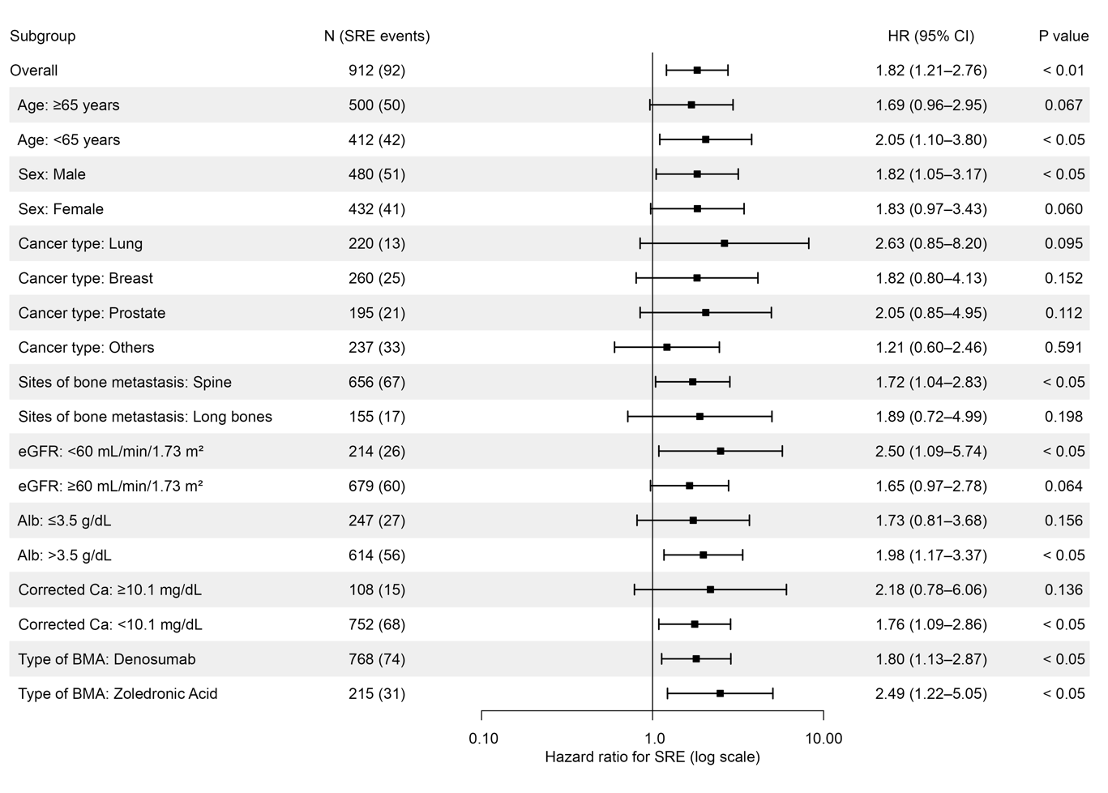
Fig. S2 Forest Plot of the Association Between Delayed BMA Initiation and Risk of SRE Clinical Subgroups Before Propensity Score Matching
Forest plot showing hazard ratios (HRs) and 95% confidence intervals (CIs) for the association between delayed versus early initiation of BMA therapy and the risk of SRE across predefined clinical subgroups. HRs were estimated using univariate Cox proportional hazards models in the 6-month landmark cohort before propensity score matching.
Early initiation of BMA therapy was used as the reference category; therefore, HRs represent the relative risk of SRE associated with delayed initiation compared with early initiation. An HR greater than 1.0 indicates an increased risk of SRE associated with delayed initiation. The vertical dashed line indicates an HR of 1.0.
Multiple selections were allowed for sites of bone metastases and type of BMA.

Abbreviations: CI, confidence interval; BMA, bone-modifying agents; eGFR, estimated glomerular filtration rate.

