Shading Acropora kenti during doldrum-like conditions can reduce mortality risk during high-thermal stress events

Butcherine, Peter^{1*}; Fiori, Amarah²; Ellis, Sophia L.¹; Hendrickson, Conor A.¹; Harrison, Daniel P.^{1,3}
Affiliation/contact
¹ National Marine Science Centre, Southern Cross University, Coffs Harbour, NSW, Australia
² College of Science and Engineering, James Cook University, Townsville, Queensland, Australia
³ School of Geosciences, University of Sydney, Sydney, NSW, Australia

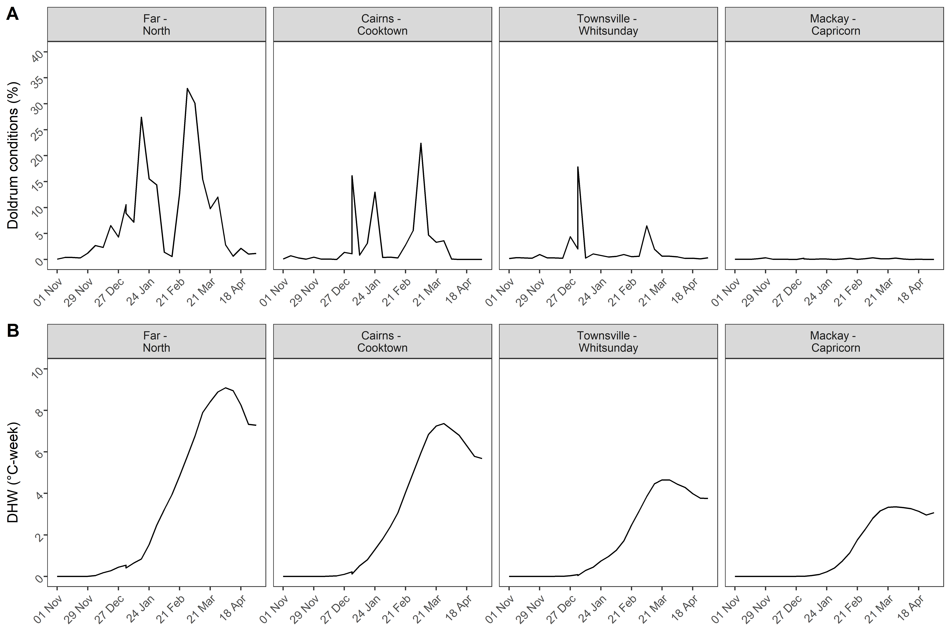
Fig. 1. Temporal and spatial variation of doldrum conditions on the Great Barrier Reef using seven years of mass beaching data. (A) mean coverage of doldrum conditions (%) and (B) mean accrued thermal stress (°C-week).

Table 1. Mean weekly water quality parameters of experimental tank water.
Water Quality Parameter | Mean | SD
Salinity (ppt) | 35.01 | 0.36
PO₄ (µmol L⁻¹) | 0.21 | 0.03
NO₂+NO₃ (µmol L⁻¹) | 1.97 | 0.20
NO₂ (µmol L⁻¹) | 0.18 | 0.03
NO₃ (µmol L⁻¹) | 1.78 | 0.19
NH₄ (µmol L⁻¹) | 0.16 | 0.05
SiO₂ (µmol L⁻¹) | 9.19 | 4.50

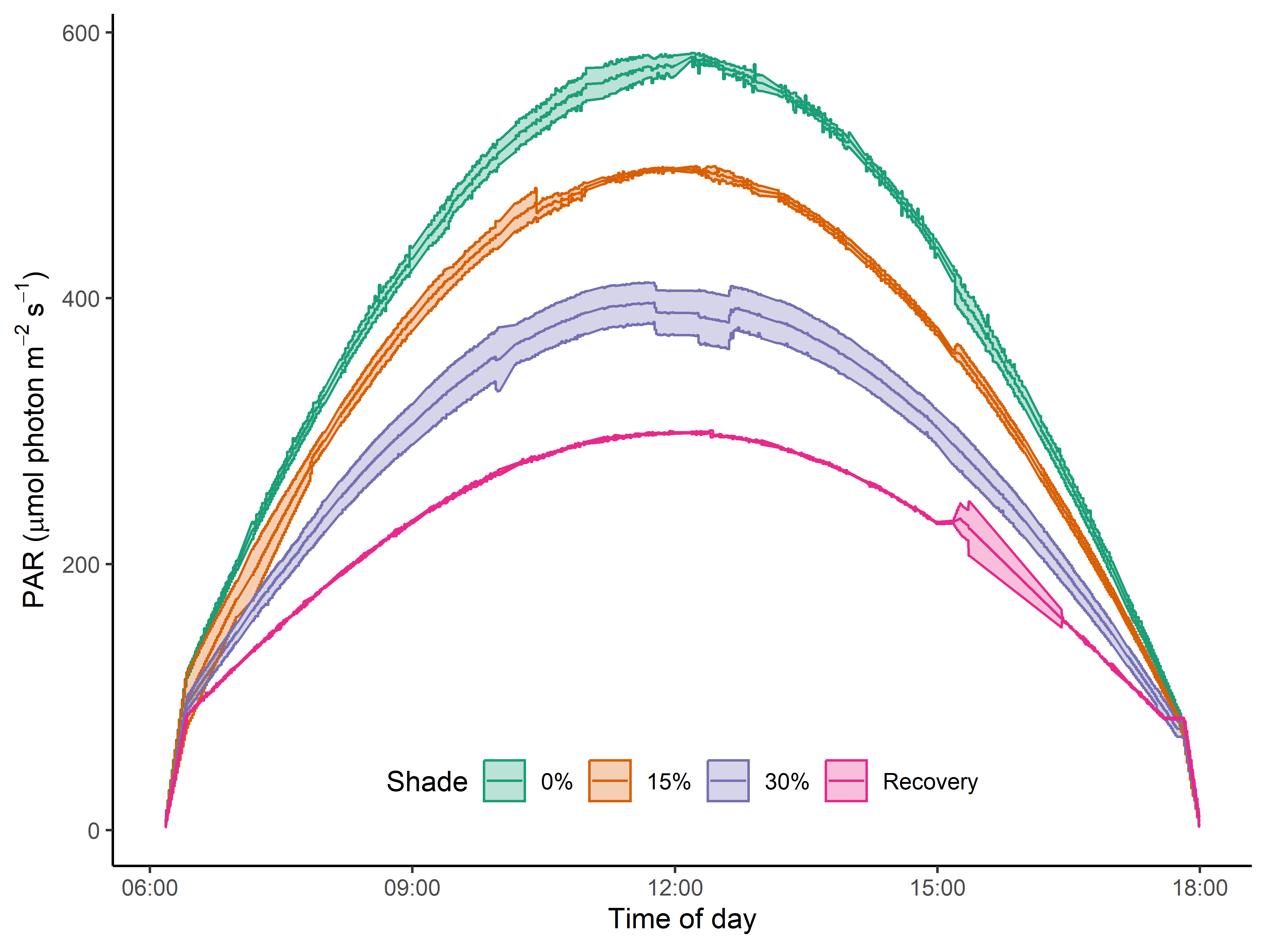 | 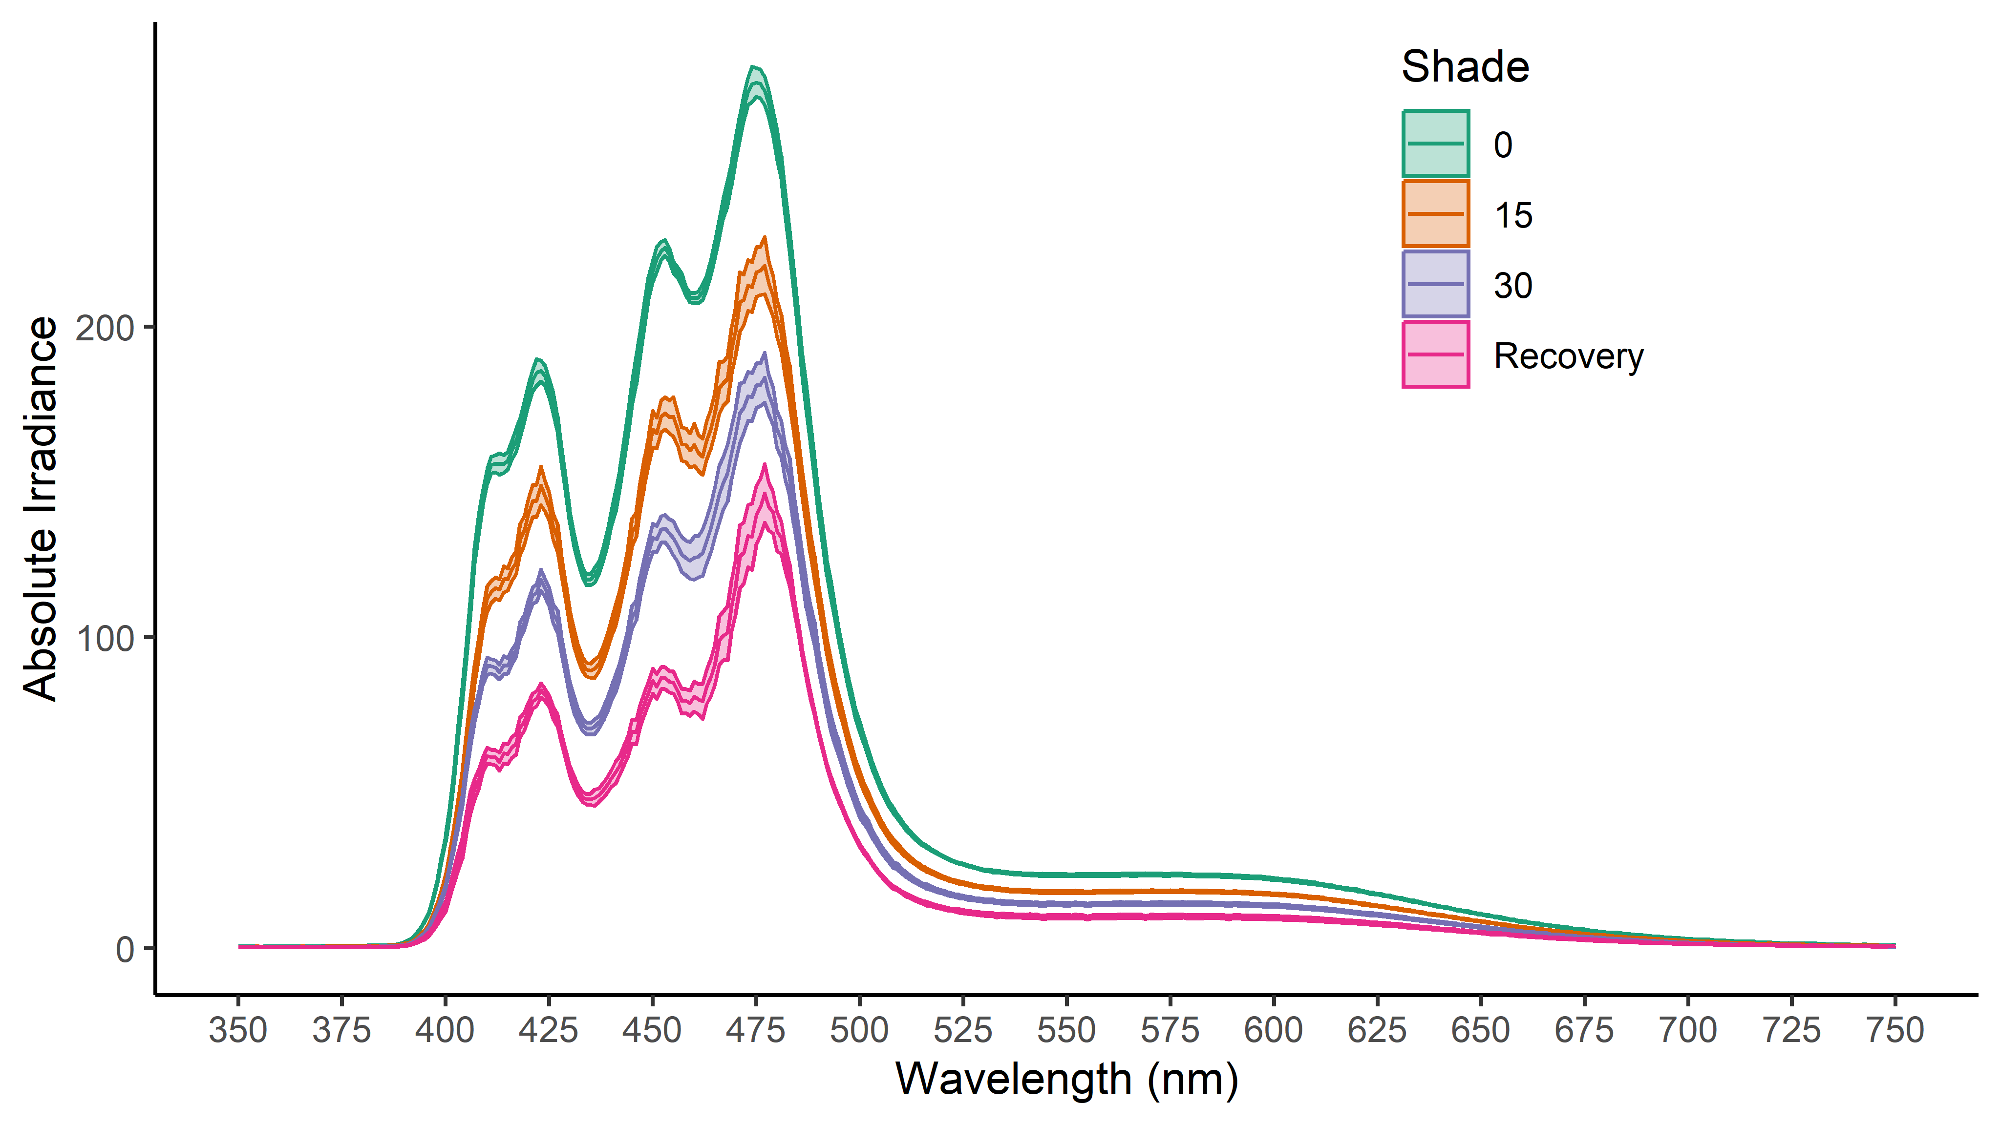
Fig. 2. (A) Mean above water PAR (µmol photons m⁻² s⁻¹) ± SE for each lighting condition over daylight hours. Mean above water absolute spectral irradiance (W m⁻² nm⁻¹) ± SE measured above water for unshaded (0%), 15% shade, 30% shaded, and recovery periods.

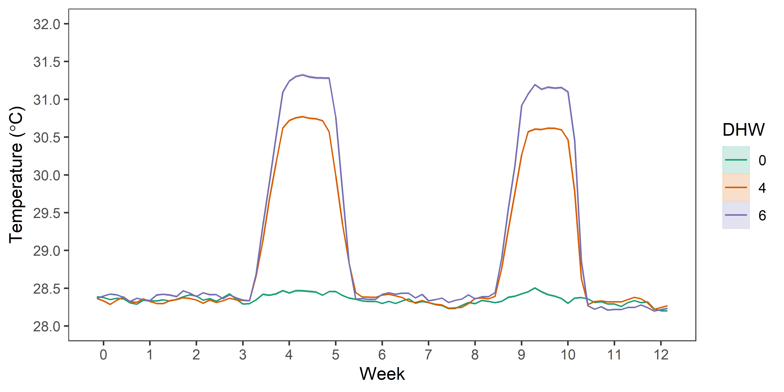
Fig. 3. Mean daily water temperature + 95% C.I. for the unheated, moderate, and high-thermal stress treatments (n = 3 tanks per treatment). Daily mean temperature was calculated using 5-minute time series data. Note the 95% C.I. is very small

Table 2. Within-temperature treatment pairwise test results for a significant day × temperature interaction among multivariate pigment concentrations from A. kenti subjected to one of 30% shade, 15% shade or unshaded treatments at unheated (0 DHW), moderate (4 DHW), or high (6 DHW) thermal stress treatments (days 5, 29, 64, and 77).
Group | Unheated |  |  | Moderate |  |  | High
 | df | t | P(Perm) | df | t | P(Perm) | df | t | P(Perm)
5, 15 | 19 | 2.84 | 0.008 | 18 | 1.41 | 0.181 | 20 | 3.87 | 0.001
5, 29 | 19 | 3.63 | 0.002 | 18 | 2.60 | 0.017 | 20 | 3.76 | 0.003
5, 50 | 19 | 1.78 | 0.063 | 17 | 1.85 | 0.061 | 20 | 2.88 | 0.008
5, 64 | 19 | 3.30 | 0.001 | 18 | 2.14 | 0.021 | 20 | 5.11 | 0.001
5, 77 | 19 | 1.55 | 0.122 | 18 | 1.27 | 0.223 | 20 | 4.67 | 0.001
15, 29 | 20 | 0.78 | 0.447 | 20 | 0.95 | 0.363 | 20 | 0.507 | 0.756
15, 50 | 20 | 3.19 | 0.002 | 19 | 0.94 | 0.427 | 20 | 1.347 | 0.184
15, 64 | 20 | 2.83 | 0.005 | 20 | 1.75 | 0.062 | 20 | 1.577 | 0.103
15, 77 | 20 | 0.97 | 0.407 | 20 | 0.69 | 0.553 | 20 | 0.557 | 0.737
29, 50 | 20 | 4.29 | 0.001 | 19 | 1.47 | 0.168 | 20 | 1.66 | 0.092
29, 64 | 20 | 3.87 | 0.001 | 20 | 2.18 | 0.017 | 20 | 1.99 | 0.034
29, 77 | 20 | 1.41 | 0.142 | 20 | 1.60 | 0.105 | 20 | 0.68 | 0.551
50, 64 | 20 | 2.02 | 0.043 | 19 | 0.93 | 0.387 | 20 | 2.56 | 0.008
50, 77 | 20 | 2.03 | 0.033 | 19 | 0.73 | 0.538 | 20 | 1.8 | 0.069
64, 77 | 20 | 2.27 | 0.007 | 20 | 1.48 | 0.128 | 20 | 1.58 | 0.095

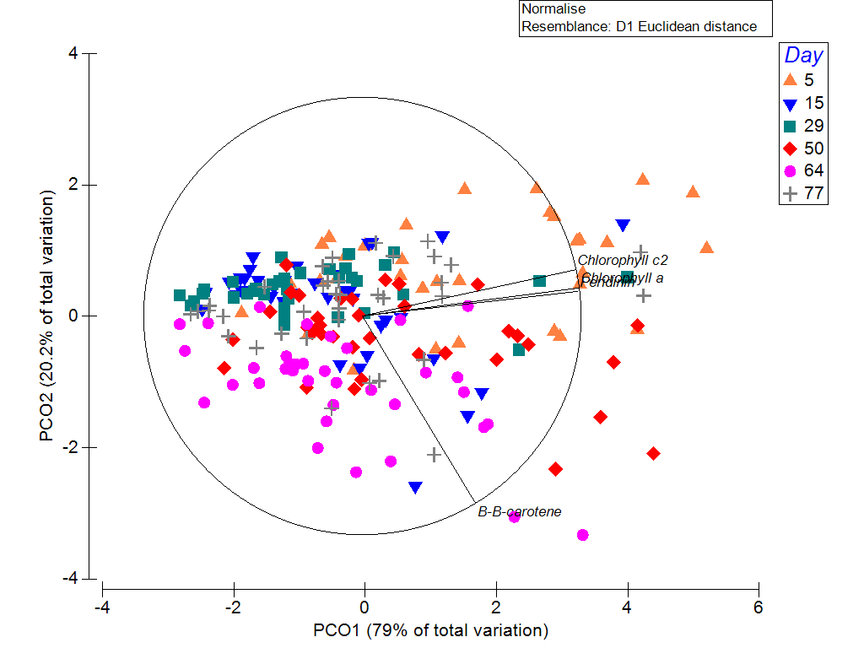
Fig. 4. Principal component ordination (PCO) plot of multivariate pigment biomarkers (chlorophyll-a, chlorophyll-c₂, peridinin, and β-carotene concentrations from A. kenti tissues subjected to one of 30% shade, 15% shade or unshaded treatments at unheated (0 DHW), moderate (4 DHW), or high (6 DHW) thermal stress treatments (sampled on days 5, 15, 29, 50, 64, and 77). The overlay shows Pearson correlation coefficients > 0.8.

Table 3: Within-day pairwise test results for a significant day × temperature interaction among multivariate pigment concentrations from A. kenti subjected to one of 30% shade, 15% shade, or unshaded treatments at unheated (0 DHW), moderate (4 DHW), or high (6 DHW) thermal stress treatments (days 5, 15, 29, 50, 64, and 77).
Day | Unheated – Moderate |  |  | Unheated – High |  |  | Moderate - High
 | df | t | P(perm) | df | t | P(perm) | df | t | P(perm)
5 | 17 | 0.20 | 0.962 | 19 | 1.39 | 0.184 | 18 | 2.00 | 0.06
15 | 20 | 0.80 | 0.524 | 20 | 0.26 | 0.92 | 20 | 0.79 | 0.56
29 | 20 | 0.49 | 0.697 | 20 | 0.55 | 0.617 | 20 | 0.30 | 0.813
50 | 19 | 1.94 | 0.055 | 20 | 1.62 | 0.113 | 19 | 0.72 | 0.546
64 | 20 | 0.66 | 0.594 | 20 | 2.33 | 0.018 | 20 | 1.28 | 0.222
77 | 20 | 0.28 | 0.914 | 20 | 1.30 | 0.216 | 20 | 1.51 | 0.134

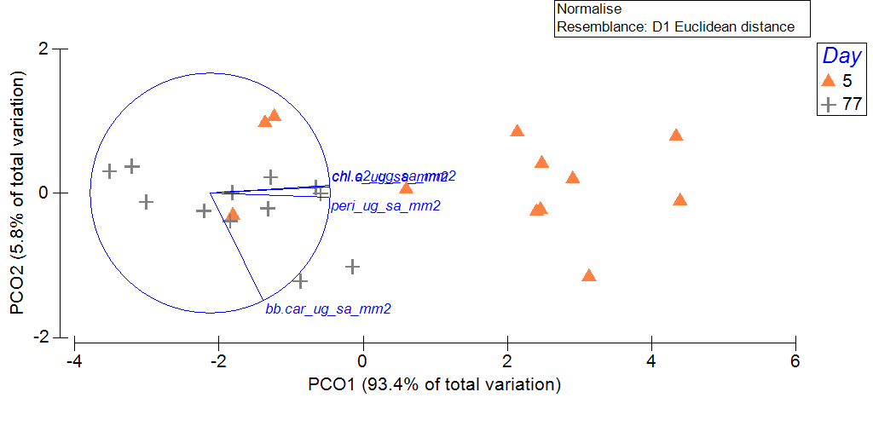
Fig. 5. Principal component ordination (PCO) plot for multivariate A. kenti pigment data for the start (day 5) and end (day 77) of the experiment from the high-stress thermal treatment.

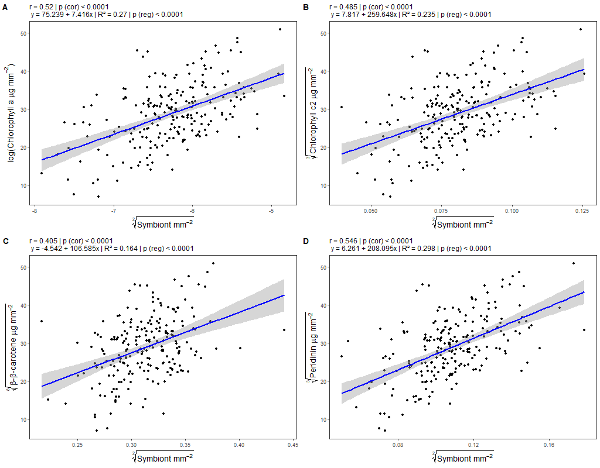
Fig. 6. Correlation and regression plots for transformed symbiont density and pigment concentration from A. kenti subjected to one of 30% shade, 15% shade, or unshaded treatments at unheated (0 DHW), moderate (4 DHW), or high (6 DHW) thermal stress treatments (days 5, 15, 29, 50, 64, and 77).

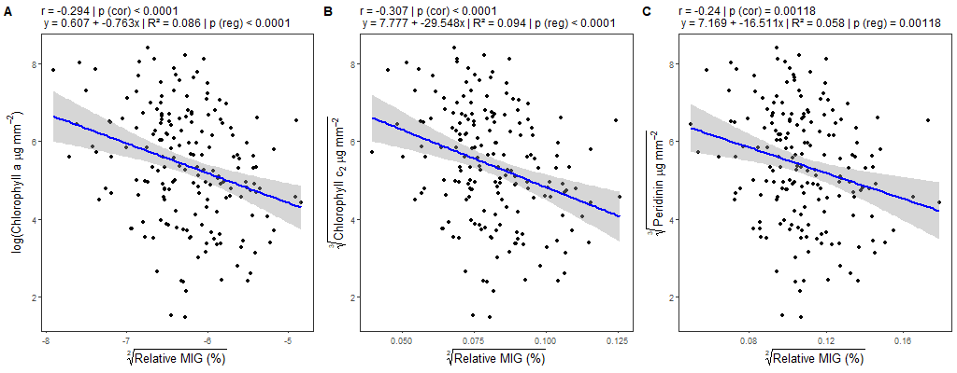
Fig. 7. Relative MIG correlation and regression statistics from A. kenti subjected to one of 30% shade, 15% shade, or unshaded treatments at unheated (0 DHW), moderate (4 DHW), or high (6 DHW) thermal stress treatments (days 5, 15, 29, 50, 64, and 77).

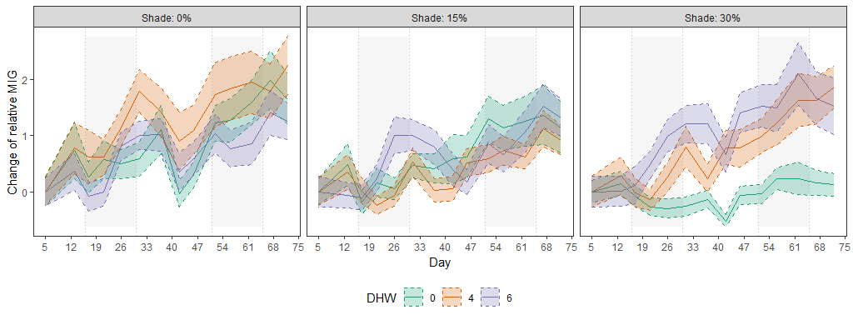
Fig. 8. Change in relative mean intensity of greys (MIG) ± 95% C.I. from A. kenti nubbins subjected to one of 30% shade, 15% shade, or unshaded treatments at unheated (0 DHW), moderate (4 DHW), or high (6 DHW) thermal stress for 78 days. Shaded vertical areas designate experimental doldrum conditions.

