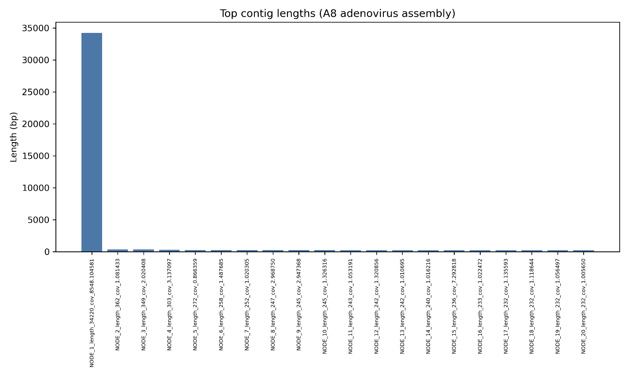
Figure S1: Length distribution of the longest contigs obtained from the SAM_A8 adenovirus de novo assembly

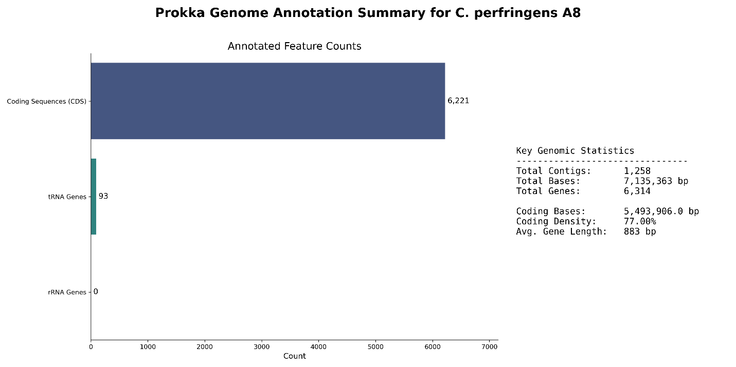
Figure S2: Prokka-based genome annotation of Clostridium perfringens SAM_A8. The bar plot summarizes annotated coding sequences (CDSs), transfer RNA (tRNA), and ribosomal RNA (rRNA) genes. Key genomic statistics, including total contigs, genome size, total gene count, coding bases, coding density, and average gene length, are shown alongside the feature counts.

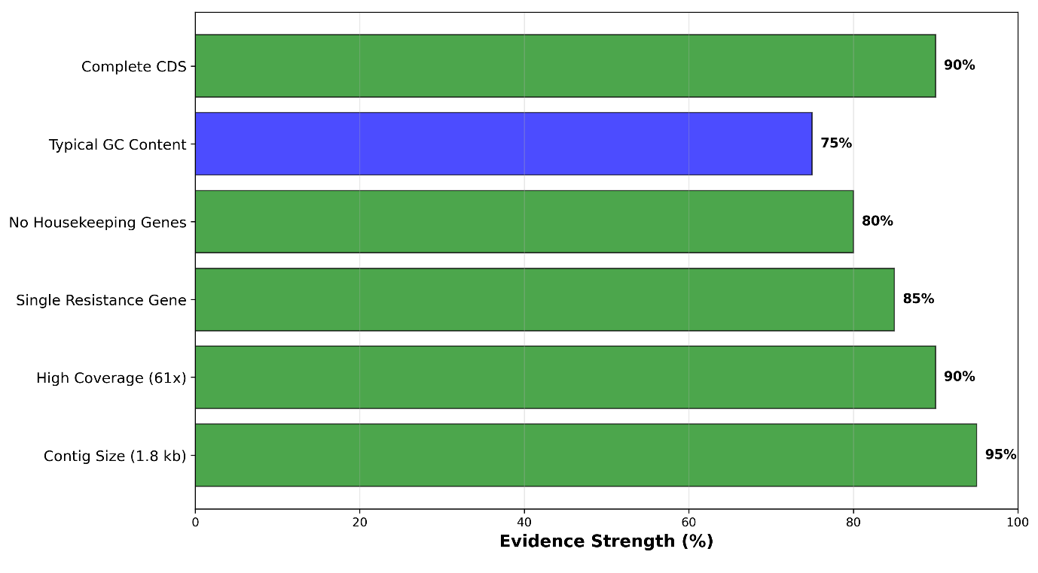
Figure S3: Multiple lines of evidence supporting plasmid-borne tetA(P) in SAM_A8. Contig-level characteristics of NODE_799 (1.8 kb; ~61× coverage) carrying the tetracycline resistance gene tetA(P) are summarized. Evaluated features include complete coding sequence structure, GC content, absence of housekeeping genes, presence of a single resistance gene, sequencing depth, and contig size. Green bars indicate features consistent with plasmid-associated elements, while blue bars denote supporting characteristics.

