A
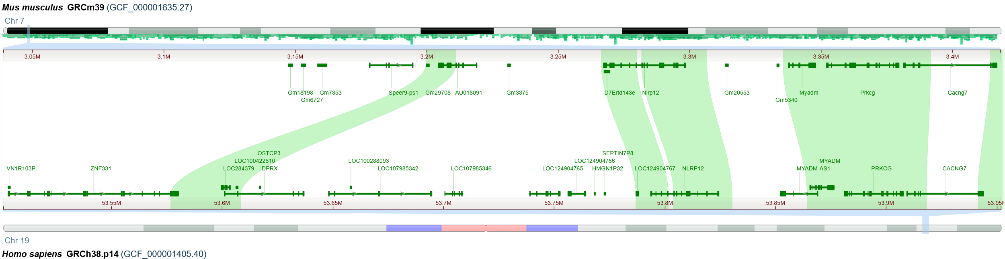
B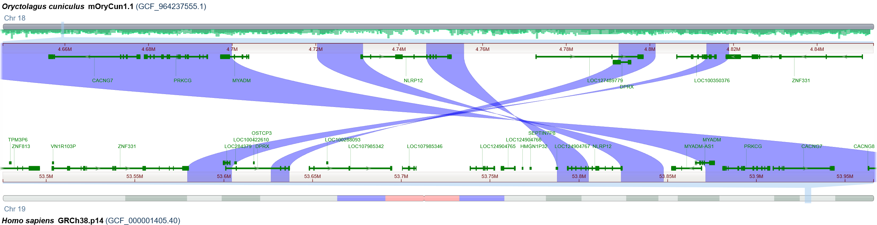C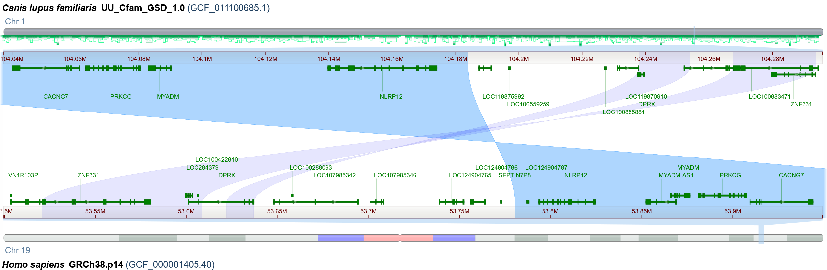D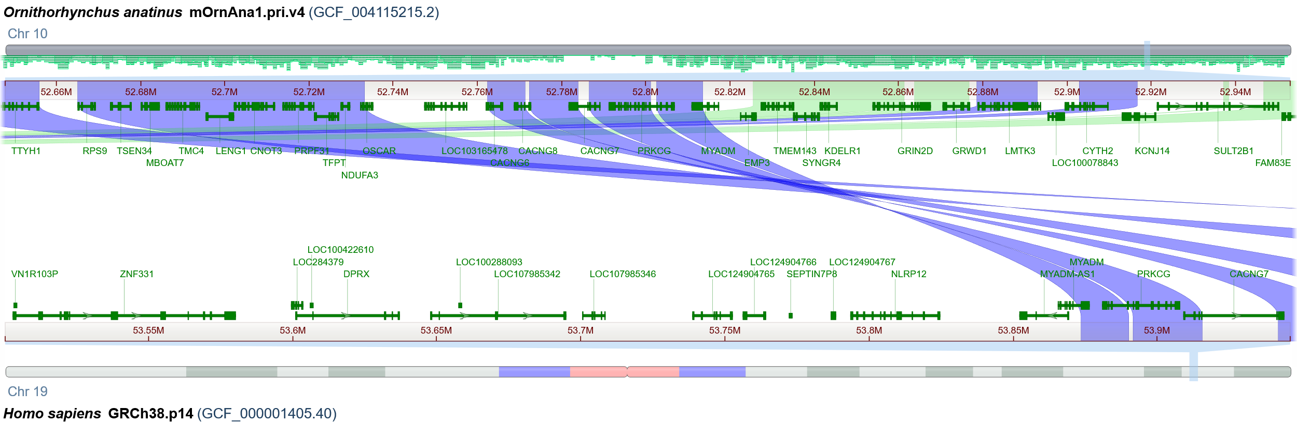E 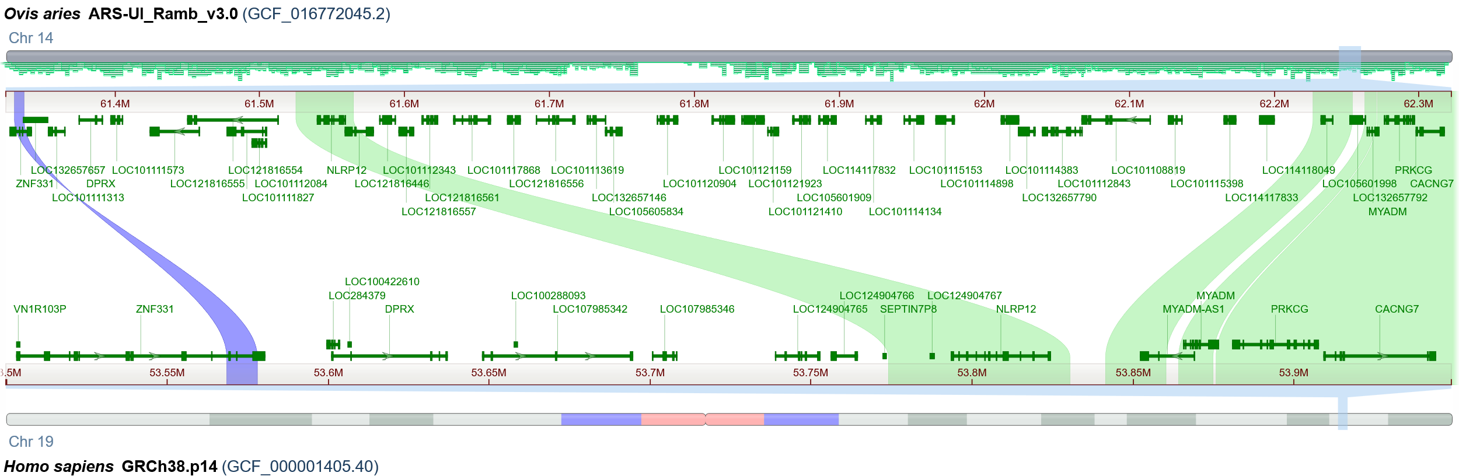F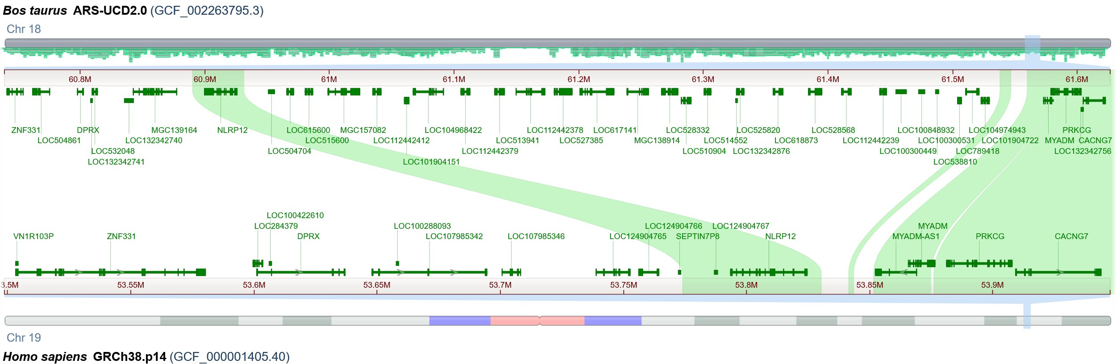G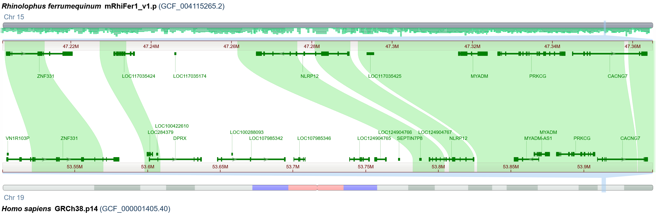H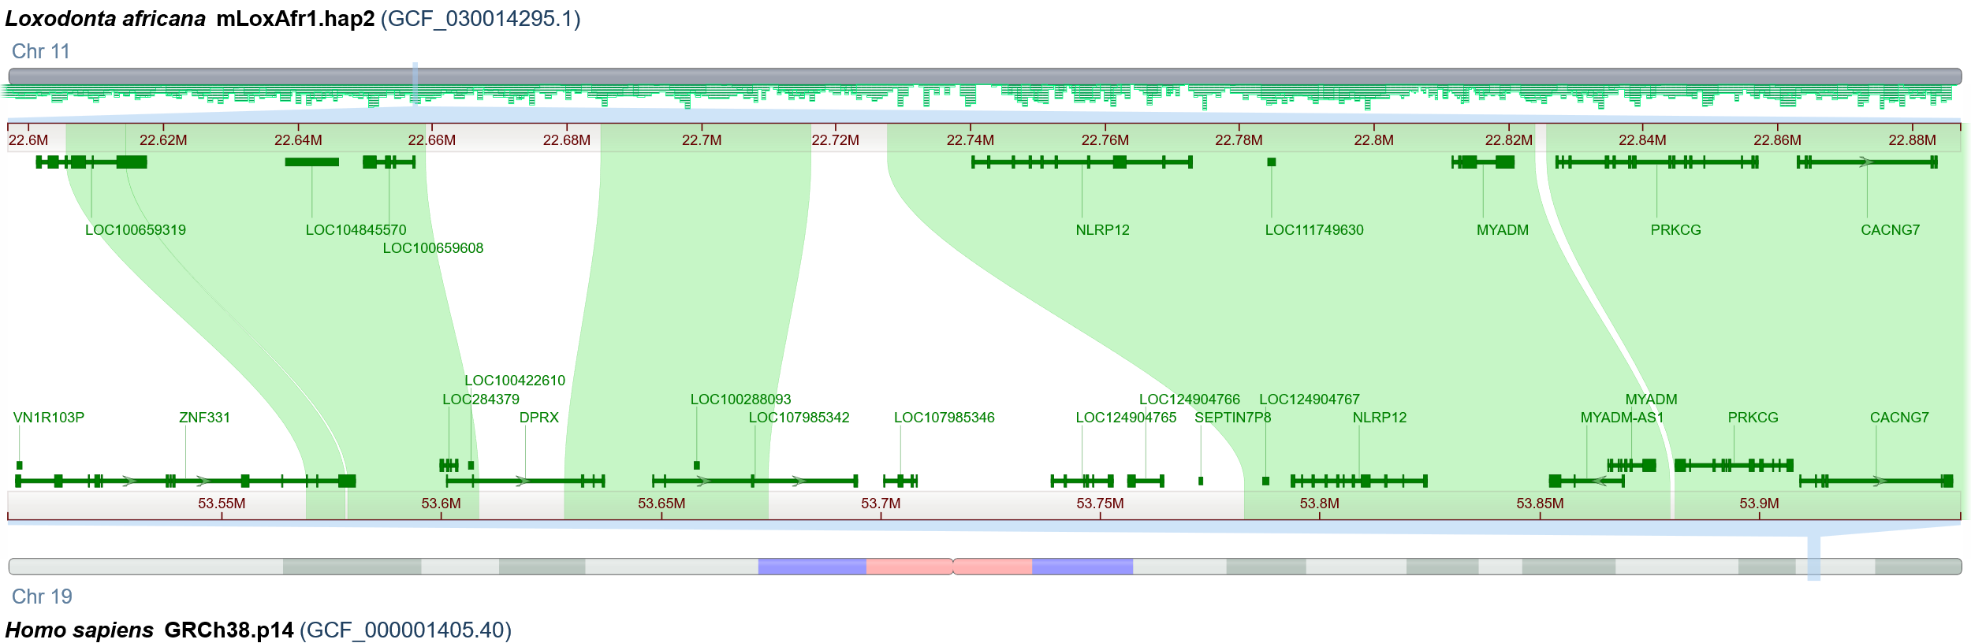
I

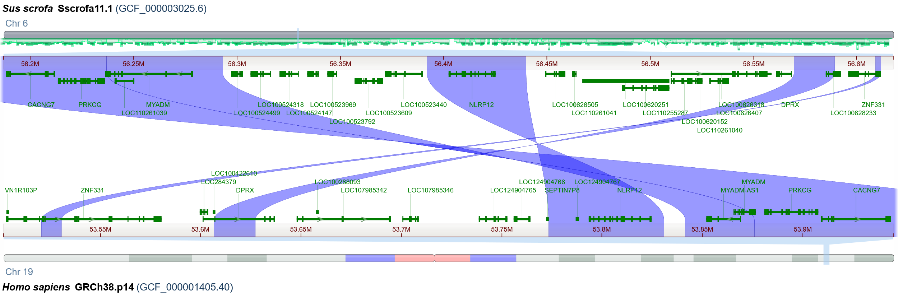

Fig S1 the region of ZDNMPC based on pair genome alignment between mammalians and human. A) human and mouse. B) human and rabbit. C) human and dog. D) human and platypus. E) human and sheep. F) human and cattle. G) human and bat. H) human and elephant. I) human and pig.

A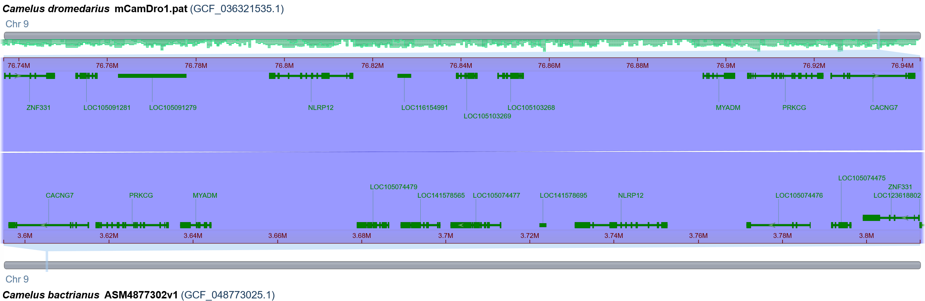B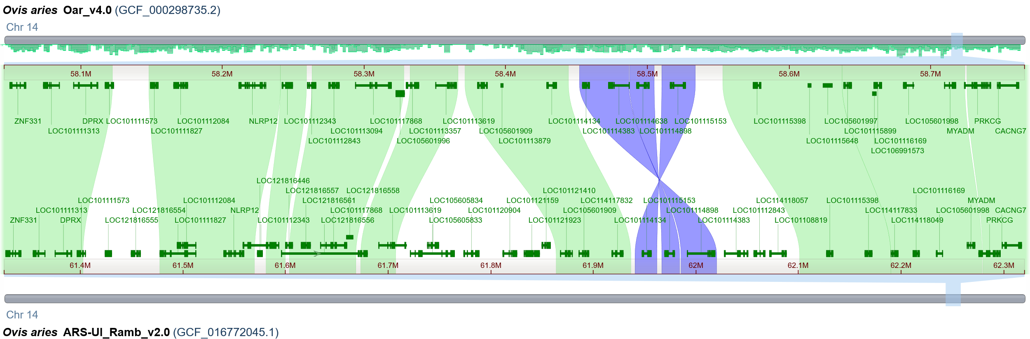C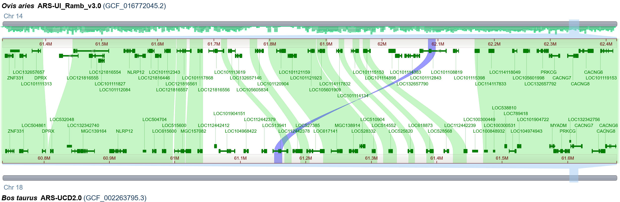 D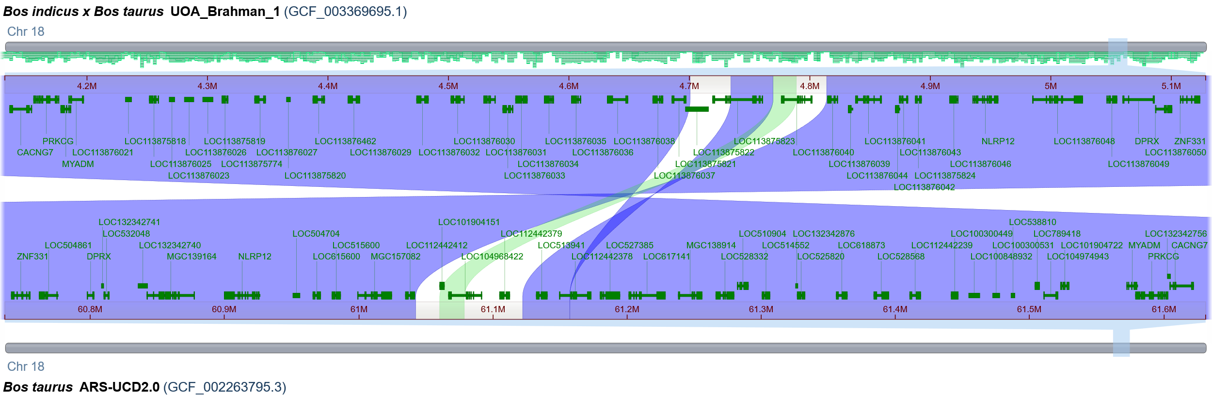E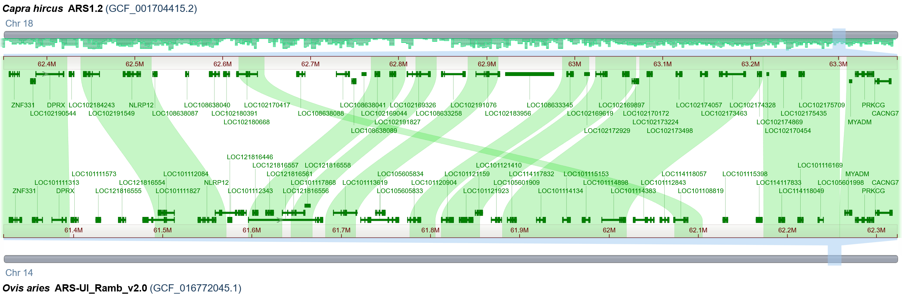F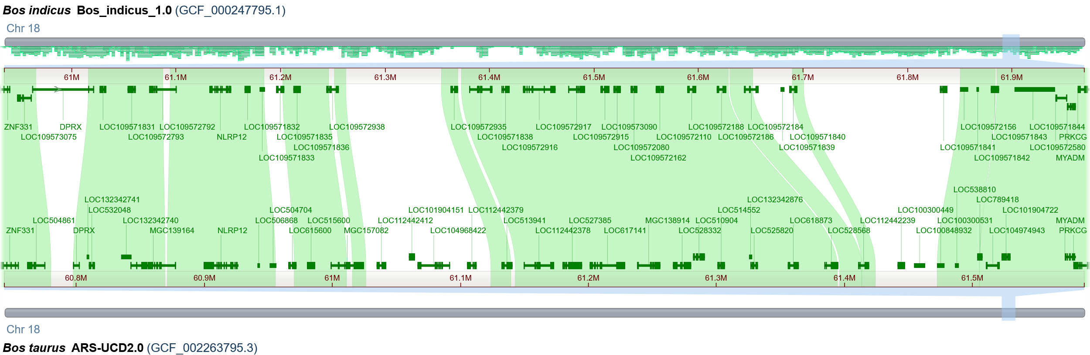
G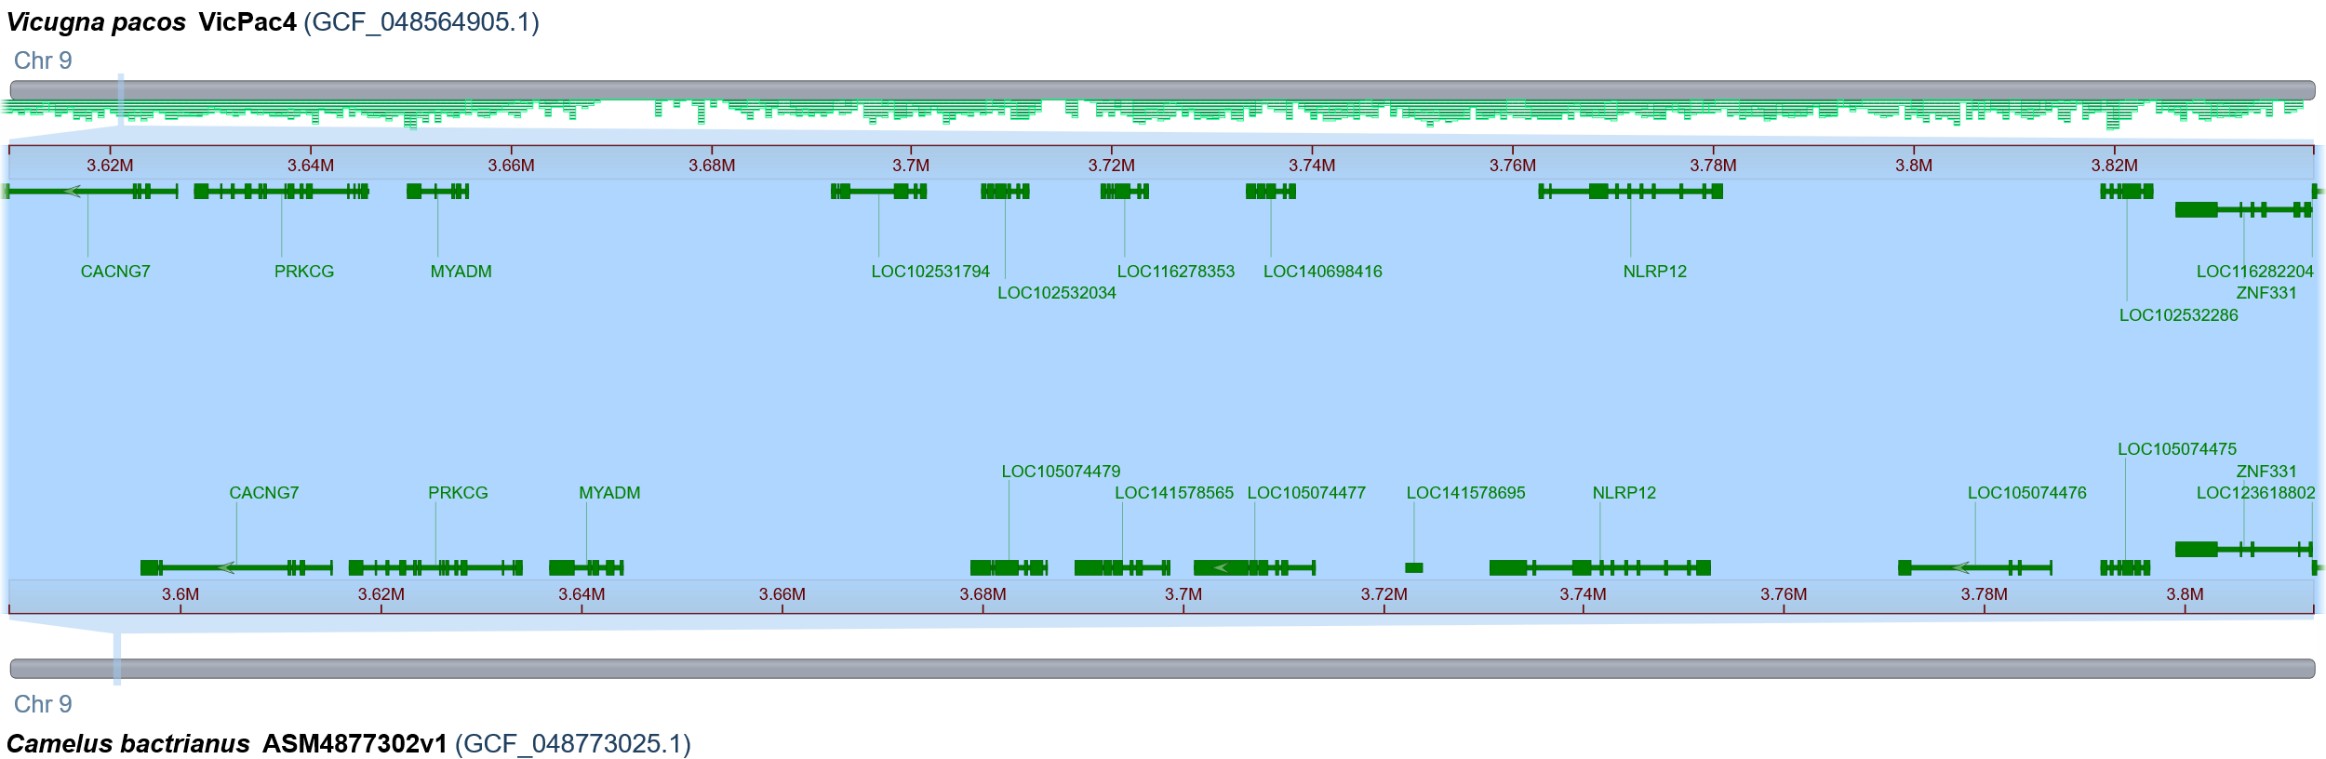
H 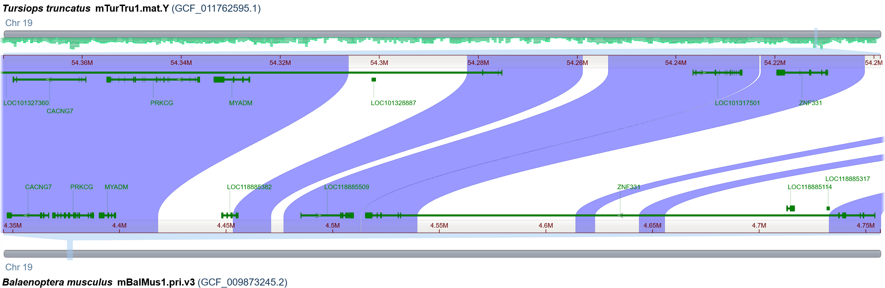

Fig S2 the location ZDNMPC based on genome alignment between Artiodactylas. A) Bactrian camel and Arabian camel. B) Rambouillet sheep and Texel sheep. C) sheep and cattle. D) cattle and hybrid cattle (Bos indicus × Bos taurus). E) goat and sheep. F) zebu cattle and cattle. G) Bactrian camel and alpaca. H) common bottlenose dolphin and blue whale.

A
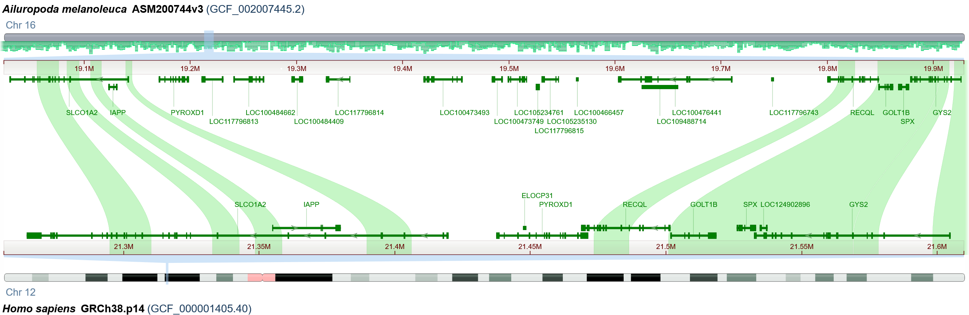B
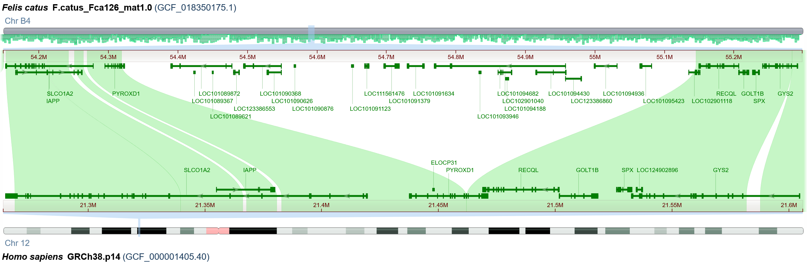C
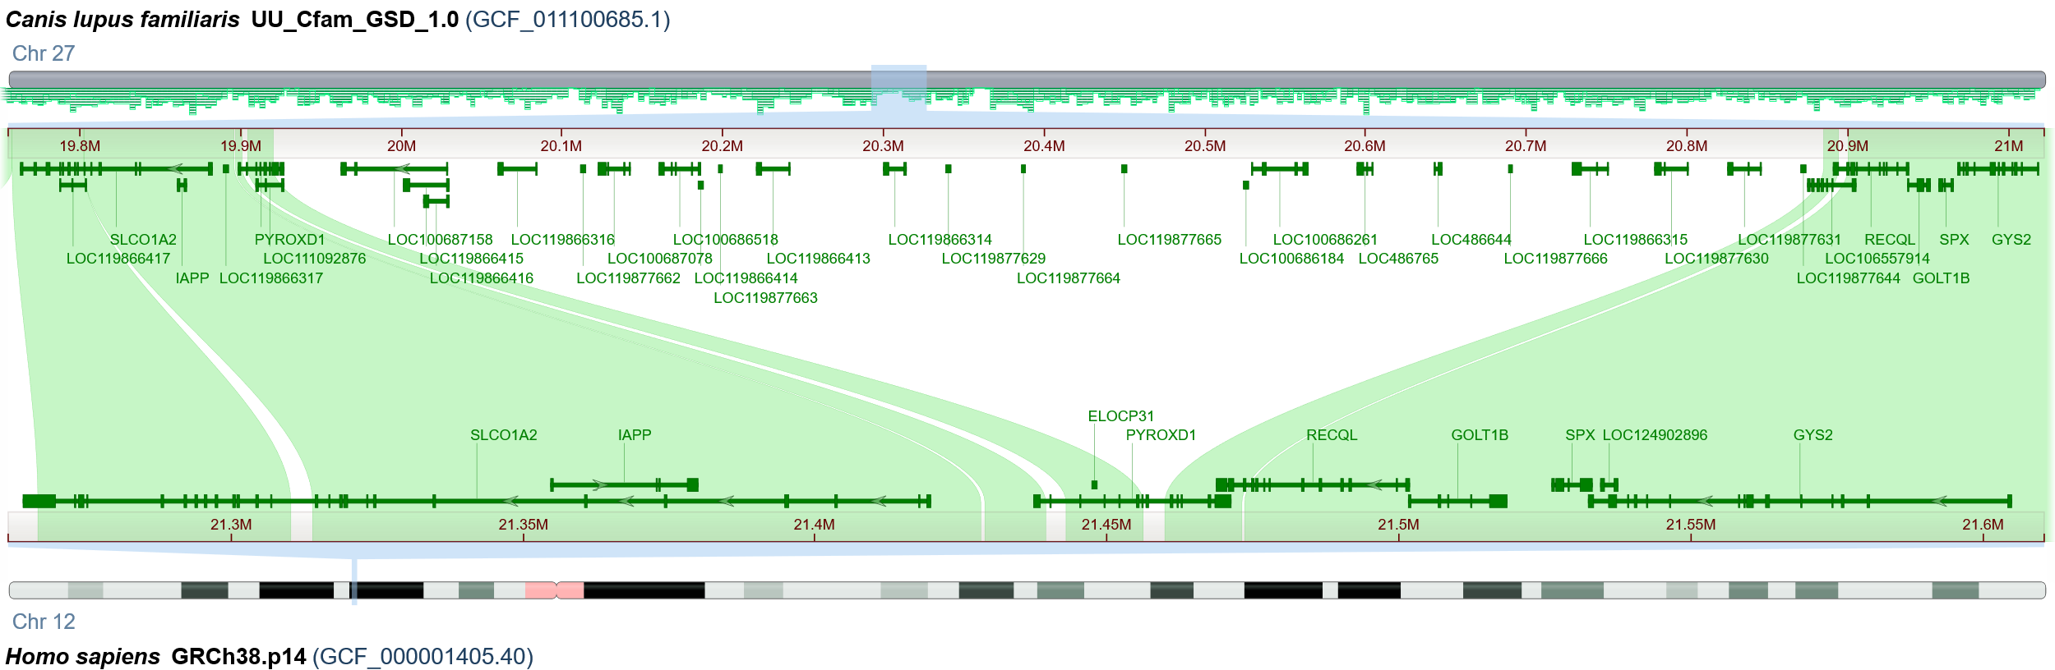
D
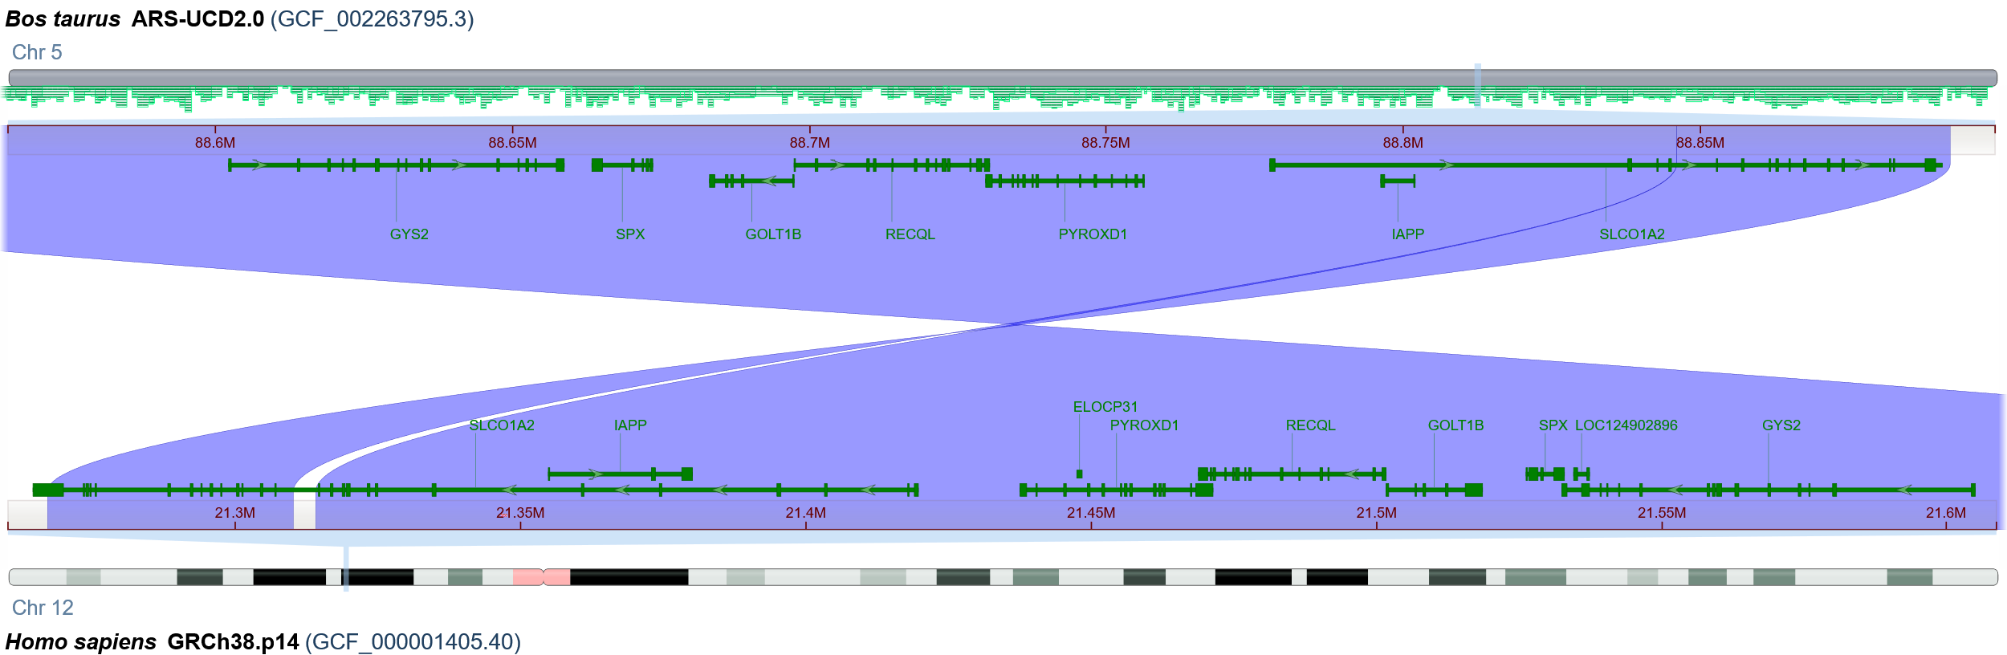

Fig S3 the location SIPRGSG based on genome alignment between carnivores and human. A) human and panda. B) human and cat. C) human and dog. D) human and cattle.
A
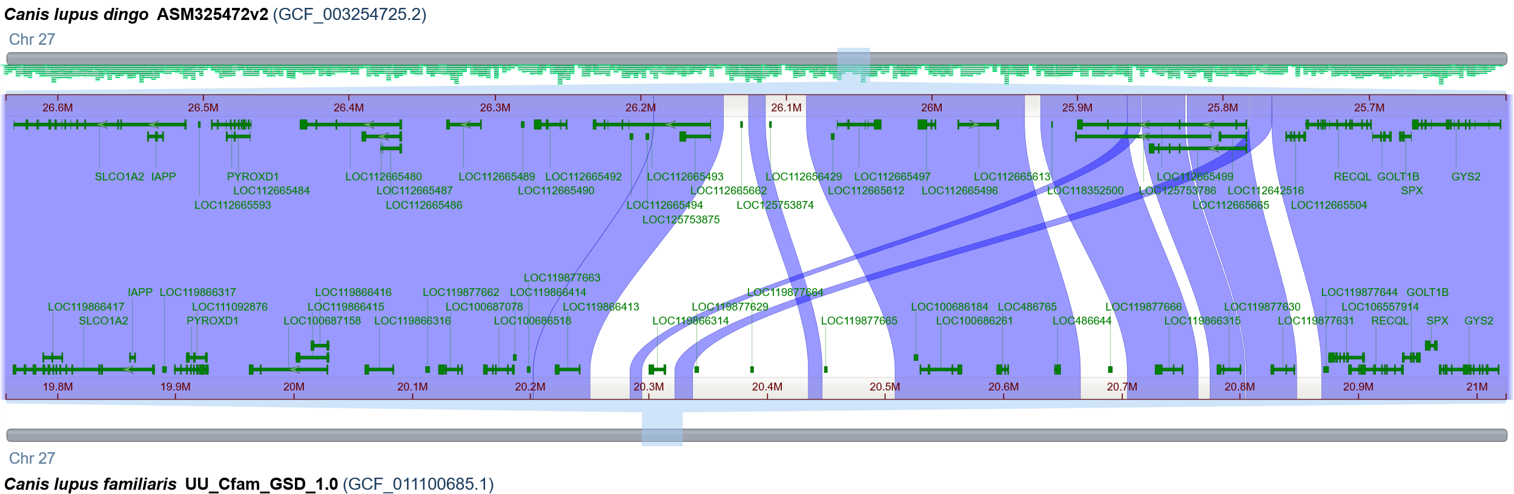
B
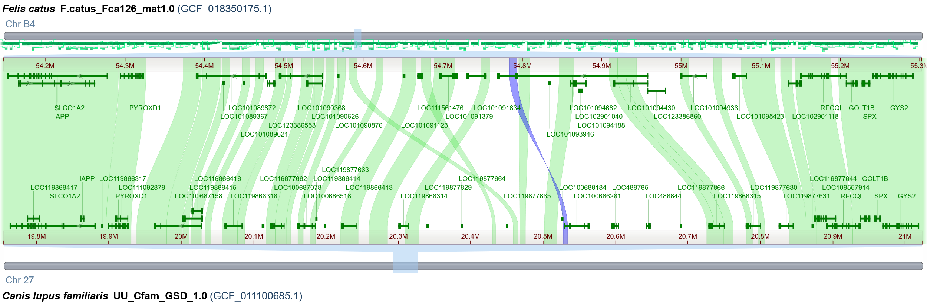
C
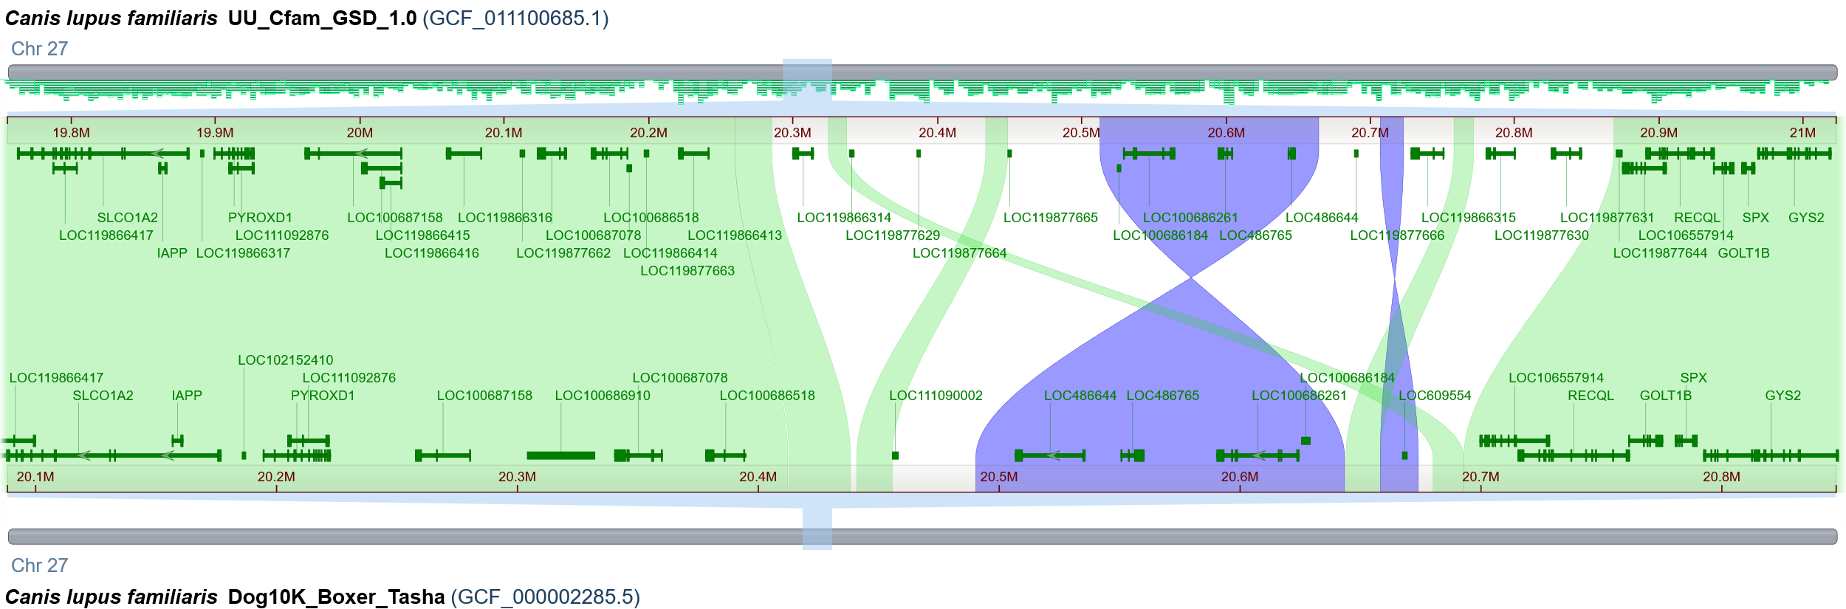
D 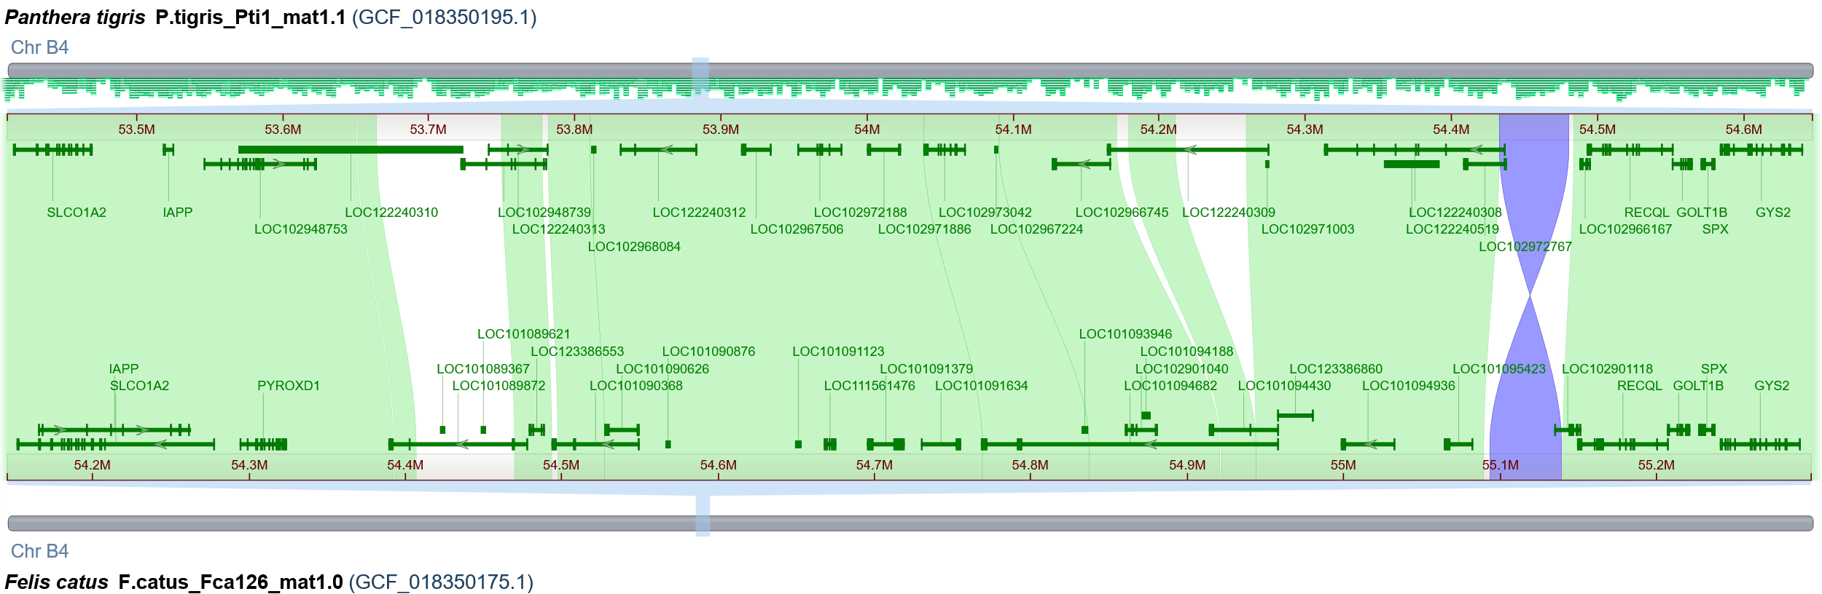

Fig S4 the location SIPRGSG based on genome alignment between Carnivores. A) dingo and dog. B) cat and dog. C) German Shepherd and boxer of dog breed. D) cat and tiger.

