Inequity by Design: Systematic Appraisal of the (in)Equities in Agriculture-Nutrition-Health Research Practices

SUPPLEMENTAL INFORMATION

Supplemental methods 1: Example search string from Pubmed database. Where blue indicates ‘equity’ terms; green indicates ‘research continuum’ terms, red indicators ‘disciplines’ terms

("Decoloni*"[Title/Abstract] OR "Coloni*"[Title/Abstract] OR "Imperial*"[Title/Abstract] OR "Racism"[Title/Abstract] OR "Racist"[Title/Abstract] OR "Xenophobia"[Title/Abstract] OR "Xenophobic"[Title/Abstract] OR "Equit*"[Title/Abstract] OR "Equal*"[Title/Abstract] OR "Fair*"[Title/Abstract] OR "Power Dynamics"[Title/Abstract] OR "Power Balance"[Title/Abstract] OR "Power Imbalance"[Title/Abstract] OR "Hierarchy"[Title/Abstract] OR "Gender Bias"[Title/Abstract] OR "Discrimination"[Title/Abstract] OR "Exploitation"[Title/Abstract] OR "Disability"[Title/Abstract] OR "Positionality"[Title/Abstract] OR "Humility"[Title/Abstract] OR "Social Values"[Title/Abstract] OR "Reflexivity"[Title/Abstract] OR "Reflection"[Title/Abstract] OR "Participat*"[Title/Abstract] OR "partner*"[Title/Abstract] OR "Shared*"[Title/Abstract] OR "benefit*"[Title/Abstract] OR "Sustainbil*"[Title/Abstract] OR "Marginalise"[Title/Abstract] OR "marginalised"[Title/Abstract] OR "marginalisation"[Title/Abstract] OR "marginalize"[Title/Abstract] OR "marginalized"[Title/Abstract] OR "marginalization"[Title/Abstract] OR "Marginali*"[Title/Abstract] OR "intersectionality"[Title/Abstract] OR "Disparity"[Title/Abstract] OR "Disparities"[Title/Abstract] OR "Empower*"[Title/Abstract] OR "empowers"[Title/Abstract] OR "empowerment"[Title/Abstract] OR "empowering"[Title/Abstract] OR "Disempower"[Title/Abstract] OR "disempowers"[Title/Abstract] OR "disempowerment"[Title/Abstract] OR "disempowering"[Title/Abstract] OR "power"[Title/Abstract] OR "deprived"[Title/Abstract] OR "deprivation"[Title/Abstract] OR "discriminate"[Title/Abstract] OR "discrimination"[Title/Abstract] OR "discriminated"[Title/Abstract] OR "vulnerable"[Title/Abstract] OR "vulnerability"[Title/Abstract] OR "disadvantag*"[Title/Abstract] OR "Injustice"[Title/Abstract] OR "justice"[Title/Abstract] OR "Inclusiv*"[Title/Abstract] OR "Equity"[Title/Abstract] OR "equities"[Title/Abstract] OR "equitably"[Title/Abstract] OR "Inequity"[Title/Abstract] OR "inequities"[Title/Abstract] OR "inequitably"[Title/Abstract] OR “Indigenous”[Title/Abstract] OR “First Nations”[Title/Abstract] OR “anti-racis*”[Title/Abstract] OR “under-represented”[Title/Abstract] OR “representation”[Title/Abstract] OR “diversity”[Title/Abstract] OR “inclusion”[Title/Abstract]) OR Parachute science"[Title/Abstract] OR "Safari science"[Title/Abstract] OR “Equitable partnerships”[Title/Abstract] OR “Equitable research partnerships”[Title/Abstract])
"Donor"[Title/Abstract] OR "fund*"[Title/Abstract] OR "Aid"[Title/Abstract] OR "grant"[Title/Abstract] OR "proposal"[Title/Abstract] OR "Citizen science"[Title/Abstract] OR "Co-Produc*"[Title/Abstract] OR "coproduc*"[Title/Abstract] OR "Partner*"[Title/Abstract] OR "writ*"[Title/Abstract] OR "financia*"[Title/Abstract] OR "institutional capacity"[Title/Abstract] OR "Ethic*"[Title/Abstract] OR "institutional review board"[Title/Abstract] OR "IRB"[Title/Abstract] OR "Data Collection"[Title/Abstract] OR “Knowledge system*”[Title/Abstract] OR "Analys*"[Title/Abstract] OR "Knowledge production"[Title/Abstract] OR "participat*"[Title/Abstract] OR "publica*"[Title/Abstract] OR "author*"[Title/Abstract] OR "Presenting results"[Title/Abstract] OR “Data visualisation”[Title/Abstract] OR “Data visualization”[Title/Abstract] OR "Findings"[Title/Abstract] OR "Acknowledge*"[Title/Abstract] OR "dissemina*"[Title/Abstract] OR "Science communication"[Title/Abstract] OR "Communicating results"[Title/Abstract] OR "Knowledge translation"[Title/Abstract] OR "Knowledge transfer"[Title/Abstract] OR “partnerships”[Title/Abstract]
("Agr*"[Title/Abstract] OR "farm*"[Title/Abstract] OR "smallholder*"[Title/Abstract] OR "Aquacultur*"[Title/Abstract] OR "Economic*"[Title/Abstract] OR "Environment*"[Title/Abstract] OR "Food system*"[Title/Abstract] OR "Geographr*"[Title/Abstract] OR "Nutrition*"[Title/Abstract] OR “Diets”[Title/Abstract] OR “Micronutrient deficiency”[Title/Abstract] OR “Obesity”[Title/Abstract] OR “Malnutrition”[Title/Abstract] OR “Global Health”[Title/Abstract] OR "Public health"[Title/Abstract] OR "Social sciences"[Title/Abstract] OR "Livestock"[Title/Abstract] OR "Fisheries"[Title/Abstract] OR "Sanitation"[Title/Abstract] OR "Hygiene"[Title/Abstract] OR "Medicine"[Title/Abstract] OR "infectious disease* "[Title/Abstract] OR "tropical medicine"[Title/Abstract] OR "Nursing"[Title/Abstract] OR "International development"[Title/Abstract] "International development")

Additional filters applied on site: PUBYEAR AFT 2012 AND ( LIMIT-TO LANGUAGE, "English" )).
No proximity operators allowed.
No subject field selections allowed.

Supplemental methods 2: Inclusion and exclusion criteria for screening

 | Inclusion | Exclusion
Date | Published from January 2012 – December 2022 (10-year period; up end of search implementation date) | Published before January 2012
Population | All (general populations of any age, geography, gender) engaged in research, either as a researcher or participant
Methods /Output | All research design & methods (qualitative, quantitative, mixed-methods, reviews) | Books, book chapters, scoping review protocols, introduction to special issues, corrigendum and corrections, conference abstracts, newspaper articles and webpages.  No full-text available
Discipline | Interdisciplinary articles documenting research practices in disciplines and thematic areas related to Agriculture and food systems (including food environments, value chains, agroecology and food safety) OR Nutrition (NCDs, malnutrition, obesity, hunger, diets) OR Global Public Health (including AMR and zoonotic disease) | Research does not explicitly focus on ANH OR NCDs, i.e. it does not focus on malnutrition or obesity or hunger or zoonotic foodborne disease, antimicrobial resistance or diets or food environments or soil health or agricultural studies or environmental epidemiology or agricultural fortification or yield studies or food quality or micro-, and macro-nutrient content or public and/or global health.
Equity | Articles clearly exploring practices related to any one (or more) of the Six Principles of Equity in Global Health Research (CCGHR). Additionally, articles that outline methods for tackling the inequity outlined or promoting equitable research practice are particularly valuable. | Articles that describe an equity as an outcome(s) and/or those not located along research continuum (i.e. equity as outcome in Agriculture-Nutrition-Health study population).
Research Continuum | Articles where the (in)equity in practice must be located along one or more stages of the research continuum. | Articles that do not focus specifically on equity within some aspect of the research continuum or on research practice.
Language | English | Non-English

Supplemental methods 3: Coding structure for data extraction

Thematic area | Codes | Description
First & last author affiliations | First author affiliation location  - Global South/LMIC  - Global North/HIC  - Indigenous population | Data extracted from location of first author's institutional affiliation.  Codes created using World Bank classification for country-income status. Authors of articles that specified being Indigenous peoples were coded for.  Select all that apply based on region where the author(s) institutions are located.
First & last author affiliations | Last author affiliation location  - Global South/LMIC  - Global North/HIC  - Indigenous population | Data extracted from location of last author's institutional affiliation.  Codes created using World Bank classification for country-income status. Authors of articles that specified being Indigenous peoples were coded for.  Select all that apply based on region where the author(s) institutions are located.
First & last author affiliations | Single author article  - Yes  - No | Single author papers were identified to flag authorship on global research authored by a single researcher.  Select yes or no based on the authorship record.
First & last author affiliations | First author-last author institution’s geographical relationship  - North x North  - North x South  - South x South  - North  - South | Data extracted from location of authors’ institutional affiliations if based in the Global North or Global South and applied to code options. If a single author, select ‘North’ or ‘South’ depending on where institutional affiliation us based.  Select all that apply
Discipline | Journal  - Journal name | Journal names were extracted to reflect discipline literature was situated in. After data extraction, journal names were then categorized based on journal descriptions into the following disciplines:  - Public Health (global health, clinical)  - Development studies & Economics,  - Environmental science & Ecology  - Agricultural(Agriculture/Aquaculture/Livestock)  - Nutrition & dietetics.  Free text based on bibliographic record
Domain: Agro-environmental, Food Systems, Nutrition & Health | - Agro-environmental  - Food systems (pre- and post-farmgate)  - Food security and diets  - Nutrition-related health  - Global public health  - Other | The broader domain/ thematic area of Agriculture-Nutrition-Health was defined as a range of research with a focus on leveraging food systems, including agriculture and/or their interlinkages to improve food security, nutrition and health and outcomes.  Select all that apply
Setting: Study classification income-classification | - LMIC: Low middle income countries  - UMIC: Upper middle income countries  - HIC: High income countries  - SIDS: Small Island Developing States  - None/NA | Income-classification of the countries within which study was set to reflect the broader context of the study. Articles with no specific country context were coded as none/NA.  Select all that apply
Setting: Study country | - List of 195 countries  - N/A | Study country reported by authors as country setting(s). Country list based on UN country list. If there was no country specified or the paper focused on a global context, N/A was coded.  Select all that apply
Setting: Context | - Rural  - Peri-urban  - Urban  - Humanitarian crisis  - Deprived areas  - Well-resourced areas  - Other  - N/A | - Rural: Area(s) located outside of urban and peri-urban areas.  - Peri-urban: Area(s) immediately adjacent to an urban area(s).  - Urban: Area(s) within a city of municipal center  - Humanitarian crisis: Area(s) where an event or series of event represents a threat to the health and wellbeing of a population(s).  - Deprived areas: Area(s) lacking amenities and services essential to health and well-being.  - Well-resourced areas: Area(s) not lacking amenities and services essential to health and well-being.  - Select all contexts where the study was carried out
Population: Researcher | - Agricultural workers  - Clinical patient group  - Indigenous population  - Infant/children/adolescents  - Refugee or migrant populations  - Racial/ethnic, religious minority groups  - Women and gender-diverse  - Deprived population  - Well-resourced populations  - General researchers  - Early career researchers  - N/A  - Other | Iteratively developed by research team based on coding first set of included papers and therefore included unusual researcher groups based on the articles reviewed.  - Agricultural workers: Individuals performing tasks related to the production of agricultural goods.  - Clinical patient group: Individuals receiving health services via a healthcare professional, including in the prevention and treatment of health conditions.  - Indigenous population: Individuals who are descendants of those who inhabited a region before other populations arrived.  - Infant/child/adolescents: Individual(s) under the age of 18 years.  - Refugee or migrant populations: Individuals who have (in)voluntarily left their country of origin.  - Racial/ethnic, religious minority groups: Individuals within a district racial, ethnic, and/or religious group that differ from a majority group.  - Women and gender-diverse: Individuals identifying as women or gender identities that fall outside of the binary framework.  - Deprived population: Individuals located in area(s) lacking amenities and services essential to health and well-being.  - Well-resourced populations: Individuals located in area(s) not lacking amenities and services essential to health and well-being.  - General researchers: Individuals employed to collect and disseminate research findings.  - Early career researchers: Individuals in the early stages of their career working to establish themselves in a specific research area.  Select all that apply
Population: Study group/community | - Agricultural workers  - Clinical patient group  - Indigenous population  - Infant/children/adolescents  - Refugee or migrant populations  - Racial/ethnic, religious minority groups  - Women and gender- diverse  - Deprived population  - Well-resourced populations  - N/A  - Other | - Agricultural workers: Individuals performing tasks related to the production of agricultural goods.  - Clinical patient group: Individuals receiving health services via a healthcare professional, including in the prevention and treatment of health conditions.  - Indigenous population: Individuals who are descendants of those who inhabited a region before other populations arrived.  - Infant/child/adolescents: Individual(s) under the age of 18 years.  - Refugee or migrant populations: Individuals who have (in)voluntarily left their country of origin.  - Racial/ethnic, religious minority groups: Individuals within a district racial, ethnic, and/or religious group that differ from a majority group.  - Women and gender-diverse: Individuals identifying as women or gender identities that fall outside of the binary framework.  - Deprived population: Individuals located in area(s) lacking amenities and services essential to health and well-being.  - Well-resourced populations: Individuals located in area(s) not lacking amenities and services essential to health and well-being.  - General researchers: Individuals employed to collect and disseminate research findings.  - Early career researchers: Individuals in the early stages of their career working to establish themselves in a specific research area.  Select all that apply
Methods | Aims and objectives | Open text based on author description of aims and objectives of the article.
Methods | Is this study a review?  - Yes  - No | Articles that were reviews were identified with the understanding that they would include a range of studies and would leverage specific methods.
Methods | Evidence type  - Empirical research (primary data)  - Empirical research (secondary data)  - Evidence synthesis or review  - Working paper or pre-print  - Tool or guidance document  - Commentary or perspective  - Grey literature  - Government report  - Other, specify | - Empirical research (primary data): Study that collects primary data (new data).  - Empirical research (secondary data): Study that uses existing data.  - Evidence synthesis or review: Study that reviews multiple studies and synthesizes information.  - Working paper or pre-print: Paper that involves analysis of quantitative or qualitative data but that is not published (yet or ever) in a peer-reviewed journal, typically found on organizational website. Will clearly state it is a working paper in title.  - Tool or guidance document: Document that provides guidance or a toolkit typically drafted by an organization.  - Commentary or perspective: Not a study but a write-up expressing informed viewpoint in one of the listed sources.  - Grey literature: Unpublished literature/non-peer review literature that typically involves evidence synthesis, meeting synthesis, etc. and is usually shared via organizations  - Government report: Unpublished literature/non-peer review document prepared and published by the government.  Select all that apply
Methods | Study methodology  - Qualitative  - Quantitative  - Mixed-methods  - Theoretical/ conceptual/methodological framework  - Synthesis/review  - Historical analysis  - N/A | - Qualitative: Study that examines non-numerical data.  - Quantitative: Study that examines numerical data.  - Mixed-methods: Study that examines both numerical and non-numerical data.  - Theoretical/conceptual/methodological framework: Study that proposes a new concept/theory/ framework based on evidence. If theory/framework leveraged to understand an issue, identify what type of data is analyzed.  - Synthesis/review: Studies that include Cochrane reviews, systematic reviews, overview reviews, umbrella reviews, reviews of reviews, case study reviews, qualitative reviews, narrative reviews, policy reviews, mini review, meta-analyses  - Historical analysis: Studies that examine evidence  - and interpreting past events, trends, and developments to understand their causes, context, and effects.  - N/A: Opinion piece/Editorial/Discussion/Blog post/ Guidance document or report that do not leverage any frameworks and provide broad summaries  Select all that apply
Research continuum | Along which stage on the research continuum is this study/article located?  - Funder research priorities  - Fostering research partnerships  - Developing grant applications  - Establishing interdisciplinary collaborations  - Setting research aims  - Securing funding and establishing financial administration  - Obtaining research conduct approvals  - Engaging study community  - Collecting data  - Analyzing data and data sharing  - Publishing peer-reviewed papers  - Disseminating research on other platforms  - Research culture | - Funder research priorities: focuses on who/where gets funding, issues related to donors of research funding.  - Fostering research partnerships: focuses on issues related to developing working relationships/ partnership and training, particularly where capacity to conduct research is low.  - Developing grant applications: focuses on the process of developing grants to conduct research (ex: time provided, who is allowed to be the lead organization/PI, etc.).  - Establishing interdisciplinary collaborations: focuses on researchers from different disciplines developing a shared understanding and intellectual coherence around a common research question or idea.  - Setting research aims: focuses on development of the research questions and focus.  - Securing funding and establishing financial administration: focuses on process and issues or requirements and time taken to set up financial pipelines to facilitate research and partnerships.  - Obtaining research conduct approvals: focuses on obtaining ethical research approval and other necessary approvals via appropriate entities (govt org, etc.) to conduct research.  - Engaging study community: focuses on sensitizing communities or population where research is taking place to what the research is about, obtaining permission, etc.  - Collecting data: focuses on process of data collection.  - Analyzing data and data sharing: focuses on issues of analyzing data and sharing data with the public and across the research team.  - Publishing peer-reviewed papers: focuses on issues related to publishing papers from author position, who undertakes writing task, time provided for review, publication fees, etc.  - Disseminating research on other platforms: discusses sharing of research on other platforms aside from journals, such as in conferences, government meetings, or the Internet  - Research culture: focuses on cross-cutting issues across the research continuum namely job security; timelines; unpaid labor, pay-gap, unsupportive work environment (including inadequate sick leave, maternity leave, etc.)  Select all that apply
(In)equitable research practices | Specific inequitable practices described?  - Access to or use of data  - Access to funding  - Access to or use of technology  - Agency over decision-making processes  - Authorship and publishing  - Conflict of interest  - Exclusion  - Exploitation  - Implicit biases  - Institutionalized prejudices  - Job security  - Lack of agency  - Marginalized or erased knowledge  - Risks to personal safety  - Stereotypes  - Stigma  - Time constraints  - Wage, pay, or salary  - Other, specify | This data depicted the conceptual aspects of equity that the article/study focuses on, drawing from the text in the manuscript. These codes were keywords commonly noted to describe key equity practice issues in global research and were added to iteratively during the full-text screening process. These descriptors are the highest level of granularity in the article and can signpost to readers who are interested in a specific equity issue.  - Access to or use of data: analysis limited to global north collaborators, 'safari science', use of secondary data.  - Access to funding: funding stipulations that favor global north institutions as prime.  - Access to or use of technology: includes internet, software, or laboratory infrastructure.  - Agency over decision-making processes: designing research questions and research process.  - Authorship and publishing: lead authors favor institutions in global north, high publishing fees are prohibitive for researchers from certain settings.  - Conflict of interest: financial relationships that disallow objectivity in work.  - Exclusion: excluding certain groups under research or during the research process ex: not engaging community members during study rollout.  - Exploitation: research is not mutually beneficial e.g.: no relevance of research to local needs, benefit sharing does not take place, did not undergo ethics review, cultural norms ignored in research undertaking.  - Implicit biases: unintentional involvement in the perpetuation of discrimination and inequity as well as the unrecognized advantages they enjoy based on group membership.  - Institutionalized prejudices: practices that are baked into institutional policies, e.g.: women systematically get paid less than men in academia and research organization.  - Job security: issues of fragile working conditions, e.g.: casualization of research work.  - Lack of agency: people/groups do not have control over their actions and consequences. e.g.: community members are not engaged in intervention research and thus have no control over interventions being administered.  - Marginalized or erased knowledge: knowledge that is overlooked and ignored. e.g.: Indigenous knowledge, local agricultural knowledge and practices  - Risks to personal safety: precarious conditions researchers or study participants are placed during planning or implementing research e.g.: risks to research participants, or to researchers in field work in humanitarian settings.  - Stereotypes: overgeneralized attributes associated with the members of a social group.  - Stigma: negative attitudes towards certain groups e.g.: persons/groups who are HIV positive, from "lower caste" groups.  - Time constraints: constriction put on time that leads to stressors on specific groups, e.g.: short grant duration, research culture that favors researchers with more resources such as training, administrative support, etc.  - Wage, pay, or salary: differential pay related to geographical origin, ethnicity, gender  - Other, specify  Select all that apply
 | Core equity principles  - Authentic partnering  - Inclusion  - Shared benefits  - Commitment to the future  - Responsiveness to the cause of inequity  - Humility | Six equity principles that guide this review based on CCGHR. See description in the main manuscript in Box 2.  Select all that apply
Solutions | Key recommendations  - None (descriptive, problem-oriented)  - Wish list recommendations  - Recommendations (solutions-oriented) | Coded to assist with summarizing solutions in articles to guide more equitable practices and share existing tools.  - None: artice was focused solely on describing inequities that exist  - Wish list recommendations (untested recommendations): article offers solutions but was not the primary intent of the article. Solutions are primarily untested.  - Recommendations (tested/ solutions-oriented recommendations): article's primary objective was to not only examine inequities but to identify solutions, testing them through lived experience or experimental setting, through undertaking interviews, and/or through summarizing solutions identified by other studies.  Open-ended text
Target audience | - Researchers  - Academic or research institutions  - Government  - Donors  - Ethical review board | Represent broad groups the recommendations in the article are addressed.  - Researchers: individual researchers or groups of researchers  - Academic or research institutions: Educational institutions or research organizations  - Government: government entities  - Donors: institutions that provide funding for research  - Ethical review board: groups that review ethical proposals for research on human subjects.
Target audience | Intended Audience  - Individual level: Researchers  - Group level: Research groups  - Regional level: Researchers in global south  - Regional level: Researchers in global north  - Inter-regional: global north x south  - Institutional-Individual interaction: Research and academic institutions  - Governmental Institution-Individual interaction: Researchers and Government institutions  - Institutional level: Higher education institutions only  - Institutional level: Donors  - Institutional level: IRBs (Institutional Review Boards)  - None of the above | Represent broad groups the recommendations are addressed to.  - Individual level: Researchers only  - Group level: Research groups (collaborations, interdisciplinary practices, research groups)  - Regional level: Researchers in global south based on UN country listing.  - Regional level: Researchers in global north based on UN country listing.  - Inter-regional: global north x south: Researchers working across global north-south divide  - Institutional-Individual interaction: Articles dealing with the interactions between institutions and researchers  - Institutional level: Higher education institutions only: Limited to academic (higher education) institutions  - Governmental Institution-Individual interaction: Articles dealing with the interactions between governments and researchers.  - Institutional level: Higher education institutions only: Restricted to higher education institutions only  - Donors: institutions that provide funding for research  Select all that apply
Date of publication | Year  - 2012  - 2013  - 2014  - 2015  - 2016  - 2017  - 2018  - 2019  - 2020  - 2021  - 2022 | Select the year of publication, according to the bibliographical record to indicate when literature was published.
Illustrative examples | Flag for excellent articles | These articles exemplified the (in)equity issues the review sought to capture.

Supplemental results 1: Trends over time of publications on (in)equitable research practices in ANH research

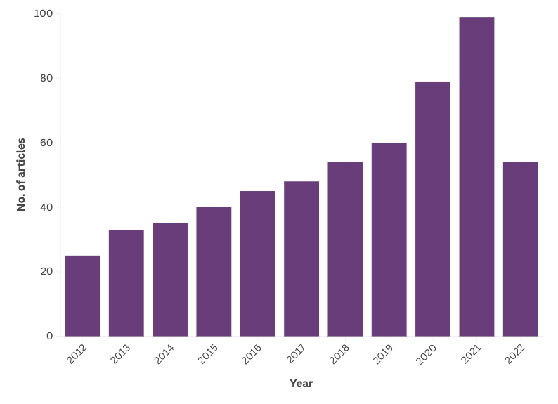
Supplemental results 2: Study setting of review articles

Study setting: Country income level | n
Low and middle income countries | 202
Upper middle income countries | 18
High income countries | 225
Small Island Developing States | 2
None (no country study setting or ‘global studies’ if more than one study setting) | 162

Supplemental results 3: Location of authors’ institutional affiliation

First author’s institutional affiliation location & identification as indigenous peoples | n
Global South | 102
Global North | 467
Indigenous peoples | 5
Last author’s institutional affiliation location | N
Global South | 101
Global North | 432
Indigenous peoples | 8

Supplemental results 4: First and last author pairs’ institutional affiliation

 | First – Last author pairs’ institutional affiliation location
Study setting | Global North - Global North | Global North - Global South | Global South - Global South | Global North (Single author) | Global South  (Single author)
LMIC* | 50 | 95 | 28 | 20 | 9
UMIC* | 5 | 4 | 6 | 2 | 1
HIC* | 179 | 23 | 0 | 23 | 0
SIDS* | 1 | 0 | 1 | 0 | 0
LMIC: Low and middle-income countries; UMIC: Upper middle-income countries; HIC: High income countries; SIDS* Small Island Developing States

Supplemental results 5: Research areas of review articles

Domain (thematic) research area | n
Agriculture & environment | 81
Food systems (pre- and post-farmgate) | 58
Food security | 10
Nutrition | 37
Global public health | 367
Other | 47

Supplemental results 6: Evidence type of review articles

Evidence type | n
Empirical research (primary data) | 264
Empirical research (secondary data) | 66
Evidence synthesis or review | 74
Working paper or pre-print | 8
Tool or guidance document | 38
Commentary or perspective | 167
Grey literature | 10

Supplemental results 7

Methods used by articles | n
Quantitative | 59
Qualitative | 173
Mixed-methods | 96
Theoretical/conceptual/methodological/framework | 156
Synthesis | 75
Historical analysis | 6
Not applicable | 53

Supplemental results 8: Study population described in review articles

Study population/group | n
Agricultural workers | 48
Clinical patient group | 18
Indigenous communities | 60
Infant, children and/or adolescents | 18
Refugee or migrant populations | 8
Racial, ethnic, or religious minoritized group | 41
Women and gender-diverse | 29
Deprived population | 45
Well-resourced populations | 2
Other | 35
Did not address specific population | 315

Supplemental results 9: Disciplines represented across review articles

Discipline | n
Public Health (global health, clinical) | 397
Development studies and Economics | 67
Environmental Science and Ecology | 96
Agricultural Sciences (Agriculture, Aquaculture and Livestock) | 81
Nutrition and dietetics | 49

Supplemental results 10: Expanded list of (in)equitable research practices

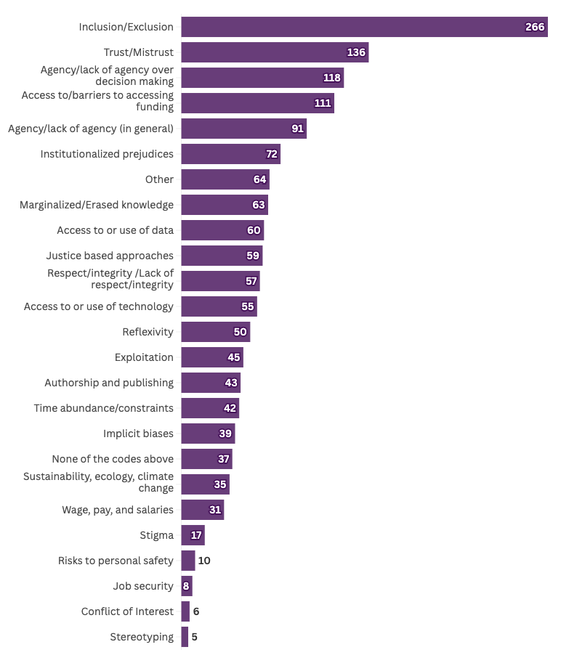

Supplemental results 11: Target audience for review articles included and solution types offered

Codes | None (descriptive, problem-oriented) | Wish list recommendations | Recommendations (solutions-oriented)
Individual level: Researchers | 51 | 125 | 107
Group level:  Research groups | 23 | 77 | 76
Regional level:  Researchers in global south | 4 | 13 | 13
Regional level:  Researchers in global north | 6 | 14 | 16
Inter-regional: global north x south | 10 | 30 | 17
Institutional (academic)-Individual researcher interaction | 12 | 32 | 28
Governmental Institution-Individual interaction | 26 | 43 | 23
Institutional level: Higher education institutions only | 4 | 14 | 16
Institutional level: Donors | 13 | 41 | 21
Ethical Review Boards | 4 | 7 | 3

Supplemental Statement 1: Reflexivity Statement

Researcher positionality shapes every stage of the research process—from the questions we ask to how we design, conduct, and interpret our work. In the interest of transparency, we offer the following reflection on our team’s collective positionality.

Our co-author team brings diverse expertise across global health, nutrition epidemiology, environmental sustainability, agriculture, food systems, and sociology. We represent a range of lived experiences and identities, including cisgender men and women, gender non-conforming/trans persons, sexually diverse and heterosexual individuals, and racialized persons. Some team members have personal experiences with resource insecurity, (im)migration, sexism, racism, natural disasters and living in conflict zones. We live and work across the United States, Colombia, the United Kingdom, and South Africa. Some team members have prior experience living and working in LMIC for several years. Our lead coordinators identify as “double agents in global health”—born and raised in the Global South, trained and working in the Global North. Our team spans various educational and career stages, from undergraduate and graduate students to early-career researchers and faculty. Despite our differences, we share a commitment to ethical, equitable, and interdisciplinary research in Agriculture, Nutrition, and Health (ANH). We approach our research with an awareness of privilege and power, a commitment to challenging these structures, and an intent to minimize harm. We hold collective ownership of this review’s data, and team members will lead different aspects of the knowledge mobilization process—within and beyond academia—to advance research equity.

