Supplementary materials:
Figures

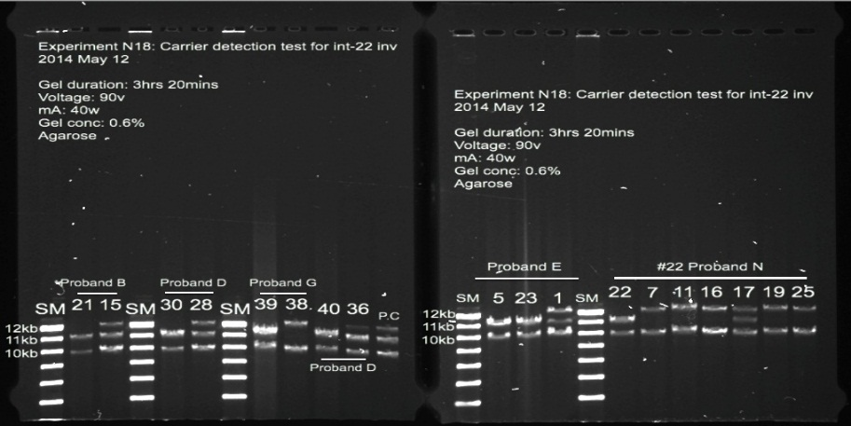
Fig S1. Long-Range PCR gel image for intron-22 inversion analysis. PCR bands for each family were separated on an agarose gel using size markers, labeled as “SM”. Each affected family is represented by probands labeled “B, D, G, E, N,” etc. Number on each lanes indicate patient ID. To confirm the intron-22 inversion results, PCR products from both carrier and non-carrier female relatives were run in parallel with patient samples on an agarose gel. These data were used exclusively for validation purposes and are not further presented in this study. In each group, the first lane corresponds to the patient sample, and the second lane represents the proband’s female relative. In Proband B’s family, Sample No. 21 showed intron-22 inversion, identified by the presence of 10 kb and 11 kb bands. Sample No. 15, his mother, displayed three bands (10 kb, 11 kb, and 12 kb), which was consistent with a heterozygous carrier pattern.

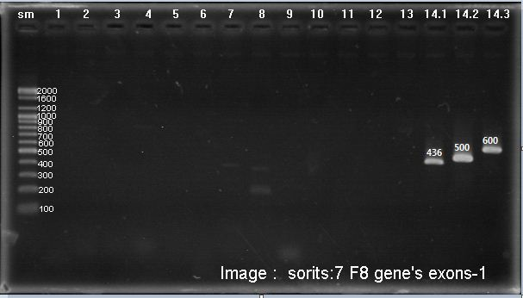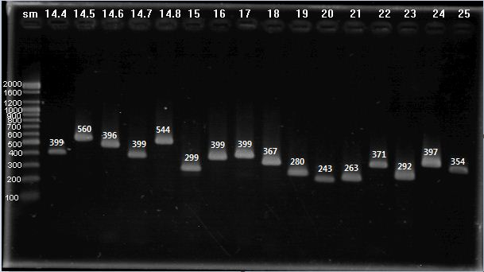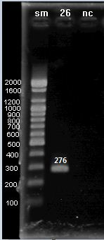
Fig S2. Gel electrophoresis image showing a large exon deletion in the F8. PCR amplification failed to amplify bands corresponding to exons 1–13, indicating a deletion spanning these exons. The patient had severe HA and a documented inhibitor.

Fig S3. Sequence chromatogram of point mutations. The mutated position is outlined with a red. a) c.902G>A identified in related patients (HA-009 and HA-033 are uncle and nephew). b) c.2003T>C mutation identified in maternal side first cousins (HA-053 and HA-054).

Fig S4. Sequence chromatogram of patient with moderate HA (HA-061). The reference sequence is displayed at the top in blue letter, representing the normal F8 sequence. The bottom rows, shown in black letters, represent the sequence alignment of the patient’s sample. The site of alteration is outlined in red, and a black arrow indicates the exact position of the inserted nucleotide of c.3637_3638insA.

Fig S5. Missense mutation c.6544C>T(p.Arg2182Cys) in exon 23 of F8. The reference sequence is displayed at the top in blue, representing the normal sequence. Bottom row with light blue color represents patient’s sample. The Black arrows are pointing at changed nucleotides.

Fig S6. Comparison of the novel c.1010-106delA variant in patient HA-095 and unaffected individuals. Altered position is outlined with red. The Adenine at the position c.1010-106 in the intron 7 was absent in patient HA-095, who was diagnosed with mild Hemophilia A. This deletion was not found in six healthy control individuals.

Fig S7. Summary of Mutation taster for novel c.2240Del mutation. This variant was not found in either ExAC and 1000 genome project. Pathogenic impact of this variant is explained by Nonsense mediated decay of F8 transcript.

