Supplementary Information

Supplementary Results

Gene Ontology Analysis of Meta-GWAS MAGMA genes
In the set of genes prioritized by MAGMA from the Meta-GWAS results, notable high gene ratios were mammary gland development (MY; GO_BP:0030879), regulation of hormone levels (MY; GO_BP:0010817), lactation (MY; GO_BP:0007595), prolactin and PI3K-AKT signalling pathway (MY; KEGG:04917; KEGG:04151), response to growth hormone and growth hormone receptor GHR signalling (MY, PC; GO_BP:0060416; WP:WP2891), EPH-Ephrin signalling, which is involved in mammary gland branching morphogenesis^{1,2} (PY, PC; REAC:R-BTA-2682334), EPO receptor signalling (MY, PC; WP:WP996), and erythrocyte (MY; GO_BP:0030218) and myeloid cell differentiation (MY, PC; GO_BP:0030099), positive regulation of cytokine production (MY, PC; GO_BP:0001819), somatodendritic compartment (PC; GO_CC:0036477), neuron apoptotic process (PC; GO_BP:0051402), and neurotransmitter receptor regulator activity (MY, PY, FY, FC; GO_MF:0099602) (Supp Table 8 and Supp Figs. 3-11).

Production QTL on chromosome 5 - LALBA
Overlapping QTL regions for MY, FC, and PC were detected between 30Mb and 32Mb on chromosome 5 near LALBA, which encodes alpha lactalbumin, the second most abundant whey protein in bovine milk³ (Supp Fig. 16 Supp Table 17). This protein plays a key role in lactose synthesis and calcium ion binding⁴. Interestingly, LALBA-deficient mice were fertile but produced much less milk that was higher in fat and protein and lacked alpha-lactalbumin as well as lactose⁵. The most significant QTL region for MY, spanned 30,899,727 to 31,204,916 bp. Top variants (p = 1.1 × 10⁻²⁹) were intergenic between RF00001 and LALBA, but several variants near the QTL peak were within LALBA, including a stop-gained variant at 31,184,185 bp (p = 1.8 × 10⁻²⁸) and a 3’UTR variant at 31,185,948 bp (p = 3.4 × 10⁻²⁸). The stop-gained variant is a strong putative causal variant as it occurs within the first exon (<100bp). The allele associated with increased MY was also associated with reduced FC and PC, segregating at low to moderate frequency in Holstein populations, and close to zero allele frequency in Jersey (Supp Fig. 16b). Several variants in the QTL region were associated with expression of LALBA in liver tissue in cattle GTEx. A large meta-GWAS study⁶ in dairy cattle also reported a QTL for PC and FC close to the LALBA (where the most significant variant was chr5:31,185,948 for FC and PC).

QTL in different populations and overlap
There was overlap of QTL regions across dairy breeds and breed groups (Supp Table 22, Supp Results). While allele effect direction was generally consistent across breed groups (Range 57.2 to 85.3%), few significant loci were shared between groups (Range 4.0 to 53.8%). A higher proportion of significant loci were shared if a QTL region was detected in a smaller breed group overlapped with a large breed group (e.g., Supp Table 22, Jersey and Holstein), indicating a substantial influence of sample size. More closely related breeds had more similar QTL effects: effects of QTL shared by pairs of breeds with low F_{st} more often had the same sign than did pairs of breeds with high F_{st} (%Dir, 0.58 R²) (Supp Table 23). However, we observed no relationship between F_{st} and percentage QTL shared (%Shared) or percentage of QTL significant (%Sign) across breed groups. Only 338 variants spread across 10 QTL regions were significant in all breed groups (Supp Table 22). Consistent trends were not observed across breeds of the LD spectrum between QTL detected with the Meta-GWAS including and excluding the Holstein breed (Supp Table 24).

QTL regions detected in multiple breeds
We found 338 variants that were significant in the same trait and in all five breed groups (HOL, JER, RDC, BROWN,DUAL, Supp Table 22). A missense variant located in the GHR gene at 31,888,449 bp on chromosome 20⁷ was detected for all breed groups for MY, FP and PP. Six variants associated with both FP and/or PP in all breeds groups were located with a previously located CNV region on chromosome 3 (variants between 15,464,742 and 15,495,684 bp)⁸. There were five variants detected in QTL regions associated with PY in all breed groups, between 85,438,110 and 85,454,960 bp on chromosome 6 (a well known QTL region encompassing several casein genes that play a key role in milk production⁹, including variants located in the CSN2 gene. While there were variants on chromosome 11 detected in QTL regions for all breed groups both for FP and PP, these variants did not overlap; variants associated with FP were located between 103,245,794 and 103,277,147 bp (encompassing ENSBTAG00000014678 and GLT6D1), whereas variants associated with PP were located between 104,173,054 and 104,184,960 bp (encompassing the ABO gene, and all variants located within the same CNV^{10,11}. The remaining variants detected for all breed groups were located on chromosomes 10 (between 46,384,772 and 46,544,085 bp; associated with PP) and 27 (between 36,466,414 and 36,537,488 bp). This chromosome 27 region is a major candidate gene region for milk fat indicating GPAT4¹² (36523101-36539737 bp). Hence, most QTL regions were not detected in all breed groups. For example, on chromosome 2, a QTL region detected for FP in JER between 122,157,740 and 122,398,415 bp was not significant in any other breed, including Holstein. The most significant variant in this QTL region was a downstream variant of ENSBTAG00000058569, located at 122,389,990 bp. There were also various QTL regions that were shared among three of the five breed groups. For example, a QTL region detected for FP in DUAL, located between 93,515,265 and 93,525,079 bp on chromosome 5, was significant in all breeds except JER. The most significant variant for this QTL region in DUAL was within an intron of MGST1 located at 93,516,066 bp¹³.

QTL regions overlap with brain gene expression and protein-protein interaction
Checking overlap between QTL regions and genes known to be associated with behaviour heat scores, resulted in 46 trait specific QTL region-gene combinations, involving 29 unique genes (Supp Table 18). Checking overlap between QTL regions and direct comparison of bovine gene expression levels on d0 (start oestrous cycle) and d12 (midcycle) revealed differential expression of a limited number (n=13) of (RefSeq) genes in the pituitary, of which none were overlapping with QTL regions. Checking overlap between QTL regions and prioritized candidate gene based on protein-protein interactions, gene expression, and text-mining, resulted in 28 trait specific QTL region-gene combinations. Of which 5 were found in 2 tissue types while the remainder was only found in 1 tissue. This involved 20 unique genes.
Taken these results together 48 unique genes relevant to fertility traits were located in or close to (-/+10k) the QTL region. Only SPTBN4 was found in both the gene set association with heat scores and the candidate gene set.

Ancestral alleles
Each allele of the significant QTL variants was classified as either ancestral or derived⁷³ to evaluate trends in allele frequency and effect direction for derived versus ancestral alleles. In production yield traits (MY, PY, FY) the median derived allele showed a positive (favourable) trait effect (ancestral effect negative), while for milk content traits (PP, FP) we observed the opposite trend (Supp Fig. 17). This was expected because in evolutionary terms concentrated but relatively low milk yield is an optimal survival scenario for both cow and calf, while the high milk yields in modern dairy cattle place considerable metabolic stress on cows^{14,15}. Similarly, for all fertility traits the ancestral alleles were always the positive effect (Supp Fig. 18). We found that the ancestral allele frequency was consistently higher for both production and fertility QTL (Supp Figs. 19 and 20).

1. Vaught, D., Chen, J. & Brantley-Sieders, D. M. Regulation of mammary gland branching morphogenesis by EphA2 receptor tyrosine kinase. Mol. Biol. Cell 20, 2572–2581 (2009).
2. Miao, H. & Wang, B. Eph/ephrin signaling in epithelial development and homeostasis. Int. J. Biochem. Cell Biol. 41, 762–770 (2009).
3. Layman, D. K., Lönnerdal, B. & Fernstrom, J. D. Applications for α-lactalbumin in human nutrition. Nutr. Rev. 76, 444–460 (2018).
4. Permyakov, E. A. & Berliner, L. J. α-Lactalbumin: structure and function. FEBS Lett. 473, 269–274 (2000).
5. Stinnakre, M. G., Vilotte, J. L., Soulier, S. & Mercier, J. C. Creation and phenotypic analysis of alpha-lactalbumin-deficient mice. Proc. Natl. Acad. Sci. 91, 6544–6548 (1994).
6. Van den Berg, I. et al. Meta-analysis for milk fat and protein percentage using imputed sequence variant genotypes in 94,321 cattle from eight cattle breeds. Genet. Sel. Evol. 51, 37 (2020).
7. Blott, S. et al. Molecular dissection of a quantitative trait locus: a phenylalanine-to-tyrosine substitution in the transmembrane domain of the bovine growth hormone receptor is associated with a major effect on milk yield and composition. Genetics 163, 253–266 (2003).
8. Karimi, K., Esmailizadeh, A., Wu, D. & Gondro, C. Mapping of genome-wide copy number variations in the Iranian indigenous cattle using a dense SNP data set. Anim. Prod. Sci. 58, 1192–1200 (2018).
9. Boettcher, P. et al. Effects of casein haplotypes on milk production traits in Italian Holstein and Brown Swiss cattle. J. Dairy Sci. 87, 4311–4317 (2004).
10. Hou, Y. et al. Genomic characteristics of cattle copy number variations. BMC Genomics 12, 127 (2011).
11. Boussaha, M. et al. Genome-wide study of structural variants in bovine Holstein, Montbéliarde and Normande dairy breeds. PloS One 10, e0135931 (2015).
12. Wang, X. et al. Identification and dissection of four major QTL affecting milk fat content in the German Holstein-Friesian population. PloS One 7, e40711 (2012).
13. Littlejohn, M. D. et al. Sequence-based association analysis reveals an MGST1 eQTL with pleiotropic effects on bovine milk composition. Sci. Rep. 6, 25376 (2016).
14. Cole, J. B., Makanjuola, B. O., Rochus, C. M., Van Staaveren, N. & Baes, C. The effects of breeding and selection on lactation in dairy cattle. Anim. Front. 13, 62–70 (2023).
15. Gross, J. J. Dairy cow physiology and production limits. Anim. Front. Rev. Mag. Anim. Agric. 13, 44 (2023).

Supplementary Figures
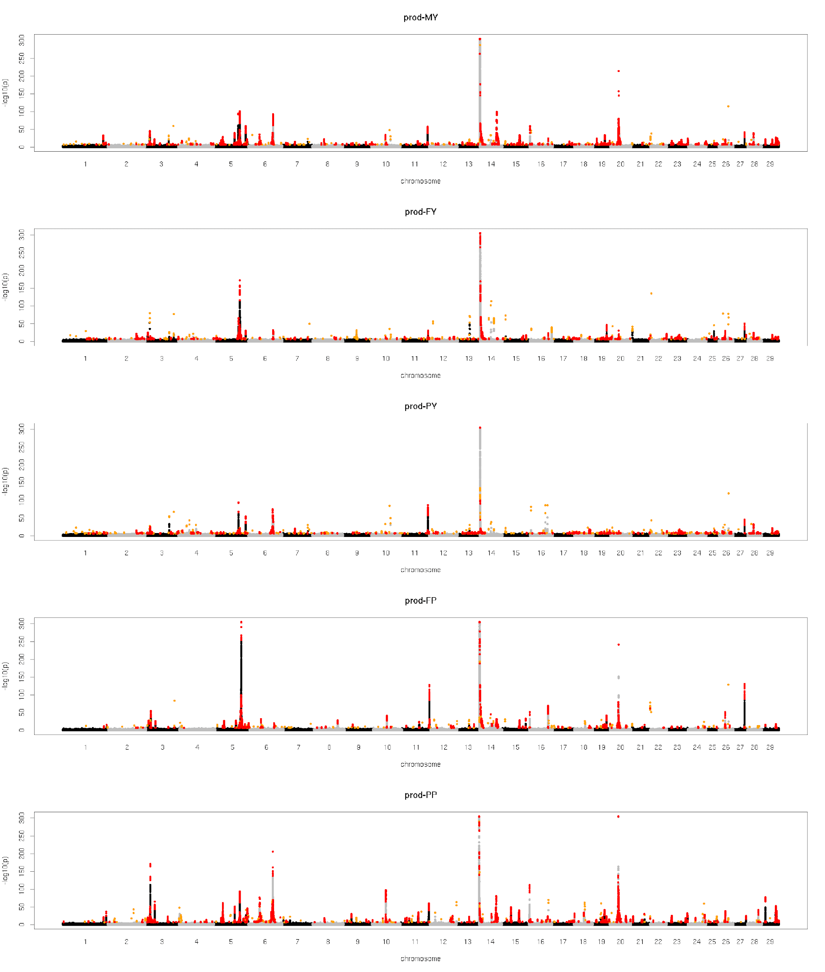
Supp Figure 1: Manhattan plot multi breed meta-GWAS for production traits. Orange = non-validated QTL regions, red = validated QTL regions.

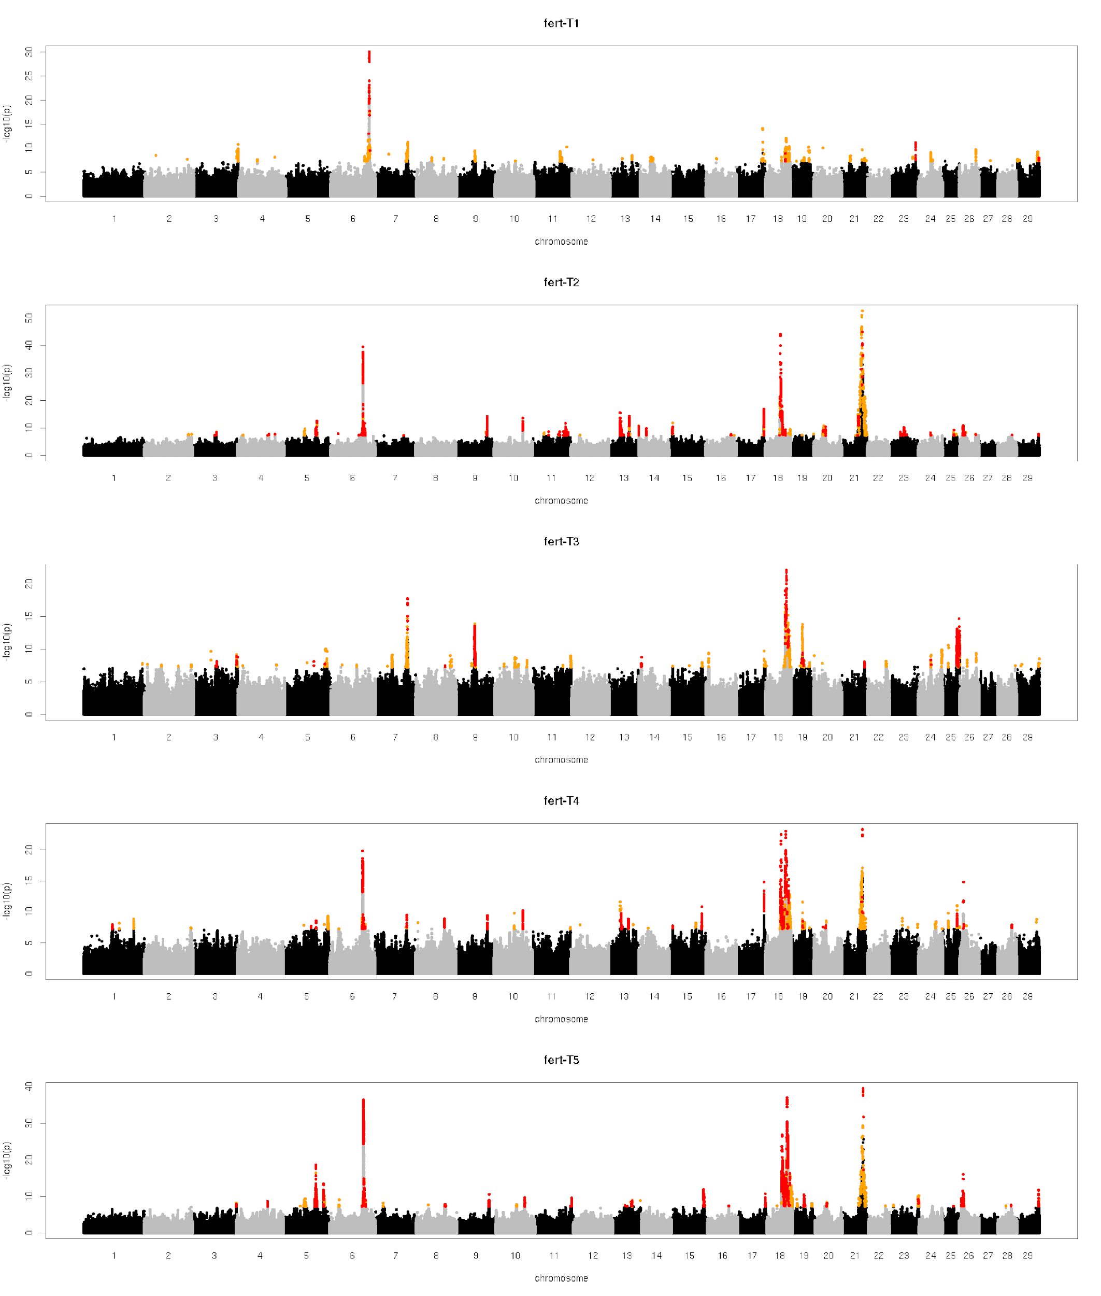
Supp Figure 2. Manhattan plot multi-breed meta-GWAS for fertility traits. Orange = non-validated QTL regions, red = validated QTL regions.

Supp Figure 3. Gene Ontology overrepresentation analysis for Milk Yield (MY)

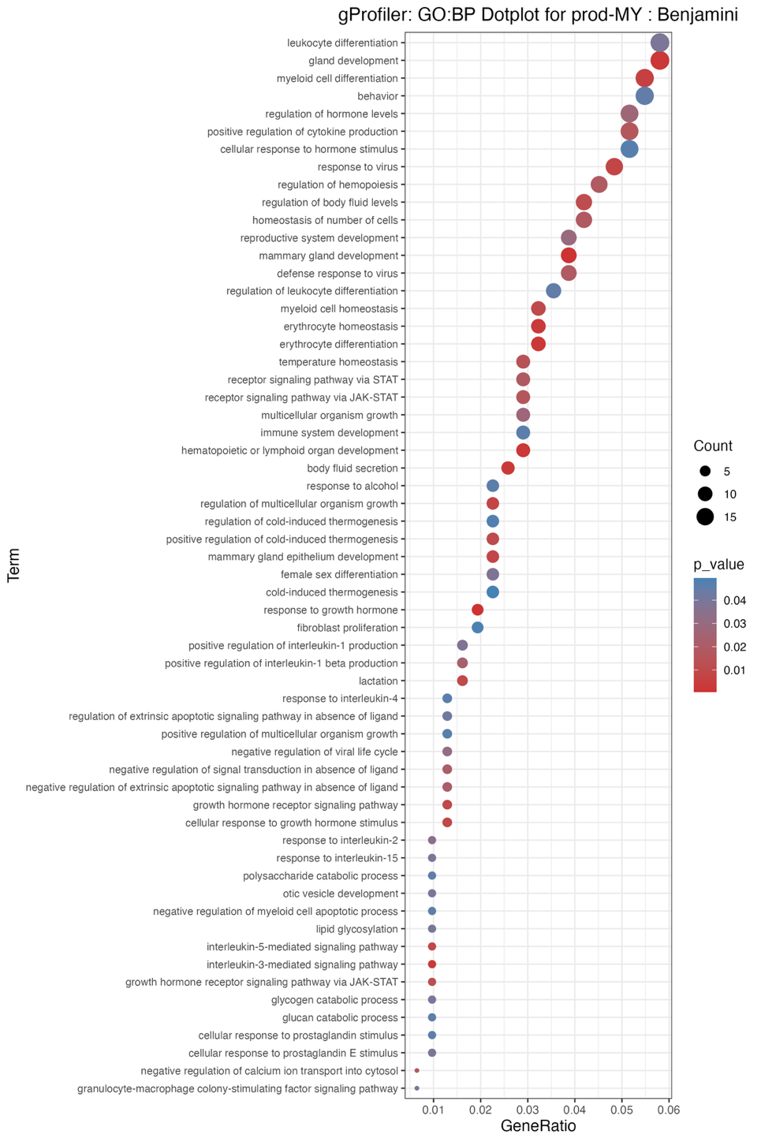
Supp Figure 3.1. Gene ratio plot for GO: Biological Process associated with MY.
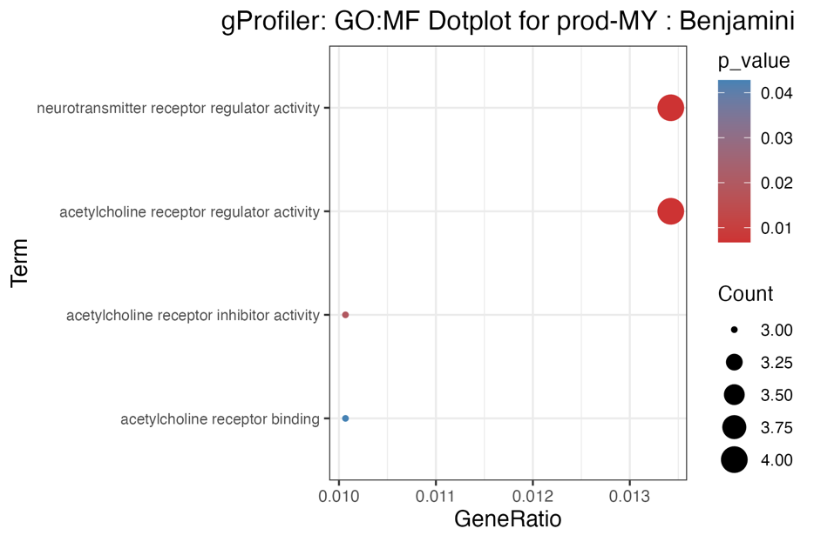
Supp Figure 3.2. Gene ratio plot for GO: Molecular Functions associated with MY.

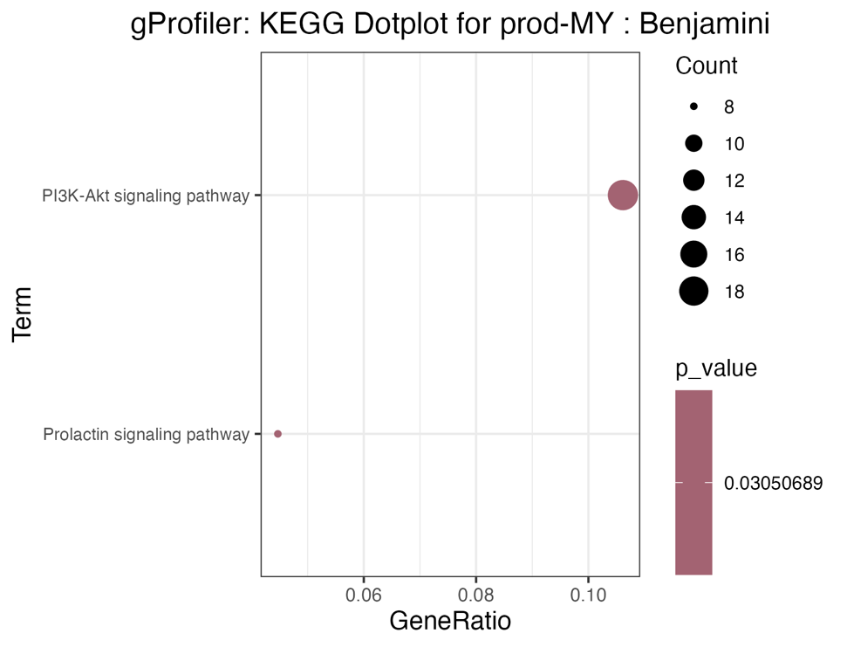
Supp Figure 3.3. Gene ratio plot for KEGG Pathways associated with MY.

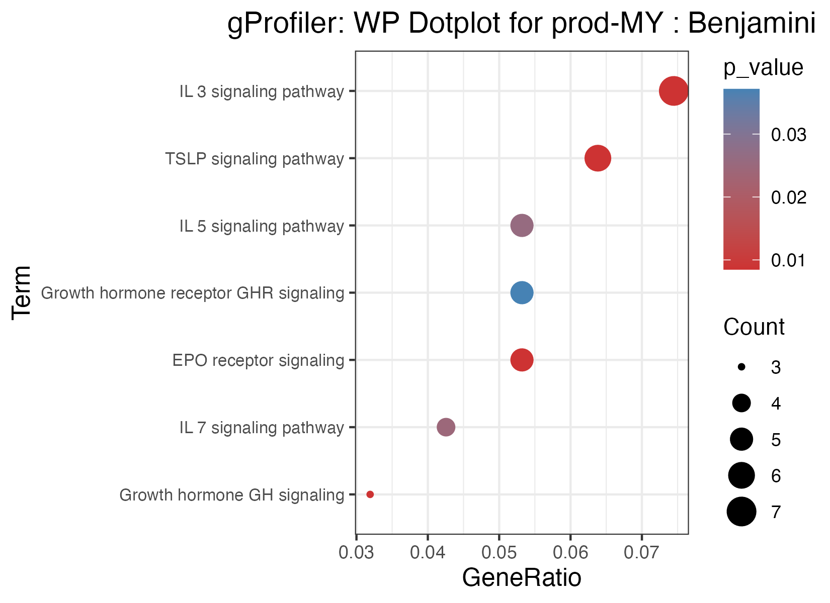
Supp Figure 3.4. Gene ratio plot for WikiPathways associated with MY.

Supp Figures 4. Overrepresentation analysis for Protein Yield (PY)

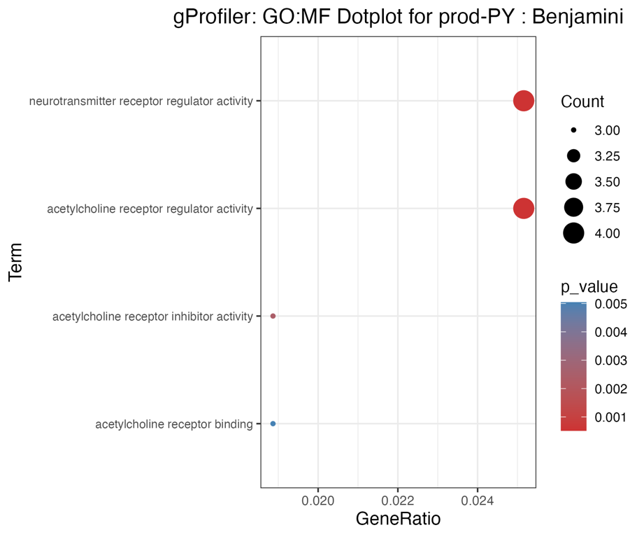
Supp Figure 4.1. Gene ratio plot for GO: Molecular Functions associated with PY.

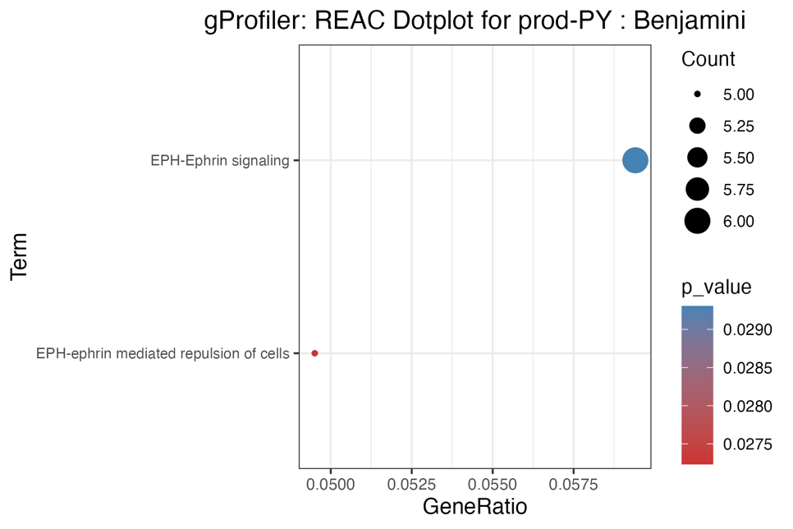
Supp Figure 4.2. Gene ratio plot for Reactome Pathways associated with PY.

Supp Figure 5. Overrepresentation analysis for Fat Yield (FY) Trait

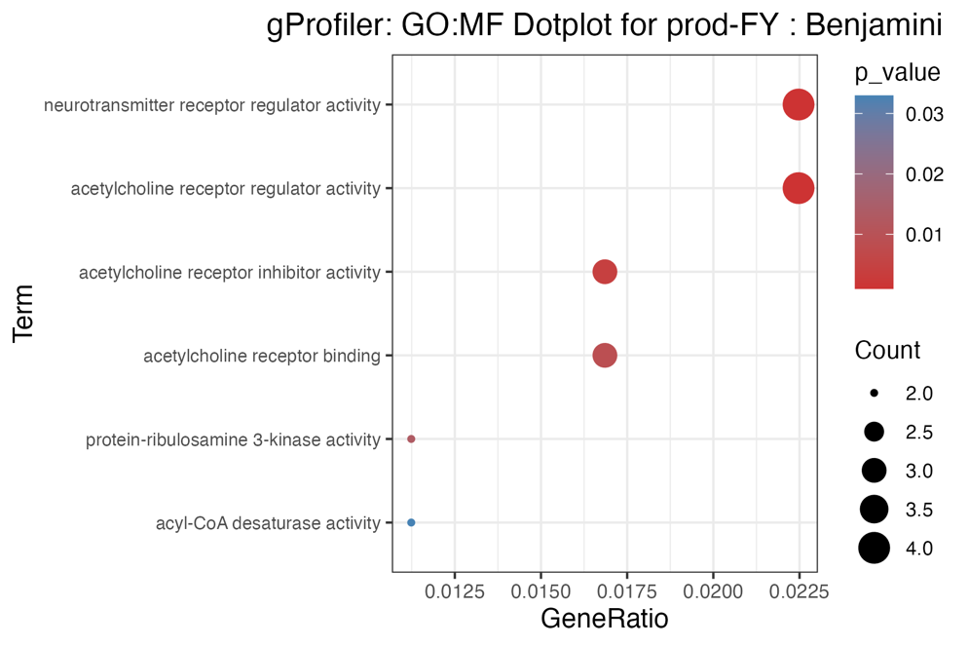
Supp Figure 5.1. Gene ratio plot for GO: Molecular Functions associated with FY.

Supp Figure 6. Overrepresentation analysis for Protein Content (PC)

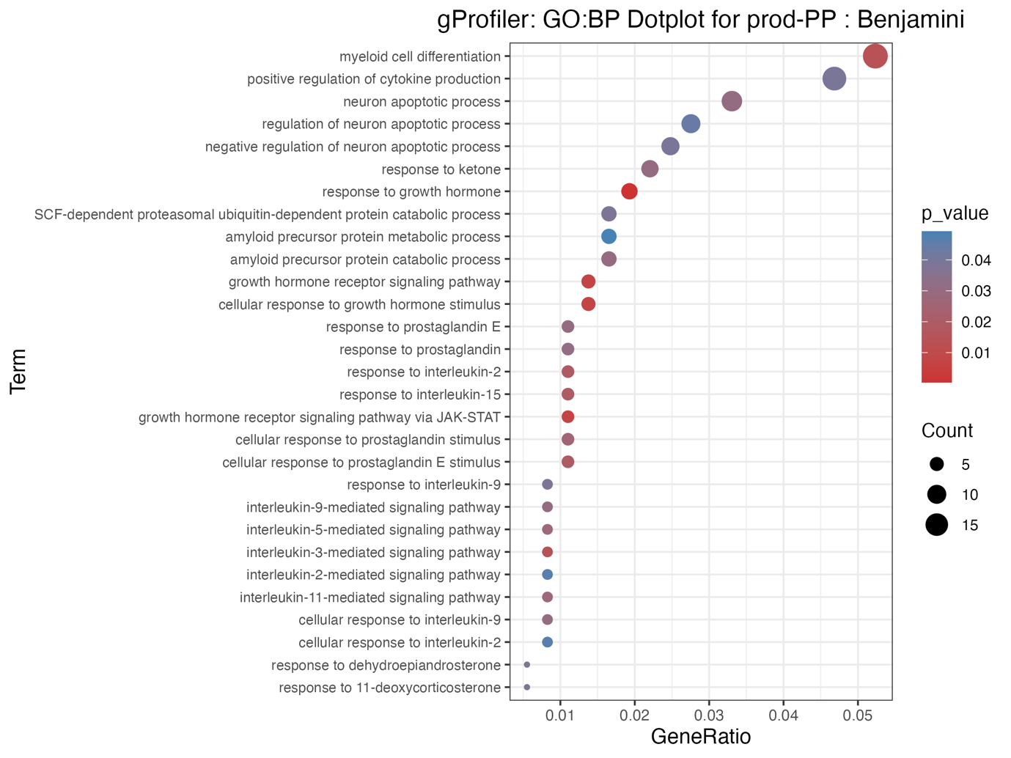
Supp Figure 6.1. Gene ratio plot for GO: Biological Processes associated with PC.

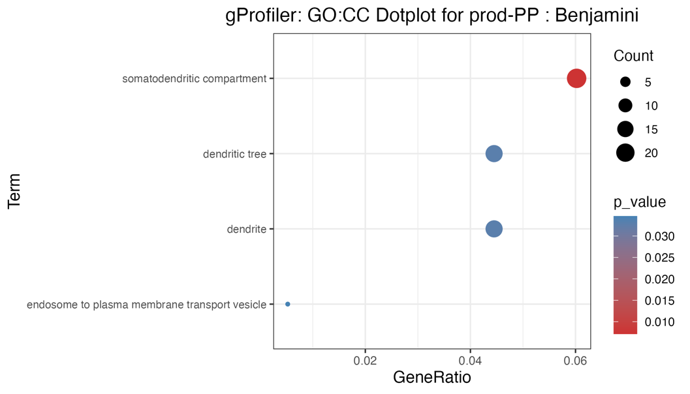
Supp Figure 6.2. Gene ratio plot for GO: Cellular Components associated with PC.

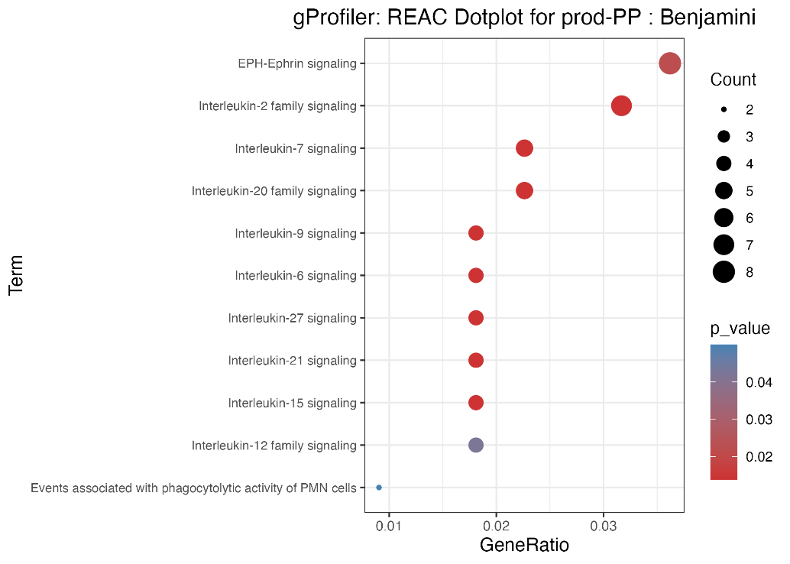
Supp Figure 6.3. Gene ratio plot for Reactome Pathways associated with PC.

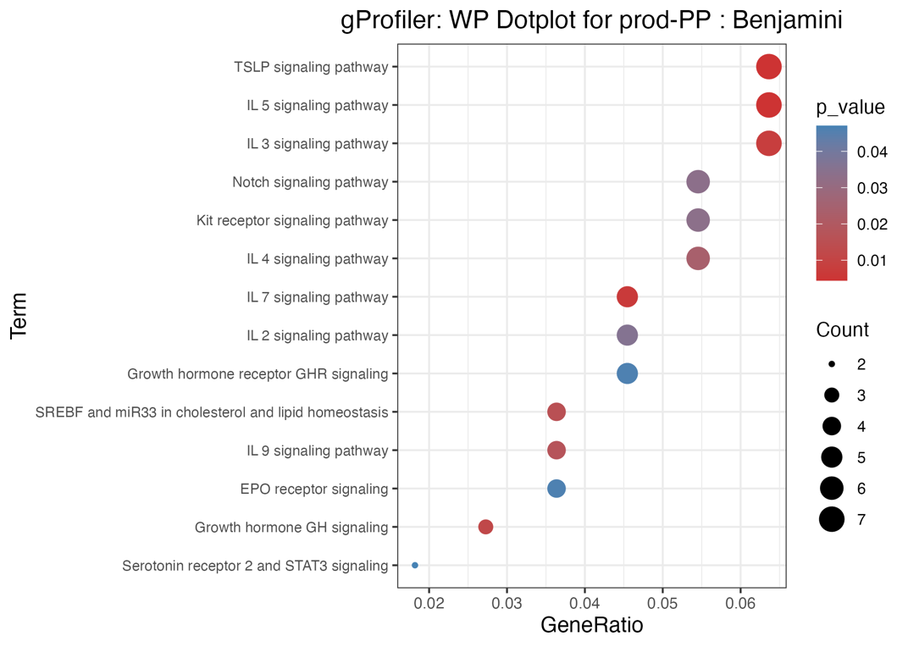
Supp Figure 6.4. Gene ratio plot for WikiPathways associated with PC.

Supp Figure 7. Overrepresentation analysis for Fat Content (FC) Trait
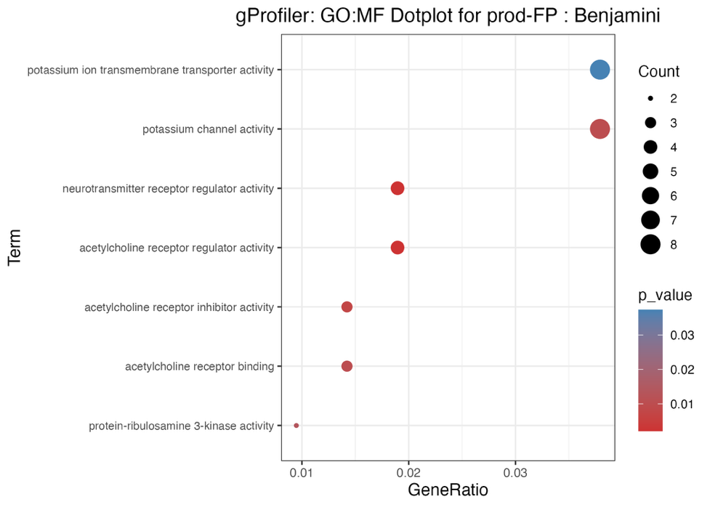
Supp Figure 7.1. Gene ratio plot for GO: Molecular Functions associated with FC.

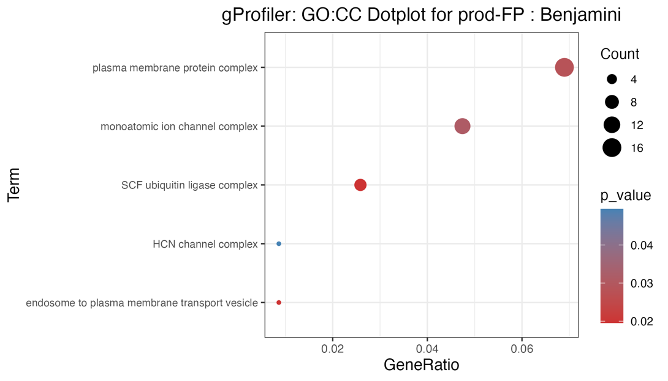
Supp Figure 7.2. Gene ratio plot for GO: Cellular Components Functions associated with FC.

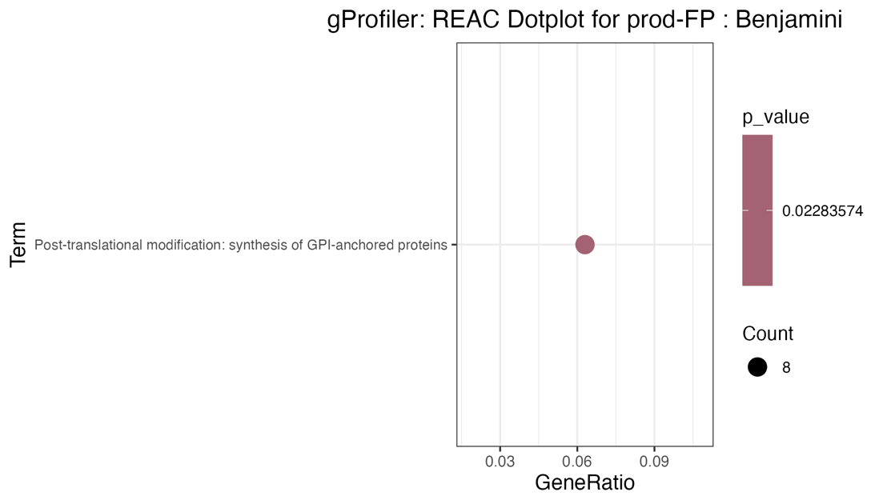
Supp Figure 7.3. Gene ratio plot for Reactome Pathways associated with FC.
Supp Figure 8. Overrepresentation analysis for Hfert

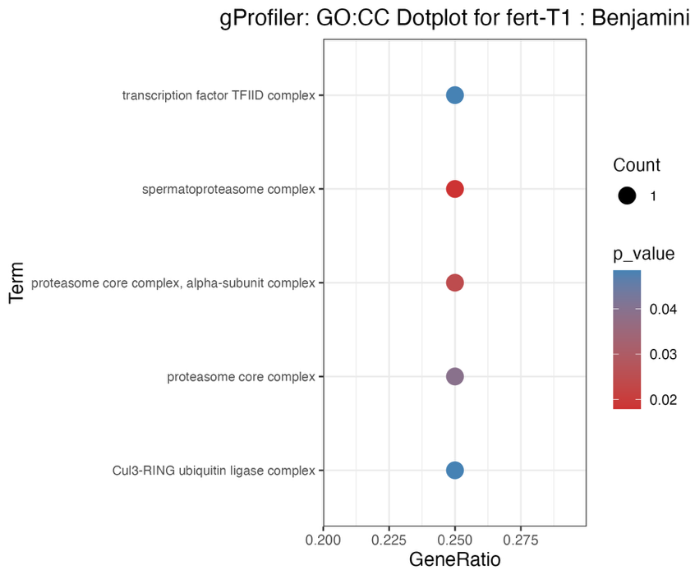
Supp Figure 8.1. Gene ratio plot for GO: Cellular Components associated with Hfert.

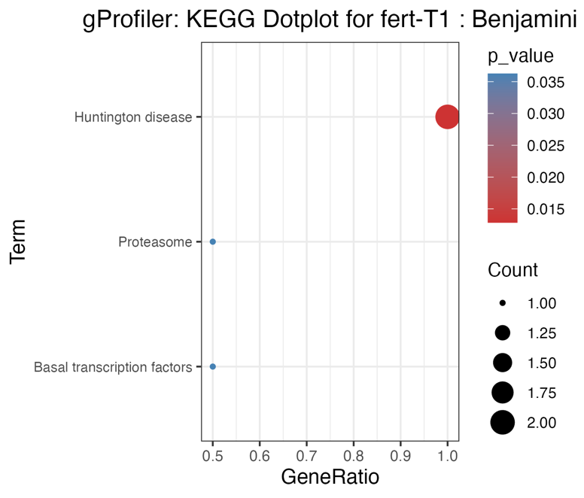
Supp Figure 8.2. Gene ratio plot for KEGG associated with Hfert.

Supp Figure 9. Overrepresentation analysis for CalvMate
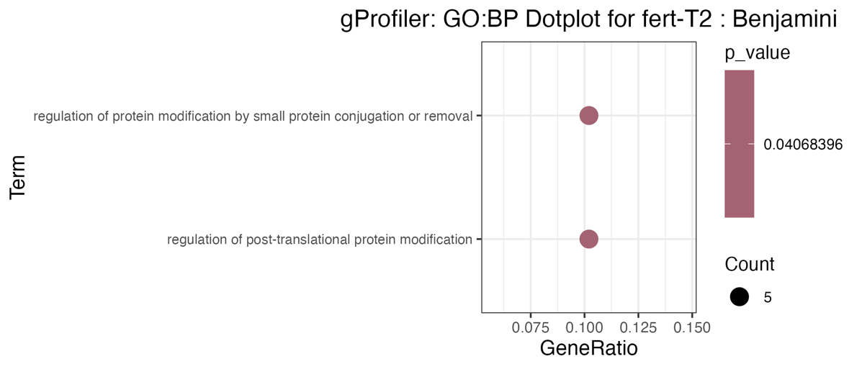
Supp Figure 9.1. Gene ratio plot for GO: Biological Processes associated with CalvMate.

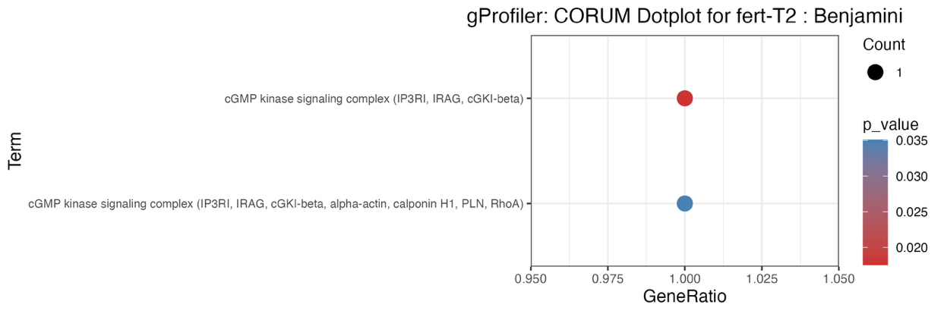
Supp Figure 9.2. Gene ratio plot for CORUM associated with CalvMate.

Supp Figure 10. Overrepresentation analysis for Int1stLast

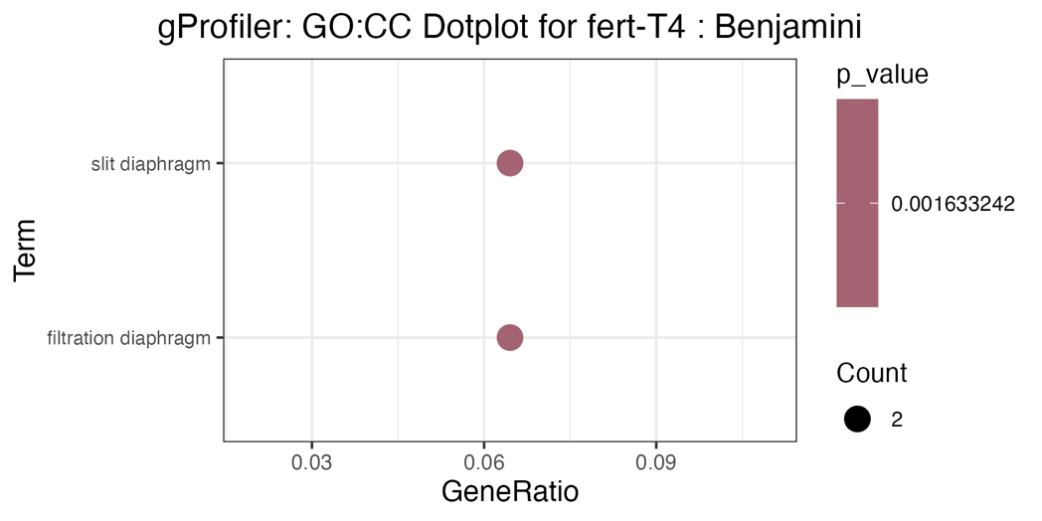
Supp Figure 10.1. Gene ratio plot for GO: Cellular Components associated with Int1stLast.

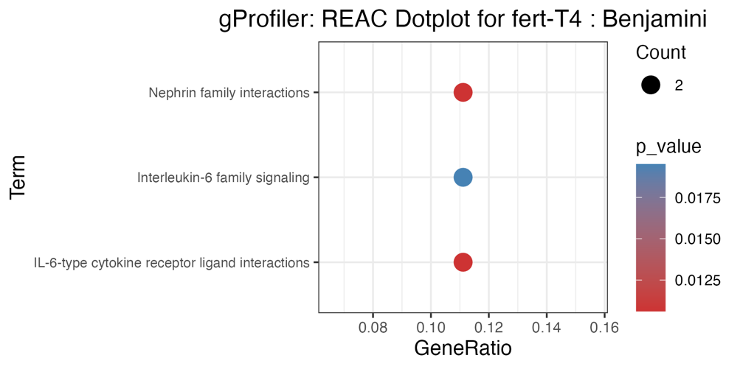
Supp Figure 10.2. Gene ratio plot for Reactome Pathways associated with Int1stLast.

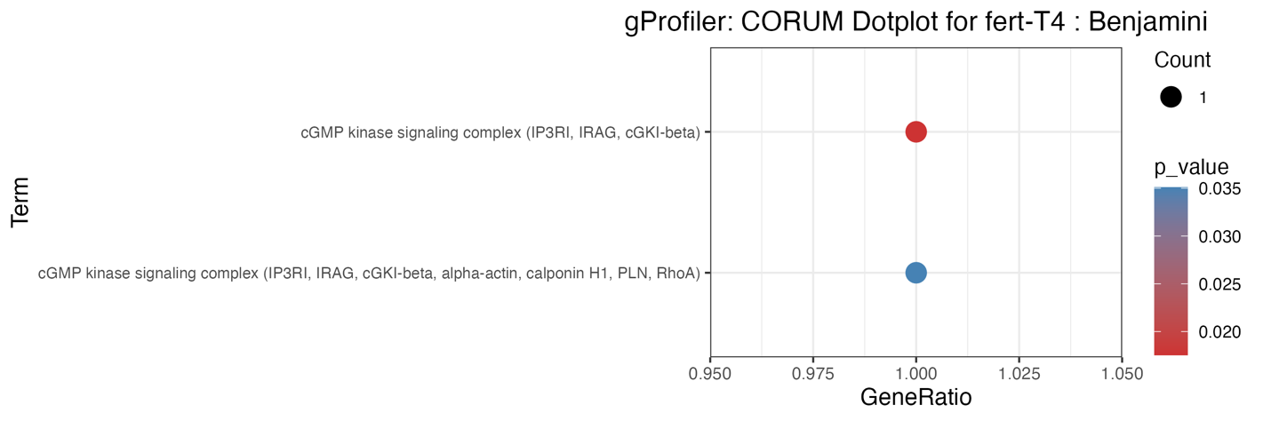
Supp Figure 10.3. Gene ratio plot for CORUM associated with int1stlast_T4.

Supp Figure 11. Overrepresentation analysis for (CalvInt) Trait

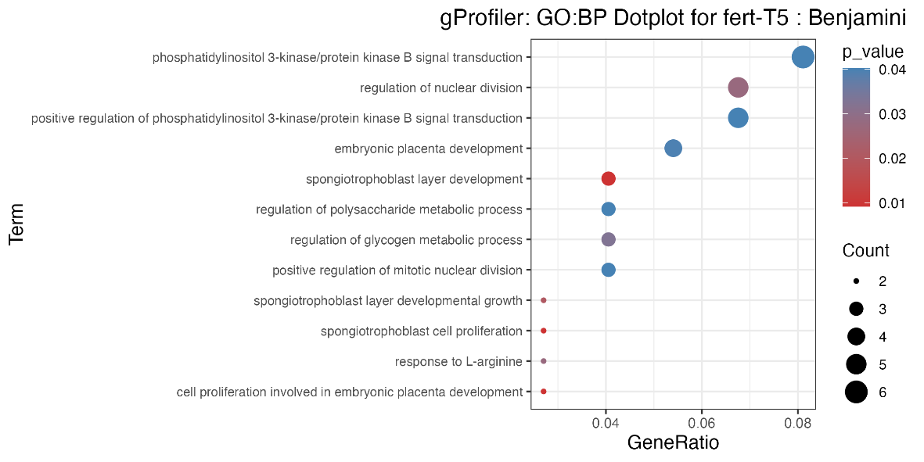
Supp Figure 11.1. Gene ratio plot for GO: Biological Processes associated with CalvInt.

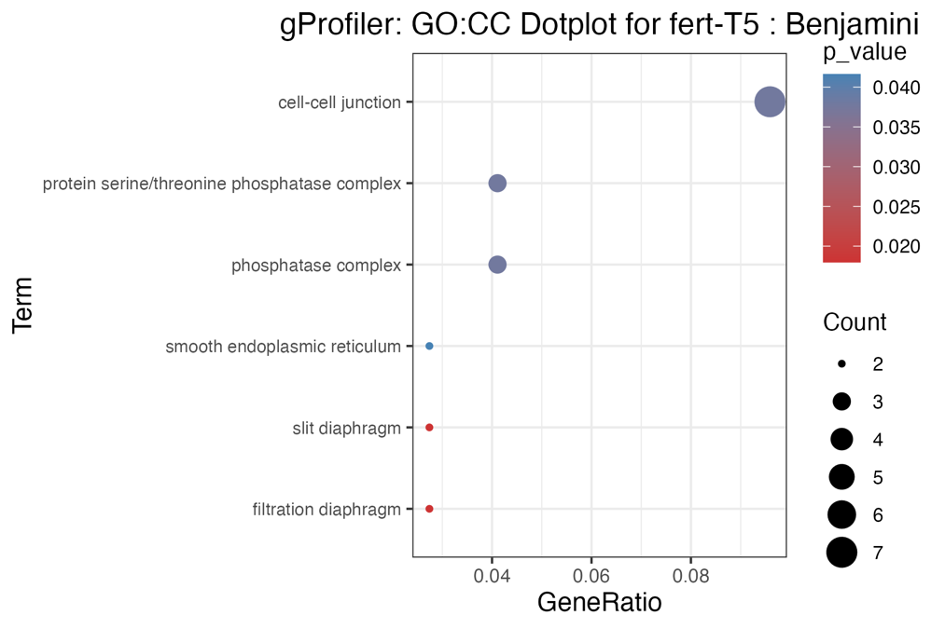
Supp Figure 11.2. Gene ratio plot for GO: Cellular Components associated with CalvInt.

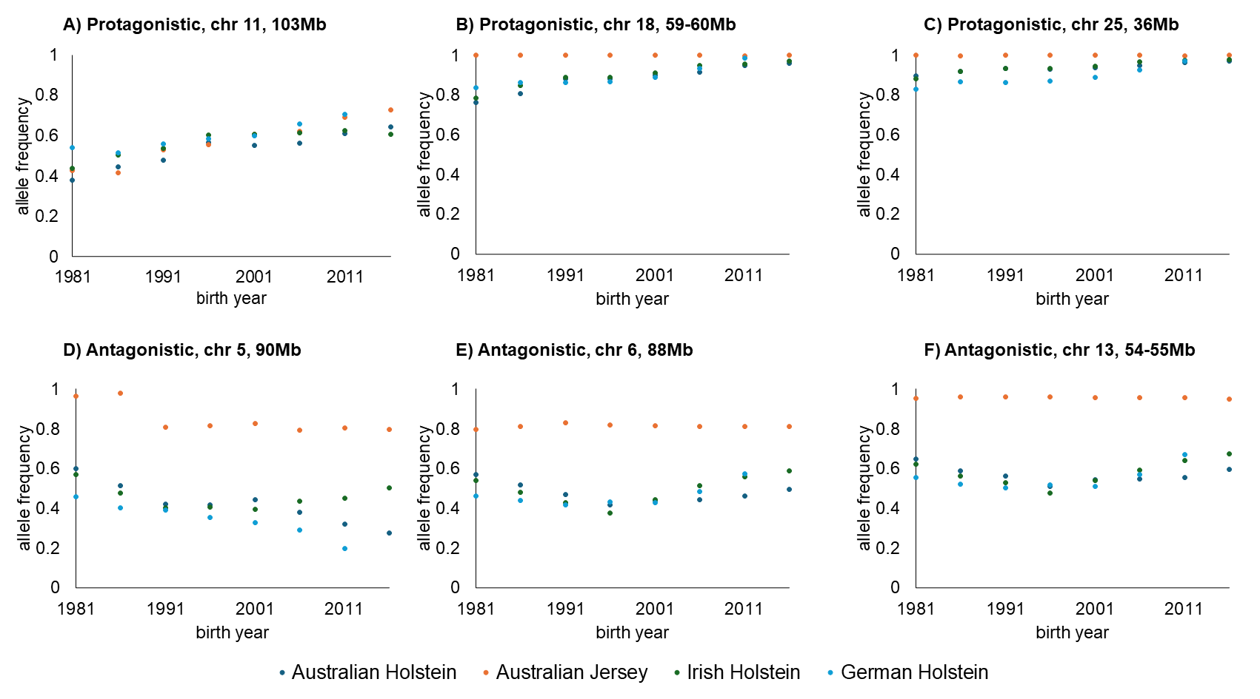
Supp Figure 12. Allele frequency shown for allele that improved fertility in synergistic and antagonistic QTL regions.

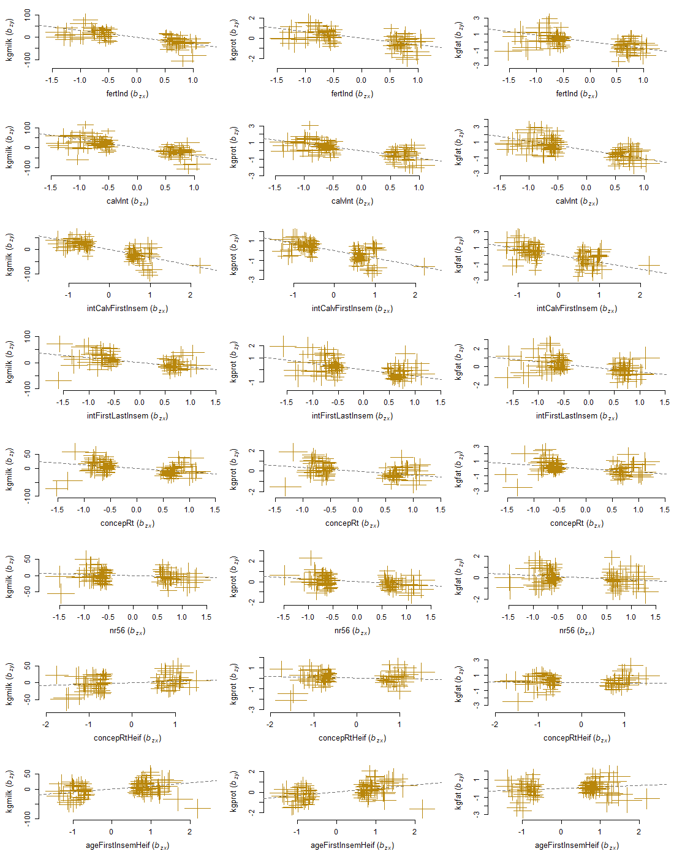
Supp Figure 13. Plots of effect sizes of all the genetic instruments from GWAS for milk production traits as intermediate traits and fertility traits as outcome traits. Error bars represent the standard error of the SNP effect. Dashed line represents the regression line.

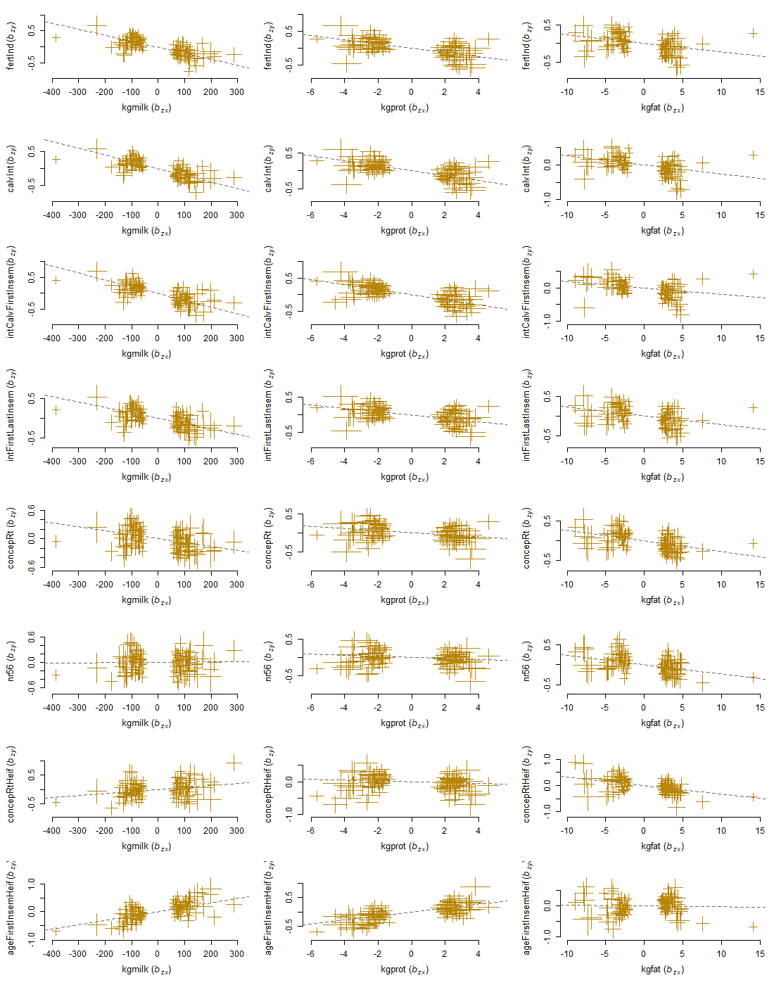
Supp Figure 14. Plots of effect sizes of all the genetic instruments from GWAS for fertility traits as intermediate traits and milk production traits as outcome traits. Error bars represent the standard error of the SNP effect. Dashed line represents the regression line.

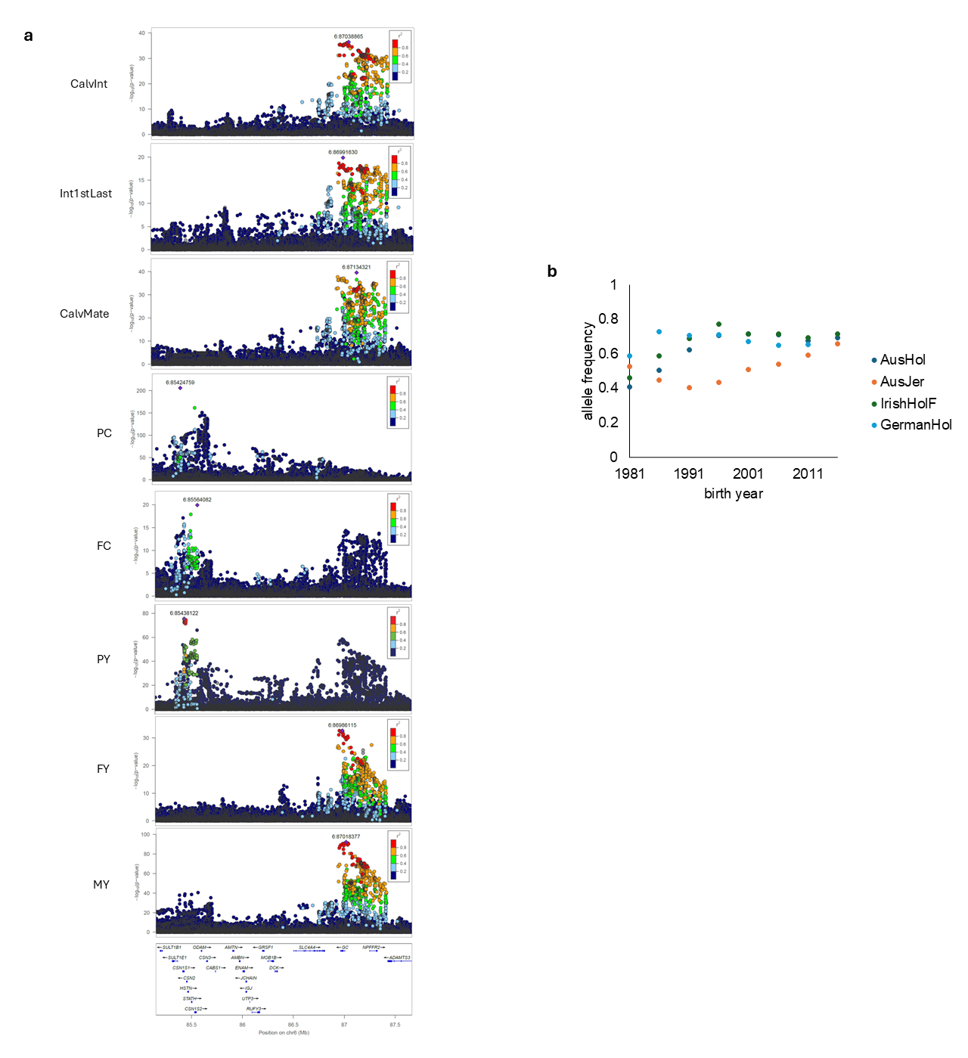
Supp Figure 15. QTL regions on chr 6 at 87Mb. a) LocusZoom plots and LD (r²) in top panels respectively, overlap with cattle GTEx and genes (bottom panel) in the region; b) allele frequencies across time for most significant variant in MY QTL at 87Mb (GC).

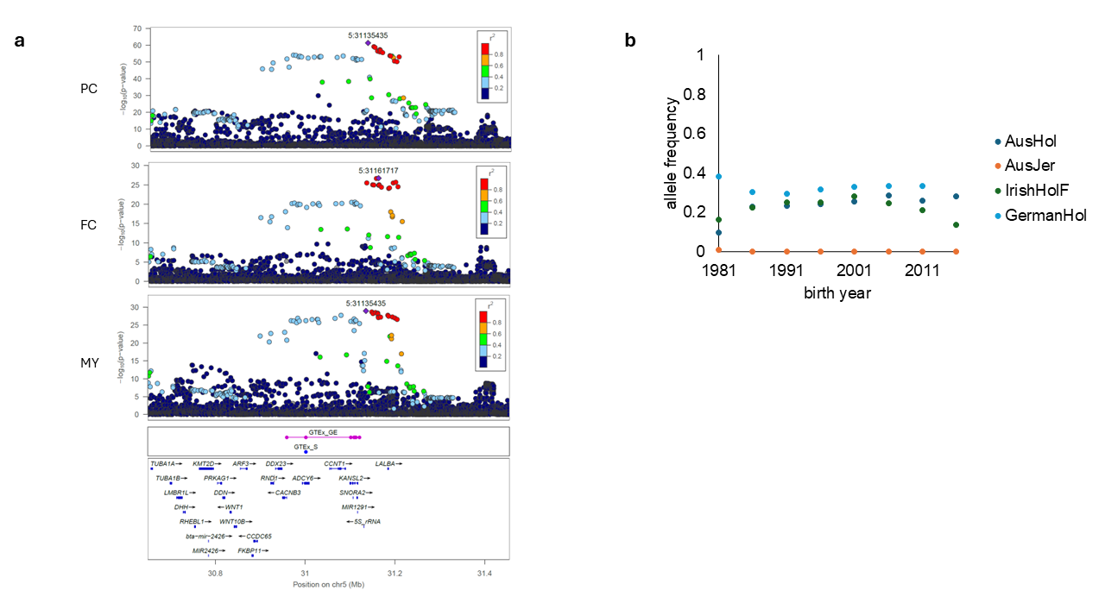
Supp Figure 16. QTL regions on chr 5. a) LocusZoom plots and LD (r²), overlap with cattle GTEx and genes in the region; b) allele frequencies across time for most significant variant in QTL at 30-32Mb (LALBA).

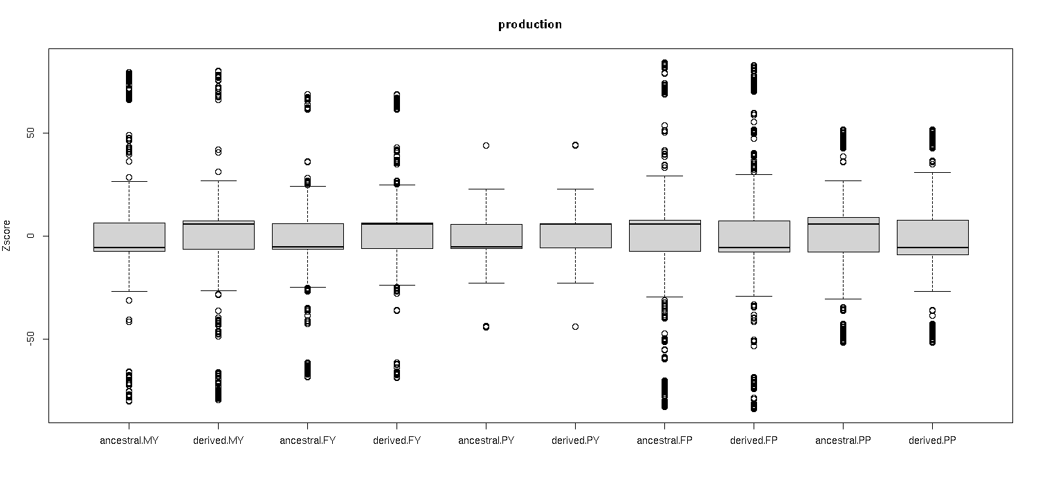
Supp Figure 17. Z-score for ancestral and derived alleles for production traits.

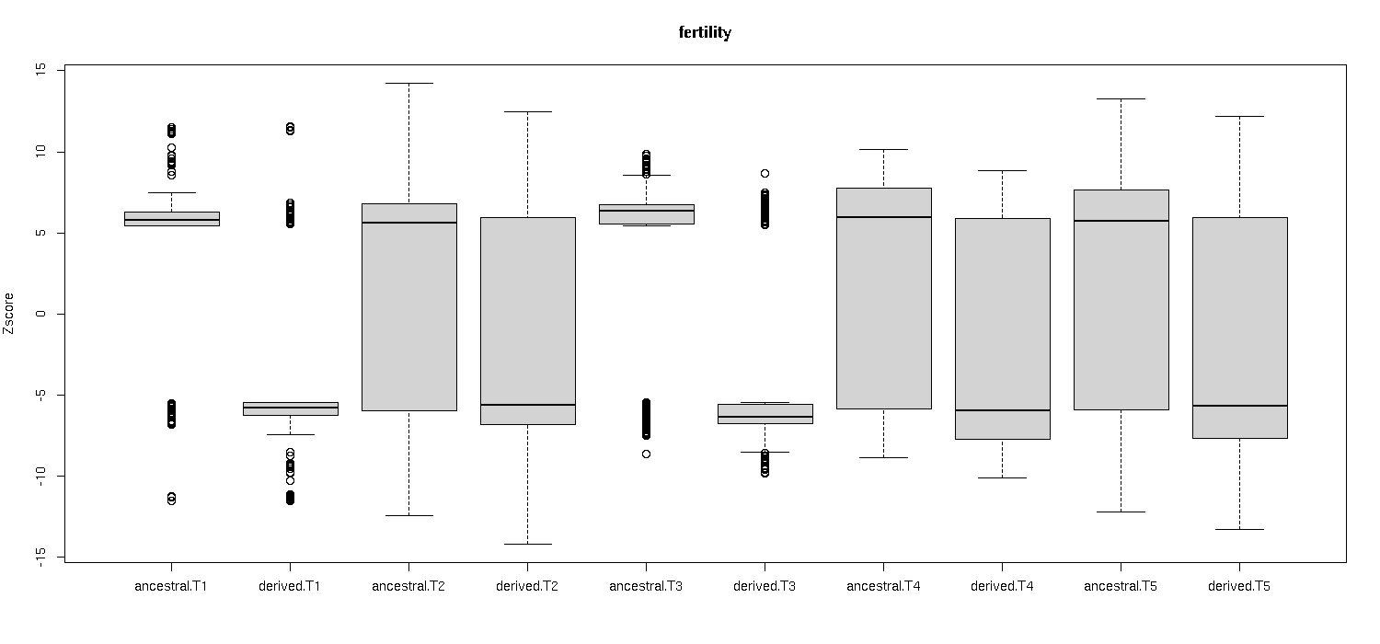
Supp Figure 18. Z-score for ancestral and derived alleles dfor fertility traits

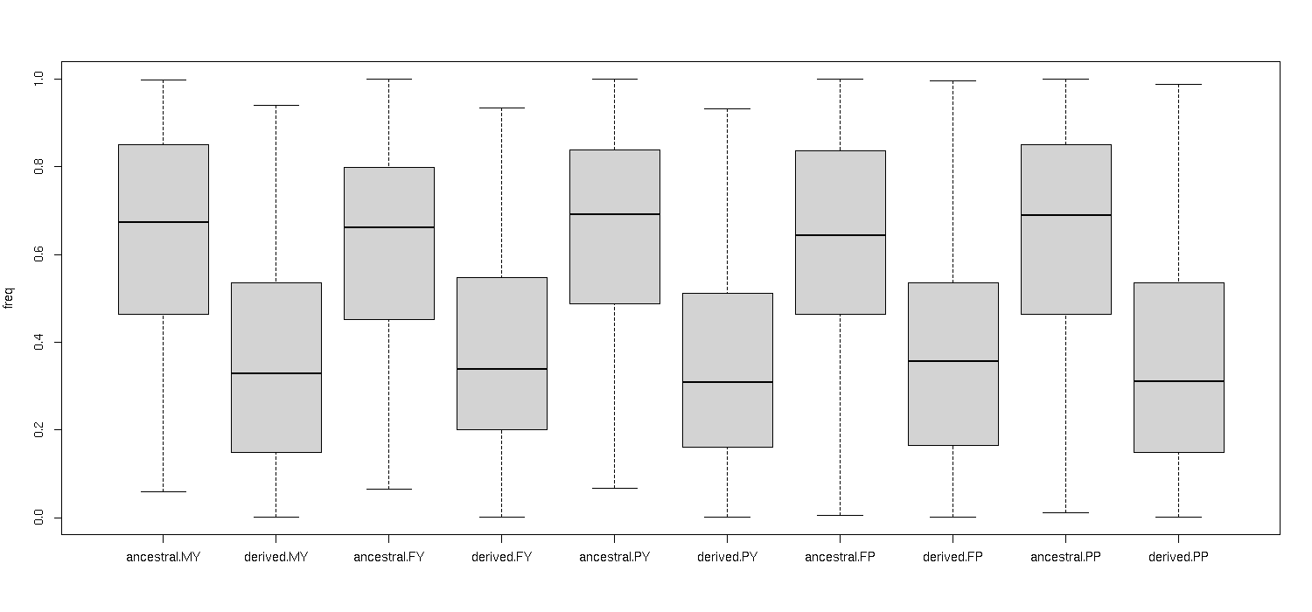
Supp Figure 19. Allele frequency for ancestral and derived alleles for production traits

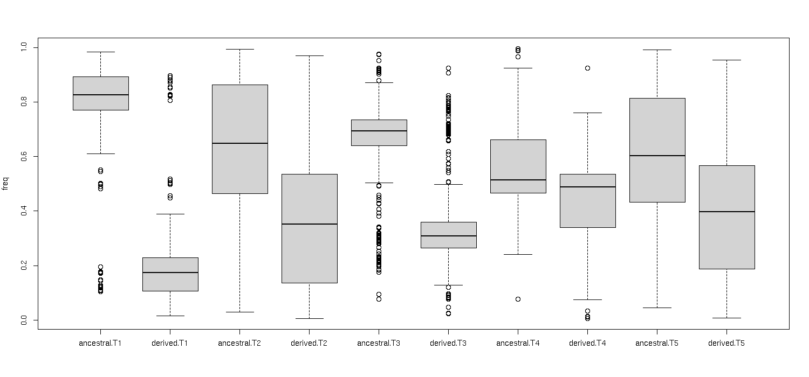
Supp Figure 20. Allele frequency for ancestral and derived alleles for fertility traits

Supplementary Tables

Supplementary Tables 2a to 2x. Number of cows and bulls per breed from each organisation and number of cows and bulls in the full multi-breed Meta-GWAS and in each breed group.

Supp Table 2a. Milk yield (MY) individuals per organisation.
organisation | breed | number of cows | number of bulls | breed category
Aarhus University | Holstein | 0 | 5,610 | Holstein
Agriculture Victoria | Holstein | 56,843 | 6,323 | Holstein
INIA | Holstein | 0 | 3,433 | Holstein
INRAE | Holstein | 0 | 10,041 | Holstein
Qualitas | Holstein | 8,764 | 3,716 | Holstein
Teagasc | Holstein | 32,468 | 48,029 | Holstein
VIT | Holstein | 0 | 13,204 | Holstein
WUR | Holstein | 0 | 5,798 | Holstein
Aarhus University | Jersey | 0 | 1,213 | Jersey
Agriculture Victoria | Jersey | 10,210 | 1,476 | Jersey
LUKE | Nordic Red | 0 | 5,052 | Red
Agriculture Victoria | Australian Red | 3,080 | 0 | Red
GENO | Norwegian Red | 32,540 | 0 | Red
TUM | Brown Swiss | 0 | 1,645 | Brown
ETH | Braunvieh | 12,396 | 3,728 | Brown + Dual purpose
INRAE | Montbéliarde | 0 | 3,152 | Dual purpose
Qualitas | Swiss Fleckvieh | 1,272 | 835 | Dual purpose
Qualitas | Simmental | 1,159 | 977 | Dual purpose
TUM | Fleckvieh | 0 | 6,184 | Dual purpose
INRAE | Normande | 0 | 2,693 | Normande
total |  | 158,732 | 123,109

Supp Table 2b. Milk yield (MY) Meta-GWAS
meta-GWAS | total number of cows | total number of bulls | total number of individuals
multi breed | 158,732 | 123,109 | 281,841
Holstein | 98,075 | 96,154 | 194,229
Jersey | 10,210 | 2,689 | 12,899
Red | 35,620 | 5,052 | 40,672
Brown | 12,396 | 5,373 | 17,769
Dual purpose | 14,827 | 14,876 | 29,703
Normande | 0 | 2,693 | 2,693

Supp Table 2c. Fat yield (FY) individuals per organisation.
organisation | breed | number of cows | number of bulls | breed category
Aarhus University | Holstein | 0 | 5,610 | Holstein
Agriculture Victoria | Holstein | 56,843 | 6,323 | Holstein
INIA | Holstein | 0 | 3,433 | Holstein
INRAE | Holstein | 0 | 10,039 | Holstein
Qualitas | Holstein | 8,763 | 3,714 | Holstein
Teagasc | Holstein | 32,468 | 48,029 | Holstein
VIT | Holstein | 0 | 13,204 | Holstein
WUR | Holstein | 0 | 5,798 | Holstein
Aarhus University | Jersey | 0 | 1,141 | Jersey
Agriculture Victoria | Jersey | 10,210 | 1,476 | Jersey
LUKE | Nordic Red | 0 | 5,052 | Red
Agriculture Victoria | Australian Red | 3,080 | 0 | Red
GENO | Norwegian Red | 32,506 | 0 | Red
TUM | Brown Swiss | 0 | 1,788 | Brown
ETH | Braunvieh | 12,388 | 3,724 | Brown + Dual Purpose
INRAE | Montbéliarde | 0 | 3,152 | Dual purpose
Qualitas | Swiss Fleckvieh | 1,272 | 835 | Dual purpose
Qualitas | Simmental | 1,159 | 977 | Dual purpose
TUM | Fleckvieh | 0 | 6,206 | Dual purpose
INRAE | Normande | 0 | 2,693 | Normande
total |  | 158,689 | 123,194

Supp Table 2d. Fat yield (FY) Meta-GWAS
meta-GWAS | total number of cows | total number of bulls | total number of individuals
multi breed | 158,689 | 123,194 | 281,883
Holstein | 98,074 | 96,150 | 194,224
Jersey | 10,210 | 2,617 | 12,827
Red | 35,586 | 5,052 | 40,638
Brown | 12,388 | 5,512 | 17,900
Dual purpose | 14,819 | 14,894 | 29,713
Normande | 0 | 2,693 | 2,693

Supp Table 2e. Protein yield (PY) individuals per organisation.
organisation | breed | number of cows | number of bulls | breed category
Aarhus University | Holstein | 0 | 5,551 | Holstein
Agriculture Victoria | Holstein | 56,843 | 6,323 | Holstein
INIA | Holstein | 0 | 3,433 | Holstein
INRAE | Holstein | 0 | 10,041 | Holstein
Qualitas | Holstein | 8,757 | 3,714 | Holstein
Teagasc | Holstein | 32,468 | 48,029 | Holstein
VIT | Holstein | 0 | 13,204 | Holstein
WUR | Holstein | 0 | 5,798 | Holstein
Aarhus University | Jersey | 0 | 1,147 | Jersey
Agriculture Victoria | Jersey | 10,210 | 1,476 | Jersey
LUKE | Nordic Red | 0 | 5,038 | Red
Agriculture Victoria | Australian Red | 3,080 | 0 | Red
GENO | Norwegian Red | 32,540 | 0 | Red
TUM | Brown Swiss | 0 | 1,783 | Brown
ETH | Braunvieh | 12,061 | 3,723 | Brown + Dual Purpose
INRAE | Montbéliarde | 0 | 3,152 | Dual purpose
Qualitas | Swiss Fleckvieh | 1,271 | 835 | Dual purpose
Qualitas | Simmental | 1,159 | 977 | Dual purpose
TUM | Fleckvieh | 0 | 6,337 | Dual purpose
INRAE | Normande | 0 | 2,693 | Normande
total |  | 158,389 | 123,254

Supp Table 2f. Protein yield (PY) Meta-GWAS
meta-GWAS | total number of cows | total number of bulls | total number of individuals
multi breed | 158,389 | 123,254 | 281,643
Holstein | 98,068 | 96,093 | 194,161
Jersey | 10,210 | 2,623 | 12,833
Red | 35,620 | 5,038 | 40,658
Brown | 12,061 | 5,506 | 17,567
Dual purpose | 14,491 | 15,024 | 29,515
Normande | 0 | 2,693 | 2,693

Supp Table 2g. Fat Content (FC) individuals per organisation.
organisation | breed | number of cows | number of bulls | breed category
Aarhus University | Holstein | 0 | 5,610 | Holstein
Agriculture Victoria | Holstein | 56,843 | 6,323 | Holstein
INRAE | Holstein | 0 | 10,053 | Holstein
Qualitas | Holstein | 8,763 | 3,714 | Holstein
Teagasc | Holstein | 32,171 | 47,653 | Holstein
Aarhus University | Jersey | 0 | 1,141 | Jersey
Agriculture Victoria | Jersey | 10,210 | 1,476 | Jersey
LUKE | Nordic Red | 0 | 5,052 | Red
Agriculture Victoria | Australian Red | 3,080 | 0 | Red
GENO | Norwegian Red | 32,506 | 0 | Red
TUM | Brown Swiss | 0 | 1,788 | Brown
ETH | Braunvieh | 12,434 | 3,747 | Brown + Dual Purpose
INRAE | Montbéliarde | 0 | 3,157 | Dual purpose
Qualitas | Swiss Fleckvieh | 1,272 | 835 | Dual purpose
Qualitas | Simmental | 1,159 | 977 | Dual purpose
TUM | Fleckvieh | 0 | 6,424 | Dual purpose
INRAE | Normande | 0 | 2,697 | Normande
total |  | 158,438 | 100,647

Supp Table 2h. Fat content (FC) Meta-GWAS
meta-GWAS | total number of cows | total number of bulls | total number of individuals
multi breed | 158,438 | 100,647 | 259,085
Holstein | 97,777 | 73,353 | 171,130
Jersey | 10,210 | 2,617 | 12,827
Red | 35,586 | 5,052 | 40,638
Brown | 12,434 | 5,535 | 17,969
Dual purpose | 14,865 | 15,140 | 30,005
Normande | 0 | 2,697 | 2,697

Supp Table 2i. Protein Content (PC) individuals per organisation.
organisation | breed | number of cows | number of bulls | breed category
Aarhus University | Holstein | 0 | 5,610 | Holstein
Agriculture Victoria | Holstein | 56,843 | 6,323 | Holstein
INRAE | Holstein | 0 | 10,053 | Holstein
Qualitas | Holstein | 8,763 | 3,714 | Holstein
Teagasc | Holstein | 32,171 | 47,653 | Holstein
Aarhus University | Jersey | 0 | 1,141 | Jersey
Agriculture Victoria | Jersey | 10,210 | 1,476 | Jersey
LUKE | Nordic Red | 0 | 5,052 | Red
Agriculture Victoria | Australian Red | 3,080 | 0 | Red
GENO | Norwegian Red | 32,506 | 0 | Red
TUM | Brown Swiss | 0 | 1,788 | Brown
ETH | Braunvieh | 12,434 | 3,747 | Brown + Dual Purpose
INRAE | Montbéliarde | 0 | 3,157 | Dual purpose
Qualitas | Swiss Fleckvieh | 1,272 | 835 | Dual purpose
Qualitas | Simmental | 1,159 | 977 | Dual purpose
TUM | Fleckvieh | 0 | 6,424 | Dual purpose
INRAE | Normande | 0 | 2,697 | Normande
total |  | 158,438 | 100,647

Supp Table 2j. Protein content (PC) Meta-GWAS
meta-GWAS | total number of cows | total number of bulls | total number of individuals
multi breed | 158,438 | 100,647 | 259,085
Holstein | 97,777 | 73,353 | 171,130
Jersey | 10,210 | 2,617 | 12,827
Red | 35,586 | 5,052 | 40,638
Brown | 12,434 | 5,535 | 17,969
Dual purpose | 14,865 | 15,140 | 30,005
Normande | 0 | 2,697 | 2,697

Supp Table 2k. Heifer fertility (HFert, T1) individuals per organisation.
organisation | breed | description | number of cows | number of bulls | breed category
INRAE | Holstein | conception rate | 0 | 9,674 | Holstein
Qualitas | Holstein | non return rate | 1,383 | 2,345 | Holstein
Qualitas | Holstein | interval first to last insemination | 1,236 | 2,257 | Holstein
VIT | Holstein | conception rate | 0 | 13,126 | Holstein
WUR | Holstein | conception rate | 0 | 5,797 | Holstein
WUR | Holstein | age first insemination | 0 | 5,750 | Holstein
GENO | Norwegian Red | number of inseminations before conception | 30,301 | 0 | Red
TUM | Brown Swiss | interval first to last insemination | 0 | 1,995 | Brown
TUM | Brown Swiss | non return rate | 0 | 1,958 | Brown
INRAE | Montbéliarde | conception rate | 0 | 2,940 | Dual purpose
Qualitas | Swiss Fleckvieh | non return rate | 326 | 655 | Dual purpose
Qualitas | Swiss Fleckvieh | interval first to last insemination | 300 | 651 | Dual purpose
Qualitas | Simmental | non return rate | 187 | 670 | Dual purpose
Qualitas | Simmental | interval first to last insemination | 164 | 658 | Dual purpose
TUM | Fleckvieh | interval first to last insemination | 0 | 6,886 | Dual purpose
TUM | Fleckvieh | non return rate | 0 | 6,979 | Dual purpose
INRAE | Normande | conception rate | 0 | 2,503 | Normande
total |  |  | 33,897 | 64,844

Supp Table 2l. Heifer fertility (HFert, T1) Meta-GWAS
meta-GWAS | total number of cows | total number of bulls | total number of individuals
multi breed | 33,897 | 64,844 | 98,741
Holstein | 2,619 | 38,949 | 41,568
Jersey | 0 | 0 | 0
Red | 30,301 | 0 | 30,301
Brown | 0 | 3,953 | 3,953
Dual purpose | 977 | 19,439 | 20,416
Normande | 0 | 2,503 | 2,503

Supp Table 2m. Interval from calving to first mating (CalfMate, T2) individuals per organisation
organisation | breed | description | number of cows | number of bulls | breed category
INIA | Holstein | interval calving to first service | 0 | 3,425 | Holstein
INRAE | Holstein | interval calving to first service | 0 | 9,717 | Holstein
Qualitas | Holstein | interval calving to first service | 1,662 | 2,745 | Holstein
VIT | Holstein | interval calving to first service | 0 | 13,167 | Holstein
WUR | Holstein | interval calving to first service | 0 | 5,797 | Holstein
GENO | Norwegian Red | interval calving to first service | 26,514 | 0 | Red
TUM | Brown Swiss | interval calving to first service | 0 | 1,972 | Brown
ETH | Braunvieh | interval calving to first service | 4,010 | 3,148 | Brown + Dual purpose
INRAE | Montbéliarde | interval calving to first service | 0 | 3,011 | Dual purpose
Qualitas | Swiss Fleckvieh | interval calving to first service | 889 | 663 | Dual purpose
Qualitas | Simmental | interval calving to first service | 684 | 736 | Dual purpose
TUM | Fleckvieh | interval calving to first service | 0 | 6,818 | Dual purpose
INRAE | Normande | interval calving to first service | 0 | 2,602 | Dual purpose
total |  |  | 33,759 | 53,801

Supp Table 2n. Interval from calving to first mating (CalfMate, T2) Meta-GWAS
meta-GWAS | total number of cows | total number of bulls | total number of individuals
multi breed | 33,759 | 53,801 | 87,560
Holstein | 1,662 | 34,851 | 36,513
Jersey | 0 | 0 | 0
Red | 26,514 | 0 | 26,514
Brown | 4,010 | 5,120 | 9,130
Dual purpose | 5,583 | 16,978 | 22,561
Normande | 0 | 2,602 | 2,602

Supp Table 2o. Conception rate (Conc, T3) individuals per organisation
organisation | breed | description | number of cows | number of bulls | breed category
Aarhus University | Holstein | conception rate | 0 | 5,603 | Holstein
INRAE | Holstein | success/failure at insemination | 0 | 9,639 | Holstein
Qualitas | Holstein | non return rate | 3,279 | 2,563 | Holstein
VIT | Holstein | cow’s ability to conceive, rate trait | 0 | 13,147 | Holstein
WUR | Holstein | conception rate | 0 | 5,797 | Holstein
WUR | Holstein | non return rate | 0 | 5,750 | Holstein
Aarhus University | Jersey | conception rate | 0 | 1,102 | Jersey
LUKE | Nordic Red | conception rate | 0 | 5,151 | Red
GENO | Norwegian Red | number of inseminations before conception | 23,186 | 0 | Red
TUM | Brown Swiss | non return rate | 0 | 1,988 | Brown
ETH | Braunvieh | non return rate | 631 | 2,991 | Brown + Dual purpose
INRAE | Montbéliarde | success/failure at insemination | 0 | 2,976 | Dual purpose
Qualitas | Swiss Fleckvieh | non return rate | 606 | 651 | Dual purpose
Qualitas | Simmental | non return rate | 419 | 715 | Dual purpose
TUM | Fleckvieh | non return rate | 0 | 6,867 | Dual purpose
INRAE | Normande | success/failure at insemination | 0 | 2,595 | Dual purpose
total |  |  | 28,121 | 67,535

Supp Table 2p. Conception rate (Conc, T2) Meta-GWAS
meta-GWAS | total number of cows | total number of bulls | total number of individuals
multi breed | 28,121 | 67,535 | 95,656
Holstein | 3,279 | 42,499 | 45,778
Jersey | 0 | 5,151 | 5,151
Red | 23,186 | 5,151 | 28,337
Brown | 631 | 4,979 | 5,610
Dual purpose | 1,656 | 14,200 | 15,856
Normande | 0 | 2,595 | 2,595

Supp Table 2q. Interval first to last insemination (Int1stLast, T4) individuals per organisation
organisation | breed | description | number of cows | number of bulls | breed category
Aarhus University | Holstein | interval first to last insemination | 0 | 5,570 | Holstein
INIA | Holstein | interval first to last insemination | 0 | 3,435 | Holstein
Qualitas | Holstein | interval first to last insemination | 3,853 | 2,629 | Holstein
VIT | Holstein | interval first to last insemination | 0 | 13,106 | Holstein
WUR | Holstein | interval first to last insemination | 0 | 5,798 | Holstein
Aarhus University | Jersey | interval first to last insemination | 0 | 1,147 | Jersey
LUKE | Nordic Red | interval first to last insemination | 0 | 5,151 | Red
TUM | Brown Swiss | interval first to last insemination | 0 | 1,977 | Brown
ETH | Braunvieh | interval first to last insemination | 1,357 | 3,041 | Brown + Dual purpose
Qualitas | Swiss Fleckvieh | interval first to last insemination | 679 | 662 | Dual purpose
Qualitas | Simmental | interval first to last insemination | 489 | 716 | Dual purpose
TUM | Fleckvieh | interval first to last insemination | 0 | 6,821 | Dual purpose
total |  |  | 6,378 | 50,053

Supp Table 2r. Interval first to last insemination (Int1stLast, T4) Meta-GWAS
meta-GWAS | total number of cows | total number of bulls | total number of individuals
multi breed | 6,378 | 50,053 | 56,431
Holstein | 3,853 | 30,538 | 34,391
Jersey | 0 | 1,147 | 1,147
Red | 0 | 5,151 | 5,151
Brown | 1,357 | 5,018 | 6,375
Dual purpose | 2,525 | 11,240 | 13,765
Normande | 0 | 0 | 0

Supp Table 2s. Calving interval (CalvInt, T5) individuals per organisation
organisation | breed | description | number of cows | number of bulls | breed category
Agriculture Victoria | Holstein | calving interval | 41,734 | 5,631 | Holstein
INIA | Holstein | days open | 0 | 4,434 | Holstein
VIT | Holstein | calving interval | 0 | 13,104 | Holstein
WUR | Holstein | calving interval | 0 | 5,798 | Holstein
Agriculture Victoria | Jersey | calving interval | 8,688 | 1,369 | Jersey
Agriculture Victoria | Australian Red | calving interval | 2,973 | 0 | Red
total |  |  | 53,395 | 30,336

Supp Table 2t. Calving interval (CalvInt, T5) Meta-GWAS
meta-GWAS | total number of cows | total number of bulls | total number of individuals
multi breed | 53,395 | 30,336 | 83,731
Holstein | 41,734 | 28,967 | 70,701
Jersey | 8,688 | 1,369 | 10,057
Red | 2,973 | 0 | 2,973
Brown | 0 | 0 | 0
Dual purpose | 0 | 0 | 0
Normande | 0 | 0 | 0

Supp Table 3c. Number of variants in production trait Meta-GWAS
trait | breeds | number of variants
MY | Multi-breed | 27828292
MY | Holstein | 24754261
MY | Jersey | 14493815
MY | Red | 19137300
MY | Brown | 18686530
MY | Dual purpose | 22210447
FY | Multi-breed | 27831555
FY | Holstein | 24755298
FY | Jersey | 14474434
FY | Red | 19136186
FY | Brown | 18686242
FY | Dual purpose | 22248746
PY | Multi-breed | 27833844
PY | Holstein | 24749496
PY | Jersey | 14480447
PY | Red | 19135729
PY | Brown | 18684161
PY | Dual purpose | 22287082
FC | Multi-breed | 27134733
FC | Holstein | 23606367
FC | Jersey | 14479811
FC | Red | 19137855
FC | Brown | 18683294
FC | Dual purpose | 22234040
PC | Multi-breed | 27108846
PC | Holstein | 23606033
PC | Jersey | 14487233
PC | Red | 19137038
PC | Brown | 18687807
PC | Dual purpose | 22170059

Supp Table 3d. Number of variants in fertility trait Meta-GWAS
trait | breeds | number of variants
Hfert | Multi-breed | 23506755
Hfert | Holstein | 19643330
Hfert | Red | 14712499
Hfert | Brown | 10016136
Hfert | Dual purpose | 19035957
CalvMate | Multi-breed | 25080074
CalvMate | Holstein | 19701560
CalvMate | Red | 14710619
CalvMate | Brown | 18441276
CalvMate | Dual purpose | 22078874
Conc | Multi-breed | 25464174
Conc | Holstein | 20134666
Conc | Jersey | 12827710
Conc | Red | 18286018
Conc | Brown | 18180567
Conc | Dual purpose | 21884870
Int1stlast | Multi-breed | 24220133
Int1stlast | Holstein | 20008981
Int1stlast | Jersey | 12865537
Int1stlast | Red | 17592807
Int1stlast | Brown | 18230078
Int1stlast | Dual purpose | 21085034
CalvInt | Multi-breed | 21128097
CalvInt | Holstein | 18903886
CalvInt | Jersey | 13370038
CalvInt | Red | 16691446

Supp Table 9a. Number of individuals (n) in GTEx for gene expression
tissue | n
Adipose | 218
Blood | 860
Conceptus | 43
Embryo | 407
Hypothalamus | 117
Ileum | 125
Jejunum | 160
Kidney | 47
Leukocyte | 65
Liver | 706
Lung | 132
Lymph_node | 100
Macrophage | 350
Mammary | 662
Milk_cell | 209
Monocytes | 209
Muscle | 859
Ovary | 223
Oviduct | 111
Pituitary | 149
Rumen | 370
Salivary_gland | 41
Skin_fibroblast | 44
Small_intestine | 43
Spleen | 54
Testis | 86
Uterus | 452

Supp Table 9p. Number of individuals (n) in GTEx for gene splicing
tissue | n
Adipose | 218
Blood | 860
Conceptus | 43
Embryo | 407
Hypothalamus | 117
Ileum | 125
Jejunum | 160
Kidney | 47
Leukocyte | 65
Liver | 706
Lung | 132
Lymph_node | 100
Macrophage | 350
Mammary | 662
Milk_cell | 209
Monocytes | 209
Muscle | 859
Ovary | 223
Oviduct | 111
Pituitary | 149
Rumen | 370
Salivary_gland | 41
Skin_fibroblast | 44
Small_intestine | 43
Spleen | 54
Testis | 86
Uterus | 452

Table 10a to 10e. GTEx enrichment results

Supp Table 10a. Summary of GTEx enrichment folds for gene expression QTL (geQTL) and gene splicing QTL (sQTL) for tissues with at least 100 samples, for validated Meta-GWAS variants associated with production and fertility.
 |  | Production |  | Fertility
tissue | nSamples | geQTL | sQTL | geQTL | sQTL
Adipose | 218 | 10.9 | 8.3 | 0 | 1
Blood | 860 | 8.4 | 8.9 | 2.8 | 2.5
Embryo | 407 | 2.4 | 0.6 | 0 | 0
Hypothalamus | 117 | 10.4 | 2.8 | 0 | 1.3
Ileum | 125 | NA | 15.6 | NA | 3.9
Intramuscular_fat | 174 | 4.9 | NA | 2.9 | NA
Jejunum | 160 | 3.5 | 12.9 | 0 | 0.9
Liver | 706 | 7.8 | 11.6 | 3.3 | 3.7
Lung | 132 | 8.4 | 13.1 | 0.2 | 2
Lymph_node | 100 | 8.8 | 11.1 | 0.9 | 3.4
Macrophage | 350 | 24.1 | 7 | 6.6 | 3.5
Mammary | 662 | 24.1 | 15.4 | 3.4 | 4.7
Milk_cell | 209 | 0.4 | 6.7 | 0 | 3.1
Monocytes | 209 | 11.2 | 3.9 | 12.7 | 2.1
Muscle | 859 | 7.7 | 8.6 | 1.5 | 3.7
Ovary | 223 | 3.3 | 5.3 | 1 | 3.1
Oviduct | 111 | 1.3 | 3.4 | 0 | 9.1
Pituitary | 149 | 11.5 | 5.9 | 0 | 1.1
Rumen | 370 | 2.5 | 13.4 | 0.3 | 1.4
Uterus | 452 | 7.2 | 12.4 | 3.4 | 3.8

Supp Table 10b. GTEx enrichment folds for gene expression QTL and production QTL, where nALL is number of variants included in the Meta-GWAS, nAllGE is the number of variants associated with gene expression in cattle GTEx, percAllGE is nAllGE/nAll*100, nQTL is the number of variants in QTL regions, nQTL_GE is the number of variants in QTL regions associated with gene expression in cattle GTEx, percQTL_GE is nQTL_GE/nQTL*100, and emrichment is percQTL_GE/percAllGE.
tissue | nAll | nAllGE | percAllGE | nQTL | nQTL_GE | percQTL_GE | enrichment
Adipose | 27862023 | 28664 | 0.102878 | 45585 | 513 | 1.12537 | 10.93888
Blood | 27862023 | 257502 | 0.924204 | 45585 | 3542 | 7.7701 | 8.407343
Embryo | 27862023 | 3089 | 0.011087 | 45585 | 12 | 0.026324 | 2.374391
Hypothalamus | 27862023 | 9058 | 0.03251 | 45585 | 154 | 0.33783 | 10.39151
Intramuscular_fat | 27862023 | 25128 | 0.090187 | 45585 | 203 | 0.445322 | 4.937746
Jejunum | 27862023 | 19286 | 0.06922 | 45585 | 112 | 0.245695 | 3.549495
Kidney | 27862023 | 5 | 1.79E-05 | 45585 | 0 | 0 | 0
Leukocyte | 27862023 | 2076 | 0.007451 | 45585 | 93 | 0.204014 | 27.38075
Liver | 27862023 | 143111 | 0.513642 | 45585 | 1836 | 4.02764 | 7.841337
Lung | 27862023 | 16167 | 0.058025 | 45585 | 222 | 0.487002 | 8.39294
Lymph_node | 27862023 | 33970 | 0.121922 | 45585 | 488 | 1.07053 | 8.78045
Macrophage | 27862023 | 35722 | 0.12821 | 45585 | 1409 | 3.09093 | 24.10834
Mammary | 27862023 | 51483 | 0.184778 | 45585 | 2028 | 4.44883 | 24.07662
Milk_cell | 27862023 | 6457 | 0.023175 | 45585 | 4 | 0.008775 | 0.378635
Monocytes | 27862023 | 19062 | 0.068416 | 45585 | 348 | 0.763409 | 11.15839
Muscle | 27862023 | 89308 | 0.320537 | 45585 | 1129 | 2.47669 | 7.72669
Ovary | 27862023 | 3672 | 0.013179 | 45585 | 20 | 0.043874 | 3.329041
Oviduct | 27862023 | 5596 | 0.020085 | 45585 | 12 | 0.026324 | 1.310669
Pituitary | 27862023 | 16456 | 0.059063 | 45585 | 310 | 0.680048 | 11.51404
Rumen | 27862023 | 28030 | 0.100603 | 45585 | 115 | 0.252276 | 2.507639
Spleen | 27862023 | 40 | 0.000144 | 45585 | 2 | 0.004387 | 30.56044
Testis | 27862023 | 1511 | 0.005423 | 45585 | 0 | 0 | 0
Uterus | 27862023 | 80805 | 0.290018 | 45585 | 957 | 2.09937 | 7.238758

Supp Table 10c. GTEx enrichment folds for gene expression QTL and fertility QTL, where nALL is number of variants included in the Meta-GWAS, nAllGE is the number of variants associated with gene expression in cattle GTEx, percAllGE is nAllGE/nAll*100, nQTL is the number of variants in QTL regions, nQTL_GE is the number of variants in QTL regions associated with gene expression in cattle GTEx, percQTL_GE is nQTL_GE/nQTL*100, and emrichment is percQTL_GE/percAllGE.
tissue | nAll | nAllGE | percAllGE | nQTL | nQTL_GE | percQTL_GE | enrichment
Adipose | 27862023 | 28664 | 0.102878 | 7230 | 0 | 0 | 0
Blood | 27862023 | 257502 | 0.924204 | 7230 | 190 | 2.62794 | 2.843463
Embryo | 27862023 | 3089 | 0.011087 | 7230 | 0 | 0 | 0
Hypothalamus | 27862023 | 9058 | 0.03251 | 7230 | 0 | 0 | 0
Intramuscular_fat | 27862023 | 25128 | 0.090187 | 7230 | 19 | 0.262794 | 2.913869
Jejunum | 27862023 | 19286 | 0.06922 | 7230 | 0 | 0 | 0
Kidney | 27862023 | 5 | 1.79E-05 | 7230 | 0 | 0 | 0
Leukocyte | 27862023 | 2076 | 0.007451 | 7230 | 11 | 0.152144 | 20.41927
Liver | 27862023 | 143111 | 0.513642 | 7230 | 121 | 1.67358 | 3.258262
Lung | 27862023 | 16167 | 0.058025 | 7230 | 1 | 0.013831 | 0.238367
Lymph_node | 27862023 | 33970 | 0.121922 | 7230 | 8 | 0.11065 | 0.907547
Macrophage | 27862023 | 35722 | 0.12821 | 7230 | 61 | 0.843707 | 6.580665
Mammary | 27862023 | 51483 | 0.184778 | 7230 | 46 | 0.636238 | 3.443256
Milk_cell | 27862023 | 6457 | 0.023175 | 7230 | 0 | 0 | 0
Monocytes | 27862023 | 19062 | 0.068416 | 7230 | 63 | 0.871369 | 12.73639
Muscle | 27862023 | 89308 | 0.320537 | 7230 | 35 | 0.484094 | 1.510259
Ovary | 27862023 | 3672 | 0.013179 | 7230 | 1 | 0.013831 | 1.049479
Oviduct | 27862023 | 5596 | 0.020085 | 7230 | 0 | 0 | 0
Pituitary | 27862023 | 16456 | 0.059063 | 7230 | 0 | 0 | 0
Rumen | 27862023 | 28030 | 0.100603 | 7230 | 2 | 0.027663 | 0.274967
Spleen | 27862023 | 40 | 0.000144 | 7230 | 0 | 0 | 0
Testis | 27862023 | 1511 | 0.005423 | 7230 | 0 | 0 | 0
Uterus | 27862023 | 80805 | 0.290018 | 7230 | 71 | 0.982019 | 3.386062

Supp Table 10d. GTEx enrichment folds for gene splice QTL and production QTL, where nALL is number of variants included in the Meta-GWAS, nAllSplice is the number of variants associated with gene splicing in cattle GTEx, percAllSplice is nAllGE/nAll*100, nQTL is the number of variants in QTL regions, nQTL_Splice is the number of variants in QTL regions associated with gene splicing in cattle GTEx, percQTL_Splicing is nQTL_Splice/nQTL*100, and emrichment is percQTL_Splice/percAllSplice.
tissue | nAll | nAllSplice | percAllSplice | nQTL | nQTL_Splice | percQTL_Splice | enrichment
Adipose | 27862023 | 80136 | 0.287617 | 45585 | 1090 | 2.39114 | 8.313625
Blood | 27862023 | 452753 | 1.62498 | 45585 | 6601 | 14.4806 | 8.911248
Conceptus | 27862023 | 23 | 8.25E-05 | 45585 | 0 | 0 | 0
Embryo | 27862023 | 1059 | 0.003801 | 45585 | 1 | 0.002194 | 0.577157
Hypothalamus | 27862023 | 14977 | 0.053754 | 45585 | 69 | 0.151366 | 2.815892
Ileum | 27862023 | 2974 | 0.010674 | 45585 | 76 | 0.166722 | 15.61945
Jejunum | 27862023 | 35399 | 0.127051 | 45585 | 750 | 1.64528 | 12.94976
Kidney | 27862023 | 9499 | 0.034093 | 45585 | 21 | 0.046068 | 1.351239
Leukocyte | 27862023 | 2619 | 0.0094 | 45585 | 11 | 0.024131 | 2.567126
Liver | 27862023 | 192276 | 0.690101 | 45585 | 3651 | 8.00921 | 11.60585
Lung | 27862023 | 49467 | 0.177543 | 45585 | 1057 | 2.31875 | 13.06022
Lymph_node | 27862023 | 58360 | 0.209461 | 45585 | 1064 | 2.3341 | 11.14336
Macrophage | 27862023 | 77307 | 0.277464 | 45585 | 880 | 1.93046 | 6.957515
Mammary | 27862023 | 133836 | 0.480353 | 45585 | 3374 | 7.40156 | 15.40858
Milk_cell | 27862023 | 29512 | 0.105922 | 45585 | 324 | 0.71076 | 6.710221
Monocytes | 27862023 | 30735 | 0.110311 | 45585 | 194 | 0.425579 | 3.857992
Muscle | 27862023 | 142175 | 0.510282 | 45585 | 2004 | 4.39618 | 8.615197
Ovary | 27862023 | 18469 | 0.066287 | 45585 | 161 | 0.353186 | 5.328102
Oviduct | 27862023 | 19543 | 0.070142 | 45585 | 110 | 0.241307 | 3.440259
Pituitary | 27862023 | 28251 | 0.101396 | 45585 | 273 | 0.598881 | 5.906357
Rumen | 27862023 | 50799 | 0.182323 | 45585 | 1110 | 2.43501 | 13.35547
Salivary_gland | 27862023 | 574 | 0.00206 | 45585 | 64 | 0.140397 | 68.14892
Skin_fibroblast | 27862023 | 1467 | 0.005265 | 45585 | 165 | 0.361961 | 68.74552
Small_intestine | 27862023 | 519 | 0.001863 | 45585 | 16 | 0.035099 | 18.84273
Spleen | 27862023 | 1897 | 0.006809 | 45585 | 16 | 0.035099 | 5.15518
Testis | 27862023 | 7309 | 0.026233 | 45585 | 20 | 0.043874 | 1.67249
Uterus | 27862023 | 142560 | 0.511664 | 45585 | 2898 | 6.35735 | 12.42485

Supp Table 10e. GTEx enrichment folds for gene splice QTL and fertility QTL, where nALL is number of variants included in the Meta-GWAS, nAllSplice is the number of variants associated with gene splicing in cattle GTEx, percAllSplice is nAllGE/nAll*100, nQTL is the number of variants in QTL regions, nQTL_Splice is the number of variants in QTL regions associated with gene splicing in cattle GTEx, percQTL_Splicing is nQTL_Splice/nQTL*100, and emrichment is percQTL_Splice/percAllSplice
tissue | nAll | nAllSplice | percAllSplice | nQTL | nQTL_Splice | percQTL_Splice | enrichment
Adipose | 27862023 | 80136 | 0.287617 | 7230 | 20 | 0.276625 | 0.961783
Blood | 27862023 | 452753 | 1.62498 | 7230 | 292 | 4.03873 | 2.485403
Conceptus | 27862023 | 23 | 8.25E-05 | 7230 | 0 | 0 | 0
Embryo | 27862023 | 1059 | 0.003801 | 7230 | 0 | 0 | 0
Hypothalamus | 27862023 | 14977 | 0.053754 | 7230 | 5 | 0.069156 | 1.286528
Ileum | 27862023 | 2974 | 0.010674 | 7230 | 3 | 0.041494 | 3.887371
Jejunum | 27862023 | 35399 | 0.127051 | 7230 | 8 | 0.11065 | 0.87091
Kidney | 27862023 | 9499 | 0.034093 | 7230 | 3 | 0.041494 | 1.217077
Leukocyte | 27862023 | 2619 | 0.0094 | 7230 | 2 | 0.027663 | 2.942854
Liver | 27862023 | 192276 | 0.690101 | 7230 | 186 | 2.57261 | 3.727875
Lung | 27862023 | 49467 | 0.177543 | 7230 | 26 | 0.359613 | 2.025498
Lymph_node | 27862023 | 58360 | 0.209461 | 7230 | 52 | 0.719225 | 3.433694
Macrophage | 27862023 | 77307 | 0.277464 | 7230 | 70 | 0.968188 | 3.489418
Mammary | 27862023 | 133836 | 0.480353 | 7230 | 164 | 2.26833 | 4.722215
Milk_cell | 27862023 | 29512 | 0.105922 | 7230 | 24 | 0.33195 | 3.13391
Monocytes | 27862023 | 30735 | 0.110311 | 7230 | 17 | 0.235131 | 2.131528
Muscle | 27862023 | 142175 | 0.510282 | 7230 | 136 | 1.88105 | 3.686295
Ovary | 27862023 | 18469 | 0.066287 | 7230 | 15 | 0.207469 | 3.129841
Oviduct | 27862023 | 19543 | 0.070142 | 7230 | 46 | 0.636238 | 9.070701
Pituitary | 27862023 | 28251 | 0.101396 | 7230 | 8 | 0.11065 | 1.091266
Rumen | 27862023 | 50799 | 0.182323 | 7230 | 18 | 0.248963 | 1.365505
Salivary_gland | 27862023 | 574 | 0.00206 | 7230 | 0 | 0 | 0
Skin_fibroblast | 27862023 | 1467 | 0.005265 | 7230 | 0 | 0 | 0
Small_intestine | 27862023 | 519 | 0.001863 | 7230 | 1 | 0.013831 | 7.425205
Spleen | 27862023 | 1897 | 0.006809 | 7230 | 0 | 0 | 0
Testis | 27862023 | 7309 | 0.026233 | 7230 | 0 | 0 | 0
Uterus | 27862023 | 142560 | 0.511664 | 7230 | 142 | 1.96404 | 3.838535

Supp Table 13a. Synergistic and antagonistic QTL regions identified, where raits: MY = milk yield, FY = fat yield, PY = protein yield, FC = fat content, PC = protein content, Hfert = heifer fertility, CalvMate = interval calving to first mating, Conc = conception rate, Int1stLast = interval first to last mating, CalvInt = calving interval, and nVariants = number of variants in QTL.
Chromosome | Start (bp) | End (bp) | nVariants | traits
Synergistic regions
11 | 103,245,794 | 103,277,147 | 166 | MY, FY, PY, FC, CalvInt
18 | 57,623,004 | 57,869,043 | 54 | PY, FP, PP, Conc, Int1stLast, CalvInt
18 | 59,259,659 | 60,135,139 | 14 | PY, FP, Conc, Int1stLast
25 | 35,714,320 | 35,869,073 | 3 | MY, Conc
Antagonistic regions
5 | 89,554,484 | 90,035,542 | 162 | MY, PY, CalvInt
5 | 105,594,077 | 105,790,990 | 4 | MY, Conc, CalvInt
6 | 82,955,902 | 82,955,902 | 1 | PY, CalvInt
6 | 87,675,298 | 87,919,948 | 440 | MY, CalvMate, Int1stLast, CalvInt
6 | 89,593,824 | 89,616,728 | 4 | MY, CalvMate, CalvInt
9 | 88,676,804 | 88,779,951 | 46 | MY, PY, CalvMate
13 | 41,720,721 | 41,720,721 | 1 | MY , CalvMate
13 | 53,788,810 | 54,595,332 | 30 | MY, PY, CalvMate, Int1stLast, CalvInt
14 | 497,507 | 553,130 | 25 | MY, FY, FC, PC, CalvMate
14 | 18,985,490 | 18,985,490 | 1 | MY, CalvMate
20 | 33,792,019 | 34,169,770 | 5 | MY, PP, Int1stLast, CalvInt
23 | 50,004,276 | 50,004,276 | 1 | MY, CalvInt
23 | 51,214,759 | 51,236,078 | 3 | MY, PC, CalvInt

Supp Table 13b. Correlations of SNP z-scores for all trait pairs
trait | MY | FY | PY | FC | PC | Hfert | CalvMate | Conc | Int1stLast | CalvInt
MY |  | 0 | 0 | 0 | 0 | 0 | 0 | 0 | 0 | 0
FY | 0.36 |  | 0.00 | 0.00 | 0.00 | 0.00 | 0.00 | 0.00 | 0.00 | 0.00
PY | 0.74 | 0.62 |  | 0.00 | 0.00 | 0.00 | 0.00 | 0.00 | 0.00 | 0.00
FC | -0.53 | 0.49 | -0.14 |  | 0.00 | 0.00 | 0.00 | 0.00 | 0.00 | 0.00
PC | -0.51 | 0.18 | 0.09 | 0.66 |  | 0.00 | 0.00 | 0.00 | 0.00 | 0.00
Hfert | -0.01 | -0.04 | -0.03 | -0.02 | -0.02 |  | 0.00 | 0.00 | 0.00 | 0.00
CalvMate | -0.17 | -0.13 | -0.15 | 0.01 | 0.04 | 0.02 |  | 0.00 | 0.00 | 0.00
Conc | -0.07 | -0.08 | -0.08 | -0.01 | 0.00 | 0.42 | 0.02 |  | 0.00 | 0.00
Int1stLast | -0.20 | -0.17 | -0.19 | 0.02 | 0.05 | 0.35 | 0.33 | 0.61 |  | 0.00
CalvInt | -0.21 | -0.19 | -0.20 | 0.00 | 0.05 | 0.20 | 0.46 | 0.32 | 0.57

Supp Table 14a. Number of animals in each birthyear cohort used for allele frequency estimation
 | Australian Holstein |  | Australian Jersey |  | Irish Holstein |  | German Holstein
birthyears | bulls | cows | bulls | cows | bulls | cows |  | bulls
1981-1985 | 157 | 0 | 58 | 0 | 245 | 16 |  | 34
1986-1990 | 220 | 1 | 52 | 0 | 458 | 0 |  | 265
1991-1995 | 446 | 167 | 71 | 3 | 995 | 1 |  | 571
1996-2000 | 880 | 1,651 | 142 | 249 | 1,893 | 19 |  | 1,895
2001-2005 | 718 | 6,115 | 115 | 2,316 | 1,898 | 128 |  | 4,456
2006-2010 | 504 | 13,049 | 104 | 3,683 | 1,915 | 2,824 |  | 4,097
2011-2015 | 505 | 25,386 | 77 | 3,254 | 13,247 | 9,445 |  | 2,250
2016-2020 | 150 | 18,254 | 23 | 2,723 | 4,626 | 1,559 |  | 0

Supp Table 14b. Allele frequencies for QTL in different classes across traits, where onlyProd/Fert are variants in QTL regions that were only associated with production or only fertility, synergistic are variants in QTL regions that had a favourable correlation between MY, PY and fertility, and antagonistic are variants in QTL regions that had a unfavourable correlation between MY, PY and fertility.
trait | onlyProd/Fert | synergistic | antagonistic
MY | 0.02 | 0.23 | -0.01
PY | 0.05 | 0.2 | -0.01
Hfert | 0 | 0.15 | -0.05
CalvMate | 0.01 | 0.15 | 0.01
Conc | 0.01 | 0.08 | -0.2
Int1stLast | 0 | 0.13 | 0.01
CalvInt | 0.01 | 0.21 | 0.01

Supp Table 15a. Average QTL size (avgSize) in basepairs (bp) in within-breed (WB) and multi-breed (MB) Meta-GWAS averaged across production and fertility traits.
traits | analysis | avgSize (bp) | avgVariants
Production | MB | 199,463 | 30
Production | WB | 223,769 | 39
Fertility | MB | 243,434 | 27
Fertility | WB | 258,540 | 40

Supp Table 15b. Average QTL size (avgSize) in basepairs (bp) per category (only production, only fertility, synergistic & antagonistic); size of original QTL region, so including non-overlapping variants
Category | avgSize (bp) | avgVariants
onlyProd | 239,665 | 32
onlyFert | 239,173 | 33
Synergistic | 304,771 | 47
Antagonistic | 319,807 | 97

Supp Table 18a. QTL regions for the 5 fertility traits overlapping with genes associated with heat (estrous) scores
Chr | Start | End | LogP_leadSNP | #SNP | Gene | Trait
5 | 55459624 | 56291220 | 9.159204 | 6 | AVIL | CalvInt
5 | 91081388 | 91533774 | 8.923724 | 82 | PIK3C2G | CalvInt
5 | 91724082 | 91883965 | 7.698753 | 3 | PIK3C2G | CalvInt
5 | 112427104 | 112449412 | 9.66274 | 6 | ZC3H7B | Conc
6 | 97621103 | 98090202 | 8.945004 | 5 | LIN54 | HFert
8 | 96447959 | 96631094 | 9.029839 | 5 | ZNF462 | Conc
10 | 76278428 | 76502072 | 10.22214 | 167 | SYNE2 | InHFertstLast
10 | 76252591 | 76740664 | 9.699839 | 89 | SYNE2 | CalvInt
10 | 76252591 | 76740664 | 9.699839 | 89 | AKAP5 | CalvInt
10 | 76404109 | 76687127 | 13.61332 | 241 | AKAP5 | CalvMate
11 | 86110231 | 86276205 | 8.690157 | 2 | LPIN1 | CalvMate
11 | 105494506 | 106038560 | 8.9859 | 37 | PTGDS | Conc
13 | 56769736 | 57228262 | 14.27778 | 72 | EDN3 | CalvMate
13 | 56946554 | 57451653 | 8.952336 | 66 | EDN3 | CalvInt
15 | 76536678 | 77033634 | 11.91364 | 30 | HARBI1 | CalvInt
18 | 49703979 | 50143072 | 15.61261 | 8 | PLD3 | CalvMate
18 | 49703979 | 50143072 | 15.61261 | 8 | SPTBN4 | CalvMate
18 | 49703979 | 50143072 | 15.61261 | 8 | SNRPA | CalvMate
18 | 49653576 | 50003156 | 10.07294 | 16 | PLD3 | CalvInt
18 | 49653576 | 50003156 | 10.07294 | 16 | SPTBN4 | CalvInt
18 | 55905257 | 55990514 | 10.22643 | 31 | SLC17A7 | CalvInt
18 | 56499635 | 56641083 | 22.98338 | 10 | FAM71E1 | CalvInt
18 | 56486383 | 56731417 | 15.07753 | 11 | FAM71E1 | InHFertstLast
18 | 56480087 | 56641083 | 10.89143 | 6 | FAM71E1 | Conc
18 | 61030145 | 61916452 | 15.2505 | 55 | CACNG6 | Conc
18 | 61058529 | 61704456 | 10.694 | 26 | CACNG6 | InHFertstLast
18 | 62828960 | 63579239 | 12.83209 | 51 | ZNF787 | InHFertstLast
18 | 62828960 | 63695848 | 13.0118 | 112 | ZNF787 | CalvInt
18 | 63373315 | 63856358 | 9.931072 | 57 | ZNF787 | Conc
19 | 28172608 | 28773117 | 13.7716 | 54 | MYH10 | Conc
19 | 27833089 | 28798766 | 10.38195 | 151 | MYH10 | CalvInt
19 | 34539271 | 34688814 | 8.013945 | 10 | TOM1L2 | HFert
19 | 50936238 | 51171397 | 10.27507 | 2 | CCDC137 | HFert
19 | 55613419 | 55897491 | 8.113453 | 4 | EVPL | CalvInt
21 | 54269659 | 55092207 | 51.04053 | 13 | KLHL28 | CalvMate
21 | 54269659 | 55092207 | 51.04053 | 13 | FANCM | CalvMate
21 | 54518908 | 55092368 | 29.37882 | 8 | KLHL28 | CalvInt
21 | 54518908 | 55092368 | 29.37882 | 8 | FANCM | CalvInt
21 | 54205960 | 55092270 | 16.57659 | 68 | KLHL28 | InHFertstLast
21 | 54205960 | 55092270 | 16.57659 | 68 | FANCM | InHFertstLast
21 | 58255867 | 58912884 | 15.82507 | 15 | OTUB2 | CalvInt
23 | 9685892 | 9716619 | 7.611899 | 5 | FKBP5 | CalvInt
25 | 35386378 | 35977019 | 13.09539 | 316 | ACHE | Conc
25 | 40468014 | 41383389 | 14.66075 | 18 | GNA12 | Conc
26 | 6566177 | 7402159 | 10.87419 | 218 | DKK1 | CalvMate
26 | 6568257 | 7071287 | 16.07094 | 4 | DKK1 | CalvInt

Supp Table 18b. QTL regions for the 5 fertility traits overlapping with prioritised candidate genes based on protein-protein interactions, gene expression, and text-mining, where Am=Amygdala, DH=dorsal hypothalamus, VH=ventral hypothalamus, HC=hippocampus, Pit=Pituitary
chr | start | end | logP | #SNP | gene | trait | Am | DH | VH | HC | Pit
5 | 55459624 | 56291220 | 9.16 | 6 | INHBE | CalvInt |  |  |  |  | 1
5 | 57014191 | 57543765 | 9.55 | 9 | PAN2 | CalvMate | 1
5 | 106587374 | 107440277 | 10.1 | 78 | FKBP4 | CalvInt |  |  |  |  | 1
10 | 61553838 | 61896315 | 7.69 | 4 | FBN1 | Conc |  |  | 1
10 | 76278428 | 76502072 | 10.22 | 167 | ESR2 | Int1stLast |  | 1
10 | 76252591 | 76740664 | 9.7 | 89 | ESR2 | CalvInt |  | 1
10 | 76404109 | 76687127 | 13.61 | 241 | ESR2 | CalvMate |  | 1
10 | 88247123 | 88912823 | 8.29 | 11 | POMT2 | Conc |  |  | 1
11 | 86110231 | 86276205 | 8.69 | 2 | GREB1 | CalvMate | 1 | 1
11 | 103245609 | 103277147 | 9.61 | 167 | PAEP | CalvInt |  | 1 |  | 1
14 | 398877 | 1077529 | 10.74 | 267 | EXOSC4 | CalvMate |  |  |  | 1
14 | 398877 | 1077529 | 10.74 | 267 | SLC39A4 | CalvMate |  | 1
15 | 76536678 | 77033634 | 11.91 | 30 | F2 | CalvInt |  |  |  | 1
17 | 68897760 | 69604425 | 10.79 | 68 | LIF | CalvInt |  |  | 1
17 | 69242369 | 69352822 | 14.83 | 41 | LIF | Int1stLast |  |  | 1
17 | 69227272 | 69332817 | 9.71 | 9 | LIF | Conc |  |  | 1
17 | 68938667 | 69371436 | 16.88 | 77 | LIF | CalvMate |  |  | 1
18 | 49703979 | 50143072 | 15.61 | 8 | SPTBN4 | CalvMate | 1
18 | 49653576 | 50003156 | 10.07 | 16 | SPTBN4 | CalvInt | 1
18 | 50327487 | 50774959 | 12 | 8 | TGFB1 | CalvMate |  |  | 1 | 1
18 | 50111526 | 50868709 | 11.41 | 6 | TGFB1 | CalvInt |  |  | 1 | 1
18 | 50866625 | 51368688 | 11.3 | 71 | DEDD2 | CalvMate |  | 1
18 | 55358669 | 55619841 | 14.88 | 45 | GYS1 | CalvInt | 1 |  |  | 1
18 | 55905257 | 55990514 | 10.23 | 31 | NOSIP | CalvInt |  |  |  | 1
19 | 26978109 | 27626799 | 13.41 | 27 | SLC2A4 | Conc | 1
25 | 26609083 | 27075599 | 8.28 | 7 | CTF1 | CalvMate | 1
25 | 35386378 | 35977019 | 13.1 | 316 | TFR2 | Conc | 1
25 | 35854564 | 35985729 | 11.08 | 37 | TFR2 | Int1stLast | 1

Supp Table 20a. GATK truth and training sets 1000 Bull Genomes Run7 and 8.
Name | Filters | Known | Training | Truth | Prior
(number variants)
Run7-TauInd-SNP-truth.vcf (9,914,679) | Based on results from Run7 Taurus and Indicus animals processed using GATK’s genotypeGVCFs tool and filtered using the traditional 1kbulls filtering thresholds (pre-Beagle correction) (ref original 1kbulls paper). | FALSE | TRUE | TRUE | 12
Run7-TauInd-SNP-truth.vcf (9,914,679) | Additionally:
Run7-TauInd-SNP-truth.vcf (9,914,679) | - MAF between 0.05 and 0.5
Run7-TauInd-SNP-truth.vcf (9,914,679) | - At least 10 ALT homozygotes
Run7-TauInd-SNP-truth.vcf (9,914,679) | - No flanking variants +/- 10bp
Run7-TauInd-SNP-truth.vcf (9,914,679) | - No HWE p-value threshold
Run7-TauInd-SNP-truth.vcf (9,914,679) | - Opposing homozygotes < 0.014
Run7-TauInd-SNP-training.vcf | Based on results from Run7 Taurus and Indicus animals processed using GATK’s genotypeGVCFs tool and filtered using the traditional 1kbulls filtering thresholds (pre-Beagle correction) (ref original 1kbulls paper). | FALSE | TRUE | FALSE | 10
-3,758,189 | As above but relaxed filters:
 | - MAF between 0.05 and 0.5
 | - At least 5 ALT homozygotes
 | - No flanking variants +/- 10bp
 | - No HWE p-value threshold
 | - Opposing homozygotes < 0.10
 | - Mutually exclusive to SNP above
Affy_truth.vcf | Comprised of filtered variants from the Affymetrix pre-screening array prior to the building of the 600k Affymetrix Bos-1 array. Selecting only variants with the frequency of “A” allele between 0.1-0.9. Converted to new reference using University of Missouri’s ARS1.2 liftover files. | FALSE | TRUE | TRUE | 12
-323,782
GGPF250_truth.vcf | Comprised of filtered variants from The University of Missouri based on 18,000 genotyped animals. Converted to new reference using University of Missouri’s ARS1.2 liftover files. | FALSE | TRUE | TRUE | 15
-89,705
HD_truth.vcf | Using our HD data. Iona’s SNP that overlap with Run6. Converted to new reference using University of Missouri’s ARS1.2 liftover files. | FALSE | TRUE | TRUE | 15
-581,468
* INDEL truth/training sets were the same as 1 and 2 above with 855,378 (Run7-TauInd-INDEL-truth.vcf) and 349,687 (Run7-TauInd-INDEL-training.vcf) INDELs respectively

Supp Table 20b. GATK tranche information for SNP
Tranche | Ti/Tv | Column 7 key
90 | 2.447 | PASS
99 | 2.3293 | VQSRTrancheSNP90.00to99.00
99.9 | 2.3752 | VQSRTrancheSNP99.00to99.90
100 | 2.2642 | VQSRTrancheSNP99.90to100.00

Supp Table 20c. GATK tranche information for INDEL
Tranche | Ti/Tv | Column 7 key
90 | NA | PASS
99 | NA | VQSRTrancheINDEL90.00to99.00
99.9 | NA | VQSRTrancheINDEL99.00to99.90
100 | NA | VQSRTrancheINDEL99.90to100.00

Supp Table 21. Imputation software used by each collaborator
Collaborator | Imputation software | 1000 Bull Genomes Reference | Breed-specific Reference
Aarhus University | Minimac4 | Run7 | Multi-Breed
Agriculture Victoria | Minimac3 | Run7 | Multi-Breed
ETH | Beagle5.1 | Run7 | 372 BSW samples
GENO | Minimac4 | Run8 | Multi-Breed
Kiel University | Beagle5 | Run7 | Multi-Breed
INIA | Minimac4 | Run7 | Multi-Breed
INRAE | Minimac4 | Run8 | Multi-Breed
Qualitas | Minimac3 | Run7 | Multi-Breed
Technical University Munich | Beagle5.1 | Run7 | Multi-Breed
Wageningen University and Research Center | Beagle5.1 | Run7 | Multi-Breed
VIT | Beagle5 | Run7 | Multi-Breed
TEAGASC | Minimac3 | Run7 | Multi-Breed

Supp Table 22a. Averaged overlap across traits between QTL regions between breeds. Overlap is measured by the percentage of QTL detected in one breed with at least one variant in a QTL region detected in a second breed (%Shared), the percentage of QTL detected in one breed with at least one variant significant in a second breed (%Sign), the percentage of variants in a QTL region detected in one breed with the same direction of effect in a second breed (%Dir).
 |  | QTL detected in breed1 |  |  |  | QTL detected in breed2
Breed1 | Breed2 | nQTL | %Shared | %Sign | %Dir | nQTL | %Shared | %Sign | %Dir
HOL | BROWN | 359 | 4.3 | 6.4 | 60 | 79 | 13.5 | 26.7 | 57.2
HOL | DUAL | 402 | 4.6 | 6.2 | 68.8 | 82 | 21.2 | 32 | 78.3
HOL | JER | 333 | 2.4 | 4 | 69 | 39 | 22.6 | 53.8 | 68.6
HOL | RDC | 380 | 4.1 | 5.8 | 76.4 | 60 | 20.8 | 32.4 | 80.9
JER | BROWN | 38 | 15.1 | 22.8 | 60.6 | 73 | 7.3 | 11.5 | 61.4
JER | DUAL | 38 | 18.2 | 24.4 | 63.4 | 67 | 8.3 | 11.6 | 78.3
JER | RDC | 38 | 12.8 | 18.3 | 63.5 | 47 | 9.6 | 13.6 | 79.4
RDC | BROWN | 48 | 12.8 | 20.1 | 78.2 | 76 | 8.3 | 11.3 | 71.1
RDC | DUAL | 54 | 16.6 | 22 | 79.1 | 76 | 10.5 | 12.5 | 85.3

Supp Table 22b. Genomic regions that contained variants in QTL regions that were detected for the same trait(s) in all five independent breed groups (HOL, JER, RDC, BROWN, and DUAL).
Trait | Chr | Start (bp) | End (bp) | nVariants
FC | 3 | 15,464,742 | 15,495,684 | 4
PC | 3 | 15,464,742 | 15,495,684 | 6
PY | 6 | 85,438,110 | 85,454,960 | 5
PC | 10 | 46,384,772 | 46,544,085 | 149
FC | 11 | 103,245,794 | 103,277,147 | 60
PC | 11 | 104,173,054 | 104,184,960 | 95
FC | 20 | 31,888,449 | 31,888,449 | 1
PC | 20 | 31,888,449 | 31,888,449 | 1
MY | 20 | 31,888,449 | 31,888,449 | 1
FC | 27 | 36,466,414 | 36,537,488 | 22

