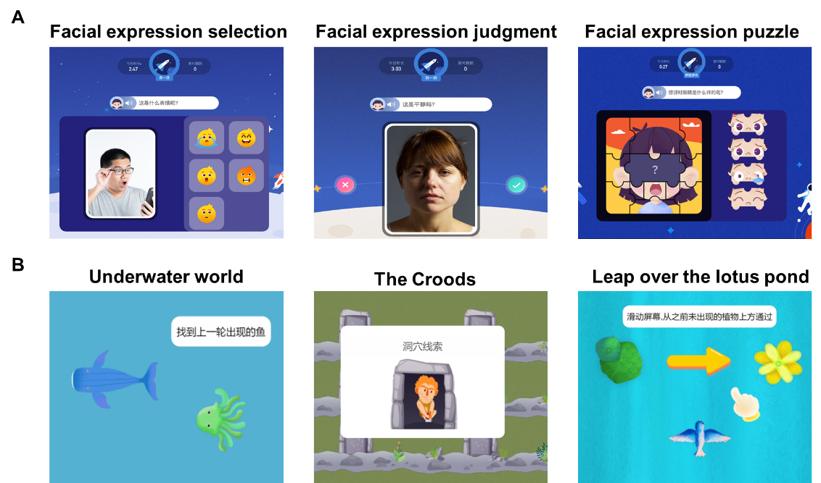
Figure S1
Figure S1 Self-help app-based intervention games provided by Beijing Infinite Brain Technologies. (A) Emotion recognition intervention. This module included three games: (1) Facial expression selection: matching a real person's expression to the correct emoji (happy, sad, angry, fear and neutral); (2) Facial expression judgement: determining if a spoken emotion label correctly matches the person's expression shown; (3) Facial expression puzzle: dragging the correct eyes or mouth into a blank face to complete an expression. (B) Memory intervention. This module included three games based on the n-back paradigm: (1) Underwater world: identifying which underwater animal appeared in the previous trial; (2) The Croods: finding the stimulus behind a gate that matches a cue; （3）Leap over the lotus pond: moving a bird to land on stimuli not seen in the last trial.

Figure S2
Figure S2 Eye-tracking paradigms. (1) Face emotion processing paradigm: Participants were required to observe happy, angry, fearful or neutral static facial expressions, respectively; （2) Dynamic social preference paradigm: Participants viewed simultaneous pairs of social (e.g. people dancing) alongside non-social geometric videos; (3) Joint attention paradigm: Participants watched videos depicting individuals using eye-gaze or a combination of eye-gaze and finger pointing to direct their attention towards target objects; (4) Social bonding paradigm: Participants observed videos of parent-child social interactions presented alongside static images of toys; (5) Restricted and repetitive social (RRS) paradigm: Participants viewed concurrent videos of stereotypical social behaviors (e.g., a child spinning) and repetitive non-social motions (e.g., a spinning fan).

