Supplementary material 2 (S2) of the CMT solution of off-fault aftershock sequence: CMT solution sample of #5 shown in Table 2 and Fig. 9.
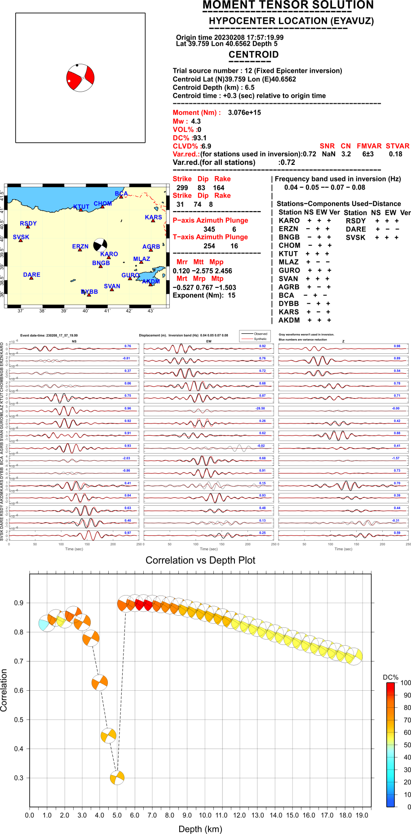
Figure S2. CMT solution (#5 in Table 2, Fig. 9) shows source mechanisms, frequency range, station components-distribution, waveform fits, correlation vs focal depth search (DC%), the same as those in Figs. S3-S8.

S3: CMT solution sample of #11 shown in Table 2 and Fig. 9;
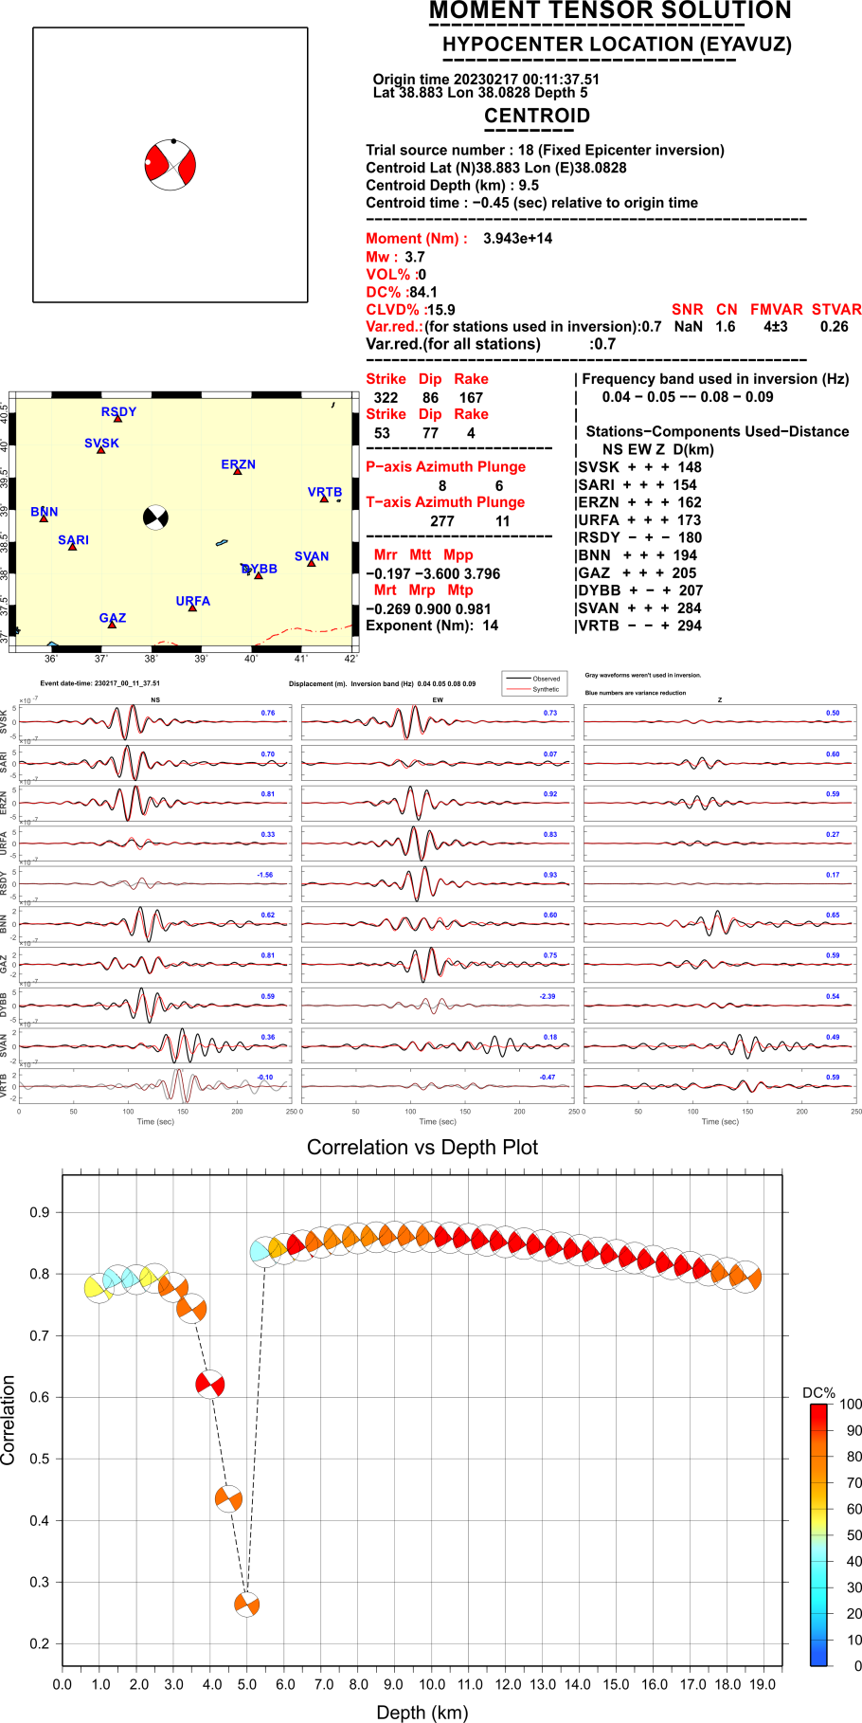
Figure S3.
S4: CMT solution sample of #12 shown in Table 2 and Fig. 9;
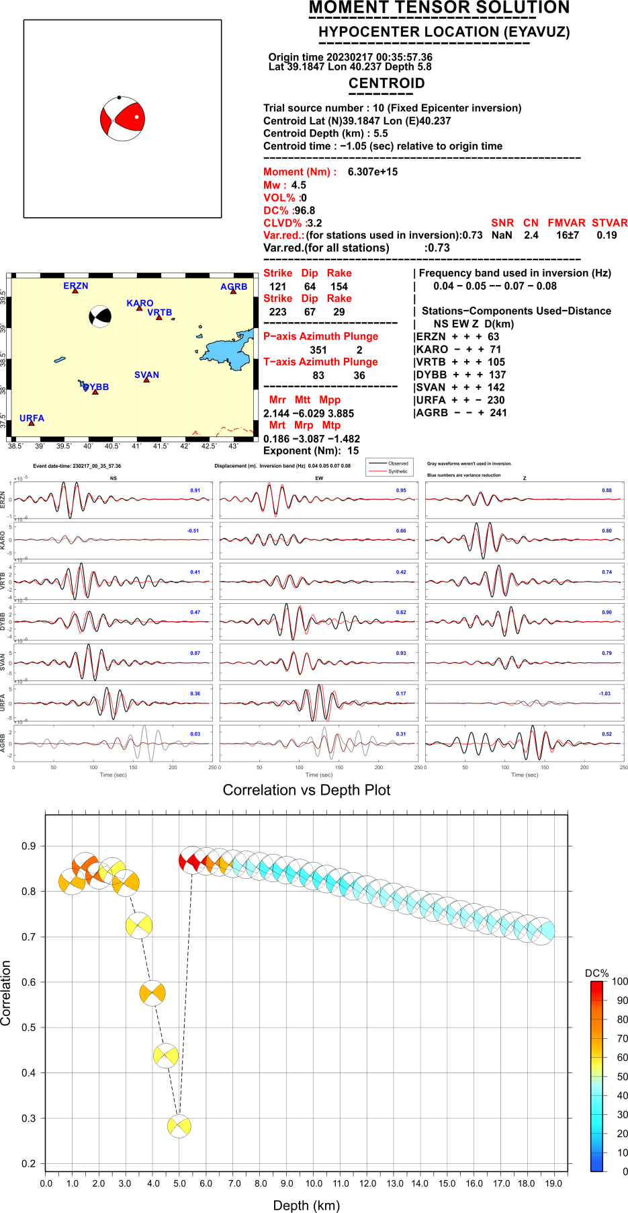
Figure S4.
S5: CMT solution sample of #17 shown in Table 2 and Fig. 9;
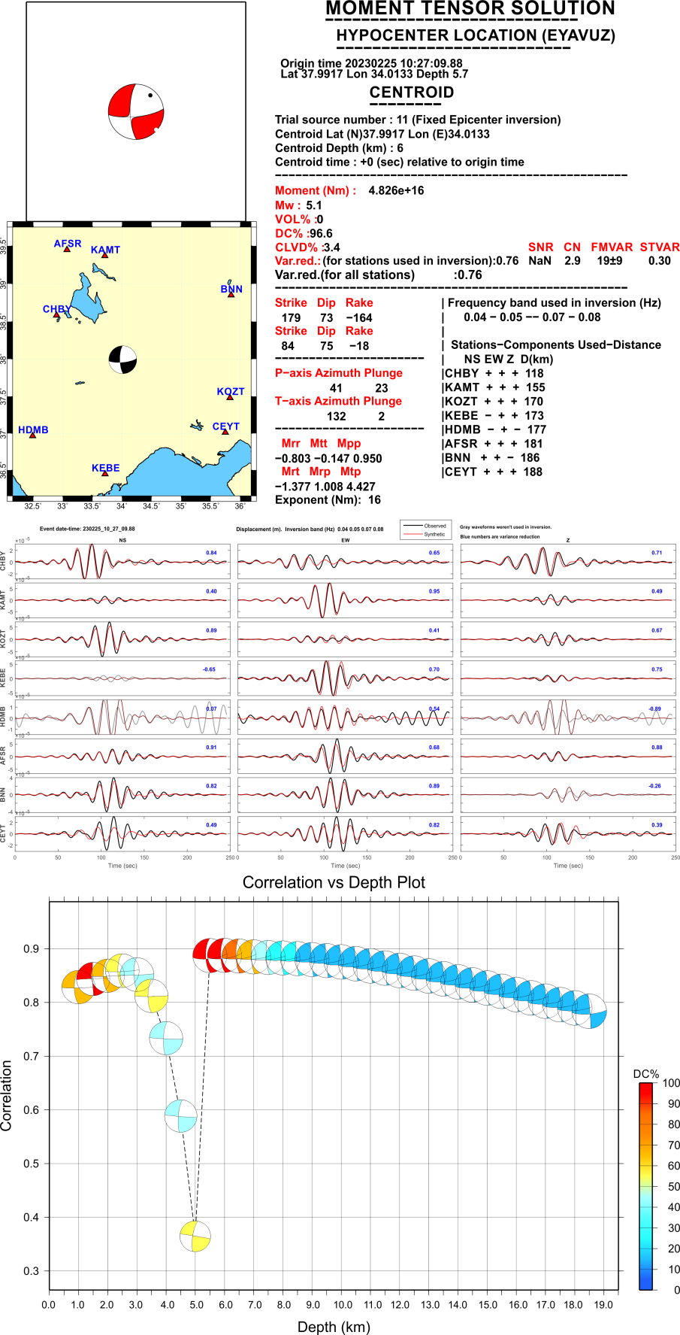
Figure S5.
S6: CMT solution sample of #18 shown in Table 2 and Fig. 9;
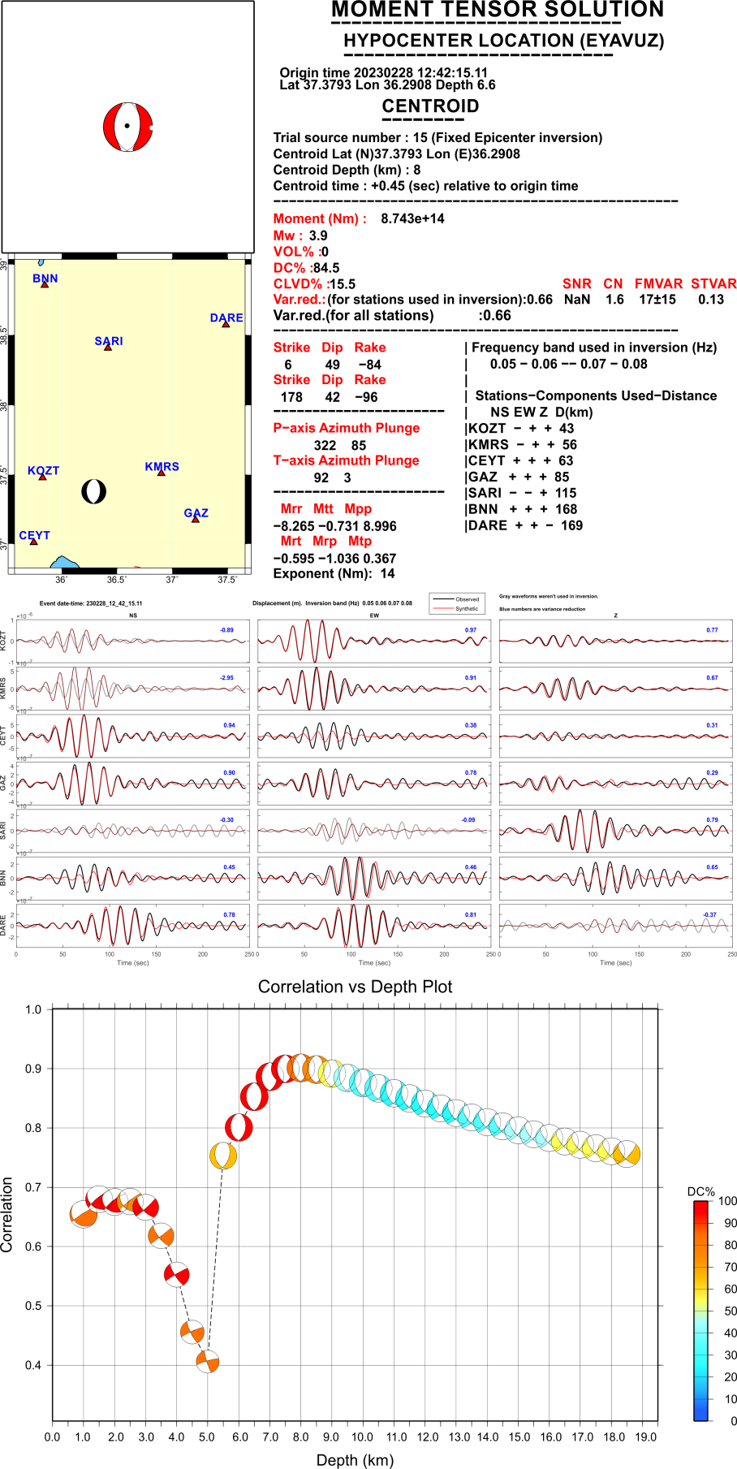
Figure S6.
S7: CMT solution sample of #38 shown in Table 2 and Fig. 9;
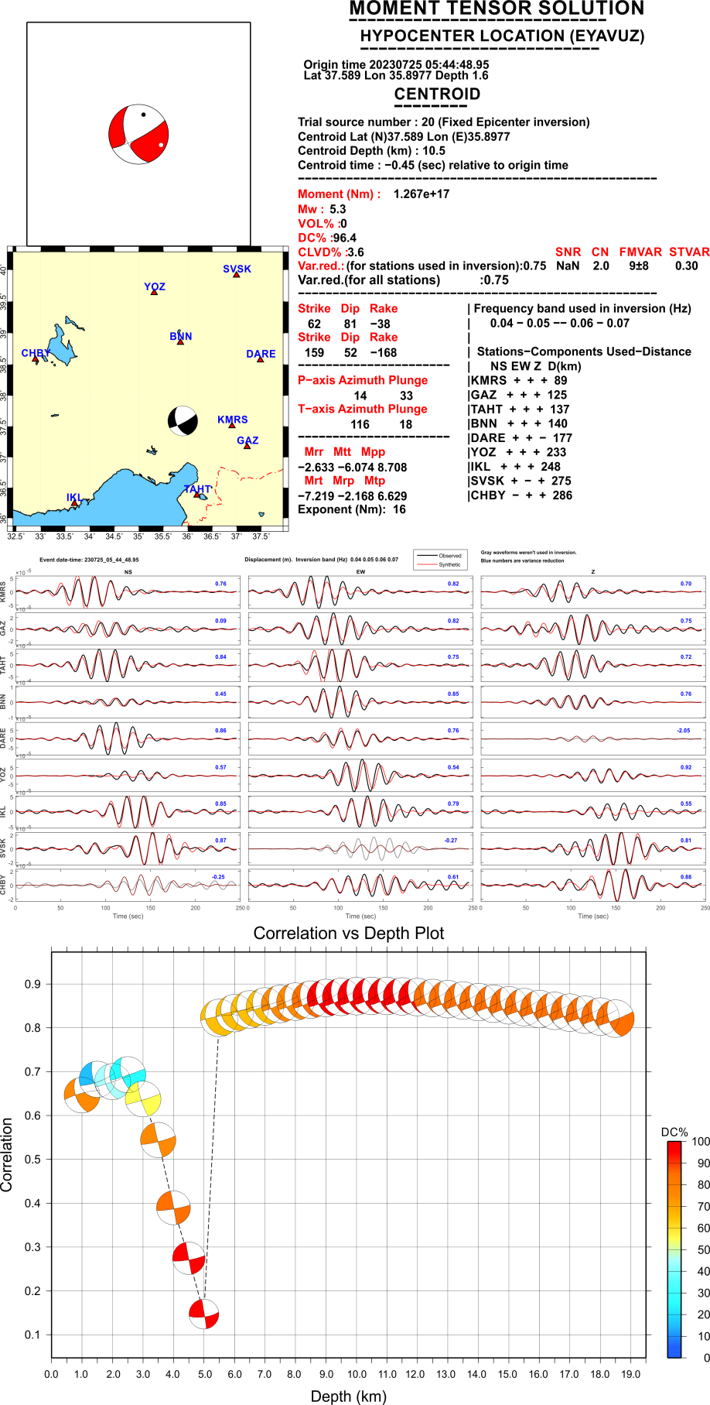
Figure S7.
S8: CMT solution sample of #40 shown in Table 2 and Fig. 9;
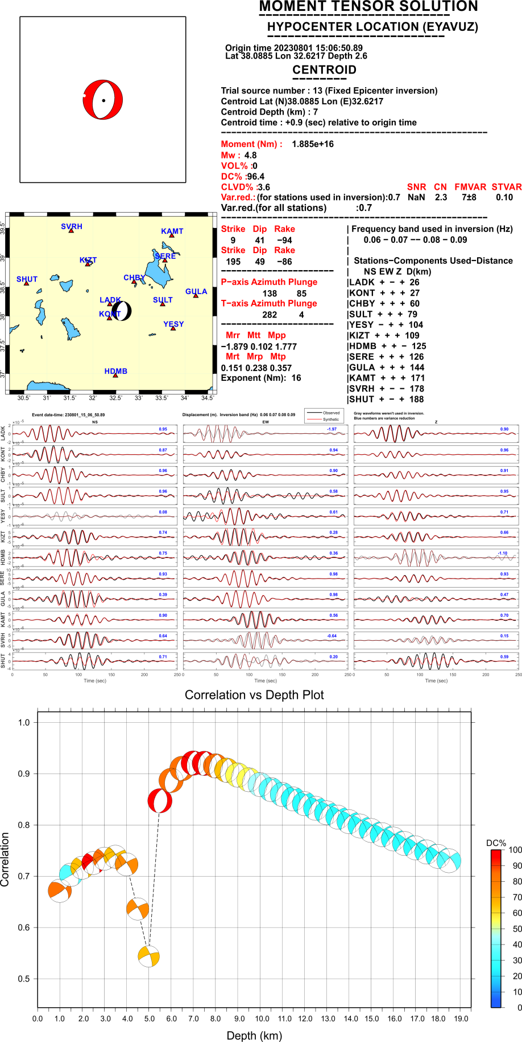
Figure S8.

