Supplementary material 1 (S1) of the GPS data: the selected samples of the time series of the used stations (2009-2022), BTMN, ERGN, ERZ2, FEEK, HORS, ONIY, RDIY, VIR2, show the quality of the processed GPS data and the calculated velocity components (V_{north}, V_{east}, V_{up}) associated with the velocity uncertainties, less than ~1 mm/year, Weighted Root Mean Square (WRMS), less than ~8 mm/year, and Normalized Root Mean Square (NRMS), less than ~5 mm/year, while the northern and eastern components range from ~160 to -160 mm.
The time series logging document of the used GPS sites and further details are provided by https://www.harita.gov.tr/public/sunum/ and detailed geodetic measurements associated with used methods such as the 2D-/3D datum and coordinate transformations from WGS84 to ED50 (and vice versa) are given by https://www.harita.gov.tr/temel-jeodezik-hesaplamalar
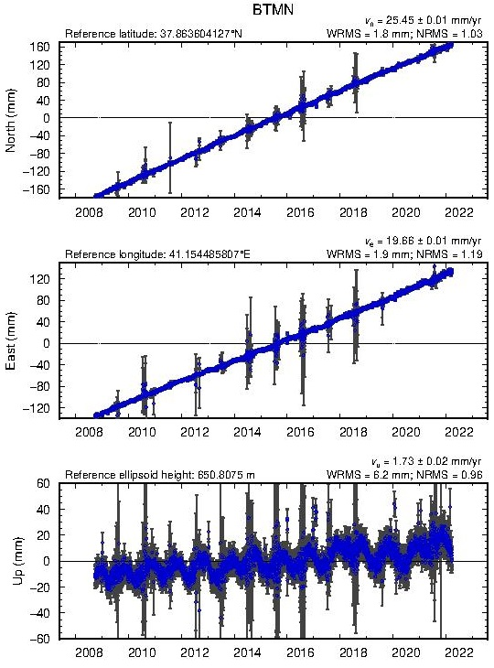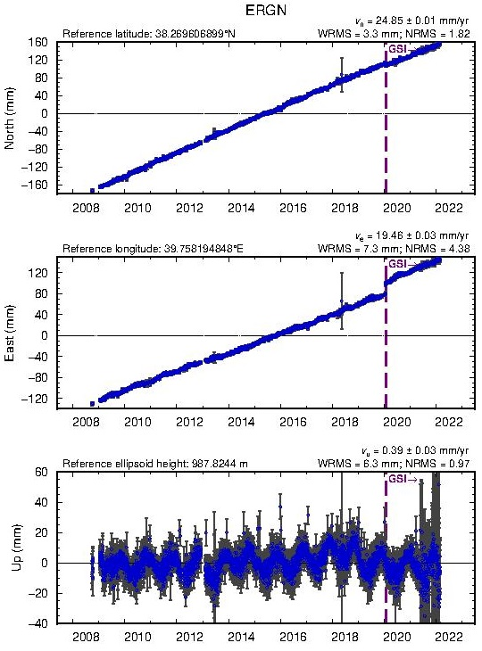

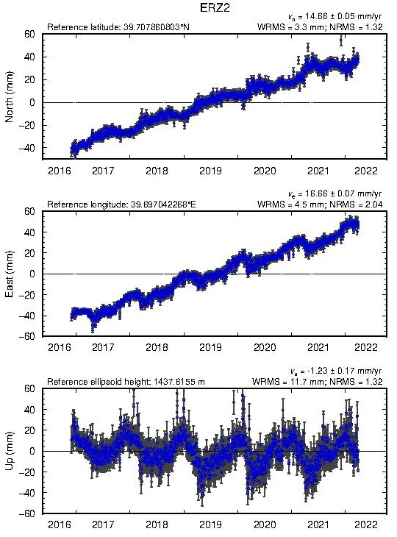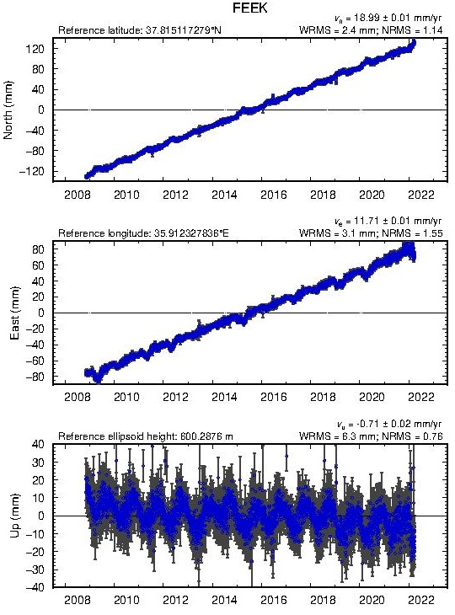
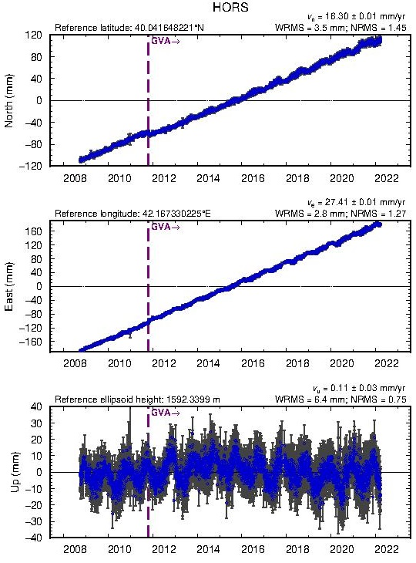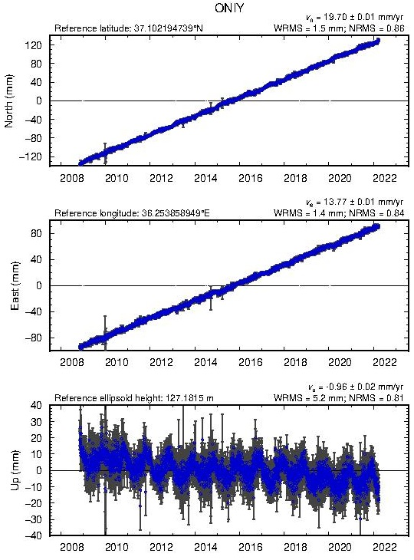
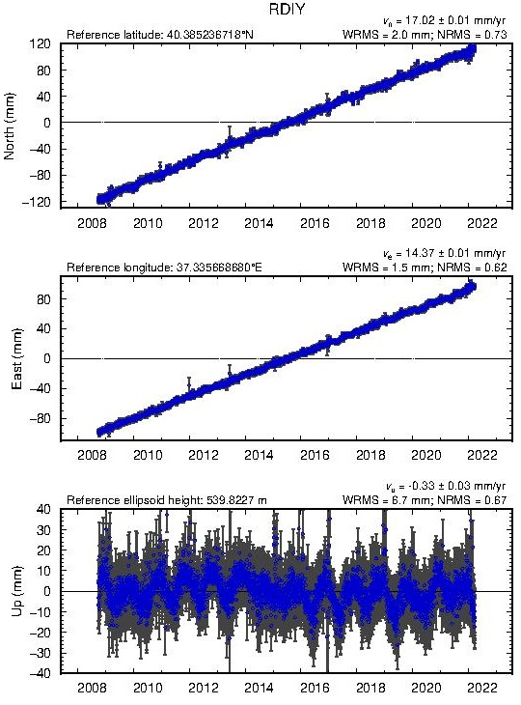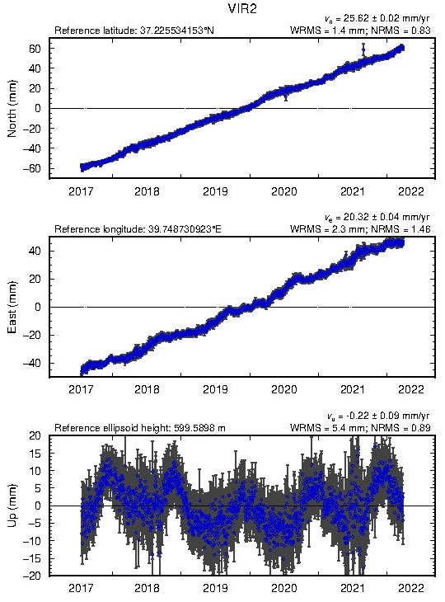
Fig. S1. The time series of the selected stations, the velocity components (mm/year) and displacements (mm) between 2009 and 2022, BTMN, ERGN, ERZ2, FEEK, HORS, ONIY, RDIY, VIR2, showing the high accuracy of the GNSS site measurements.

