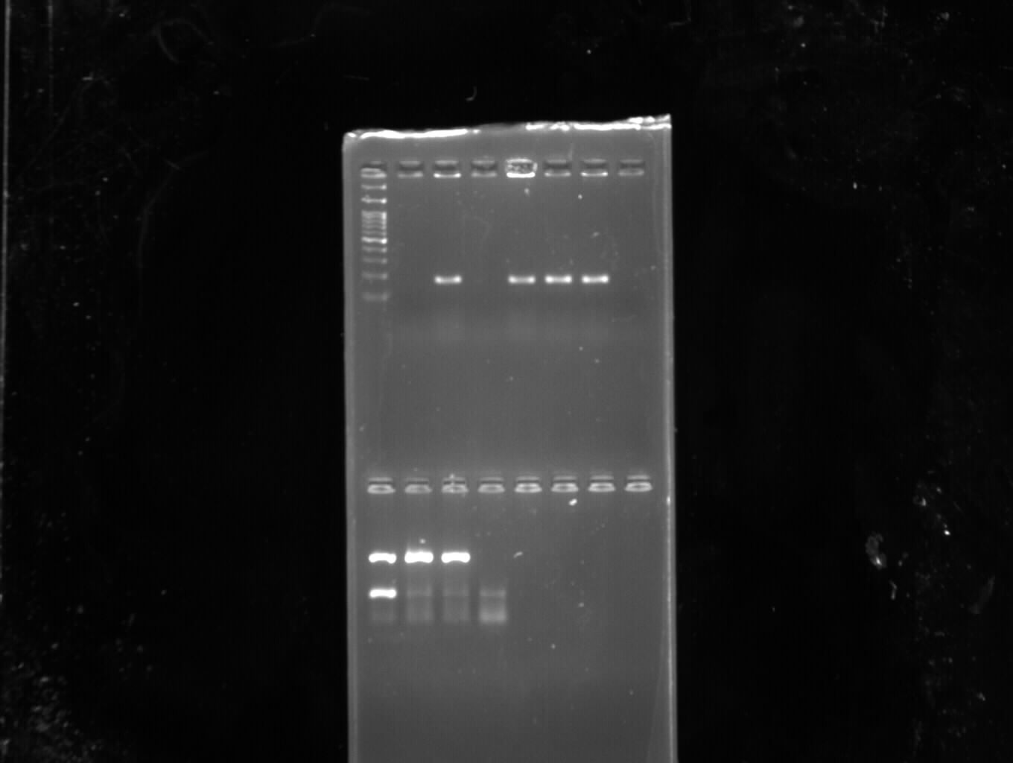

Photograph 4: PCR amplification of agr III gene in staphylococcal isolates

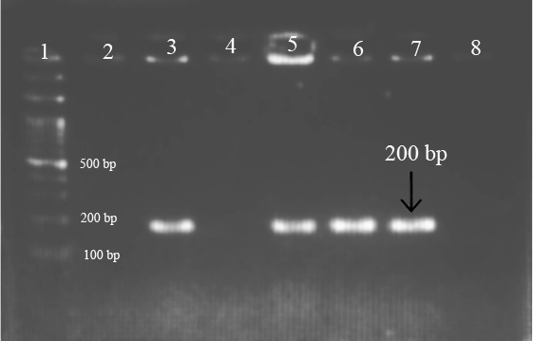

Photograph 4: PCR amplification of agr III gene in staphylococcal isolates

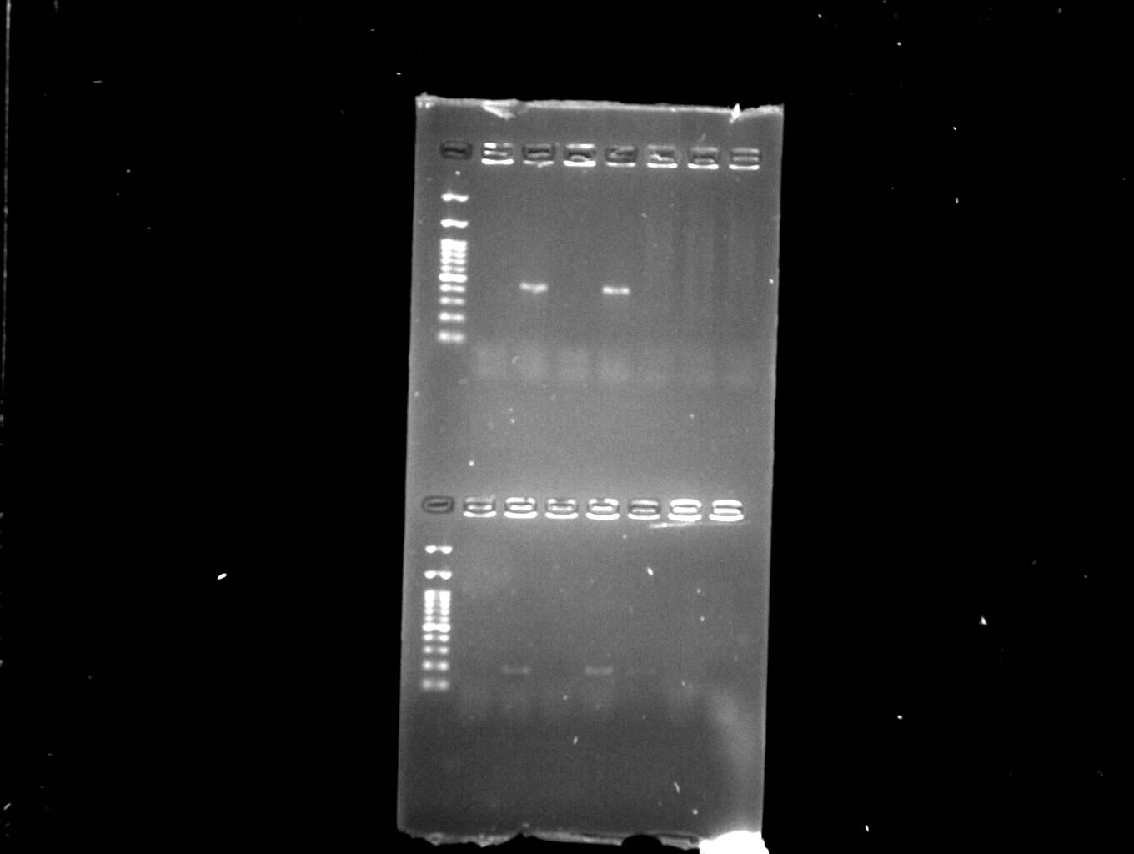

Photograph 2: PCR amplification of agr I gene in staphylococcal isolates

Photograph 2: PCR amplification of agr I gene in staphylococcal isolates

Photograph 5: PCR amplification of agr IV gene in staphylococcal isolates

Photograph 3: PCR amplification of agr II gene in staphylococcal isolates

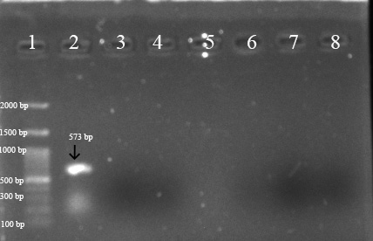

Photograph 3: PCR amplification of agr II gene in staphylococcal isolates

