Supplementary Materials

Table S1. General population data¹
Age groups | Population size
<12 months | 362,358
12–23 months | 384,107
24–35 months | 402,455
36–47 months | 441,107
48–59 months | 422,889
5–17 years | 4,889,576
18–34 years | 4,412,336
35–49 years | 4,084,912
50–64 years | 3,013,783
≥65 years | 1,869,876
Total | 20,283,399

Table S2. Incoming birth cohort data²
Year in model | Number of <12-month-olds in incoming birth cohort
Year 2 | 362,358
Year 3 | 357,968
Year 4 | 355,522
Year 5 | 353,442
Year 6 | 353,472
Year 7 | 355,236
Year 8 | 357,368
Year 9 | 360,695
Year 10 | 364,726

Table S3. IPD serotype distribution³
 | PCV10 | PCV13 | PCV15 | PCV20
2-17 years | 20% | 60% | 70% | 80%
18-57 years | 16% | 52% | 52% | 66%
58+ years | 13% | 62% | 69% | 87%
Abbreviation: PCV, pneumococcal conjugate vaccine
Note: the serotype distribution children of <2years of age used in the model was assumed to be the same as 2-17 years

Table S4. Utility parameters
QALY decrements
0–17 years⁴⁻⁶ | 0.023 | 0.008 | 0.006 | 0.004 | 0.005
≥18 years^{7,8} | 0.130 | 0.130 | 0.130 | 0.045 | -
Baseline utilities⁹ | <18 years | 18–34 years | 35–49 years | 50–64 years | 65+ years
Female | 0.91 | 0.90 | 0.84 | 0.76 | 0.61
Male | 0.91 | 0.91 | 0.85 | 0.78 | 0.67
Abbreviations: QALY, quality-adjusted life years

Table S5. Alternative input parameters for hospitalized and non-hospitalized pneumonia incidence (2022).
Age | IPD incidence ¹⁰ |  | Proportion of meningitis¹⁰
Age | Base case | Scenario* | Base case | Scenario*
<12 months | 18.3 | 10.9 | 2.60% | 4.20%
12-23 months | 11.9 | 7.4 | 3.10% | 5.10%
24-35 months | 12.3 | 7.8 | 4.10% | 6.60%
36-47 months | 12.9 | 8.4 | 4.90% | 8.00%
48-59 months | 13.4 | 8.9 | 5.70% | 9.30%
5 - 17 years | 8.4 | 5.1 | 2.60% | 4.50%
18 - 34 years | 12.5 | 9.1 | 9.80% | 15.30%
35 - 49 years | 21.1 | 12.5 | 1.80% | 3.00%
50 - 64 years | 29.6 | 17.4 | 1.60% | 2.70%
65+ years | 36.5 | 20.2 | 2.60% | 2.70%
The proportion of bacteremic pneumonia (not caused by S.pne) was 20% in KZH adults and this was assumed across all ages. This assumption was used to extract the number of bacteremic pneumonia caused by S.pne in Kazakhstan to obtain representative incidences for bacteremia
Table S6. Alternative discount rate estimates.
Parameter | Base case | Scenario
Cost discount rate | 5% | 1%-10%
Health discount rate | 5% | 1%-10%

Table S7. Alternative direct effects for PCV10-SII.
 | Base Case |  | Scenario¶
 | Post-primary dose VE (<12 months) | Post-booster dose VE (<2 years) | Post-primary dose VE (<12 months) | Post-booster dose VE (<2 years)
IPD¹¹ | 37.3% | 49.3% | 47.6% | 62.9%
All-cause inpatient pneumonia¹² | 10.7% | 14.2% | 13.7% | 18.1%
All-cause outpatient pneumonia¹³ | 2.5% | 3.3% | 3.2% | 4.3%
All-cause AOM¹⁴ | 5.9% | 4.3% | 4.2% | 5.5%

Table S8. Alternative indirect effects for PCV10-SII.
 |  | <18 years | 18-34 years | 35-64 years | ≥65 years
IPD ¹⁵ | Base case | 46.1% | 48.9% | 42.8% | 40.6%
IPD ¹⁵ | Scenario | 58.9% | 62.4% | 54.6% | 51.8%
All-cause inpatient pneumonia^{16,17} | Base case | 16.4% | 8.3%
All-cause inpatient pneumonia^{16,17} | Scenario | 21.6% | 10.6%
All-cause outpatient pneumonia^{16,17} | Base case | 12.5% | 0.0%
All-cause outpatient pneumonia^{16,17} | Scenario | 15.9%
All-cause AOM¹⁸ | Base case | 11.1% | 0.0%
All-cause AOM¹⁸ | Scenario | 14.2%

Figure S1. Deterministic sensitivity analysis results for PCV20-PFE 2+1 vs PCV10-SII 3+0
- DSA cost results

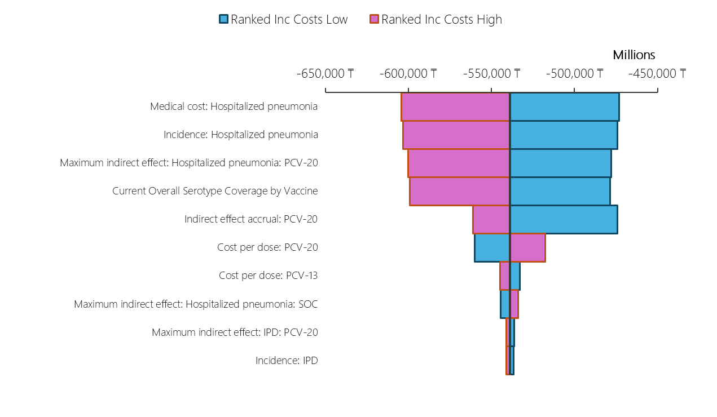
- DSA QALY result

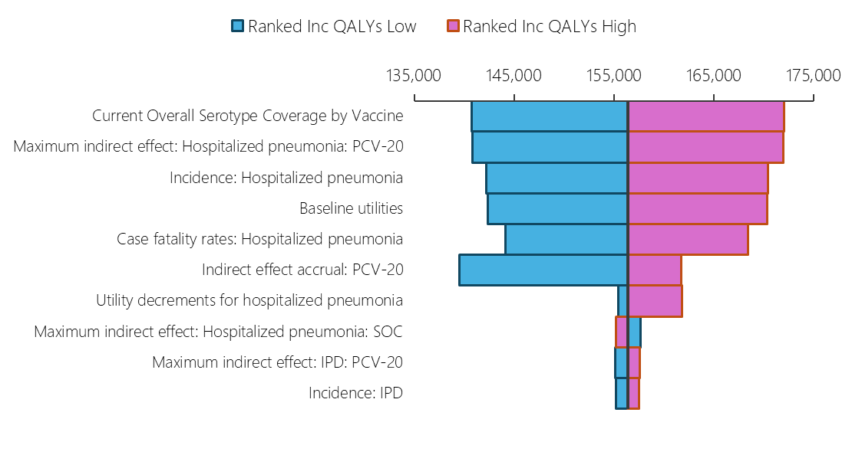

Figure S2. Deterministic sensitivity analysis results for PCV20-PFE 3+1 vs PCV10-SII 3+0
- DSA cost results
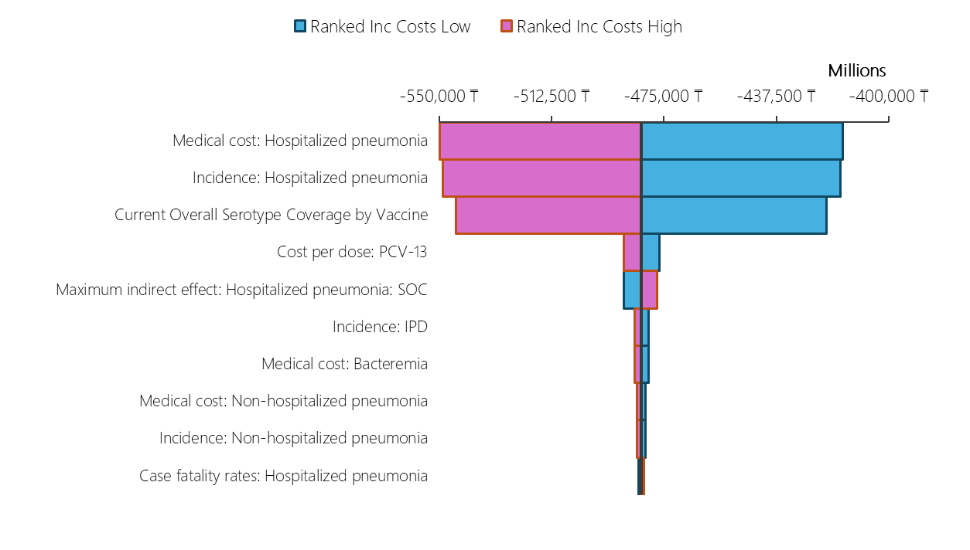
- DSA QALY result

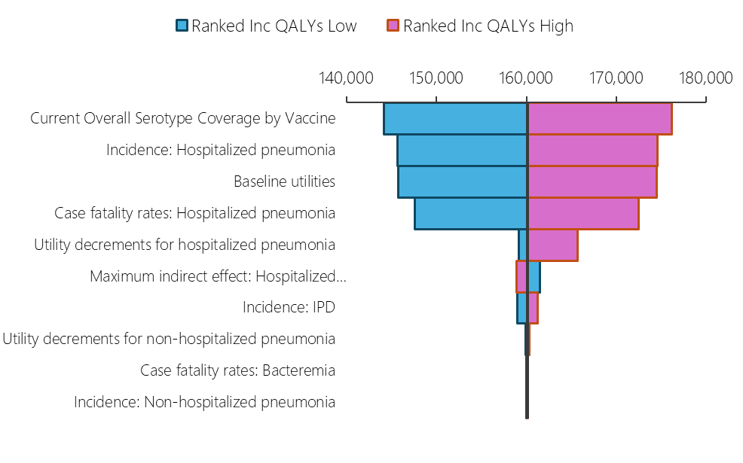

Figure S3. Probabilistic sensitivity analysis cost-effectiveness plane for PCV20-PFE 2+1 vs PCV10-SII 3+0 and PCV20-PFE 3+1 vs PCV10-SII 3+0
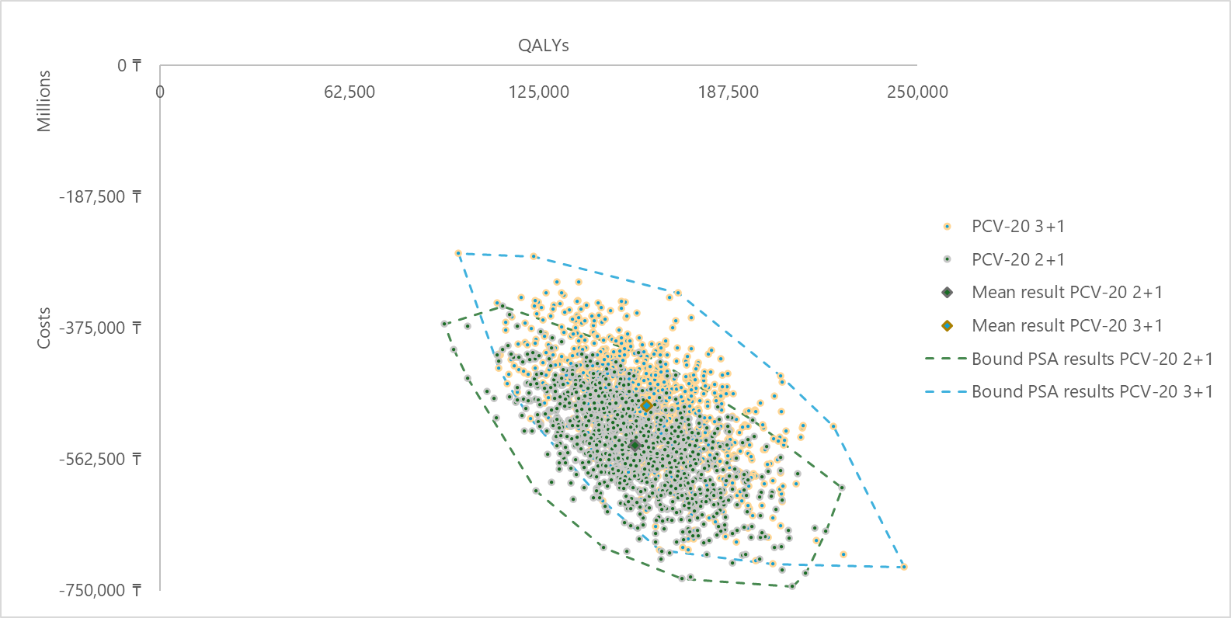

Table S9. PSA summary of results
 | PCV20-PFE 2+1 | PCV20-PFE 3+1
Proportion per quadrant Vs SoC :PCV10-SII 3+0
Less Costly / More Effective | 100% | 100%
QALY results summary Vs SoC: PCV10-SII 3+0
Base Values | 156,355 | 160,116
Mean Values | 156,616 | 160,671
Cost results summary Vs SoC: PCV10-SII 3+0
Base Values | -538,765,413,162 ₸ | -482,527,936,942 ₸
Mean Values | -542,166,843,642 ₸ | -486,266,871,028 ₸

References

- Bureau of National statistics. Agency for Strategic planning and reforms of the Republic of Kazakhstan. (Date of change: 06.10.2025)
- United Nations, Department of Economic and Social Affairs, Population Division (2024)-Kazakhstan. World Population Prospects 2024, Online Edition.
- National Reference Centre. Analýza epidemiologickej situácie a činnosti odborov epidemiológie v Slovenskej republike za rok 2019. 2019 30 June 2023]; Available from: https://www.uvzsr.sk/documents/d/ruvzbb/vs_2019_nrc_pneumokoky.
- Melegaro, A. and W.J. Edmunds, Cost-effectiveness analysis of pneumococcal conjugate vaccination in England and Wales. Vaccine, 2004. 22(31-32): p. 4203-14.
- Rozenbaum, M.H., et al., Cost effectiveness of pneumococcal vaccination among Dutch infants: an economic analysis of the seven valent pneumococcal conjugated vaccine and forecast for the 10 valent and 13 valent vaccines. Bmj-British Medical Journal, 2010. 340.
- Stoecker, C., et al., Cost-effectiveness of using 2 vs 3 primary doses of 13-valent pneumococcal conjugate vaccine. Pediatrics, 2013. 132(2): p. e324-32.
- Mangen, M.J., et al., The impact of community-acquired pneumonia on the health-related quality-of-life in elderly. BMC Infect Dis, 2017. 17(1): p. 208.
- Mangen, M.J., et al., Cost-effectiveness of adult pneumococcal conjugate vaccination in the Netherlands. Eur Respir J, 2015. 46(5): p. 1407-16.
- Zrubka, Z., et al., Towards a Central-Eastern European EQ-5D-3L population norm: comparing data from Hungarian, Polish and Slovenian population studies. The European Journal of Health Economics, 2019. 20: p. 141-154.
- Data provided to Pfizer.
- Savulescu, C., et al., Effectiveness of 10 and 13-valent pneumococcal conjugate vaccines against invasive pneumococcal disease in European children: SpIDnet observational multicentre study. Vaccine, 2022. 40(29): p. 3963-3974.
- Hansen, J., et al., Effectiveness of heptavalent pneumococcal conjugate vaccine in children younger than 5 years of age for prevention of pneumonia: updated analysis using World Health Organization standardized interpretation of chest radiographs. Pediatr Infect Dis J, 2006. 25(9): p. 779-81.
- Black, S.B., et al., Effectiveness of heptavalent pneumococcal conjugate vaccine in children younger than five years of age for prevention of pneumonia. Pediatr Infect Dis J, 2002. 21(9): p. 810-5.
- Black, S., et al., Efficacy, safety and immunogenicity of heptavalent pneumococcal conjugate vaccine in children. Northern California Kaiser Permanente Vaccine Study Center Group. Pediatr Infect Dis J, 2000. 19(3): p. 187-95.
- Ladhani, S.N., et al., Rapid increase in non-vaccine serotypes causing invasive pneumococcal disease in England and Wales, 2000–17: a prospective national observational cohort study. The Lancet Infectious Diseases, 2018. 18(4): p. 441-451.
- Levy, C., et al., Impact of PCV13 on community-acquired pneumonia by C-reactive protein and procalcitonin levels in children. Vaccine, 2017. 35(37): p. 5058-5064.
- Rodrigo, C., et al., Impact of infant 13-valent pneumococcal conjugate vaccine on serotypes in adult pneumonia. Eur Respir J, 2015. 45(6): p. 1632-41.
- Lau, W.C., et al., Impact of pneumococcal conjugate vaccines on childhood otitis media in the United Kingdom. Vaccine, 2015. 33(39): p. 5072-9.

