Supplementary file

Revealing Genetic Diversity in the Rice Breeding Lines (Oryza sativa x O. rufipogon) Based on Whole Genome Sequencing Variants (SNPs/InDels)

Shukdeb Sarkar, Jayita Sarkar, Bhumika T. Yonzon, Pankaj Shil, and Subhas Chandra Roy*

Plant Genetics & Molecular Breeding Laboratory, Department of Botany, University of North Bengal, Siliguri-734013, India

*Correspondence:subhascr2011@gmail.com

Supplementary Table 1: Description of the libraries
Sl. No. | Sample ID | Qubit Conc. (ng/ul) | Vol (ul) | Yield (ng) | Barcode 1 | Index Sequence 1 | Barcode 2 | Index Se-quence 2
1 | Yamuna | 25.2 | 10 | 252 | 244 | TCTGTTCTCG | 244 | CGTGAATCGC
2 | Wild Rice | 22.6 | 10 | 226 | 245 | GATACTTCAC | 245 | GAGCAGCCTT
3 | YR 13 | 21.6 | 10 | 216 | 246 | AGTGCTGATA | 246 | TCGATTACCA
4 | YR 32 | 20.4 | 10 | 204 | 247 | ATCCTTCGGT | 247 | CAGTCCAATT

Supplementary Table 2:Number of changes by type for Wild rice, Yamuna, YR13 and YR32
Type |  | Wild | Yamuna | YR13 | YR32
SNP | Total - | 399570 | 540839 | 1209121 | 781711
SNP | Homo - | 59501 | 190208 | 168522 | 101420
SNP | Hetero - | 340069 | 350631 | 1040599 | 680291
MNP | Total - | 223 | 289 | 486 | 313
MNP | Homo - | 0 | 0 | 0 | 0
MNP | Hetero - | 223 | 289 | 486 | 313
INS | Total - | 24576 | 32704 | 87218 | 52324
INS | Homo - | 3852 | 13627 | 11021 | 6472
INS | Hetero - | 20724 | 19077 | 76197 | 45852
DEL | Total - | 28441 | 35864 | 97076 | 60318
DEL | Homo - | 3160 | 12962 | 9713 | 5783
DEL | Hetero - | 25281 | 22902 | 87363 | 54535
Total | Homo | 66,513 | 216,797 | 189,256 | 113,675
Total | Hetero | 386,297 | 392,899 | 1,204,645 | 780,991
Total | Grand Total | 452,810 | 609,696 | 1,393,901 | 894,666
SNP: Single Nucleotide Polymorphism, MNP: Multiple Nucleotide Polymorphism, INS: Insertion and DEL: Deletion

Supplementary Table 3: Ts/Tv (Transitions/Transversions) for Wild rice, Yamuna, YR13 and YR32
Type | Wild | Yamuna | YR13 | YR32
Transitions (Ts) | 283790 | 386213 | 857297 | 556506
Transversions (Tv) | 115780 | 154626 | 351824 | 225205
Ts/Tv ratio | 2.451 | 2.497 | 2.436 | 2.471

Supplementary Table 4: Number of effects by type and region for Wild rice, Yamuna, YR13 and YR32
Type |  | Wild | Yamuna | YR13 | YR32
Downstream - | Count - | 389537 | 523212 | 1226174 | 782875
Downstream - | Percent - | 30.80% | 30.76% | 30.74% | 30.80%
Exon - | Count - | 121445 | 163948 | 312616 | 218705
Exon - | Percent - | 9.60% | 9.64% | 7.84% | 8.60%
Intergenic - | Count - | 249488 | 339580 | 820794 | 509396
Intergenic - | Percent - | 19.73% | 19.97% | 20.58% | 20.04%
Intron - | Count - | 92642 | 122218 | 303952 | 191388
Intron - | Percent - | 7.32% | 7.19% | 7.62% | 7.53%
Splice site acceptor - | Count - | 326 | 492 | 984 | 668
Splice site acceptor - | Percent - | 0.03% | 0.03% | 0.03% | 0.03%
Splice site donar - | Count - | 325 | 474 | 947 | 684
Splice site donar - | Percent - | 0.03% | 0.03% | 0.02% | 0.03%
Upstream - | Count - | 392064 | 528569 | 1258710 | 798521
Upstream - | Percent - | 31.00% | 31.08% | 31.56% | 31.41%
UTR 3 Prime - | Count - | 12000 | 13888 | 41906 | 25701
UTR 3 Prime - | Percent - | 0.95% | 0.82% | 1.05% | 1.01%
UTR 5 Prime - | Count - | 7009 | 8442 | 22744 | 14025
UTR 5 Prime - | Percent - | 0.55% | 0.50% | 0.57% | 0.55%

Supplementary Table 5: Number of effects by impact for Wild rice, Yamuna, YR13 and YR32
Type |  | Wild | Yamuna | YR13 | YR32
High- | Count - | 7765 | 11340 | 21107 | 14675
High- | Percent - | 0.61% | 0.67% | 0.53% | 0.58%
Low- | Count - | 53722 | 70592 | 131643 | 93430
Low- | Percent - | 4.25% | 4.15% | 3.30% | 3.68%
Moderate - | Count - | 61499 | 84077 | 164422 | 113678
Moderate - | Percent - | 4.86% | 4.94% | 4.12% | 4.47%
Modifier- | Count - | 1141865 | 1534830 | 3671713 | 2320234
Modifier- | Percent - | 90.28% | 90.24% | 92.05% | 91.28%

Supplementary Table 6: Number of effects by functional class for Wild rice, Yamuna, YR13 and YR32
Type |  | Wild | Yamuna | YR13 | YR32
Missense - | Count - | 59948 | 82065 | 159415 | 110461
Missense - | Percent - | 52.01% | 52.90% | 54.11% | 53.43%
Nonsense - | Count - | 2522 | 3603 | 6248 | 4601
Nonsense - | Percent - | 2.19% | 2.32% | 2.12% | 2.23%
Silent - | Count - | 52804 | 69465 | 128965 | 91682
Silent - | Percent - | 45.81% | 44.78% | 43.77% | 44.35%

Supplementary Table 7: Gene of interest having significant SNPs
WILD rice
Chrom | Position | Reference | Variant | Type | Zygosity | Gene_ID | Effect | old_AA/new_AA | Old_codon/New_codon | Codon_Num(CDS) | Genes | Trait | Gene/QTL
1 | 38385057 | A | G | SNP | Hom | LOC_Os01g66100 | NON_SYNONYMOUS_CODING | Q/R | cAg/cGg | 340 | Os01g0883800 | Plant height | sd1
7 | 2839810 | C | A | SNP | Het | LOC_Os07g05900 | NON_SYNONYMOUS_CODING | R/L | cGc/cTc | 57 | Os07g0153600 | Prostrate growth | PROG1
7 | 2839811 | G | C | SNP | Het | LOC_Os07g05900 | NON_SYNONYMOUS_CODING | R/G | Cgc/Ggc | 57 | Os07g0153600 | Prostrate growth | PROG1
7 | 2839819 | T | C | SNP | Het | LOC_Os07g05900 | NON_SYNONYMOUS_CODING | K/R | aAg/aGg | 54 | Os07g0153600 | Prostrate growth | PROG1
7 | 2839821 | G | C | SNP | Het | LOC_Os07g05900 | SYNONYMOUS_CODING | A/A | gcC/gcG | 53 | Os07g0153600 | Prostrate growth | PROG1
7 | 2839822 | G | T | SNP | Het | LOC_Os07g05900 | NON_SYNONYMOUS_CODING | A/D | gCc/gAc | 53 | Os07g0153600 | Prostrate growth | PROG1
YAMUNA
Chrom | Position | Reference | Variant | Type | Zygosity | Gene_ID | Effect | old_AA/new_AA | Old_codon/New_codon | Codon_Num(CDS) | Genes
4 | 33073259 | C | T | SNP | Het | LOC_Os04g55560 | NON_SYNONYMOUS_CODING | R/W | Cgg/Tgg | 199 | Os04g0649100 | Heading date | Hd6
4 | 33073259 | C | T | SNP | Het | LOC_Os04g55560 | NON_SYNONYMOUS_CODING | R/W | Cgg/Tgg | 199 | Os04g0649100 | Heading date | Hd6
6 | 9337029 | C | G | SNP | Hom | LOC_Os06g16370 | NON_SYNONYMOUS_CODING | N/K | aaC/aaG | 165 | Os06g0275000 | Heading date | Hd1
11 | 7193692 | G | A | SNP | Hom | LOC_Os11g12740 | SYNONYMOUS_CODING | N/N | aaC/aaT | 623 | Os11g0235200 | Panicle length | SP1
YR 13
Chrom | Position | Reference | Variant | Type | Zygosity | Gene_ID | Effect | old_AA/new_AA | Old_codon/New_codon | Codon_Num(CDS) | Genes
1 | 31556517 | G | T | SNP | Het | LOC_Os01g54860 | SYNONYMOUS_CODING | T/T | acC/acA | 22 | Os01g0752200 | Grain number | NOG1
1 | 36447526 | A | G | SNP | Het | LOC_Os01g62920 | SYNONYMOUS_CODING | L/L | Tta/Cta | 385 | Os01g0848400 | Seed shattering | qSH1
2 | 28863920 | C | A | SNP | Het | LOC_Os02g47280 | SYNONYMOUS_CODING | L/L | ctG/ctT | 326 | Os02g0701300 | Grain size | GS2
2 | 28863920 | C | A | SNP | Het | LOC_Os02g47280 | SYNONYMOUS_CODING | L/L | ctG/ctT | 298 | Os02g0701300 | Grain size | GS2
3 | 31566439 | A | G | SNP | Het | LOC_Os03g55490 | SYNONYMOUS_CODING | E/E | gaA/gaG | 110 | Os03g0762000 | Heading date | Hd6
3 | 31566439 | A | G | SNP | Het | LOC_Os03g55490 | SYNONYMOUS_CODING | E/E | gaA/gaG | 110 | Os03g0762000 | Heading date | Hd6
4 | 33073441 | G | A | SNP | Het | LOC_Os04g55560 | SYNONYMOUS_CODING | K/K | aaG/aaA | 226 | Os04g0649100 | Heading date | Hd6
4 | 33073441 | G | A | SNP | Het | LOC_Os04g55560 | SYNONYMOUS_CODING | K/K | aaG/aaA | 226 | Os04g0649100 | Heading date | Hd6
6 | 6652370 | G | A | SNP | Het | LOC_Os04g57530 | SYNONYMOUS_CODING | G/G | ggC/ggT | 103 | Os04g0670900 | Seed shattering | SH4
6 | 9337101 | C | T | SNP | Het | LOC_Os06g16370 | SYNONYMOUS_CODING | V/V | gtC/gtT | 189 | Os06g0275000 | Heading date | Hd1
6 | 9337148 | G | A | SNP | Hom | LOC_Os06g16370 | NON_SYNONYMOUS_CODING | R/Q | cGg/cAg | 205 | Os06g0275000 | Heading date | Hd1
6 | 9338330 | G | A | SNP | Het | LOC_Os06g16370 | NON_SYNONYMOUS_CODING | G/S | Ggt/Agt | 387 | Os06g0275000 | Heading date | Hd1
7 | 800963 | G | A | SNP | Het | LOC_Os07g02350 | SYNONYMOUS_CODING | I/I | atC/atT | 240 | Os07g0114400 | Phosphorus uptake | Pstol
YR 32
Chrom | Position | Reference | Variant | Type | Zygosity | Gene_ID | Effect | old_AA/new_AA | Old_codon/New_codon | Codon_Num(CDS) | Genes
1 | 31556517 | G | T | SNP | Het | LOC_Os01g54860 | SYNONYMOUS_CODING | T/T | acC/acA | 22 | Os01g0752200 | Grain number | NOG1
6 | 6649871 | T | G | SNP | Het | LOC_Os06g12310 | SYNONYMOUS_CODING | A/A | gcA/gcC | 201 | Os02g0745100 | Hull color | Lsi1
6 | 9338068 | A | C | SNP | Hom | LOC_Os06g16370 | NON_SYNONYMOUS_CODING | R/S | agA/agC | 299 | Os06g0275000 | Heading date | Hd1
7 | 800963 | G | A | SNP | Het | LOC_Os07g02350 | SYNONYMOUS_CODING | I/I | atC/atT | 240 | Os07g0114400 | Phosphorus uptake | Pstol
8 | 20382857 | A | T | SNP | Het | LOC_Os08g32870 | NON_SYNONYMOUS_CODING | K/I | aAa/aTa | 244 | Os08g0424500 | Aroma | Badh2
11 | 7193921 | C | A | SNP | Hom | LOC_Os11g12740 | NON_SYNONYMOUS_CODING | G/V | gGc/gTc | 547 | Os11g0235200 | Panicle length | SP1
11 | 7193923 | G | A | SNP | Hom | LOC_Os11g12740 | SYNONYMOUS_CODING | D/D | gaC/gaT | 546 | Os11g0235200 | Panicle length | SP1
11 | 7193929 | C | G | SNP | Hom | LOC_Os11g12740 | SYNONYMOUS_CODING | S/S | tcG/tcC | 544 | Os11g0235200 | Panicle length | SP1
11 | 7194160 | T | C | SNP | Hom | LOC_Os11g12740 | SYNONYMOUS_CODING | A/A | gcA/gcG | 467 | Os11g0235200 | Panicle length | SP1

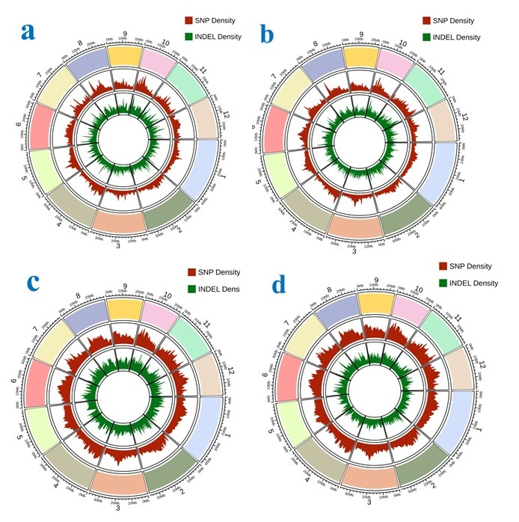
Supplementary Figure 1. An annotated Circos plot depicts the distribution pattern of SNP and InDel variants in rice lines. The outermost circle represents 12 chromosomes of the rice genome. The middle red circle represent the SNP density and innermost green circle represent the InDel density identified in the rice lines using whole genome sequencing data (a) Yamuna, (b) Wild rice, (c) YR13 and (d) YR32

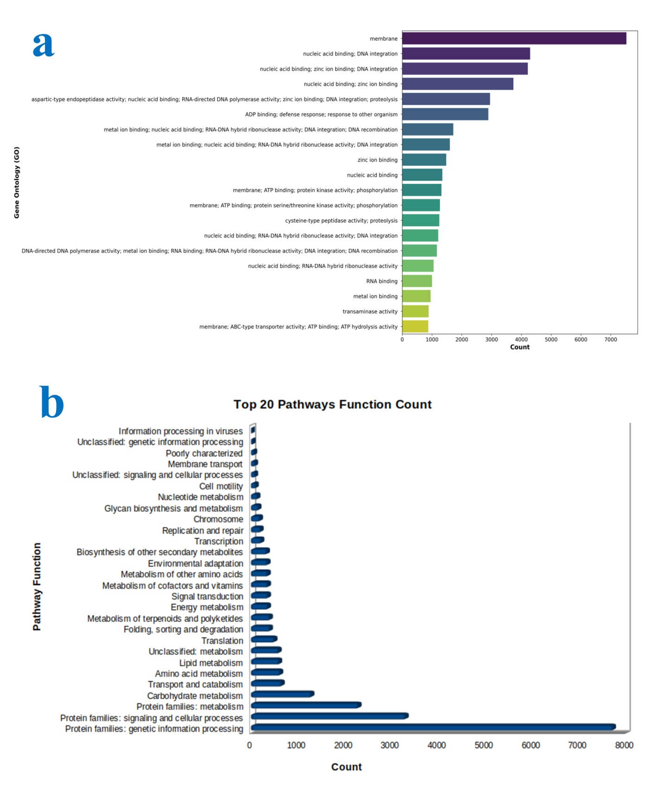
Supplementary Figure 2.Gene Ontology (GO) annotation and KEGG pathway mapping of Yamuna a: GO enrichment analysis for the differentially abundant proteins harboring large effect/nonsynonymous SNPs and InDels in the genes and b: Enrichment map of KEGG pathways in which the differentially abundant proteins participate.
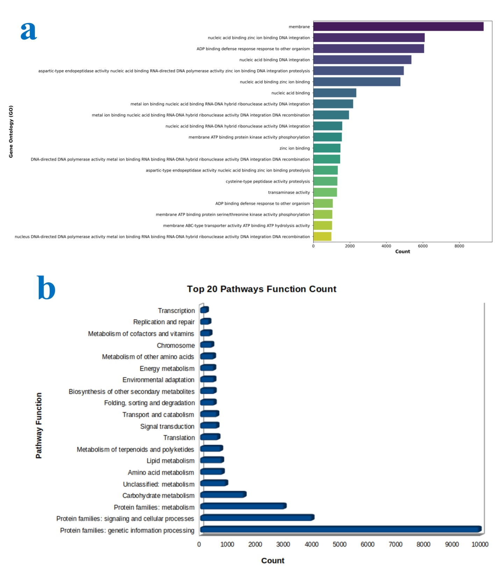
Supplementary Figure 3.Gene Ontology (GO) annotation and KEGG pathway mapping of Wild rice a: GO enrichment analysis for the differentially abundant proteins harboring large effect/nonsynonymous SNPs and InDels in the genes and b: Enrichment map of KEGG pathways in which the differentially abundant proteins participate.

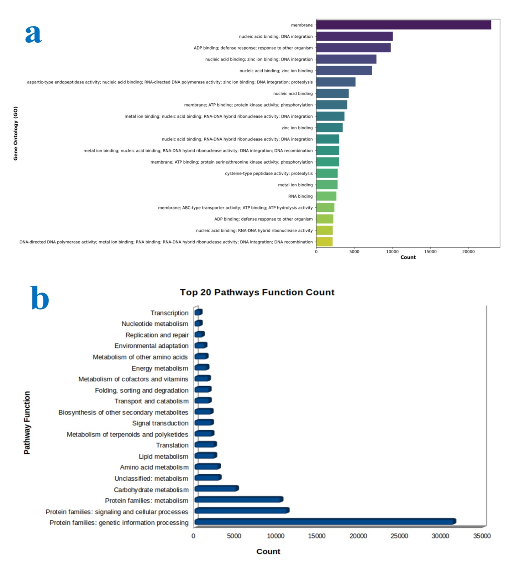
Supplementary Figure 4. Gene Ontology (GO) annotation and KEGG pathway mapping of breeding lines YR13 a: GO enrichment analysis for the differentially abundant proteins harboring large effect/nonsynonymous SNPs and InDels in the genes and b: Enrichment map of KEGG pathways in which the differentially abundant proteins participate.

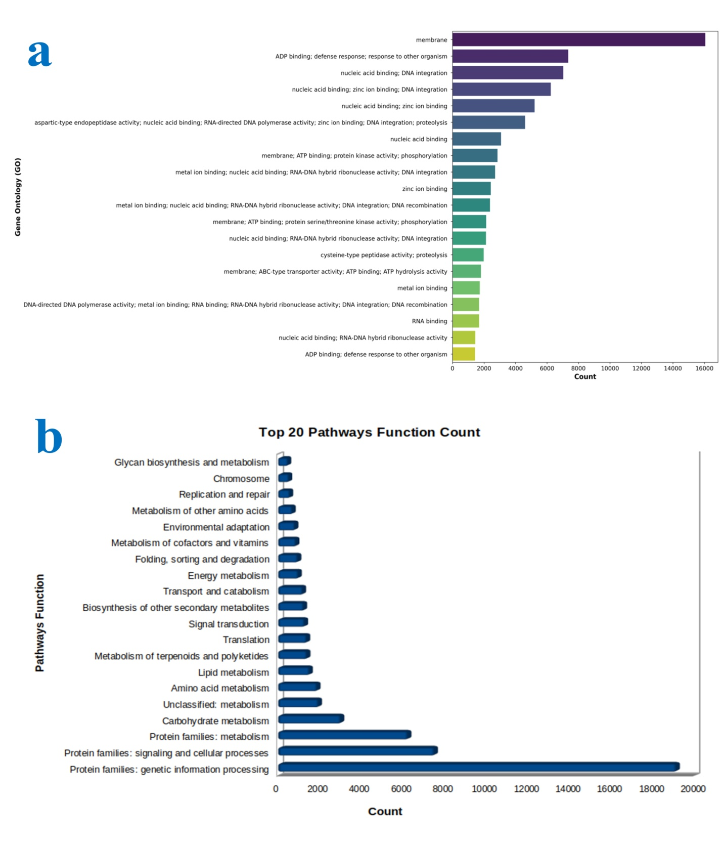Supplementary Figure 5. Gene Ontology (GO) annotation and KEGG pathway mapping of breeding lines YR32 a: GO enrichment analysis for the differentially abundant proteins harboring large effect/nonsynonymous SNPs and InDels in the genes and b: Enrichment map of KEGG pathways in which the differentially abundant proteins participate.

