High-level production of NMN in Escherichia coli through co-utilization of glucose and glycerol

Jiajia Gan^{1,2}, Yongzhi He¹, Yanfeng Zhang³, Jin Zhong^{1,2,}*, Zhiyang Dong^{1,}*, Xiuzhen Chen^{1,}*
¹ State Key Laboratory of Microbial Diversity and Innovative Utilization, Institute of Microbiology, Chinese Academy of Sciences, Beijing, 100101, China
² School of Life Science, University of Chinese Academy of Sciences, Beijing, 100049, China
³ ShenZhen Siyomicro Bio-Tech Co., Ltd, Shenzhen, 518100, China

*Corresponding author
Xiuzhen Chen: chenxiuzhen@im.ac.cn
Zhiyang Dong: dongzy@im.ac.cn
Jin Zhong: zhongj@im.ac.cn

Table S1. Primers used for gene editing.
Name | Sequences (5’-3’)
gRNA-pgi-F | taccagctgatccaccagttttagagctagaaatagca
gRNA-pgi-R | tggtggatcagctggtagaaactagtattatacctaggact
gRNA-pykA-F | cgttcagttcgacaatggttttagagctagaaatagca
gRNA-pykA-R | cattgtcgaactgaacgtccactagtattatacctaggact
gRNA-pykF-F | ccgactcgcgcagaagcgttttagagctagaaatagca
gRNA-pykF-R | gcttctgcgcgagtcgggcgactagtattatacctaggact
gRNA-glpK-F | gtgaactatgcgttggagttttagagctagaaatagca
gRNA-glpK-R | tccaacgcatagttcacttcactagtattatacctaggact
pgi-up-F | catcagaaagcacaatatcagcgc
pgi-up-R | tagcaatactcttctgattttgagaattgtga
pgi-down-F | aaatcagaagagtattgctatcatcgtcgatatgtaggccg
pgi-down-R | cgcaagcgcagatatggcaaa
pykA-up-F | cccacgatgcgatgaataagttctt
pykA-up-R | gtaatactccgttgactgaaacaaccag
pykA-down-F | ttcagtcaacggagtattacgtacgttgccggatgcgg
pykA-down-R | gattatgtctggaacacggtgcg
pykF-up-F | ataacaatatgctttggttcctgcc
pykF-up-R | attaattcacaaaagcaatagacagtcttagtctttaagttgagaaggatg
pykF-down-F | tattgcttttgtgaattaatttgtatatcgaagcg
pykF-down-R | cagtagagtcagcgcagaatg
glpk-up-F | atcgtttcacaagttgccggc
glpk*-up-R | accgcactttccaacgcatagttcacttcg
glpk*-down-F | atgcgttggaaagtgcggtg
glpk-down-R | ggcaaaccgttgagcgaactg
pgi-JD-F | ccaggttccagtccttcagct
pgi-JD-R | gtattagaaccatcaccgccaccg
pykA-JD-F | cattcactggataaatctgccatcaacc
pykA-JD-R | ccgtcgatattcctgccatgctg
pykF-JD-F | ctgcgctgaatgcgtttattgg
pykF-JD-R | cgataaagcgttgtatcgtcggg
glpk-JD-F | ctttctgtgctgcggctttagtt
glpk-JD-R | aattctcacctgtatgccagacagc
sp-JD-F | accgcctttgagtgagct
sp-JD-R | atcagaggtagttggcgtcatcg

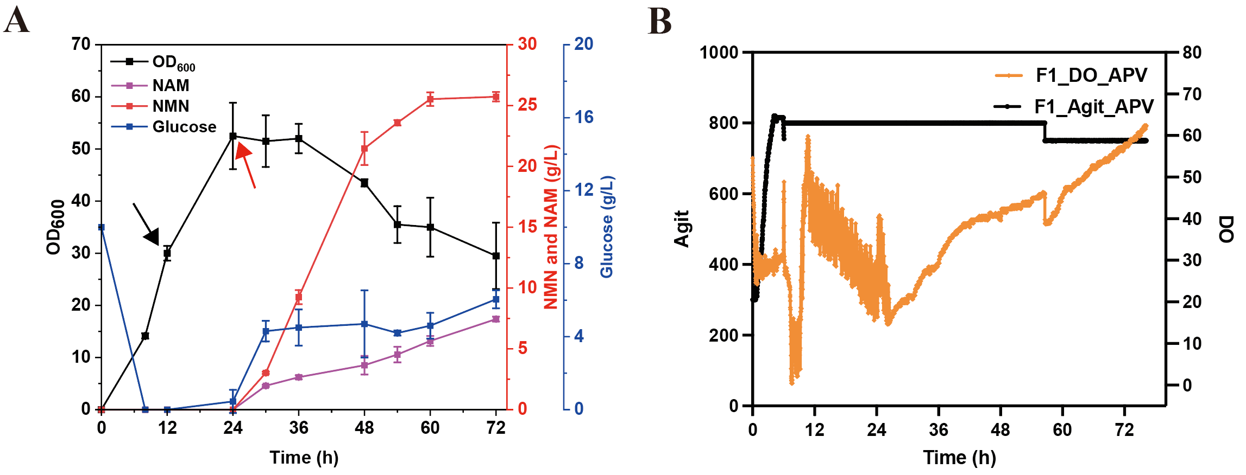

Fig S1. Fed-batch production of NMN008 in 2 L bioreactors. (A) NMN production, residual nicotinamide, cell growth (OD₆₀₀), and consumption of glucose during fermentation. (B) Relationship between dissolved oxygen (DO) and agitation speed. The black arrows represent the addition of arabinose and lactose to induce protein expression. The red arrows represent the start of the conversion.

