SUPPLEMENTARY MATERIAL

Table S1. Location of the sampling points of the Mocorito River aquifer
SP | Longitude | Latitude
1 | -107.97163 | 25.46517
2 | -108.13171 | 25.43721
3 | -108.19576 | 25.29359
4 | -108.1502 | 25.36881
5 | -108.13493 | 25.37833
6 | -108.15846 | 25.31937
7 | -108.161147 | 25.365346

Table S2. Statistical analysis of the water quality parameters of the Mocorito River aquifer
Parameters | Units | n | Average | Standard Deviation | Coefficient of Variation | Minimum | Maximum | Range | Standardized Skewness | Standardized Kurtosis
Ammonia | mg/L | 64 | 0.0406 | 0.03176 | 78.27% | 0.0035 | 0.1415 | 0.138 | 4.37441 | 2.9701
Nitrite | mg/L | 64 | 0.0133 | 0.01206 | 90.92% | 0.005 | 0.0472 | 0.0422 | 4.27928 | 0.8332
Nitrate | mg/L | 64 | 9.6364 | 6.04797 | 62.76% | 0.031 | 32.555 | 32.524 | 3.51046 | 3.4669
Organic nitrogen | mg/L | 64 | 0.1955 | 0.20183 | 103.26% | 0 | 0.7529 | 0.7529 | 3.7454 | 1.0015
Total nitrogen | mg/L | 64 | 9.7084 | 5.97226 | 61.52% | 0.1357 | 33.137 | 33.0013 | 3.97683 | 4.3785
Total phosphorus | mg/L | 64 | 0.1078 | 0.08178 | 75.85% | 0.0159 | 0.6245 | 0.6086 | 14.0452 | 41.5784
Phosphate | mg/L | 64 | 0.3044 | 0.15007 | 49.30% | 0.0487 | 0.8996 | 0.8509 | 4.25439 | 6.2019
Total chlorides | mg/L | 64 | 25.9939 | 19.3222 | 74.33% | 10 | 111.051 | 101.051 | 7.74564 | 10.5359
Fecal coliforms | MPN/100mL | 64 | 498.1410 | 3039.92 | 610.25% | 1 | 24196 | 24195 | 25.3668 | 100.163
Total organic carbon | mg/L | 64 | 1.2247 | 1.42014 | 115.96% | 0.103 | 8.191 | 8.088 | 11.0587 | 21.0205
Total dissolved solids | mg/L | 64 | 1007.9800 | 682.574 | 67.72% | 392 | 3484 | 3092 | 6.56211 | 6.1963
Hydrogen potential | UpH | 64 | 7.6063 | 0.35405 | 4.65% | 7 | 8.3 | 1.3 | 0.216913 | -1.1034
Total fluorides | mg/L | 64 | 0.3344 | 0.12573 | 37.60% | 0.036 | 0.626 | 0.59 | 0.40266 | -0.2774
Silica | mg/L | 64 | 55.1973 | 12.0278 | 21.79% | 31.18 | 89.68 | 58.5 | 2.53105 | 0.79286
Electrical conductivity | ms/cm² | 64 | 1606.3500 | 1153.59 | 71.81% | 596 | 7300 | 6704 | 9.28358 | 16.2822
Total hardness | mg/L | 64 | 488.1640 | 353.824 | 72.48% | 144.955 | 1930 | 1785.05 | 7.3854 | 8.6428
Total alkalinity | mg/L | 64 | 379.2420 | 95.7447 | 25.25% | 136.62 | 634.38 | 497.76 | 1.76512 | 0.2785
Redox potential | mV | 64 | 206.2530 | 116.659 | 56.56% | 55.1 | 618.5 | 563.4 | 5.73675 | 5.7673
Sulfates | mg/L | 63 | 165.5760 | 171.425 | 103.53% | 16.968 | 854.461 | 837.493 | 6.06584 | 5.8869
Calcium | mg/L | 62 | 126.9780 | 104.27 | 82.12% | 40.44 | 589 | 548.56 | 7.52811 | 10.1322
Magnesium | mg/L | 62 | 46.2526 | 31.7464 | 68.64% | 12.61 | 157.5 | 144.89 | 6.00394 | 5.0240
Potassium | mg/L | 63 | 4.2349 | 4.46054 | 105.33% | 0.409 | 31.37 | 30.961 | 13.2081 | 35.8945
Sodium | mg/L | 64 | 181.6450 | 142.519 | 78.46% | 17.18 | 630.4 | 613.22 | 5.50145 | 3.9791
Bicarbonate | mg/L | 64 | 379.7580 | 94.4307 | 24.87% | 136.62 | 634.38 | 497.76 | 1.8701 | 0.4956
Water temperature | °C | 64 | 28.1945 | 1.30214 | 4.62% | 24.9 | 31.7 | 6.8 | -0.126347 | 0.6470

Table S3. ANOVA results for water quality parameters from the seven sampling points from the Mocorito River aquifer*.
Parameter | Source | Sum of Squares | df | Mean Square | F-ratio | P-value | Significance (α=0.05)
NH3 (Ammoniacal Nitrogen, mg/L) | Between Groups | 0.019074 | 6 | 0.003179 | 4.07 | 0.0018 | Significant
 | Within Groups | 0.044504 | 57 | 0.000781
 | Total (Corrected) | 0.063578 | 63
NO2 (Nitrites, mg/L) | Between Groups | 0.004594 | 6 | 0.000766 | 9.53 | 0.0000 | Significant
 | Within Groups | 0.004580 | 57 | 0.000080
 | Total (Corrected) | 0.009175 | 63
NO3 (Nitrates, mg/L) | Between Groups | 1566.29 | 6 | 261.048 | 20.16 | 0.0000 | Significant
 | Within Groups | 738.121 | 57 | 12.950
 | Total (Corrected) | 2304.41 | 63
ON (Organic Nitrogen, mg/L) | Between Groups | 0.947957 | 6 | 0.157993 | 5.56 | 0.0001 | Significant
 | Within Groups | 1.61852 | 57 | 0.028395
 | Total (Corrected) | 2.56647 | 63
TN (Total Nitrogen, mg/L) | Between Groups | 1550.57 | 6 | 258.428 | 21.15 | 0.0000 | Significant
 | Within Groups | 696.511 | 57 | 12.220
 | Total (Corrected) | 2247.08 | 63
TP (Total Phosphorus, mg/L) | Between Groups | 0.037161 | 6 | 0.006194 | 0.92 | 0.4883 | Not Significant
 | Within Groups | 0.38423 | 57 | 0.006741
 | Total (Corrected) | 0.421391 | 63
PO4 (Phosphates, mg/L) | Between Groups | 0.505632 | 6 | 0.084272 | 5.26 | 0.0002 | Significant
 | Within Groups | 0.913234 | 57 | 0.016022
 | Total (Corrected) | 1.41887 | 63
TCl (Total Chlorides, mg/L) | Between Groups | 7531.44 | 6 | 1255.24 | 4.47 | 0.0009 | Significant
 | Within Groups | 15989.5 | 57 | 280.517
 | Total (Corrected) | 23520.9 | 63
FC (Fecal Coliforms, MPN/100mL) | Between Groups | 7.072E7 | 6 | 1.179E7 | 1.31 | 0.2661 | Not Significant
 | Within Groups | 5.115E8 | 57 | 8.973E6
 | Total (Corrected) | 5.822E8 | 63
TOC (Total Organic Carbon, mg/L) | Between Groups | 24.8542 | 6 | 4.14236 | 2.31 | 0.0458 | Significant
 | Within Groups | 102.204 | 57 | 1.79306
 | Total (Corrected) | 127.058 | 63
TDS (Total Dissolved Solids, mg/L) | Between Groups | 2.52606E7 | 6 | 4.2101E6 | 58.65 | 0.0000 | Significant
 | Within Groups | 4.09161E6 | 57 | 71782.7
 | Total (Corrected) | 2.93522E7 | 63
pH (UpH) | Between Groups | 0.9304 | 6 | 0.155067 | 1.27 | 0.2863 | Not Significant
 | Within Groups | 6.9671 | 57 | 0.12223
 | Total (Corrected) | 7.8975 | 63
TF (Total Fluorides, mg/L) | Between Groups | 0.618677 | 6 | 0.103113 | 15.58 | 0.0000 | Significant
 | Within Groups | 0.377306 | 57 | 0.006619
 | Total (Corrected) | 0.995984 | 63
SiO2 (mg/L) | Between Groups | 4433.89 | 6 | 738.981 | 9.00 | 0.0000 | Significant
 | Within Groups | 4680.19 | 57 | 82.109
 | Total (Corrected) | 9114.07 | 63
EC (Electrical Conductivity, ms/cm²) | Between Groups | 5.92689E7 | 6 | 9.87816E6 | 22.92 | 0.0000 | Significant
 | Within Groups | 2.45693E7 | 57 | 431040
 | Total (Corrected) | 8.38382E7 | 63
TH (Total Hardness, mg/L) | Between Groups | 6.22936E6 | 6 | 1.03823E6 | 35.70 | 0.0000 | Significant
 | Within Groups | 1.65769E6 | 57 | 29082.3
 | Total (Corrected) | 7.88705E6 | 63
TA (Total Alkalinity, mg/L) | Between Groups | 491026 | 6 | 81837.6 | 53.93 | 0.0000 | Significant
 | Within Groups | 86498.6 | 57 | 1517.52
 | Total (Corrected) | 577524 | 63
SO4 (Sulfates, mg/L) | Between Groups | 1.44423E6 | 6 | 240705 | 42.06 | 0.0000 | Significant
 | Within Groups | 297570 | 52 | 5722.5
 | Total (Corrected) | 1.7418E6 | 58
Ca (mg/L) | Between Groups | 487021 | 6 | 81170.2 | 27.15 | 0.0000 | Significant
 | Within Groups | 152480 | 51 | 2989.8
 | Total (Corrected) | 639501 | 57
Mg (mg/L) | Between Groups | 47419.6 | 6 | 7903.27 | 35.65 | 0.0000 | Significant
 | Within Groups | 11306.1 | 51 | 221.687
 | Total (Corrected) | 58725.7 | 57
K (mg/L) | Between Groups | 184.483 | 6 | 30.747 | 9.06 | 0.0000 | Significant
 | Within Groups | 166.233 | 49 | 3.3925
 | Total (Corrected) | 350.715 | 55
Na (mg/L) | Between Groups | 697232 | 6 | 116205 | 12.05 | 0.0000 | Significant
 | Within Groups | 540062 | 56 | 9643.97
 | Total (Corrected) | 1.23729E6 | 62
HCO3 (mg/L) | Between Groups | 463024 | 6 | 77170.7 | 44.54 | 0.0000 | Significant
 | Within Groups | 98756.1 | 57 | 1732.56
 | Total (Corrected) | 561780 | 63
WT (Water Temperature, °C) | Between Groups | 10.2504 | 6 | 1.7084 | 1.01 | 0.4290 | Not Significant
 | Within Groups | 96.5702 | 57 | 1.69421
 | Total (Corrected) | 106.821 | 63
* The ANOVA results indicate that several water quality parameters exhibited statistically significant differences among the groups studied (p < 0.05) among the 7 sampling sites. Specifically, ammoniacal nitrogen (NH3), nitrites (NO2), nitrates (NO3), organic nitrogen (ON), total nitrogen (TN), phosphates (PO4), total chlorides (TCl), total organic carbon (TOC), total dissolved solids (TDS), total fluorides (TF), silica (SiO2), electrical conductivity (EC), total hardness (TH), total alkalinity (TA), sulfates (SO4), calcium (Ca), magnesium (Mg), potassium (K), sodium (Na), and bicarbonates (HCO3) all showed significant differences across the groups, suggesting variation in nutrient, ionic, and general water quality characteristics. In contrast, total phosphorus (TP), fecal coliforms (FC), pH, and water temperature (WT) did not show statistically significant differences (p > 0.05), indicating relative stability of these parameters across the sampling groups. These results suggest that nutrient and ionic content are more variable and responsive to group-related factors than indicators of microbial contamination, pH, or thermal conditions. Overall, the findings highlight the importance of monitoring nitrogen, phosphorus, and key ions for understanding water quality variability, while parameters such as TP, FC, pH, and WT may remain relatively constant under similar environmental conditions.

Table S4. ANOVA results for water quality parameters from the two sampling periods (rainy and dry seasons) in the Mocorito River aquifer.*
Parameter | Source | Sum of Squares | df | Mean Square | F-ratio | P-value | Significance (α=0.05)
Fecal Coliforms (MPN/100 mL) | Between Groups | 6.48793×10⁶ | 1 | 6.48793×10⁶ | 0.69 | 0.4082 | Not Significant
Fecal Coliforms (MPN/100 mL) | Within Groups | 5.7053×10⁸ | 61 | 9.35295×10⁶
Fecal Coliforms (MPN/100 mL) | Total (Corrected) | 5.77018×10⁸ | 62
Total Organic Carbon (mg/L) | Between Groups | 1.13709 | 1 | 1.13709 | 0.58 | 0.4491 | Not Significant
Total Organic Carbon (mg/L) | Within Groups | 97.695 | 50 | 1.9539
Total Organic Carbon (mg/L) | Total (Corrected) | 98.8321 | 51
Ammoniacal Nitrogen (mg/L) | Between Groups | 0.00254341 | 1 | 0.00254341 | 2.45 | 0.1227 | Not Significant
Ammoniacal Nitrogen (mg/L) | Within Groups | 0.0622566 | 60 | 0.00103761
Ammoniacal Nitrogen (mg/L) | Total (Corrected) | 0.0648 | 61
Nitrites (mg/L) | Between Groups | 0.000225538 | 1 | 0.000225538 | 1.96 | 0.1662 | Not Significant
Nitrites (mg/L) | Within Groups | 0.00700621 | 61 | 0.000114856
Nitrites (mg/L) | Total (Corrected) | 0.00723175 | 62
Nitrates (mg/L) | Between Groups | 1.12252 | 1 | 1.12252 | 0.03 | 0.8618 | Not Significant
Nitrates (mg/L) | Within Groups | 2202.13 | 60 | 36.7022
Nitrates (mg/L) | Total (Corrected) | 2203.25 | 61
Organic Nitrogen (mg/L) | Between Groups | 0.0043875 | 1 | 0.0043875 | 0.11 | 0.7466 | Not Significant
Organic Nitrogen (mg/L) | Within Groups | 2.53945 | 61 | 0.0416304
Organic Nitrogen (mg/L) | Total (Corrected) | 2.54384 | 62
Total Nitrogen (mg/L) | Between Groups | 0.00012 | 1 | 0.00012 | 0.00 | 0.9986 | Not Significant
Total Nitrogen (mg/L) | Within Groups | 2132.51 | 58 | 36.7675
Total Nitrogen (mg/L) | Total (Corrected) | 2132.51 | 59
Total Phosphorus (mg/L) | Between Groups | 0.0112373 | 1 | 0.0112373 | 1.69 | 0.1983 | Not Significant
Total Phosphorus (mg/L) | Within Groups | 0.405252 | 61 | 0.00664347
Total Phosphorus (mg/L) | Total (Corrected) | 0.416489 | 62
Total Phosphates (mg/L) | Between Groups | 0.0296682 | 1 | 0.0296682 | 1.31 | 0.2572 | Not Significant
Total Phosphates (mg/L) | Within Groups | 1.38351 | 61 | 0.0226804
Total Phosphates (mg/L) | Total (Corrected) | 1.41317 | 62
Total Dissolved Solids (mg/L) | Between Groups | 2657.87 | 1 | 2657.87 | 0.01 | 0.9406 | Not Significant
Total Dissolved Solids (mg/L) | Within Groups | 2.89801×10⁷ | 61 | 475083
Total Dissolved Solids (mg/L) | Total (Corrected) | 2.89827×10⁷ | 62
pH | Between Groups | 0.00604884 | 1 | 0.00604884 | 0.05 | 0.8255 | Not Significant
pH | Within Groups | 7.52389 | 61 | 0.123343
pH | Total (Corrected) | 7.52994 | 62
Total Fluorides (mg/L) | Between Groups | 0.00382338 | 1 | 0.00382338 | 0.25 | 0.6158 | Not Significant
Total Fluorides (mg/L) | Within Groups | 0.916551 | 61 | 0.0150254
Total Fluorides (mg/L) | Total (Corrected) | 0.920375 | 62
Silica (mg/L) | Between Groups | 5.33489 | 1 | 5.33489 | 0.04 | 0.8483 | Not Significant
Silica (mg/L) | Within Groups | 8816.99 | 61 | 144.541
Silica (mg/L) | Total (Corrected) | 8822.33 | 62
Electrical Conductivity (µS/cm) | Between Groups | 294041 | 1 | 294041 | 0.22 | 0.6428 | Not Significant
Electrical Conductivity (µS/cm) | Within Groups | 8.25809×10⁷ | 61 | 1.35379×10⁶
Electrical Conductivity (µS/cm) | Total (Corrected) | 8.2875×10⁷ | 62
Total Hardness (mg/L) | Between Groups | 28255.4 | 1 | 28255.4 | 0.27 | 0.6080 | Not Significant
Total Hardness (mg/L) | Within Groups | 6.37436×10⁶ | 60 | 106239
Total Hardness (mg/L) | Total (Corrected) | 6.40262×10⁶ | 61
Total Alkalinity (mg/L) | Between Groups | 781.337 | 1 | 781.337 | 0.09 | 0.7594 | Not Significant
Total Alkalinity (mg/L) | Within Groups | 503710 | 61 | 8257.53
Total Alkalinity (mg/L) | Total (Corrected) | 504491 | 62
Water Temperature (°C) | Between Groups | 24.2419 | 1 | 24.2419 | 17.91 | 0.0001 | Significant
Water Temperature (°C) | Within Groups | 82.5574 | 61 | 1.3534
Water Temperature (°C) | Total (Corrected) | 106.799 | 62
Sulfates (mg/L) | Between Groups | 1690.86 | 1 | 1690.86 | 0.05 | 0.8162 | Not Significant
Sulfates (mg/L) | Within Groups | 1.70541×10⁶ | 55 | 31007.4
Sulfates (mg/L) | Total (Corrected) | 1.7071×10⁶ | 56
Calcium (mg/L) | Between Groups | 9482.79 | 1 | 9482.79 | 0.83 | 0.3674 | Not Significant
Calcium (mg/L) | Within Groups | 619813 | 54 | 11478.0
Calcium (mg/L) | Total (Corrected) | 629296 | 55
Magnesium (mg/L) | Between Groups | 142.486 | 1 | 142.486 | 0.14 | 0.7147 | Not Significant
Magnesium (mg/L) | Within Groups | 56972.8 | 54 | 1055.05
Magnesium (mg/L) | Total (Corrected) | 57115.3 | 55
Potassium (mg/L) | Between Groups | 0.332374 | 1 | 0.332374 | 0.05 | 0.8220 | Not Significant
Potassium (mg/L) | Within Groups | 337.874 | 52 | 6.49759
Potassium (mg/L) | Total (Corrected) | 338.207 | 53
Sodium (mg/L) | Between Groups | 8762.29 | 1 | 8762.29 | 0.41 | 0.5238 | Not Significant
Sodium (mg/L) | Within Groups | 1.17057×10⁶ | 55 | 21283.1
Sodium (mg/L) | Total (Corrected) | 1.17933×10⁶ | 56
Bicarbonates (mg/L) | Between Groups | 367.11 | 1 | 367.11 | 0.04 | 0.8333 | Not Significant
Bicarbonates (mg/L) | Within Groups | 501356 | 61 | 8218.96
Bicarbonates (mg/L) | Total (Corrected) | 501724 | 62
*The comparison between the rainy season (June–October) and the dry season (November–May) shows that nearly all evaluated water quality parameters exhibit no statistically significant differences (p > 0.05), indicating seasonal stability in the aquifer’s hydrochemical composition. Only water temperature displayed significant variation between periods (F = 17.91; p = 0.0001), reflecting the direct influence of climatic conditions, while all other indicators (nutrients, dissolved salts, major ions, alkalinity, hardness, coliforms, and conductivity) remained consistent across both seasons.

Table S5. Ionic balance error values (±%)*.
Site | Average (%) | Coefficient of variation (%)
1 | 33.53±2.72 | 8.11
2 | 17.96±4.78 | 26.62
3 | 20.98±3.9 | 18.58
4 | 13.24±1.83 | 13.82
5 | 21.68±4.47 | 20.61
6 | 30.58±3.34 | 10.92
7 | 12.6±2.09 | 16.59
* The ionic balance showed that Sites 1 and 6 have high and consistent values, indicating stable conditions, while Sites 2 and 5 present moderate averages with high variability, reflecting fluctuating or heterogeneous conditions. Sites 4 and 7 have low but stable values. Overall, the combination of average values and variability highlights differences in site conditions and potential environmental influences.

Table S6. Pearson Correlation Matrix
Parameters | NH3 | NO2 | NO3 | ON | TN | TP | PO4 | TCl | FC | TOC | TDS | pH | TF | MBAS | SIO2 | EC | TH | TA | RP | SO4 | Ca | Mg | K | Mn | Na | HCO3 | WT
NH3 | 1 | 0.2387 | -0.4066 | 0.1647 | -0.3557 | 0.0167 | 0.1224 | 0.1923 | 0.3478 | -0.0215 | -0.0342 | -0.1166 | -0.2581 | 0.0555 | -0.2294 | -0.0189 | -0.0328 | -0.1738 | -0.0538 | 0.025 | 0.0316 | -0.078 | -0.0789 | -0.0103 | -0.14 | -0.1752 | -0.0789
NO2 | 0.2387 | 1 | 0.2114 | 0.1398 | 0.242 | 0.0228 | 0.1558 | 0.1412 | -0.1024 | 0.3206 | 0.4817 | -0.0736 | -0.0501 | 0.0542 | -0.0552 | 0.4642 | 0.474 | 0.3695 | -0.2667 | 0.4498 | 0.3747 | 0.4829 | 0.1095 | 0.5728 | 0.3163 | 0.3708 | -0.0472
NO3 | -0.4066 | 0.2114 | 1 | 0.0301 | 0.9758 | 0.1013 | 0.2294 | -0.0063 | -0.0826 | 0.2729 | 0.6203 | -0.048 | 0.351 | -0.0275 | -0.0627 | 0.6326 | 0.5515 | 0.7618 | -0.1963 | 0.5054 | 0.5272 | 0.5752 | 0.0613 | 0.5391 | 0.6421 | 0.7585 | 0.2409
ON | 0.1647 | 0.1398 | 0.0301 | 1 | 0.0765 | -0.0343 | -0.0265 | 0.2889 | 0.2245 | -0.1267 | 0.4376 | -0.1021 | -0.4406 | 0.4824 | -0.1303 | 0.4407 | 0.4553 | 0.0313 | 0.2455 | 0.4566 | 0.5528 | 0.4746 | 0.0098 | 0.3464 | 0.1824 | 0.0371 | 0.1599
TN | -0.3557 | 0.242 | 0.9758 | 0.0765 | 1 | 0.1073 | 0.2609 | 0.0122 | -0.0818 | 0.2655 | 0.6356 | -0.0895 | 0.3407 | 0.0074 | -0.0789 | 0.6565 | 0.5655 | 0.7721 | -0.1883 | 0.5171 | 0.543 | 0.5721 | 0.0701 | 0.5476 | 0.6467 | 0.7691 | 0.2602
TP | 0.0167 | 0.0228 | 0.1013 | -0.0343 | 0.1073 | 1 | 0.5402 | -0.0274 | -0.0552 | 0.2203 | 0.0584 | 0.2245 | 0.0368 | 0.0031 | -0.1358 | 0.055 | 0.0165 | 0.101 | -0.1915 | -0.0794 | -0.045 | -0.1167 | -0.1394 | -0.0241 | 0.0713 | 0.0933 | -0.0264
PO4 | 0.1224 | 0.1558 | 0.2294 | -0.0265 | 0.2609 | 0.5402 | 1 | 0.0958 | -0.0651 | 0.4026 | 0.024 | 0.1418 | 0.2423 | 0.1131 | -0.1488 | 0.0282 | -0.0902 | 0.3669 | -0.1145 | -0.0215 | 0.0054 | -0.0814 | -0.1501 | 0.0389 | 0.0438 | 0.3578 | -0.0137
TCl | 0.1923 | 0.1412 | -0.0063 | 0.2889 | 0.0122 | -0.0274 | 0.0958 | 1 | -0.0814 | 0.2009 | 0.2625 | -0.2738 | -0.27 | 0.2565 | -0.2184 | 0.2842 | 0.2949 | 0.1294 | 0.3581 | 0.2002 | 0.2436 | 0.2269 | 0.2201 | 0.3816 | 0.0744 | 0.1312 | -0.0623
FC | 0.3478 | -0.1024 | -0.0826 | 0.2245 | -0.0818 | -0.0552 | -0.0651 | -0.0814 | 1 | -0.038 | -0.0013 | 0.1713 | -0.1732 | 0.0967 | -0.1069 | 0.0166 | 0.0198 | -0.1711 | -0.0563 | 0.1082 | 0.0693 | -0.0079 | 0.0444 | -0.0639 | -0.0616 | -0.1744 | 0.2217
TOC | -0.0215 | 0.3206 | 0.2729 | -0.1267 | 0.2655 | 0.2203 | 0.4026 | 0.2009 | -0.038 | 1 | 0.2123 | -0.025 | 0.0498 | 0.1885 | -0.0889 | 0.1821 | 0.1728 | 0.3601 | -0.12 | 0.208 | 0.128 | 0.2366 | 0.2489 | 0.2919 | 0.1762 | 0.3543 | 0.0109
TDS | -0.0342 | 0.4817 | 0.6203 | 0.4376 | 0.6356 | 0.0584 | 0.024 | 0.2625 | -0.0013 | 0.2123 | 1 | -0.2841 | -0.2281 | 0.0036 | -0.3435 | 0.968 | 0.9686 | 0.6058 | -0.1667 | 0.9418 | 0.9223 | 0.9328 | 0.2385 | 0.9128 | 0.6888 | 0.6148 | 0.2149
pH | -0.1166 | -0.0736 | -0.048 | -0.1021 | -0.0895 | 0.2245 | 0.1418 | -0.2738 | 0.1713 | -0.025 | -0.2841 | 1 | 0.2371 | -0.0078 | 0.1277 | -0.3087 | -0.3149 | -0.088 | -0.2911 | -0.2587 | -0.2965 | -0.2871 | -0.1518 | -0.3786 | -0.064 | -0.0822 | 0.0824
TF | -0.2581 | -0.0501 | 0.351 | -0.4406 | 0.3407 | 0.0368 | 0.2423 | -0.27 | -0.1732 | 0.0498 | -0.2281 | 0.2371 | 1 | -0.1657 | 0.3807 | -0.2125 | -0.3038 | 0.3928 | -0.0907 | -0.2572 | -0.2929 | -0.2119 | -0.1682 | -0.2391 | 0.1278 | 0.3813 | -0.1177
MBAS | 0.0555 | 0.0542 | -0.0275 | 0.4824 | 0.0074 | 0.0031 | 0.1131 | 0.2565 | 0.0967 | 0.1885 | 0.0036 | -0.0078 | -0.1657 | 1 | 0.0322 | 0.0065 | 0.0052 | 0.021 | 0.3613 | 0.0182 | 0.0344 | 0.0823 | -0.0174 | 0.0482 | -0.0837 | 0.012 | -0.0956
SIO2 | -0.2294 | -0.0552 | -0.0627 | -0.1303 | -0.0789 | -0.1358 | -0.1488 | -0.2184 | -0.1069 | -0.0889 | -0.3435 | 0.1277 | 0.3807 | 0.0322 | 1 | -0.3317 | -0.337 | -0.0457 | 0.0372 | -0.3317 | -0.2972 | -0.1874 | -0.18 | -0.3027 | -0.041 | -0.0574 | -0.0158
EC | -0.0189 | 0.4642 | 0.6326 | 0.4407 | 0.6565 | 0.055 | 0.0282 | 0.2842 | 0.0166 | 0.1821 | 0.968 | -0.3087 | -0.2125 | 0.0065 | -0.3317 | 1 | 0.9623 | 0.5436 | -0.1372 | 0.8618 | 0.8687 | 0.8904 | 0.2146 | 0.9039 | 0.6142 | 0.5516 | 0.2715
TH | -0.0328 | 0.474 | 0.5515 | 0.4553 | 0.5655 | 0.0165 | -0.0902 | 0.2949 | 0.0198 | 0.1728 | 0.9686 | -0.3149 | -0.3038 | 0.0052 | -0.337 | 0.9623 | 1 | 0.4808 | -0.1148 | 0.9003 | 0.8925 | 0.9078 | 0.3047 | 0.9285 | 0.5899 | 0.4899 | 0.2286
TA | -0.1738 | 0.3695 | 0.7618 | 0.0313 | 0.7721 | 0.101 | 0.3669 | 0.1294 | -0.1711 | 0.3601 | 0.6058 | -0.088 | 0.3928 | 0.021 | -0.0457 | 0.5436 | 0.4808 | 1 | -0.1813 | 0.5391 | 0.5396 | 0.5713 | 0.1589 | 0.533 | 0.7037 | 0.9916 | 0.0779
RP | -0.0538 | -0.2667 | -0.1963 | 0.2455 | -0.1883 | -0.1915 | -0.1145 | 0.3581 | -0.0563 | -0.12 | -0.1667 | -0.2911 | -0.0907 | 0.3613 | 0.0372 | -0.1372 | -0.1148 | -0.1813 | 1 | -0.1607 | -0.0934 | -0.0931 | -0.1199 | -0.0933 | -0.2682 | -0.2049 | -0.0532
SO4 | 0.025 | 0.4498 | 0.5054 | 0.4566 | 0.5171 | -0.0794 | -0.0215 | 0.2002 | 0.1082 | 0.208 | 0.9418 | -0.2587 | -0.2572 | 0.0182 | -0.3317 | 0.8618 | 0.9003 | 0.5391 | -0.1607 | 1 | 0.9063 | 0.9232 | 0.2258 | 0.8417 | 0.6534 | 0.5494 | 0.1998
Ca | 0.0316 | 0.3747 | 0.5272 | 0.5528 | 0.543 | -0.045 | 0.0054 | 0.2436 | 0.0693 | 0.128 | 0.9223 | -0.2965 | -0.2929 | 0.0344 | -0.2972 | 0.8687 | 0.8925 | 0.5396 | -0.0934 | 0.9063 | 1 | 0.8935 | 0.2462 | 0.8481 | 0.674 | 0.5474 | 0.2771
Mg | -0.078 | 0.4829 | 0.5752 | 0.4746 | 0.5721 | -0.1167 | -0.0814 | 0.2269 | -0.0079 | 0.2366 | 0.9328 | -0.2871 | -0.2119 | 0.0823 | -0.1874 | 0.8904 | 0.9078 | 0.5713 | -0.0931 | 0.9232 | 0.8935 | 1 | 0.2174 | 0.8794 | 0.6542 | 0.5816 | 0.2267
K | -0.0789 | 0.1095 | 0.0613 | 0.0098 | 0.0701 | -0.1394 | -0.1501 | 0.2201 | 0.0444 | 0.2489 | 0.2385 | -0.1518 | -0.1682 | -0.0174 | -0.18 | 0.2146 | 0.3047 | 0.1589 | -0.1199 | 0.2258 | 0.2462 | 0.2174 | 1 | 0.3151 | 0.1207 | 0.1578 | -0.0054
Mn | -0.0103 | 0.5728 | 0.5391 | 0.3464 | 0.5476 | -0.0241 | 0.0389 | 0.3816 | -0.0639 | 0.2919 | 0.9128 | -0.3786 | -0.2391 | 0.0482 | -0.3027 | 0.9039 | 0.9285 | 0.533 | -0.0933 | 0.8417 | 0.8481 | 0.8794 | 0.3151 | 1 | 0.5874 | 0.5377 | 0.1842
Na | -0.14 | 0.3163 | 0.6421 | 0.1824 | 0.6467 | 0.0713 | 0.0438 | 0.0744 | -0.0616 | 0.1762 | 0.6888 | -0.064 | 0.1278 | -0.0837 | -0.041 | 0.6142 | 0.5899 | 0.7037 | -0.2682 | 0.6534 | 0.674 | 0.6542 | 0.1207 | 0.5874 | 1 | 0.7092 | 0.1704
HCO3 | -0.1752 | 0.3708 | 0.7585 | 0.0371 | 0.7691 | 0.0933 | 0.3578 | 0.1312 | -0.1744 | 0.3543 | 0.6148 | -0.0822 | 0.3813 | 0.012 | -0.0574 | 0.5516 | 0.4899 | 0.9916 | -0.2049 | 0.5494 | 0.5474 | 0.5816 | 0.1578 | 0.5377 | 0.7092 | 1 | 0.0505
WT | -0.0789 | -0.0472 | 0.2409 | 0.1599 | 0.2602 | -0.0264 | -0.0137 | -0.0623 | 0.2217 | 0.0109 | 0.2149 | 0.0824 | -0.1177 | -0.0956 | -0.0158 | 0.2715 | 0.2286 | 0.0779 | -0.0532 | 0.1998 | 0.2771 | 0.2267 | -0.0054 | 0.1842 | 0.1704 | 0.0505 | 1

Table S7. Analysis of main components
Parameters | Component | Component | Component | Component | Component | Component | Component
Parameters | 1 | 2 | 3 | 4 | 5 | 6 | 7
NH3 | -0.019813 | -0.227558 | 0.327639 | 0.212641 | -0.117985 | 0.37 | 0.147814
NO2 | 0.163309 | -0.013292 | 0.203636 | 0.0575409 | -0.256523 | 0.476105 | 0.055039
NO3 | 0.233996 | 0.274725 | -0.0927699 | -0.0308162 | 0.151082 | -0.128525 | -0.0327144
ON | 0.126132 | -0.302705 | 0.0427115 | -0.00669091 | 0.426668 | 0.126978 | 0.0519693
TN | 0.239256 | 0.260145 | -0.067636 | -0.0368293 | 0.162952 | -0.112424 | -0.0174976
TP | 0.00974698 | 0.142696 | 0.403771 | 0.218365 | 0.0917035 | -0.315472 | 0.246231
PO4 | 0.0377559 | 0.215415 | 0.522484 | 0.0358841 | 0.130574 | -0.115333 | 0.118053
TCl | 0.0858943 | -0.215103 | 0.258769 | -0.336522 | -0.0345961 | -0.109227 | -0.0690676
FC | -0.0100887 | -0.153204 | 0.0279051 | 0.412945 | 0.241923 | 0.152017 | -0.357134
TOC | 0.101137 | 0.119276 | 0.36858 | -0.0989141 | -0.130981 | -0.0487941 | -0.441389
TDS | 0.311626 | -0.0722791 | -0.0231913 | 0.053329 | -0.0173989 | -0.0331507 | 0.0841568
pH | -0.0845023 | 0.19924 | 0.0643123 | 0.326898 | 0.250249 | 0.0896723 | -0.22767
TF | -0.0351564 | 0.426099 | -0.0708691 | -0.133231 | 0.0468262 | 0.193171 | 0.0141201
MBAS | 0.0109176 | -0.146853 | 0.257926 | -0.281015 | 0.429457 | 0.194737 | -0.248475
SIO2 | -0.0940385 | 0.162981 | -0.221832 | -0.164514 | 0.146553 | 0.446239 | -0.0818449
EC | 0.301401 | -0.0810292 | -0.0289516 | 0.0525123 | 0.0101579 | -0.0688815 | 0.0950828
TH | 0.296492 | -0.135769 | -0.0664754 | 0.051394 | -0.0505578 | -0.0639764 | 0.0431649
TA | 0.236448 | 0.272654 | 0.0777972 | -0.1356 | 0.0190895 | 0.107059 | -0.0340308
RP | -0.0604772 | -0.203159 | -0.0157639 | -0.475044 | 0.291922 | -0.138123 | 0.0642528
SO4 | 0.292226 | -0.108555 | -0.0515175 | 0.0821195 | -0.00981025 | 0.0617449 | 0.0153707
Ca | 0.291154 | -0.125905 | -0.0664696 | 0.0589724 | 0.0593497 | -0.00123544 | 0.0528034
Mg | 0.296771 | -0.0906558 | -0.101883 | -0.0214064 | 0.0236621 | 0.0924263 | -0.00189721
K | 0.0869231 | -0.0833208 | -0.0259034 | -0.0646935 | -0.348617 | -0.170389 | -0.621043
Mn | 0.293061 | -0.106436 | 0.0114269 | -0.0443373 | -0.123105 | -0.0116234 | 0.0143521
Na | 0.242567 | 0.142512 | -0.0969302 | 0.0396085 | 0.0334982 | 0.114206 | 0.042656
HCO3 | 0.238316 | 0.269467 | 0.0745899 | -0.129445 | 0.00565348 | 0.112695 | -0.0252446
WT | 0.0756482 | -0.0160692 | -0.16237 | 0.297484 | 0.291919 | -0.225271 | -0.184961

Clustering Using SOM Maps
A Self-Organizing Maps (SOM) analysis was applied to the physicochemical parameters obtained from seven sampling sites to identify patterns in groundwater quality. As noted by Hao et al (2025) and Singha et al (2025), SOM analysis reveals groupings of variables associated with common geohydrochemical processes. In this study, three main groups were distinguished (Fig 10): dissolved minerals (EC, TDS, TH), nutrients and organic matter (NH₃, NO₂, NO₃, TOC, P, fecal coliforms), and major ions (Cl⁻, SO₄²⁻, Ca²⁺, Na⁺, Mg²⁺, K⁺).
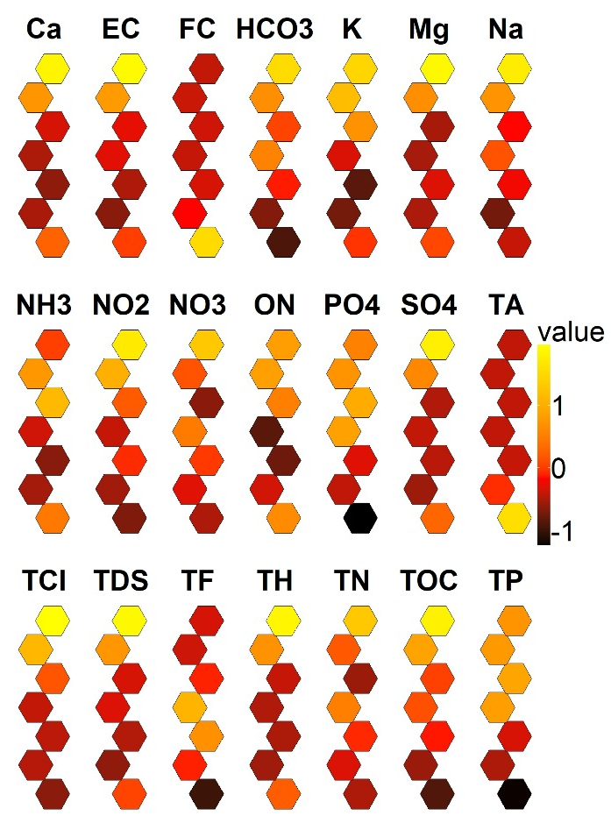 | 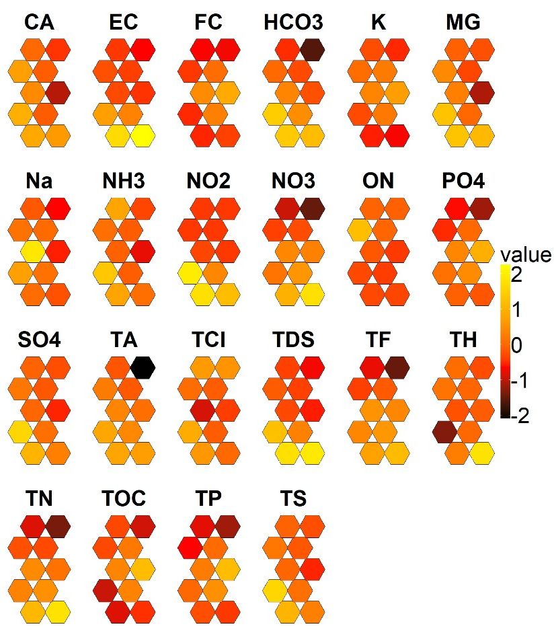
(a) | (b)
Fig 10. SOM matrices of groundwater sample variables from the seven sampling sites (a) and for the 2012–2022 period.
The results show that SP1 exhibited the highest mineralization, with elevated values of EC, hardness, and salts, as well as high concentrations of NO₂, NO₃, NH₃, and TOC, suggesting a high agricultural influence. Groundwater quality varied significantly between the sites. SP6 showed the best water quality and SP5 was notable for its high fecal coliform counts. In contrast, SP4 presented a mixed profile, with an accumulation of ammonium (NH4⁺) and organic nitrogen under more reducing conditions. SP3 and SP7 were characterized by low nutrient concentrations, reflecting lower anthropogenic pressure. SP1 registered the highest major ions concentrations, while SP3 and SP6 showed the lowest values.
Temporal analysis indicated that 2015 and 2018 were the most critical years due to high mineralization (TA, EC, TDS, TH), whereas 2013–2014 reflected better water quality. Between 2015 and 2017, high concentration of NH₃, NO₂, P, and NO₃ were observed, indicating higher agricultural pressure and reduction processes. In 2016, maximum values of SO₄²⁻, Cl⁻, Ca²⁺, Na⁺, and K⁺ were detected, confirming intense mineralization processes. The SOM analysis identified a 2- to 3-year cycle in water quality parameters, a pattern related to shifts in recharge, land use, or extreme climatic events.
Spatial and seasonal patterns indicated that the most critical sites (SP1 and SP5) coincided with the years of highest mineralization and organic load (2015–2017, 2018), reinforcing the relationship between local anthropogenic pressures and climatic conditions that favor nutrient and salt leaching. In contrast, the sites with better quality (SP6 and SP3) were associated with periods of low ionic concentrations (2013–2014), confirming the strong dependence between spatial and temporal variability in groundwater quality.

Figures


15% Geochemical &
Biogeochemical Factors
pH, redox conditions, organic
matter content
10% Physical & Climatic
Factors
Rainfall, temperature,
evapotranspiration
Land use, waste management, overextraction
25% Anthropogenic Factors
Aquifer type, conductivity, depth to water table
15% Hydrogeological
Factors
20% Contaminant-
Specific Factors
Solubility, density, biodegradability
Fractures, faults, karst systems
15% Structural &
Geological Discontinuities

Figure S1. Distribution of Factors Affecting Groundwater Pollution.
Fig 1S shows the spatial relationship between the average annual groundwater availability (mm³/year) and the Water Quality Index (WQI) across the different aquifers in Sinaloa. A clear gradient is observed: aquifers with high water availability (upper areas of the graph) generally exhibit better water quality values (lower WQI), whereas those with low availability tend to cluster in the poorest water quality categories (higher WQI).

