Supplementary information
Plastic Exposure Modifies Soil Hydro-Physical Properties: A Global Meta-Analysis

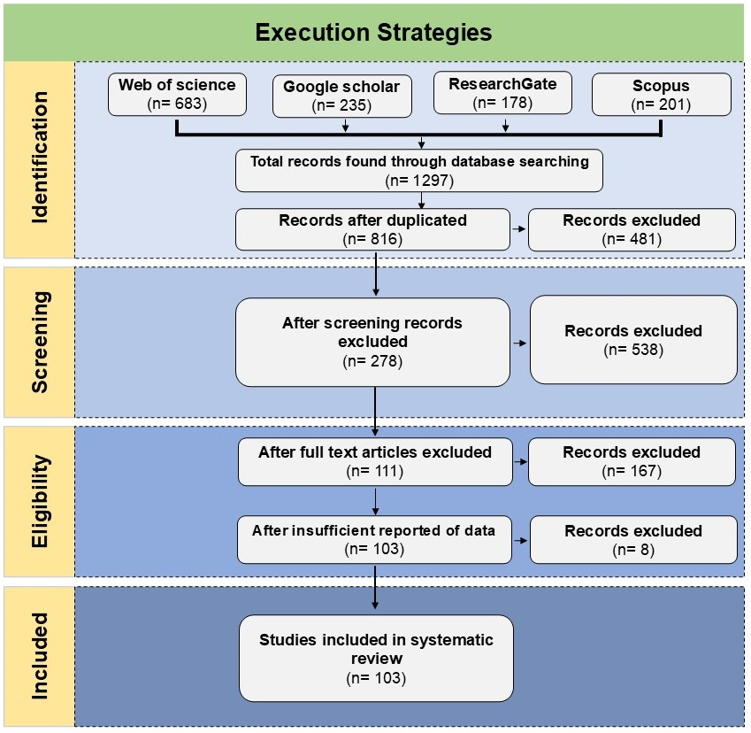
Figure S1. Flow diagram illustrating the publication selection process for conducting the meta-analysis, including the identification, screening, exclusion, and inclusion of studies after analysis.

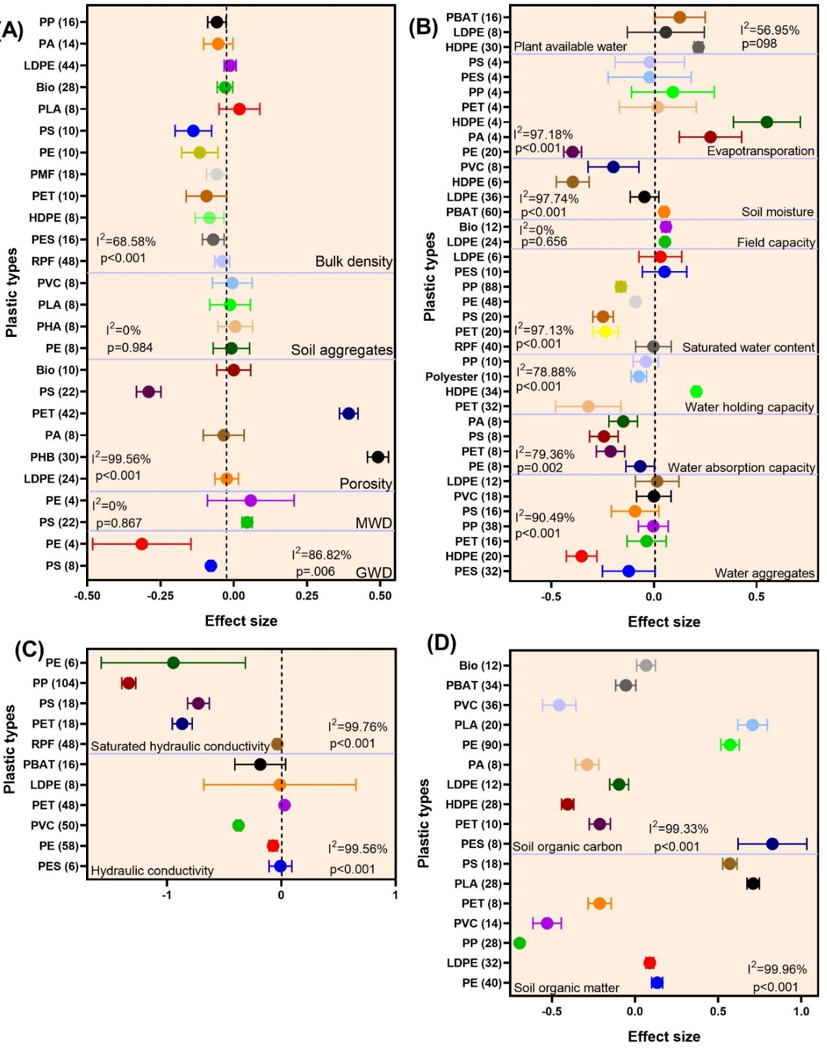
Figure S2. Forest plots of the effect sizes of different microplastic and nanoplastic polymer types on key soil physical and hydrological properties. (A) Impact on soil physiological parameters. (B) Impacts on soil water indicators, (C) impact on soil hydraulic conductivity, and (D) organic indicators. The numbers in parentheses next to each polymer type indicate the number of observations (n). The overall effect size for each parameter is represented symbol shape, with its position indicating the mean effect size and its width representing the 95% confidence interval. The I² statistic (%) denotes the degree of heterogeneity among studies, and the p-value indicates the significance of the overall effect.

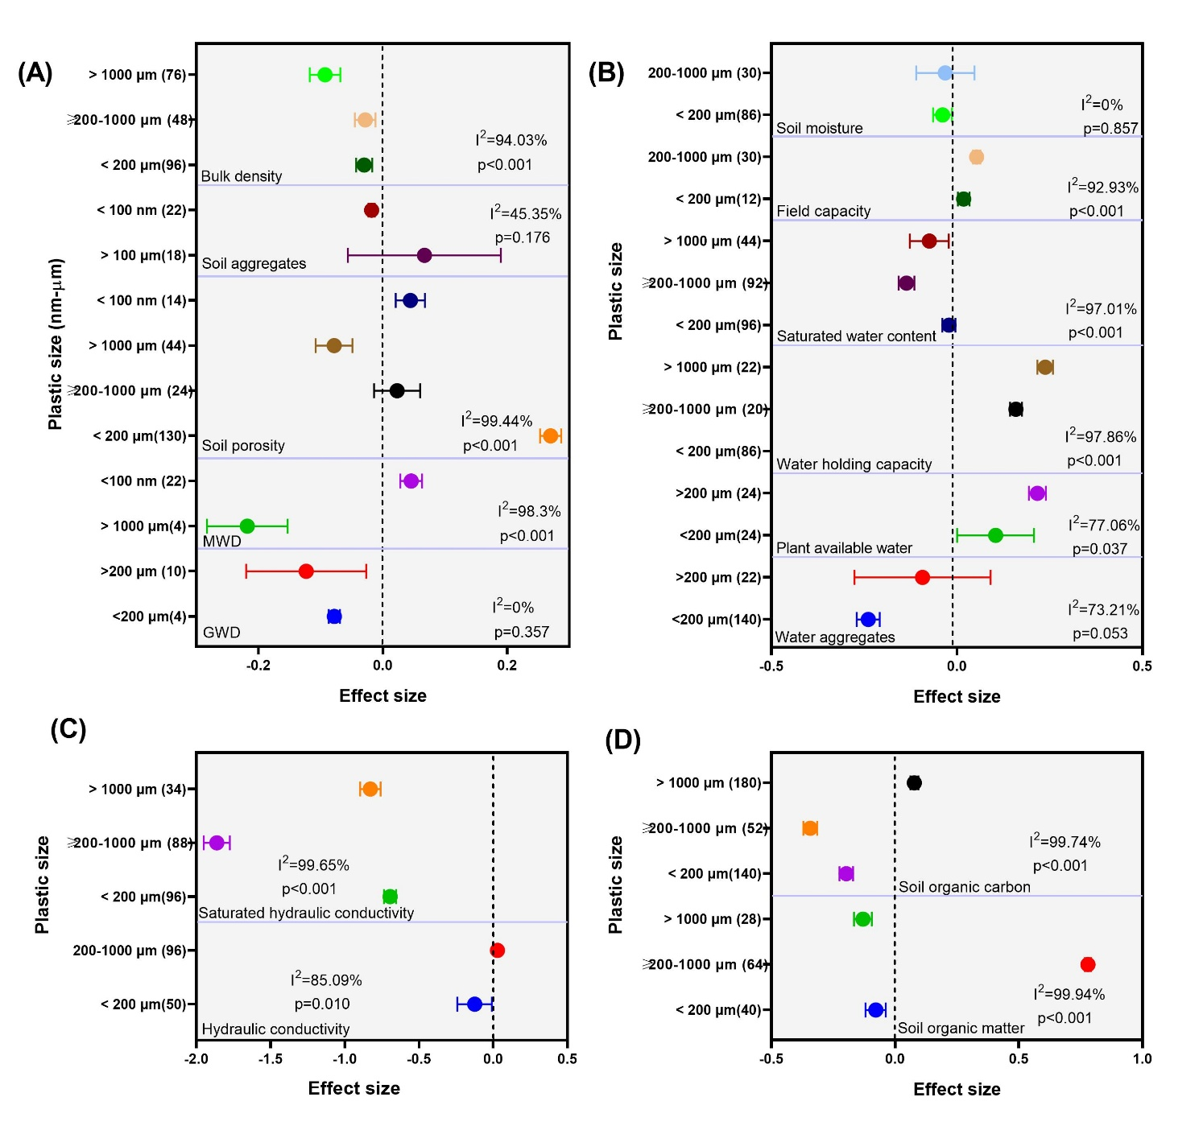
Figure S3. Forest plots of microplastic and nanoplastic size on key soil physical, hydrological, and organic properties. (A) Impact on soil physiological parameters. (B) impacts on soil water indicators, (C) impact on soil hydraulic conductivity, and (D) organic indicators. The numbers in parentheses next to each polymer type indicate the number of observations (n). The overall effect size for each parameter is represented symbol shape, with its position indicating the mean effect size and its width representing the 95% confidence interval. The I² statistic (%) denotes the degree of heterogeneity among studies, and the p-value indicates the significance of the overall effect.
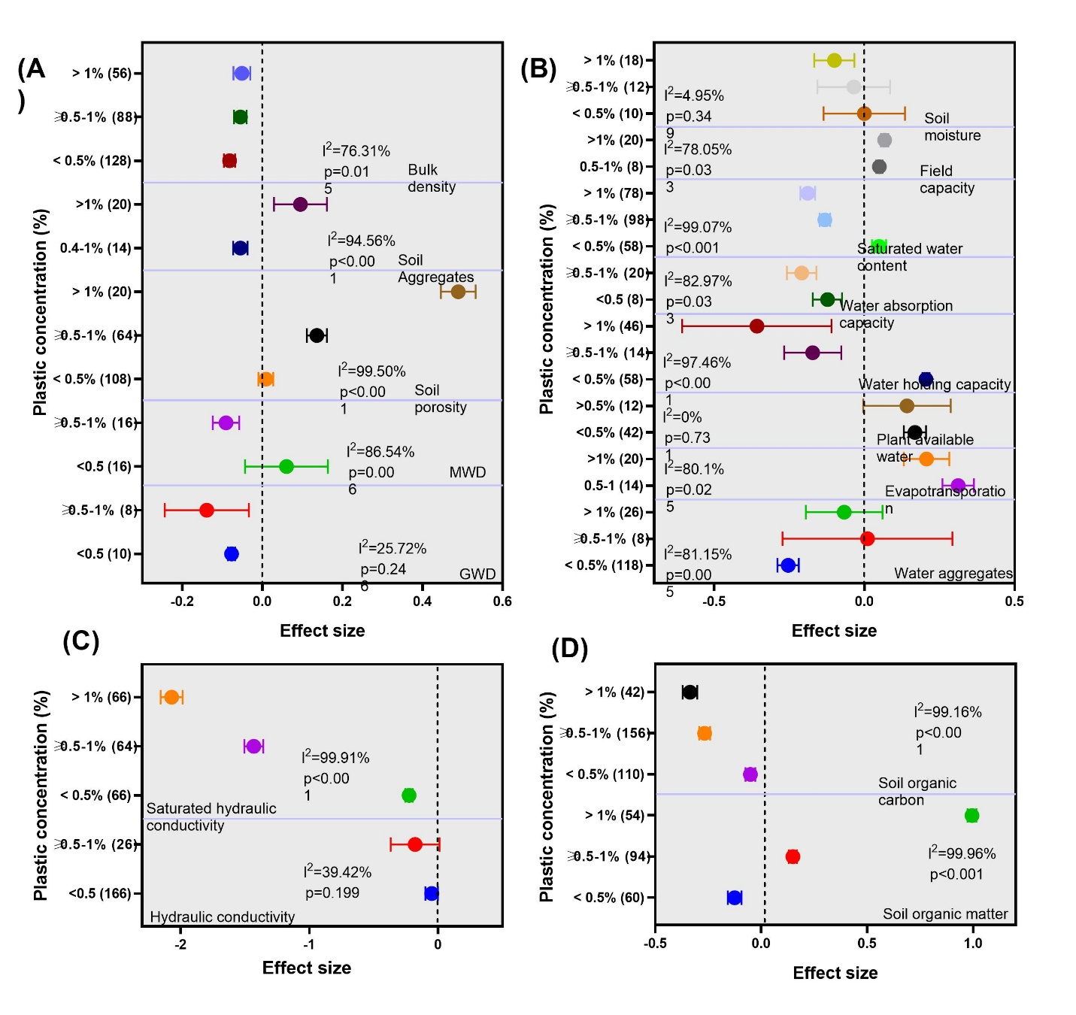

Figure S4. Forest plots of microplastic and nanoplastic concentration on soil physical, hydrological, and organic properties. (A) Impact on soil physiological parameters. (B) impacts on soil water indicators, (C) impact on soil hydraulic conductivity, and (D) organic indicators.
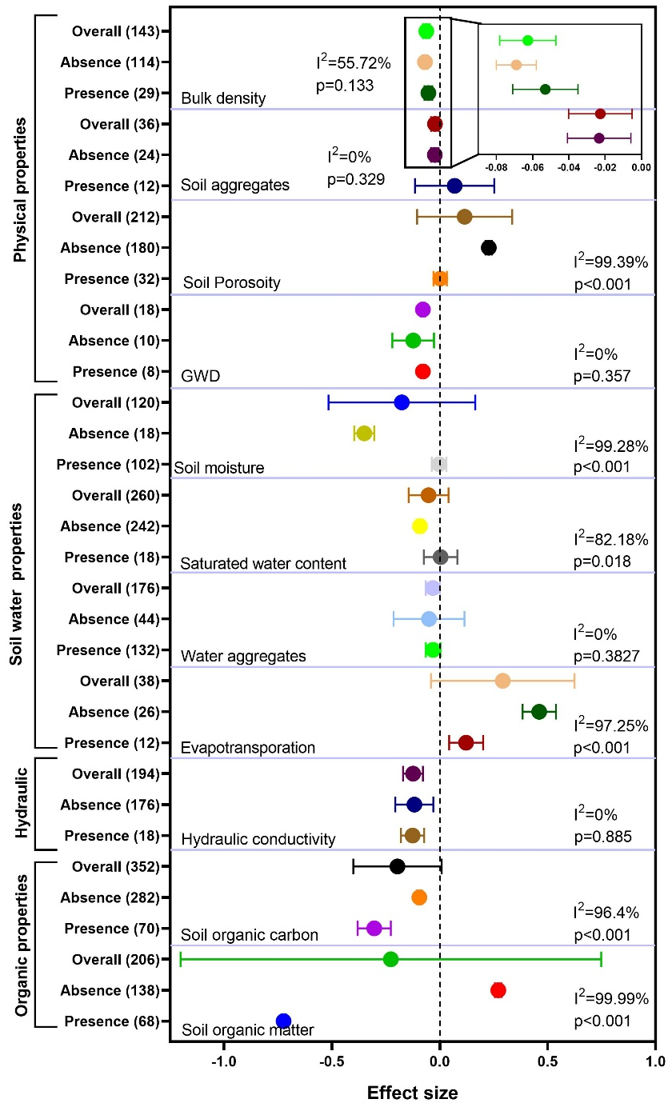
Figure S5. Forest plots showing the effect sizes and 95% confidence intervals for soil properties under plant presence and absence.

