Supplementary Materials for manuscript “Modeling cognitive decline trajectories in early Alzheimer’s disease: insights from East Asian cohorts.”

Contents

Methods 3
Trajectory identification 3
Validation cohort: The cohort data from the Memory Clinic at the National Center for Geriatrics and Gerontology (NCGG) 3
Threshold determination 3
Data harmonization for IADL score 3
Figure S1 Flowchart of individuals’ enrollment in the development cohort 4
Figure S2 Workflow of the trajectory identification, feature selection, model building and evaluation, and external validation 5
Figure S3 Fit-criteria assessment plots for the Mini-Mental State Examination score trajectory modeling 6
Figure S4 The correlations and p-values from chi-squared tests comparing two groups (G1 and G2) from our trajectory model with the binary classification of MMSE decline rates in the validation cohort, based on percentile-based stratification 7
Figure S5 (a) Calibration plot and (b) recalibration plot for fast/slow cognitive decline in the validation cohort 8
Table S1 Health status assessment using the chronic diseases shown in the list 9
Table S2 Determination of the optimal order in the polynomial model using the development cohort (sample size: nG1 =94; nG2 =157) 10
Table S3 Parameters estimations for trajectories of cognitive decline in the development cohort (sample size: nG1 =94; nG2 =157) 11
Table S4 Comparisons of performance between logistic regression model and prediction models with other ML methods for cognitive decline trajectories in the development cohort (sample size: nG1 =94; nG2 =157) 12
Table S5 Differences in MMSE decline rates between fast-decliners (G1) and slow-decliners (G2) of the development cohort during three periods (baseline–follow-up 2, follow-up 2–follow-up 5, and baseline–follow-up 5) 13
References 14

Methods

Trajectory identification
We determined the optimal number of trajectories using a forward model selection approach, starting with a two-trajectory model and adding one trajectory was added at a time [1]. Linear and quadratic terms were added to model the trajectory shapes, testing models with two to twenty trajectories. The model’s goodness-of-fit was assessed using the following four criteria: (1) the proportion of individuals within each trajectory >10%, (2) the posterior probability of trajectory assignment within each trajectory was >90%, (3) lower standard deviation (SD) of posterior probability within each trajectory, and (4) higher Bayesian information criterion (BIC). A fit-criteria assessment plot (F-CAP) was used to guide the selection of the number of trajectories, k [2]. Each trajectory was modeled with its own intercept and linear and/or quadratic terms in the polynomial model [3].

Validation cohort: The cohort data from the Memory Clinic at the National Center for Geriatrics and Gerontology (NCGG)
In brief, the Memory Clinic at the NCGG is one of the six national centers for advanced and specialized medicine, locate in one of the most populous prefectures (Aichi) in Japan. The cohort data from the Memory Clinic at the NCGG is a cohort of 951 AD subjects who visited the Memory Clinic at the NCGG between July 2010 and June 2021, and they are subsequently followed up as needed. During their visit, assessments such as the Mini-Mental State Examination (MMSE), Clinical Dementia Rating, and Lawton Instrumental Activities of Daily Living (IADL) Scale are assessed.

Threshold determination
The optimal threshold value was determined by maximizing the correlation between two groups (G1 and G2) from our trajectory model and a binary status for classifying annual change in MMSE using percentile-based stratification. Annual rates of change were calculated as the difference of baseline and second follow-up scores divided by duration of follow-up in years. The stratification was started from 1st percentile to 99th percentile. A chi-square test was used to estimate the correlation between the probabilistic-driven groups (G1 and G2) and the binary status in a contingency table.

Data harmonization for IADL score
In development cohort, the IADL score ranged from 0 to 23, with lower scores indicating greater independence in instrumental functioning. The IADL score in the validation cohort was calculated by summing the number of "Yes" responses (range 0–8 for female, 0–5 for male), with “Yes” indicates an independent event. Higher score indicates greater independence. Therefore, in this validation study, the IADL score was inversely transferred in proportion by the following formula:

$$\left\{\begin{matrix}\frac{\left(5 - total number of "Yes" responses\right)}{5}, for male; \\ \frac{\left(8 - total number of "Yes" responses\right)}{8}, for female.\end{matrix}\right.$$
The proportion was then transferred to 0–23 scale.

Figure S1 Flowchart of individuals’ enrollment in the development cohort

AD, Alzheimer’s disease; aMCI, amnestic mild cognitive impairment; CDR, clinical dementia rating; MMSE, mini-mental state examination; GBTM, group-based trajectory modeling.

Figure S2 Workflow of the trajectory identification, feature selection, model building and evaluation, and external validation
The trajectory prediction and testing performance involved a model built with a logistic regression method and 10-fold cross-validation.

AD, Alzheimer’s disease; AUC, area under the curve; GBTM, group-based trajectory modeling; MMSE, mini-mental state examination; NPS, neuropsychiatric symptoms; NPT, neuropsychological tests.

(a) Assigned/Estimated percentage of individuals belonging to the smallest group.

(b) Average posterior probability and standard deviation; AvePP- indicates the lowest average posterior probability value for a particular trajectory; SD+ indicates the highest standard deviation (SD) value for a particular trajectory.

(c) Akaike’s information criterion (AIC), Bayesian information criterion (BIC), and Likelihood (L); j (see figure legend) is the selection of the number of trajectories, k.

Figure S3 Fit-criteria assessment plots for the Mini-Mental State Examination score trajectory modeling

Four criteria include (1) the proportion of individuals within each trajectory >10%, panel (a); (2) average posterior probability (AvePP) of assignment within each trajectory >90%, and (3) lower standard deviation (SD) of posterior probability within each trajectory, panel (b); and (4) higher Bayesian information criterion (BIC), panel (c). Final number of selected trajectory groups =2. See Figure 1(a) in the main article for the associated trajectory plot.

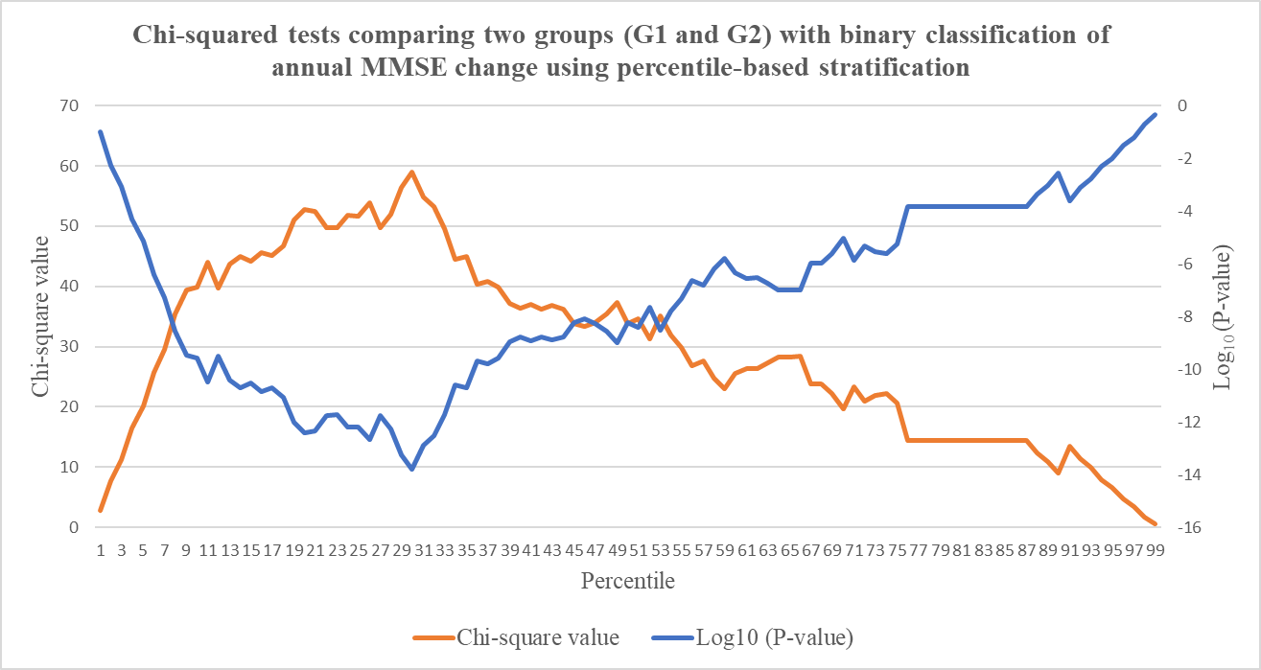
Optimal threshold

Figure S4 The correlations and p-values from chi-squared tests comparing two groups (G1 and G2) from our trajectory model with the binary classification of MMSE decline rates in the validation cohort, based on percentile-based stratification

G1, Fast-decliners; G2, Slow-decliners; MMSE, Mini-Mental Status Examination.

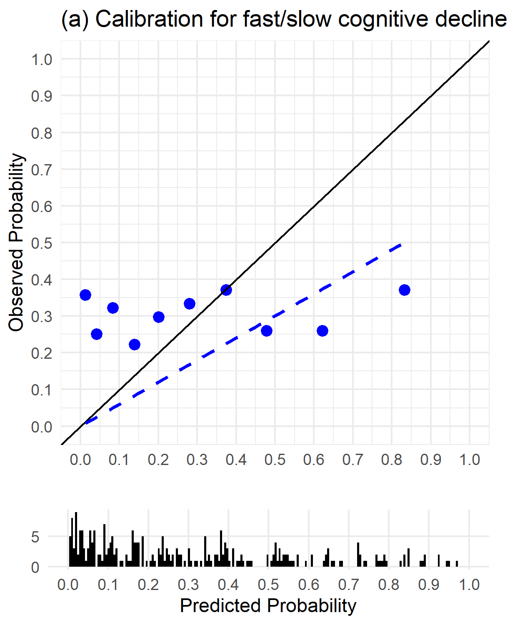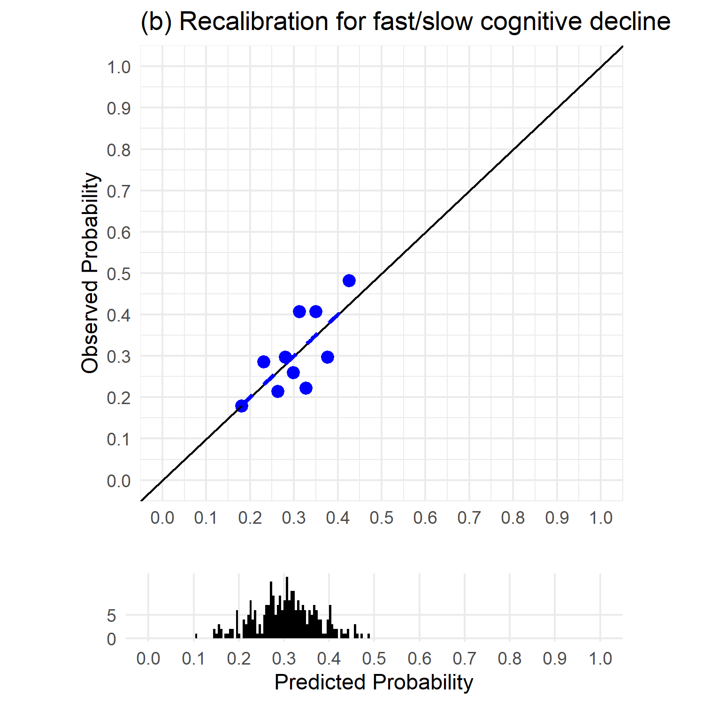

Figure S5 (a) Calibration plot and (b) recalibration plot for fast/slow cognitive decline in the validation cohort

A perfect model has a recalibration slope of 1, and intercept of 0, depicted by a 45-degree line on the recalibration plot.

Table S1 Health status assessment using the chronic diseases shown in the list

Domain | No | Variable
Cardiovascular diseases | 1 | Coronary artery disease
 | 2 | Atrial fibrillation
 | 3 | Angioplasty/stent/endarterectomy
 | 4 | Cardiac bypass procedure
 | 5 | Pacemaker implantation
 | 6 | Congestive heart failure
Cerebrovascular diseases | 7 | Ischemic stroke
 | 8 | Hemorrhagic stroke
 | 9 | Transient ischemic attack
Other neurologic conditions | 10 | Seizures
 | 11 | Traumatic brain injury
 | 12 | Presence of chronic focal neurological signs
Substance abuse and psychiatric disorders | 13 | Smoker
Substance abuse and psychiatric disorders | 14 | Anxiety disorder
Medical/metabolic conditions | 15 | Hypertension
 | 16 | Dyslipidemia
 | 17 | Diabetes
 | 18 | Vitamin B12 deficiency
 | 19 | Thyroid disease
 | 20 | Bladder incontinence
 | 21 | Bowel incontinence

Table S2 Determination of the optimal order in the polynomial model using the development cohort (sample size: nG1 =94; nG2 =157)

 | G1 | G2 | Criteriaª
 | G1 | G2 | BIC | AIC | Likelihood
Order | 2 | 2 | -1924.5 | -1887.6 | -1871.6
Order | 1 | 2 | -1921.4 | -1886.7 | -1871.7
Order | 1 | 1 | -1918.4 | -1886.1 | -1872.1
Order | 1 | 0 | -1929.7 | -1899.6 | -1886.6

ªValues in bold indicate the best-fitting model using the optimal BIC and AIC. Both groups G1 and G2 have linear trajectories.

AIC, Akaike Information Criterion; BIC, Bayesian Information Criterion; G1, fast-decliners; G2, Slow-decliners

Table S3 Parameters estimations for trajectories of cognitive decline in the development cohort (sample size: nG1 =94; nG2 =157)

Group membership | Parameter | Coefficient | Estimate | P-value
Fast-decliners (G1) | Intercept | $$β_{0}^{G1}$$ | 21.66 | <.001*
 | Follow-up time (years) | $$β_{1}^{G1}$$ | -2.55 | <.001*
 | Health statusª | $$α_{2}^{G1}$$ | 0.01 | 0.941
 | Depressive symptoms^{b} | $$α_{3}^{G1}$$ | -0.01 | 0.923
Slow-decliners (G2) | Intercept | $$β_{0}^{G2}$$ | 24.38 | <.001*
 | Follow-up time (years) | $$β_{1}^{G2}$$ | -0.68 | <.001*
 | Health status | $$α_{2}^{G2}$$ | -0.06 | 0.541
 | Depressive symptoms | $$α_{3}^{G2}$$ | -0.04 | 0.360
 | Sigma | $$σ$$ | 2.52 | <.001*
Group membership | Parameter | Coefficient | Estimate | P-value
G1 |  |  | Reference | -
G2 | Constant | $$θ_{0}$$ | 3.15 | 0.171
 | Age, years | $$θ_{1}$$ | -0.04 | 0.117
 | Education, years | $$θ_{2}$$ | 0.01 | 0.366
 | APOE ε4 allele count | $$θ_{3}$$ | -0.85 | 0.003*
 | Sex, female (reference: male) | $$θ_{4}$$ | 0.28 | 0.749
More details on parameters for GBTM model are presented in following. For each participant i, the posterior probability of membership in G1 (fast-decliners) and G2 (slow-decliners) based on the participant’s three repeated measurements of MMSE Y_{i} = {y_{i1}, y_{i2}, y_{i3}}.
$\hat{P}\left(G1 | Y_{i}\right)=\frac{\hat{P}\left(Y_{i} | G1\right){\hat{π}}_{j}}{\sum_{j=1}^{2}{\hat{P}\left(Y_{i} | Gj\right){\hat{π}}_{j}}}=\frac{\prod_{t=1}^{3}{\hat{P}\left(y_{it} | G1\right)}{\hat{π}}_{j}}{\sum_{j=1}^{2}{\prod_{t=1}^{3}{\hat{P}\left(y_{it} | Gj\right)}{\hat{π}}_{j}}}$ and $\hat{P}\left(G2 | Y_{i}\right)=1-\hat{P}\left(G1 | Y_{i}\right)$
where
(i) $logit\left(\hat{P}\left(y_{it} | Gj\right)\right)=β_{0}^{Gj}+β_{1}^{Gj}{Follow-up time}_{t}+α_{2}^{Gj}{Health status}_{t}+α_{3}^{Gj}{Depressive symptoms}_{t}$, in the measurement t;
(ii) ${\hat{π}}_{j}$ is the estimated proportion of the population in group j
${\hat{π}}_{G2}=\frac{e^{θ_{0}+θ_{1}{Age}_{i}+θ_{2}{Eudcation}_{i}+θ_{3}{APOE ε4 count}_{i}+θ_{4}{Female}_{i}}}{1+e^{θ_{0}+θ_{1}{Age}_{i}+θ_{2}{Eudcation}_{i}+θ_{3}{APOE ε4 count}_{i}+θ_{4}{Female}_{i}}}$and ${\hat{π}}_{G1}=1-{\hat{π}}_{G2}$.
In the development cohort, the average posterior probabilities of assignment of fast- and slow-decliners were 90.04% and 95.02%, respectively.

*p <0.05.
ªHealth status using the chronic diseases shown in the Supplementary Table S1.
^{b}Depressive symptoms were assessed by the 15-item Geriatric Depression Scale.

Table S4 Comparisons of performance between logistic regression model and prediction models with other ML methods for cognitive decline trajectories in the development cohort (sample size: nG1 =94; nG2 =157)

Prediction model | AUC | 95% CI | SE
 | Development cohort
Logistic regression (Model 3ª) | 0.841 | 0.771–0.892 | 0.026
Random forest^{b} | 0.832 | 0.795–0.895 | 0.027
Support vector machine^{c} | 0.720 | 0.635–0.804 | 0.043
 | Validation cohort^{d}
Logistic regression | 0.715 | 0.649–0.780 | 0.033

ªThe age, sex, education, baseline MMSE, IADL scores, and APOE ε4 allele count were selected as final predictors. Refer to Table 3 in the main article for details of the final prediction model.
^{b}For random forest with 1000 decision trees, the variable selection was evaluated using Gini importance method.
^{c}For support vector machine with radial basis function kernel, the hyper-parameters (including C and gamma values) was evaluated by creating a grid search of all the hyper-parameters combinations and find a best hyper-parameter.
^{d}The performance of the LR model (Model 3) in the external validation cohort. The estimated coefficients (from our data) of the LR (Model 3) were used to predict the risk of fast cognitive decline for the patients in the validation cohort.

AUC, area under the curve; CI, confidence interval; LR, logistic regression; ML, machine learning; SE, stanrard error.

Table S5 Differences in MMSE decline rates between fast-decliners (G1) and slow-decliners (G2) of the development cohort during three periods (baseline–follow-up 2, follow-up 2–follow-up 5, and baseline–follow-up 5)
Time | Average MMSE decline/year (standard error)
 | G1: Fast-decliners | G2: Slow-decliners
Baseline–2nd FU | 2.6 (1.3) | 0.7 (1.0)
2nd FU–5th FU | 1.9 (1.2) | 1.6 (0.8)
Baseline–5th FU | 2.6 (1.0) | 1.0 (0.7)
The slope of MMSE (i.e., the rate of MMSE decline) was measured in each group and each period, following the rules proposed by a previous study [4]. First, the slope of MMSE over time was estimated for each individual (who had at least two visits), using a simple linear regression model where the outcome variable was MMSE and the independent variable was follow-up time. This model assumes that, for each individual, there is an underlying linear MMSE trajectory, and the observed MMSE values vary randomly in this individual-specific linear trajectory. The resulting estimated slope, expressed in MMSE decline/year, gives an individual’s annual MMSE decline. Then we averaged across individuals’ scores to get an average MMSE decline/year.

FU; follow-up.

References

- Nagin DS. Group-based modeling of development: Cambridge, MA: Harvard University Press, 2005.
- Klijn SL, Weijenberg MP, Lemmens P et al. Introducing the fit-criteria assessment plot - A visualisation tool to assist class enumeration in group-based trajectory modelling. Stat Methods Med Res. 2017;26:2424-36.
- Muthen B, Muthen LK. Integrating person-centered and variable-centered analyses: Growth mixture modeling with latent trajectory classes. Alcohol Clin Exp Res. 2000;24:882-91
- Leffondre K, Boucquemont J, Tripepi G et al. Analysis of risk factors associated with renal function trajectory over time: a comparison of different statistical approaches. Nephrol Dial Transplant. 2015;30:1237-43.

