Supplementary Information

Intrinsic ferroelectricity in Y-doped HfO₂ thin films

Yu Yun,^{1†} Pratyush Buragohain,^{1†} Ming Li,^{1†} Zahra Ahmadi,² Yizhi Zhang,³ Xin Li,¹ Haohan Wang,¹ Lingling Tao,¹ Haiyan Wang,³ Jeffrey E. Shield,^{2,4} Evgeny Y. Tsymbal,^{1,4}* Alexei Gruverman,^{1,4}* Xiaoshan Xu^{1,4}*

¹ Department of Physics and Astronomy, University of Nebraska-Lincoln, Lincoln, Nebraska 68588, USA
² Department of Mechanical and Materials Engineering, University of Nebraska–Lincoln, Lincoln, Nebraska 68588, USA
³ School of Materials Engineering, Purdue University, West Lafayette, Indiana 47907, USA
⁴ Nebraska Center for Materials and Nanoscience, University of Nebraska, Lincoln, Nebraska 68588, USA

†Joint first authors.
*Corresponding authors: tsymbal@unl.edu, agruverman2@unl.edu, xiaoshan.xu@unl.edu

Section 1: Correlation between crystallinity and polarization.

The thickness of YHO (5% Y doped-HfO₂) films was measured by x-ray reflectivity (XRR), as shown in Fig. S1. The clear oscillations resulted from the YHO and LSMO (La_{0.7}Sr_{0.3}MnO₃) layer indicate the smooth interface and surface.

The rocking curves of YHO (111) peaks are displayed in Fig. S2. The growth temperature (T_{s}) was changed from 750°C to 970°C and all the YHO films were grown on LSMO/STO (SrTiO₃) (001). The rocking curve width essentially measures the size of the reciprocal lattice point. For epitaxial thin films, the effect of finite crystallite size dominates since the crystal orientation of the film follows that of the substrate which is a large single crystal. The rocking curve contains two components: a broaden peak and a sharp peak, which correspond to small grain (<10 nm) and large grain (~100 nm) calculated by Scherrer formula. The fraction of large grain and small grain is derived from the sharp/broaden peak area ratio, which is an indicator of crystallinity. The large/small grain ratio is positively correlated to the crystallinity. The large/small grain ratio as a function of T_{s} is shown in Fig. 1d, which is great agreement with the trend of ferroelectric polarization.

The θ-2θ XRD scans of YHO/LSMO/STO (001) films with various T_{s} are shown in Fig. S3. The peak position of YHO (111) shifts to higher angle as T_{s} increase, indicating the out-of-plane (OOP) d spacing increases with T_{s}, which is consistent with the results in previous report about Hf_{0.5}Zr_{0.5}O₂ (HZO) films ¹.

The surface morphology of YHO films grown on LSMO/STO (001) was measured by atomic force microscopy (AFM). For T_{s} ≤ 890°C, the flat surface with atomic terrace was observed, as depicted in Fig. 2c, and the large/small grain ratio reaches the maximum. As T_{s} further increases, the surface of the films becomes much rougher and some islands appear around the terraces, as shown in Fig. S4. The areas of the AFM images are 1μm×1μm. The heights of surface along the blue in the AFM images is measured and shown below the AFM images. The heights and sizes of islands increases with T_{s}, which could be attributed to the decay of LSMO layer due to high growth temperature. These islands could not only reduce the grain size and crystallinity, but also lead to the high leakage current.

To further investigate the crystal structure of YHO/LSMO/STO (110) films, we carried out the scanning transmission electron microscopy (STEM) analysis. The low magnification STEM image of YHO/LSMO/STO (110) films taken under the high angle annular dark field (HAADF) mode is shown in Fig. S5a. The different layers are labeled. The energy dispersive x-ray spectroscopy (EDS) mapping demonstrates the element distribution of Hf, La and Sr (Fig. S5b, c and d). Fig. S5e,f show the interface between the YHO film and the LSMO bottom electrode with clean interface between the layers. The epitaxial relationships are determined to be YHO $\left[11\overline{2}\right]$ // LSMO $\left[1\overline{1}0\right]$ and YHO $\left[1\overline{1}0\right]$// LSMO $\left[001\right]$. The entire TEM image (Fig. 5f) appears to be a YHO grain without any grain boundary, suggesting the good crystallinity of the films, which is much larger than the grain size (~10 nm) of HZO epitaxial films in previous report ².

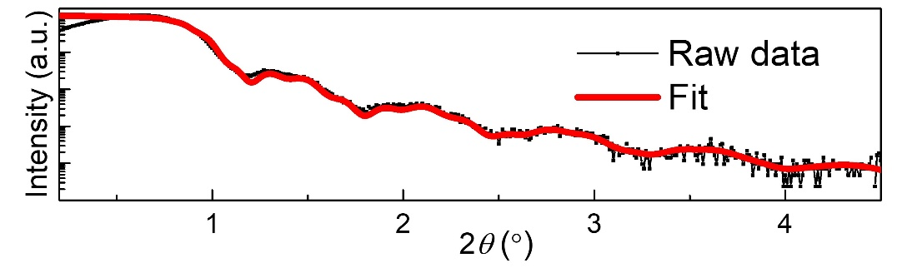
Fig. S1. X-ray reflectivity (XRR) of the YHO/LSMO/STO (100) thin film.

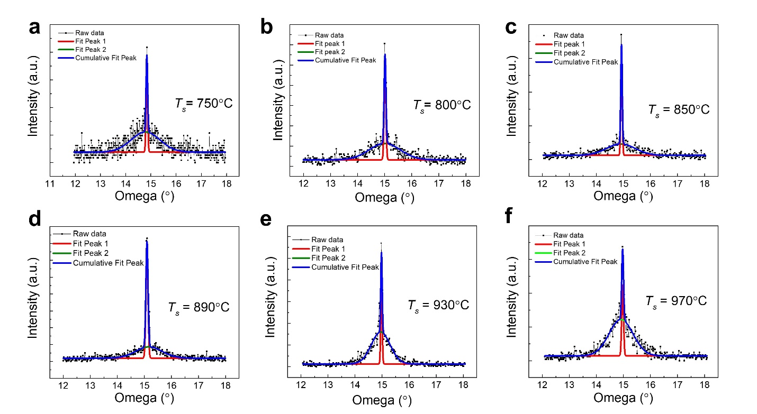
Fig. S2. Rocking curves of the (111) peaks for the YHO films grown on LSMO/STO (001) with various growth temperatures (a-f).
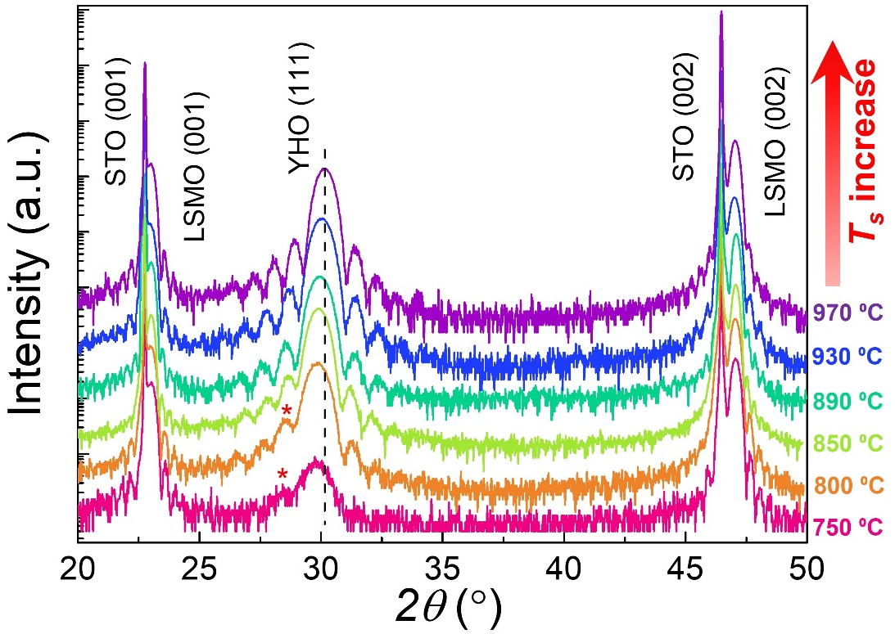
Fig. S3. θ-2θ XRD scans for YHO/LSMO/STO (001) samples with various growth temperature (T_{s}). The out-of-plane lattice constant of YHO films decreases as the T_{s} increases.

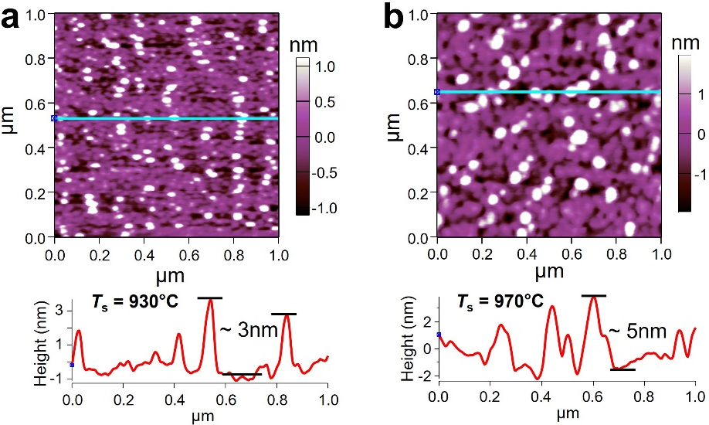
Fig. S4. Atomic force image of YHO films with (a) T_{s} = 930°C and (b) T_{s} = 970°C grown on LSMO/STO (001). The height of the islands increases with T_{s}, which is due to the decay of LSMO layer.

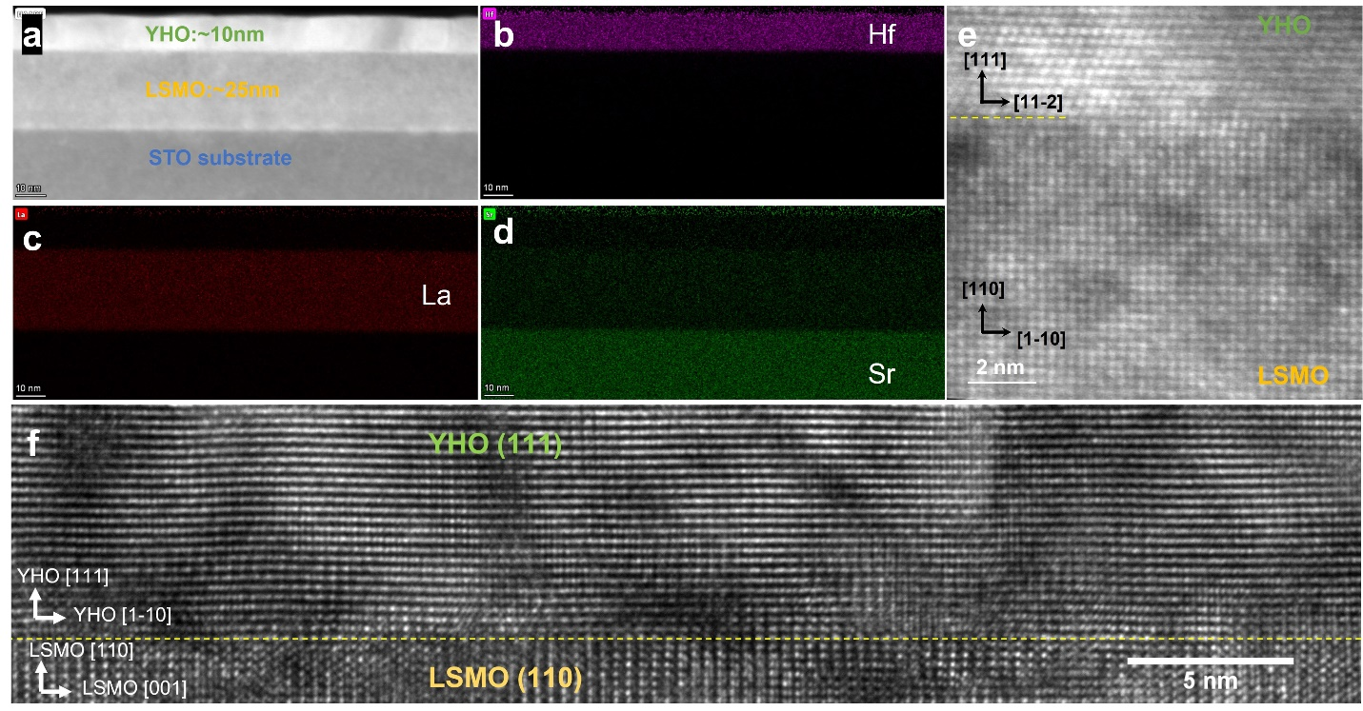

Fig. S5. (S)TEM image of YHO (111)/LSMO (110)/STO (110) films. (a) Low magnification STEM-HAADF image of the YHO/LSMO/STO (110) stack. (b-d) EDS mapping of Hf, La, and Sr respectively of the same area as (a). (e,f) shows the epitaxial relation YHO $\left[11\overline{2}\right]$ // LSMO $\left[1\overline{1}0\right]$ and YHO $\left[1\overline{1}0\right]$// LSMO $\left[001\right]$.

Section 2: Electrical characterization

Temperature-dependent imprint behavior was characterized as shown in Fig. S6. Previously, it was shown that the direction of imprint was strongly dependent on the poling history – if the last poling pulse was positive (negative), then the imprint or the internal bias will be negative (positive). This tunable imprint is called fluid imprint, which could be attributed to charge injection and subsequent trapping at defect sites at the interface between YHO films and electrodes ³. In addition, the magnitude of the imprint was found to gradually increase with time ³. At room temperature, such a fluid imprint behavior was observed on the capacitors with YHO films grown on LSMO/STO (110) (Fig. S6), where the P-V loops were found to be left or right shifted depending on whether the polarity of the last pulse was positive or negative. However, at 20 K, the imprint remains ‘frozen-in’ (Fig. S6 b,c) and the direction of the imprint was found to be only dependent on the polarity of the last pulse that was applied to the capacitors before cooling down from room temperature. The imprint did not change even after waiting for nearly 2 hours after reversing the polarity of the poling pulses. This suggests that there is minimal movement of additional charges such as oxygen vacancies at 20 K, which can otherwise move under the depolarization field at higher temperatures. The contribution of the oxygen migration on the polarization switching, which was identified as the main source of large polarization of the HZO epitaxial films at room temperature ⁴, could thus be excluded. The polarization (~37 μC/cm²) at 20 K could be regarded as the intrinsic polarization value of the YHO films along (111) direction. It is worth noting that the ferroelectric easy axis of YHO films is along (001) direction, so the actual polarization value could be around ~ 60 μC/cm².
The endurance of the devices with YHO films grown on LSMO/STO (110) was also measured at room temperature, as shown in Fig. S7. The polarization was almost constant (~ 50 μC/cm²) until about 10⁴ cycles. As the number of cycles further increases, polarization starts to decrease gradually. This instabilities in the field cycling process are commonly observed and explained by the defect (i.e., oxygen vacancies) movement and generation ⁵. The endurance measurements at 20 K (not shown here) demonstrated that no reduction in polarization was observed, up to 10⁷ cycles. This also highlights that instabilities induced by the defect movement or oxygen migration could be strongly restricted at low temperature.
In addition, the time scale of the switching process as a function of applied voltage at 300K was performed as shown in Fig. S8. The typical switching time (t_{SW}) is from 12 μs to 26 μs, which is must faster than the results in HZO films previously ⁴.

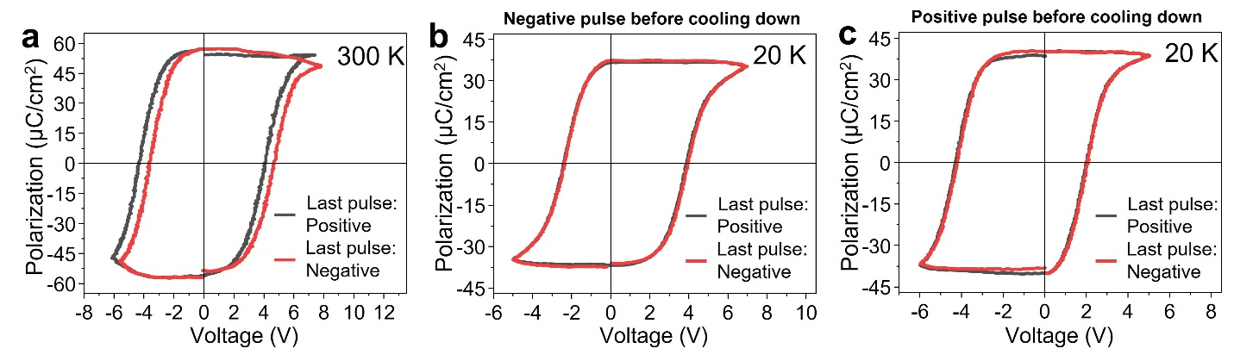
Fig. S6. Imprint at different temperatures for YHO films grown on LSMO/STO (110). (a) P-V loops at 300 K after the positive and negative set pulse. The imprint depends on the previous pulse. Imprint at 20 K with (b) negative set pulse and (c) positive set pulse before cooling down. The imprint cannot be changed by the set pulse at 20K, indicating that oxygen migration is restricted strongly.

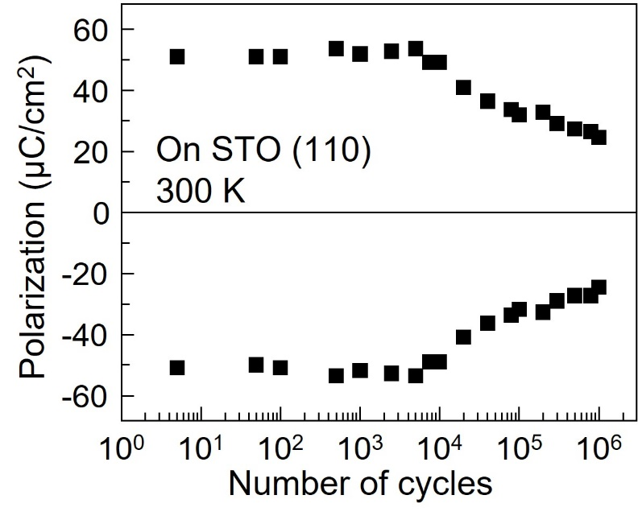
Fig. S7. The endurance of YHO films grown on LSMO/STO (110).

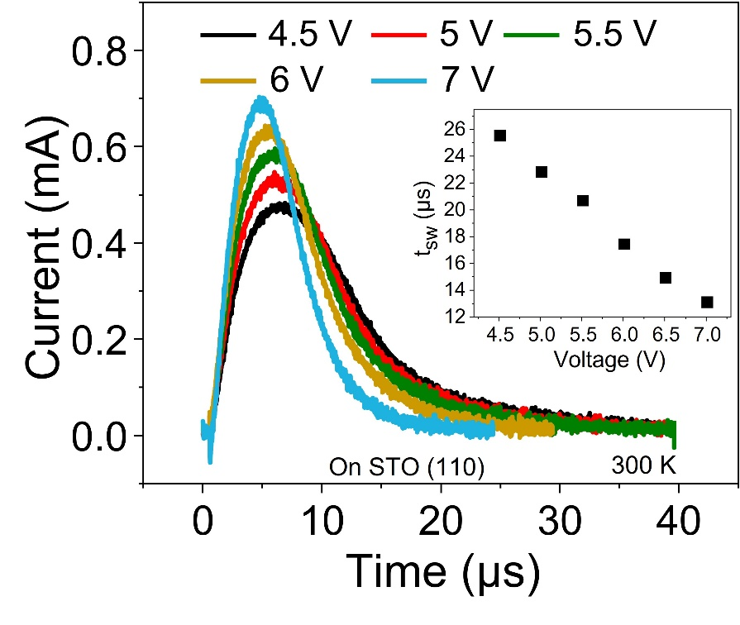

Fig. S8. Switching time with various applied voltage at 300 K.

Section 3: Structural distortions

The rhombohedral distortion of the YHO/LSMO/STO (001) films is characterized by the measurements of {111} d-spacing using the Bruker D8 XRD with 2D detector. The measurement of {111} d spacing is sensitive to the rhombohedral distortion. The difference in lattice parameter in a, b, c only can give a second order contribution. The 2θ scans of {111} peaks along OOP and IP direction with χ = 71° for the samples with various T_{s} are displayed in Fig. S9. For all the samples, the IP {111} peaks with various φ angle localized at the similar 2θ angle, which is distinctly higher than the 2θ angle of OOP {111} peaks. This is the signature of the rhombohedral symmetry ^{2,6}. The 12-fold IP symmetry resulted from the symmetry mismatch between YHO and LSMO films ^{2,6}. The corresponding {111} d-spacing values are summarized in Fig. S10, indicating the rhombohedral distortion exists in all the YHO/LSMO/STO (110) films. The OOP d-spacing increases with T_{s}, meanwhile, IP d-spacing keeps almost constant, as shown in Fig. S11. This suggests that the anisotropy of strain and stress reduced as T_{s} increases. The trend of OOP d-spacing is consistent with the results in Fig. S2 and previous reports about HZO films ¹. Regarding as nonlinear trend of the polarization as a function of the T_{s} in Fig. 1d, the strain effect is unlike the reason of the evolution of the polarization with various T_{s}.
On the other hand, the rhombohedral distortion in YHO films grown on LSMO/STO (110) is also evident in Fig. S12. There is also a distinct difference between OOP and IP d-spacing, indicating the rhombohedral distortion also exists. The rhombohedral distortion of YHO/LSMO/STO (110) is smaller than that of YHO/LSMO/STO (001), as displayed in Table 1. The YHO films grown on LSMO/STO (110) exhibits 6-fold symmetry with 2 different domains rotated by 180°, which is attributed to the 2-fold symmetry of the substrate and 3-fold symmetry of the YHO films. This heterostructure was never reported before, which could give rise to the reduced grain boundary and better crystallinity. The epitaxial relationship and XRD aliment are illustrated in the inset of Fig. S12b.
To identify orthorhombic distortion, we carried out the measurements of {002} d-spacing, which is sensitive to the difference of lattice constant a, b, c. The derivation of angle α, β, γ from 90° is quite small, which can only give a secondary contribution to lattice constant. The representative measurements of {002} d-spacing of YHO films grown on LSMO/STO (001) and LSMO/STO (110) at χ = 55° are plotted in Fig. S13a and b, respectively. The {002} peaks demonstrate same symmetric relationship as the {111} peaks. It is obviously observed that there are two peaks. The peaks can be fitted very well by double gaussian peaks, as shown in Fig. S14. The double peaks correspond to the two different lattice constants, which is one of the important evidence of the orthorhombic distortion, as we mentioned in main text. The orthorhombic distortion is the origin of the ferroelectric polarization instead of the rhombohedral distortion.
The RHEED patterns of the YHO/LSMO/STO (110) films at room temperature are shown in Fig. S15. The clear streaks for each layers suggest the good crystallinity and smooth surface and interface. The epitaxial relationship is constant with the results of TEM in Fig. S5. The labels of the streaks of YHO films are shown in Fig. 4h.

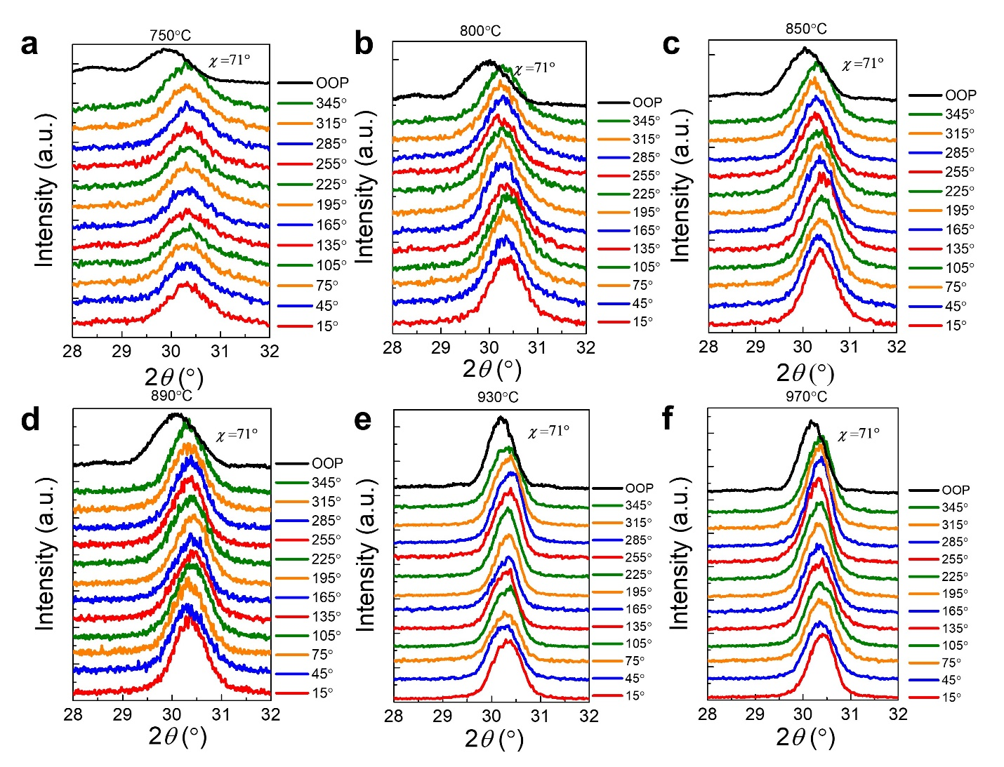
Fig. S9. The 2θ scans of {111} peaks along out of plane (OOP) and in plane (IP) with φ angle differing by 30° at an angle (χ) of ~71° for the YHO/LSMO/STO (001) films grown at various temperature (a-f).
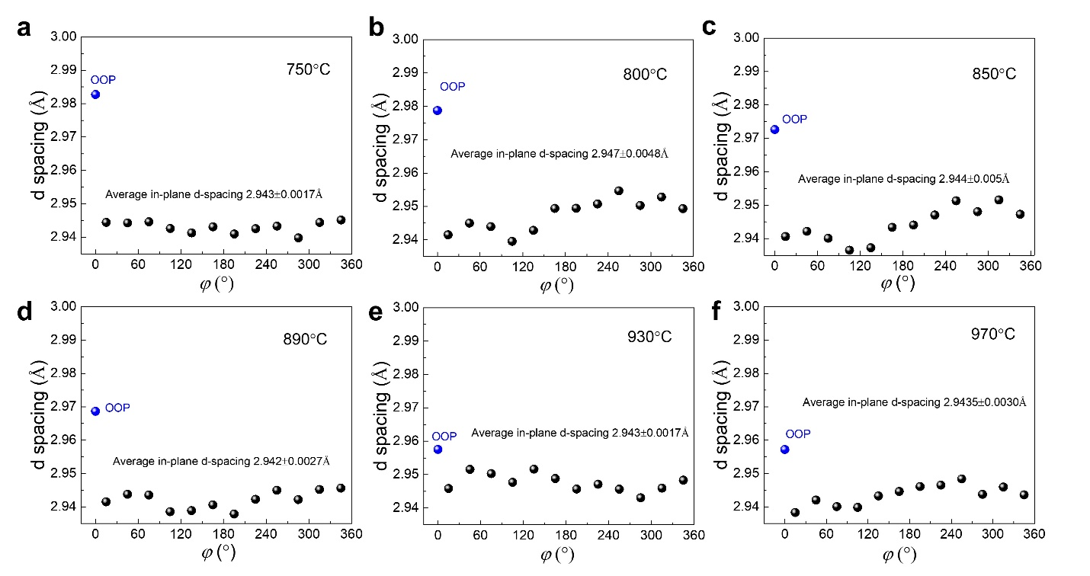
Fig. S10. The {111} d-spacing along OOP and IP for the YHO/LSMO/STO (001) samples grown at various temperature (a-f).

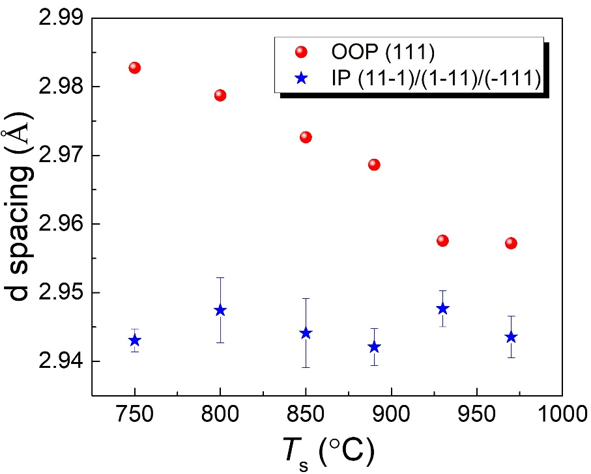
Fig. S11. The d-spacing of OOP (111) and average IP d-spacing (11-1)/(1-11)/(-111) as a function of growth temperature (T_{s}) for the YHO/LSMO/STO (001) films.

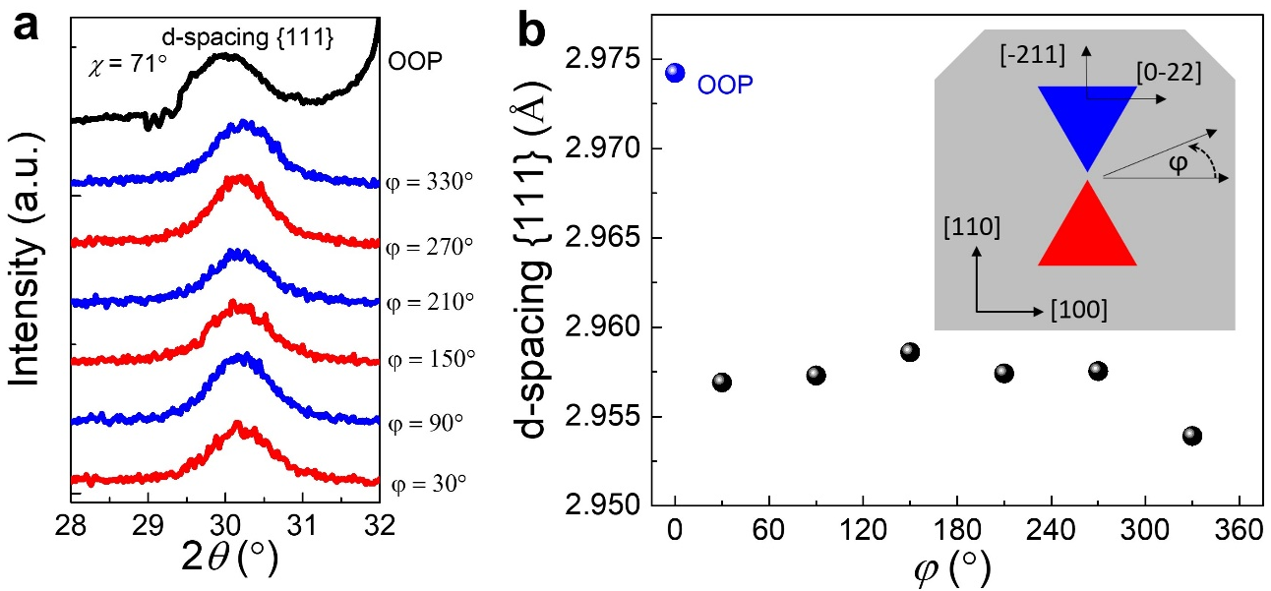
Fig. S12. The d-spacing {111} of the YHO/LSMO/STO (110) films. (a) The 2θ scan of {111} peaks along OOP and IP direction. (b) The {111} d spacing. Inset: epitaxial relationship between YHO and LSMO/STO (110), and the azimuthal direction represents φ, with a (0°–360°) range.

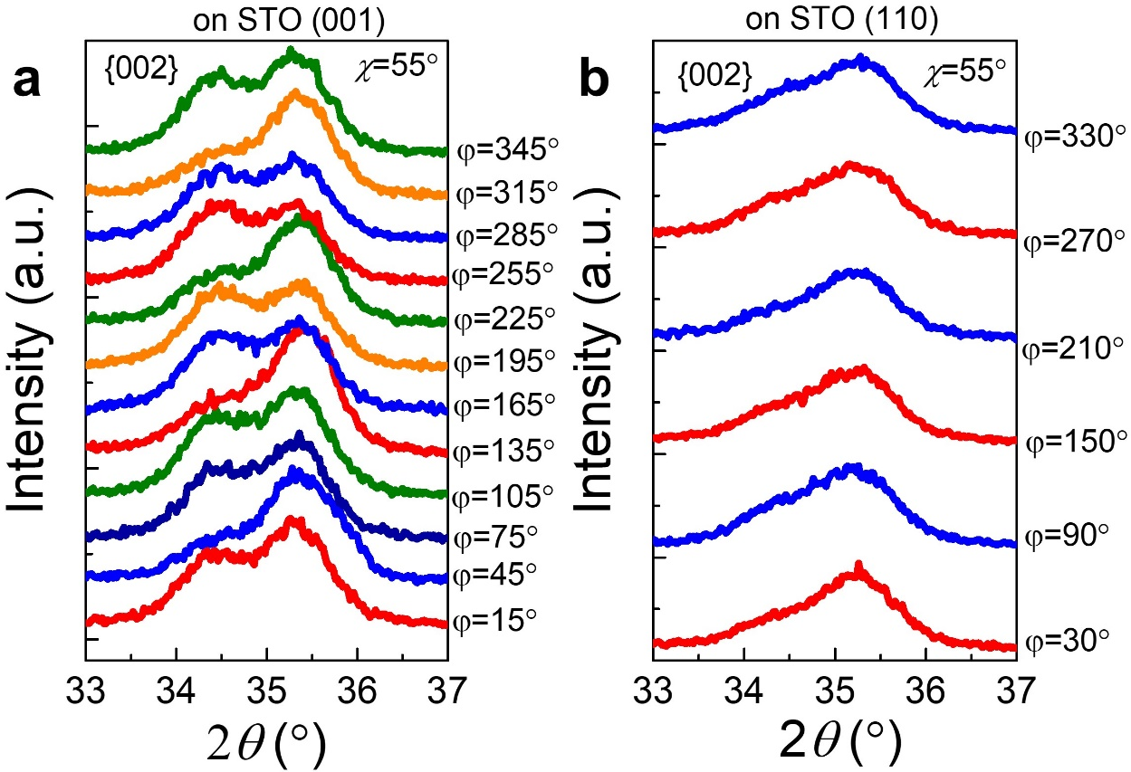
Fig. S13. The 2θ scan of the {002} peaks for YHO films grown on (a) LSMO/STO (001) and (b) LSMO/STO (110).
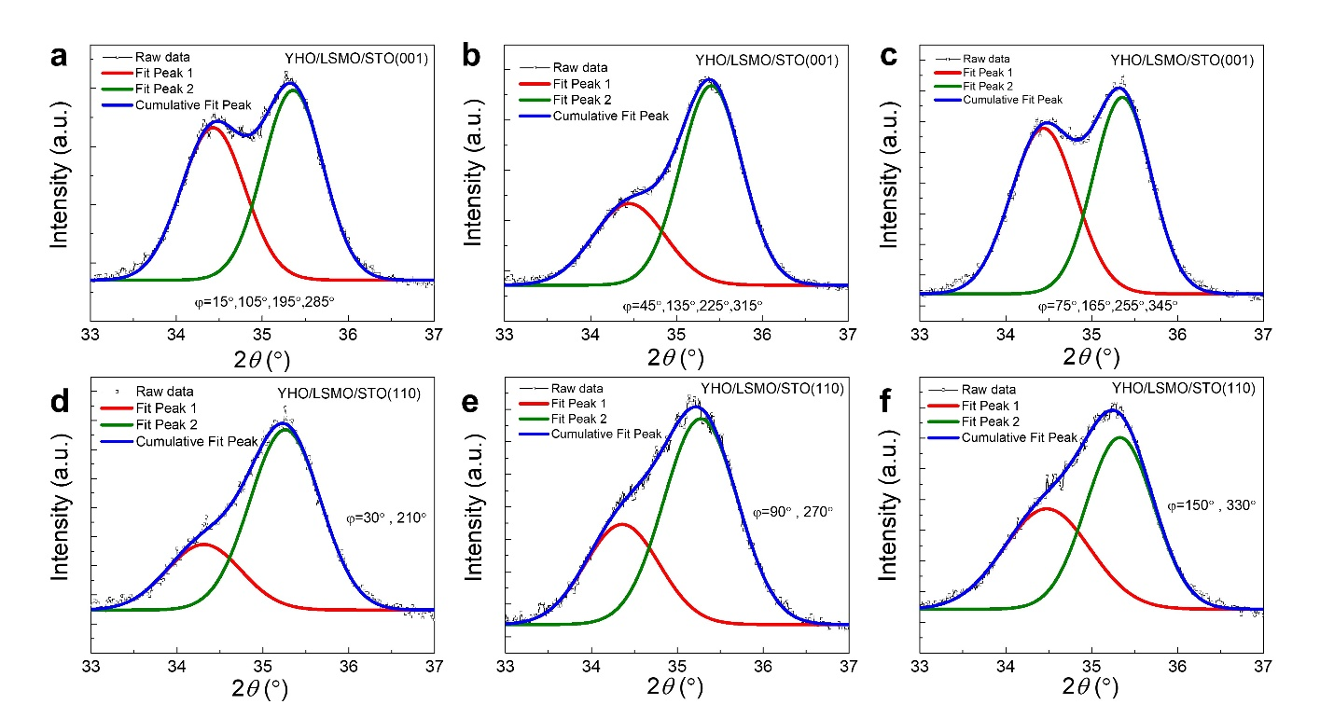
Fig. S14. The fitting of {002} peaks of YHO films grown on (a-c) LSMO/STO (001) and (d-f) LSMO/STO (110) with various φ angle.

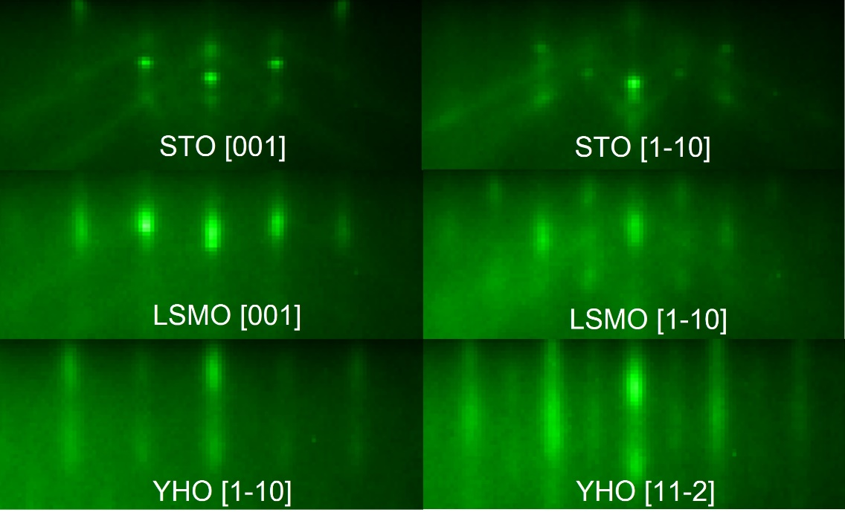
Fig. S15. The RHEED pattern of each layer of YHO/LSMO/STO (110) films. The e-beams are parallel to STO [001] (left column) and STO [1-10] (right column), respectively.

Section 4: Density functional theory study.

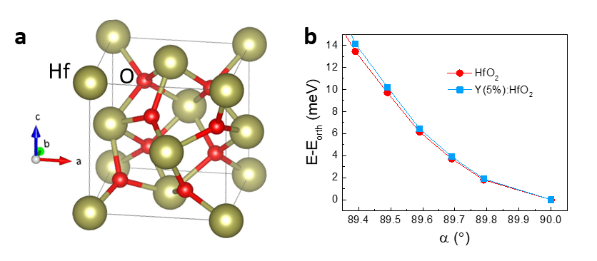
Fig. S16. Results of DFT calculations for bulk undoped and 5% Y-doped HfO₂. (a) The atomic structure of an orthorhombic HfO₂ unit cell used in the DFT calculations. (b) Change in the total energy of bulk undoped HfO₂ (red lines and symbols) and 5% Y-doped HfO₂ (blue lines and symbols) as a function of rhombohedral distortion of the orthorhombic Pca2₁ unit cell quantified by angle α. The energy of the orthorhombic Pca2₁ structure (α = 90°) E_{orth} is taken as a reference.

Besides the small effect of the Y doping and the rhombohedral distortion on the spontaneous polarization (see main text), we found that rhombohedral distortion of the orthorhombic phase enhances the total energy of both the undoped and Y-doped HfO₂ (Fig. S16b) slightly. As seen from Fig. S16b, the total energy is increased by about 6 meV per unit cell with the angle α being reduced from 90° to 89.6° corresponding to our XRD data. This result indicates that the rhombohedral distortion occurring in our experiment does not minimize the bulk total energy of the grown hafnia film directly. It is a rather a consequence of the anisotropic strain imposed by the substrate.

References:
1 Lyu, J., Fina, I., Solanas, R., Fontcuberta, J. & Sanchez, F. Growth Window of Ferroelectric Epitaxial Hf_{0.5}Zr_{0.5}O₂ Thin Films. ACS Appl. Electron. Mater. 1, 220-228 (2019).
2 Wei, Y. F. et al. A rhombohedral ferroelectric phase in epitaxially strained Hf_{0.5}Zr_{0.5}O₂ thin films. Nat. Mater. 17, 1095-1100 (2018).
3 Buragohain, P. et al. Fluid Imprint and Inertial Switching in Ferroelectric La:HfO₂ Capacitors. ACS Appl. Mater. Interfaces 11, 35115-35121 (2019).
4 Nukala, P. et al. Reversible oxygen migration and phase transitions in hafnia-based ferroelectric devices. Science 372, 630-635 (2021).
5 Islamov, D. R. et al. Identification of the nature of traps involved in the field cycling of Hf_{0.5}Zr_{0.5}O₂-based ferroelectric thin films. Acta Mater. 166, 47-55 (2019).
6 Nukala, P. et al. Guidelines for the stabilization of a polar rhombohedral phase in epitaxial Hf_{0.5}Zr_{0.5}O₂ thin films. Ferroelectrics 569, 148-163 (2020).

