Supplementary Information
Photocatalytic selective oxidation of methane by quantum sized bismuth vanadate
Yingying Fan^{1,2}, Wencai Zhou¹, Xueying Qiu¹, Hongdong Li¹, Yuheng Jiang,^{1,3} Zhonghui Sun², Dongxue Han²*, Li Niu², Zhiyong Tang¹*
¹Chinese Academy of Science (CAS) Key Laboratory of Nanosystem and Hierarchy Fabrication, CAS Center for Excellence in Nanoscience, National Center for Nanoscience and Technology and University of Chinese Academy of Sciences, Beijing 100190, P. R. China. *e-mail: zytang@nanoctr.cn
²Center for Advanced Analytical Science, School of Chemistry and Chemical Engineering, School of Civil Engineering, Analytical and Testing Center, Guangzhou University, Guangzhou 510006, P. R. China. *e-mail: dxhan@gzhu.edu.cn
³Center for Nanochemistry, Peking University, Beijing 100871, P. R. China.

Part S1. Supplementary quantitative assessment of photocatalytic efficiency
Turnover number (TON) calculation. In the calculation of TON, the moles of active sites can be replaced by the moles of photocatalyst according to the reported work¹. Thus, for 10 mg q-BiVO₄, the number of active sites is calculated to be 30.9 μmol as the total mole of q-BiVO₄.
As a typical example, the moles of product after 7 h reaction (Fig. 3c) are figured out to be 80 μmol based on the generated amount of CH₃OH (1.7 mmol g⁻¹ × 0.01 g), HCHO (5.6 mmol g⁻¹ × 0.01 g) and CO₂ (0.7 mmol g⁻¹ × 0.01 g). Thus, the TON value with 10 mg q-BiVO₄ is calculated to be 2.6 via the following formula (1).
TON = $\frac{\text{ moles of (CH}\text{3}\text{OH + HCHO + CO}\text{2}\text{) }}{\text{ moles of q-BiVO}\text{4}}$ (1)
Quantum efficiency (Q.E.) calculation. The Q.E. values of q-BiVO₄ towards CH₄ oxidation (CH₄:O₂ = 1:1) at monochromatic wavelengths of 365, 420, 470, 535 and 630 nm are measured and calculated according to the following equation.
η = $\frac{\text{R}\text{(electron) }\text{N}\text{A}}{\text{I S t /}{\text{ E}}_{\text{λ}}}$ × 100% (2)
where N_{A}, I, S and t represent the Avogadro’s constant (6.02 × 10²³ mol⁻¹), light intensity irradiated on the sample, irradiation area (23.75 cm⁻²) and reaction time (3 h), respectively. Taken λ = 365 nm as an example, the value of E_{λ} is obtained to be 5.4 × 10⁻¹⁹ J through the formula of hc / λ. R(electron) stands for the number of electrons engaged in formation of the products.
$\text{H}\text{2}\text{O }\underset{→}{\text{- e}\text{-}} \text{•}\text{OH} \text{+} \text{H}\text{+}$ (3)
$\text{O}\text{2} \underset{→}{\text{+ 2e}\text{-}\text{, + 2H}\text{+}}\text{ H}\text{2}\text{O}\text{2} \underset{→}{\text{+ e}\text{-}\text{, + H}\text{+}} \text{•}\text{OH +} \text{H}\text{2}\text{O}$ (4)
$\text{CH}\text{4}\text{ + }\text{•}\text{OH }→ \text{•}\text{CH}\text{3}\text{ +} \text{H}\text{2}\text{O}$ (5)
$\text{•}\text{CH}\text{3 }\text{+ O}\text{2} \underset{→}{\text{+ e}\text{-}\text{, + H}\text{+}}\text{ CH}\text{3}\text{OOH}$ (6)
$\text{CH}\text{3}\text{OOH }\underset{→}{\text{+ 2e}\text{-}\text{, + 2H}\text{+}} \text{CH}\text{3}\text{OH + H}\text{2}\text{O}$ (7)
$\text{CH}\text{3}\text{OH + }\text{•}\text{OH }→ \text{•}\text{CH}\text{2}\text{OH +} \text{H}\text{2}\text{O}$ (8)
$\text{•}\text{CH}\text{2}\text{OH + }\text{•}\text{OH }→ \text{HOCH}\text{2}\text{OH }→ \text{HCHO + H}\text{2}\text{O}$ (9)
$\text{HCHO + O}\text{2} \underset{→}{\text{+ 4e}\text{-}}\text{ CO}\text{2}\text{ + H}\text{2}\text{O}$ (10)
As displayed in equation (3) and (4), the formation of •OH involves two possible routes: one is H₂O oxidation and the other is O₂ reduction. In consideration of charge balance throughout the whole system, we assume that the H₂O oxidation by holes contributes 91% •OH while O₂ reduction by electrons offers the left 9% •OH. Hence, the CH₄ molecule is activated by •OH to form •CH₃ and the generated •CH₃ subsequently combines with O₂ to produce CH₃OH; this process needs 0.91 × 1 + 0.09 × 3 + 1 + 2 = 4.18 electrons. HCHO can be produced through the integration between activated •CH₂OH and •OH, which requires 0.91 × 1 + 0.09 × 3 + 1 + 2 + 2 × (0.91 × 1 + 0.09 × 3) = 6.54 electrons. As the final product, CO₂ is generated by the oxidation of HCHO, and the entire process includes 0.91 × 1 + 0.09 × 3 + 1 + 2 + 2 × (0.91 × 1 + 0.09 × 3) + 4 = 10.54 electrons. Therefore, the number of reacted electrons is N_{A} = (n (CH₃OH) × 4.18 + n (HCHO) × 6.54 + n (CO₂) × 10.54). Under the irradiation of monochromatic light (365 nm, I = 0.027 W/cm²), the photocatalytic CH₄ oxidation has been carried out with the generated amount of CH₃OH, HCHO and CO₂ as 84.1, 40.7 and 3.5 μmol (Table S2), respectively. Thus, under the reaction condition of CH₄ : O₂ = 1:1, the Q.E. = 6.02 × 10²³ mol⁻¹ × (84.1 μmol × 4.18 + 40.7 μmol × 6.54 + 3.5 μmol × 10.54) × 100% / (0.027 W cm⁻² × 23.75 cm² × 3 × 3600 s / 5.4 × 10⁻¹⁹ J) = 3.07%. Analogously, the Q.E. value at the wavelengths of 420, 470, 535 and 630 nm is calculated to be 0.82%, 0.47%, 0% and 0%, respectively, as shown in Table S2.

Part S2. Supplementary figures
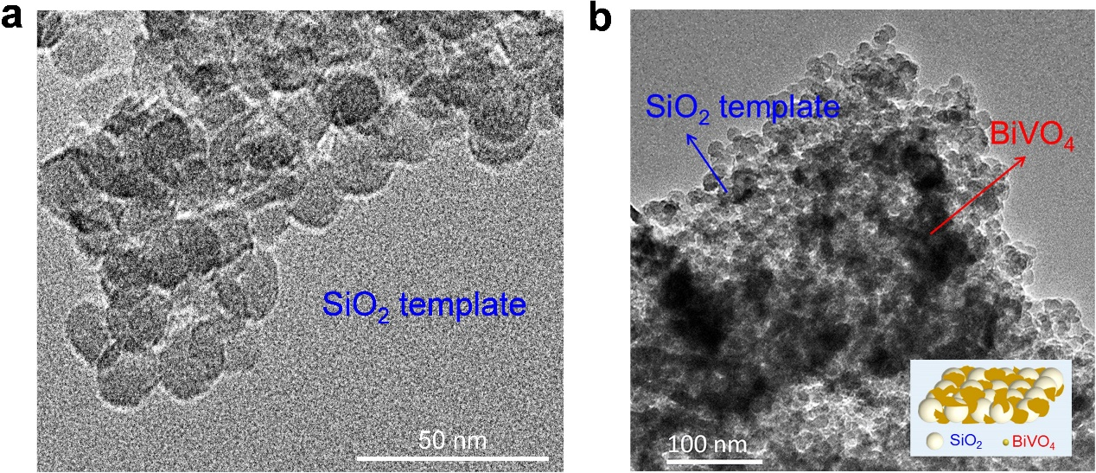
Fig. S1 TEM images of (a) pure silica template and (b) a composite structure containing silica template encapsulated by BiVO₄ after calcination.
As shown in Fig. S1a, the pure silica template is uniform with an average diameter of ~12 nm. After reaction, a composite structure with silica template encapsulated by BiVO₄ is obtained (Fig. S1b).

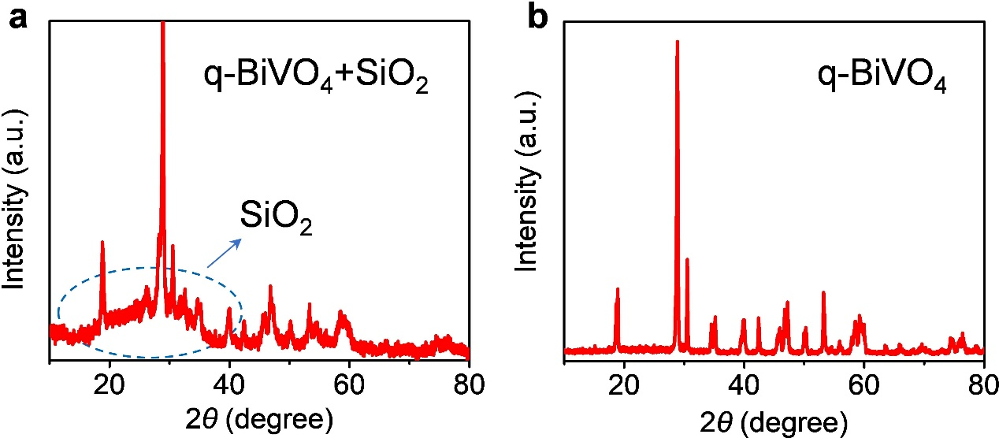
Fig. S2 XRD patterns (a) before and (b) after removal of silica template.
The XRD pattern of BiVO₄ with SiO₂ template shows an amorphous shoulder^{2, 3} at 2θ = 20º - 40º, resulting from the existence of silica template (Fig. S2a). XRD curve with a flat baseline in Fig. S2b confirms the successful removal of silica template from BiVO₄ sample.

Fig. S3 Estimation of the average aggregation size of q-BiVO₄ by Debye-Scherrer method within Jade software tool.
The Jade software tool has been used for particle size analysis, which is designed in the light of Debye-Scherrer formula. To confirm the calculation accuracy, a low-angle range from 17.598º to 31.249º (2θ) was taken for fitting. As shown by the value in the red circle (upper panel in Fig. S3), the average particle size is calculated to be 10.5 nm (105 Å), which is about 2.3 times larger than the TEM result (4.5 nm). This should be attributed to the particle aggregation. Note that such particle aggregation has no impact on the quantum confinement effect of q-BiVO₄.
Fig. S4 (a) HAADF-STEM image and (b-d) corresponding element mapping images of q-BiVO₄.
Element mapping images based on high-angle annular dark field scanning transmission electron microscopy (HAADF-STEM, Fig. S4) indicate that all the Bi, V and O elements are homogeneously distributed over q-BiVO₄

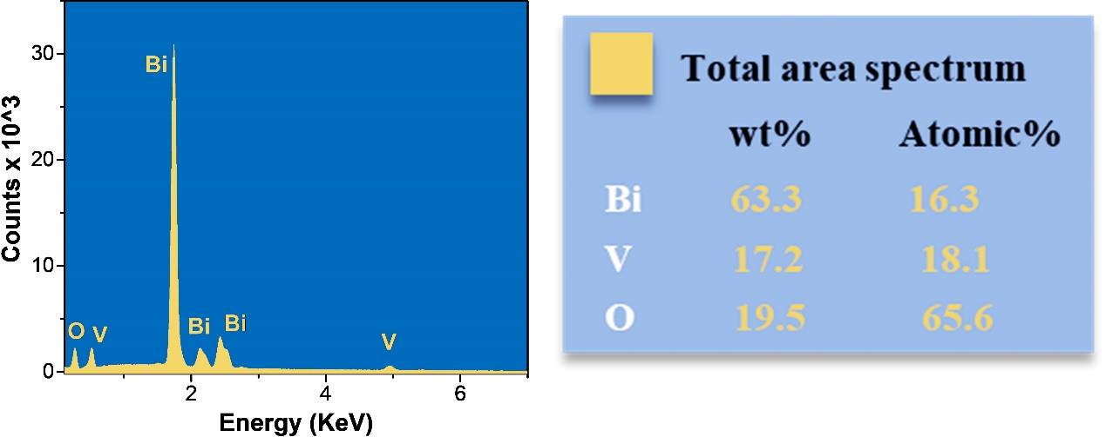
Fig. S5 EDX spectroscopy of q-BiVO₄.
EDX spectrum and corresponding element analysis show that as-synthesized catalyst contains three elements of Bi, V and O with mass fractions of 63.3, 17.2 and 19.5% and atomic ratios of 16.3, 18.1 and 65.6%, respectively, which are quantitatively consistent with the ratio in BiVO₄ material. This result is another solid evidence for successful preparation of q-BiVO₄.

Fig. S6 Detailed configuration of high-pressure photocatalytic reactor.
The configuration of high-pressure photocatalytic reactor includes a quartz window on the top plate, gas inlet and gas outlet, cooling water inlet and cooling water outlet as well as a mechanical pressure gauge on the reactor well.

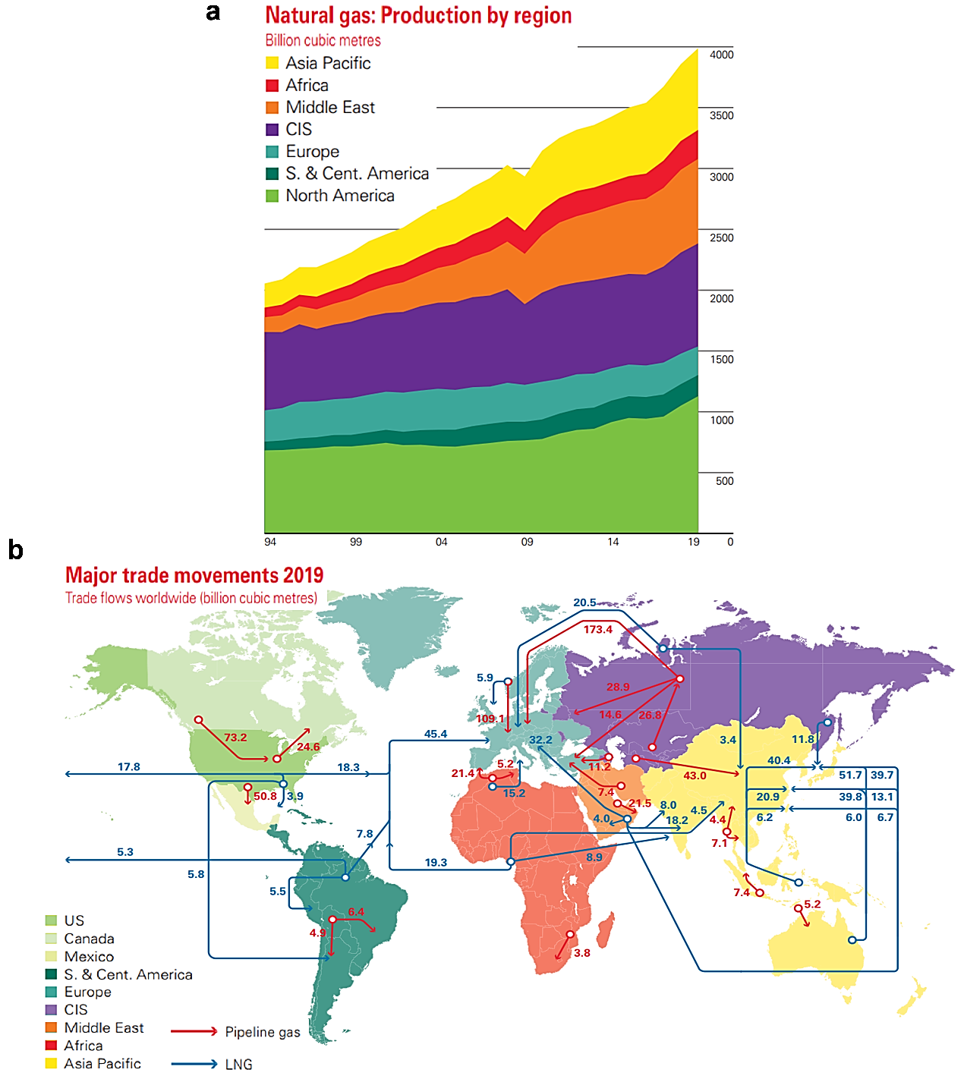
Fig. S7 (a) Natural gas production in different regions around the World over the last 26 years. (b) Major trade movements of natural gas. Fig. S7 is reprinted from the BP Statistical Review of World Energy 2019⁴.
Considering the storage condition and practical transportation of natural gas, the high-pressure mode of CH₄ conversion can be regarded as an energy-saving process. As shown in Fig. S7, the natural gas is substantially discovered at the high latitude regions (Fig. S7a) such as North America (28.3%) and Commonwealth of Independent States (CIS, 21.2%), where the lack of intensive solar light irradiation is unfavorable for photocatalytic CH₄ conversion. Thus, considering the practical application in the future, the photocatalytic methane conversion needs to be carried out in the regions with adequate solar energy. While, in the light abundant Africa, the storage of natural gas only accounts for 6.0%. Thanks to the global energy trade (Fig. S7b), the natural gas from solar energy deficient regions is conveniently transported to equatorial regions in the forms of pipeline gas and liquefied natural gas (LNG). The pressure rating of pipeline gas reaches more than 70 bar⁵, which is even higher than our reaction system (20 bar). And in order to reduce the storage volume, natural gas is constantly condensed into compressed natural gas (CNG) or frozen as LNG, which both can release 200 - 250 bar of pressured gas⁶. Therefore, the ideal catalysis system is that the transportation and storage of natural gas would directly provide the high pressured CH₄ for photocatalytic reaction, in order to avoid the additional energy waste of its release to atmospheric pressure. Furthermore, the industrial preparation of O₂ is known to originate from cryogenic air separation, where the original product is liquid O₂ or high-pressure O₂⁷. Therefore, the direct utilization of 10 bar O₂ in our work can also be regarded as an energy-saving process.

Fig. S8 Reaction temperature recorded after 1, 2 and 3 h reaction.
The surface temperature of catalyst under light irradiation (300 nm < λ < 600 nm), which is equipped with an external 25ºC cooling water system, is monitored using a radiation thermometer. During the whole photocatalytic reaction, the surface temperature of catalyst can maintain at 28.5±0.5ºC as shown in Fig. S8. Compared with the 25ºC external cooling water, the slight temperature increase of the surface temperature of catalyst is likely attributed to the photothermal effect of reactive photocatalyst, which has been reported in previous study⁸.

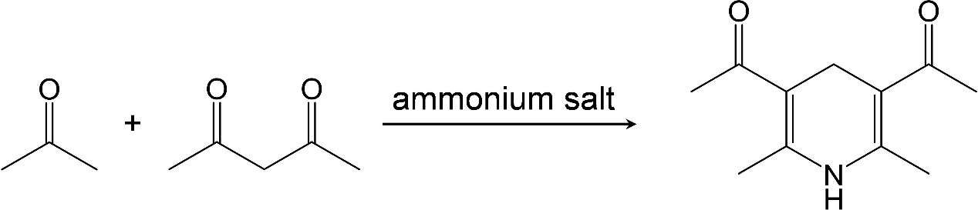
Fig. S9 Reaction mechanism on acetylacetone color-developing method to detect HCHO.
The quantitative determination of HCHO in aqueous solution through the acetylacetone method is based on the Hantzsch reaction principle⁹. In the presence of excessive ammonium salt, HCHO will react with acetylacetone and ammonia to form yellow-colored 3,5-diacetyl-1,4-dihydrolutidine, which possesses characteristic UV-Vis absorption at 413 nm. The UV-Vis absorption peak intensity at 413 nm is proportional to the concentration of HCHO.

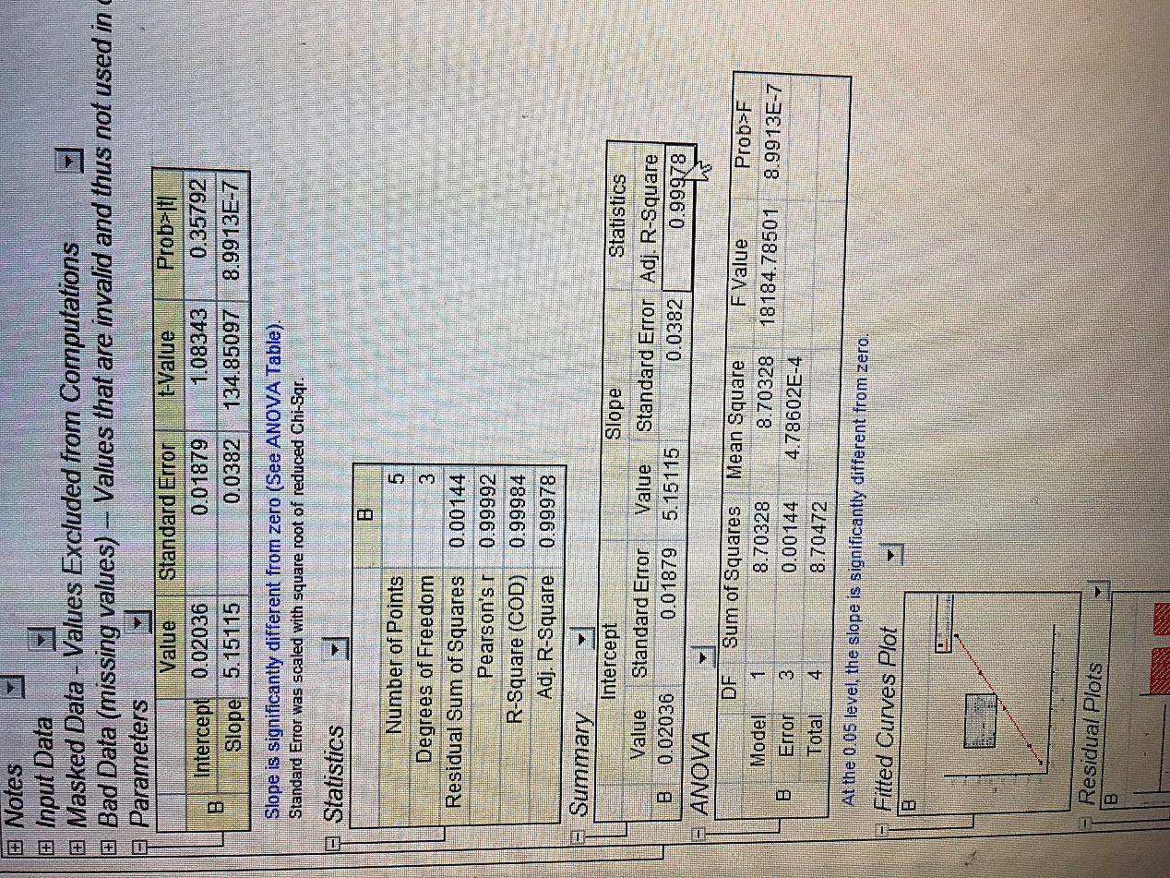
Fig. S10 Standard curve between HCHO concentration and UV-Vis absorption intensity.
The standard curve was established as follows. Through preparation of five different concentration of HCHO aqueous solutions (0.1, 0.2, 0.4, 0.6 and 0.8 μmol mL⁻¹), a standard curve was made between HCHO concentration and UV-Vis absorption intensity at 413 nm (Fig. S10) with R-square and Adj. R-square value of 0.99984 and 0.99978, respectively.

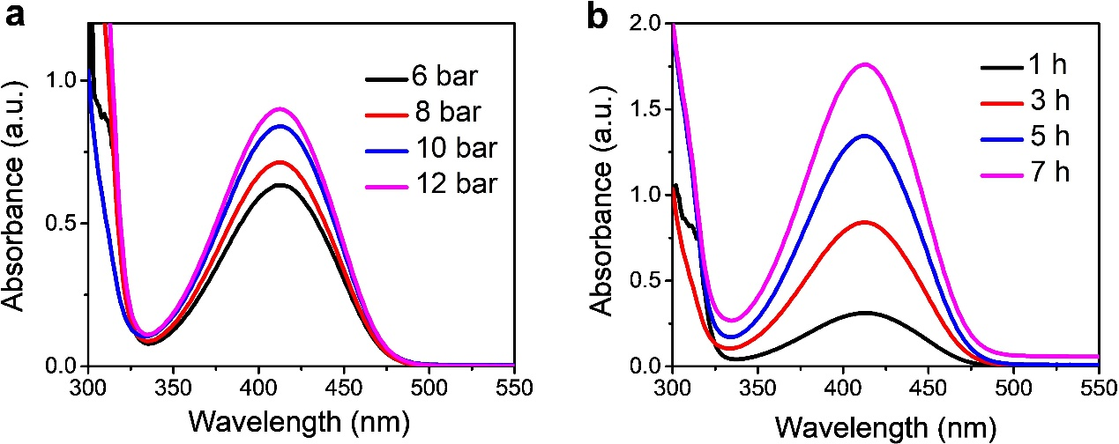
Fig. S11 Typical real-time UV-Vis absorption spectra of acetylacetone color-developing method at different O₂ amounts and reaction times.

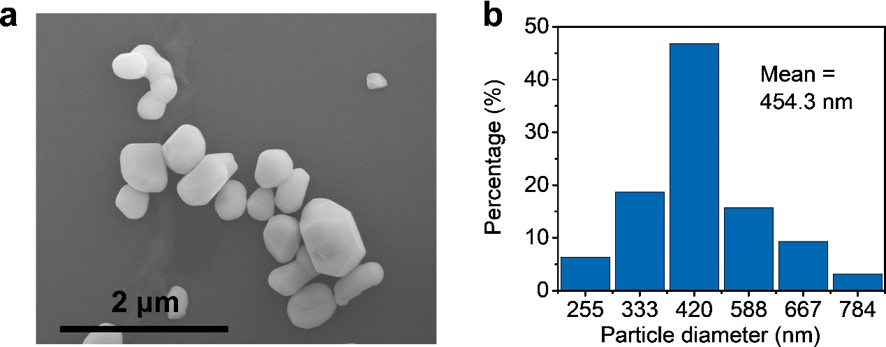
Fig. S12 (a) SEM image of s-BiVO₄. (b) Particle size distribution of s-BiVO₄.
The submicro-sized BiVO₄ particles (s-BiVO₄) with average size of 454.3 nm were synthesized by the standard precipitation method, which are used as the contrast samples.

Fig. S13 Photocatalytic conversion of CH₄ and O₂ under different condition. (a) Different photocatalyst of q-BiVO₄ and s-BiVO_{4.} (b) Different O₂ amount. (c) Different reaction time. (d) Different H₂O amount. Typical reaction condition: 10 mg q-BiVO₄, 10 bar O₂, 10 bar CH₄, 10 mL H₂O, 3 h reaction time, Hg lamp with irradiation wavelength of 300-600 nm and light density of 170 mW cm⁻². According to different experiment requirement, the reaction parameters are changed. (e) Different light intensity under the irradiation in the wavelength range from 300 to 600 nm. (f) Different wavelength with adjustable light intensity, 365 nm 27 mW cm⁻², 420 nm 108 mW cm⁻², 470 nm 100 mW cm⁻², 535 nm 100 mW cm⁻² and 630 nm 100 mW cm⁻². (g) Selective oxidation of CH₄ to HCHO. (h) Selective oxidation of CH₄ to CH₃OH.
The conversion percentage of CH₄ and O₂ under different reaction condition is calculated (Fig. S13). Benefitting from the quantum confinement effect, q-BiVO₄ (0.23% CH₄ and 0.23% O₂) exhibits higher conversion of CH₄ and O₂ compared with s-BiVO₄ (0.05% CH₄ and 0.05% O₂, Fig. S13a). Since CH₄ and O₂ are responsible for the carbon and oxygen sources for the oxygenated products, respectively, their consumption is equal at the certain yield of CH₃OH, HCHO and CO₂. Given the same charging amount of CH₄ (10 bar) and O₂ (10 bar) in Fig. S13a, c - h, their conversion percentage is of the same value. As the charging O₂ amount increasing (Fig. S13b), the corresponding conversion percentage of CH₄ increases gradually from 0.07 to 0.25%, caused by its sufficient oxidization in abundant O₂ atmosphere and its own charging amount decrease; as comparison, the conversion of O₂ shows a maximum (0.23%) at 10 bar. This is reasonable since incorporation of too much O₂ (>10 bar) would decrease its conversion percentage though total conversion amount increases. With the reaction time extending from 1 to 7 h (Fig. S13c), the conversion percentage of both CH₄ and O₂ progressively increases from 0.07% to 0.40%, resulting from the reactant consumption. Owning to the enhanced dissolved amount of CH₄ and O₂ (Fig. S13d), oxygenates are promoted, leading to the conversion increase of CH₄ and O₂ from 0.23% to 0.54%, respectively.
In terms of light irradiation, high light intensity represents large energy input for oxidation. Therefore, the conversions ratio of CH₄ and O₂ increases synchronously from 0.08 to 0.23% with light intensity increasing from 100 to 170 mW cm⁻² (Fig. S13e). Under irradiation of different wavelength with adjustable light intensity (365 nm 27 mW cm⁻², 420 nm 108 mW cm⁻², 470 nm 100 mW cm⁻², 535 nm 100 mW cm⁻² and 630 nm 100 mW cm⁻²), both conversions of CH₄ and O₂ demonstrate the similar trend with the diffuse reflectance spectrum of q-BiVO₄ (Fig. S13f). The slight decline of CH₄ and O₂ at 365 nm is ascribed to the relatively low light intensity (27 mW cm⁻²). Employing 300-400 nm UV as light source, highly selective generation of HCHO (86.7%, 13.1 mmol g⁻¹) is obtained with 0.73% conversion of both CH₄ and O₂ (Fig. S13g). On the other hand, the visible light is utilized as irradiation source for selective production of CH₃OH (Fig. S13h). Upon the solvent ascending from 10 to 80 mL, the selectivity and productivity of CH₃OH enhances from 92.8% and 0.3 mmol g⁻¹ to 96.6% and 1.1 mmol g⁻¹ along with the conversion ratio of both CH₄ and O₂ reaching 0.06% (Fig. S13h).
Fig. S14 (a) Schematic diagram of PEC test within a conventional three-electrode cell. (b) Photocurrent test of q-BiVO₄ and s-BiVO₄.
The kinetic argument of q-BiVO₄ compared with s-BiVO₄ is explained through photocurrent test combined with the corresponding band structure. According to the previous works^{10, 11, 12}, the kinetic assessment of •OH generation would be carried out by photocurrent experiment. The photoelectrochemical (PEC) test was performed on a CHI920D electrochemical workstation through a conventional three-electrode cell (Fig. S14a), including a modified indium tin oxide (ITO) with BiVO₄ sample as the working electrode, an Ag/AgCl (3 mol L⁻¹ KCl) as the reference electrode and a Pt wire as the auxiliary electrode. In Mott-Schottky plot, the positive slope of 1/C² versus V reveals the n-type characteristics of both q-BiVO₄ (Fig. S26c) and s-BiVO₄ (Fig. S31c). Based on the previous works^{11, 12}, the n-type semiconductor makes a photoanode in PEC system, which acts as the electron donor. Under light irradiation, the photogenerated electrons as majority carriers in BiVO₄ semiconductor will migrate into the Pt electrode for reduction reaction, while the left holes in BiVO₄ electrode contribute to oxidation reaction. At the externally applied bias of 0 V vs. Ag/AgCl, the kinetic energy depends on the overpotentials of conduction and valence bands vs. the required redox reaction potentials. To be specific to q-BiVO₄ system, the reduction overpotential = E (conduction band) - E (O₂/•OH) = 0.075 V (vs. NHE at pH=0) - 0.695 V (vs. NHE at pH=0) = -0.620 V, while the oxidation overpotential = E (valence band) - E (O₂/•OH) = 2.555 V (vs. NHE at pH=0) - 2.380 V (vs. NHE at pH=0) = 0.175 V. Similarly, the reduction and oxidation overpotentials in s-BiVO₄ system are calculated to be -0.611 and 0.094 V, respectively. Evidently, with the larger overpotential on q-BiVO₄ than s-BiVO₄, higher kinetic energy is equipped by q-BiVO₄ for photocatalytic CH₄ oxidation. Seen from the PEC I-t curves (Fig. S14b), both q-BiVO₄ and s-BiVO₄ exhibit the photoanodic feature, in agreement with the photocurrent analysis in Fig. S14a. Compared with s-BiVO₄, about 3.6 folds of photocurrent argument over q-BiVO₄ are obtained, indicating the enhanced kinetic efficiency. Besides, the fast photocurrent response of q-BiVO₄ is attributed to its quantum size with shortened carrier migration path, while the prompt current decay is ascribed to the rapid consumption of reactive substances under high kinetic efficiency (red curve in Fig. S14b). On the contrary, the large sized s-BiVO₄ possesses the long migration route for charge carriers, leading to the slow photocurrent response; meanwhile, the low kinetic reaction efficiency results in a small and steady photocurrent (blue curve in Fig. S14b).

Fig. S15 N₂ adsorption-desorption isotherms of both q-BiVO₄ and s-BiVO₄.
N₂ adsorption-desorption isotherms of both q-BiVO₄ and s-BiVO₄ are conducted to measure the Brunauer-Emmett-Teller (BET) specific surface areas, which are 226.9 and 160.9 m² g⁻¹, respectively. The larger BET surface area of q-BiVO₄ relative to s-BiVO₄ (454.3 nm) is attributed to their smaller particle size (4.5 nm).

Fig. S16 (a) Typical UV-Vis absorption spectrum of acetylacetone color-developing method, using for quantifying the yield of HCHO in P25 system. (b) GC spectrum of CO₂ produced over P25. (c) Productivity of HCHO and CO₂ from CH₄ oxidation using P25 as photocatalyst.
Taking commercial P25 TiO₂ nanoparticles as the photocatalyst, a contrast experiment is carried out under Hg light irradiation (300 nm < λ < 600 nm) with incorporation of 10 bar CH₄ and 10 bar O₂ at room temperature (25ºC cooling water). Only HCHO (Fig. S16a) and CO₂ (Fig. S16b) are found in the products over P25 system. The productivity of HCHO and CO₂ (Fig. S16c) is tested to be 48.9 and 16.3 μmol g⁻¹, respectively.

Fig. S17 (a) Productivity of CH₃OH, HCHO and CO₂ from photocatalytic CH₄ oxidation at different reaction time, and the generation rate of oxygenate k_{oxygenate} = 10.78 umol h⁻¹. (b) Remained amount of CH₄ after reaction at different time with its consumption rate k_{consumed methane} = 10.86 umol h⁻¹. (c) Remained amount of O₂ after reaction at different time with its consumption rate k_{consumed oxygen} = 10.93 umol h⁻¹.
Since CH₄ and O₂ are the carbon and oxygen sources for all the oxygenated products, the balance between the consumption rate of feed gas and generation rate of products should be established according to the consumed amount of CH₄ and O₂ as well as the yield of CH₃OH, HCHO and CO₂. Typically, 10 mg of q-BiVO₄ was dispersed in 10 mL of H₂O, and then 10 bar O₂ and 10 bar CH₄ were charged into the reaction vessel. Hg lamp with irradiation wavelength 300-600 nm and light density 170 mW cm⁻² was taken as the light source. After irradiation for 1, 3, 5 and 7 h, the products and left reactants are quantified (Fig. S17). By summing up the productivity of CH₃OH, HCHO and CO₂ at different reaction time (1, 3, 5 and 7 h), the generation rate of oxygenate k_{oxygenate} is calculated to be 10.78 umol h⁻¹ (Fig. S17a). The left amount of CH₄ (Fig. S17b) and O₂ (Fig. S17c) after different reaction time is quantified via GC measurements, and the consumed amount of CH₄ and O₂ after photocatalytic reaction is estimated to be 20.01 μmol (CH₄, 1 h), 40.04 μmol (CH₄, 3 h), 62.57 μmol (CH₄, 5 h), 81.28 (CH₄, 7 h), 18.78 μmol (O₂, 1 h), 42.68 μmol (O₂, 3 h), 63.86 μmol (O₂, 5 h), and 83.31 μmol (O₂, 7 h). As a result, the consumption rate of CH₄ and O₂ is fitted to be k_{consumed methane} = 10.86 umol h⁻¹ and k_{consumed oxygen} = 10.93 umol h⁻¹, respectively. The similar value of k_{oxygenate}, k_{consumed methane} and k_{consumed oxygen} demonstrates the satisfied balance between the consumption rate of feed gas and generation rate of products. As a typical example, the product signals of CH₃OH (Fig. S18a), HCHO (Fig. S18b) and CO₂ (Fig. S18c insert) as well as the remained signals of CH₄ (Fig. S18c) and O₂ (Fig. S18d) after 7 h reaction are presented.

Fig. S18 Product signal and remained gas after photocatalytic CH₄ oxidation for 7 h. (a) ¹H NMR spectrum of CH₃OH. The DMSO was added as internal standard. (b) UV-Vis absorption spectrum of acetylacetone color-developing method for HCHO estimation. (c) GC spectra of remained CH₄ and generated CO₂ based on flame ionization detector. (d) GC spectrum of remained O₂ based on thermal conductivity detector.

Fig. S19 Concentration of as-produced CH₃OH and HCHO with varying H₂O amount added. Reaction condition: 10 mg q-BiVO₄, 10-80 mL H₂O, 10 bar CH₄, 10 bar O₂, 25°C, Hg lamp with irradiation wavelength of 300 nm < λ < 600 nm and light intensity of 170 mW cm⁻².

Fig. S20 (a) ¹H NMR spectrum for CH₃OH quantitation in 80 mL H₂O. (b) UV-Vis absorption spectrum of colored HCHO over q-BiVO₄ in 80 mL H₂O. (c) GC-gas spectrum of generated CO₂ from 80 mL H₂O.
Fig. S20 shows the signals of generated CH₃OH, HCHO and CO₂ over q-BiVO₄ at 80 mL of H₂O under visible Xenon lamp irradiation (400-780 nm). Reaction condition: 10 mg q-BiVO₄, 80 mL H₂O, 10 bar CH₄, 10 bar O₂, room temperature, Xenon lamp with wavelength of 400 nm < λ < 700 nm and light intensity of 170 mW cm⁻².

Fig. S21 Concentration of produced CH₃OH with varying H₂O amount added. Reaction condition: 10 mg q-BiVO₄, 10-80 mL H₂O, 10 bar CH₄, 10 bar O₂, room temperature, Xenon lamp with irradiation wavelength of 400 nm < λ < 780 nm and light intensity of 170 mW cm⁻².
The enhanced selectivity of CH₃OH is ascribed to its diluted concentration within large solvent volume (Fig. S21), depressing the overoxidation.

Fig. S22 ¹H NMR spectrum of the product generated in thermocatalytic reaction 30ºC using q-BiVO₄ as catalyst.
In order to examine the thermal effect on photocatalytic reaction, the thermocatalytic reaction of CH₄ at 30ºC (similar but higher than 28.5ºC in photocatalytic reaction, Fig. S8) is carried out. The reaction condition included that 10 mg q-BiVO₄ was dispersed in 10 mL H₂O, 10 bar CH₄ and 10 bar O₂ were charged into reaction vessel, and reaction was kept at 30ºC. After 3 h reaction, the product was checked by ¹H NMR spectrum. Obviously, no desired CH₃OH is found (Fig. S22).

Fig. S23 (a) ¹³C NMR (top) and ¹³C DEPT-135 (bottom) spectra of the product produced from ¹³CH₄ oxidation after reaction for 7 h. (b) ¹H NMR spectrum of the product.
¹³C NMR, ¹³C DEPT-135 and ¹H NMR spectra verify that C1 oxygenates are derived from CH₄.

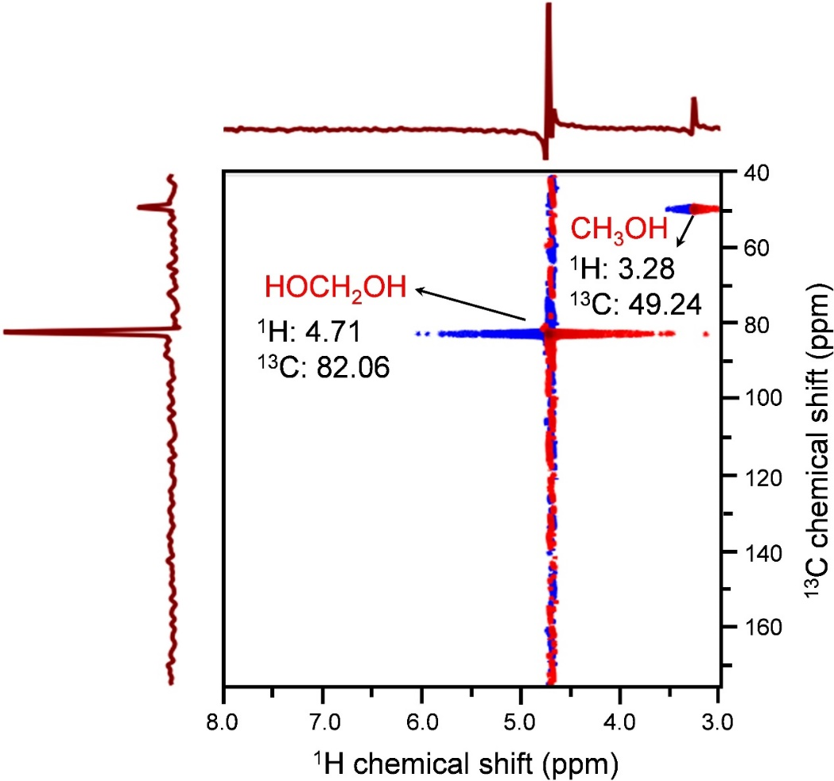
Fig. S24 2D ¹H-¹³C HMQC spectrum of reaction products from ¹³CH₄ oxidation after 7 h.
2D ¹H-¹³C HMQC (heteronuclear multiple-quantum correlation, Fig. S24) and 2D ¹H-¹³C HMBC (heteronuclear multiple-bond correlation, Fig. S25) spectra are both sets of 2D NMR spectroscopy, which give data plotted in a space defined by two frequency axes rather than one frequency axe. So, more information is provided by 2D ¹H-¹³C HMQC and 2D ¹H-¹³C HMBC compared with single frequency spectrum. In 2D ¹H-¹³C HMQC, ¹H chemical shift at 3.28 ppm well correlates with ¹³C chemical shift at 49.24 ppm. It is known that ¹H chemical shift at 3.28 ppm and ¹³C chemical shift at 49.24 ppm are ¹H and ¹³C NMR characteristic peaks of CH₃OH, respectively. Therefore, this correlation further proves the formation of CH₃OH. Similarly, ¹H chemical shift at 4.71 ppm combined with ¹³C chemical shift at 82.06 ppm confirms the generation of HCHO (HOCH₂OH).
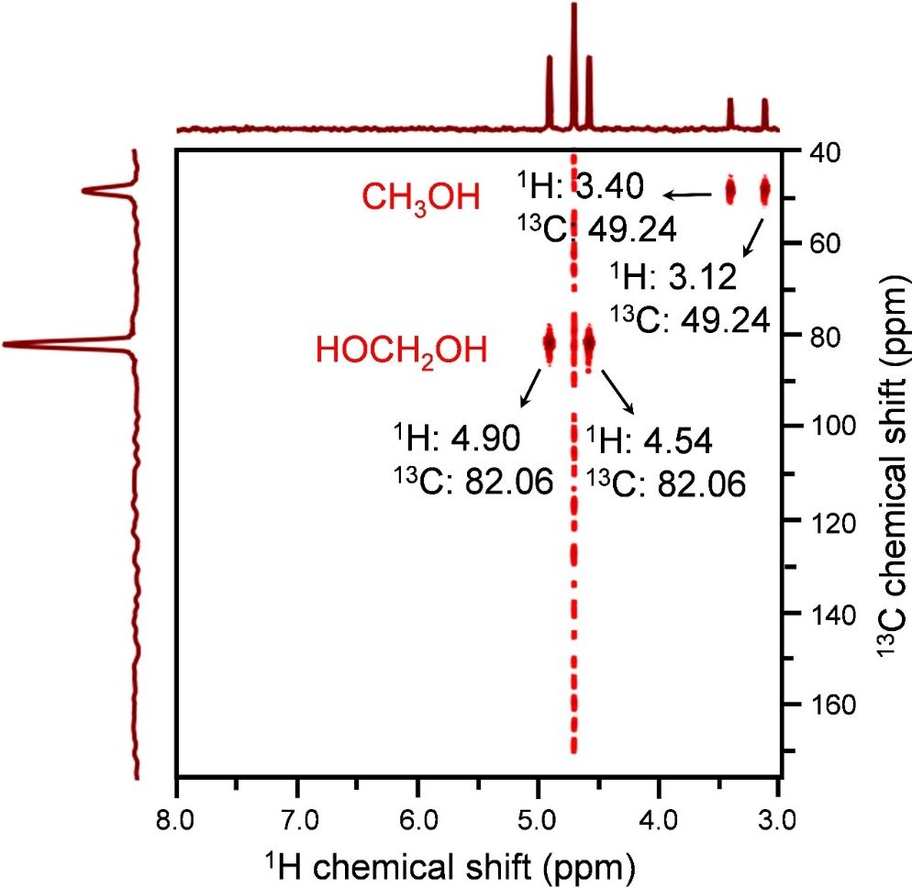
Fig. S25 2D ¹H-¹³C HMBC spectrum of reaction products from ¹³CH₄ oxidation after 7 h.
2D ¹H-¹³C HMBC is focused on ¹H-¹³C correlation over long ranges of about 2-4 bonds. The appearance on satellite peaks of ¹H chemical shift (3.40 ppm and 3.12 ppm) crossing ¹³C chemical shift (49.24 ppm) confirms the one-bond correlation between ¹H and ¹³C, which is consistent with one-carbon molecule structure of CH₃OH. Based on the same theory, the one-bond correlation feature with ¹H satellite peaks (4.90 ppm and 4.54 ppm) overlapping ¹³C peak at 82.06 ppm verifies the one-carbon molecule structure of HOCH₂OH.

Fig. S26 (a) UV-Vis diffuse reflectance spectrum and (b) transformed Kubelka-Munk function of q-BiVO₄. (c) Mott-Schottky plots of q-BiVO₄ with frequencies of 500, 700 and 900 Hz. Each error bars denote the standard deviation of data from three individual experiments.
The UV-Vis diffuse reflectance spectrum (Fig. S26a), transformed Kubelka-Munk function plots (Fig. S26b) and Mott-Schottky plots (Fig. S26c) were performed to accurately calculate the band structure of q-BiVO₄. Through Kubelka-Munk transformation from the UV-Vis diffuse reflectance spectrum, the bandgap value of q-BiVO₄ is calculated to be 2.480 eV. Mott-Schottky plots at different frequencies reveal that the flat conduction band potential of q-BiVO₄ is 0.075 V (vs. NHE at pH=0). The valence band potential of q-BiVO₄ can be derived from the value between bandgap and conduction band, which is 2.555 V (vs. NHE at pH=0). All of the values are tested three-times, and the average value and the standard deviation are calculated and displayed as error bars, respectively. The error bars exhibit narrow range as shown in red circles and their magnifications, indicating the good reproducibility of instrument and sample.

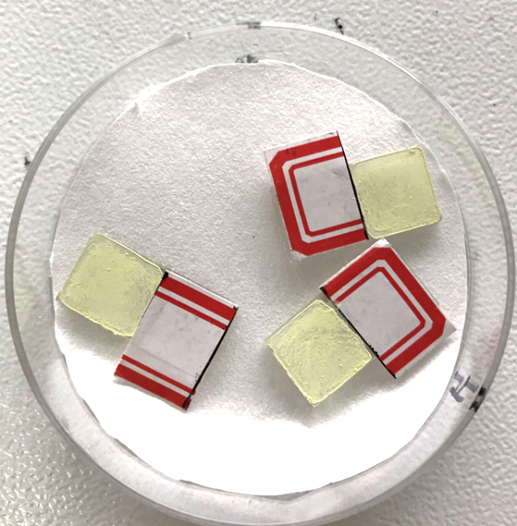
Fig. S27 Three 1 cm × 1 cm sized ITO substrates modified with q-BiVO₄ used as working electrodes for Mott-Schottky test. The tag paper was used to control the electrode area.
Typically, 5 mg q-BiVO₄ was ultrasonically dispersed in 1 mL mixed solution (0.2 mL ethanol + 0.8 mL water) and dropped onto three 1 cm × 1 cm sized indium tin oxide (ITO) substrates as working electrode. Taking Ag/AgCl as reference electrode and Pt wire mesh as counter electrode, the Mott-Schottky plots were tested on CHI 760E electrochemical workstation in 1 M Na₂SO₄ solution under the frequencies of 500, 700 and 900 Hz, respectively.

Fig. S28 UPS spectrum of q-BiVO₄ with the high-binding energy cutoff (Fermi level) and low-binding-energy cutoff (valence band edge binding energy) regions.
Fig. S28 shows the typical ultraviolet photoelectron spectroscopy (UPS) spectrum with the energy information on both relative valence band (VB, high binding energy cutoff) and Fermi level (low binding energy cutoff) of sample. Through subtraction of the width value between Fermi level (0.7 eV) and relative VB (14.9 eV) from the standard He I UPS energy (21.2 eV)¹³, the VB location of q-BiVO₄ relative to vacuum level is calculated to be 7.0 V, which is converted to 2.6 V (vs. NHE at pH=0).

Fig. S29 (a) Fluorescence spectra of 1 mM coumarin solution taking q-BiVO₄ as photocatalyst or without catalyst in absence of O₂ under visible light. (b) Fluorescence spectra of 1 mM coumarin solution with or without O₂ incorporation using q-BiVO₄ as photocatalyst under visible light.
In the absence of O₂ (Fig. S29a), an enhanced fluorescence signal was achieved with q-BiVO₄ photocatalyst under visible light irradiation, indicating that the holes from valence band can successfully oxidize H₂O into •OH. After the solution is saturated with O₂ (Fig. S29b), the fluorescence intensity with q-BiVO₄ displays 2.3 times augment than that in absence of O₂, confirming that O₂ also greatly contributes to the generation of •OH.

Fig. S30 (a) O₂ signals from GC spectra in anaerobic CH₄ oxidation using q-BiVO₄ and s-BiVO₄ as photocatalysts, respectively. (b) ¹H NMR spectrum using q-BiVO₄ as photocatalyst. Reaction condition: 10 mg q-BiVO₄, 10 mL H₂O, 20 bar CH₄, Hg lamp, atmosphere temperature with 25ºC cooling water.
In order to detect if there is O₂ production, photocatalytic CH₄ oxidation was carried out with 10 mg q-BiVO₄ or s-BiVO₄ dispersed in 10 mL H₂O and 20 bar CH₄. In the gaseous product, about 57.6 and 8.8 μmol O₂ is produced by q-BiVO₄ and s-BiVO₄, respectively (Fig. S30a), confirming the higher oxidation ability of q-BiVO₄ than s-BiVO₄. Nevertheless, no signal of CH₃OH is distinguished (Fig. S30b) in liquid phase product, which reveals that small amount of O₂ can not afford the distinct yield of CH₃OH.

Fig. S31 (a) UV-Vis diffuse reflectance spectrum and (b) transformed Kubelka-Munk function of s-BiVO₄. (c) Mott-Schottky plots of s-BiVO₄ with frequencies of 500, 700 and 900 Hz. (d) UPS spectrum of s-BiVO₄ with the high-binding energy cutoff (Fermi level) and low-binding-energy cutoff (valence band edge binding energy) regions.
The UV-Vis diffuse reflectance spectrum (Fig. S31a), transformed Kubelka-Munk function plots (Fig. S31b) and Mott-Schottky plots (Fig. S31c) are recorded to accurately calculate the band structure of s-BiVO₄. Through Kubelka-Munk transformation from the UV-Vis diffuse reflectance spectrum, the bandgap value of s-BiVO₄ is calculated to be 2.390 eV. Mott-Schottky plots at different frequencies reveal that the flat conduction band potential of s-BiVO₄ is 0.084 V (vs. NHE at pH=0). The valence band potential of s-BiVO₄ can be derived from the value between bandgap and conduction band, which is 2.474 V (vs. NHE at pH=0).
Fig. S31d displays the typical UPS spectrum with the energy information on both relative valence band (VB, high binding energy cutoff) and Fermi level (low binding energy cutoff) of sample. Through subtraction of the width value between Fermi level (1.5 eV) and relative VB (15.8 eV) from the standard He I UPS energy, the VB location of s-BiVO₄ is calculated to be 2.5 V (vs. NHE at pH=0).

Fig. S32 Band energy diagram of s-BiVO₄.
As shown in Fig. S32, the conduction and valence bands of s-BiVO₄ are tested to be 0.084 and 2.474 V (vs. NHE at pH=0), respectively.

Fig. S33 Fluorescence spectra of 1 mM coumarin solution taking q-BiVO₄ and s-BiVO₄ as photocatalysts (a) with or (b) in absence of O₂.
The more negative conduction band and positive valence band of q-BiVO₄ lead to more •OH for CH₄ oxidation than s-BiVO₄ with or without O₂.

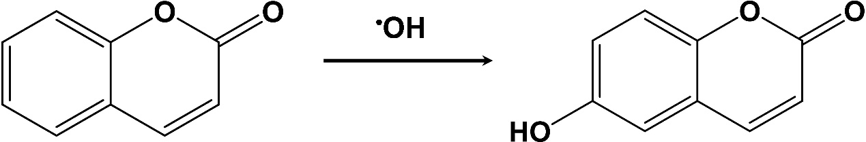

Fig. S34 Reaction mechanism on the •OH detection by coumarin.
Coumarin molecules can readily couple with •OH to form the corresponding fluorescent 7-OH-coumarin derivatives.

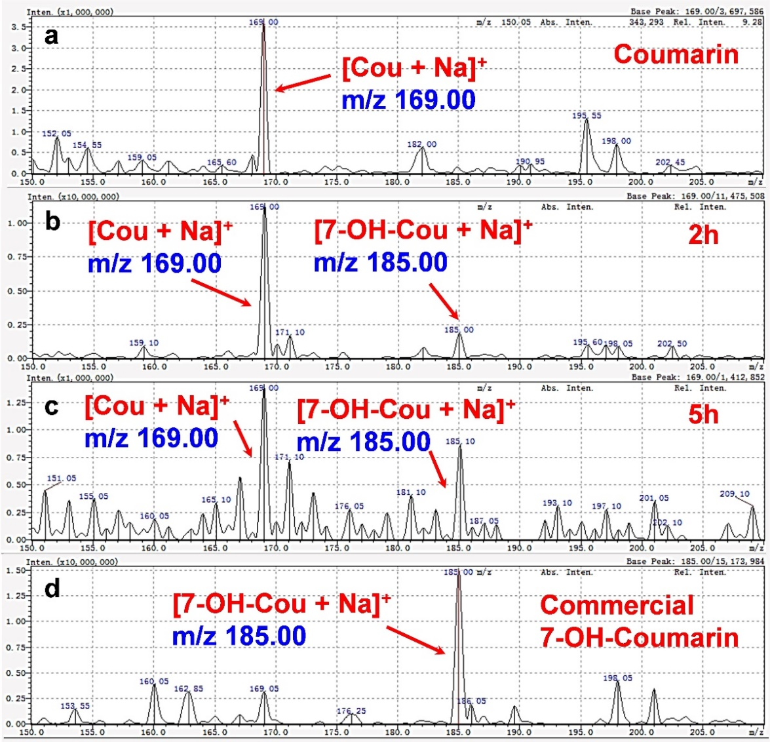
Fig. S35 LC-MS fingerprint of coumarin solution (a) before and after (b) 2 h, (c) 5 h irradiation. (d) LC-MS fingerprint of commercial pure 7-OH-coumarin.
The fluorescent products from coumarin trapping •OH during light irradiation were detected by LC-MS. Coumarin before light irradiation shows a major peak at m/z = 169, corresponding to [Cou + Na]⁺ (Fig. S35a). After illumination for 2 h, fluorescent derivative 7-OH-coumarin is obtained at the peak of m/z = 185, corresponding to [7-OH-Cou + Na]⁺ (Fig. S35b). After continuous irradiation for 5 h, obvious intensity increase is observed at m/z = 185 (Fig. S35c), meaning the yield increases of 7-OH-coumarin. To further confirm the successful formation of 7-OH-coumarin, commercial pure 7-OH-coumarin is tested via LC-MS. A major peak corresponding to [7-OH-Cou + Na]⁺ is also found at m/z = 185 (Fig. S35d). All these results prove the successful formation of 7-OH-coumarin via trapping •OH radical by coumarin.

Fig. S36 ¹H NMR spectrum of the liquid phase product from thermocatalytic reaction without H₂O₂ at 60ºC..
In absence of H₂O₂ (Fig. S36), no product is found.

Fig. S37 Productivity of CH₃OH, HCHO and CO₂ using (a) CH₄ and (b) CD₄ as reactant, respectively. Reaction condition: 10 mg q-BiVO₄, 10 mL H₂O, 10 bar CH₄, 10 bar O₂, atmosphere temperature, 420 nm monochromatic light with light intensity of 100 mW cm⁻².
The rate-determining step of C-H bond breakage is verified through kinetic isotope effect (KIE).
KIE = k_{H} / k_{D}
where k_{H} and k_{D} stand for the reaction rate constant of CH₄ and CD₄, respectively. In the typical CH₄ oxidation experiment, under irradiation of 420 nm monochromatic light, the amount of oxygenated products is measured in two separate reactors: one with CH₄ (Fig. S37a) and the other with isotopic CD₄ (Fig. S37b). In both CH₄ and CD₄ systems, the total oxygenates are fitted with reaction time to acquire the corresponding reaction rate constant k_{H} and k_{D} (Fig. 6f). Finally, the KIE is calculated based on k_{H} / k_{D}.

Fig. S38 Reusability of q-BiVO₄ for CH₄ oxidation. Reaction condition: 10 mg q-BiVO₄, 10 mL H₂O, 10 bar CH₄, 10 bar O₂, atmosphere temperature, 3 h, Hg lamp with wavelength of 300-600 nm and light density 170 mW cm⁻².
After five photocatalytic cycles, q-BiVO₄ almost preserves its initial catalytic activity.

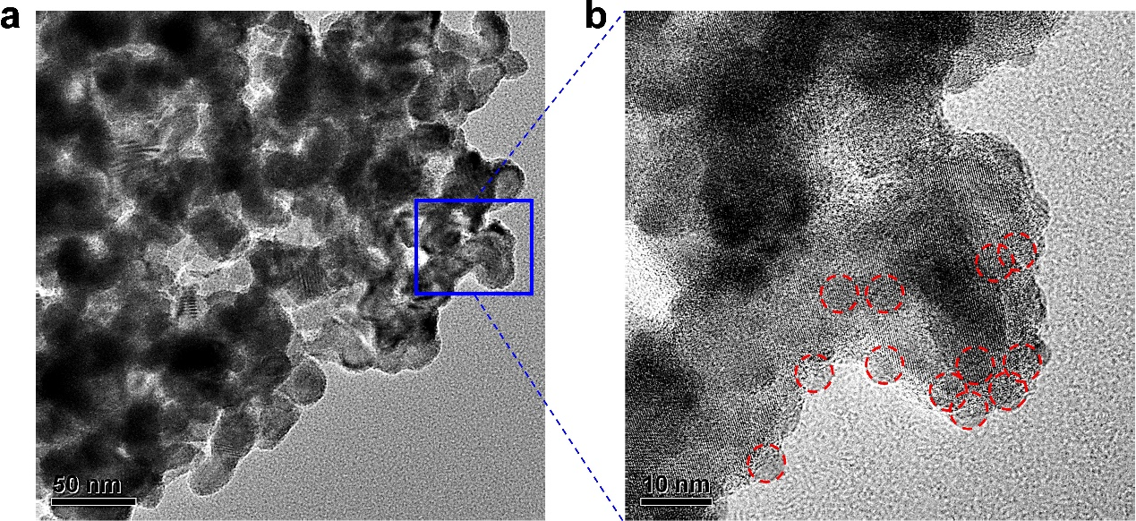
Fig. S39 Morphology of q-BiVO₄ after five cycles of photocatalysis tests.
TEM images disclose that q-BiVO₄ catalyst keeps its initiate morphology and size after five cycles of photocatalytic test.

Fig. S40 XRD patterns of q-BiVO₄ catalyst before and after five cycles recyclability test.
As shown in Fig. S40, the XRD pattern of q-BiVO₄ before and after reaction is tested and all the crystal peaks are normalized based on the intensity of (040) peak. Compared with the (121) peak before reaction, the peak intensity of (121) after reaction shows a decrease. In consideration of the tiny size of q-BiVO₄ (4.5 nm), the topmost (121) crystal peak and distinct lattice fringe of (121) plane (Fig. 2f), one can infer that plentiful (121) facet sites may exist on the surface of pristine q-BiVO₄. During the photocatalytic reaction, a mass of •OH is generated and adsorbed on the surface of q-BiVO₄, leading to partial disappearance of the exposed (121) facets. Therefore, the peak signal of (121) exhibits some degree of decline.

Fig. S41 XPS spectra of q-BiVO₄ before and after reaction: (a) O 1s, (b) V 2p and (c) Bi 4f.
As shown in X-ray photoelectron spectroscopies (XPS, Fig. S41a), the O 1s chemical state on the surface of q-BiVO₄¹⁴ presents lattice oxygen atom (O²⁻, 529.6 eV), adsorbed hydroxyl group (-OH, 531.0 eV) and molecular-type O₂⁻ (532.8 eV). Compared with that before reaction, the peak intensity of -OH shows an increase, whereas the strength of O₂⁻ reduces after reaction. This is reasonable that the nucleophilic -OH group adsorbed on the surface of q-BiVO₄ donates some electrons, making its surface being rich electron state and thus reducing the adsorption ability of electrophilic O₂. Besides, the rich electronic state is also reflected by the slightly blue shift of O 1s (Fig. S41a), V 2p (Fig. S41b) and Bi 4f peaks (Fig. S41c) after reaction, respectively.
The reduction degree of Bi³⁺ is investigated by XPS measurement before and after reaction. Since no signal of metal Bi⁰ (157 eV)¹⁵ is observed after reaction (Fig. S41c), we suppose that Bi³⁺ in BiVO₄ is not reduced to Bi⁰. Nevertheless, slightly blue shift of both Bi³⁺ 4f_{5/2} and Bi³⁺ 4f_{7/2} peaks is found from 164.2 and 158.9 eV to 163.9 and 158.6 eV, respectively. This result means that Bi³⁺ is endowed with an enriched electron state, but not yet reduced to low valent state¹⁶.
Fig. S42 (a) Raman and (b) UV-Vis diffuse reflectance spectra of q-BiVO₄ before and after reaction.
Raman bands at 328.7, 368.1 and 827.0 cm⁻¹ (Fig. S42a) are assigned to the asymmetric and symmetric deformation modes of the VO₄³⁻ tetrahedron as well as the stretching mode of V-O bonds in q-BiVO₄ sample, respectively. The blue shift of V-O bond after reaction (823.3 cm⁻¹) relative to that before reaction (827.0 cm⁻¹) indicates the longer bond length¹⁴. According to the previous report, the absorption of -OH group happens on metal V atom site¹⁷, which possibly takes V away from O in V-O bond, so the bond of V-O gets stretched out. The change of V-O bond certainly affects the vibration of VO₄³⁻ tetrahedron, shown by the Raman shift from 328.7 and 368.1 to 332.6 and 364.6 cm⁻¹, respectively. It is known that under light irradiation, the electrons will be excited from O 2p (valence band) to V 3d (conduction band)¹⁷. Therefore, the extended bond length of V-O after reaction will increase the difficulty for electron excitation, thus more energy is required than before reaction. This deduction is supported by the slightly blue shift of UV-Vis diffuse reflectance spectrum of q-BiVO₄ sample after reaction (Fig. S42b).

Fig. S43 ICP-OES result of aqueous solution (a) before and (b) after reaction.
In order to investigate the dissolved amount of catalyst, inductively coupled plasma optical emission spectrometer (ICP-OES) test on Bi element was conducted in reaction solution. 10 mg of q-BiVO₄ was dispersed into 10 mL H₂O with stirring for 3 h under dark condition. Through centrifugation, the aqueous solution was collected as sample 1. Meanwhile, the other 10 mg q-BiVO₄ was dispersed into 10 mL H₂O, and 10 bar CH₄ and 10 bar O₂ were charged. After photocatalytic reaction for 3 h with stirring, the aqueous solution was obtained through centrifugation, denoted as sample 2. Both samples were tested by ICP-OES to check the dissolved amount of catalyst during reaction. ICP-OES result shows that 3.018 ppb Bi (pre-dilution with 500 times) is dissolved in the solution before reaction under dark condition (sample 1, Fig. S43a). After light irradiation for 3 h, the concentration of Bi increases to 61.470 ppb (pre-dilution with 500 times) as shown in sample 2 (Fig. S43b). As the solution volume is 10 mL, the amount of corrosive Bi is calculated to be 0.29 mg that accounts for 2.9 wt% of the original mass, indicating that BiVO₄ is slightly photocorroded.

Part S3. Supplementary tables
Table S1. Comparison of q-BiVO₄ and s-BiVO₄ on per-surface-area basis.
Entry | Catalyst | Product Amount (μmol cm⁻²)
Entry | Catalyst | CH₃OH | HCHO | CO₂
1 | s-BiVO₄ | 32.6 | 28.9 | 6.2
2 | q-BiVO₄ | 102.5 | 83.5 | 13.5
Reaction condition: 10 mg catalyst, 10 bar O₂, 10 bar CH₄, 10 mL H₂O, Hg lamp with irradiation wavelength of 300 nm < λ < 600 nm and light intensity of 170 mW cm⁻², 25ºC cooling water.

Table S2 Q.E. value of q-BiVO₄ irradiated by different monochromatic light of 365, 420, 470, 535 and 630 nm, respectively.
Wavelength (nm) | Light intensity (mW cm⁻²) | E_{λ} (J) | Amount of products (μmol) |  |  | Q.E. (%)
Wavelength (nm) | Light intensity (mW cm⁻²) | E_{λ} (J) | CH₃OH | HCHO | CO₂ | Q.E. (%)
365 | 27 | 5.4 × 10⁻¹⁹ | 84.1 | 40.7 | 3.5 | 3.07
420 | 108 | 4.7 × 10⁻¹⁹ | 104.9 | 51.3 | 3.1 | 0.82
470 | 100 | 4.2 × 10⁻¹⁹ | 56.0 | 32.8 | 2.5 | 0.47
535 | 100 | 3.7 × 10⁻¹⁹ | 0 | 0 | 0 | 0
630 | 100 | 3.2 × 10⁻¹⁹ | 0 | 0 | 0 | 0
Reaction condition: 100 mg q-BiVO₄, 80 mL H₂O, 10 bar O₂, 10 bar CH₄, irradiation area of 23.75 cm², irradiation time of 3 h, 25°C cooling water. Note that 27 mW cm⁻² is the maximum light intensity of 365 nm LED monochromatic light source (Perfect Light Company) due to its rather low luminous efficiency compared with other LED monochromatic light sources.

Table S3. Contrast experiments under visible light irradiation (400 nm < λ < 780 nm).
Entry | Catalyst | CH₄ (bar) | O₂ (bar) | H₂O (mL) | Time (h) | Product Amount (μmol) |  | Productivity (μmol g⁻¹)
 |  |  |  |  |  | CH₃OH | HCHO | CH₃OH | HCHO
1 | -- | 10 | 10 | 10 | 3 | 0 | 0 | -- | --
2 | q-BiVO₄ | 10 | 10 | 0 | 3 | 0 | 0 | 0 | 0
3 | q-BiVO₄ | 20 | 0 | 10 | 3 | 0 | 0 | 0 | 0
4 | q-BiVO₄ | 0 | 20 | 10 | 3 | 0 | 0 | 0 | 0
Reaction condition: total gas pressure of O₂ and CH₄ = 20 bar; catalyst mass = 10 mg; H₂O volume = 10 mL; light irradiation by Xenon lamp with wavelength of 400 nm < λ < 780 nm and light intensity of 170 mW cm⁻²; cooling water = 25ºC.

Table S4. STY and selectivity comparisons about the state-of the-art works on photocatalytic CH₄ oxidation reactions.
Entry | Catalyst | CH₃OH |  | HCHO |  | Reference
Entry | Catalyst | STY  (mmol g⁻¹ h⁻¹) | Selectivity  (%) | STY  (mmol g⁻¹ h⁻¹) | Selectivity  (%) | Reference
1 | Bi₂WO₆ | 0.02 | 27.6 | 0 | 0 | ACS Catal. 4, 3013-3019 (2014)
2 | WO₃/La | ~0.03 | ~47.1 | 0 | 0 | Appl. Catal. B 187, 30–36 (2016)
3 | V-HBEA | 0.01 | 5.3 | 0 | 0 | ACS Catal. 7, 2878-2885 (2017)
4 | BiVO₄ bipyramids | 0.11 | 85.0 | 0 | 0 | ACS Appl. Nano Mater. 1, 6683−6691(2018)
5 | 0.33 _{metal}wt.% FeO_{x}/TiO₂ | 0.35 | 90.0 | 0 | 0 | Nat. Catal. 1, 889–896 (2018)
6 | Cu-0.5/PCN | 0.03 | 18.8 | 0 | 0 | Nat. Commun. 10, 506 (2019)
7 | 0.1 wt% Pd/ZnO | 3.04 | 26.2 | 5.52 | 47.5 | J. Am. Chem. Soc. 141, 20507-20515 (2019)
8 | q-BiVO₄ | 0.37 | 96.6 | 4.37 | 86.7 | This work
A space-time yield (STY) is a vital benchmark for yield assessment of CH₃OH and HCHO when reaction time is taken into consideration.

Supplementary References
1. Song H, et al. Direct and Selective Photocatalytic Oxidation of CH₄ to Oxygenates with O₂ on Cocatalysts/ZnO at Room Temperature in Water. J. Am. Chem. Soc. 141, 20507-20515 (2019).

2. Hatchard TD, Dahn JR. In Situ XRD and Electrochemical Study of the Reaction of Lithium with Amorphous Silicon. J. Electrochem. Soc. 151, 838-842 (2004).

3. Hou J, et al. Hollow TiO₂ submicrospheres assembled by tiny nanocrystals as superior anode for lithium ion battery. J. Mater. Chem. A 7, 23733-23738 (2019).

4. Statistical Review of World Energy. bp 69th edition (2020).

5. Dispenza C, Dispenza G, La Rocca V, Panno G. Exergy recovery during LNG regasification: Electric energy production – Part one. Appl. Therm. Eng. 29, 380-387 (2009).

6. Farzaneh-Gord M, Deymi-Dashtebayaz M. A new approach for enhancing performance of a gas turbine (case study: Khangiran refinery). Appl. Energ. 86, 2750-2759 (2009).

7. Prakash Rao MM. Industrial Oxygen: Its Generation and Use. 2007 ACEEE Summer Study on Energy Efficiency in Industry (2007).

8. Robatjazi H, et al. Plasmon-driven carbon–fluorine (C(sp³)–F) bond activation with mechanistic insights into hot-carrier-mediated pathways. Nat. Catal. 3, 564-573 (2020).

9. Bisgaard P, M⊘lhave L, Rietz B, Wilhardt P. Quantitative Determination of Formaldehyde In Air Using the Acetylacetone Method. Anal. Lett. 16, 1457-1468 (1983).

10. Yang L, Xiong Y, Dong H, Peng H, Zhang Y, Xiao P. Enhanced charge separation and oxidation kinetics of BiVO₄ photoanode by double layer structure. J. Power Sources 343, 67-75 (2017).

11. Shi X, et al. Unassisted photoelectrochemical water splitting exceeding 7% solar-to-hydrogen conversion efficiency using photon recycling. Nat. Commun. 7, 11943 (2016).

12. Gu S, Zhou X, Zheng F, Fang L, Dong W, Shen M. Improved photocathodic performance in Pt catalyzed ferroelectric BiFeO₃ films sandwiched by a porous carbon layer. Chem. Commun. 53, 7052-7055 (2017).

13. Brown PR, et al. Energy Level Modification in Lead Sulfide Quantum Dot Thin Films through Ligand Exchange. ACS Nano 8, 5863-5872 (2014).

14. Yu J, Kudo A. Effects of Structural Variation on the Photocatalytic Performance of Hydrothermally Synthesized BiVO₄. Adv. Funct. Mater. 16, 2163-2169 (2006).

15. Roulet H, Dufour G, Cheenne A, Rochet F, Cartier C. Physicochemistry of laser-deposited BiSrCaCuO thin films studied by XPS and XAS. Appl. Surf. Sci. 47, 173-185 (1991).

16. Van CN, et al. Heteroepitaxial approach to explore charge dynamics across Au/BiVO₄ interface for photoactivity enhancement. Nano Energy 15, 625-633 (2015).

17. Li P, Chen X, He H, Zhou X, Zhou Y, Zou Z. Polyhedral 30-Faceted BiVO₄ Microcrystals Predominantly Enclosed by High-Index Planes Promoting Photocatalytic Water-Splitting Activity. Adv. Mater. 30, 1703119-1703124 (2018).

