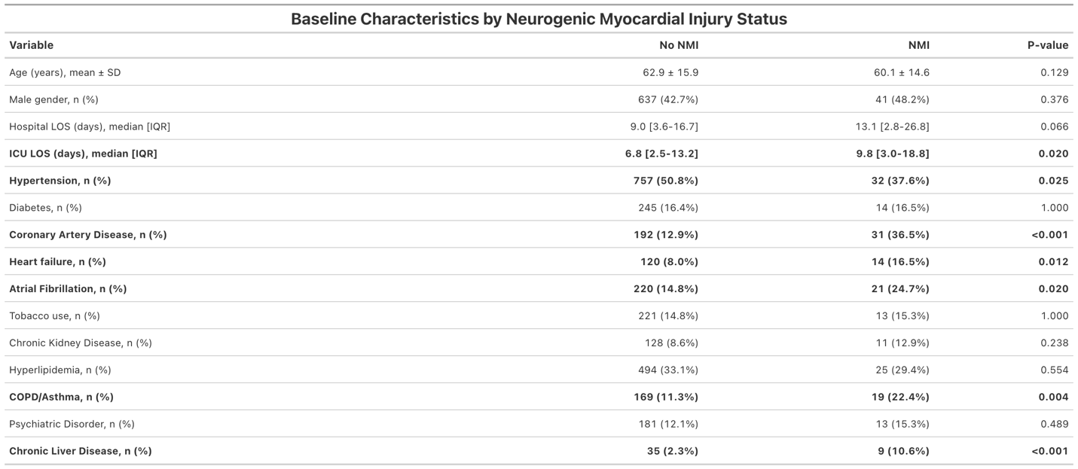
Table 1. Baseline Characteristics by Neurogenic Myocardial Injury Status
Values are mean ± standard deviation, median [interquartile range], or n (%), as indicated.
Abbreviations: COPD, chronic obstructive pulmonary disease; ICU, intensive care unit; IQR, interquartile range; LOS, length of stay; SD, standard deviation.

