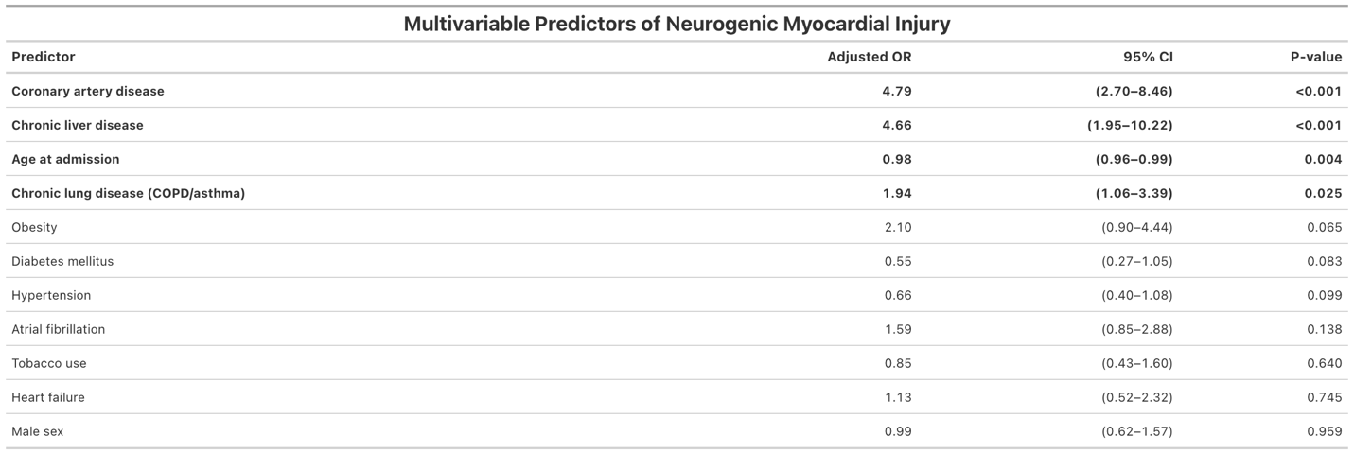
Table 3. Multivariable Predictors of Neurogenic Myocardial Injury in the Primary Model
Adjusted odds ratios and 95% confidence intervals from the primary multivariable logistic regression model in the full cohort (N = 1,576).
Abbreviations: CI, confidence interval; COPD, chronic obstructive pulmonary disease; OR, odds ratio.

