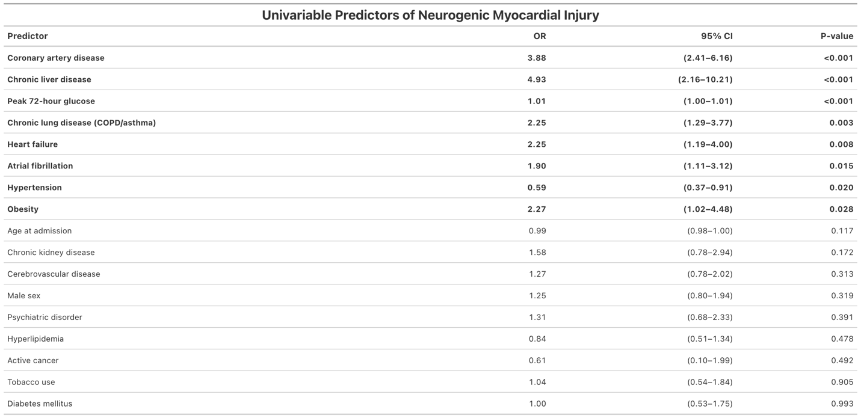
Table 2. Univariable Predictors of Neurogenic Myocardial Injury
Odds ratios and 95% confidence intervals from separate univariable logistic regression models for each candidate predictor. Peak 72-hour glucose analysis was restricted to patients with available glucose measurements. Abbreviations: CI, confidence interval; COPD, chronic obstructive pulmonary disease; NMI, neurogenic myocardial injury; OR, odds ratio.

