Supplementary Information/Extended Data

Statistical Considerations

The safety, efficacy, pharmacokinetic (PK), and pharmacodynamic analysis populations comprised all participants who received at least one dose of the combination of FAP-4-1BBL and cibisatamab. For efficacy analyses, participants were required to have at least one evaluable post-baseline assessment, such as a tumor response evaluation.

Dose escalation and dose selection were guided by a modified continual reassessment method (mCRM) incorporating overdose control through the escalation with overdose control (EWOC) framework, in conjunction with clinical judgment. Multiple participants were enrolled at each dose level, with a minimum of three participants required per level to inform mCRM-based decisions. Escalation decisions were made jointly by the sponsor and participating investigators following a comprehensive review of available safety data and in accordance with the clinical trial protocol.

Supplementary Figures
Supplementary Figure 1 Study design Part 1: QW FAP-4-1BBL dose-escalation in combination with Q3W cibisatamab*
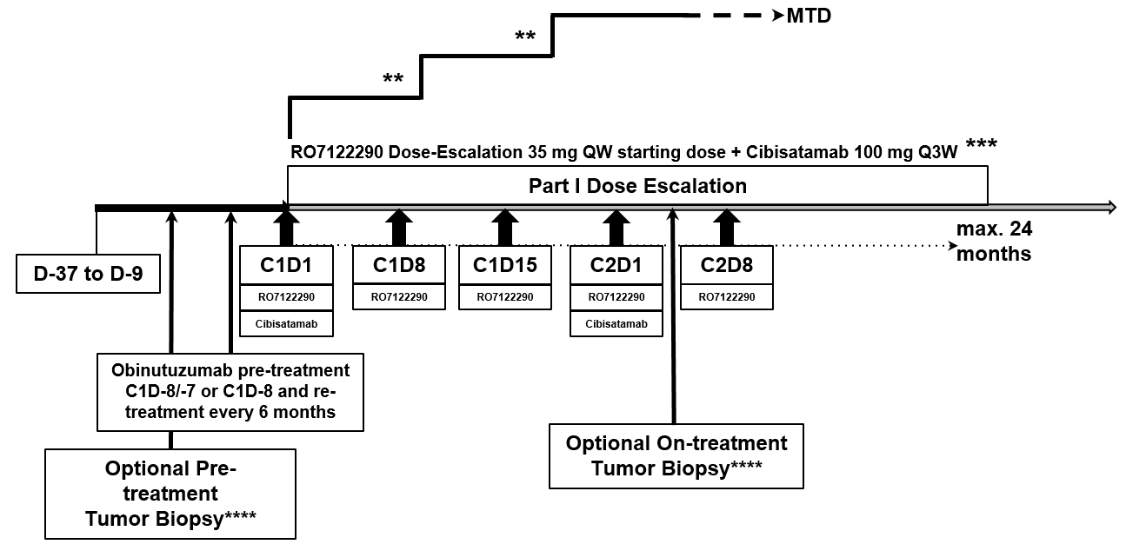

C = Cycle; D = Day; MTD = Maximum tolerated dose; QW = Once a week; Q3W = Every 3 weeks.
Modified continual reassessment method (mCRM) with escalation with overdose control (EWOC) design; n ≥ 3 per cohort; N: up to approximately 60 evaluable participants (Part 1 and Part 2 combined not to exceed approximately 80 evaluable participants)
For a FAP-4-1BBL QW schedule in combination with cibisatamab in a Q3W schedule, 1 cycle 21 days, which corresponds to 3 doses of FAP-4-1BBL and 1 dose of cibisatamab.
* Depending on the nature and the time course of emerging safety events, the dosing frequency for FAP-4-1BBL during Part 1 can be modified as described in Protocol Section 4.1.
** If deemed necessary to further characterize the safety, PK, and/or pharmacodynamic profile of FAP-4-1BBL, additional participants may be enrolled at specific dose levels.
*** Based on emerging safety data, FAP-4-1BBL may be initiated only at C1D8,15 or C2D1.
**** For the first 3 evaluable participants at every dose level, optional tumor biopsies at baseline and on treatment can be collected. For each additional evaluable participant at each dose level (up to a maximum of 9 participants), mandatory tumor biopsies at baseline and on treatment will be collected.

Supplementary Figure 2 Study design Part 2: Q3W FAP-4-1BBL in combination with Q3W cibisatamab*
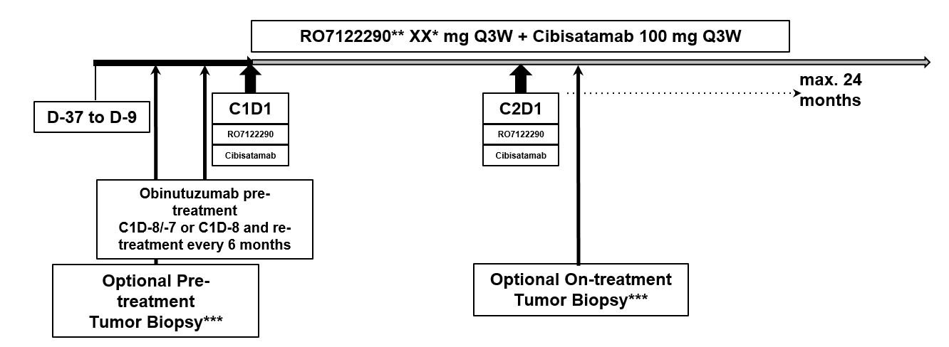

C = Cycle; D = Day; Q3W = Every 3 weeks.
A maximum of 5 specific dose levels will be tested; N: Up to approximately 40 evaluable participants (Part 1 and Part 2 combined not to exceed approximately 80 evaluable participants).
For a FAP-4-1BBL Q3W schedule in combination with cibisatamab in a Q3W schedule, 1 cycle 21 days, which corresponds to 1 dose of FAP-4-1BBL and 1 dose of cibisatamab.
* The selection of FAP-4-1BBL dose levels will be based on emerging clinical data, including safety, PK, and/or pharmacodynamic from Part 1 and Part 2.
** Based on emerging safety data, FAP-4-1BBL may be initiated only at Cycle 2.
*** For the first 3 evaluable participants at every dose level, optional tumor biopsies at baseline and on treatment can be collected. For each additional evaluable participant at each dose level (up to a maximum of 9 participants), mandatory tumor biopsies at baseline and on treatment will be collected.

Supplementary Figure 3 KM Plot cibisatamab + FAP-4-1BBL QW low dose (35+50) vs high dose (90+130) - progression free survival
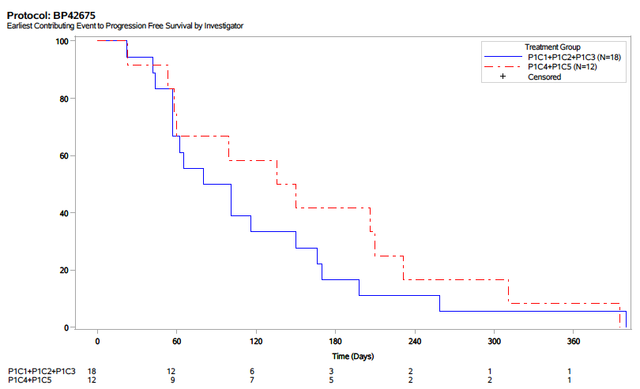
PFS was evaluable in 18 participants receiving low-dose FAP-4-1BBL QW (35 or 50 mg; blue line) and 12 participants receiving high-dose FAP-4-1BBL QW (90 or 130 mg; red dotted line). Both groups received cibisatamab Q3W. Small sample sizes limit the interpretation of the PFS data; however, consistent with PD data and responses, PFS appears to be longer in the FAP-4-1BBL higher dose cohorts compared with the lower dose cohorts. (See figure 4b KM plot). In the group of lower doses (n=18), time to event median was 90.5 days (95% CI 57-150), while in the group of higher doses (n=12), time to event median was 143 days (95% CI 60-210). Of note, all participants in the higher FAP-4-1BBL dose cohorts received a reduced cibisatamab dose of 60 mg at the first cycle, while 15 out of 18 participants received 100 mg cibisatamab also at the first cycle.

Supplementary Figure 4 C_{max} following first administration versus CRS QW regimen
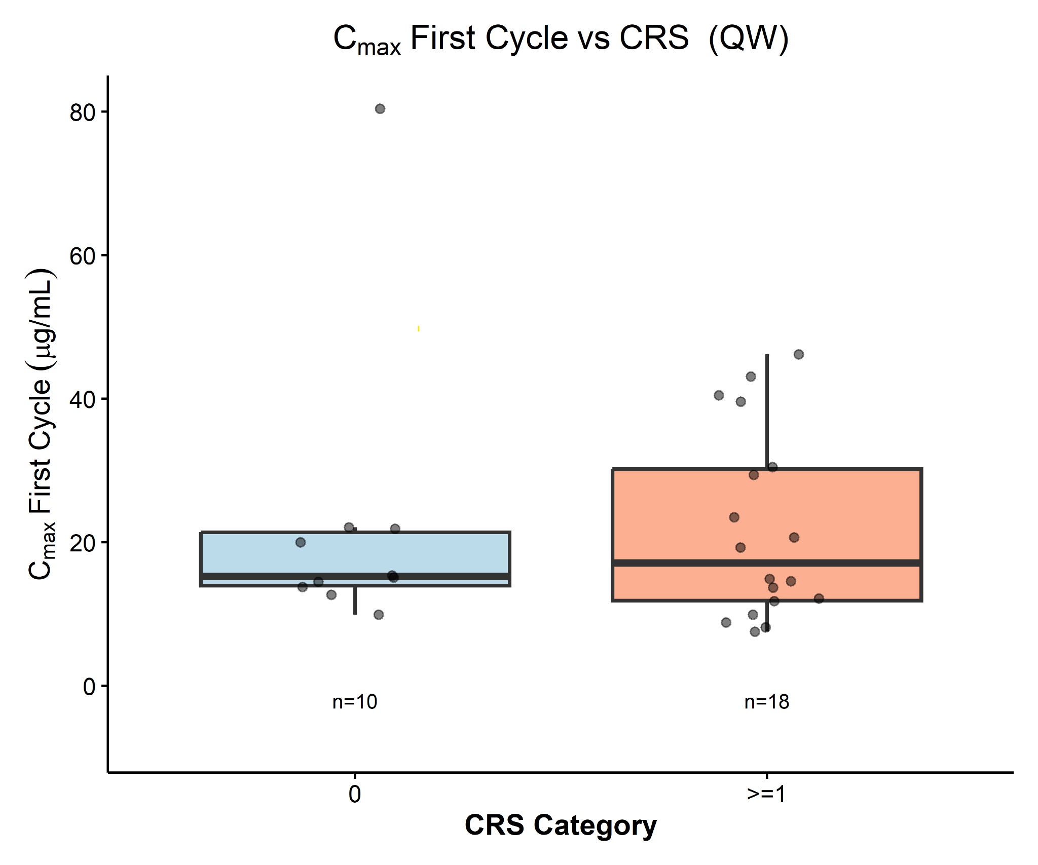
Cmax following first administration versus CRS Q3W regimen
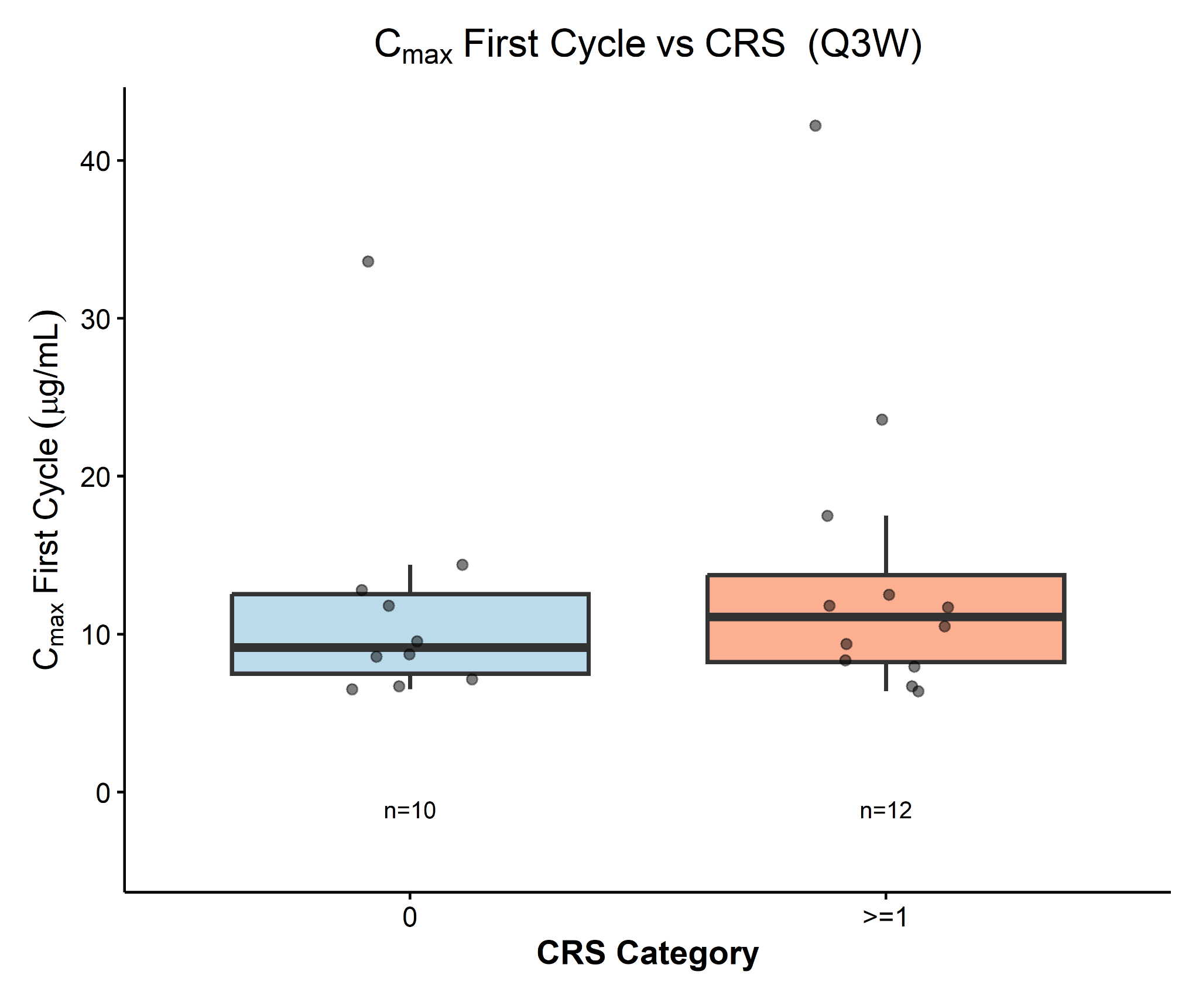
Cmax following first administration versus IRR QW regimen

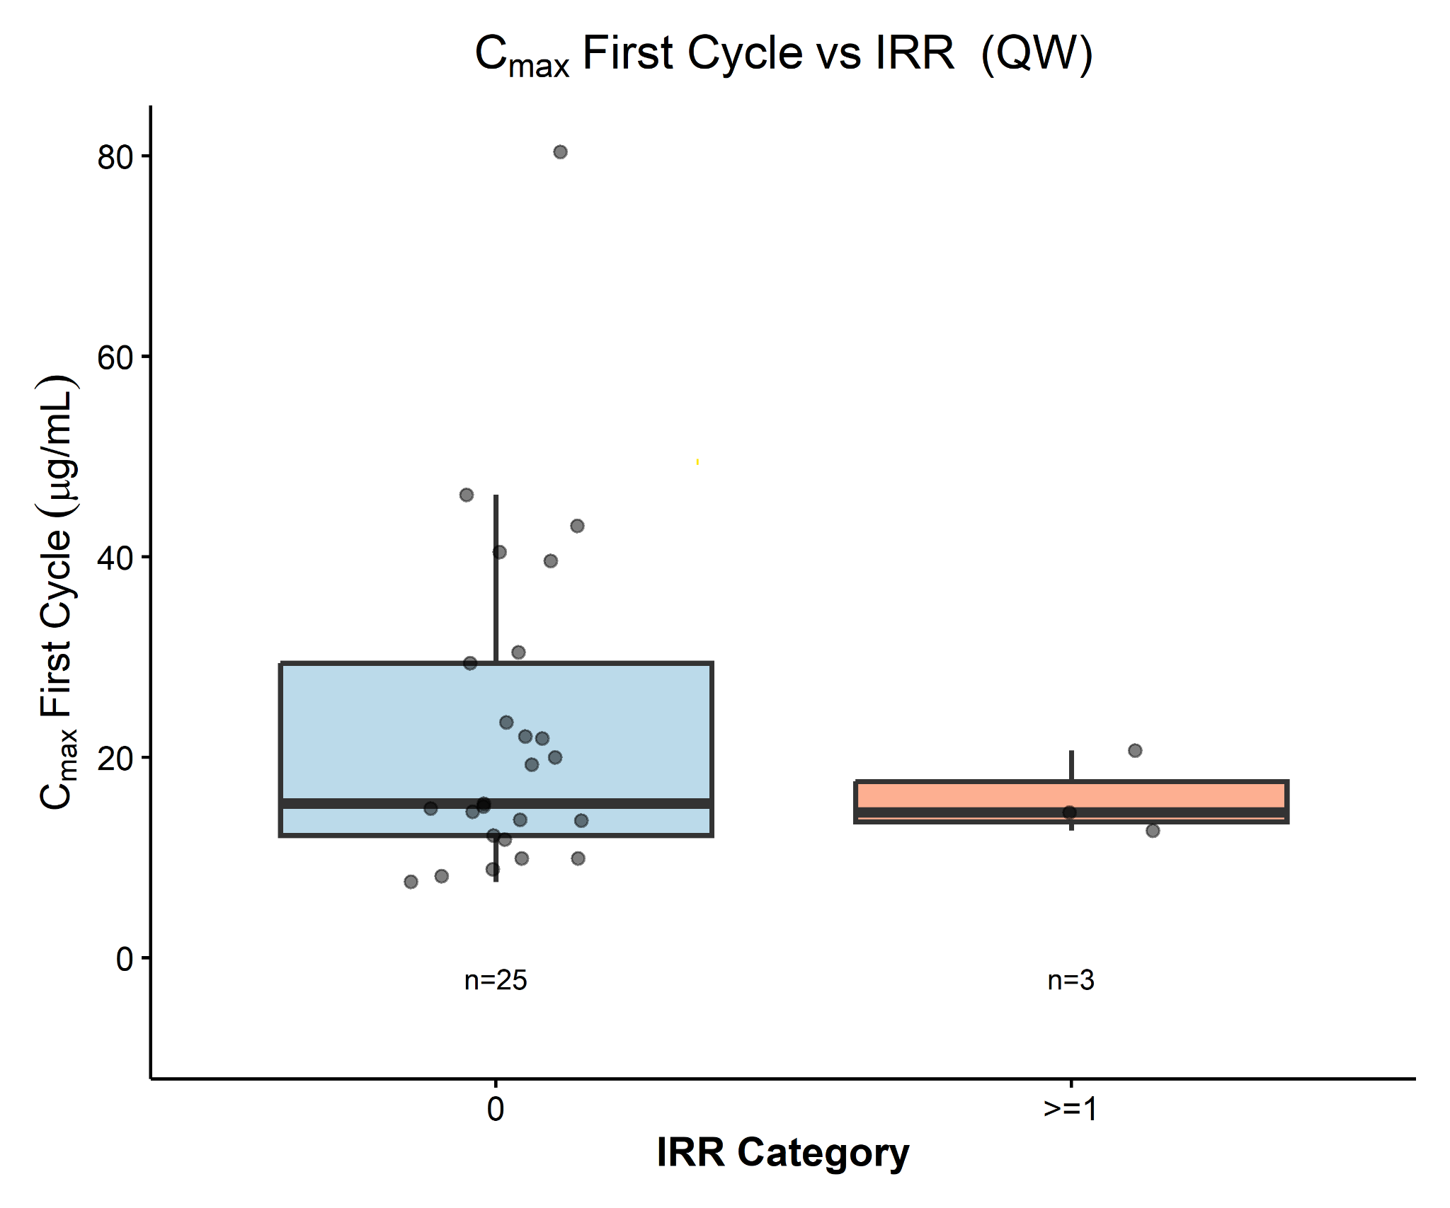
Cmax following first administration versus IRR Q3W regimen

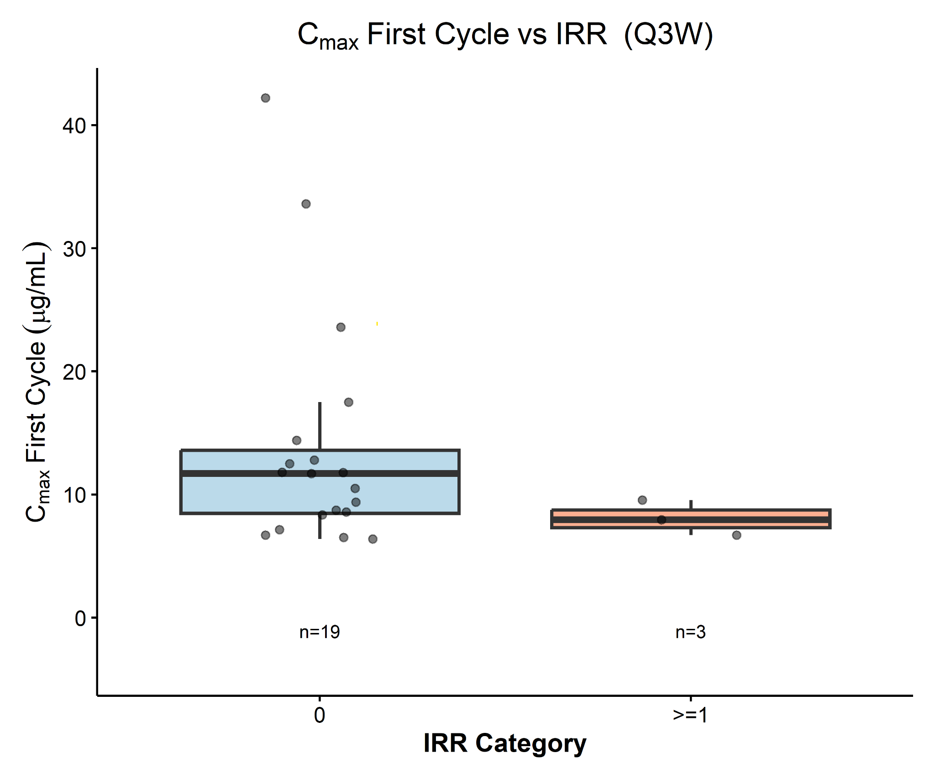

AUC versus rash QW regimen

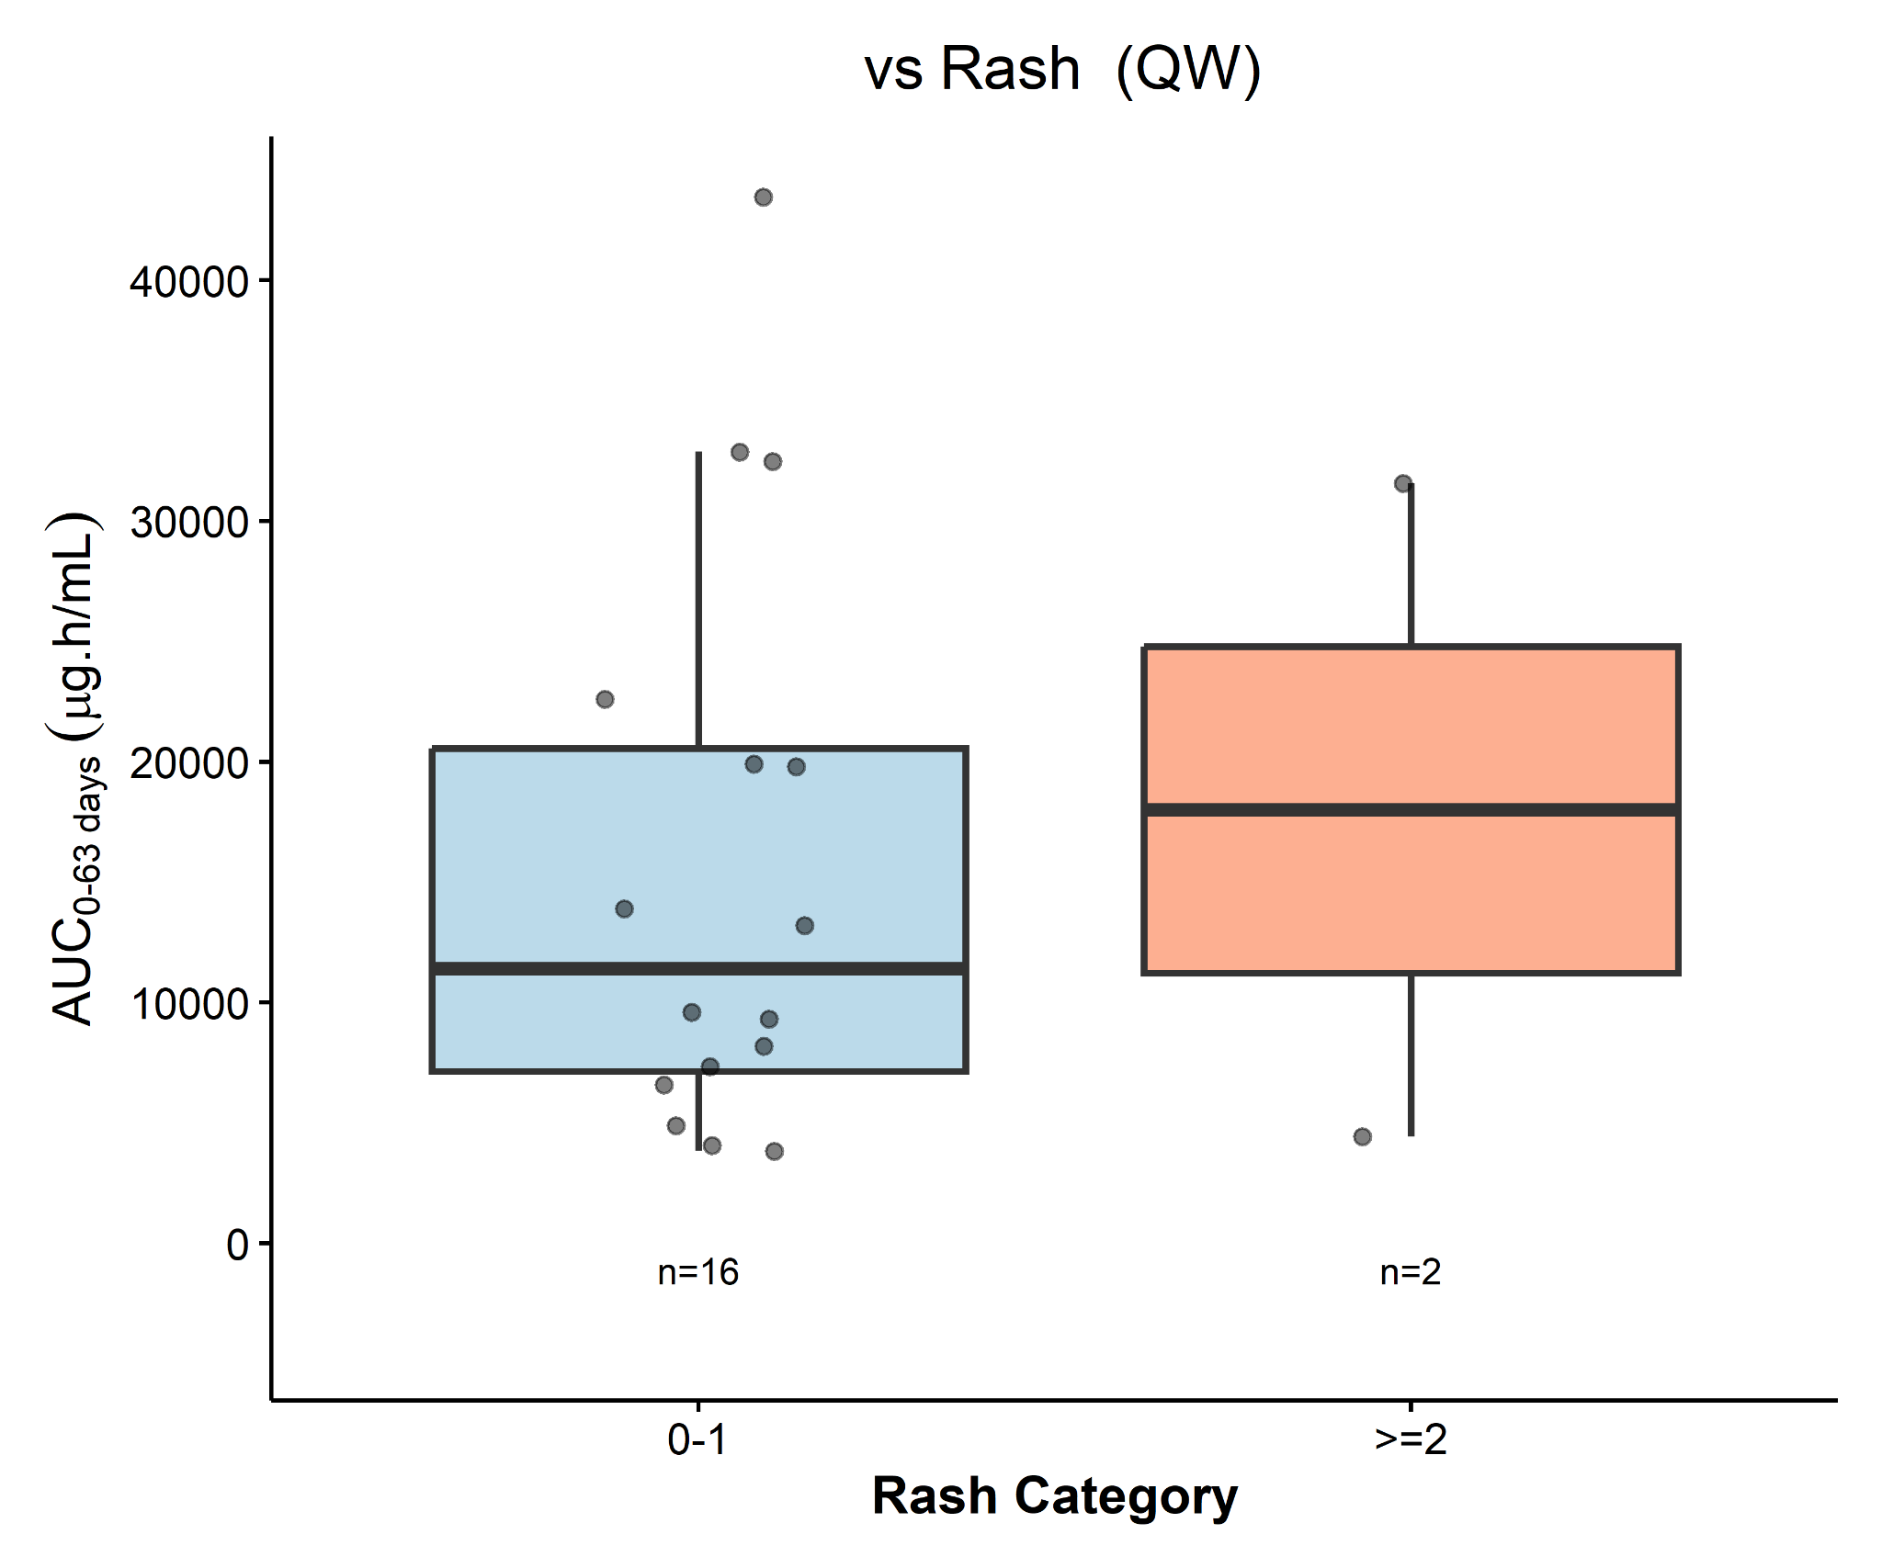
AUC versus rash Q3W regimen

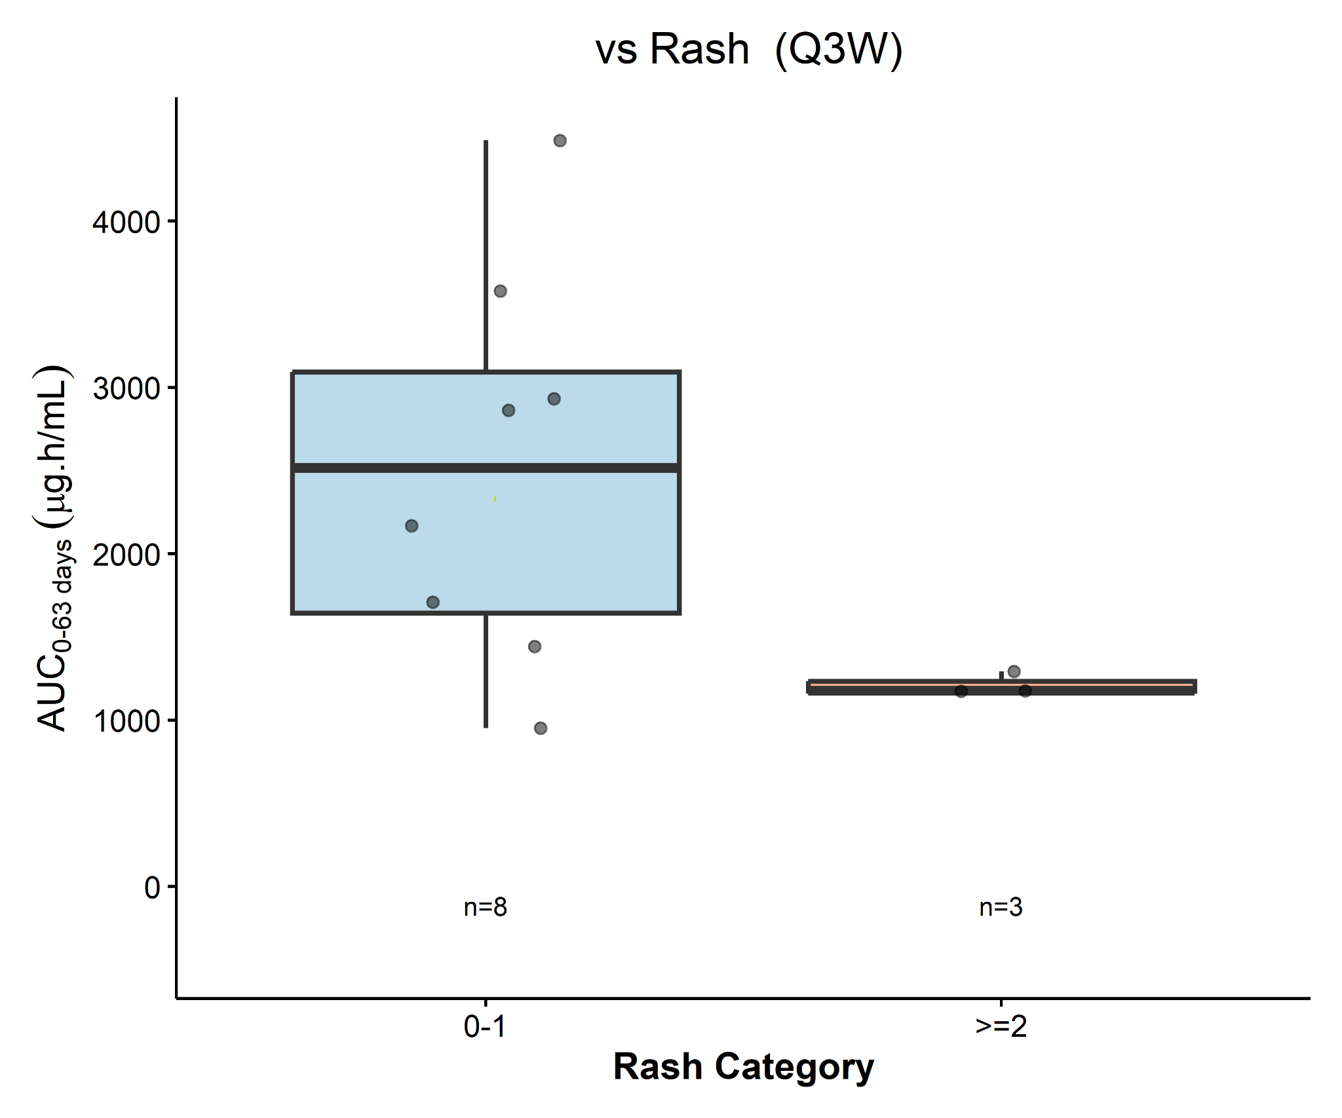

AUC versus diarrhea QW regimen

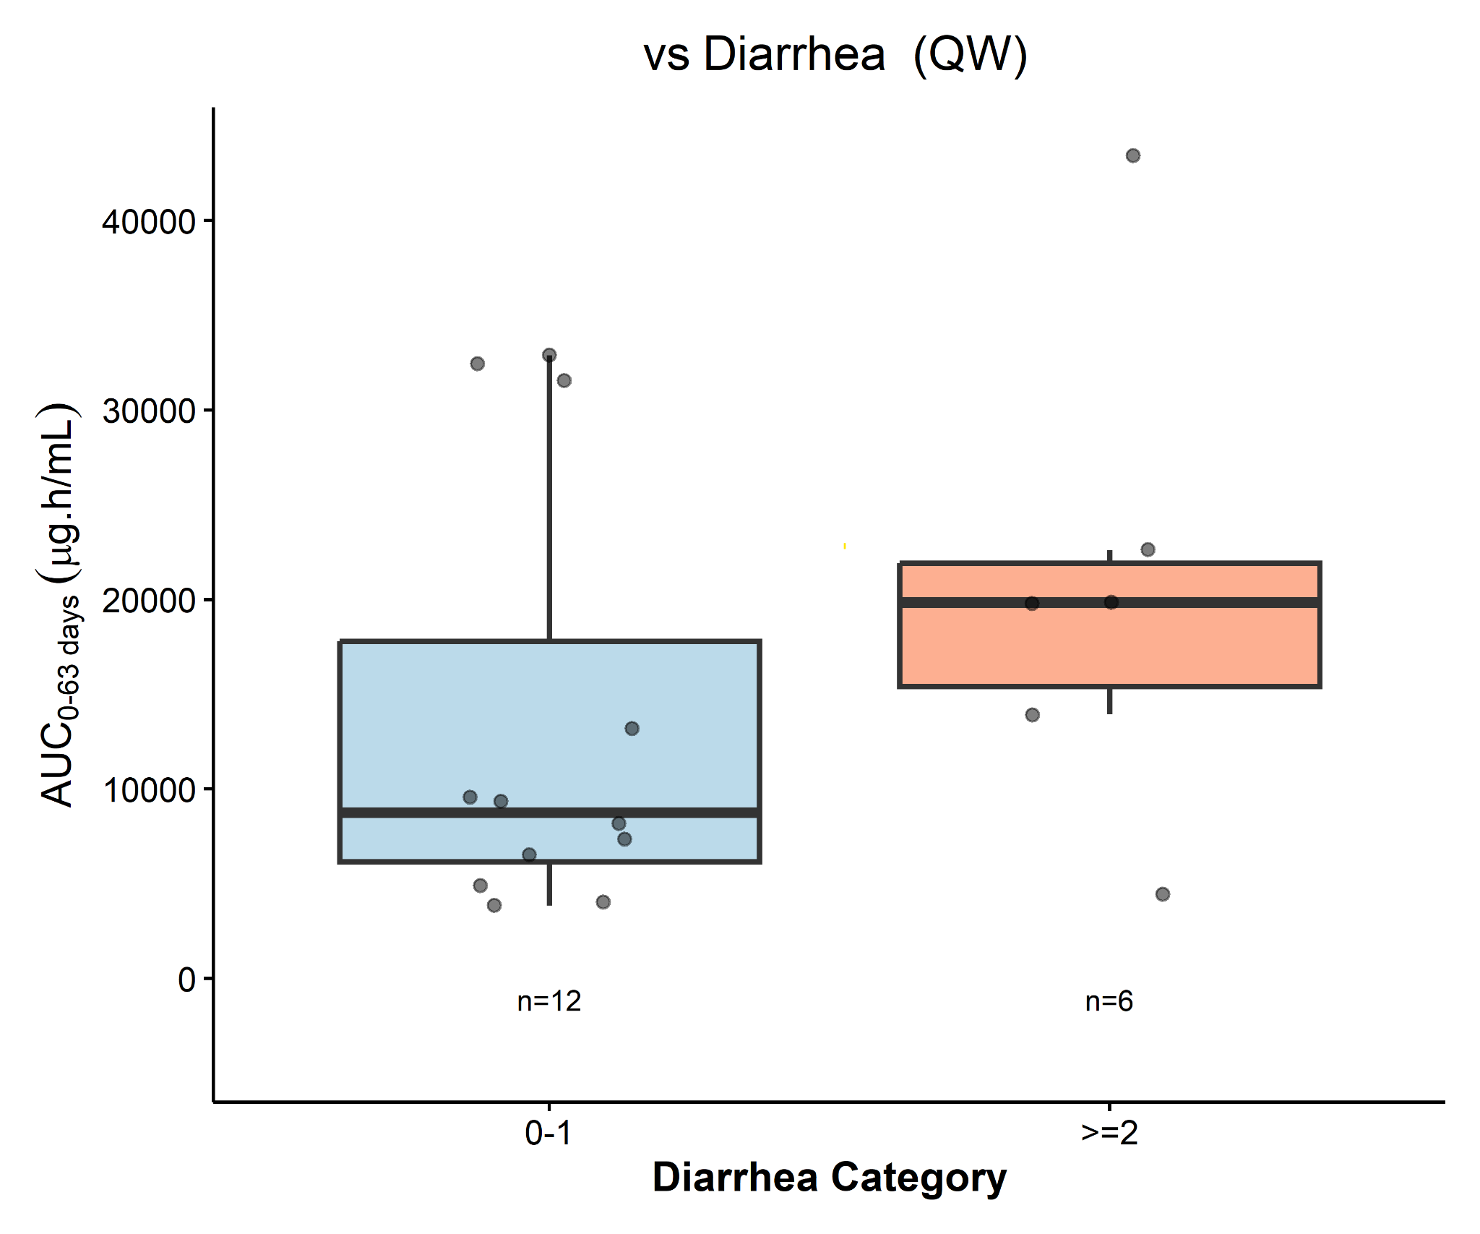
AUC versus diarrhea Q3W regimen
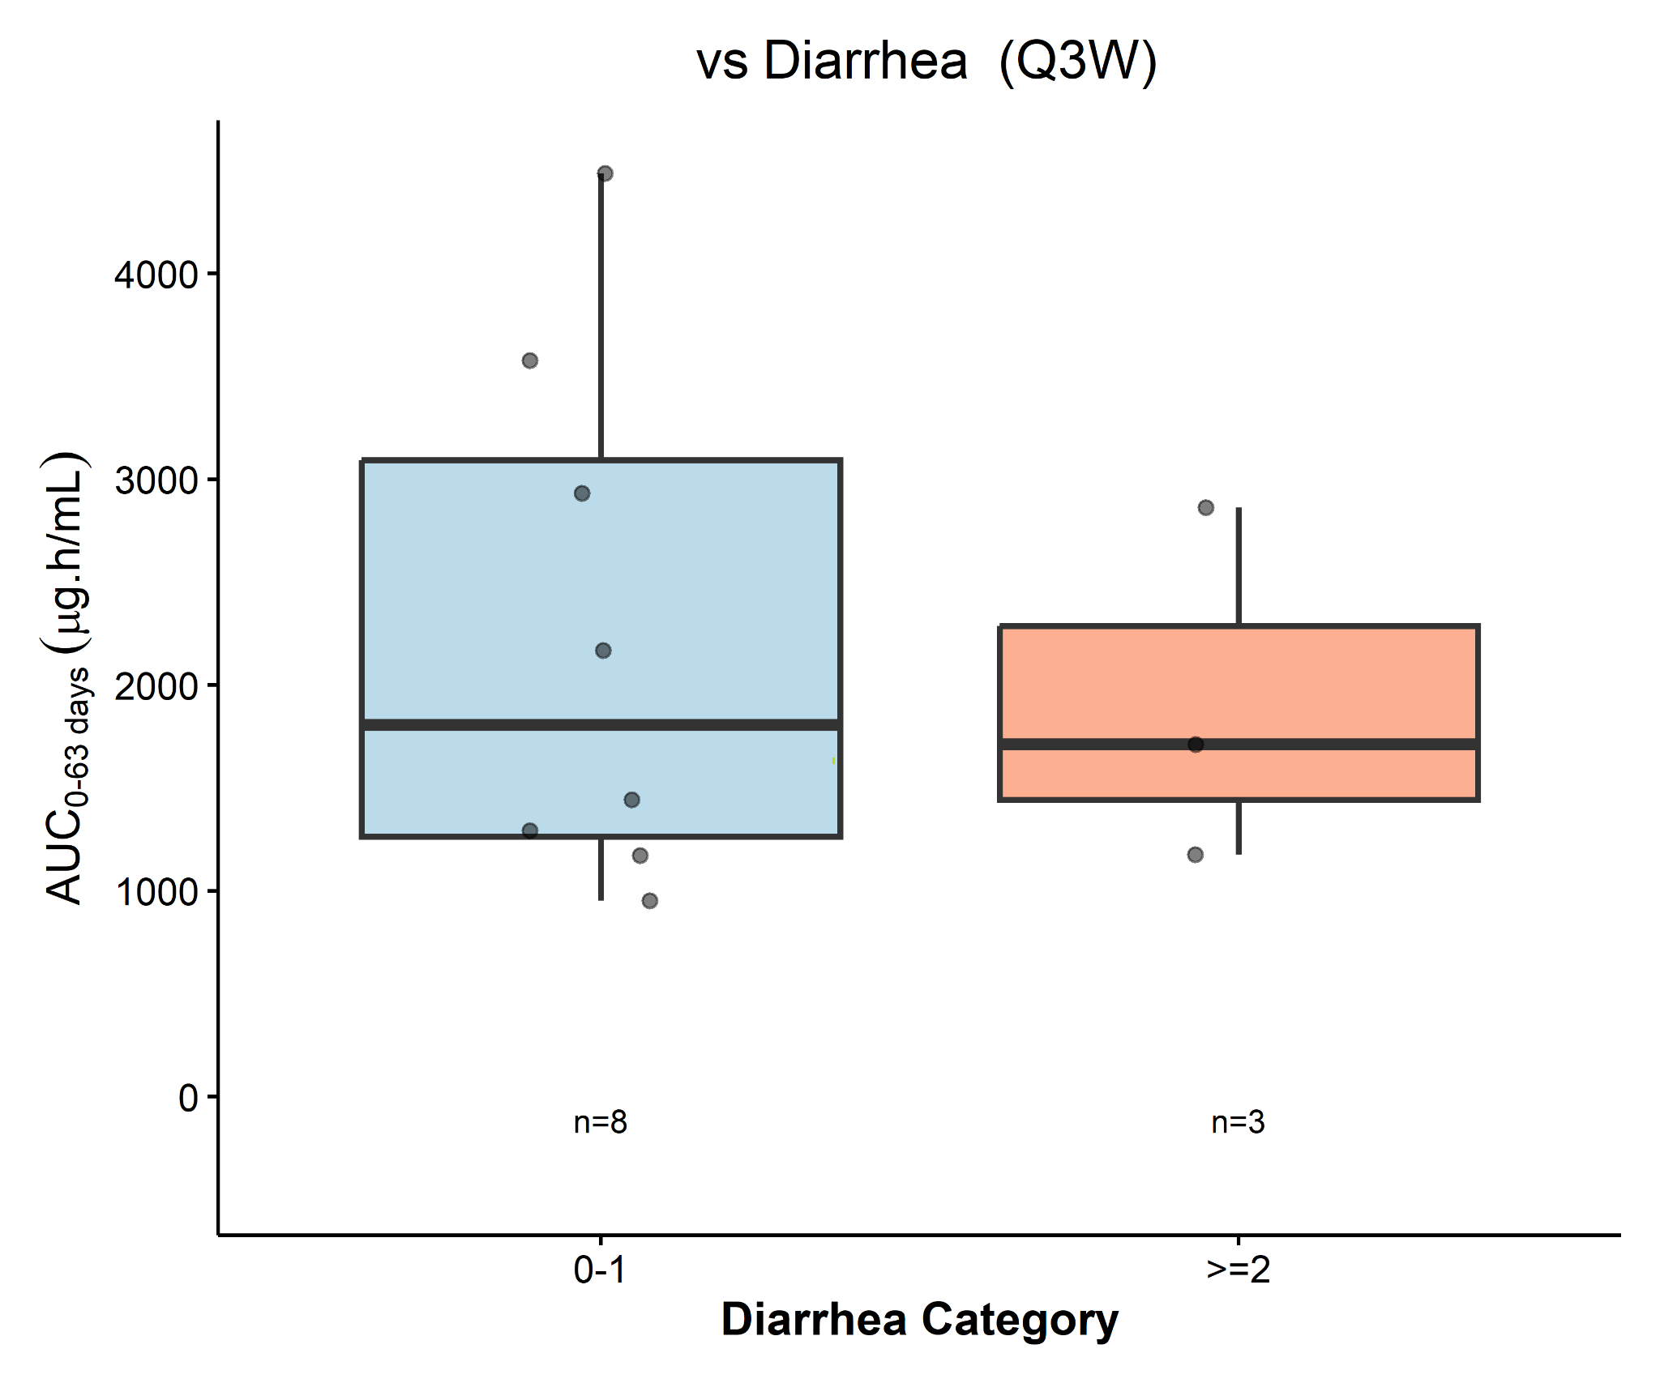

AUC versus colitis QW regimen
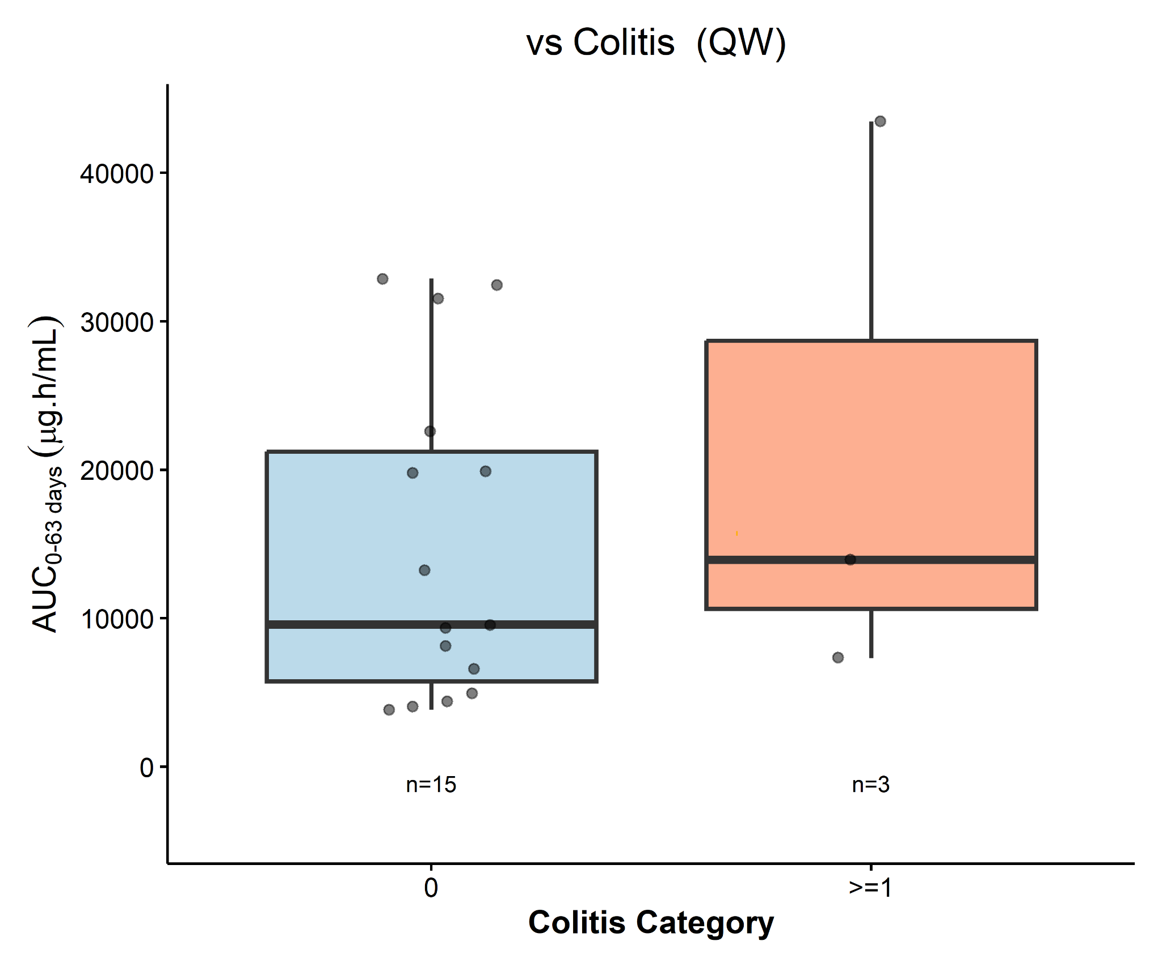
AUC versus colitis Q3W regimen
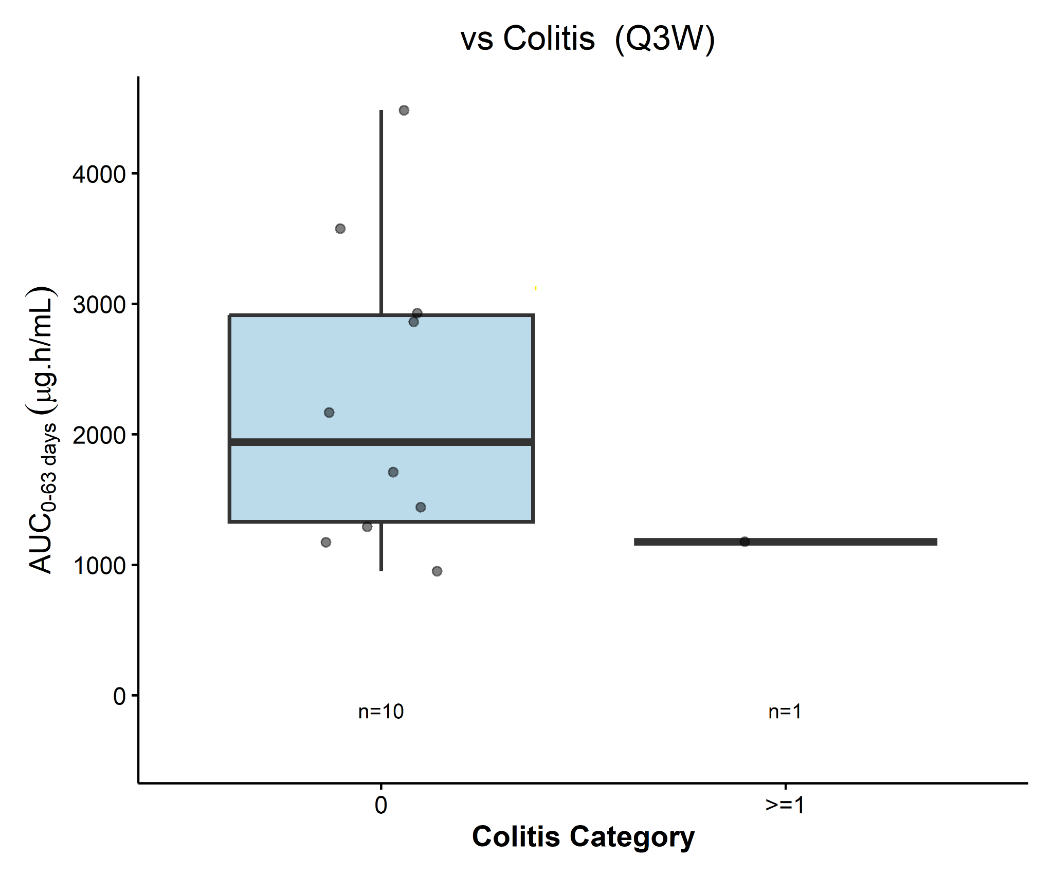

Supplementary Figure 5 Baseline biomarker associations with clinical response
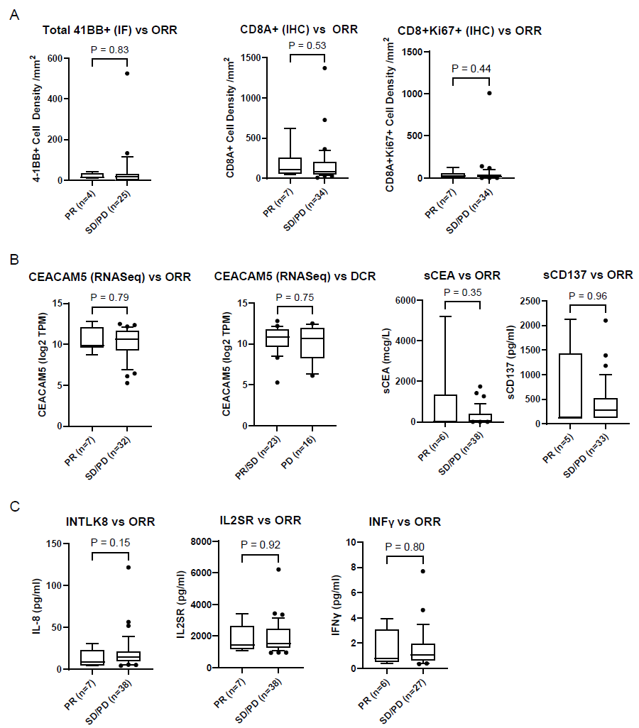
Baseline Biomarker Associations with Clinical Response: (A) Tissue biomarkers (4-1BB by IF; CD8 and CD8+Ki67 by IHC) versus ORR/DCR. (B) CEACAM5 expression (RNA-seq) by ORR and DCR. (C) Baseline serum sCEA and sCD137 levels by ORR. (D) Baseline cytokines (IL-8, IL1-RA, IFNγ) by ORR. No significant associations were observed.

Supplementary Figure 6 Tumor pharmacodynamics
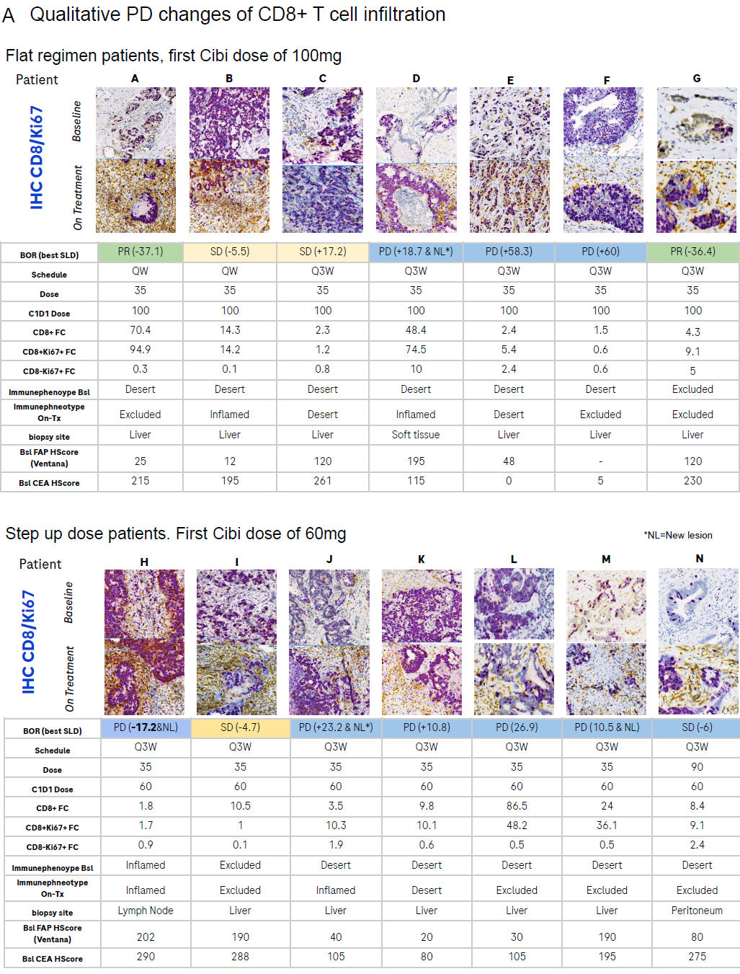
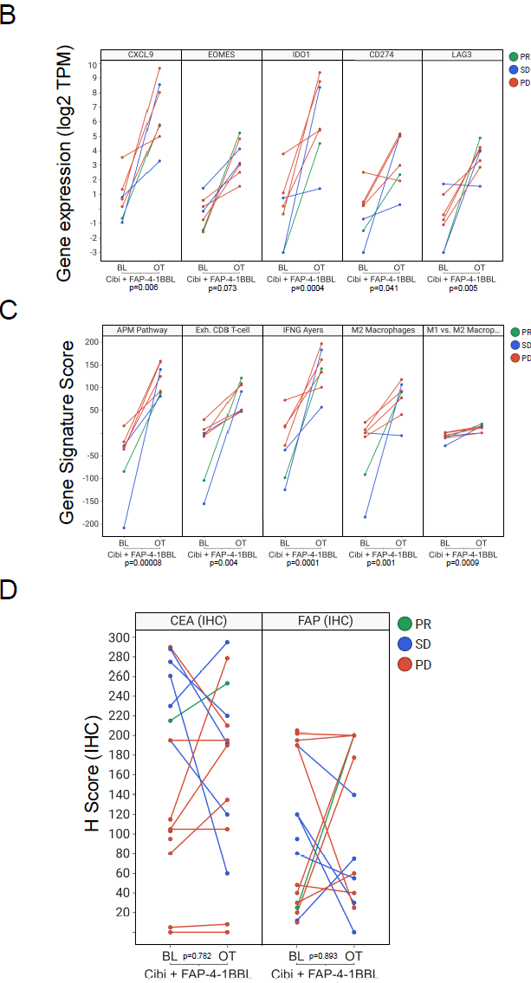
Tumor Pharmacodynamics: (A) Representative duplex CD8/Ki67 IHC of paired baseline and on-treatment biopsies from all participants providing fresh paired biopsies. Participants receiving cibisatamab 100 mg all cycles (top) or cibistamab 60 mg at cycle 1 followed by 100 mg for subsequent treatment cycles (bottom). Tables summarize BOR, treatment regimen, fold-change in CD8+ and CD8+Ki67+ cells, immune-phenotype shifts, biopsy site, and baseline FAP/CEA scores. (B/C) RNA-seq of paired biopsies (n=6) after combination treatment showing induction of APM, IFNγ response, cytotoxic T-cell, T-effector, and M2-macrophage signatures (B), with a modest increase in the M1/M2 index. Single-gene analysis demonstrated upregulation of CD274, CXCL9, EOMES, IDO1, and LAG3 (C). Lines denote BOR (PR, SD, PD). (D) Paired IHC showed no consistent change in CEA H-score and heterogeneous, non-directional changes in FAP intensity, suggesting continued target availability for cibisatamab and FAP-4-1BBL.

Supplementary Figure 7 ctDNA
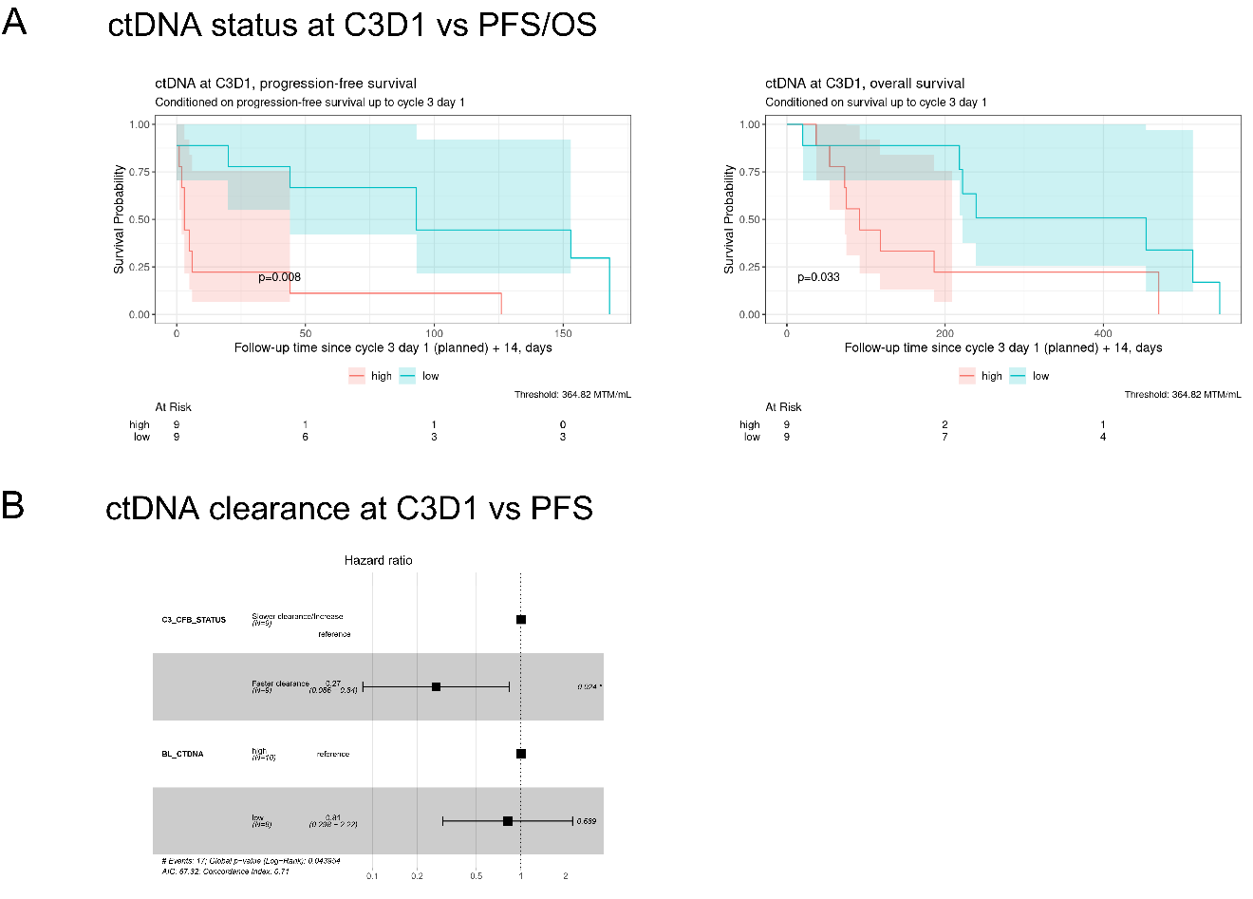

Figure Supplementary ctDNA (A) response association at C3D1: Kaplan–Meier curves for PFS and OS stratified by ctDNA level at Cycle 3 Day 1 (threshold: 384.42 MTM/ml). (B) Faster ctDNA clearance at cycle 3 was associated with improved PFS (HR = 0.27, 95% CI: 0.086–0.84, p = 0.024). Squares indicate HR estimates; horizontal lines, 95% CIs; dashed line, HR = 1.

Supplementary Tables
Supplementary Table 1 Baseline characteristics

Characteristic | Part I Cohort 1  QW 35 mg + Cibi 100 mg  (N=12) | Part I Cohort 2  QW 50 mg + Cibi 100 mg  (N=3) | Part I Cohort 3  QW 50 mg + Cibi C1 60 → C2 100 mg  (N=3) | Part I Cohort 4  QW 90 mg + Cibi C1 60 → C2 100 mg  (N=7) | Part I Cohort 5  QW 130 mg + Cibi 100 mg  (N=5) | Part II Cohort 1  Q3W 35 mg + Cibi 100 mg  (N=11) | Part II Cohort 2  Q3W 35 mg + Cibi C1 60 → C2 100 mg  (N=10) | Part II Cohort 3  Q3W 90 mg + Cibi C1 60 → C2 100 mg  (N=3) | All  (N=54)
Age, mean (SD), yr | 57.7 (11.8) | 63.7 (6.8) | 55.3 (15.0) | 52.6 (10.8) | 54.8 (10.5) | 55.5 (13.7) | 60.2 (13.5) | 55.0 (7.8) | 56.8 (11.7)
Age, median (range), yr | 59 (41–74) | 66 (56–69) | 63 (38–65) | 50 (39–74) | 51 (46–72) | 58 (36–74) | 60.5 (34–76) | 59 (46–60) | 57 (34–76)
Age <65 yr, n (%) | 7 (58.3) | 1 (33.3) | 2 (66.7) | 6 (85.7) | 4 (80.0) | 7 (63.6) | 6 (60.0) | 3 (100) | 36 (66.7)
Male sex, n (%) | 7 (58.3) | 2 (66.7) | 2 (66.7) | 3 (42.9) | 4 (80.0) | 8 (72.7) | 6 (60.0) | 2 (66.7) | 34 (63.0)
White race, n (%) | 4 (33.3) | 0 | 1 (33.3) | 3 (42.9) | 1 (20.0) | 3 (27.3) | 3 (30.0) | 0 | 15 (27.8)
Weight, mean (SD), kg | 79.82 (18.26) | 72.03 (18.69) | 81.50 (22.62) | 81.41 (20.66) | 82.82 (25.13) | 76.90 (17.39) | 76.62 (20.16) | 65.83 (12.00) | 78.05 (18.57)
Weight, median (range), kg | 77.45 (52.0–108.1) | 78.80 (50.9–86.4) | 82.70 (58.3–103.5) | 75.60 (60.0–121.8) | 82.20 (54.5–120.9) | 74.10 (51.9–116.1) | 79.00 (37.1–104.6) | 61.00 (57.0–79.5) | 77.35 (37.1–121.8)

Supplementary Table 2 Summary of adverse events
 | Part I |  |  |  |  | Part II |  |  | All  (N=52)
 | Cohort 1  (N=12) | Cohort 2  (N=3) | Cohort 3  (N=3) | Cohort 4  (N=7) | Cohort 5  (N=5) | Cohort 1  (N=10) | Cohort 2  (N=9) | Cohort 3  (N=3) | All  (N=52)
Total No. of pts with at least  one AE, n (%) | 12 (100%) | 3 (100%) | 3 (100%) | 7 (100%) | 5 (100%) | 10 (100%) | 9 (100%) | 3 (100%) | 52 (100%)
Total No. of AEs | 250 | 36 | 44 | 153 | 92 | 159 | 222 | 18 | 974
Total No. of patients with at least one, n (%)
AE with fatal outcome | 1 (8.3%) | 1 (33.3%) | 0 | 0 | 0 | 0 | 1 (11.1%) | 1 (33.3%) | 4 (7.7%)
Serious AE | 10 (83.3%) | 3 (100%) | 2 (66.7%) | 4 (57.1%) | 4 (80.0%) | 5 (50.0%) | 5 (55.6%) | 1 (33.3%) | 34 (65.4%)
AE leading to withdrawal from FAP-4-1BBL | 1 (8.3%) | 1 (33.3%) | 0 | 2 (28.6%) | 0 | 2 (20.0%) | 1 (11.1%) | 1 (33.3%) | 8 (15.4%)
AE leading to FAP-4-1BBL dose modification/ dose interruption | 6 (50.0%) | 3 (100%) | 2 (66.7%) | 3 (42.9%) | 4 (80.0%) | 1 (10.0%) | 2 (22.2%) | 0 | 21 (40.4%)
AE related to FAP-4-1BBL leading to withdrawal from treatment | 0 | 0 | 0 | 0 | 0 | 0 | 0 | 1 (33.3%) | 1 (1.9%)
AE related to FAP-4-1BBL leading to dose modification/interruption | 6 (50.0%) | 3 (100%) | 2 (66.7%) | 3 (42.9%) | 2 (40.0%) | 1 (10.0%) | 0 | 0 | 17 (32.7%)
Grade 3-5 AE | 8 (66.7%) | 3 (100%) | 3 (100%) | 6 (85.7%) | 4 (80.0%) | 6 (60.0%) | 7 (77.8%) | 1 (33.3%) | 38 (73.1%)
No. of patients with a DLT | 1 (8.3%) | 1 (33.3%) | 0 | 0 | 0 | 0 | 0 | 0 | 2 (3.8%)

Supplementary Table 3 adverse events in ≥ 30% patients overall regardless of relationship to study treatment
MedDRA Preferred Term | Part I  Cohort 1  QW 35mg + Cibi 100mg  (n=12) | Part I  Cohort 2  QW 50mg + Cibi 100mg  (n=3) | Part I  Cohort 3  QW 50mg + Cibi C1 60mg C2 100mg  (n=3) | Part I  Cohort 4  QW 90mg + Cibi C1 60mg C2 100mg  (n=7) | Part I  Cohort 5  QW 130mg + Cibi C1 60mg C2 100mg  (n=5) | Part II  Cohort 1  Q3W 35mg+ Cibi 100mg  (n=10) | Part II  Cohort 2  Q3W 35mg+  Cibi C1 60mg C2 100mg  (n=9) | Part II  Cohort 3  Q3W 90mg+  Cibi C1 60mg C2 100mg  (n=3) | All  (n=52)
Fatigue | 8 (66.7% | 2 (66.7%) | 3 (100%) | 5 (71.4%) | 3 (60.0%) | 6 (60.0%) | 5 (55.6%) | 1 (33.3%) | 33 (63.5%)
Cytokine release syndrome | 6 (50.0%) | 1 (33.3%) | 3 (100%) | 6 (85.7%) | 2 (40.0%) | 6 (60.0%) | 4 (44.4%) | 2 (66.7%) | 30 (57.7%)
Diarrhea | 6 (50.0%) | 1 (33.3%) | 2 (66.7%) | 5 (71.4%) | 3 (60.0%) | 5 (50.0%) | 6 (66.7%) | 1 (33.3%) | 29 (55.8%)
Pyrexia | 7 (58.3%) | 1 (33.3%) | 2 (66.7%) | 2 (28.6%) | 3 (60.0%) | 5 (50.0%) | 5 (55.6%) | 1 (33.3%) | 26 (50.0%)
Decreased appetite | 7 (58.3%) | 1 (33.3%) | 1 (33.3%) | 1 (14.3%) | 4 (80.0%) | 4 (40.0%) | 4 (44.4%) | 1 (33.3%) | 23 (44.2%)
Cough | 4 (33.3%) | 0 | 0 | 3 (42.9%) | 2 (40.0%) | 3 (30.0%) | 4 (44.4%) | 1 (33.3%) | 17 (32.7%)
Anemia | 5 (41.7%) | 3 (100%) | 1 (33.3%) | 3 (42.9%) | 1 (20.0%) | 1 (10.0%) | 3 (33.3%) | 0 | 17 (32.7%)
Nausea | 4 (33.3%) | 0 | 1 (33.3%) | 3 (42.9%) | 2 (40.0%) | 2 (20.0%) | 4 (44.4%) | 0 | 16 (30.8%)
Arthralgia | 5 (41.7%) | 2 (66.7%) | 1 (33.3%) | 2 (28.6%) | 2 (40.0%) | 1 (10.0%) | 3 (33.3%) | 0 | 16 (30.8%)

Supplementary Table 4: Cytokine release syndrome
 | Cibisatamab 60→100 mg dose (n=27) | Cibisatamab flat dose (n=25) | All Participants (n=52)
All grades | 17 (63.0%) | 13 (52.0%) | 30 (57.7%)
Grade 1 | 14 (51.9%) | 11 (44.0%) | 25 (48.1%)
Grade 2 | 3 (11.1%) | 0 | 4 (7.7%)
Grade 3 | 0 | 2 (8.0%) | 2 (3.8%)
Grade 4 | 0 | 0 | 0
Grade 5 | 0 | 0 | 0
SAE | 4 (14.8%) | 9 (36.0%) | 13 (25.0%)

Supplementary Table 5 Summary of FAP-4-1BBL PK parameters in Cycle 1
Cohort | C_{max} (ug/mL) | AUC_{inf} (hr*ug/mL) | Half life (hr) | Vz (mL) | CL (mL/hr)
Part 1 Cohort 1 QW 35 mg | 11.9 (31.2, n=12) | 619 (54.7, n=11) | 39.5 (32.1, n=11) | 3220 (28.6, n=11) | 56.6 (54.7, n=11)
Part 1 Cohort 2 QW 50 mg | 16.1 (22.4, n=3) | 1070 (27.4, n=3) | 49.9 (19.7, n=3) | NE | NE
Part 1 Cohort 3 QW 50 mg | 11.8 (32.6, n=3) | 799 (44.1, n=3) | 46.7 (24.0, n=3) | 4220 (19.0, n=3) | 62.6 (44.1, n=3)
Part 1 Cohort 4 QW 90 mg | 29.1 (34.5, n=7) | 2450 (42.8, n=5) | 61.7 (18.6, n=5) | 3080 (32.4, n=4) | 36.4 (50.0, n=4)
Part 1 Cohort 5 QW 120 mg | 39.4 (52.2, n=5) | 2830 (45.6, n=4) | 51.7 (32.4, n=4) | 3530 (59.9, n=3) | 54.1 (35.6, n=3)
Part 2 Cohort 1 Q3W 35 mg | 10.4 (31.2, n=10) | 615 (43.4, n=10) | NE | 2660 (52.2, n=10) | 56.9 (43.4, n=10)
Part 2 Cohort 2 Q3W 35 mg | 8.7 (26.9, n=9) | 508 (37.0, n=9) | NE | 3200 (45.6, n=9) | 68.9 (37.0, n=9)
Part 2 Cohort 3 Q3W 90 mg | 32.2 (29.9, n=3) | 2660 (33.3, n=3) | NE | 1730 (44.9, n=3) | 33.8 (33.3, n=3)
NE = Not evaluable or reported when n<3; Geometric Mean (Geo Mean, n)

Supplementary Table 6 Summary of cibisatamab PK parameters in Cycle 1
Cohort | Cmax (ug/mL) | AUCinf (hr*ug/mL) | Half life (hr) | Vz (mL) | CL (mL/hr)
Part 1 Cohort 1 QW | 22.3 (55.0, n=12) | 959 (79.1, n=11) | 89.6 (46.2, n=11) | 13500 (104.9, n=11) | 104 (79.1, n=11)
Part 1 Cohort 2 QW | 24.5 (31.6, n=3) | 1310 (4.2, n=3) | 95.4 (9.1, n=3) | 10500 (12.4, n=3) | 76.1 (4.2, n=3)
Part 1 Cohort 3 QW | 13.2 (27.1, n=3) | 483 (19.8, n=3) | 75.8 (66.0, n=3) | 13600 (43.5, n=3) | 124 (19.8, n=3)
Part 1 Cohort 4 QW | 16 (39.8, n=7) | 1030 (49.0, n=6) | 98.2 (24.1, n=6) | 8230 (59.7, n=6) | 58.1 (49.0, n=6)
Part 1 Cohort 5 QW | 12.4 (21.2, n=5) | 709 (22.1, n=5) | 80.6 (40.8, n=5) | 9830 (36.9, n=5) | 84.6 (22.1, n=5)
Part 2 Cohort 1 Q3W | 24.1 (17.6, n=10) | 1420 (77.0, n=9) | 106 (40.1, n=9) | 13800 (38.8, n=8) | 83.8 (51.1, n=8)
Part 2 Cohort 2 Q3W | 13.8 (24.9, n=9) | 739 (26.9, n=7) | 98.3 (14.6, n=7) | 11500 (19.8, n=7) | 81.2 (26.9, n=7)
Part 2 Cohort 3 Q3W | 15.3 (17.8, n=3) | 842 (55.5, n=3) | 76.8 (39.2, n=3) | 7890 (49.2, n=3) | 71.3 (55.5, n=3)

Supplementary Table 7 Cibisatamab + FAP-4-1BBL treatment exposure (days)
Combination Schedule | FAP-4-1BBL Dose (mg) | Cibisatamab (mg) | # of participants evaluable for efficacy | FAP-4-1BBL Median | Cibicatamab Median | FAP-4-1BBL Mean | Cibicatamab mean
FAP-4-1BBL QW  + Cibisatamab Q3W | 35 | 100 | 12** | 123 | 116 | 153.9 | 147.4
FAP-4-1BBL QW  + Cibisatamab Q3W | 50 | 100 | 3 | 36 | 50 | 52.3 | 52.3
FAP-4-1BBL QW  + Cibisatamab Q3W | 50 | 60→100 | 3 | 114 | 98 | 97.7 | 83.0
FAP-4-1BBL QW  + Cibisatamab Q3W | 90 | 60→100 | 6* | 99 | 85 | 121.7 | 133.9
FAP-4-1BBL QW  + Cibisatamab Q3W | 130 | 60→100 | 5 | 85 | 85 | 131.6 | 125.6
FAP-4-1BBL Q3W  + Cibisatamab Q3W | 35 | 100 | 10 | 64 | 64 | 108.1 | 108.1
FAP-4-1BBL Q3W  + Cibisatamab Q3W | 35 | 60→100 | 9 | 85 | 85 | 87.6 | 87.6
FAP-4-1BBL Q3W  + Cibisatamab Q3W | 90 | 60→100 | 3 | 43 | 43 | 40.7 | 40.7
All | All | All | 51 | 85 | 85 | 111.5 | 110.2
60→100: cibisatamab 60 mg at C1, 100 mg from C2. *1 participant withdrew due to AE, no RECIST assessment performed. **1 participant withdrew after a single study dose (FAP-4-1BBL +cibisatamab). However, the participant was reported with cPR later on without receiving any anticancer treatment after study withdrawal according to the main site investigator.

Supplementary Table 8 Study BP42675 objectives and endpoints
Objectives | Endpoints
Primary (Part I and Part II)
To determine the maximum tolerated dose (MTD) and/or recommended Phase 2 dose (RP2D) in the QW and/or Q3W regimens of RO7122290 in combination with cibisatamab after pre-treatment with obinutuzumab | - Nature and frequency of dose-limiting toxicities (DLTs; Part I only)
To characterize the safety and tolerability profile of RO7122290 in combination with cibisatamab after pre-treatment with obinutuzumab | - Incidence, nature, and severity of adverse events (AEs) graded according to the National Cancer Institute Common Terminology Criteria for Adverse Events (NCI CTCAE) v5 with the exception of cytokine release syndrome (CRS), which is graded according to the ASTCT grading scale for CRS (with individual signs and symptoms of CRS graded separately using the CTCAE v5.0 grading scale)
Secondary (Part I and Part II)
To characterize the pharmacokinetics (PK) of RO7122290, cibisatamab, and obinutuzumab after administration of RO7122290 in combination with cibisatamab following pre-treatment with obinutuzumab | - PK profiles and parameters derived for RO7122290, cibisatamab, and obinutuzumab, as appropriate, including but not limited to:  - Serum/plasma concentrations  - Maximum concentration (C_{max})  - Time of maximum concentration (T_{max})  - Clearance (CL)  - Volume of distribution (V)  - Area under the curve (AUC)  - Half-life (t_{1/2})
To evaluate the immune response after treatment of RO7122290 in combination with cibisatamab following pre-treatment with obinutuzumab | - Incidence and titer of RO7122290, cibisatamab, and obinutuzumab anti-drug antibodies (ADAs) during the study relative to the prevalence of ADA at baseline
To characterize treatment-induced pharmacodynamic (PD) effects of RO7122290 in combination with cibisatamab, after pre-treatment with obinutuzumab | Peripheral blood lymphocytes:  - Treatment-induced change on T-cell proliferation (CD8/Ki67).
To evaluate the preliminary anti-tumor activity of RO7122290 in combination with cibisatamab after pre-treatment with obinutuzumab | - Objective response rate (ORR) defined as complete response (CR) + partial response (PR)  - Disease control rate (DCR); defined as response rate (RR) + stable disease (SD)  - Duration of response (DoR)  - Progression-free survival (PFS)  - All according to the Response Evaluation Criteria in Solid Tumors (RECIST) Version 1.1
To assess the relationship between the CEACAM5, CEA, FAP, and 4-1BB tumor expression levels and anti-tumor activity | - Differences in overall response or in changes of target lesions based on CEACAM5, CEA, FAP, and 4-1BB expression levels on archival or fresh tumor tissue using immuno-histochemical methods (CEA, FAP, and 4-1BB) and qRT-PCR (CEACAM5)
Exploratory (Part I and Part II)
To investigate the treatment-induced PD effects of RO7122290 in combination with cibisatamab after pre-treatment with obinutuzumab in peripheral blood samples | - Treatment-induced change in levels of soluble CD25, soluble 4-1BB, soluble CEA, and ctDNA  - Treatment-induced change on peripheral blood lymphocyte subsets (T cells, NK cells, monocytes, B cells), including but not limited to markers of T cell regulation, activation, and proliferation.  - Treatment-induced change on cytokine and inflammation marker levels, including but not limited to tumor necrosis factor alpha (TNF alpha), interferon gamma (IFN-gamma), Interleukin (IL)-2, IL-6, IL-8, IL-10
To investigate treatment-induced PD effects of RO7122290 in combination with cibisatamab after pre-treatment with obinutuzumab in fresh tumor tissue samples | Treatment-induced change in the following cell subsets by immune-histochemical methods:  - T cells, proliferating T cells, as well as other markers, including but not limited to FAP  - Change from baseline in density (cell/mm²) of proliferating T cells (CD8/Ki67)  Gene expression profiling by ribonucleic acid (RNA) sequencing to assess treatment-induced changes in gene expression levels and gene signatures.
To further evaluate preliminary anti-tumor activity of RO7122290 in combination with cibisatamab after pre-treatment with obinutuzumab | - ORR  - DCR; defined as RR + SD  - DoR  - PFS  All according to immune RECIST (iRECIST)  - Magnitude and duration of changes in target lesion size estimated by tumor kinetic modeling  - Overall survival (OS) if data are mature  - Association between ctDNA levels and (early) anti-tumor activity (e.g., ORR, PFS)
To explore potential effects of ADA | - Relationship between ADA status and PK, safety, PD, and anti-tumor activity
To characterize the PK profile of tocilizumab | - Serum concentration or PK parameters for tocilizumab
To evaluate the immune response after treatment with tocilizumab | - Incidence of ADAs to tocilizumab during the study relative to the prevalence of ADAs at baseline
To further assess the relationship between the FAP tumor expression levels and anti-tumor activity | - Differences in overall response or in changes of target lesions on the basis of mRNA FAP expression levels in archival and/or fresh tumor tissue

Additional Information
Supplementary Table 9 List of antibody reagents
List of antibody reagents
Reagent | Clone | Manufacturer | Catalog #
T cell proliferation and activation panel
BV421 CD3 | SK7 | BD Bioscience | 563798
FITC CD4 | SK3+SK4 | BD Bioscience | 347413
PE HLA-DR | G46-6 | BD Bioscience | 555812
PerCP-Cy5.5 CD8 | RPA-T4 | BD Bioscience | 341050
AF647 IgG1 | MOPC-21 | BD Bioscience | 557714
AF647 Ki67 | B56 | BD Bioscience | 558615
TBNK immune checkpoints panel
FITC CD3 | SK7 | BD Bioscience | 345764
PE Tim3 | F38-2E2 | Biolegend | 345006
PerCP-Cy5.5 CD134 | Ber-ACT35 | Biolegend | 350010
Pe-Cy7 CD152 | L3D10 | Biolegend | 349914
APC-H7 CD8 | SK1 | BD Bioscience | 641400
APC CD137 | 4B4 | BD Bioscience | 550890
AF700 CD19 | HIB19 | BD Bioscience | 557921
BV421 CD278 | DX29 | BD Bioscience | 562970
BV510 CD4 | SK3 | BD Bioscience | 562970
BV605 CD16 | 3G8 | BD Bioscience | 563172
BV605 CD56 | NCAM16.2 | BD Bioscience | 562780
PD-1 expression on T cell subsets
BV421 CD279 | EH12.1 | BD Bioscience | 562516
BV510 CD3 | UCHT1 | BD Bioscience | 563109
FITC CD4 | SK3+SK4 | BD Bioscience | 347413
PE CD197 | 150503 | BD Bioscience | 560765
PerCP-Cy5.5 CD8 | SK1 | BD Bioscience | 341050
APC CD45RA | HI100 | BD Bioscience | 550855

Supplementary Table 10 IHC and immunofluorescence assays
Antibodies Immunohistochemistry
Primary Antibody | Clone | Manufacturer | Catalog #
CEA | T84.66 | VMS | 790-4795
FAP | SP325 | Spring Biosciences | M6250
CD8  (CD8/Ki67 duplex) | SP-239 | Abcam | ab178089
Ki67  (CD8/Ki67 duplex) | 30-9 | VMS | 790-4286

Supplementary Table 11 Multiplex immunofluorescence (mIF) procedure
Antibodies Multiplex Immunofluorescence
Primary Antibody | Clone and color channel | Manufacturer | Catalog #
4-1BB | 4-1BB (D2Z4Y), yellow (R6G) | Cell Signaling Technology | 34594
ki67 | Ki-67 (30-9), red (Red610) | VMS | 790-4286
CD3 | CD3 (SP162), teal (DCC) | Abcam | ab135372
CD8 | CD8 (SP239), magenta (Cy5) | Abcam | ab178089
OX-40 | OX40 (ACT35), green (FAM) | Invitrogen | 14-1347-82

