Integrative In-Silico Characterization of Methyl Orange and its Degradants Using Physiochemical, Spectral, Docking and ADMET evaluation
Abu Yousufª, Kaiser Mahmood Fahim^{b*}, Musa Miah Shakil^{c}, Farzana Islam^{d}, Md. Mohibul Islam^{e}, Tanzim Talha^{e}

Supporting Data

Content | Page
Table S1. A table with different characteristics (MF, MW, Structure) of MO and its degradants | SI Page-2
Table S2. Vibration frequencies of MO degradants | SI Page-3
Table S3. Electronic transition table of the MO degradants | SI Page-4
Table S4. The binding affinity and nonbonding interactions of MO degradants with the receptor protein (HSA) | SI Page-5
Table S5. Ligand interactions | SI Page-6

Table S1. A table with different characteristics (MF, MW, Structure) of MO and its degradants
Degradants | MF | MW | Structure | Optimized Structure
MO | C₁₄H₁₅N₃O₃SNa | 327.337 |  | 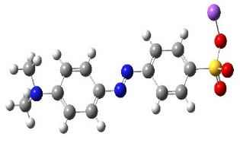
MO1 | C₆H₇NO₃S | 173.190 |  | 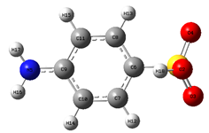
MO2 | C₈H₁₁N | 121.179 |  | 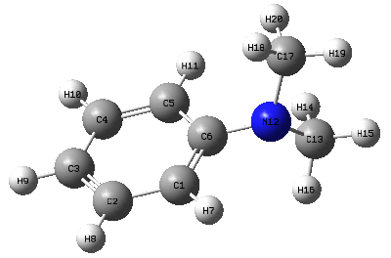
MO3 | C₆H₅NaO₄S | 196.157 |  | 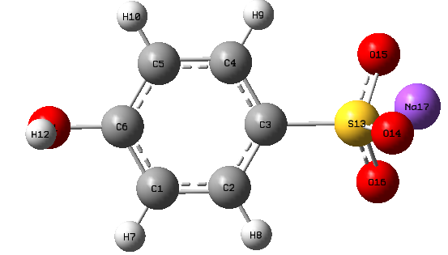
MO4 | C₈H₁₂N₂ | 136.194 |  | 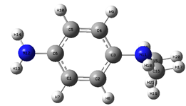
MO5 | C₆H₆O₃S | 158.178 |  | 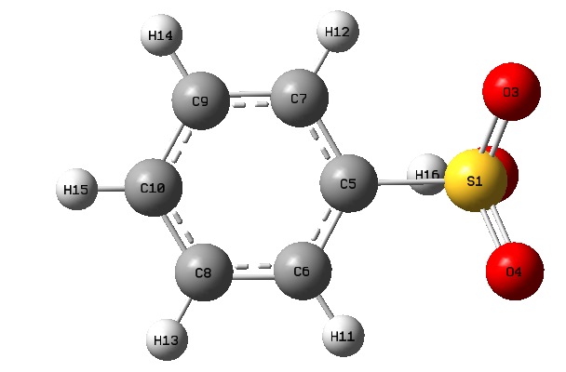
MO6 | C₈H₁₁NO | 137.179 |  | 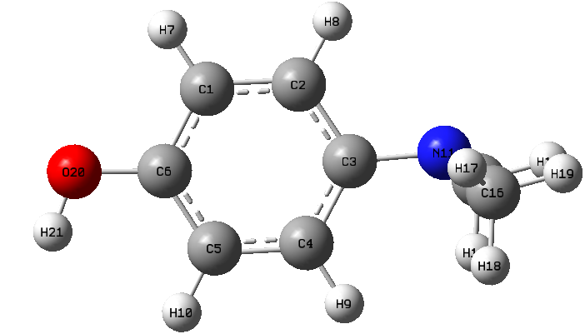

MO = Methyl Orange, MO1 = Sulfanilic acid, MO2 = N, N dimethyl benzeneamine, MO3 = Sodium-4-hydroxybenzene sulfonate, MO4 = N, N-dimethyl-p-phenylenediamine, MO5 = Benzenesulfonic acid, MO6 = 4-(dimethylamino) phenol.

Table S2. Vibration frequencies of MO degradants

Degradants | Assignment | Vibrational Frequencies(cm⁻¹)
Degradants | Assignment | Scaled | Experimental
MO | νC-H | 2905 | 3000-2840
MO | νC=C | 1601 | 1650-1600
MO | νC-N | 1347 | 1386-1266
MO | νO-H | 3636 | 3550-3200
MO | νS=O | 1303 | 1350-1342
MO1 | νC=C^{b} | 713 | 730-665
MO1 | νN-H | 3478 | 3500
MO1 | νO-H | 3664 | 3550-3200
MO1 | νS=O | 1119 | 1165-1150
MO1 | νC=N | 1610 | 1690-1640
MO2 | νC-H | 2838 | 3000-2840
MO2 | νC=C | 1587 | 1650-1600
MO2 | νC-N | 1277 | 1386-1266
MO3 | νC-Hª | 3058 | 3100-3000
MO3 | νC=C | 1591 | 1650-1600
MO3 | νO-H | 3691 | 3550-3200
MO3 | νS=O | 1182 | 1195-1168
MO4 | νC-H^{b} | 1448 | 1465
MO4 | νC=C | 1617 | 1650-1600
MO4 | νN-H | 3436 | 3500
MO4 | νC-N | 1320 | 1342-1266
MO5 | νC-Hª | 3109 | 3100-3000
MO5 | νC=C | 1574 | 1650-1600
MO5 | νO-H | 3660 | 3550-3200
MO5 | νS=O | 1285 | 1350-1342
MO6 | νC-H | 2957 | 3000-2840
MO6 | νC-Hª | 3048 | 3100-3000
MO6 | νC=C | 1598 | 1650-1600
MO6 | νO-H | 3694 | 3550-3200
MO6 | νC-N | 1281 | 1386-1266
a = aromatic, b=bend

Degradants | Transition states | Wavelength (nm) | Excitation energy (eV) | Configuration of electronic transitions | Oscillator strength
MO | S₀→S₂ | 499.39 | 2.48 | (-0.101) H→L, (0.128) H-1→L | 0.016
MO1 | S₀→S₂ | 274.14 | 4.52 | (0.237) H-2→L, (-0.102) H-3→L, (0.652) H→L+1 | 0.000
MO2 | S₀→S₂ | 282.14 | 4.39 | (0.463) H→L, (0.533) H→L+1 | 0.000
MO3 | S₀→S₂ | 396.87 | 3.12 | (0.697) H-1→L | 0.004
MO4 | S₀→S₂ | 287.19 | 4.32 | (-0.13632) H-2→ L+2, (0.11171) H-2→L+3, (0.67782) H→L | 0.039
MO5 | S₀→S₂ | 276.58 | 4.48 | (0.689) H-1→L, (0.10377) H→L | 0.001
MO6 | S₀→S₂ | 275.87 | 4.76 | (0.701) H→L+2 | 0.000

Table S3. Electronic transition table of the MO degradant
Table S4. The binding affinity and nonbonding interactions of MO degradants with the receptor protein (HSA)
Degradants | Binding affinity (Kcal/mol)  Autodock | Residue in contact | Interaction Type | Distance(A°)
MO | -8.0 | ARG209  LYS351  SER202  TRP214  LEU481  LYS199  ALA210  VAL482 | CoHB  CHB  PDHB  PS  A  A  PA  PA | 2.566  2.706  3.145  5.751  4.989  3.947  3.697  5.264
MO1 | -6.4 | ALA158  TYR138  TYR161  LEU135 | CHB  PPS  PPS  CoHB | 2.467  4.296  4.349  2.467
MO2 | -6.2 | LEU135  TYR138  TYR161  ALA158  ILE142 | CHB  PPS  PPS  A  A | 3.625  4.524  4.189  4.455  5.054
MO3 | -6.5 | PHE211  SER202  TRP214  LYS199  LEU481 | CHB  MA  PPS  PA  PA | 2.779  2.406  4.605  5.259  5.434
MO4 | -6.0 | LEU135  TYR138  TYR161  ALA158  ILE142 | CHB  PPS  PPS  A  A | 3.731  4.409  4.265  4.378  5.077
MO5 | -6.4 | LEU139  ALA158  TYR138  TYR161 | CHB  CHB  PPS  PPS | 2.824  2.289  4.795  4.003
PPS = Pi-Pi Stacked, A = Alkyl, PA = Pi-Alkyl, CoHB = Conventional Hydrogen Bond, CHB=Carbon Hydrogen Bond, PS=Pi-Sigma, PPTS=Pi-Pi T-Shaped, MA=Metal Acceptor, PDHB = Pi Donor Hydrogen Bond

Table S5. Ligand interactions
MO+8rcp | 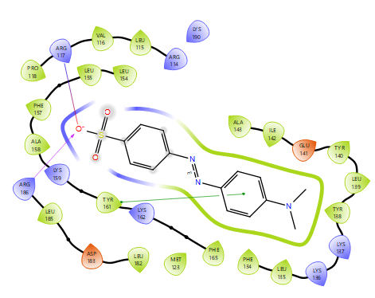
MO1+ 8rcp | 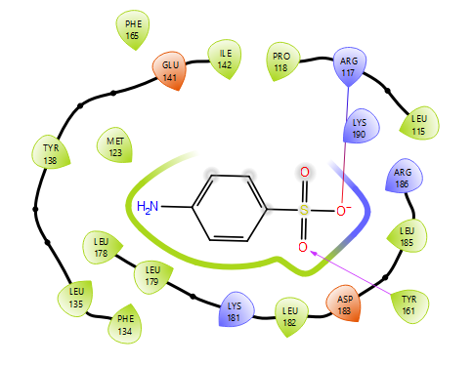
MO2+ 8rcp | 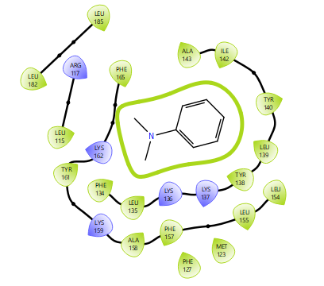
MO3+ 8rcp | 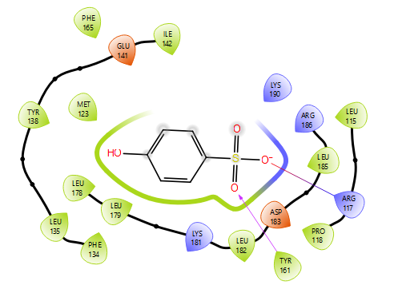
MO4+ 8rcp | 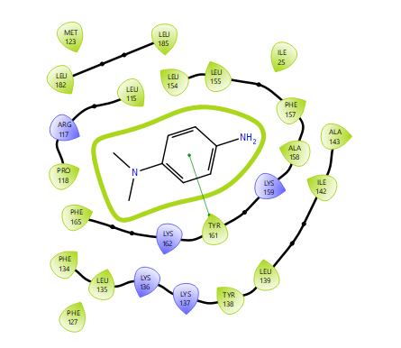
MO5+ 8rcp | 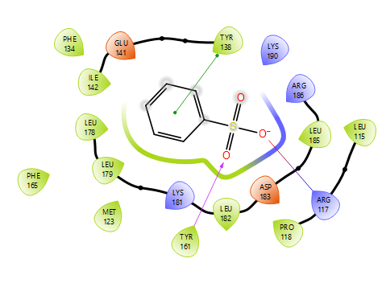
MO6+ 8rcp | 