Extended Data Figures

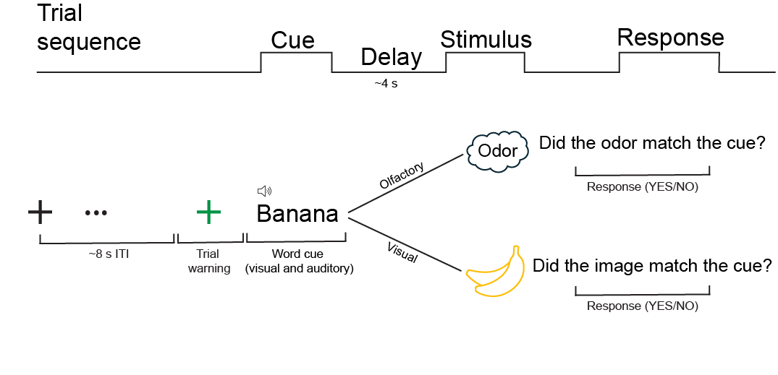
Extended Data Figure 1. Olfactory and visual control task design: For both versions, each trial began with a visual cue consisting of a written and spoken word (e.g. banana), followed by a delay after which an odor was presented in the olfactory version and a picture was presented in the visual version. Participants then indicated whether the stimulus matched the cue. Therefore, an identical cue took on two different meanings: in one case indicating that an odor would arrive soon, and in the other case indicating that a picture would arrive soon. Critically, the cues were otherwise identical, and no odor or picture was presented during the cues.

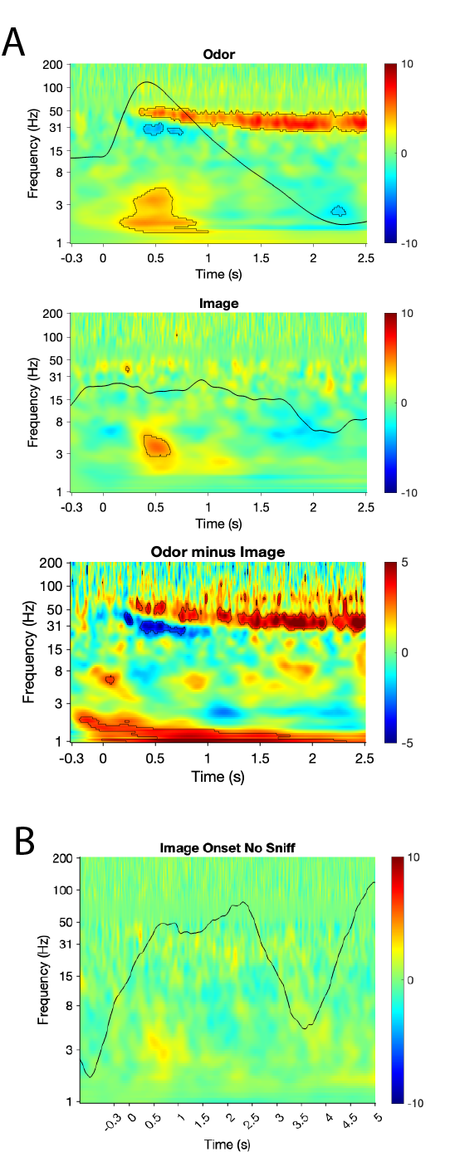
Extended Data Figure 2. A: Time-frequency amplitude spectrograms for odor (top), image (middle), and their difference (bottom). Statistical significance is outlined in black, as described in methods. A significant increase in theta and gamma was evident in response to odors compared to images (p<0.05, n=40 trials, permutation test of amplitude differences, cluster-corrected). B: The significant response to images in the theta range in A was driven by spontaneous alignment of sniffs with stimulus onset (see Perl et al., 2019⁷⁸). Time-frequency amplitude spectrogram of responses to images with trials containing
spontaneous sniffs removed, showing no significant effects (p>.05).

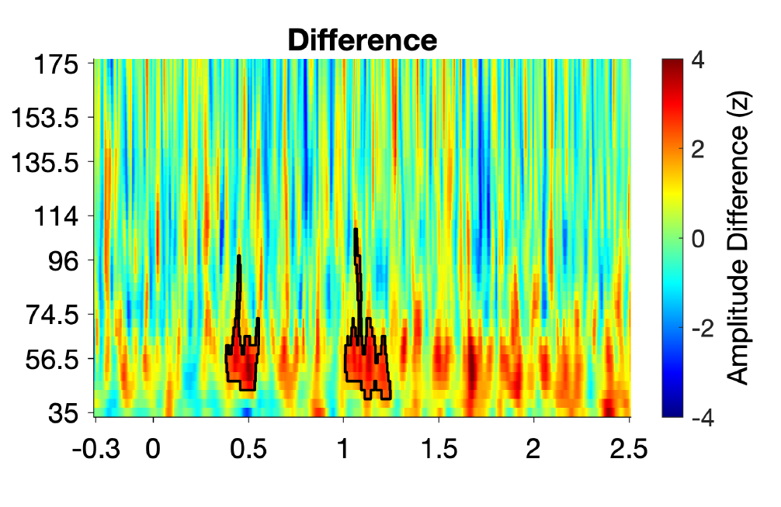

Extended Data Figure 3. Difference in time-frequency amplitude spectrograms computed for odor and air. Black outline indicates statistical significance (P < 0.05, n=122 trials, permutation test, cluster corrected).

