SUPPLEMENTARY INFORMATION

Ecosystem multifunctionality shows unique stability responses to global change drivers
Felipe Rezende^{1,2*}, Daiane Montoia-Comparsi^{1,2}, Paula M. Rosa^{1,2}, Francisco Valente-Neto², Lucas W. Zorzetti^{1,2}, Ian Donohue³, Pablo A. P. Antiqueira⁴, Angélica L. González⁵, Loiani O. Santana^{6,7}, Laura A. Ortega-Corredor^{6,7}, Matheus H. O. Matos^{6,7}, Felipe M. Zanon^{6,7}, Luiz Felipe M. Velho⁷, Luzia C. Rodrigues⁷, Gustavo Q. Romero^{2*}
¹Programa de Pós-Graduação em Ecologia (PPG-ECO), Instituto de Biologia (IB), Universidade Estadual de Campinas (UNICAMP), Campinas, SP, Brazil
²Laboratório de Interações Multitróficas e Biodiversidade (LIMBIO), Departamento de Biologia Animal (DBA), Instituto de Biologia (IB), Universidade Estadual de Campinas (UNICAMP), Campinas, SP, Brazil
³Zoology, School of Natural Sciences, Trinity College Dublin, Dublin, Ireland
⁴School of Life Sciences, University of Essex, Wivenhoe Park, Colchester, UK
⁵Department of Biology and Center for Computational and Integrative Biology, Rutgers University, Camden 08103, USA
⁶Programa de Pós-Graduação Em Ecologia de Ambientes Aquáticos Continentais (PEA), Universidade Estadual de Maringá (UEM), Av. Colombo, 5790, Maringá, Paraná, CEP 87020-900, Brazil
⁷Núcleo de Pesquisas em Limnologia, Ictiologia e Aquicultura (NUPELIA), Universidade Estadual de Maringá (UEM), Av. Colombo, 5790, Maringá, Paraná, CEP 87020-900, Brazil

*Corresponding authors:
Felipe Rezende – felipe.rfo7@gmail.com
Gustavo Q. Romero - gqromero@unicamp.br

CONTENTS
Supplementary Methods
Supplementary Table S1. Schedule of community assembly, treatment application, and sampling of communities and proxies for ecosystem functions.
Supplementary Table S2. Results of generalized linear mixed effect models (GLMM) assessing the effects of experimental global change drivers on distinct representations of overall ecosystem stability (OES).
Supplementary Table S3. Results of generalized linear mixed effect models (GLMM) assessing the effects of experimental global change drivers on multiple functional stability components of effective multifunctionality.
Supplementary Table S4. Results of generalized linear mixed effect models (GLMM) assessing the effects of experimental global change drivers on functional overall stability of single ecosystem functions.
Supplementary Table S5. Results of generalized linear mixed effect models (GLMM) assessing the effects of experimental global change drivers on multiple functional stability components of chlorophyll-α.
Supplementary Table S6. Results of generalized linear mixed effect models (GLMM) assessing the effects of experimental global change drivers on multiple functional stability components of zooplankton biomass.
Supplementary Table S7. Results of generalized linear mixed effect models (GLMM) assessing the effects of experimental global change drivers on multiple functional stability components of diel dissolved oxygen production (diel ΔO₂).
Supplementary Table S8. Results of generalized linear mixed effect models (GLMM) assessing the effects of experimental global change drivers on multiple functional stability components of dissolved inorganic nitrogen (DIN).
Supplementary Table S9. Results of generalized linear mixed effect models (GLMM) assessing the effects of experimental global change drivers on multiple functional stability components of ammonium:nitrate ratio (N-ratio).
Supplementary Table S10. Results of generalized linear mixed effect models (GLMM) assessing the effects of experimental global change drivers on multiple functional stability components of total phosphorus (TP).
Supplementary Figure S1. Effects of different global change drivers on temporal dynamics of multiple functions related to ecosystem productivity
Supplementary Figure S2. Effects of different global change drivers on temporal dynamics of multiple functions related to nutrient cycling.
Supplementary Figure S3. Effects of different global change drivers on functional overall stability related to multiple ecosystem functions.
Supplementary Figure S4. Pairwise correlations among multiple stability metrics for ecosystem multifunctionality under different global change scenarios.
Supplementary Figure S5. Permutation tests for effects of global change drivers on pairwise correlations among multiple stability metrics for ecosystem multifunctionality.
Supplementary Figure S6. Pairwise correlations among multiple stability metrics for different ecosystem functions under different warming scenarios.
Supplementary Figure S7. Permutation tests for effects of warming on pairwise correlations among multiple stability metrics for different ecosystem functions.
Supplementary Figure S8. Pairwise correlations among multiple stability metrics for different ecosystem functions under nutrient enrichment scenarios.
Supplementary Figure S9. Permutation tests for effects of nutrient enrichment on pairwise correlations among multiple stability metrics for different ecosystem functions.
Supplementary Figure S10. Pairwise correlations among multiple stability metrics for different ecosystem functions under litter input scenarios.
Supplementary Figure S11. Permutation tests for effects of litter input reduction on pairwise correlations among multiple stability metrics for different ecosystem functions.
Supplementary Figure S12. Correlation matrix between each ecosystem function and the effective multifunctionality index.

SUPPLEMENTARY METHODS

I – Community assembling
The experiment started on September 12th, 2022, and lasted about 160 days with the final sampling and interruption of the treatments officially carried out on March 3rd, 2023.
- First steps (day -42)
We established sixty experimental mesocosms using 310L polyethylene tanks distributed equidistantly in the experimental field.
Forty-two days prior starting the experiment, each mesocosm was filled with 300L of filtered and dechlorinated water. The experimental mesocosms were filled using a water regulation system connected to the CPQBA’s water distribution network. The regulation system included a network of pipes, two activated-carbon dechlorinating filters (BigBlue 10’’), and a float-valve system to keep water volume constant over the experiment.
Next, we inoculated 300ml of fine sediment from surrounding natural lake (22º47’49’’S 47º07’00’’W) for the initial colonization of the microbiota and structuring of the benthic substrate. Previously to addition in the mesocosms, the sediment material was sieved through an 850 µm mesh to remove leaf material and coarse debris and then exhaustively homogenized in a 50-liter container.

- Planktonic community assembling (days -37 and -30)
Five days after filling the tanks, we inoculated the mesocosms with zooplankton or phytoplankton samples, composed of filtered water from the same surrounding lake. Using 60 µm and 20 µm plankton nets for zooplankton and phytoplankton, respectively, each component was filtered from 36,000L of water, concentrated to 15L, previously homogenized in a 20-liter container and then added in equal amounts (200 mL) to each mesocosm. We also inoculated 200mL of unfiltered water to incorporate organisms smaller than 20μm. Zooplankton inoculation was added 7 days after phytoplankton inoculation to mitigate the effects of predation on phytoplanktonic community establishment.
- Macroinvertebrate community assembling (day -30)
After the first insertions of planktonic organisms, 6g of dried leaves of Inga sp. were added to establish detritivore macroinvertebrates, and mesocosms were left unperturbed for 30 days to ensure effective colonization (by natural dispersion) of other main groups of aquatic macroinvertebrates.
- Fish introduction (day 8)
Eight days after the beginning of the experiment, we introduced 2 males and 3 females of Poecilia sp., a generalist omnivorous fish whose diet incorporates multiple feeding items from both planktonic and benthic strata, to compose the mesocosm food web as a top predator which couples planktonic and benthic compartments of the aquatic food web. Poecilia sp. individuals were collected with a 200μm mesh kick net in a flooded region of the Atibaia River (Paulínia – SP; 22º44’53’’S 47º12’29’’W) and underwent approximately four hours of acclimatization before being introduced into the mesocosms. All activities involving manipulation and experimentation with fishes were previously approved by the Animal Use Ethics Committee of the State University of Campinas (CEUA/UNICAMP – permission number 5983-1/2022).
II- Experimental design
Our experiment was performed in a multifactorial design randomized in five blocks, with twelve interactive combinations of climate change and land use scenarios, involving climate warming (i.e., increasing temperature and thermal variability), nutrient enrichment via fertilizer additions, and reduction of litter allochthonous input as a proxy of loss of riparian vegetation.
- Experimental warming scenarios
The warming treatment simulated future climate warming scenarios for the end of the century according to pessimistic high CO₂ emission scenarios projected for Brazil for the year 2100¹. The warming treatment was composed of three levels: i) ambient, which represented the current ambient temperature scenario (control); ii) constant warming, which comprised instantaneous increases of 4°C above the control temperature; and iii) variable warming, comprising the same average increment of 4°C throughout the experiment duration, but incorporating a variability term in the increment to promote periodic oscillations from +2ºC to +6ºC (i.e. +4°C ± 2°C), representing a future warming scenario under higher thermal variability, temperature ranges and occurrence of heatwave events.
These warming scenarios were implemented with a custom-made automated temperature control system, connected to a power source and a digital controller, which interfaced with 500W heaters and temperature sensors in the mesocosms via an underground cable network in the CPQBA experimental field. The system operated in a triad structure, using temperature readings from control tanks as a reference². It automatically activated heaters in the two adjacent tanks, adjusting their temperatures in real time to match the target differences defined by the constant or variable warming scenarios. In the constant warming treatment, temperatures were maintained at a steady +4 °C above the control. In the variable warming treatment, temperatures increased gradually from +2 °C to +6 °C above the reference in 4-day cycles. Temperature increments rose by 1 °C per cycle until reached +6 °C, then resetting to +2 °C and repeating the cycle, which resulted in ±2 °C fluctuations around a +4 °C average. Temperature regulation was continuous, capturing fine scale changes every 10 minutes and activating the heaters and maintaining precise thermal differentials between control and heated mesocosms. Thus, our system simulated natural diel temperature variation at local scale and real time, increasing the degree of realism. As a backup, we used HOBO temperature loggers to store temperature data recorded every 30 minutes throughout the experimental duration.
- Nutrient enrichment scenarios
The nutrient enrichment factor was implemented at two treatment levels: i) non-enriched level (natural), which reproduced the natural water abiotic conditions (control); and ii) enriched level, which included the addition of nitrogen and phosphorus via urea and monoammonium phosphate (MAP), two common agricultural fertilizers used worldwide. Nutrient additions were applied during the first 40 days of the experiment, in three pulses equally distributed every 20 days to avoid potential leaching by intense rainfall. Each nutrient pulse consisted of adding 1.048g of urea and 217.65mg of MAP, providing the total addition of 1546mg of nitrogen and 176mg of phosphorus at a molar N:P ratio of 19.41. This nutrient enrichment protocol was based on annual patterns of the frequency and amount of leached nitrogen (N) and phosphorus (P) previously observed in empirical studies with conventional agricultural crops (e.g. sugarcane, maize, rice)^{3–5}.
- Litter input scenarios
The litter input treatment manipulated different amounts of litter input based on estimated values of litter lateral input on Atlantic Forest (131g/m² year)⁶. We used leaves from Inga sp. (Fabaceae), collected from trees near nearby lakes, as source of leaf litter. We collected branches with leaves 40 days before introduction on mesocosms to allow natural senescence. After 30 days, the collected leaves were soaked in water for 5 days to remove excess nitrogen, then dried at 60°C for 48 hours and weighed. The treatment consisted of two levels: i) natural input, which received 12g dry leaf litter biomass every 40 days, simulating litter input in natural conditions; and ii) reduced input, which received 2.4g dry leaf litter biomass every 40 days, simulating 80% reduction of allochthonous input due to riparian vegetation loss.
III – Data sampling
At each mesocosm, we periodically sampled abiotic and biotic parameters at intervals of 20 days, totaling nine sampling intervals, to track the temporal dynamics of planktonic communities and multiple ecosystem functions (Supplementary Table S1). For certain major taxonomic groups (i.e., macroinvertebrates and prokaryotic microbiota), which were sampled at 40-day intervals, the low temporal resolution precluded reliable comparisons with other time series. As a result, they were excluded from further analysis in this work.
- Abiotic parameters
Water physicochemical parameters [e.g. pH, dissolved O₂ concentration, turbidity, total dissolved solids (TDS), conductivity and oxidation-reduction potential (ORP)] were measured at each sampling event, during both day and night, using Horiba U52 multiparameter probes. Per mesocosm, we collected 500 mL and 250 mL of water samples in HDPE containers to further quantify dissolved N and P forms (e.g., ammonium, nitrate, phosphate) and total phosphorus (TP) concentrations, respectively. Total nutrient samples were immediately frozen (-20ºC). Dissolved nutrient samples were filtered using vacuum pumps and 0.8 µm glass microfiber filters (HNM GF52/C), then frozen. Filters were stored in labeled aluminum foil envelopes and frozen for subsequent chlorophyll analysis.
Ammonium concentrations were determined by spectrophotometry using the iodophenol blue method of reaction of ammonium with phenol and hypochlorite in an alkaline medium, catalyzed by sodium nitroprusside⁷. Nitrate concentrations were quantified by spectrophotometry using a cadmium reduction method to nitrite through a flow-injection system⁸. Phosphate concentrations were measured via spectrophotometer through the ascorbic acid - molybdenum blue method⁹. Total phosphorus was determined by the same previous method after converting all phosphorus forms to phosphate via acid-persulfate digestion⁹. Chlorophyll-a concentrations were determined by spectrophotometry after extraction of retained material on microfiber filters with acetone⁹.
- Phytoplankton
For surveying phytoplanktonic assemblages, we directly sampled on each mesocosm 50 mL water column samples and immediately fixed them in situ with 5% acid Lugol’s solution. After sampling, phytoplankton abundances were estimated in an inverted microscope (Carl Zeiss Axiovert 135) following Utermöhl¹⁰ after the sedimentation method following Lund et al.¹¹, and identified to the lowest possible taxonomic level (species or morphospecies).
- Zooplankton
Zooplankton communities were collected on each mesocosm from 2L water samples previously filtered through a 10 µm mesh. The retained material was concentrated to 50 mL and then fixed in situ with a solution of alkaline Lugol, formalin, and sodium thiosulfate¹². Next, zooplankton morphospecies were counted and identified to the lowest possible taxonomic level (species or morphospecies). Zooplankton abundances were estimated differently according to its components. Ciliates were counted in 10 mL Utermöhl chambers using an inverted microscope (Olympus CK40) at 400× magnification. Testate amoebae, rotifers, copepods and cladocerans were counted using Sedgwick-Rafter chambers in a compound microscope (Olympus CX31) at 100× and 200× magnification.
Zooplankton biomass was estimated using allometric relationships based on species-specific biovolume referring to each mesocosm, calculated from the mean body length, width, and thickness of up to five randomly selected individuals. Biovolume was converted into dry carbon biomass assuming a conversion factor of 1μm³ ~ 0.19 pgC¹³.
IV- Ecosystem functioning
- Assessing proxies for ecosystem functioning
We defined six proxies for multiple ecosystem functions estimated after the selection and adaptation of abiotic parameters. We estimated primary and secondary productivity from chlorophyll-α concentrations and zooplankton biomass, respectively. We evaluated nitrogen cycling from two different proxies: a) dissolved inorganic nitrogen, estimated by summing concentrations of dissolved ionic forms of nitrogen (i.e. ammonium and nitrate) and representing the nitrogen pool directly available to basal organisms; and b) the ammonium/nitrate ratio (previously mentioned as N-ratio), which informs about the distribution of different inorganic nitrogen forms in the water column. N-ratio is an important driver of phytoplanktonic species composition and water quality, where low values are commonly associated with the greater presence of toxic cyanobacteria species^{14,15}. Since phosphate was unsuitable to work due to strong bias resulting from zero-inflated measurement (N=442 data points), we used only total phosphorus (TP) to estimate phosphorus cycling. TP values include inorganic phosphorus dissolved in the water and P forms assimilated on organic compounds or organisms. We used the diel dynamics of dissolved oxygen (DO) to estimate the net oxygen balance in the ecosystem, assuming DO at morning is mostly determined by the aerobic respiration of organisms overnight and DO at night is mainly determined by accumulated oxygen production via photosynthesis over the day¹⁶. Hence, we measured the diel oxygen balance (ΔO₂) by calculating the difference in dissolved O₂ concentrations between dusk and dawn¹⁶.
- Missing data
Prior to quantifying each function, we imputed a total of thirty-two missing values - DO_{day} (1|540), DO_{night} (1|540), TP (6|540), ammonium (9|540), nitrate (12|540), and zooplankton biomass (3|540) - evenly distributed across experimental treatments and time intervals using mean substitution approach within each treatment and time sampling combination.
- Quantifying ecosystem multifunctionality
To investigate how different global change scenarios influence dynamics and stability of ecosystem multifunctionality, we used a new approach of effective multifunctionality that relates the average level of performance of multiple functions of a system (from the traditional averaging approach¹⁷) with the degree of performance evenness of these functions¹⁸. Prior to quantifying multifunctionality, we standardized the six measured functions scaling them by the maximum transformation with range 0-1, where 0 and 1 means the minimum and maximum values of performance of a function, respectively¹⁷. Then, we calculated effective multifunctionality as the following product:
${}_{}^{q}{M_{ef}= A\frac{{}_{}^{q}N}{k}}$ (1)
where k is the number of functions measured, A is the arithmetic mean of the standardized values of the six measured functions and ${}_{}^{q}N$ is the effective number of functions of order q, calculated as:
${}_{}^{q}N= {\left(\sum_{i=1}^{k}{{\left(\frac{F_{i}}{\sum{F_{i}}}\right)}^{q}}\right)}^{\frac{1}{\left(1-q\right)}}$ (2)
where $F_{i}$ is the standardized value of a function i. The effective number of functions is analogous to the effective number of species of order q used to estimate species diversity through Hill numbers¹⁸. It informs about the number of functions we would observe in an equivalent system where all functions perform at the same performance level, such that larger q values increase the weight of high-performing functions¹⁸. When divided by k, the resulting term acts as a penalty term for A in systems where the performance evenness of functions is low. In this study, we use order q = 1, when ${}_{}^{q}N$ is analogous to Shannon diversity index and ${}_{}^{q}{M_{ef}}$ can highlight unequal performance levels of ecosystem functioning without completely disregarding the importance of low-performance functions for ecosystem multifunctionality¹⁸.
V – Temporal dynamics and ecological stability
- Effect size dynamics
To assess long-term response dynamics of ecosystem functioning to our treatments, we standardized their temporal trends by quantifying the effect size of each treatment combination on each mesocosm at each time interval. The effect size was calculated via log-response ratio (LRR) of functional variables under disturbed conditions relative to a baseline composed by the mean value of these variables in undisturbed control conditions (i.e., mesocosms under ambient temperature, without nutrient enrichment, and with natural litter input)^{19,20}. We also calculated LRR for each control replicate for all functional components to estimate the variability within the undisturbed control treatment.
To derive the functional LRR trends for ecosystem functions and multifunctionality, we used the standardized values of each function and the effective multifunctionality index of disturbed mesocosms (F_{trat}) and their respective baseline (i.e. mean of the five control replicates; F_{baseline}) for each sampling time interval.
- Stability components
We quantified five components of ecological stability: temporal invariability; resistance to pulse disturbance; final recovery; resilience; and overall ecosystem vulnerability (OEV). Stability metrics were chosen according to their underlying ecological response to pulse and/or press disturbances^{19,21–23} and calculated from temporal trends of raw and LRR-standardized values for each functional component (see Table 1 for details). To mitigate potential confounding effects of transient dynamics caused by adding generalist fish predators (Poecillidae) on day 8, estimation for all long-term metrics considered only the interval between days 20 to 160 of the experimental time.
Temporal invariability informs about the magnitude of fluctuations of functional components over time, such that higher invariability implies greater stability²⁴. It was measured as the inverse of the coefficient of variation (CV⁻¹; that is, the mean divided by the standard deviation) of standardized function values over time.
Resistance is the ability of an ecosystem to withstand disturbances and evaluates how much a disturbed ecosystem maintains functions and attributes at a similar level to an undisturbed state²⁴. Since resistance is generally interpreted as a response to pulse disturbances²¹, our experimental design limited us to estimating resistance only for nutrient pulses, comparing the differences in resistance between the other experimental treatments (i.e. warming and litter input). Moreover, given that low resistance is associated with overperformance and underperformance of a variable related to its control reference²⁴, we focused on the effect magnitude of nutrients on the variables rather than the effect direction (i.e. positive or negative). Hence, resistance to pulse was estimated as the opposite of the maximum value of the absolute LRR (i.e. - |LRR_{max}|) observed over time intervals after the nutrient pulses (i.e. from the 20-day to 60-day sampling intervals).
Similarly, final recovery describes the degree of functional restoration observed during the last experimental time sampling¹⁹. Like resistance, we can assume low recovery from over- or underperformance of a function, thus it is also measured as the opposite of the absolute LRR but observed in the last time interval (i.e. - |LRR₁₆₀|).
Resilience refers to the return rate of an ecosystem functions toward their pre-disturbance performance levels after the disturbance²⁵. It is estimated from the slope of the recovery trajectory, determined by a linear regression of the LRR in function of time^{19,21}. Higher values indicate faster return of a function toward baseline values, while lower or negative values indicate negligible recovery to continued deviation from baseline after disturbance. In cases where disturbances promote overperformance, resilience values are multiplied by -1 to keep the same interpretation.
Overall ecosystem vulnerability (OEV), an integrative stability metric that captures all long-term deviations of a given ecosystem function observed throughout its time series²². Thus, OEV is a metric that evaluates how disturbances propagate in the functional dynamics and can be analogously compared to resistance under different or multiple disturbance types. OEV is measured as the area under the curve (AUC) over the absolute LRR time series, where high OEV values indicate low stability.
- Overall ecosystem stability
Overall ecosystem stability (OES) is an analogous concept to ecosystem multifunctionality, representing an aggregate measure that integrates multiple stability components simultaneously²⁶. In summary, overall stability (OS) was formulated as the sum of all stability metrics attributed to a given ecosystem function, while OES pools the different OS indexes associated with all measured functions. In addition to this approach, we chose to investigate the OES concept in another way, estimating it also as the sum of the stability components measured in our study associated to the ecosystem multifunctionality index (or multifunctional overall stability – MOS). Assuming different aspects of OES is important to assess similarities or discrepancies between the MOS and OES estimated from aggregated OSs of different ecosystem functions and MOS.
In our study, overall stability of each (multi)functional aspect was calculated as OS(x) = Inv(x) + Rec(x) + Rsl(x) + Ivl(x), where x is a given value of ecosystem function, Inv(x) is its temporal invariability, Rec is its recovery degree, Rsl is its resilience (return rate) and Ivl(x) is its overall ecosystem invulnerability (the opposite of OEV). We opted by using invulnerability (i.e. OEV values multiplied by -1) instead of OEV to standardize the interpretation of this component with the other stability metrics (i.e. higher values ​​imply higher stability and vice-versa). Meanwhile, given that resistance was restricted only to enriched systems, we could not insert it in the OS calculation.
Following Pennekamp et al.²⁶, before calculating OS, each stability metric was previously standardized by z-scoring (i.e. subtracting the mean and then dividing by the standard deviation) and then converted into the same currency by using a generalized logistic function:
$y(x)=L+ \frac{U-L}{{\left(C+Qe^{-Bx}\right)}^{1/v}}$ (3)
where x is the z-score of stability component, L and U represent the lower and upper asymptotes, respectively, B is a gradient, v is a term which affects the symmetry of the sigmoidal curve, Q determines the position of y(0), and C is a constant that changes the shape of the curve. In this case, the chosen parameters were L=0, U=1, B=5, v=1, C=1 and Q=1, such that converted stability metrics ranged from 0 to 1 and y(0) = 0.5. Our method did not unevenly weigh each stability component, assuming each stability component has equal importance for OS²⁶.
VI – Dimensionality of stability
We estimated the effective dimensionality of stability and their changes under disturbances by assembling n-dimensional ellipsoids that synthesize the relationships between different stability metrics and how they jointly respond to disturbances^{27–29}. We assembled the ellipsoids from the correlation matrices between stability metrics for each functional component. As we did for estimating OES, all stability metrics were previously standardized by z-scoring to reduce biases from different scales. Likewise, resistance was restricted only to enriched systems and could not be used to calculate covariance matrices, so we assembled ellipsoids with four rather than five dimensions.
Attributes of the ellipsoid (e.g., shape and volume) inform about different aspects of dimensionality of stability as degree of interdependence of different stability metrics and the total variability present in the multivariate relationships between these metrics²⁸. To determine the shape of ellipsoid, we quantified the length of each semi-axis as λ_{i}^{0.5}, where λ_{i} is the ith eigenvalue of the pairwise covariance matrix for each level of a given treatment. Each set of semi-axis lengths was then standardized by dividing by the maximum semi-axis length within the same set²⁸. Ellipsoidal volume, for each level of a given treatment, was calculated as:
$V = \frac{π^{n/2}}{Γ\left(\frac{n}{2}+1\right)} \prod_{i=1}^{n}{\left(λ_{i}^{0.5}\right)}$ (4)
where n is the dimensionality of the covariance matrix. As we did for the length of the semi-axes, for each level of a given treatment, we standardized the volume by dividing it by the largest theoretical volume (i.e., when all semi-axes have observed maximum length within a set), so that the maximum relative volume is equal to 1^{27–29}.
VII – Statistical analysis
- Testing Hypothesis 1 – Interactive effects of global change drivers on multiple stability components and the overall ecosystem stability (OES)
We fitted generalized linear mixed-effects models (GLMMs) to test direct, additive and interactive effects of treatments on the OES and its underlying stability components, both quantified for each (multi)functional component. We considered the experimental drivers and their interactive combinations as fixed effects in the model and the block effect as a random effect. Initially, we fit models assuming a Gaussian distribution for the response variable. However, in specific cases where gaussian distribution was not suitable, alternative distribution families (e.g., Gamma, Beta, etc) were adopted as appropriate. In cases where model assumptions—such as homoscedasticity and normality for Gaussian models, or residual uniformity for non-Gaussian families—were violated, we employed alternative link functions (e.g., log) or applied direct transformations to the response variables (see Supplementary Tables S2-S10 for details). We verified multicollinearity in the variables through variance inflation factors (VIFs), considering VIF >3 as evidence of collinearity³⁰. To simplify the model structure, we used the Akaike Information Criterion corrected for small samples (AICc), removing non-significant variables of the complete model via backward selection until simplifying to an additive model. We considered ΔAICc > 2 units to distinguish between different models, opting for those with the lowest AICc value. In cases of model singularity, we independently tested the significance of the block effect via one-way ANOVA. Subsequently, new models were fitted without random effects, retaining or excluding block as a fixed effect depending on its explanatory contribution. Model selection was performed using AICc, following the same criteria described above. Significance values of retained fixed effects in the final models were obtained by running a type II (for additive terms) or III (for interactive terms) ANOVA on each of the models, following Wald chi-square (for GLMM) statistic tests with a significance level of p-value ≤ 0.05.
Treatment effect sizes on OES and single stability components were quantified as the LRR between stability values for disturbed mesocosms and the mean value of control mesocosms. For metrics already expressed on a log-scale (e.g., resistance, recovery), effect sizes were calculated as direct differences between values. For OEV, where increasing LRR indicate decreasing stability, the resulting LRR was multiplied by –1 to simplify comparison with the other metrics.
- Testing Hypothesis 2 – Individual effects of global change drivers on pairwise correlations among stability components and on the dimensionality of stability
We calculated non-parametric Spearman’s rank correlations to detect pairwise relationships between stability metrics, considering distinct contexts according to our hypothesis for the magnitude and nature of relationships between stability metrics associated with the same functional component. We also aimed to assess whether our experimental drivers influenced bivariate (i.e. correlations) and multivariate relationships (i.e. ellipsoids) among stability metrics (that is, their dimensionality). For individual effects of treatments, we calculated pairwise correlations and constructed covariance matrices for ellipsoids using 20 replicates per warming scenario and 30 replicates per each nutrient enrichment or litter input loss scenarios. However, the limited sample size within each multifactorial combination, particularly for two-way (N ≤ 15) and three-way (N = 5) interactions, precluded the calculation of robust correlations and covariance matrices at interactive levels of drivers. Consequently, our analytical framework was restricted to evaluating only individual effects of each experimental driver separately on dimensionality of stability.
We run permutation tests to assess these differences on pairwise relationships among stability metrics and the multidimensional structure of ellipsoids in response to experimental drivers (testing H2)²⁸. To generate null distributions for hypothesis testing, we performed 9999 random permutations of each treatment combination among observations without replacement. For each permutation, we recalculate pairwise correlations and ellipsoid metrics for each permuted treatment group and computed the pairwise differences between treatment levels on correlations and relative values of volume and semi-axis length. Finally, observed differences in the correlations and ellipsoid metrics were compared to the respective null distributions derived from the permuted datasets. Significance was assessed using two-tailed tests for the differences, where p-values were calculated as the proportion of permuted values that exceeded the observed differences, assuming significance level at p-value ≤ 0.05.
REFERENCES
1. Lee, H. et al. Climate Change 2023: Synthesis Report. Contribution of Working Groups I, II and III to the Sixth Assessment Report of the Intergovernmental Panel on Climate Change. (2023).
2. Antiqueira, P. A. P., Petchey, O. L. & Romero, G. Q. Warming and top predator loss drive ecosystem multifunctionality. Ecol. Lett. 21, 72–82 (2018).
3. Schiesari, L. et al. Community reorganization stabilizes freshwater ecosystems in intensively managed agricultural fields. J. Appl. Ecol. 60, 1327–1339 (2023).
4. Ghiberto, P. J., Libardi, P. L., Brito, A. S. & Trivelin, P. C. O. Leaching of nutrients from a sugarcane crop growing on an Ultisol in Brazil. Agric. Water Manag. 96, 1443–1448 (2009).
5. Wang, R., Min, J., Kronzucker, H. J., Li, Y. & Shi, W. N and P runoff losses in China’s vegetable production systems: Loss characteristics, impact, and management practices. Sci. Total Environ. 663, 971–979 (2019).
6. Tonin, A. M. et al. Plant litter dynamics in the forest-stream interface: precipitation is a major control across tropical biomes. Sci. Rep. 7, 10799 (2017).
7. Machereth, F., Heron, J. & Talling, J. Water analysis: Some Methods for limnologists-Freshwater Biological Association. Sci Pub (1978).
8. Giné, M. F., F, H. B., Zagatto, E. A. G. & Reis, B. F. Simultaneous determination of nitrate and nitrite by flow injection analysis. Anal. Chim. Acta 114, 191–197 (1980).
9. Galterman, H., Clymo, R. & OHSTAD, M. Methods for physical and chemical analysis of fresh water. IBP Handb. 8, 213 (1978).
10. Utermohl, H. Zur Vervollkommung der quantitativen phytoplankton-methodik. Mitt Int Ver Limnol 9, 38 (1958).
11. Lund, J. W. G., Kipling, C. & Le Cren, E. D. The inverted microscope method of estimating algal numbers and the statistical basis of estimations by counting. Hydrobiologia 11, 143–170 (1958).
12. Sherr, E. B. & Sherr, B. F. Preservation and storage of samples for enumeration of heterotrophic protists. in Handbook of methods in aquatic microbial ecology 207–212 (CRC Press, 2018).
13. Putt, M. & Stoecker, D. K. An experimentally determined carbon : volume ratio for marine “oligotrichous” ciliates from estuarine and coastal waters. Limnol. Oceanogr. 34, 1097–1103 (1989).
14. Kharbush, J. J., Robinson, R. S. & Carter, S. J. Patterns in sources and forms of nitrogen in a large eutrophic lake during a cyanobacterial harmful algal bloom. Limnol. Oceanogr. 68, 803–815 (2023).
15. Yang, N. et al. Differential effects of nitrate and ammonium on the growth of algae and microcystin production by nitrogen-fixing Nostoc sp. and non-nitrogen-fixing Microcystis aeruginosa. Water Sci. Technol. 88, 136–150 (2023).
16. Shurin, J. B., Clasen, J. L., Greig, H. S., Kratina, P. & Thompson, P. L. Warming shifts top-down and bottom-up control of pond food web structure and function. Philos. Trans. R. Soc. B Biol. Sci. 367, 3008–3017 (2012).
17. Byrnes, J. E. K. et al. Investigating the relationship between biodiversity and ecosystem multifunctionality: challenges and solutions. Methods Ecol. Evol. 5, 111–124 (2014).
18. Byrnes, J. E. K., Roger, F. & Bagchi, R. Understandable multifunctionality measures using Hill numbers. Oikos 2023, e09402 (2023).
19. Hillebrand, H. et al. Decomposing multiple dimensions of stability in global change experiments. Ecol. Lett. 21, 21–30 (2018).
20. White, L., O’Connor, N. E., Yang, Q., Emmerson, M. C. & Donohue, I. Individual species provide multifaceted contributions to the stability of ecosystems. Nat. Ecol. Evol. 4, 1594–1601 (2020).
21. Donohue, I. et al. Navigating the complexity of ecological stability. Ecol. Lett. 19, 1172–1185 (2016).
22. Urrutia‐Cordero, P. et al. Integrating multiple dimensions of ecological stability into a vulnerability framework. J. Ecol. 110, 374–386 (2022).
23. White, L., O’Connor, N. E., Gilson, A. & Donohue, I. Species contributions to ecosystem stability change with disturbance type. Oikos 2024, e10077 (2024).
24. Pimm, S. L. The complexity and stability of ecosystems. Nature 307, 321–326 (1984).
25. Holling, C. Engineering Resilience Versus Ecological Resilience. (Engineering within ecological constraints/National Academy Press, 1996).
26. Pennekamp, F. et al. Biodiversity increases and decreases ecosystem stability. Nature 563, 109–112 (2018).
27. Polazzo, F. & Rico, A. Effects of multiple stressors on the dimensionality of ecological stability. Ecol. Lett. 24, 1594–1606 (2021).
28. Donohue, I. et al. On the dimensionality of ecological stability. Ecol. Lett. 16, 421–429 (2013).
29. Radchuk, V. et al. The dimensionality of stability depends on disturbance type. Ecol. Lett. 22, 674–684 (2019).
30. Zuur, A. F., Ieno, E. N. & Elphick, C. S. A protocol for data exploration to avoid common statistical problems. Methods Ecol. Evol. 1, 3–14 (2010).

Supplementary Table S1. Schedule of community assembly, treatment application, and sampling of communities and proxies for ecosystem functions. Days are numbered relatively to treatment application (day 0). The symbol o indicates application of a given treatment, # indicates the inoculation of a given community, and x indicates sampling of planktonic communities and ecosystem functions. Uninterrupted application of a treatment and community natural colonization are both represented by the symbols ~o~ and ~#~, respectively. Parameters colored in red were not included in the analysis of this study. W: warming treatment; N: nutrient enrichment (urea and monoammonium phosphate); L: leaf litter input; Phyto: phytoplankton; Zoo: zooplankton; Macro: aquatic macroinvertebrates; Micro: microbiota (bacteria, cyanobacteria, archaea and unicellular eukaryotes); fish: Poecilia sp. individuals; [Chl]: chlorophyll-α concentration; [O₂]: dissolved oxygen concentrations at morning and night; [NH₄⁺]: ammonium concentration; [NO₃⁻]: nitrate concentration; [PO₄³⁻]: phosphate concentration; [TP]: total dissolved phosphorus; LB: leaf litter biomass.
Days | -37 | -30 | -3 | 0 | 8 | 20 | 40 | 60 | 80 | 100 | 120 | 140 | 160
Experimental treatments
W |  |  |  | ~o~ | ~o~ | ~o~ | ~o~ | ~o~ | ~o~ | ~o~ | ~o~ | ~o~ | ~o~
N |  |  |  | o |  | o | o
L |  | o |  | o |  |  | o |  | o |  | o
Communities
Phyto | # |  |  | x |  | x | x | x | x | x | x | x | x
Zoo |  | # |  | x |  | x | x | x | x | x | x | x | x
Macro | ~#~ | ~#~ | ~#~ | x |  |  | x |  | x |  | x |  | x
Micro | # |  |  | x |  |  | x |  | x |  | x |  | x
Fish |  |  |  |  | # |  |  |  |  |  |  |  | x
Water abiotic/biotic parameters
[Chl] |  |  |  | x |  | x | x | x | x | x | x | x | x
[O₂] |  |  |  | x |  | x | x | x | x | x | x | x | x
[NH₄⁺] |  |  |  | x |  | x | x | x | x | x | x | x | x
[NO₃⁻] |  |  |  | x |  | x | x | x | x | x | x | x | x
[PO₄³⁻] |  |  |  | x |  | x | x | x | x | x | x | x | x
[TP] |  |  |  | x |  | x | x | x | x | x | x | x | x
LB |  |  |  |  |  |  |  |  |  |  |  |  | x
Supplementary Table S2. Results of generalized linear mixed effect models (GLMM) assessing the effects of experimental global change drivers on distinct representations of overall ecosystem stability (OES). Each model included one type of representation of OES as the response variable, either as multifunctional overall stability (MOS) or as the average of the overall stabilities of multiple ecosystem functions (aggregated OS). We used interactive combinations of warming, nutrient enrichment and litter input as our fixed-effect predictors, while block effect was used as random effect. For each model, the table reports the fixed and random effect structures, error distribution family, and dispersion components (random effect and residual) for both the full model (including all interaction terms) and the final model determined via backward selection using the corrected Akaike Information Criterion (AICc). Absolute AICc values for each model and their relative differences to the full model (ΔAICc) are reported in the same column. In cases of model singularity, results from a one-way ANOVA were used to test the block effect (as a fixed predictor) on residuals from the fixed-effects-only model, guiding whether block was excluded as random effect or retained as fixed effect. The table also presents Wald χ² statistics and associated p-values from Type II (for additive models) and Type III (for interactive models) ANOVA, indicating the significance of each fixed effect. Significant effects (p < 0.05) are highlighted in bold. Predictor codes: W = warming; N = nutrient enrichment; L = litter input reduction; W × N = warming × nutrient; W × L = warming × litter; N × L = nutrient × litter; W × N × L = warming × nutrient × litter.
Model | Response | Predictors | Family (link) | Random effect (variance) | Dispersion estimate (σ²) | AICc (ΔAICc) | χ² | P
MOS.full | MOS | W x N x L | Gaussian (identity) | 1|block (0.035) | 0.450 | 162.968 (0)
MOS.final | MOS | W x N+ L | Gaussian (identity) | 1|block (0.033) | 0.478 | 150.594 (12.37)
 |  | W |  |  |  |  | 0.275 | 0.871
 |  | N |  |  |  |  | 9.156 | 0.002
 |  | L |  |  |  |  | 1.248 | 0.264
 |  | WxN |  |  |  |  | 12.808 | 0.002
avOS.full | Aggregated OS | W x N x L | Gaussian (identity) | 1|block (1.605e⁻⁹) | 3.043 | 274.373 (0)
aggOS.final | Aggregated OS | W x N + L | Gaussian (identity) |  | 3.290 | 260.564 (13.81)
 |  | W |  |  |  |  | 3.100 | 0.212
 |  | N |  |  |  |  | 1.435 | 0.231
 |  | L |  |  |  |  | 1.009 | 0.315
 |  | WxN |  |  |  |  | 11.985 | 0.002
 |  |  |  | Resid (aggOS.final) ~ block; ANOVA; F_{4,55} = 0.049; p = 0.995

Supplementary Table S3. Results of generalized linear mixed effect models (GLMM) assessing the effects of experimental global change drivers on multiple functional stability components of effective multifunctionality. Each model included one stability component (temporal invariability, resistance, recovery, resilience, or OEV) as the response variable. We used interactive combinations of warming, nutrient enrichment and litter input as our fixed-effect predictors, while block effect was used as random effect. For each model, the table reports the fixed and random effect structures, error distribution family, and dispersion components (random effect and residual) for both the full model (including all interaction terms) and the final model determined via backward selection using the corrected Akaike Information Criterion (AICc). Absolute AICc values for each model and their relative differences to the full model (ΔAICc) are reported in the same column. In cases of model singularity, results from a one-way ANOVA were used to test the block effect (as a fixed predictor) on residuals from the fixed-effects-only model, guiding whether block was excluded as random effect or retained as fixed effect. The table also presents Wald χ² statistics and associated p-values from Type II (for additive models) and Type III (for interactive models) ANOVA, indicating the significance of each fixed effect. Significant effects (p < 0.05) are highlighted in bold. Predictor codes: W = warming; N = nutrient enrichment; L = litter input reduction; W × N = warming × nutrient; W × L = warming × litter; N × L = nutrient × litter; W × N × L = warming × nutrient × litter.
Model | Response | Predictors | Family (link) | Random effect (variance) | Dispersion estimate (σ²) | AICc (ΔAICc) | χ² | p
Inv.full | Temporal invariability | W x N x L | Gaussian (identity) | 1|block (5.544e⁻¹¹) | 0.160 | 97.590 (0)
Inv.final | Temporal invariability | W+N+L | Gaussian (identity) |  | 0.175 | 79.313 (18.28)
 |  | W |  |  |  |  | 3.709 | 0.156
 |  | N |  |  |  |  | 19.957 | <0.001
 |  | L |  |  |  |  | 0.236 | 0.627
 |  |  |  | resid (Inv.final) ~ block; ANOVA; F_{4,55} = 0.704; p = 0.593
Res.full | Resistance to pulse | W x L | Gaussian (identity) | 1|block (0.001) | 0.027 | 1.334 (0)
Res.final | Resistance to pulse | W + L | Gaussian (identity) | 1|block (6.0e⁻⁴) | 0.030 | -3.286 (4.62)
 |  | W |  |  |  |  | 20.682 | <0.001
 |  | L |  |  |  |  | 0.023 | 0.880
Rec.full | Recovery degree + 1 | W x N x L | Beta (logit) | 1|block (1.792e⁻¹⁰) | 4.62 | -25.216 (0)
Rec.final | Recovery degree +1 | W+N+L | Beta (logit) |  | 4.17 | -43.061 (17.84)
 |  | W |  |  |  |  | 3.245 | 0.197
 |  | N |  |  |  |  | 0.096 | 0.756
 |  | L |  |  |  |  | 2.707 | 0.100
 |  |  |  | resid (Rec.final) ~ block; ANOVA; F_{4,55} = 0.650; p = 0.629
Rsl.full | Resilience | W x N x L | Gaussian (identity) | 1|block (1.009e⁻¹⁴) | 1.052e⁻⁵ | -480.127 (0)
Rsl.final | Resilience | W x N + L | Gaussian (identity) | - 1|block | 1.120e⁻⁵ | -495.101 (14.97)
 |  | W |  |  |  |  | 4.439 | 0.109
 |  | N |  |  |  |  | 5.123 | 0.024
 |  | L |  |  |  |  | 0.136 | 0.712
 |  | W x N |  |  |  |  | 12.553 | 0.002
 |  |  |  | resid (Rsl.final) ~ block; ANOVA; F_{4,55} = 0.065; p = 0.992
Vul.full | OEV | W x N x L | Gaussian (identity) | 1|block (4.13) | 140.20 | 505.705 (0)
Vul.final | OEV | W x N + L | Gaussian (identity) | 1|block (3.377) | 149.239 | 493.406 (12.30)
 |  | W |  |  |  |  | 0.700 | 0.705
 |  | N |  |  |  |  | 1.409 | 0.235
 |  | L |  |  |  |  | 2.935 | 0.087
 |  | W x N |  |  |  |  | 69.764 | <0.001

Supplementary Table S4. Results of generalized linear mixed effect models (GLMM) assessing the effects of experimental global change drivers on functional overall stability of single ecosystem functions. Each model included overall stability values for each ecosystem function represented in this study. We used interactive combinations of warming, nutrient enrichment and litter input as our fixed-effect predictors, while block effect was used as random effect. For each model, the table reports the fixed and random effect structures, error distribution family, and dispersion components (random effect and residual) for both the full model (including all interaction terms) and the final model determined via backward selection using the corrected Akaike Information Criterion (AICc). Absolute AICc values for each model and their relative differences to the full model (ΔAICc) are reported in the same column. In cases of model singularity, results from a one-way ANOVA were used to test the block effect (as a fixed predictor) on residuals from the fixed-effects-only model, guiding whether block was excluded as random effect or retained as fixed effect. The table also presents Wald χ² statistics and associated p-values from Type II (for additive models) and Type III (for interactive models) ANOVA, indicating the significance of each fixed effect. Significant effects (p < 0.05) are highlighted in bold. Predictor codes: W = warming; N = nutrient enrichment; L = litter input reduction; W × N = warming × nutrient; W × L = warming × litter; N × L = nutrient × litter; W × N × L = warming × nutrient × litter.
Model | Response | Predictors | Family (link) | Random effect (variance) | Dispersion estimate (σ²) | AICc (ΔAICc) | χ² | P
chlOS.full | OS (chlorophyll) | W x N x L | Gaussian (identity) | 1|block (3.003e⁻¹⁰) | 0.608 | 177.756 (0)
chlOS.final | OS (chlorophyll) | W + N+ L | Gaussian (identity) |  | 0.737 | 165.570 (12.19)
 |  | W |  |  |  |  | 1.356 | 0.507
 |  | N |  |  |  |  | 0.012 | 0.914
 |  | L |  |  |  |  | 2.257 | 0.133
 |  |  |  | Resid (chlOS.final) ~ block, ANOVA; F_{4,55} = 0.547; p = 0.702
zbOS.full | OS (zooplankton biomass) | W x N x L | Gaussian (identity) | 1|block (0.009) | 0.223 | 119.709 (0)
zbOS.final | OS (zooplankton biomass) | W + N + L | Gaussian (identity) | 1|block (0.007) | 0.255 | 105.849 (13.86)
 |  | W |  |  |  |  | 3.570 | 0.168
 |  | N |  |  |  |  | 0.490 | 0.484
 |  | L |  |  |  |  | 1.124 | 0.289
o2OS.full | OS (diel ΔO₂) | W x N x L | Gaussian (identity) | 1|block (8.815e⁻¹⁰) | 0.969 | 205.727 (0)
o2OS.final | OS (diel ΔO₂) | W + N + L | Gaussian (identity) |  | 1.040 | 186.416 (19.31)
 |  | W |  |  |  |  | 0.788 | 0.674
 |  | N |  |  |  |  | 1.794 | 0.180
 |  | L |  |  |  |  | 0.244 | 0.621
 |  |  |  | Resid (o2OS.final) ~ block; ANOVA; F_{4,55} = 0.911; p = 0.464
dinOS.full | OS (DIN) | W x N x L | Gaussian (identity) | 1|block (0.010) | 0.313 | 139.459 (0)
dinOS.final | OS (DIN) | W + N + L | Gaussian (identity) | 1|block (0.004) | 0.384 | 129.539 (9.92)
 |  | W |  |  |  |  | 0.210 | 0.900
 |  | N |  |  |  |  | 0.463 | 0.496
 |  | L |  |  |  |  | 0.334 | 0.563
NrOS.full | OS (N-ratio) | W x N x L | Gaussian (identity) | 1|block (3.180e⁻¹⁰) | 0.382 | 149.823 (0)
NrOS.final | OS (N-ratio) | W + N + L | Gaussian (identity) |  | 0.472 | 138.812 (11.01)
 |  | W |  |  |  |  | 5.841 | 0.054
 |  | N |  |  |  |  | 1.305 | 0.253
 |  | L |  |  |  |  | 0.749 | 0.387
 |  |  |  | Resid (NrOS.final) ~ block, ANOVA; F_{4,55} = 0.688; p = 0.603
tpOS.full | OS (TP) | W x N x L | Gaussian (identity) | 1|block (0.032) | 0.357 | 149.495 (0)
tpOS.final | OS (TP) | W x N + L | Gaussian (identity) | 1|block (0.030) | 0.380 | 137.146 (12.35)
 |  | W |  |  |  |  | 12.368 | 0.002
 |  | N |  |  |  |  | 1.300 | 0.254
 |  | L |  |  |  |  | 5.620 | 0.018
 |  | WxN |  |  |  |  | 11.538 | 0.003

Supplementary Table S5. Results of generalized linear mixed effect models (GLMM) assessing the effects of experimental global change drivers on multiple functional stability components of chlorophyll-α. Each model included one stability component (temporal invariability, resistance, recovery, resilience, or OEV) as the response variable. We used interactive combinations of warming, nutrient enrichment and litter input as our fixed-effect predictors, while block effect was used as random effect. For each model, the table reports the fixed and random effect structures, error distribution family, and dispersion components (random effect and residual) for both the full model (including all interaction terms) and the final model determined via backward selection using the corrected Akaike Information Criterion (AICc). Absolute AICc values for each model and their relative differences to the full model (ΔAICc) are reported in the same column. In cases of model singularity, results from a one-way ANOVA were used to test the block effect (as a fixed predictor) on residuals from the fixed-effects-only model, guiding whether block was excluded as random effect or retained as fixed effect. The table also presents Wald χ² statistics and associated p-values from Type II (for additive models) and Type III (for interactive models) ANOVA, indicating the significance of each fixed effect. Significant effects (p < 0.05) are highlighted in bold. Predictor codes: W = warming; N = nutrient enrichment; L = litter input reduction; W × N = warming × nutrient; W × L = warming × litter; N × L = nutrient × litter; W × N × L = warming × nutrient × litter.
Model | Response | Predictors | Family (link) | Random effect (variance) | Dispersion estimate (σ²) | AICc (ΔAICc) | χ² | p
Inv.full | Temporal invariability | W x N x L | Log-normal (log) | 1|block (5.973e⁻¹²) | 0.318 | 63.357 (0)
Inv.final | Temporal invariability | W + N + L + WxN + WxL | Log-normal (log) |  | 0.344 | 59.250 (4.11)
 |  | W |  |  |  |  | 0.900 | 0.637
 |  | N |  |  |  |  | 3.613 | 0.057
 |  | L |  |  |  |  | 1.830 | 0.176
 |  | W x N |  |  |  |  | 15.484 | <0.001
 |  | W x L |  |  |  |  | 9.675 | <0.001
 |  |  |  | Resid (Inv.final) ~ block; ANOVA; F_{4,55} = 0.218; p = 0.927
Res.full | Resistance to pulse | W x L | Gaussian (identity) | 1|block (0.026) | 0.139 | 52.616 (0)
Res.final | Resistance to pulse | W + L | Gaussian (identity) | 1|block (0.025) | 0.143 | 43.044 (6.57)
 |  | W |  |  |  |  | 4.781 | 0.091
 |  | L |  |  |  |  | 8.786 | 0.003
Rec.full | Recovery degree | W x N x L | Gaussian (identity) | 1|block (6.618e⁻¹²) | 0.088 (n=59) | 61.887 (0)
Rec.final | Recovery degree | W + N + L | Gaussian (identity) |  | 0.104 (n=59) | 47.330 (14.56)
 |  | W |  |  |  |  | 0.207 | 0.901
 |  | N |  |  |  |  | 0.404 | 0.525
 |  | L |  |  |  |  | 5.286 | 0.021
 |  |  |  | Resid (Rec.final) ~ block; ANOVA; F_{4,54} = 0.589; p = 0.672
Rsl.full | Resilience | W x N x L | Gaussian (identity) | 1|block (5.481e⁻¹³) | 5.188e⁻⁵ | -384.384 (0)
Rsl.final | Resilience | W x N + L | Gaussian (identity) |  | 5.540e⁻⁵ | -398.946 (14.56)
 |  | W |  |  |  |  | 2.650 | 0.266
 |  | N |  |  |  |  | 2.510 | 0.113
 |  | L |  |  |  |  | 1.127 | 0.288
 |  | W x N |  |  |  |  | 8.671 | 0.013
 |  |  |  | Resid (Rsl.final) ~ block; ANOVA; F_{4,55} = 1.077; p = 0.377
Vul.full | OEV | W x N x L | Gaussian (identity) | 1|block (47.97) | 651.97 | 599.570 (0)
Vul.final | OEV | W x N + L | Gaussian (identity) | 1|block (42.26) | 720.49 | 589.333 (10.24)
 |  | W |  |  |  |  | 25.185 | <0.001
 |  | N |  |  |  |  | 9.947 | 0.002
 |  | L |  |  |  |  | 3.716 | 0.054
 |  | W x N |  |  |  |  | 20.631 | <0.001

Supplementary Table S6. Results of generalized linear mixed effect models (GLMM) assessing the effects of experimental global change drivers on multiple functional stability components of zooplankton biomass. Each model included one stability component (temporal invariability, resistance, recovery, resilience, or OEV) as the response variable. We used interactive combinations of warming, nutrient enrichment and litter input as our fixed-effect predictors, while block effect was used as random effect. For each model, the table reports the fixed and random effect structures, error distribution family, and dispersion components (random effect and residual) for both the full model (including all interaction terms) and the final model determined via backward selection using the corrected Akaike Information Criterion (AICc). Absolute AICc values for each model and their relative differences to the full model (ΔAICc) are reported in the same column. In cases of model singularity, results from a one-way ANOVA were used to test the block effect (as a fixed predictor) on residuals from the fixed-effects-only model, guiding whether block was excluded as random effect or retained as fixed effect. The table also presents Wald χ² statistics and associated p-values from Type II (for additive models) and Type III (for interactive models) ANOVA, indicating the significance of each fixed effect. Significant effects (p < 0.05) are highlighted in bold. Predictor codes: W = warming; N = nutrient enrichment; L = litter input reduction; W × N = warming × nutrient; W × L = warming × litter; N × L = nutrient × litter; W × N × L = warming × nutrient × litter.
Model | Response | Predictors | Family (link) | Random effect (variance) | Dispersion estimate (σ²) | AICc (ΔAICc) | χ² | p
Inv.full | Temporal invariability | W x N x L | Gamma (log) | 1|block (0.009) | 0.078 | -3.207 (0)
Inv.final | Temporal invariability | W + N + L | Gamma (log) | 1|block (0.007) | 0.105 | -8.078 (4.87)
 |  | W |  |  |  |  | 1.650 | 0.438
 |  | N |  |  |  |  | 0.019 | 0.890
 |  | L |  |  |  |  | 0.240 | 0.624
Res.full | Resistance to pulse | W x L | Gaussian (identity) | 1|block (1.02e⁻⁹) | 1.532 | 120.795 (0)
Res.final | Resistance to pulse | W + L | Gaussian (identity) |  | 1.820 | 115.54 (5.26)
 |  | W |  |  |  |  | 4.318 | 0.115
 |  | L |  |  |  |  | 0.002 | 0.962
 |  |  |  | Resid (Res.final) ~ block; ANOVA; F_{4,25} = 0.462; p = 0.763
Rec.full | ln(Recovery degree*(-1)) | W x N x L | Gaussian (identity) | 1|block (9.023e⁻¹⁰) | 1.272 | 222.038 (0)
Rec.final | ln(Recovery degree*(-1)) | W + N + L | Gaussian (identity) |  | 1.380 | 203.173 (18.86)
 |  | W |  |  |  |  | 12.279 | 0.002
 |  | N |  |  |  |  | 0.808 | 0.368
 |  | L |  |  |  |  | 3.631 | 0.057
 |  |  |  | Resid (Rec.final) ~ block.; ANOVA; F_{4,55} = 0.545; p = 0.703
Rsl.full | Resilience | W x N x L | Gaussian (identity) | 1|block (2.203e⁻⁵) | ~ L  -0.39 ± 0.13  z = -2.96  p = 0.003 | -292.060 (0)
Rsl.final | Resilience | W + N+ L + WxN + WxL + NxL | Gaussian (identity) | 1|block (2.075e⁻⁵) | ~ L  -0.41 ± 0.14  z = -3.01  p = 0.003 | -296.062 (4.00)
 |  | W |  |  |  |  | 32.945 | <0.001
 |  | N |  |  |  |  | 11.869 | <0.001
 |  | L |  |  |  |  | 0.418 | 0.518
 |  | W x N |  |  |  |  | 11.000 | 0.004
 |  | W x L |  |  |  |  | 10.705 | 0.005
 |  | N x L |  |  |  |  | 5.859 | 0.015
Vul.full | OEV | W x N x L | Gaussian (identity) | 1|block (1.871e⁻³) | 4797 | 716.152 (0)
Vul.final | OEV | W + N x L | Gaussian (identity) | 1|block (5.241e⁻⁵) | 5491 | 705.743 (10.41)
 |  | W |  |  |  |  | 19.338 | <0.001
 |  | N |  |  |  |  | 21.306 | <0.001
 |  | L |  |  |  |  | 4.000 | 0.045
 |  | N x L |  |  |  |  | 9.026 | 0.003

Supplementary Table S7. Results of generalized linear mixed effect models (GLMM) assessing the effects of experimental global change drivers on multiple functional stability components of diel dissolved oxygen production (diel ΔO₂). Each model included one stability component (temporal invariability, resistance, recovery, resilience, or OEV) as the response variable. We used interactive combinations of warming, nutrient enrichment and litter input as our fixed-effect predictors, while block effect was used as random effect. For each model, the table reports the fixed and random effect structures, error distribution family, and dispersion components (random effect and residual) for both the full model (including all interaction terms) and the final model determined via backward selection using the corrected Akaike Information Criterion (AICc). Absolute AICc values for each model and their relative differences to the full model (ΔAICc) are reported in the same column. In cases of model singularity, results from a one-way ANOVA were used to test the block effect (as a fixed predictor) on residuals from the fixed-effects-only model, guiding whether block was excluded as random effect or retained as fixed effect. The table also presents Wald χ² statistics and associated p-values from Type II (for additive models) and Type III (for interactive models) ANOVA, indicating the significance of each fixed effect. Significant effects (p < 0.05) are highlighted in bold. Predictor codes: W = warming; N = nutrient enrichment; L = litter input reduction; W × N = warming × nutrient; W × L = warming × litter; N × L = nutrient × litter; W × N × L = warming × nutrient × litter.
Model | Response | Predictors | Family (link) | Random effect (variance) | Dispersion estimate (σ²) | AICc (ΔAICc) | χ² | p
Inv.full | Temporal invariability | W x N x L | Gamma (log) | 1|block (1.630e⁻¹⁰) | 0.055 | 155.063 (0)
Inv.final | Temporal invariability | W + N + L | Gamma (log) |  | 0.065 | 141.467 (13.60)
 |  | W |  |  |  |  | 4.276 | 0.118
 |  | N |  |  |  |  | 0.970 | 0.325
 |  | L |  |  |  |  | 2.111 | 0.146
 |  |  |  | Resid (Inv.final) ~ block; ANOVA; F_{4,55} = 1.069; p = 0.381
Res.full | Resistance to pulse | W x L | Gaussian (identity) | 1|block (5.539e⁻¹²) | 0.014 | -19.005 (0)
Res.final | Resistance to pulse | W + L | Gaussian (identity) |  | 0.015 | -29.042 (10.04)
 |  | W |  |  |  |  | 10.278 | 0.006
 |  | L |  |  |  |  | 0.010 | 0.922
 |  |  |  | Resid (Res.final) ~ block; ANOVA; F_{4,25} = 0.793; p = 0.541
Rec.full | Recovery degree | W x N x L | Gaussian (identity) | 1|block (0.005) | 0.052 | 34.008 (0)
Rec.final | Recovery degree | W + N + L | Gaussian (identity) | 1|block (0.005) | 0.059 | 20.186 (13.82)
 |  | W |  |  |  |  | 0.022 | 0.989
 |  | N |  |  |  |  | 0.036 | 0.850
 |  | L |  |  |  |  | 0.200 | 0.655
Rsl.full | Resilience | W x N x L | Gaussian (identity) | 1|block (1.795e⁻¹⁴) | 8.308e⁻⁶ | -494.289 (0)
Rsl.final | Resilience | W + N + L | Gaussian (identity) |  | 8.680e⁻⁶ | -515.432 (21.14)
 |  | W |  |  |  |  | 0.161 | 0.923
 |  | N |  |  |  |  | 0.106 | 0.744
 |  | L |  |  |  |  | 2.256 | 0.133
 |  |  |  | Resid (Rsl.final) ~ block; ANOVA; F_{4,55} = 0.492; p = 0.741
Vul.full | ln(OEV) | W x N x L | Gaussian (identity) | 1|block (3.716e⁻¹¹) | 0.119 | 79.712 (0)
Vul.final | ln(OEV) | W + N + L | Gaussian (identity) |  | 0.142 | 66.624 (13.09)
 |  | W |  |  |  |  | 0.859 | 0.651
 |  | N |  |  |  |  | 4.169 | 0.041
 |  | L |  |  |  |  | 0.550 | 0.458
 |  |  |  | Resid (Vul.final) ~ block; ANOVA; F_{4,55} = 0.735; p = 0.572

Supplementary Table S8. Results of generalized linear mixed effect models (GLMM) assessing the effects of experimental global change drivers on multiple functional stability components of dissolved inorganic nitrogen (DIN). Each model included one stability component (temporal invariability, resistance, recovery, resilience, or OEV) as the response variable. We used interactive combinations of warming, nutrient enrichment and litter input as our fixed-effect predictors, while block effect was used as random effect. For each model, the table reports the fixed and random effect structures, error distribution family, and dispersion components (random effect and residual) for both the full model (including all interaction terms) and the final model determined via backward selection using the corrected Akaike Information Criterion (AICc). Absolute AICc values for each model and their relative differences to the full model (ΔAICc) are reported in the same column. In cases of model singularity, results from a one-way ANOVA were used to test the block effect (as a fixed predictor) on residuals from the fixed-effects-only model, guiding whether block was excluded as random effect or retained as fixed effect. The table also presents Wald χ² statistics and associated p-values from Type II (for additive models) and Type III (for interactive models) ANOVA, indicating the significance of each fixed effect. Significant effects (p < 0.05) are highlighted in bold. Predictor codes: W = warming; N = nutrient enrichment; L = litter input reduction; W × N = warming × nutrient; W × L = warming × litter; N × L = nutrient × litter; W × N × L = warming × nutrient × litter.
Model | Response | Predictors | Family (link) | Random effect (variance) | Dispersion estimate (σ²) | AICc (ΔAICc) | χ² | p
Inv.full | Temporal invariability | W x N x L | Gamma (log) | 1|block (0.005) | 0.021 | 48.717 (0)
Inv.final | Temporal invariability | W x L + N | Gamma (log) | 1|block (0.005) | 0.024 | 39.669 (9.05)
 |  | W |  |  |  |  | 0.451 | 0.798
 |  | N |  |  |  |  | 27.824 | <0.001
 |  | L |  |  |  |  | 0.060 | 0.806
 |  | W x L |  |  |  |  | 10.010 | 0.007
Res.full | Resistance to pulse*(-1) | W x L | Gamma (log) | 1|block (1.512e⁻¹¹) | 0.061 (n=29) | -27.501 (0)
Res.final | Resistance to pulse*(-1) | W x L | Gamma (log) |  | 0.061 (n=29) | -31.368 (3.81)
 |  | W |  |  |  |  | 11.868 | 0.003
 |  | L |  |  |  |  | 7.712 | 0.005
 |  | W x L |  |  |  |  | 16.394 | <0.001
 |  |  |  | Resid (Res.final) ~ block; ANOVA; F_{4,24} = 0.275; p = 0.891
Rec.full | Recovery degree*(-1) | W x N x L | Beta (logit) | 1|block (0.400) | 6.82 | -1.218 (0)
Rec.final | Recovery degree*(-1) | W + N + L | Beta (logit) | 1|block (0.327) | 5.44 | -11.359 (10.14)
 |  | W |  |  |  |  | 0.216 | 0.897
 |  | N |  |  |  |  | 0.032 | 0.857
 |  | L |  |  |  |  | 0.277 | 0.598
Rsl.full | Resilience | W x N x L | Gaussian (identity) | 1|block (3.685e⁻⁸) | 9.573e⁻⁶ | -485.563 (0)
Rsl.final | Resilience | W x N + L | Gaussian (identity) |  | 1.150e⁻⁵ | (7.73)
 |  | W |  |  |  |  | 1.916 | 0.383
 |  | N |  |  |  |  | 0.002 | 0.966
 |  | L |  |  |  |  | 5.990 | 0.014
 |  | W x N |  |  |  |  | 13.722 | 0.001
 |  |  |  | Resid (Rsl.final) ~ block; ANOVA; F_{4,55} = 1.076; p = 0.377
Vul.full | OEV | W x N x L | Gaussian (identity) | 1|block (7.044e⁻⁸) | 56.530 | 449.695 (0)
Vul.final | OEV | W x N + L | Gaussian (identity) |  | 58.800 | 433.570 (16.12)
 |  | W |  |  |  |  | 0.524 | 0.769
 |  | N |  |  |  |  | 3.945 | 0.047
 |  | L |  |  |  |  | 2.402 | 0.121
 |  | W x N |  |  |  |  | 16.362 | <0.001
 |  |  |  | Resid (Vul.final) ~ block; ANOVA; F_{4,55} = 0.341; p =0.849

Supplementary Table S9. Results of generalized linear mixed effect models (GLMM) assessing the effects of experimental global change drivers on multiple functional stability components of ammonium:nitrate ratio (N-ratio). Each model included one stability component (temporal invariability, resistance, recovery, resilience, or OEV) as the response variable. We used interactive combinations of warming, nutrient enrichment and litter input as our fixed-effect predictors, while block effect was used as random effect. For each model, the table reports the fixed and random effect structures, error distribution family, and dispersion components (random effect and residual) for both the full model (including all interaction terms) and the final model determined via backward selection using the corrected Akaike Information Criterion (AICc). Absolute AICc values for each model and their relative differences to the full model (ΔAICc) are reported in the same column. In cases of model singularity, results from a one-way ANOVA were used to test the block effect (as a fixed predictor) on residuals from the fixed-effects-only model, guiding whether block was excluded as random effect or retained as fixed effect. The table also presents Wald χ² statistics and associated p-values from Type II (for additive models) and Type III (for interactive models) ANOVA, indicating the significance of each fixed effect. Significant effects (p < 0.05) are highlighted in bold. Predictor codes: W = warming; N = nutrient enrichment; L = litter input reduction; W × N = warming × nutrient; W × L = warming × litter; N × L = nutrient × litter; W × N × L = warming × nutrient × litter.
Model | Response | Predictors | Family (link) | Random effect (variance) | Dispersion estimate (σ²) | AICc (ΔAICc) | χ² | p
Inv.full | Temporal invariability | W x N x L | Gaussian (identity) | 1|block (5.060e⁻¹²) | 0.023 | -18.181 (0)
Inv.final | Temporal invariability | W + N + L | Gaussian (identity) |  | 0.026 | -34.584 (16.40)
 |  | W |  |  |  |  | 22.761 | <0.001
 |  | N |  |  |  |  | 9.701 | 0.002
 |  | L |  |  |  |  | 1.226 | 0.268
 |  |  |  | Resid (Inv.final) ~ block; ANOVA; F_{4,55} = 0.505; p = 0.732
Res.full | Resistance to pulse | W x L | Gaussian (identity) | 1|block (0.008) | 0.055 | 24.471 (0)
Res.final | Resistance to pulse | W + L | Gaussian (identity) | 1|block (0.008) | 0.059 | 18.694 (5.78)
 |  | W |  |  |  |  | 14.719 | <0.001
 |  | L |  |  |  |  | 5.387 | 0.020
Rec.full | Recovery degree*(-1) | W x N x L | Gamma (log) | 1|block (0.298) | 1.290 | -1.024 (0)
Rec.final | Recovery degree*(-1) | W + N + L | Gamma (log) | 1|block (0.291) | 1.500 | -10.093 (9.07)
 |  | W |  |  |  |  | 2.602 | 0.272
 |  | N |  |  |  |  | 1.875 | 0.171
 |  | L |  |  |  |  | 1.784 | 0.182
Rsl.full | Resilience + 0.004 | W x N x L | Beta (logit) | 1|block (0.029) | 277 | -412.893 (0)
Rsl.final | Resilience + 0.004 | W + N + L | Beta (logit) | 1|block (0.024) | 258 | -430.767 (17.87)
 |  | W |  |  |  |  | 5.040 | 0.080
 |  | N |  |  |  |  | 0.784 | 0.376
 |  | L |  |  |  |  | 3.503 | 0.061
Vul.full | ln(OEV) | W x N x L | Gaussian (identity) | 1|block (0.003) | 0.115 | 79.186 (0)
Vul.final | ln(OEV) | W x N + L | Gaussian (identity) | 1|block (0.002) | 0.128 | 69.615 (4.07)
 |  | W |  |  |  |  | 8.587 | 0.014
 |  | N |  |  |  |  | 0.568 | 0.451
 |  | L |  |  |  |  | 0.006 | 0.936
 |  | W x N |  |  |  |  | 12.113 | 0.002

Supplementary Table S10. Results of generalized linear mixed effect models (GLMM) assessing the effects of experimental global change drivers on multiple functional stability components of total phosphorus (TP). Each model included one stability component (temporal invariability, resistance, recovery, resilience, or OEV) as the response variable. We used interactive combinations of warming, nutrient enrichment and litter input as our fixed-effect predictors, while block effect was used as random effect. For each model, the table reports the fixed and random effect structures, error distribution family, and dispersion components (random effect and residual) for both the full model (including all interaction terms) and the final model determined via backward selection using the corrected Akaike Information Criterion (AICc). Absolute AICc values for each model and their relative differences to the full model (ΔAICc) are reported in the same column. In cases of model singularity, results from a one-way ANOVA were used to test the block effect (as a fixed predictor) on residuals from the fixed-effects-only model, guiding whether block was excluded as random effect or retained as fixed effect. The table also presents Wald χ² statistics and associated p-values from Type II (for additive models) and Type III (for interactive models) ANOVA, indicating the significance of each fixed effect. Significant effects (p < 0.05) are highlighted in bold. Predictor codes: W = warming (cW: constant warming; vW: variable warming); N = nutrient enrichment; L = litter input reduction; W × N = warming × nutrient; W × L = warming × litter; N × L = nutrient × litter; W × N × L = warming × nutrient × litter.
Model | Response | Predictors | Family (link) | Random effect (variance) | Dispersion estimate (σ²) | AICc (ΔAICc) | χ² | P
Inv.full | ln(Temporal invariability) | W x N x L | Gaussian (identity) | 1|block (0.025) | 0.100 | 76.368 (0)
Inv.final | ln(Temporal invariability) | W + N + L | Gaussian (identity) | 1|block (0.024) | 0.114 | 62.868 (13.50)
 |  | W |  |  |  |  | 26.598 | <0.001
 |  | N |  |  |  |  | 0.573 | 0.449
 |  | L |  |  |  |  | 0.242 | 0.623
Res.full | Resistance to pulse | W x L | Gaussian (identity) | 1|block (0.012) | 0.131 (n=29) | 48.661 (0)
Res.final | Resistance to pulse | W + L | Gaussian (identity) |  | ~ W (n=29)  cW: 0.70±0.22  z = 3.102  p = 0.002  vW:-0.13±0.27  z = -0.47  p = 0.638 | 42.984 (5.68)
 |  | W |  |  |  |  | 55.069 | <0.001
 |  | L |  |  |  |  | 0.002 | 0.967
 |  |  |  | Resid(Res.final) ~ block; ANOVA; F_{4,24} = 1.707; p = 0.181
Rec.full | Recovery degree*(-1) | W x N x L | Tweedie (log) | 1|block (0.066) | 0.560 | 146.289 (0)
Rec.final | Recovery degree*(-1) | W + N + L + WxN + NxL | Tweedie (log) | 1|block (0.095) | 0.624 | 140.140 (6.15)
 |  | W |  |  |  |  | 7.989 | 0.018
 |  | N |  |  |  |  | 4.380 | 0.036
 |  | L |  |  |  |  | 5.566 | 0.018
 |  | WxN |  |  |  |  | 9.887 | 0.007
 |  | NxL |  |  |  |  | 6.603 | 0.010
Rsl.full | Resilience | W x N x L | Gaussian (identity) | 1|block (9.167e⁻¹²) | 1.761e⁻⁴ | -311.054 (0)
Rsl.final | Resilience | W x N + L | Gaussian (identity) |  | ~ W  cW: 0.66±0.16  z = 4.17  p < 0.001  vW:-0.15±0.16  z = -0.94  p = 0.346 | -332.974 (21.92)
 |  | W |  |  |  |  | 7.517 | 0.023
 |  | N |  |  |  |  | 9.146 | 0.002
 |  | L |  |  |  |  | 1.324 | 0.250
 |  | WxN |  |  |  |  | 8.437 | 0.015
 |  |  |  | Resid (Rsl.final) ~ block; ANOVA; F_{4,55} = 1.105; p = 0.364
Vul.full | OEV | W x N x L | Gaussian (identity) | 1|block (6.347e⁻⁹) | 3625 | 699.334 (0)
Vul.final | OEV | W x N + L | Gaussian (identity) | 1|block (5.233e⁻⁵) | 4021 | 689.825 (9.51)
 |  | W |  |  |  |  | 14.097 | <0.001
 |  | N |  |  |  |  | 7.209 | 0.007
 |  | L |  |  |  |  | 9.907 | 0.002
 |  | W x N |  |  |  |  | 34.690 | <0.001

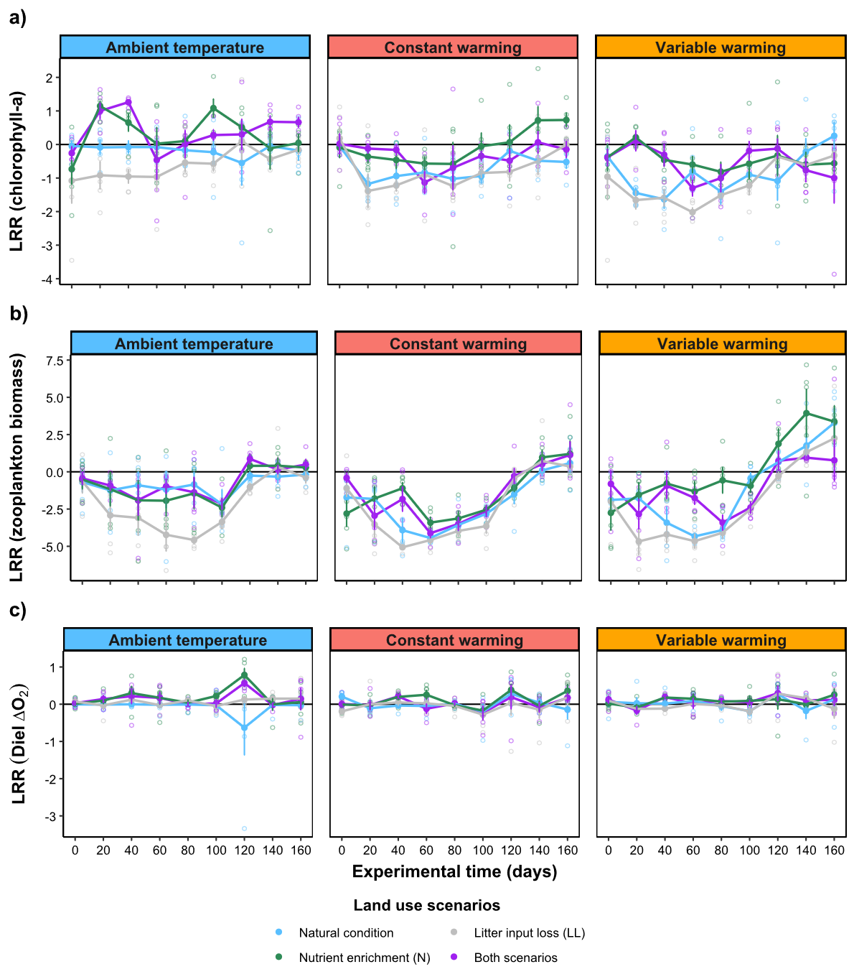
Supplementary Figure S1. Effects of different global change drivers on temporal dynamics of multiple functions related to ecosystem productivity. X- and Y-axes represent the experimental duration (days) and log response ratio (LRR; mean ± s.e.m, n=5) of the standardized values of chlorophyll-α (a), zooplankton biomass (b) and diel ΔO₂ (c), comparing disturbed experimental conditions with control. Trend lines represent temporal dynamics of mean LRR (± s.e.m.; n=5) for each treatment combination, and boxes denote different experimental warming scenarios. Colors of the trend lines indicate different land use scenarios combining nutrient enrichment and litter input reduction. The black line represents the baseline value for all treatment combinations, calculated as the LRR between the control mean value against itself at each time interval.

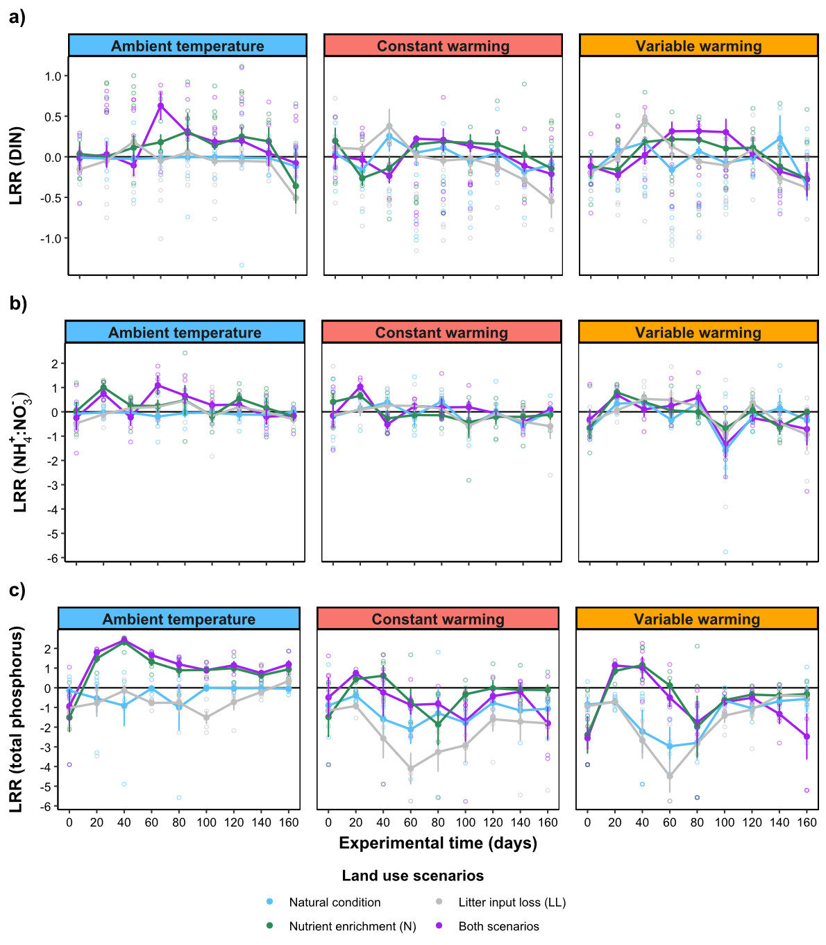
Supplementary Figure S2. Effects of different global change drivers on temporal dynamics of multiple functions related to nutrient cycling. X- and Y-axes represent the experimental duration (days) and log response ratio (LRR; mean ± s.e.m, n=5) of the standardized values of dissolved inorganic nitrogen (DIN; a), ammonium:nitrate ratio (N-ratio; b) and total phosphorus (c), comparing disturbed experimental conditions with control. Trend lines represent temporal dynamics of mean LRR (± s.e.m.; n=5) for each treatment combination, and boxes denote different experimental warming scenarios. Colors of the trend lines indicate different land use scenarios combining nutrient enrichment and litter input reduction. The black line represents the baseline value for all treatment combinations, calculated as the LRR between the control mean value against itself at each time interval.

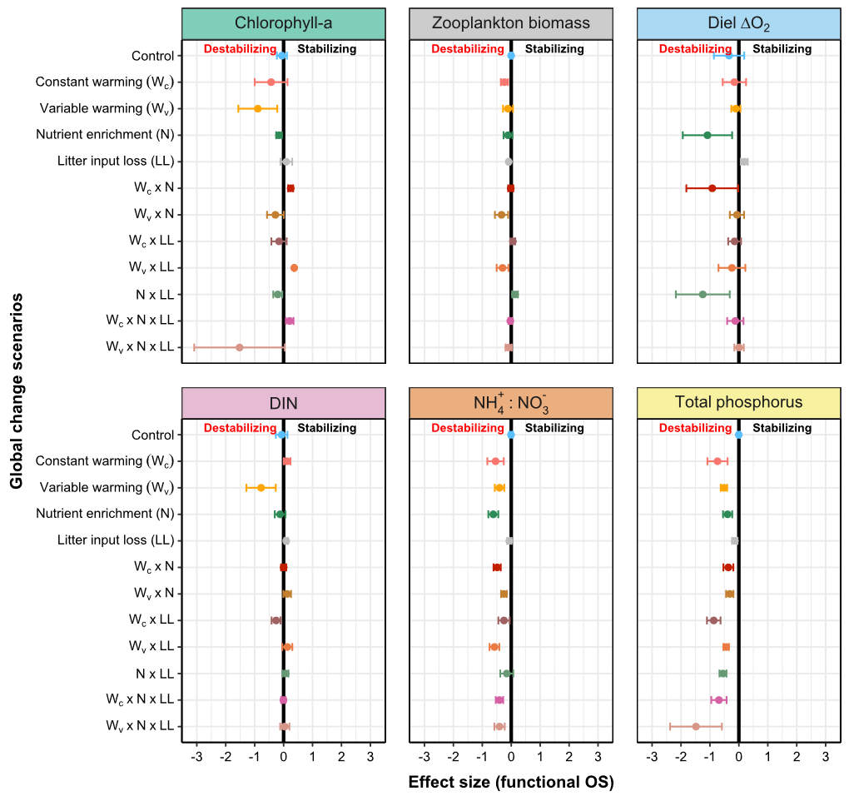
Supplementary Figure S3. Effects of different global change drivers on functional overall stability related to multiple ecosystem functions. X-axis represents treatment effect sizes (mean ± s.e.m, n=5) on different aspects of functional overall stability (OS), calculated as log response ratio (LRR) between disturbed and undisturbed experimental conditions. Y-axis and underlying different colors indicate the multifactorial combination of experimental warming, nutrient enrichment and litter input reduction. Each facet represents a specific ecosystem function. Data points to the right or left of the vertical black line at zero indicate stabilizing or destabilizing effects, respectively.

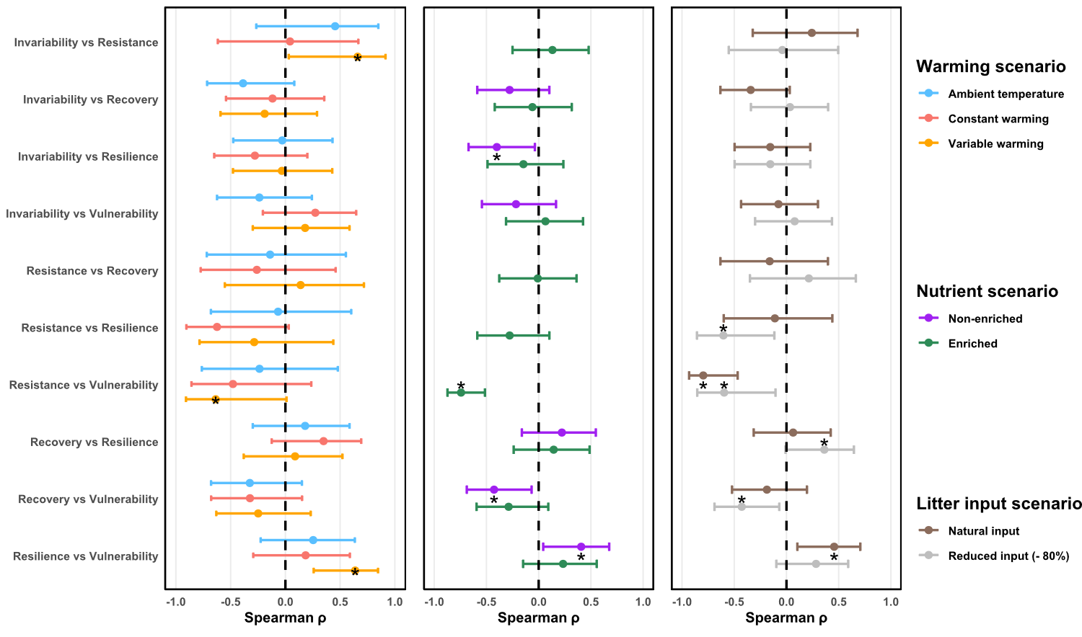
Supplementary Figure S4. Pairwise correlations among multiple stability metrics for ecosystem multifunctionality under different global change scenarios. X- and Y- axes represent Spearman’s correlation coefficients and different pairwise combinations among stability metrics. Each panel represents correlation values and their error bars (95% CI) calculated for different categories of experimental warming (left); nutrient enrichment (center); or litter input loss (right). Black asterisks denote significant correlations (p-value <0.05).

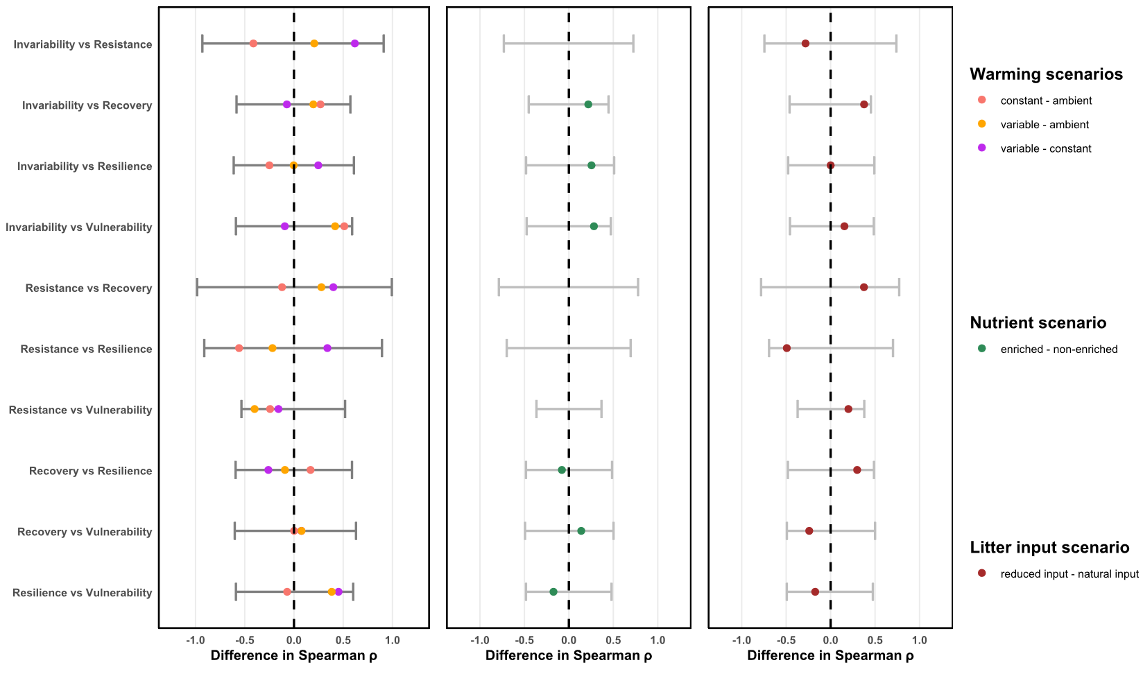
Supplementary Figure S5. Permutation tests for effects of global change drivers on pairwise correlations among multiple stability metrics for ecosystem multifunctionality. Pairwise differences in Spearman’s correlation coefficients between treatment levels for random permutations of the data (grey lines, 95% CI shown here) and observed values for different categories (colored dots) of experimental warming (left); nutrient enrichment (center); and litter input loss (right). Asterisks would denote significantly greater pairwise differences (p-value <0.05) between treatment categories than the null expectations.

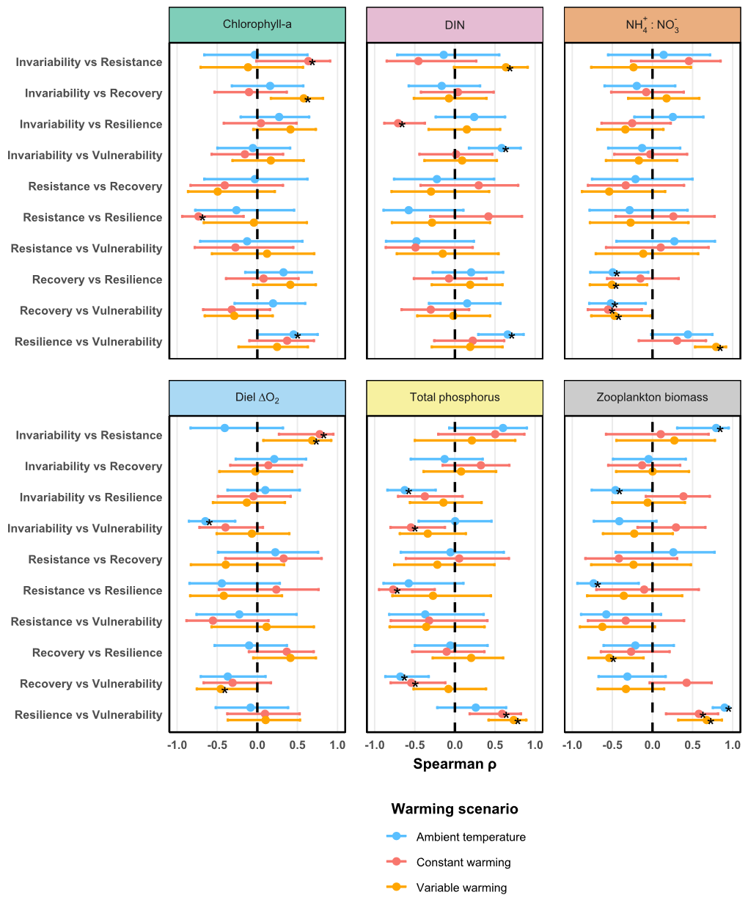
Supplementary Figure S6. Pairwise correlations among multiple stability metrics for different ecosystem functions under different warming scenarios. X- and Y- axes represent Spearman’s correlation coefficients and different pairwise combinations among stability metrics. Each panel represents correlation values and their error bars (95% CI) calculated for different ecosystem functions. Colors indicate different warming treatments. Black asterisks denote significant correlations (p-value <0.05).
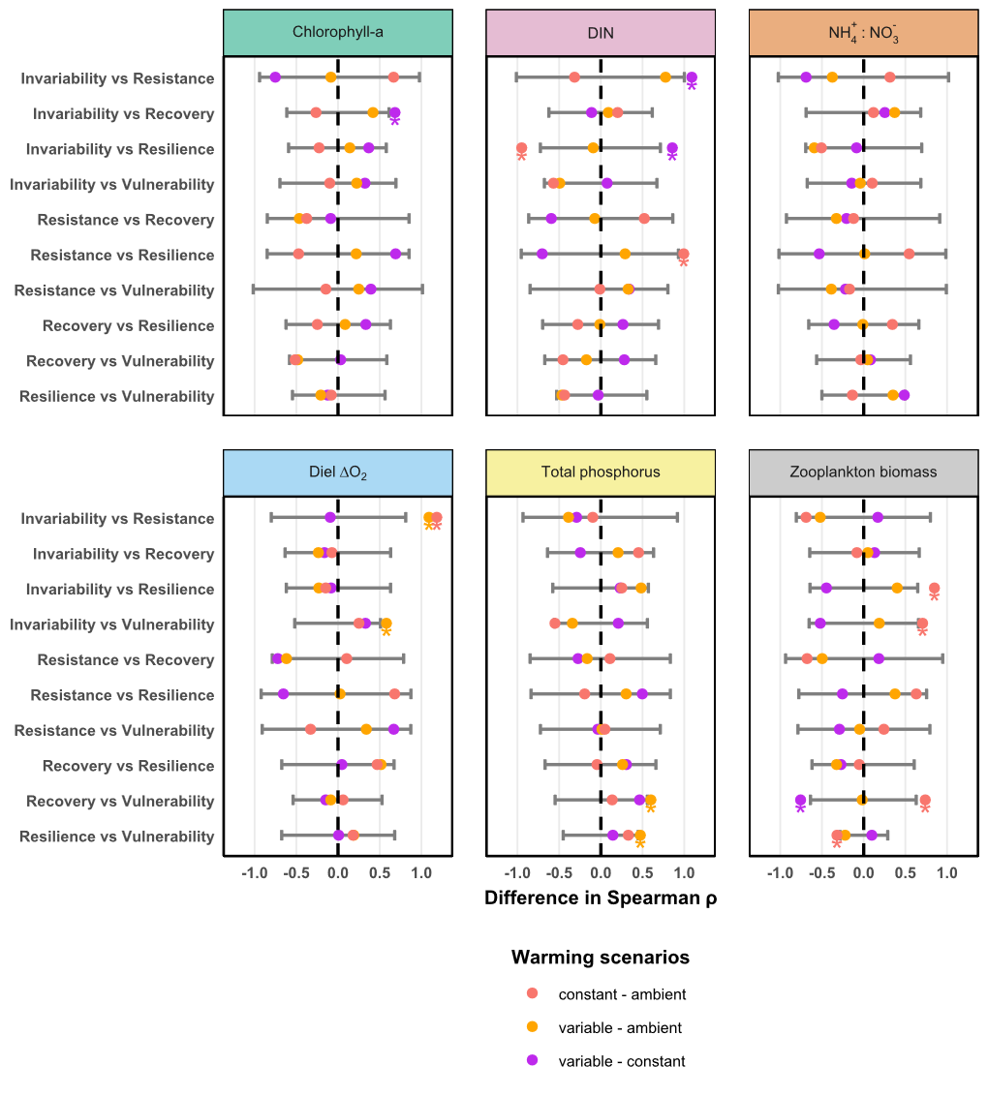
Supplementary Figure S7. Permutation tests for effects of warming on pairwise correlations among multiple stability metrics for different ecosystem functions. Pairwise differences in Spearman’s correlation coefficients between treatment levels for random permutations of the data (grey lines, 95% CI shown here) and observed values for different categories of experimental warming (indicated by colors). Each panel represents different ecosystem functions. Colored asterisks denote significantly greater pairwise differences (p-value <0.05) between treatment categories than the null expectations.

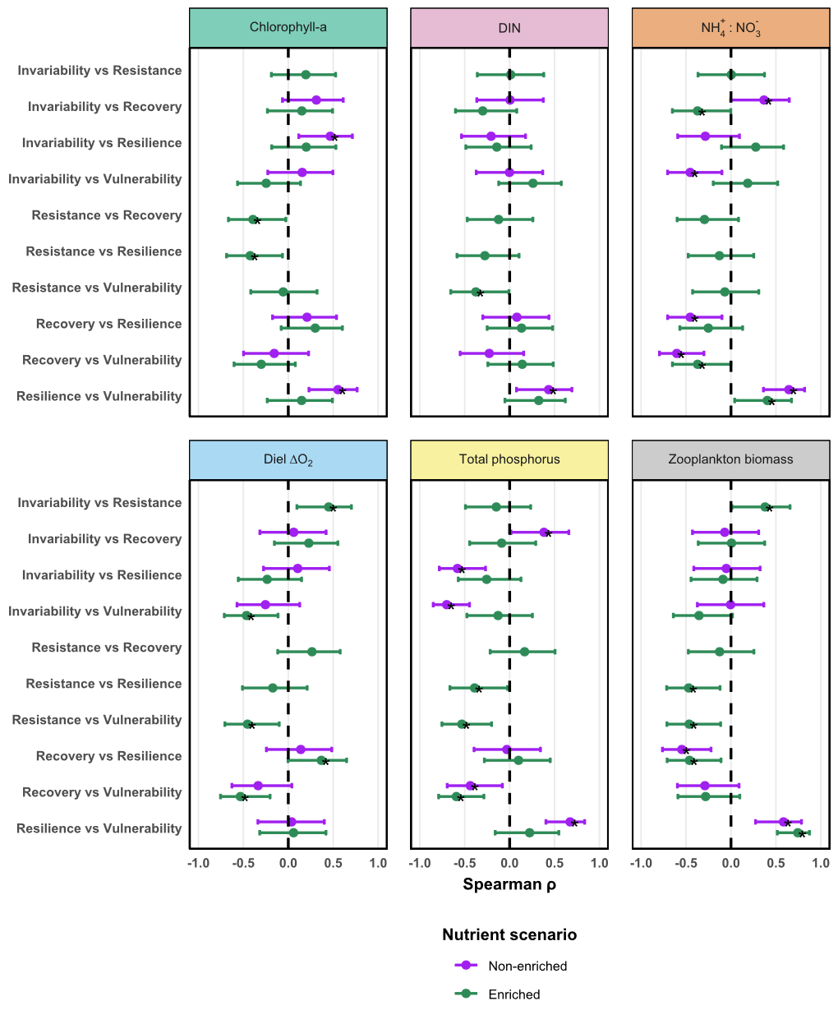
Supplementary Figure S8. Pairwise correlations among multiple stability metrics for different ecosystem functions under nutrient enrichment scenarios. X- and Y- axes represent Spearman’s correlation coefficients and different pairwise combinations among stability metrics. Each panel represents correlation values and their error bars (95% CI) calculated for different ecosystem functions. Colors indicate different nutrient enrichment treatments. Black asterisks denote significant correlations (p-value <0.05).

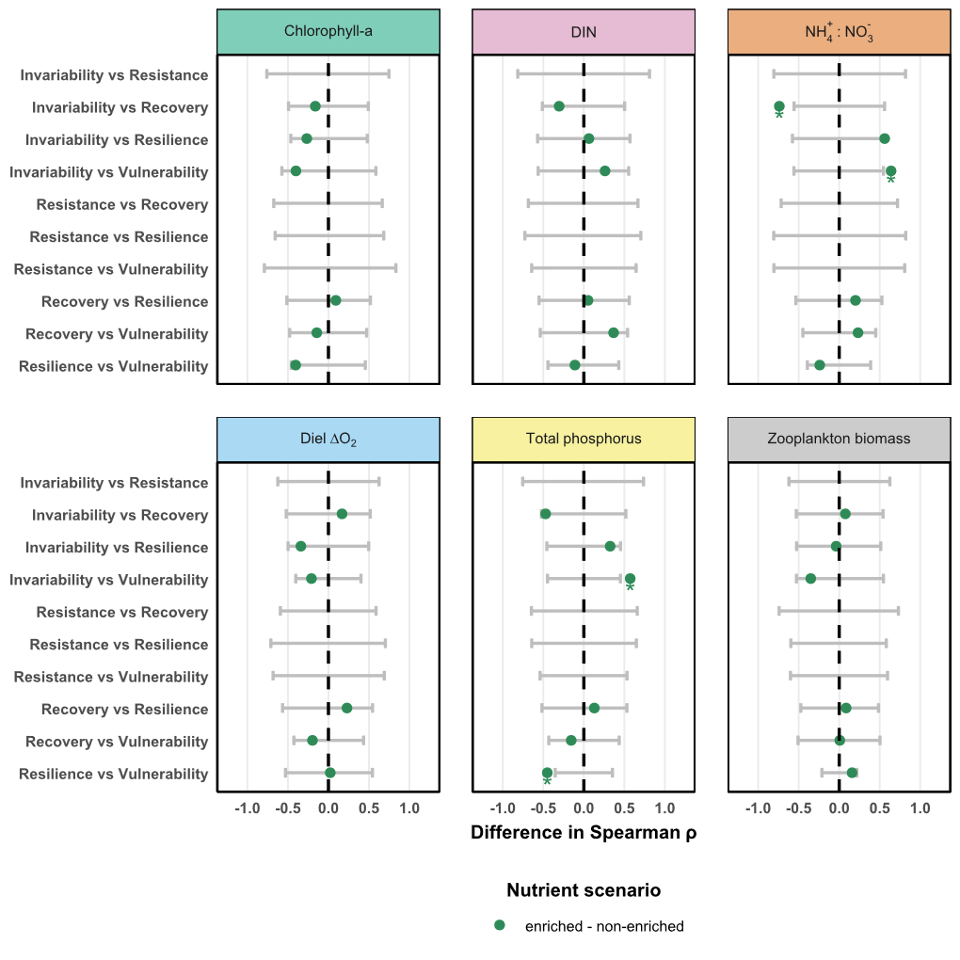
Supplementary Figure S9. Permutation tests for effects of nutrient enrichment on pairwise correlations among multiple stability metrics for different ecosystem functions. Pairwise differences in Spearman’s correlation coefficients between treatment levels for random permutations of the data (grey lines, 95% CI shown here) and observed values for different categories of nutrient enrichment. Each panel represents different ecosystem functions. Colored asterisks denote significantly greater pairwise differences (p-value <0.05) between treatment categories than the null expectations.
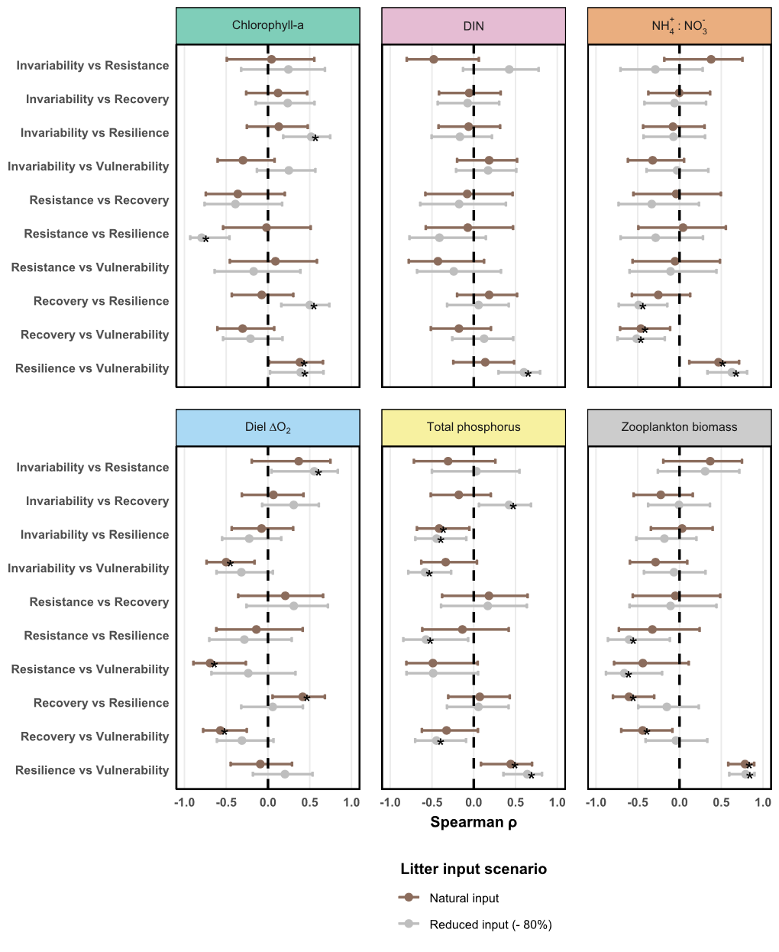
Supplementary Figure S10. Pairwise correlations among multiple stability metrics for different ecosystem functions under litter input scenarios. X- and Y- axes represent Spearman’s correlation coefficients and different pairwise combinations among stability metrics. Each panel represents correlation values and their error bars (95% CI) calculated for different ecosystem functions. Colors indicate different litter input treatments. Black asterisks denote significant correlations (p-value <0.05).
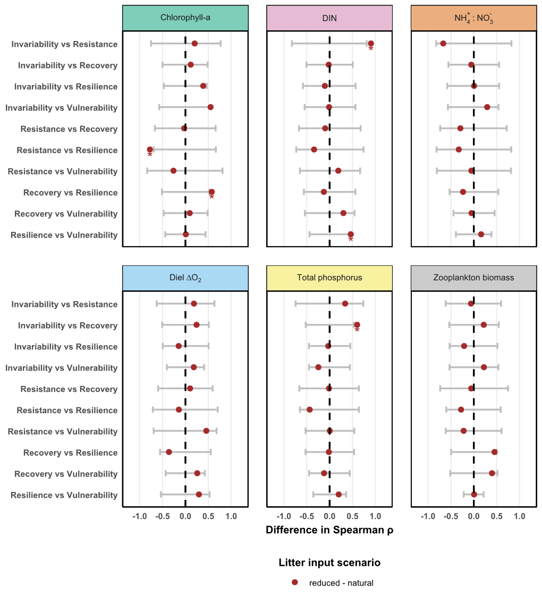
Supplementary Figure S11. Permutation tests for effects of litter input reduction on pairwise correlations among multiple stability metrics for different ecosystem functions. Pairwise differences in Spearman’s correlation coefficients between treatment levels for random permutations of the data (grey lines, 95% CI shown here) and observed values for different categories of nutrient enrichment. Each panel represents different ecosystem functions. Colored asterisks denote significantly greater pairwise differences (p-value <0.05) between treatment categories than the null expectations.

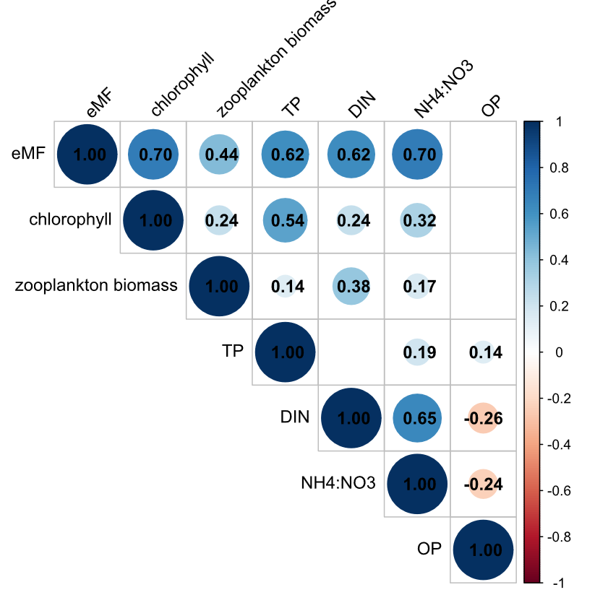
Supplementary Figure S12. Correlation matrix between each ecosystem function and the effective multifunctionality index. Panel shows Spearman’s rank correlation coefficient values calculated from the effective multifunctionality index of order q=1 (eff.mf1.std) and standardized values of chlorophyll-α concentration; zooplankton biomass, diel ΔO₂ (OP); dissolved inorganic nitrogen (DIN); ammonium:nitrate ratio ([NH₄⁺]:[NO₃⁻] or N-ratio); and total phosphorus concentration (TP) over the duration of the experiment (n=540 samples). Only statistically significant correlation coefficients (p-value < 0.05) are represented in the panel.

