Supporting Information for
The crucial roles of citrus branch compost in enhancing soil nutrients, optimizing microbial community structure, and improving fruit quality over its raw materials
Jinye Li · Songwei Wu · Jixiang Zheng · Xuecheng Sun · Qiling Tan · Chengxiao Hu

J. Li · S. Wu · X. Sun · Q. Tan · C. Hu ()
Hubei Provincial Engineering Laboratory for New Fertilizers/College of Resources and Environment, Huazhong Agricultural University, Wuhan, 430070, China
e-mail: hucx@mail.hzau.edu.cn
J. Li · S. Wu · C. Hu
National Key Laboratory for Germplasm Innovation & Utilization of Horticultural Crops, Huazhong Agricultural University, Wuhan, 430070, China
J. Zheng
Guangxi Fruit Industry Technology Research Institute, Nanning 530105, China

This file includes:
Supplementary Tables 1 to 6
Supplementary Figures 1 to 7

Supplementary Tables
Table S1 Composition of N, P and K in different treatments
Treatment | Chemical fertilizer (kg/tree) |  |  | Material nutrition (kg/tree)
Treatment | N | P₂O₅ | K₂O | N | P₂O₅ | K₂O
CK | 0.56 | 0.18 | 0.36 | 0 | 0 | 0
CB | 0.28 | 0.10 | 0.24 | 0.27 | 0.10 | 0.14
CI | 0.30 | 0 | 0.20 | 0.26 | 0.23 | 0.16
CC | 0.28 | 0 | 0.20 | 0.27 | 0.21 | 0.17
CM | 0.56 | 0.18 | 0.36 | 0 | 0 | 0
Table S2 Basic properties of compost and its raw materials
Types of materials | pH | TC % | TN % | TP % | TK %
Citrus branch compost | 8.35±0.02 | 30.4±11.9 | 2.1±0.1 | 0.7±0.01 | 1.1±0.02
Crushed branch | 6.69±0.01 | 59.2±1.5 | 1.3±0.2 | 0.5±0.01 | 0.7±0.01
Rice straw biochar | 8.76±0.02 | 35.8±5.2 | 1.8±0.1 | 0.3±0.05 | 0.8±0.02
microbial inoculant | Compound Bacillus subtilis+Trichoderma harzianum
The data in the table are expressed as "mean ± standard deviation". Total carbon: TC, Total nitrogen: TN, Total phosphorus: TP, Total potassium: TK

Table S3 Sequencing fragments and primers
Sequencing region | Primer sequence | Fragment length
Bacteria V4 | 515F (5-GTGCCAGCMGCCGCGGTAA-3') | 310 bp
 | 806R (5-GGACTACHVGGGTWTCTAAT-3')
Fungi ITS2 | ITS3-F (5-GCATCGATGAAGAACGCAGC-3')  ITS4-R (5-TCCTCCGCTTATTGATATGC-3') | 450 bp

Table S4 Changes in pH value and nutrient content of compost
Compost time | pH value | TOC (g/kg) | TK (%) | TP (%) | TN (%) | C/N
1st day | 8.3±0.0b | 533.2±31.2a | 1.2±0.1b | 0.7±0.1a | 2.0±0.2a | 27.2±2.1a
15th day | 7.9±0.0c | 519.5±14.4a | 1.3±0.0a | 0.8±0.0a | 2.1±0.3a | 24.7±3.2b
42rd day | 7.8±0.0d | 398.9±60.5b | 1.2±0.0b | 0.7±0.0a | 2.5±0.2a | 16.1±3.3c
59th day | 8.9±0.0a | 303.9±11.9c | 1.1±0.0c | 0.7±0.0a | 2.1±0.1a | 14.3±1.5c
The data in the table are expressed as "mean ± standard deviation".
Table S5 The correlation between bacterial and fungal species in each treatment
Species  Treatment | Bacterial edge |  |  | Fungal edge
Species  Treatment | Positive | Negative | P/N | Positive | Negative | P/N
CK | 1004 | 889 | 1.13 | 711 | 612 | 1.16
CB | 1886 | 1892 | 1.00 | 1099 | 1085 | 1.01
CI | 991 | 976 | 1.02 | 870 | 529 | 1.64
CC | 888 | 916 | 0.97 | 817 | 466 | 1.75
CM | 1006 | 1041 | 0.97 | 812 | 792 | 1.03
Table S6 The details of functional genes related to C, N, and P cycling
Function groups | Gene symbols | Gene names
C-degradation | PYG | glycogen phosphorylase [EC:2.4.1.1]
C-degradation | malQ | 4-alpha-glucanotransferase [EC:2.4.1.25]
C-degradation | pulA | pullulanase [EC:3.2.1.41]
C-degradation | celB | cellobiose PTS system EIIC component
C-degradation | bglX | beta-glucosidase [EC:3.2.1.21]
C-degradation | bglB | beta-glucosidase [EC:3.2.1.21]
C-degradation | CBH2 | cellulose 1,4-beta-cellobiosidase [EC:3.2.1.91]
C-degradation | csn | chitosanase [EC:3.2.1.132]
C-degradation | csxA | exo-1,4-beta-D-glucosaminidase [EC:3.2.1.165]
C-degradation | gspK | glucosamine kinase [EC:2.7.1.8]
C-degradation | vdh | benzaldehyde dehydrogenase (NAD) [EC:1.2.1.28]
C-fixation | sdhD | succinate dehydrogenase / fumarate reductase, membrane anchor subunit
C-fixation | frdA | fumarate reductase flavoprotein subunit [EC:1.3.5.4]
C-fixation | IDH1 | isocitrate dehydrogenase [EC:1.1.1.42]
C-fixation | ACO | aconitate hydratase [EC:4.2.1.3]
C-fixation | acnB | aconitate hydratase 2 / 2-methylisocitrate dehydratase [EC:4.2.1.3 4.2.1.99]
C-fixation | fumE | carbonic anhydrase [EC:4.2.1.1]
C-fixation | ppc | phosphoenolpyruvate carboxylase [EC:4.1.1.31]
C-fixation | pycB | pyruvate carboxylase subunit B [EC:6.4.1.1]
C-fixation | pps | pyruvate, water dikinase [EC:2.7.9.2]
C-fixation | porC | pyruvate ferredoxin oxidoreductase gamma subunit [EC:1.2.7.1]
C-fixation | acsB | acetyl-CoA synthase [EC:2.3.1.169]
C-fixation | mct | 2-methylfumaryl-CoA isomerase [EC:5.4.1.3]
C-fixation | meh | 3-methylfumaryl-CoA hydratase [EC:4.2.1.153]
C-fixation | rbcL | ribulose-bisphosphate carboxylase large chain [EC:4.1.1.39]
N-cycling | chiA | chitinase [EC:3.2.1.14]
N-cycling | ureC | urease subunit alpha [EC:3.5.1.5]
N-cycling | gdh | glutamate dehydrogenase (NAD(P)+) [EC:1.4.1.3]
N-cycling | nifD | nitrogenase molybdenum-iron protein alpha chain [EC:1.18.6.1]
N-cycling | nifK | nitrogenase molybdenum-iron protein beta chain [EC:1.18.6.1]
N-cycling | anfG | nitrogenase delta subunit [EC:1.18.6.1]
N-cycling | hao | hydroxylamine dehydrogenase [EC:1.7.2.6]
N-cycling | amoA | methane/ammonia monooxygenase subunit A [EC:1.14.18.3 1.14.99.39]
N-cycling | nirS | nitrite reductase (NO-forming) / hydroxylamine reductase [EC:1.7.2.1 1.7.99.1]
N-cycling | nirK | nitrite reductase [EC:1.7.2.1]
N-cycling | nosZ | nitrous-oxide reductase [EC:1.7.2.4]
N-cycling | norB | nitric oxide reductase subunit B [EC:1.7.2.5]
N-cycling | narB | ferredoxin-nitrate reductase [EC:1.7.7.2]
N-cycling | nasA | assimilatory nitrate reductase catalytic subunit [EC:1.7.99.-]
N-cycling | narH | nitrate reductase / nitrite oxidoreductase, beta subunit [EC:1.7.5.1 1.7.99.-]
N-cycling | nirB | nitrite reductase (NADH) large subunit [EC:1.7.1.15]
P-cycling | gcd | glutaryl-CoA dehydrogenase [EC:1.3.8.6]
P-cycling | ppa | inorganic pyrophosphatase [EC:3.6.1.1]
P-cycling | phoA | 3'-phosphoadenosine 5'-phosphosulfate synthase [EC:2.7.7.4 2.7.1.25]
P-cycling | phoD | sphingomyelin phosphodiesterase acid-like 3 [EC:3.1.4.-]
P-cycling | phnJ | alpha-D-ribose 1-methylphosphonate 5-phosphate C-P lyase [EC:4.7.1.1]
P-cycling | phnP | phosphoribosyl 1,2-cyclic phosphate phosphodiesterase [EC:3.1.4.55]
P-cycling | phoB | porphobilinogen synthase [EC:4.2.1.24]
P-cycling | phoR | ribose-phosphate pyrophosphokinase [EC:2.7.6.1]
P-cycling | ugpQ | glycerophosphoryl diester phosphodiesterase [EC:3.1.4.46]
P-cycling | phnC | phosphonate transport system ATP-binding protein [EC:3.6.3.28]

Supplementary Figures
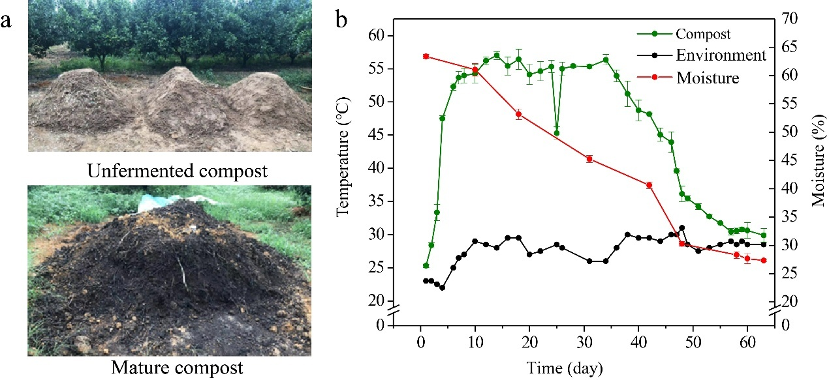
Fig. S1 Changes in compost material appearance (a), temperature and moisture (b).

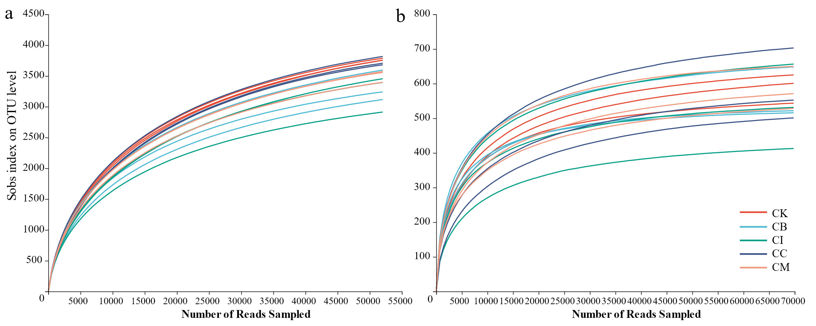
Fig. S2 Rarefaction curves of detected bacterial (a) and fungal (b) species of each treatment

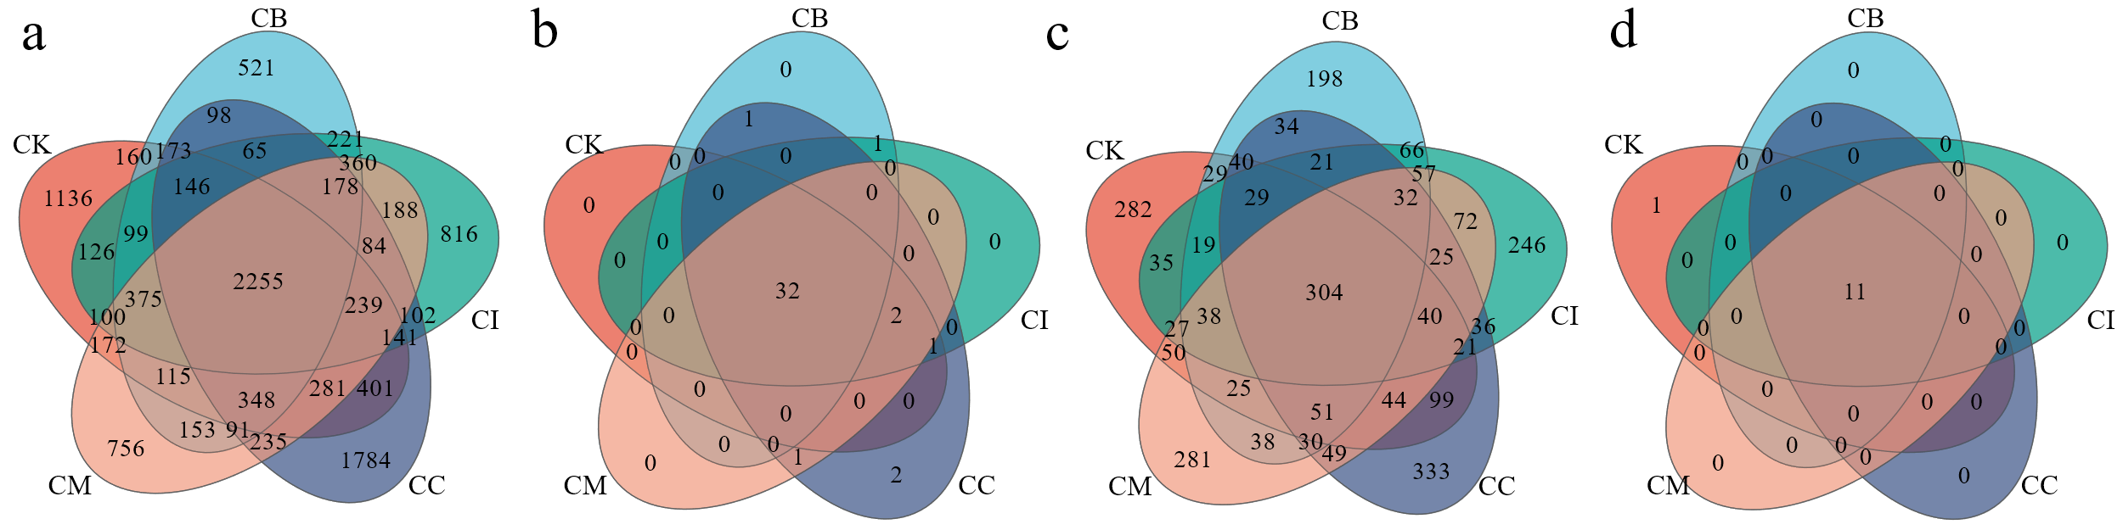
Fig. S3 Venn diagram of soil microbial community. a-b: bacterial OTU and phylum level, c-d: fungal OTU and phylum level
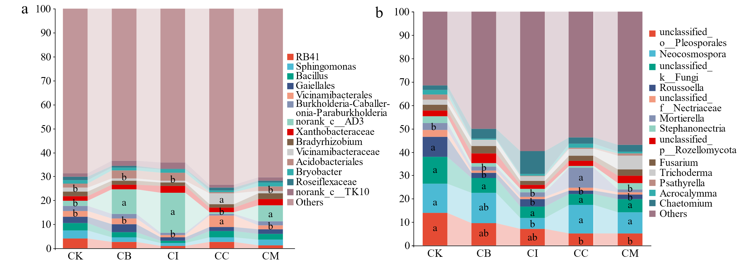Fig. S4 Composition of bacterial (a) and fungal (b) genus level in different treatments
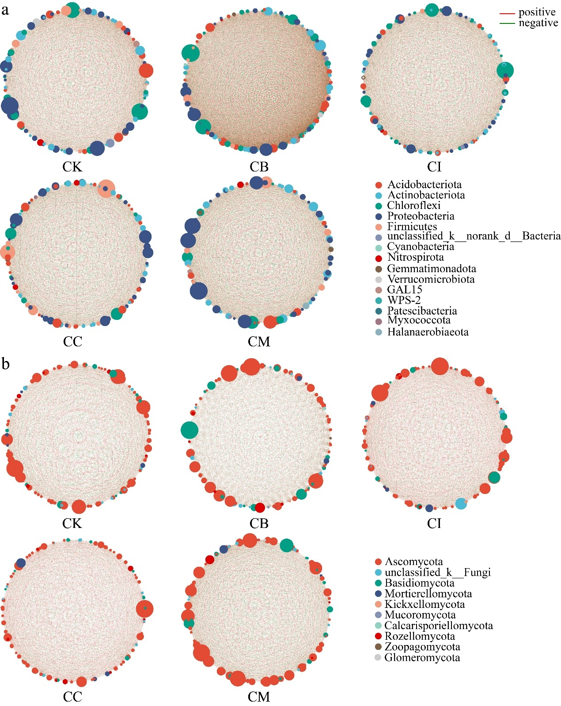
Fig. S5 Microbial cooccurrence networks based on Spearman correlation analysis in different treatments. A: bacteria, B: fungi. Selecting the top 100 OTU bacterial abundances to draw a network diagram (R² ≥ 0.5, P <0.01). Node colors representing gate level classification, and the size of nodes are proportional to the relative abundance of the OTUs.

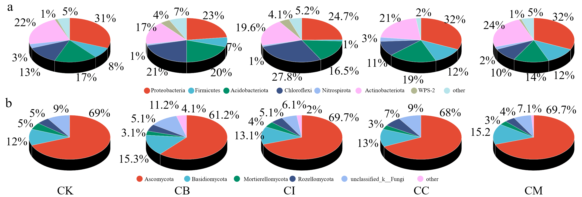
Fig. S6 Number of nodes in bacterial (a) and fungal (b) phylum in each treatment
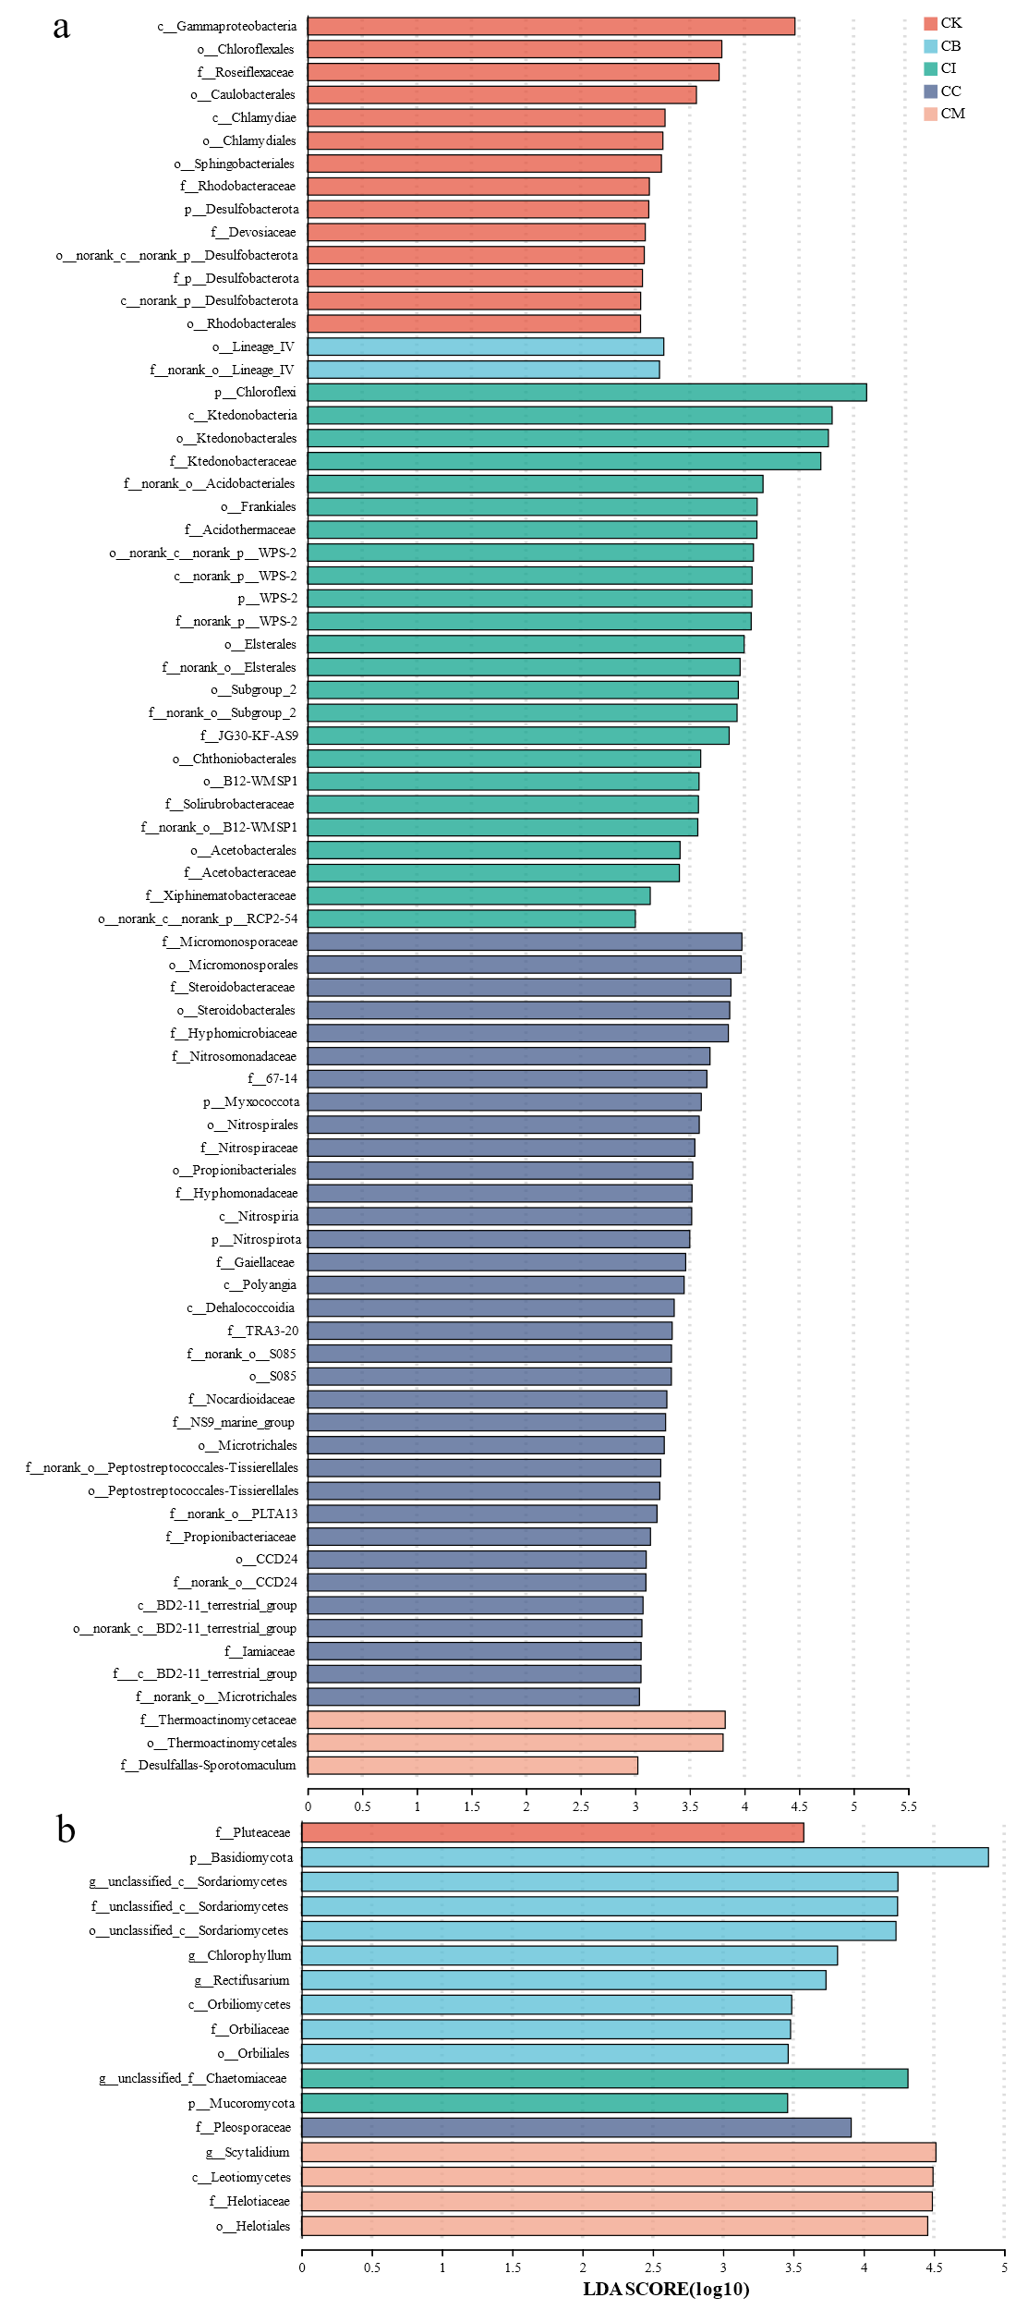
Fig. S7 LEfSe bar chart of bacteria (a) and fungi (b). The letters before names are abbreviations of different taxonomic levels (phylum-p, class-c, order-o, family-f, genus-g).

