Comparison of the effects of different types of nasointestinal tube placement techniques for ICU patients: A systematic review and Bayesian network meta-analysis of randomized controlled trials

Peiyi Li¹; Jia Peng¹; Mengyu He¹; Liqin Wang¹; Xu Lu¹; Xi Liu¹; Shuang Wu¹*

Table of Contents
Supplementary Part A: Search Strategies
Table S1 Search strategy of PubMed 3
Table S2 Search strategy of Web of Science 4
Table S3 Search strategy of Cochrane Central Register of Controlled Trials 4
Table S4 Search strategy of Embase 5
Table S5 Search strategy of CNKI, VIP, CBM and WanFang 5
Supplementary Part B: Consistency and inconsistency
Fig S1 Consistency model and inconsistency model fit for placement success rate. 6
Fig S2 Consistency model and inconsistency model fit for procedure time. 6
Fig S3 Consistency model and inconsistency model fit for complication incidence rate. 7
Fig S4 Consistency model and Inconsistency model fit for direct healthcare costs. 7
Supplementary Part C: Rank probability plots and Forest plots
Fig S5 Rank probability plot and forest plot for placement success rate. 8
Fig S6 Rank probability plot and forest plot for procedure time. 9
Fig S7 Rank probability plot and forest plot for complication incidence rate. 10
Fig S8 Rank probability plot and forest plot for direct healthcare costs. 11

Supplementary Part A: Search Strategies

Table S1 Search strategy of PubMed
Searches
1 | ("Intensive Care Units"[MeSH] OR "ICU"[Title/Abstract] OR "intensive care"[Title/Abstract] OR "critically ill"[Title/Abstract] OR "critical patient*"[Title/Abstract] OR "intensive therapy unit"[Title/Abstract]
2 | ("Intubation, Gastrointestinal"[MeSH] OR "nasointestinal tube*"[Title/Abstract] OR "naso-intestinal tube*"[Title/Abstract] OR "nasoenteral tube*"[Title/Abstract] OR "naso-enteral tube*"[Title/Abstract] OR "nasojejunal tube*"[Title/Abstract] OR "naso-jejunal tube*"[Title/Abstract] OR "post-pyloric tube*"[Title/Abstract] OR "transpyloric tube*"[Title/Abstract]) OR "trans-pyloric tube*"[Title/Abstract]
3 | ("insertion"[Title/Abstract] OR "placement"[Title/Abstract] OR "intubation"[Title/Abstract] OR "technique*"[Title/Abstract] OR "method*"[Title/Abstract] OR "approach*"[Title/Abstract] OR "guidance"[Title/Abstract] OR "guided"[Title/Abstract]) OR "magnetic*"[Title/Abstract] OR "electromagnetic*"[Title/Abstract] OR "ultrasonography"[Title/Abstract] OR "endoscop*"[Title/Abstract] OR "fluoroscop*"[Title/Abstract] OR "ultrasound"[Title/Abstract] OR "blind"[Title/Abstract] OR camera*[Title/Abstract] OR image-guided[Title/Abstract] )
4 | #1 AND #2 AND #3

Table S2 Search strategy of Web of Science
Searches
1 | (TS= ("Intensive Care Units") OR TS=("ICU") OR TS= ("intensive care") OR TS= ("critically ill") OR TS= ("critical patient*") OR TS= ("intensive therapy unit") )
2 | (TS= ("nasointestinal tube*") OR TS= ("naso-intestinal tube*") OR TS= ("nasoenteral tube*") OR TS= (naso-enteral tube*) OR TS= ("nasojejunal tube*") OR TS= ("naso-jejunal tube*") OR TS= ("post-pyloric tube*") OR TS= ("transpyloric tube*") OR TS= ("trans-pyloric tube*") )
3 | (TS=("insertion") OR TS=("placement") OR TS=("intubation") OR TS=(technique*) OR TS=("method*") OR TS=("approach*") OR TS=("guidance") OR TS=("guided") OR TS=(magnetic*) OR TS=("electromagnetic*") OR TS=("ultrasonography") OR TS=("endoscop*") OR TS=("fluoroscop*") OR TS=("ultrasound") OR TS=("blind") OR TS=("camera") OR TS=("image-guided"))
4 | #1 AND #2 AND #3

Table S3 Search strategy of Cochrane Central Register of Controlled Trials
Searches
1 | ("Intensive Care Units" OR "ICU" OR "intensive care" OR "critically ill" OR "critical patient*" OR "intensive therapy unit" )
2 | ("nasointestinal tube*" OR "naso-intestinal tube*" OR "nasoenteral tube*" OR naso-enteral tube* OR "nasojejunal tube*" OR "naso-jejunal tube*" OR "post-pyloric tube*" OR "transpyloric tube*" OR "trans-pyloric tube*")
3 | ("insertion" OR "placement" OR "intubation" OR technique* OR "method*" OR "approach*" OR "guidance" OR "guided" OR "magnetic*" OR "electromagnetic*" OR "ultrasonography" OR "endoscop*" OR "fluoroscop*" OR "ultrasound" OR "blind" OR "camera" OR "image-guided")
4 | #1 AND #2 AND #3

Table S4 Search strategy of Embase
Searches
1 | ('Intensive Care Units'/exp OR 'ICU'/exp OR 'intensive care'/exp OR 'critically ill'/exp OR 'critical patient*'/exp OR 'intensive therapy unit'/exp )
2 | ('nasointestinal tube*'/exp OR 'naso-intestinal tube*'/exp OR 'nasoenteral tube*'/exp OR 'naso-enteral tube*'/exp OR 'nasojejunal tube*'/exp OR 'post-pyloric tube*'/exp OR 'naso-jejunal tube*'/exp OR 'transpyloric tube*'/exp OR 'trans-pyloric tube*'/exp)
3 | ('insertion'/exp OR 'placement'/exp OR 'intubation'/exp OR 'technique*'/exp OR 'method*'/exp OR 'approach*'/exp OR 'guidance'/exp OR 'guided'/exp OR 'magnetic*'/exp 'electromagnetic*'/exp OR 'ultrasonography'/exp 'endoscop*'/exp OR 'fluoroscop*'/exp 'ultrasound'/exp OR 'blind'/exp )
4 | #1 AND #2 AND #3

Table S5 Search strategy of CNKI, VIP, CBM and WanFang
Searches
1 | (ICU OR 重症监护 OR 重症监护室 OR 危重症 OR 重症患者)
2 | (鼻肠管 OR 鼻空肠管 OR 鼻肠内插管 OR 幽门后营养管 OR 十二指肠插管)
3 | (置管 OR 插管 OR 技术 OR 方法 OR 超声 OR 内窥镜 OR 可视化 OR 磁导航 OR 盲插)
4 | #1 AND #2 AND #3

Supplementary Part B: Consistency and inconsistency
In terms of model fit, both fixed-effects and random-effects models were examined. The random-effects model demonstrated a superior fit, with lower DIC values, showed a better fit for the data than the fixed-effects model. Supplementary Figure S1 illustrates the consistency and inconsistency models. The consistency model demonstrated a marginally lower DIC value, suggesting a superior fit.
A B
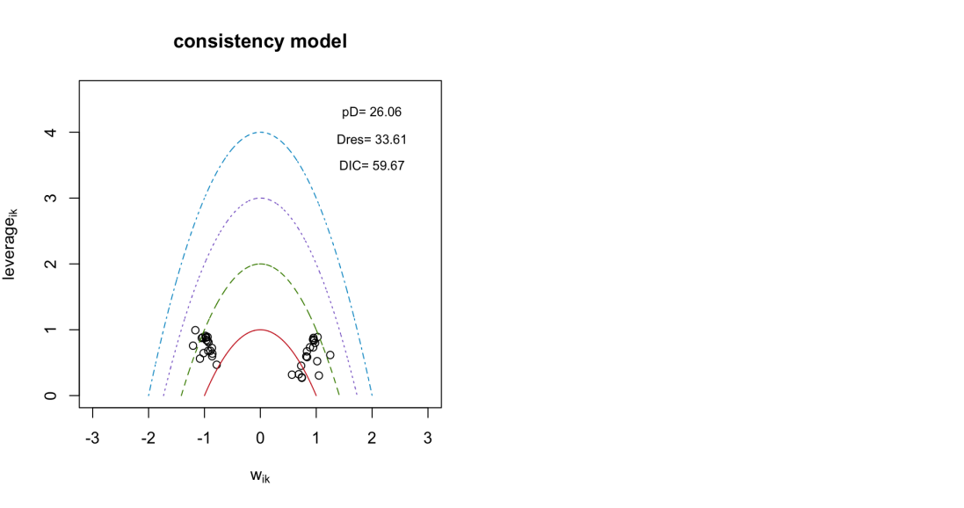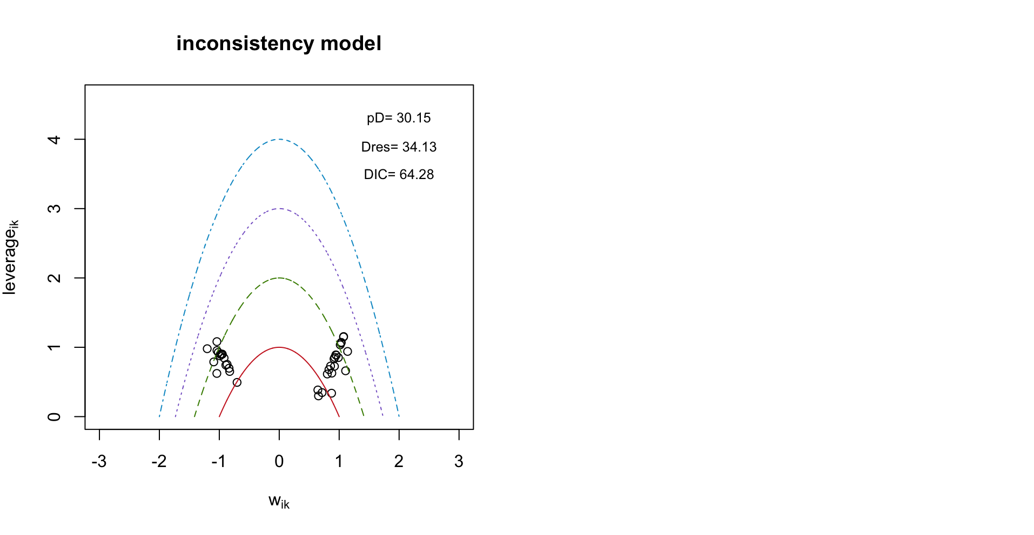

Fig S1 A Consistency model fit for placement success rate. B Inconsistency model fit for placement success rate.
A B
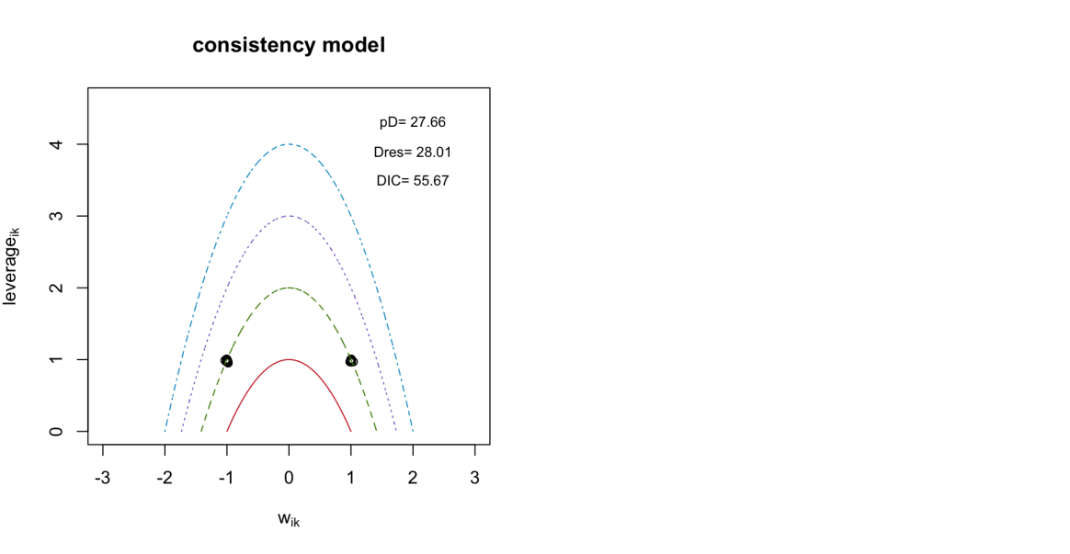

Fig S2 A Consistency model fit for procedure time. B Inconsistency model fit for procedure time.
A B
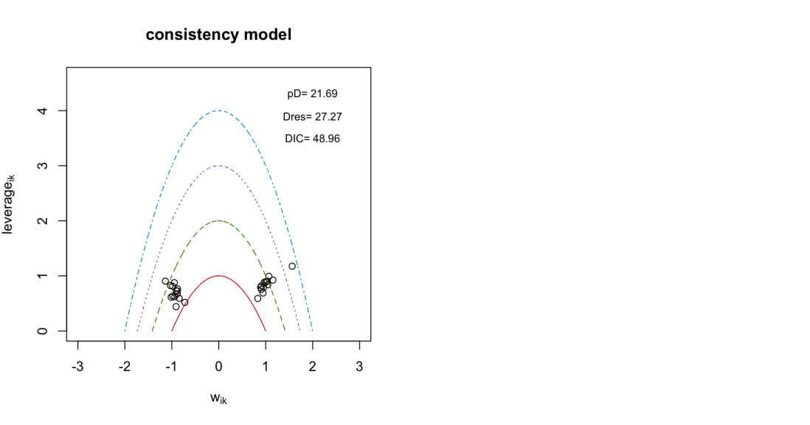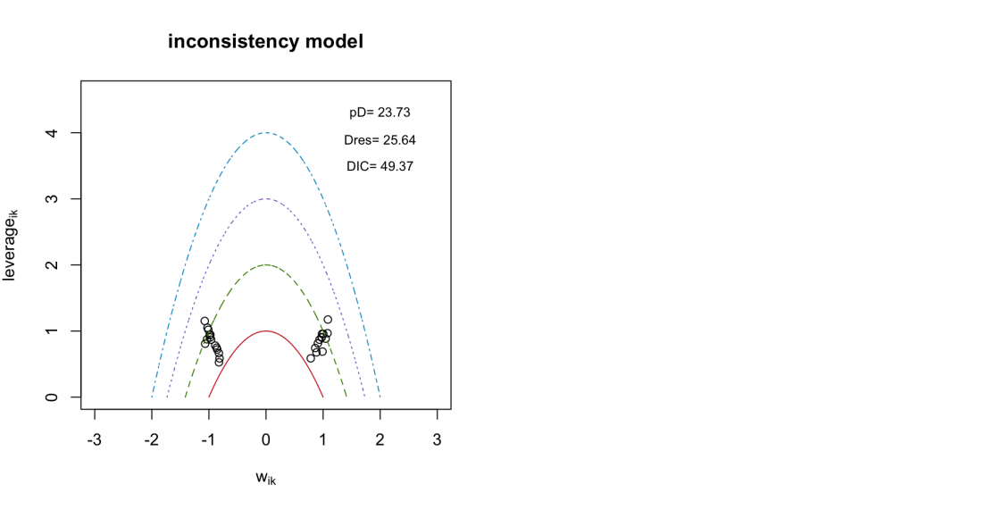

Fig S3 A Consistency model fit for complication incidence rate. B Inconsistency model fit for complication incidence rate.
A B
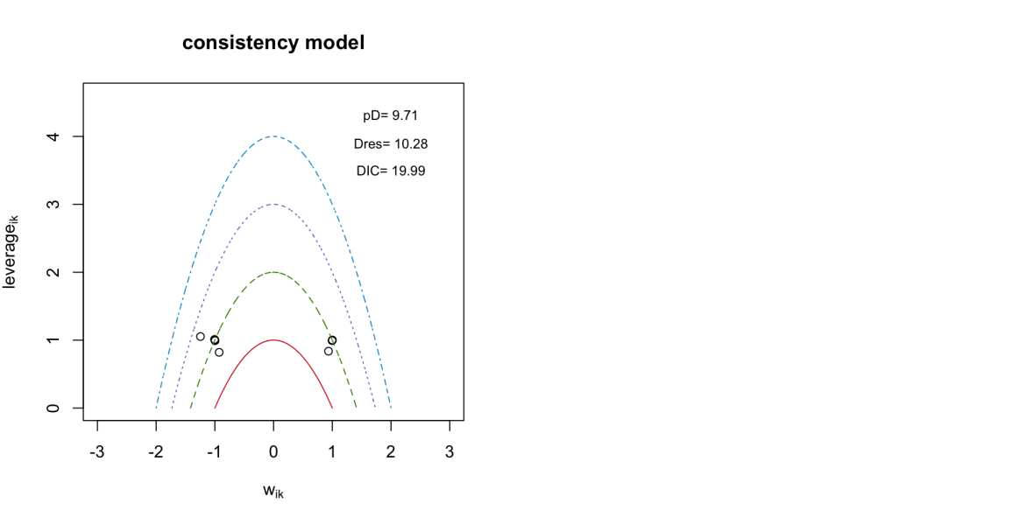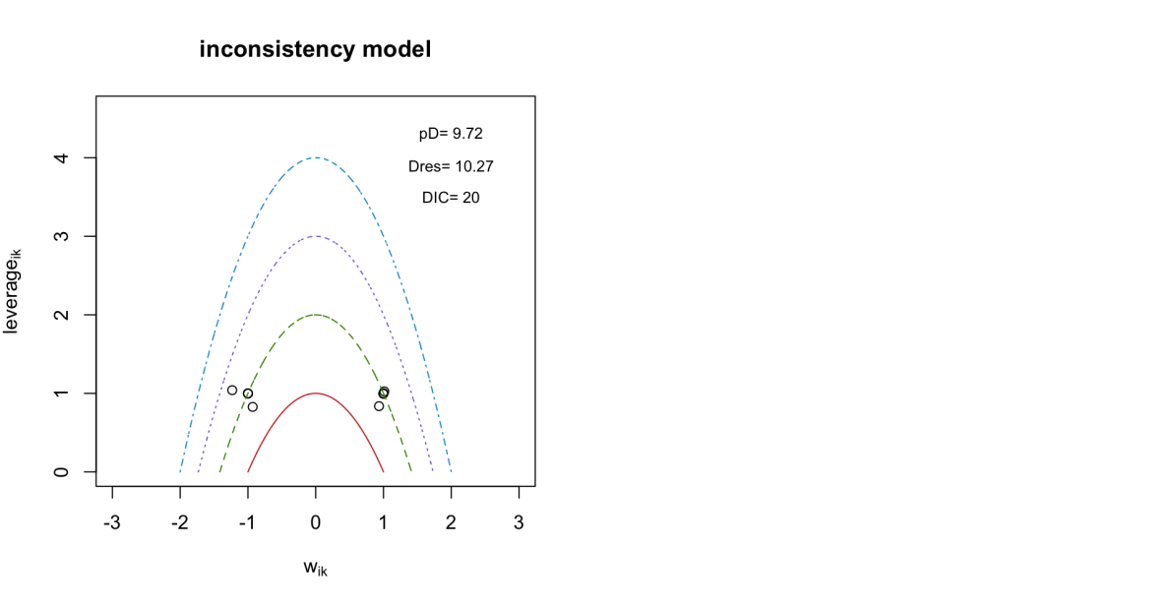

Fig S4 A Consistency model fit for direct healthcare costs. B Inconsistency model fit for direct healthcare costs.

Supplementary Part C: Rank probability plots and Forest plots
A
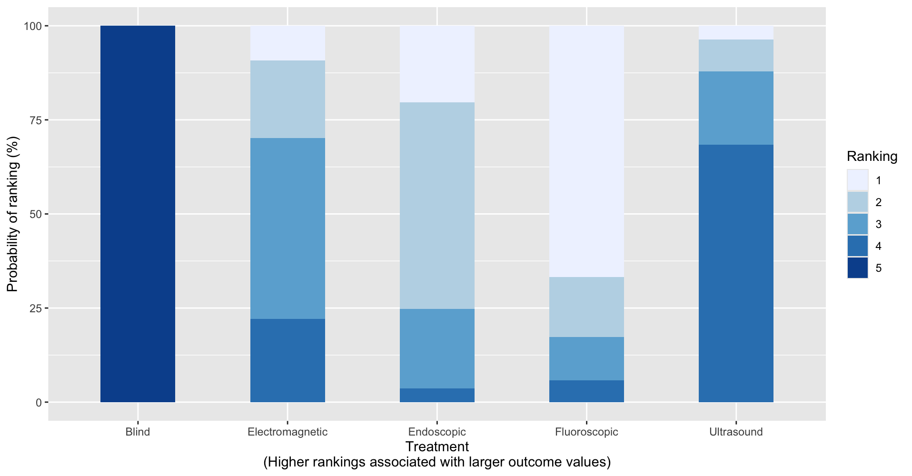
B
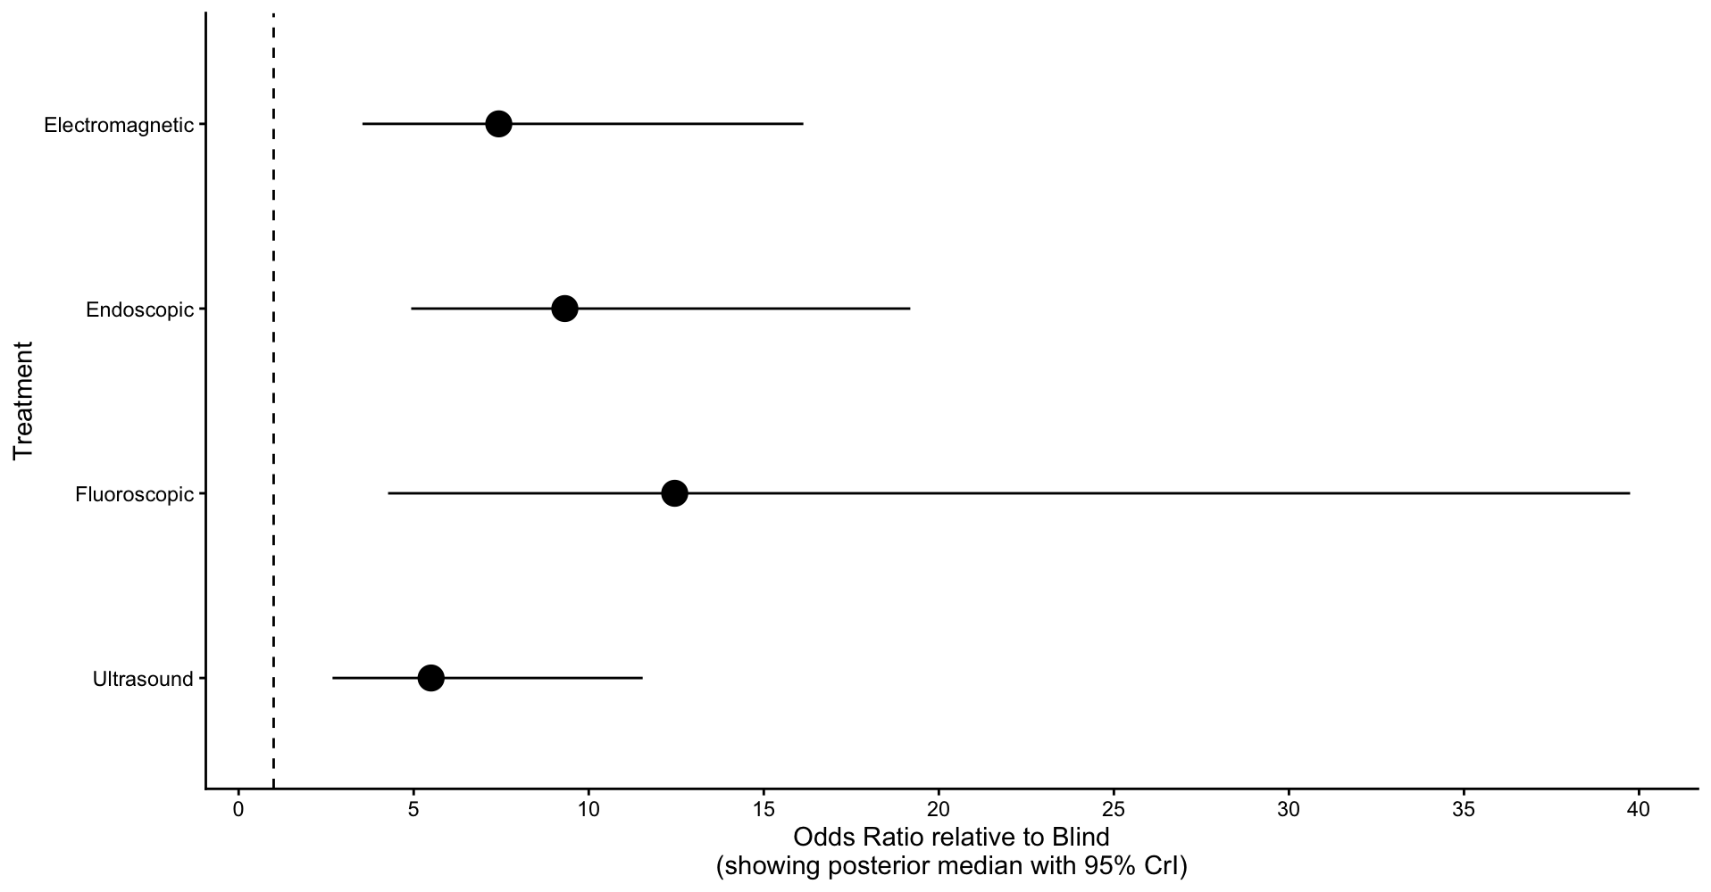

Fig S5 A Rank probability plot for placement success rate. B Forest plot for placement success rate.

A
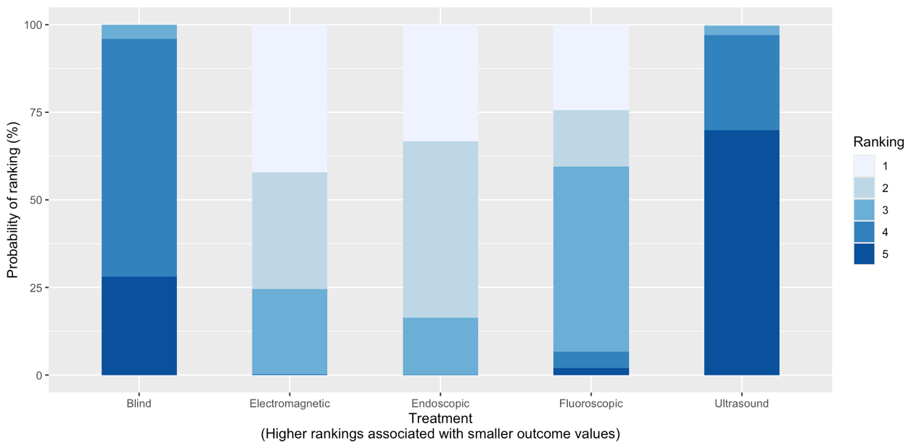
B
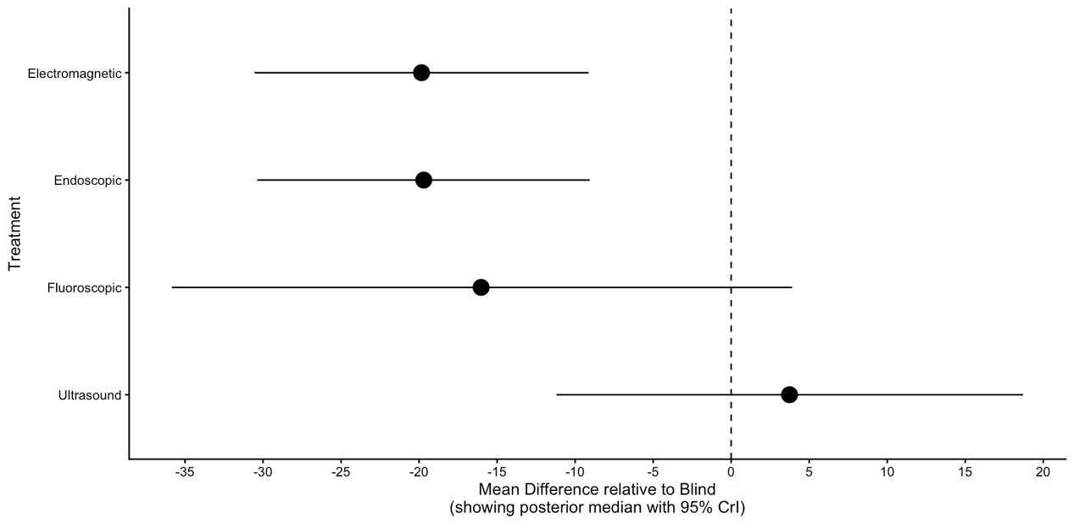

Fig S6 A Rank probability plot for procedure time. B Forest plot for procedure time.

A
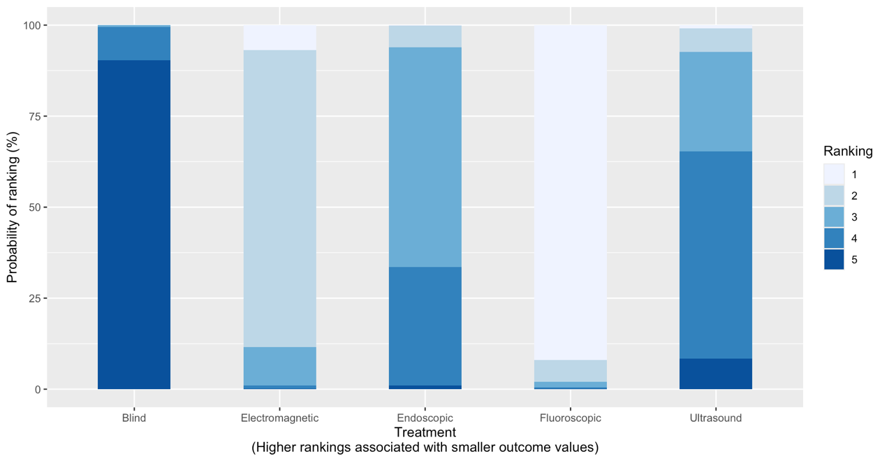
B
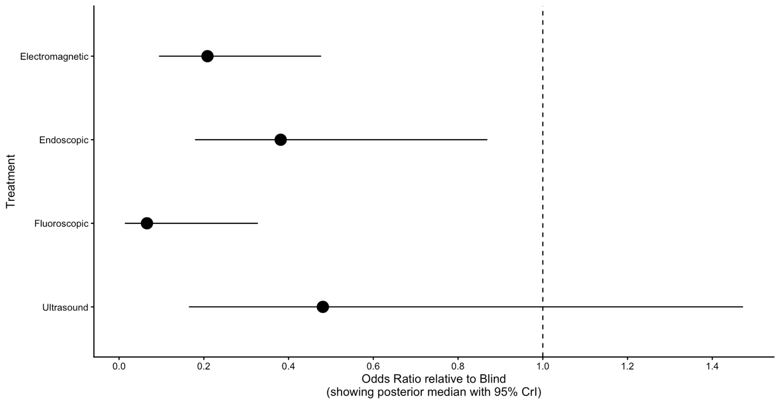

Fig S7 A Rank probability plot for complication incidence rate. B Forest plot for complication incidence rate.

A
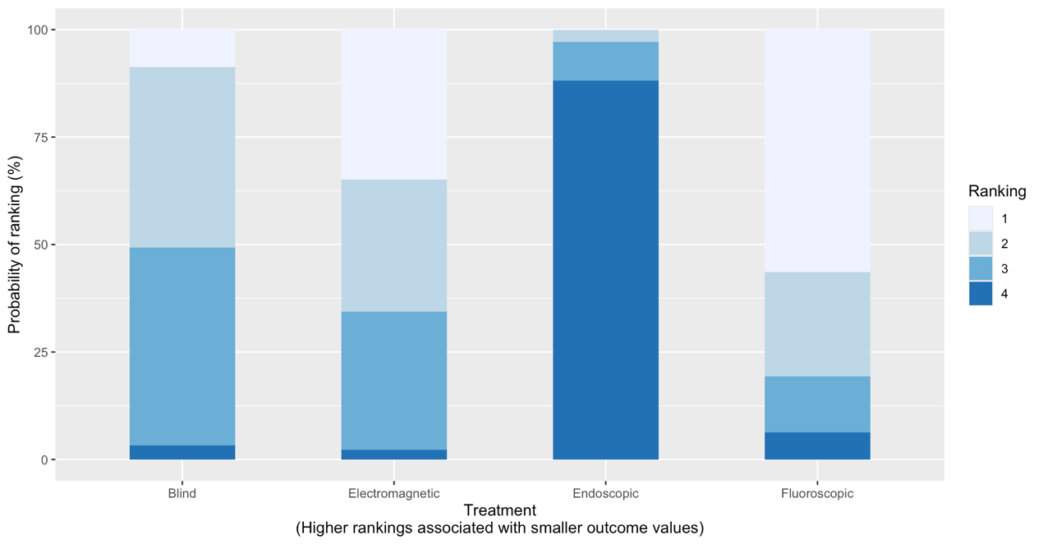
B
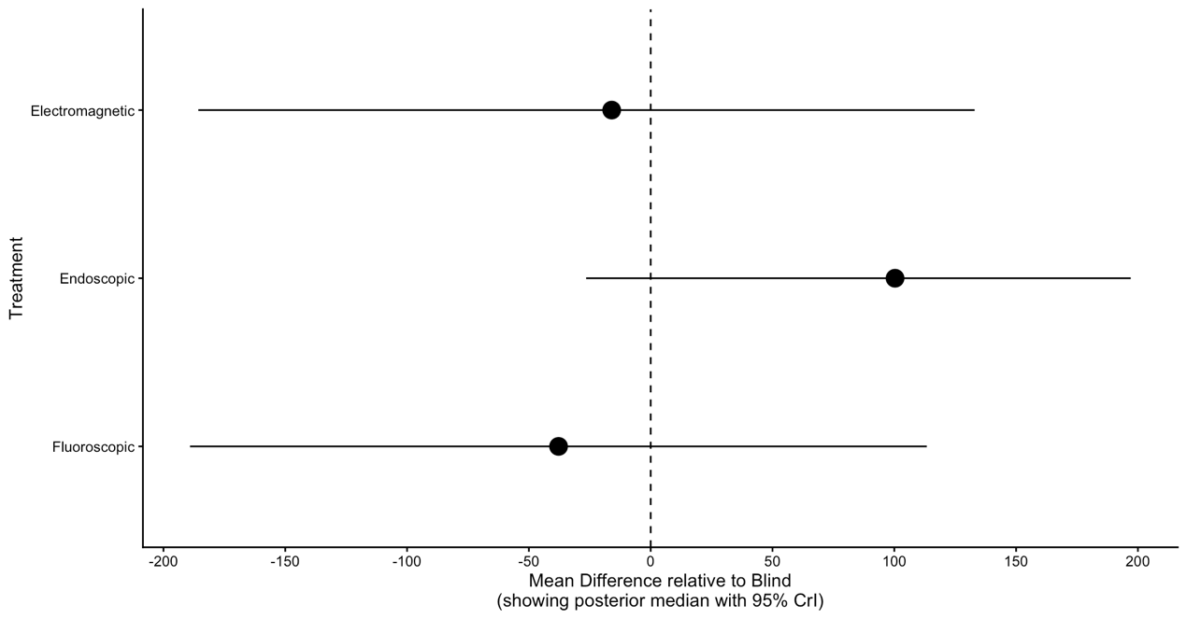

Fig S8 A Rank probability plot for direct healthcare costs. B Forest plot for direct healthcare costs.

