Supplementary Material
S1 Clinical Characteristics of the patients with the pathogenic or likely pathogenic variants 2
S2 Clinical Characteristics of the patients with VUS 2
S3 Pedigrees of the Families with Diagnostic Variants 4
S4 Diagnostic rates and study populations in recent studies 5
S5 List of the Common and Distinct Genes implicated in different diagnostic groups by study 6

S1 Clinical Characteristics of the patients with the pathogenic or likely pathogenic variants
Patient ID | Clinical Characteristics
28382 | Myoclonus-dystonia. AO: 37. No other neurological symptoms.
10369 | Generalized dystonia. AO:20. No family history.
3137 | Generalized dystonia. AO:6. Positive family history.
10398 | Focal dystonia. Subtype: Cervical dystonia. AO:17. No family history.
21103 | Focal dystonia. Subtype: Cervical dystonia. AO:20. No family history.
21339 | Focal dystonia. AO:40. Positive family history.
29928 | Cervical dystonia, tremor. AO:48.
28963 | Focal dystonia and hemifacial Spasm. AO:32. No other neurological symptoms. No family history.
28259 | Left lateral Collis, generalized myoclonus, choreiform movement disorders, ataxic gait, hypothyroidism, generalized epileptic seizure. AO:1. No family history.
21307 | Subtype: Cervical dystonia, Tremor. AO: 70. MRI: Steep cervical spine with slight retro curves in the middle and lower cervical thirds. Positive family history.
15242 | Generalized dystonia. AO: 1. No other symptoms. No family history.

S2 Clinical Characteristics of the patients with VUS

ID | Body Distribution of Dystonia | Type of Dystonia | Variant
13479 | Generalized | Isolated | KMT2B:NM_014727:c.4463G>A:p.R1488Q
14406 | Focal | Isolated | COL4A1:NM_001303110:c.7C>A:p.P3T
17709 | Segmental | Isolated | PANK2:NM_153638:c.131G>T:p.R44L
25185 | Generalized | Isolated | PI4KA:NM_058004:c.2665A>G:p.M889V
27678 | Focal | Combined | FUS:NM_004960:c.1240G>A:p.G414S:
27765 | Generalized | Combined | ATP7B:NM_001005918:c.1621G>A:p.E541K
28122 | Focal | Combined | PDGFB:NM_002608:c.115C>A:p.R39S
28338 | Segmental | Isolated | HECW2:NM_020760:c.3040A>G:p.I1014V
29711 | Focal | Isolated | SPR:NM_003124:c.472C>G:p.L158V
29735 | Focal | Combined | DHX30:NM_138615:c.87G>A:p.M29I
29848 | Focal | Combined | AFG3L2:NM_006796:c.790A>G:p.I264V
29988 | Focal | Combined | TH:NM_199292:c.67G>A:p.A23T
30303 | Focal | Isolated | GNAL:NM_182978:c.265G>A:p.A89T
30617 | Focal | Combined | TRPM7:NM_017672:c.4084C>T:p.P1362S
30793 | Focal | Isolated | CACNA1A:NM_023035:c.7091G>A:p.G2362D
30957 | Focal | Combined | LRRK2:NM_198578:c.3683G>C:p.S1228T
31171 | Focal | Isolated | ADCY5:NM_183357:c.2818G>A:p.E940K
31191 | Focal | Isolated | CACNA1B:NM_001243812:c.4738C>T:p.R1580C
31291 | Focal | Combined | PPP2R2B:NM_181677:c.647A>G:p.N216S
31302 | Focal | Isolated | TET3:NM_001287491:c.55G>A:p.D19N
31378 | Focal | Combined | SGCE:NM_001099401:c.391T>C:p.I131V
31527 | Focal | Combined | NKX2-1:NM_001079668:c.1187T>C:p.L396P
31568 | Focal | Combined | VPS4A:NM_013245:c.1226G>A:p.R409Q
31616 | Generalized | Isolated | RELN:NM_005045:c.139G>A:p.E47K
31742 | Segmental | Combined | ANO3:NM_001313727:c.2374G>A:p.V792I
31813 | Focal | Combined | HIVEP2:NM_006734:c.7163A>G:p.D2388G
32070 | Focal | Isolated | IFIH1:NM_022168:c.A802delAGAAGGAAGTGTCAGC-:p.S268delEGSVS
32175 | Focal | Isolated | PLA2G6:NM_001199562:c.101C>T:p.S34L
32294 | Focal | Isolated | SCN8A:NM_001177984:c.4612T>C:p.Y1538H
32498 | Generalized | Isolated | GCH1:NM_001024024:c.328C>G:p.Q110E
32602 | Focal | Isolated | PPP2R2B:NM_181677:c.881G>A:p.R294H
32714 | Focal | Isolated | KMT2B:NM_014727:c.3895G>T:p.A1299S
32719 | Focal | Isolated | IRF2BPL:NM_024496:c.1220C>T:p.A407V
32743 | Generalized | Isolated | THAP1:NM_018105:c.238A>G:p.I80V
32758 | Focal | Isolated | PRRT2:NM_001256443:c.224C>T:p.P75L
33086 | Focal | Combined | CACNA1B:NM_000718:c.6965C>T:p.S2322L
33427 | Generalized | Combined | PRKRA:NM_001316362:c.365G>C:p.S122T
33487 | Generalized | Isolated | TUBB4A exon4 duplication
33499 | Focal | Isolated | CBS:NM_000071:c.1643G>A:p.R548Q
33583 | Focal | Combined | SCN8A:NM_001177984:c.3685C>T:p.R1229C
33607 | Focal | Isolated | CACNA1A:NM_000068:c.3052G>A:p.E1018K:
33698 | Focal | Isolated | HIVEP2:NM_006734:c.944T>G:p.L315W
33845 | Focal | Combined | SGCE:NM_001099400:c.1280G>A:p.R427H
34491 | Focal | Isolated | LRRK2:NM_198578:c.2248G>A:p.E750K
35053 | Focal | Isolated | KMT2B:NM_014727:c.G6754ins+CCCCC
35126 | Focal | Isolated | ADCY5:NM_183357:c.1024C>G:p.L342V
35271 | Focal | Isolated | PLA2G6:NM_003560:c.1267G>A:p.A423T
35446 | Focal | Isolated | KMT2B:NM_014727:c.1391C>T:p.T464M
35473 | Focal | Combined | PANK2:NM_153638:c.796G>A:p.V266M
35496 | Focal | Isolated | ALDH18A1:NM_002860:c.211A>G:p.K71E
35695 | Focal | Isolated | PRKAR1B:NM_001164759:c.949C>T:p.R317C
36131 | Focal | Combined | CACNA1A:NM_000068:c.3187C>T:p.P1063S
36606 | Generalized | Combined | SPTBN1:NM_178313:c.2210A>G:p.Q737R

S3 Pedigrees of the Families with Diagnostic Variants
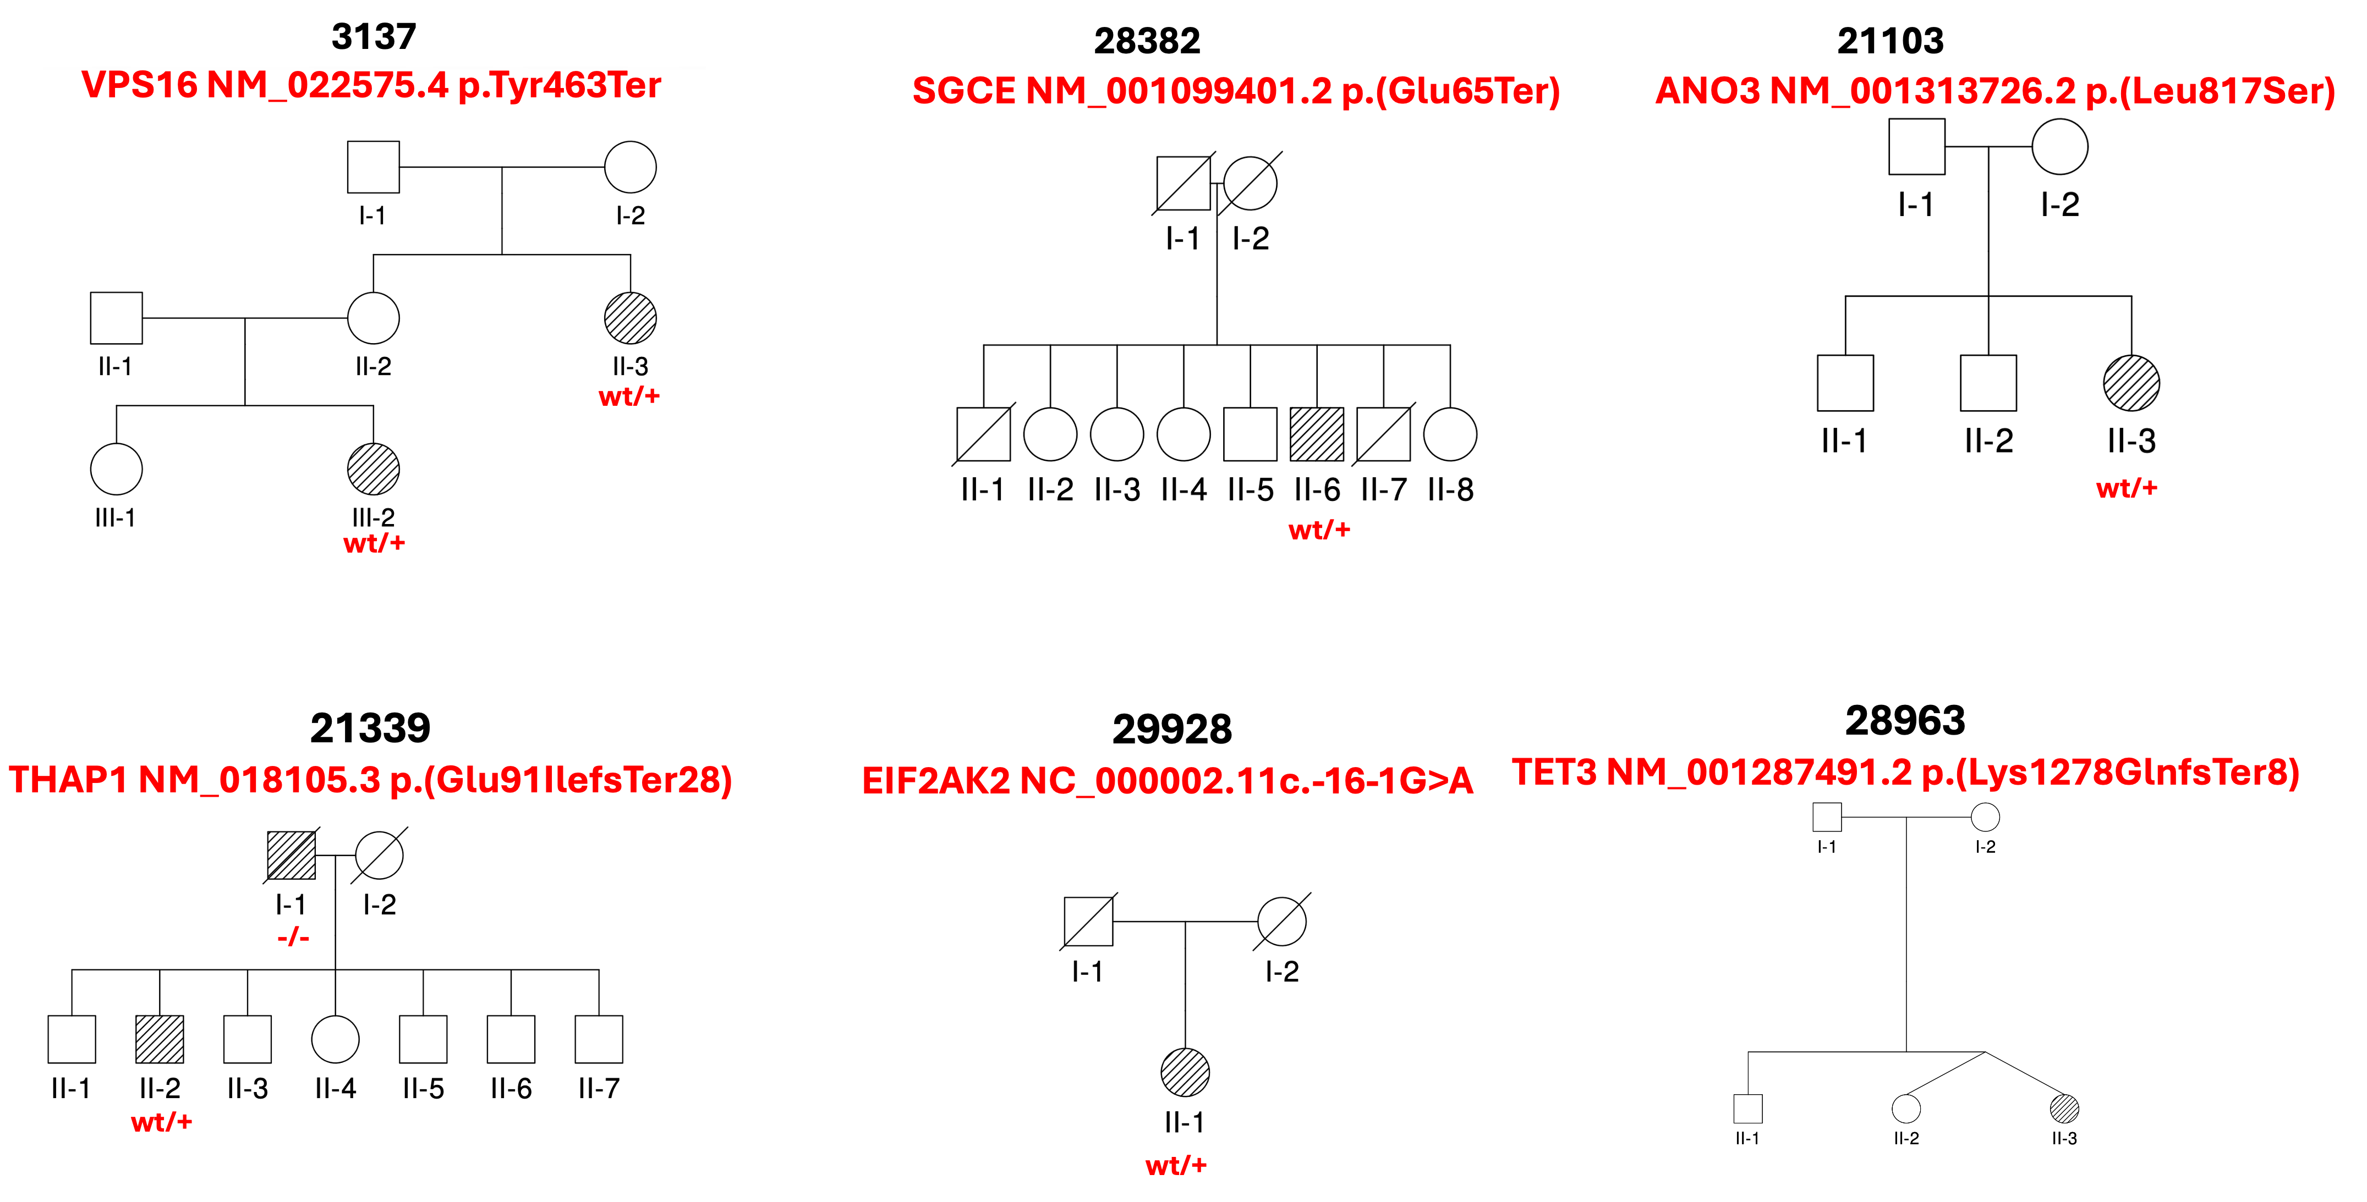
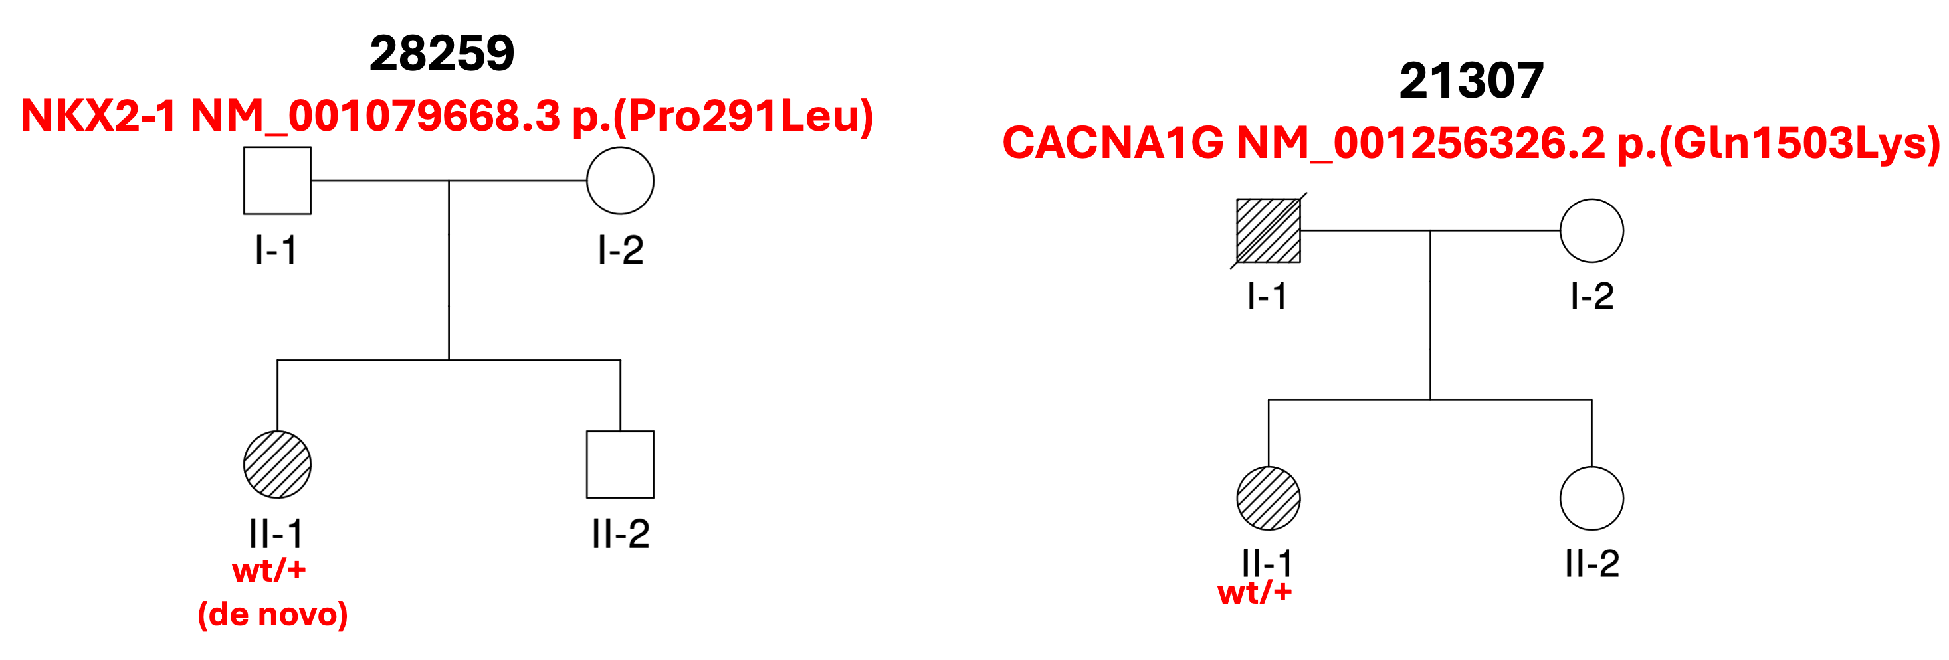

S4 Diagnostic rates and study populations in recent studies
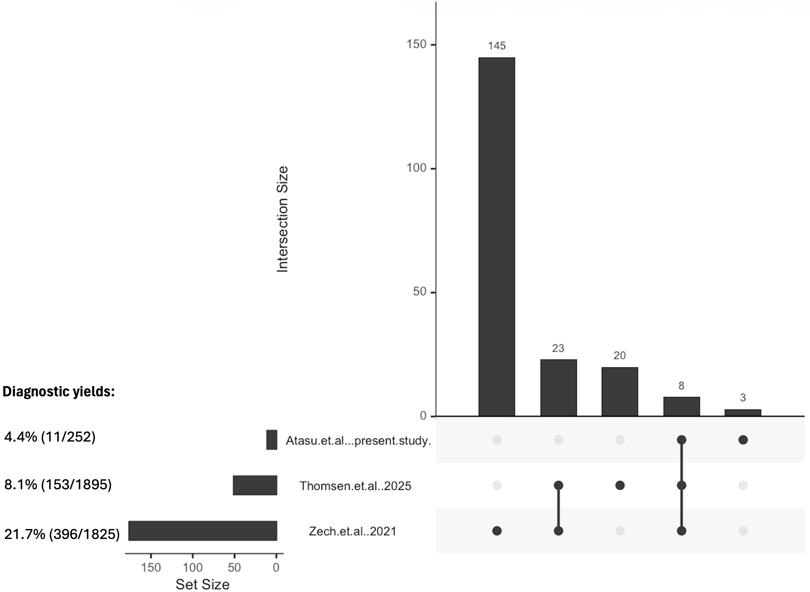

S5 List of the Common and Distinct Genes implicated in different diagnostic groups by study
Study | Gene List | Number of Genes
Thomsen et al., 2025 | ACTB, ADCY5, AFG3L2, ANO3, ATL1, ATP1A3, C19orf12, CACNA1A, CHD6, CHMP2B, COL4A1, CTNNB1, EIF2AK2, EIF4A2, FTL, GCH1, GNAL, GNAO1, GNB1, GRN, IFIH1, IRF2BPL, KCNJ10, KCNMA1, KCNN2, KCNQ2, KCTD7, KIF1A, KLC1, KMT2B, MECP2, NKX2-1, NR4A2, PDE10A, PRKCG, PSEN1, SCN8A, SETX, SGCE, SLC2A1, SLC6A1, SPAST, SPR, TBP, TCF20, THAP1, TOR1A, TUBB4A, TWNK, VPS16, ZMYND11 | 51
Zech et al., 2025 | ACTB, ADAR, ADCY5, AFG3L2, ALS2, ANK2, ANO3, AOPEP, ASXL3, ATL1, ATM, ATP1A3, ATP2B2, ATP5F1A, ATP5F1B, ATP5MC3, ATP7B, ATP8A2, AUTS2, BCL11B, BRAF, C19orf12, CACNA1A, CACNA1E, CAMK4, CAMTA1, CASK, CD40LG, CHD3, CHD4, CHD8, CNTNAP1, COQ8A, CP, CSDE1, CTNNB1, CUL3, CUX1, CWF19L1, DDC, DHCR24, DLG4, DLL1, DNAJC6, DNM1L, DNMT1, EBF3, ECHS1, EEF1A2, EIF2AK2, ERCC4, ERCC8, FA2H, FBXO31, FGF14, FITM2, FOXP2, FRMD5, FRYL, FTL, GABBR2, GABRA1, GAD1, GCH1, GJA1, GJC2, GNAL, GNB1, GRIA2, GRIA3, GRID2, GRIN1, GRIN2A, HECW2, HEXA, INTS11, IRF2BPL, KCNA2, KCNB1, KCNJ10, KCNMA1, KIF1A, KIF5A, KMT2B, LIG4, LRRK2, MAG, MATR3, MECP2, MECR, MED23, MICU1, MMAA, MORC2, MRE11, MSL3, NAA15, NARS2, NAV3, NEFL, NGLY1, NKX2-1, NPC1, NR4A2, NUP54, PANK2, PARK7, PCDH12, PDE10A, PDHA1, PINK1, PLA2G6, PNKD, PNPLA6, POLG, POLR1A, POLR3A, PPP2R5D, PPT1, PRKCG, PRKN, PRRT2, PSEN1, PTS, PURA, RALA, RARB, RERE, RHOBTB2, SATB1, SCN2A, SCO2, SCP2, SERAC1, SETX, SGCE, SHQ1, SLC19A3, SLC20A2, SLC2A1, SON, SOX2, SOX6, SPAST, SPG11, SPG7, SPR, SPTBN1, SRRM2, SYNE1, TBC1D24, TBX1, TCF20, TECPR2, TFE3, TH, THAP1, TMEM240, TOR1A, TTPA, TUBB4A, UBE3A, VLDLR, VPS16, WAC, WARS2, WASHC5, WDR73, WFS1, YY1, ZC4H2, ZEB2, ZMYND11, ZNF142, ZNF335 | 175
Atasu et al. (present study) | TET3, SGCE, NKX2-1, CACNA1G, KMT2B, VPS16, GNAL, ANO3, THAP1, VPS4A, EIF2AK2 | 11
Common genes in all three studies | SGCE, NKX2-1, KMT2B, VPS16, GNAL, ANO3, THAP1, EIF2AK2 | 8
Common genes in Thomsen et al. (2025) and Zech et al. (2025) | ACTB, ADCY5, AFG3L2, ANO3, CACNA1A, CTNNB1, EIF2AK2, FTL, GCH1, GNAL, GNB1, IRF2BPL, KCNJ10, KCNMA1, KIF1A, KMT2B, NKX2-1, NR4A2, PDE10A, PRKCG, PSEN1, SETX, SGCE, SLC2A1, SPAST, SPR, TCF20, THAP1, TOR1A, VPS16, ZMYND11 | 31

