Supporting Information

Heteronuclear Binary-Atom-Controlled Cobalt-Based Catalyst for Lithium-Sulfur Batteries
Qiang. Liu^{1,2}, Feiyu Wang², Liming Song^{2,3}, Xianwu,Li², Yong Xiang^{4,5}, Fan Chen^{5*}
1 School of Mechanical Engineering University of Science and Technology Beijing
Beijing 100083, China
2. Inner Mongolia North Hauler Joint Stock Co.,Ltd, Baotou 014010, China，
3.Inner Mongolia University of Science & Technology, Baotou 014010, China
4.Institute of Electronic and Information Engineering of UESTC in Guangdong, Dong Guan 523808, China
5.School of Materials and Energy, University of Electronic Science and Technology of China, Chengdu 611731, China

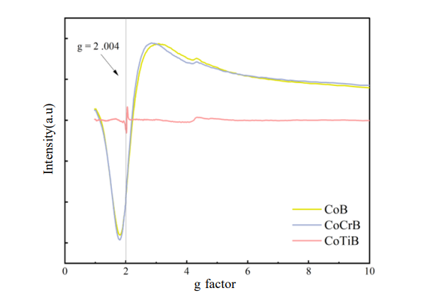
Figure S1 Electron paramagnetic resonance test.

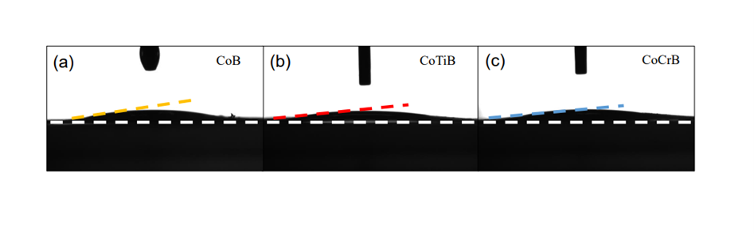
Figure S2 Contact Angle of CoB, CoTiB and CoCrB

