Supplementary File: 1 Details of Control variables used in analysis

Control variables include socio-demographic and health domains. The age of the respondents was categorized as 45-59 years, 60-69 years and 70 years and above. Education status was categorised as ‘No formal education’, ‘Primary education’ and ‘Secondary & Above’. The religion was coded as ‘Hindu’, ‘Muslim’ and ‘Other’ while Caste was recoded as ‘Scheduled Caste (SC) & Scheduled Tribe (ST)’, ‘Other Backward Class (OBC)’ and ‘Others’. The residential status of respondents was categorized as ‘Urban’ and ‘Rural’ while the present region of their staying was grouped into ‘North’, ‘Central’, ‘East’, ‘North East’, ‘West’ and ‘South’. The LASI data provides the household wealth status of the respondents in five quintiles, estimated using the household consumption expenditure for food and non-food items. In this study, it was further recoded into three groups: ' poor’ for the individuals in ‘poorest & poorer’, ‘middle’, and ‘rich’ for the individuals in the ‘richer & richest’ wealth quintiles. The living status of the respondent were recoded as ‘Alone/with Others’ and ‘With spouse’.

The study generated social activity status using twelve social activities of the respondents. This includes Eat out of the house, Go to park/beach for relaxing, Play cards or indoor games, Play outdoor games/sports/exercise/jog/yoga, Visit relatives /friends, Attend cultural performances etc., Attend religious functions etc. Attend political/ community/ organization meetings, read books/newspapers/magazines, Watch television/listen radio, Use a computer, and also Talking to friends. The status of social activity was coded as ‘No’ and ‘At least one’. The study also computed a composite score for the food insecurity index for the respondents by compiling the following five questions such as; Reduced the size of meals, Did not eat enough food of choice, Hungry but didn’t eat, Not eat for a whole day, and Lost weight in the last 12 months because there was not enough food. The food insecurity status was coded as ‘No food insecurity’ and ‘Food insecurity in at least one indicator’. The respondents were asked whether they had felt ill-treated and the responses were coded as “No’ and ‘Yes’. Similarly, they were asked whether they ever consumed tobacco and alcohol and their responses were coded as ‘No and ‘Yes. The respondents were also enquired about difficulties for six ADL (for Dressing, Walking, Bathing, Eating, Get in or out of bed, using toilet) and seven IADL (Preparing a hot meal, Shopping for groceries, Making telephone calls, Taking medications, Doing work around the house, Managing money and also Getting around or finding address). The study recoded ADL status and IADL status as ‘Yes’, if the respondent reports any of them and ‘No’ if do not report such difficulties. The respondents were asked if any of the Diagnosed chronic conditions or diseases such as hypertension, diabetes, cancer, chronic lung disease, chronic heart disease, stroke, chronic bone/joint disease, and high cholesterol. The respondents were classified as per the presence of the above as; ‘No Morbidity’, ‘Single Morbidity’ and ‘Two or more Morbidity’ category.

Supplementary File: 2

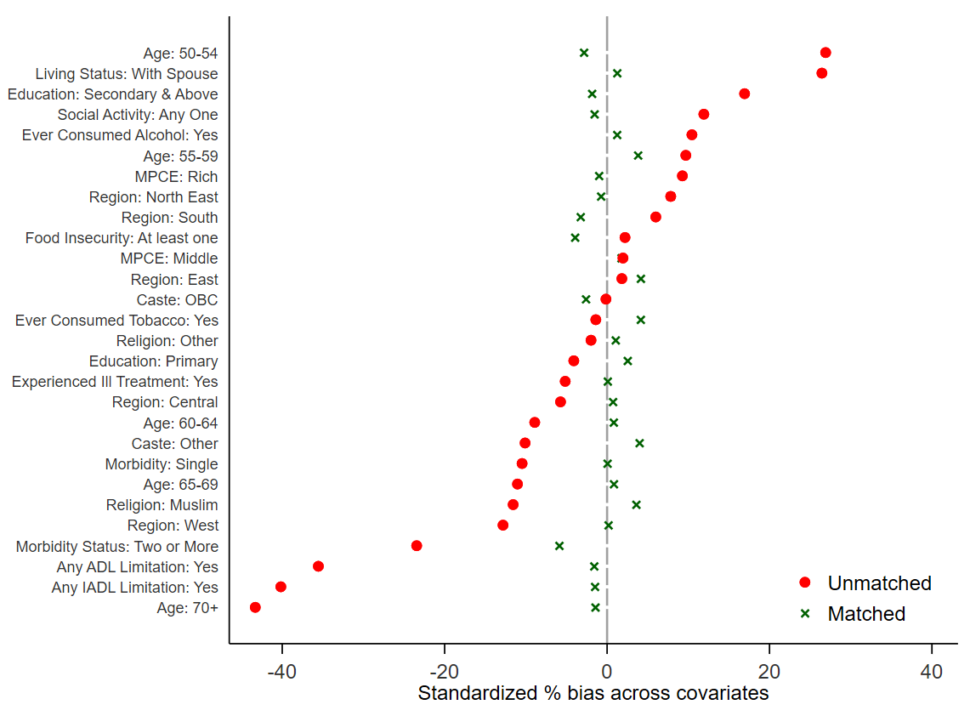
Figure 2: Standardized % bias across covariates

Supplementary File: 3
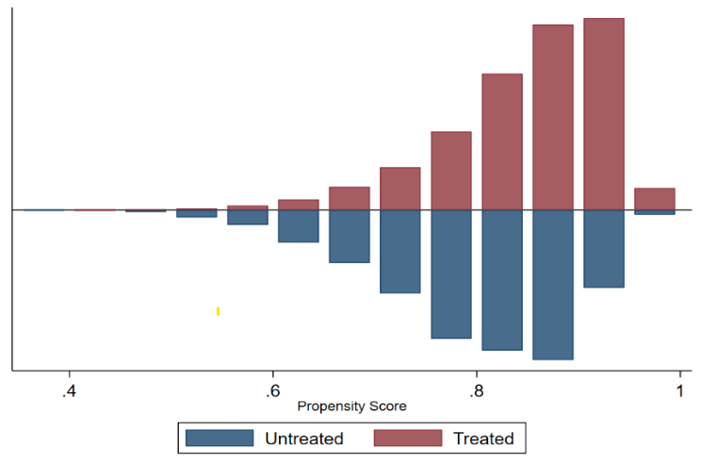
Figure 3: Predicted Probability of regular cash income: matched sample, India, LASI wave 1, 2017-2018

