Supplementary Table S1 Percentages of damage in association white-matter tract relate to supra-tentorial region in each cluster
 | Cluster 1 | Cluster 2 | Cluster 3 | p value | ε² | 95% CI
Arcuate fasciculus (%), median (range)  Inferior front-occipital fasciculus (%), median (range)  Uncinate fasciculus (%), median (range)  Vertical occipital fasciculus (%), median (range)  Superior longitudinal fasciculus (%), median (range)  Middle longitudinal fasciculus (%), median (range)  Inferior longitudinal fasciculus (%), median (range)  Acoustic radiation (%), median (range)  Optic radiation (%), median (range)  Corticothalamic pathway (%), median (range)  Corticostriatal pathway (%), median (range)  Corpus callosum anterior (%), median (range)  Corpus callosum mid-anterior (%), median (range)  Corpus callosum central (%), median (range)  Corpus callosum mid-posterior (%), median (range)  Corpus callosum posterior (%), median (range)  Cinglum (%), median (range)  Fornix (%), median (range)  Frontal aslant tract (%), median (range)  Extreme capsule (%), median (range)  U-fiber (%), median (range) | 0 (0-100)  0 (0-100)  0 (0-100)  0 (0-100)  0 (0-75.03)  0 (0-100)  0 (0-100)  0 (0-100)  0 (0-100)  3.91 (0-99.33)  5.90 (0-92.86)  0 (0-91.86)  0 (0-43.33)  0 (0-45.36)  0 (0-83.37)  0 (0-95.38)  0 (0-89.74)  0 (0-63.89)  0 (0-97.34)  0 (0-100)  0.01(0-50.90) | 0 (0-100)  0 (0-100)  0 (0-73.02)  0 (0-29.85)  0 (0-100)  0 (0-100)  0 (0-95.35)  0 (0-97.20)  0 (0-100)  10.57 (0-76.43)  6.60 (0-94.18)  0 (0-20.27)  0 (0-74.11)  0 (0-91.68)  0 (0-88.50)  0 (0-85.22)  0 (0-47.46)  0 (0-0)  0 (0-100)  0 (0-100)  0.70 (0-71.94) | 0 (0-100)  0 (0-100)  0 (0-41.14)  0 (0-100)  0 (0-66.48)  0 (0-100)  0 (0-100)  0 (0-100)  0 (0-100)  7.06 (0-99.01)  5.14 (0-96.13)  0 (0-35.89)  0 (0-99.36)  0 (0-89.83)  0 (0-66.29)  0 (0-95.38)  0 (0-33.28)  0 (0-100)  0 (0-75.99)  4.11 (0-100)  0.09 (0-50.90) | 0.748  0.995  0.383  0.653  0.972  0.334  0.947  0.218  0.944  0.690  0.936  0.875  0.623  0.479  0.665  0.159  0.088  0.123  0.430  0.303  0.851 | 0  0  0  0  0  0.003  0  0.014  0  0  0  0  0  0  0  0.023  0.038  0.031  0  0.005  0 | 0-0.093  0-0.072  0-0.123  0-0.108  0-0.084  0-0.163  0-0.082  0-0.183  0-0.074  0-0.098  0-0.08  0-0.087  0-0.115  0-0.124  0-0.112  0-0.196  0-0.236  0-0.189  0-0.110  0-0.156  0-0.083
Supplementary Table S2. Percentages of damage in white-matter tract relate to infra-tentorial region and commissure fibers in each cluster
 | Cluster 1 | Cluster 2 | Cluster 3 | p value | ε² | 95% CI
Corticospinal tract (%), median (range)  Reticulo-spinal tract (%), median (range)  Spino-thalamic tract (%), median (range)  Fronto-pontine tract (%), median (range)  Parieto-pontine tract (%), median (range)  Temporo-pontine tract (%), median (range)  Occipito-pontine tract (%), median (range)  Lateral lemniscus (%), median (range)  Medial lemniscus (%), median (range)  Medial longitudinal fasciculus (%), median (range)  Dorsal longitudinal fasciculus (%), median (range)  Central tegmental tract (%), median (range)  Superior cerebellar peduncle (%), median (range)  Middle cerebellar peduncle (%), median (range)  Inferior cerebellar peduncle (%), median (range)  Cerebellar vermis (%), median (range)  Cerebellar hemisphere (%), median (range)  Anterior commissure (%), median (range)  Posterior commissure (%), median (range) | 3.91 (0-99.33)  0 (0-100)  0 (0-96.48)  8.77 (0-100)  9.70 (0-100)  0 (0-100)  0 (0-100)  0 (0-100)  0 (0-87.10)  0 (0-100)  0 (0-100)  0 (0-100)  0 (0-49.00)  0 (0-71.54)  0 (0-100)  0 (0-98.03)  0 (0-37.26)  0 (0-99.38)  0 (0-28.79) | 10.57 (0-76.43)  0 (0-0)  0 (0-33.85)  0.49 (0-100)  14.01 (0-99.91)  0 (0-97.41)  0 (0-95.77)  0 (0-98.68)  0 (0-12.90)  0 (0-0)  0 (0-33.33)  0 (0-20.00)  0 (0-54.99)  0 (0-24.50)  0 (0-66.12)  0 (0-100)  0 (0-57.85)  0 (0-98.16)  0 (0-1.70) | 7.07 (0-99.01)  0 (0-66.67)  0 (0-100)  0.19 (0-100)  44.00 (0-100)  0 (0-100)  0 (0-100)  0 (0-0)  0 (0-99.19)  0 (0-100)  0 (0-100)  0 (0-100)  0 (0-45.01)  0 (0-58.40)  0 (0-3.24)  0 (0-7.16)  0 (0-9.97)  0 (0-99.95)  0 (0-100) | 0.898  0.167  0.013  0.439  0.431  0.104  0.186  0.354  0.013  0.128  0.078  0.029  0.494  0.187  0.322  0.496  0.719  0.682  0.423 | 0  0.022  0.094  0  0  0.035  0.019  0.001  0.093  0.029  0.043  0.079  0  0.019  0.004  0  0  0  0 | 0-0.09  0-0.114  0.007-0.272  0-0.142  0-0.141  0-0.196  0-0.179  0-0.092  0.005-0.273  0-0.195  0-0.255  0-0.280  0-0.118  0-0.164  0-0.120  0-0.093  0-0.083  0-0.107  0-0.155

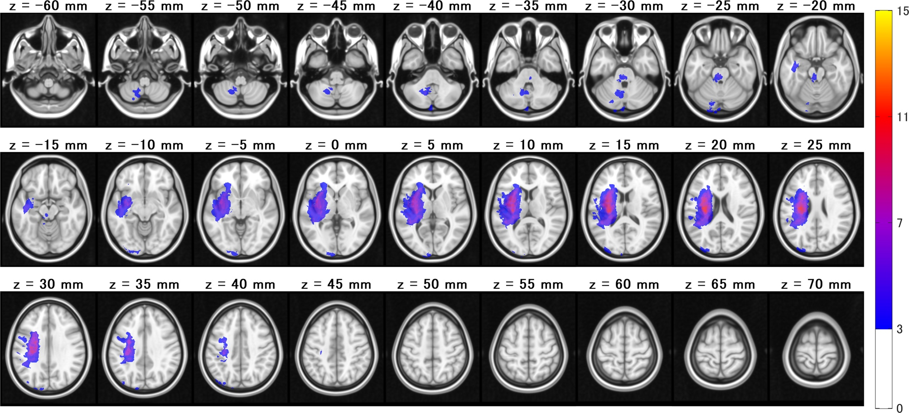
Supplementary Figure S1
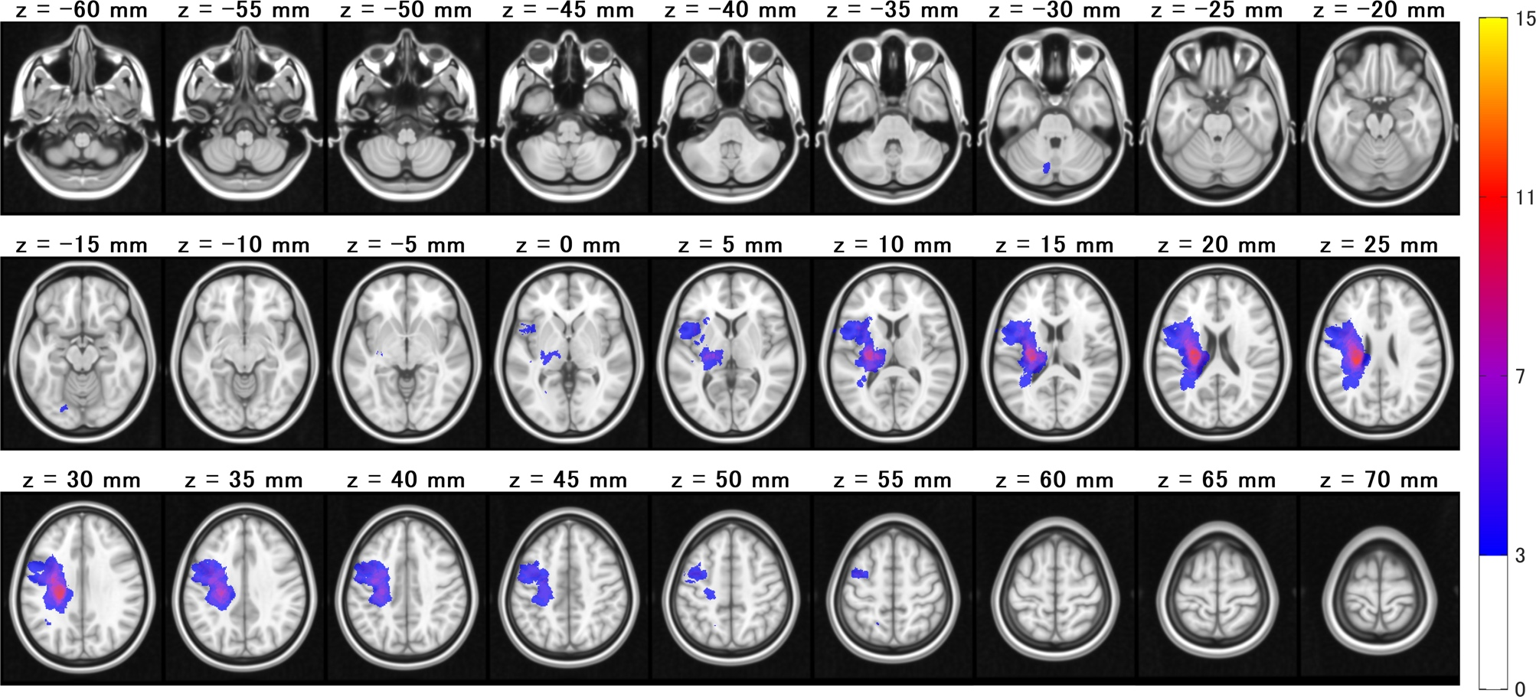
Supplementary Figure S2

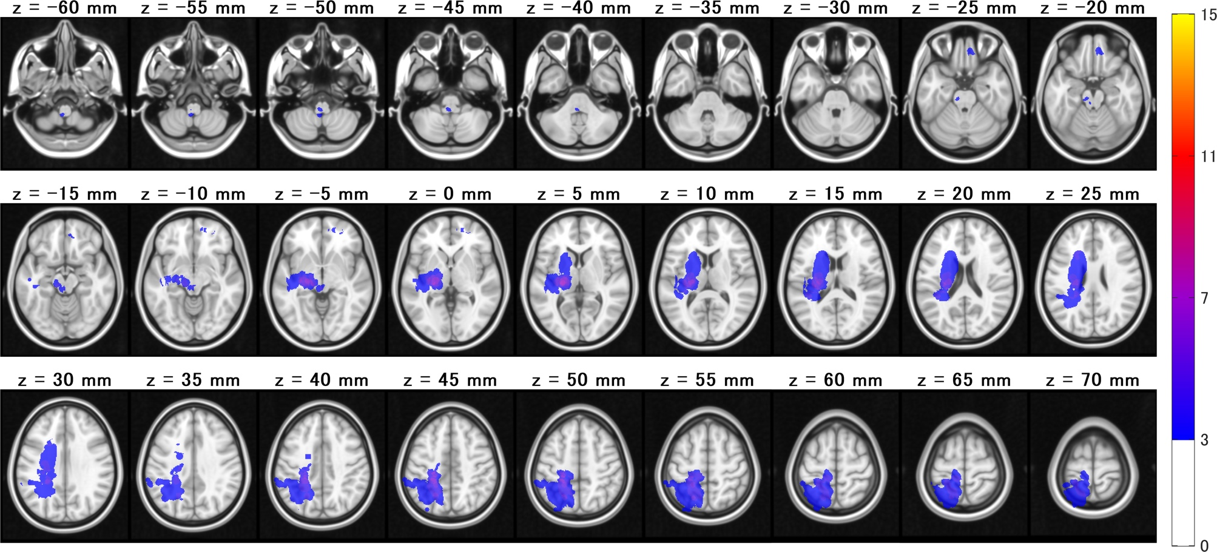
Supplementary Figure S3
Supplementary information

Supplementary Table S1. Percentages of damage in association fibers relate to supra-tentorial region in each cluster.

Supplementary Table S2. Percentages of damage in fibers relate to infra-tentorial region and commissure fibers in each cluster.
Bold represents significant differences between clusters.

Supplementary Figure S1. Lesion-frequency heat map in the cluster 1 (n = 32)
Brighter colors indicate regions with a greater number of patients with lesions (i.e., higher lesion overlap).

Supplementary Figure S2. Lesion-frequency heat map in the cluster 2 (n = 25)
Brighter colors indicate regions with a greater number of patients with lesions (i.e., higher lesion overlap).

Supplementary Figure S3. Lesion-frequency heat map in the cluster 3 (n = 18).
Brighter colors indicate regions with a greater number of patients with lesions (i.e., higher lesion overlap).

