Appendix: Additional Analyses of the UCLA Loneliness scale scores across 35 nations

Percentage above cut-off

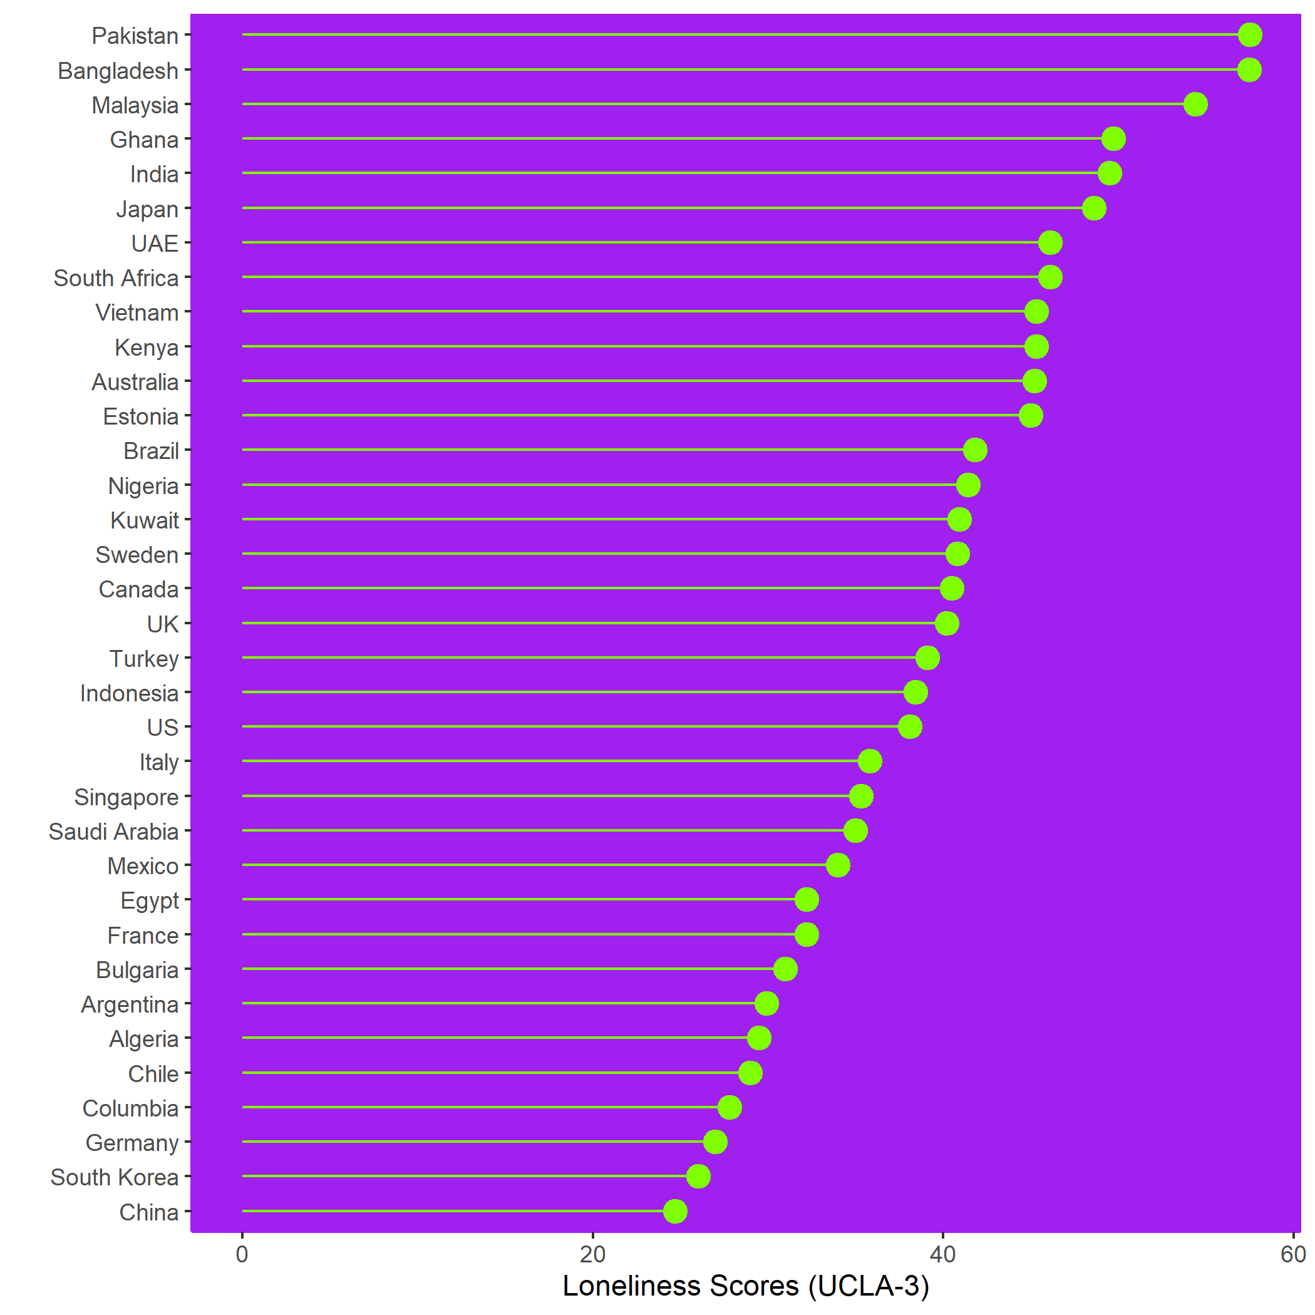

Figure A1: Percentage of the study population scoring above the cut-off score on the UCLA-3 loneliness scale. Data listed in descending order

Means Scores on the UCLA-3

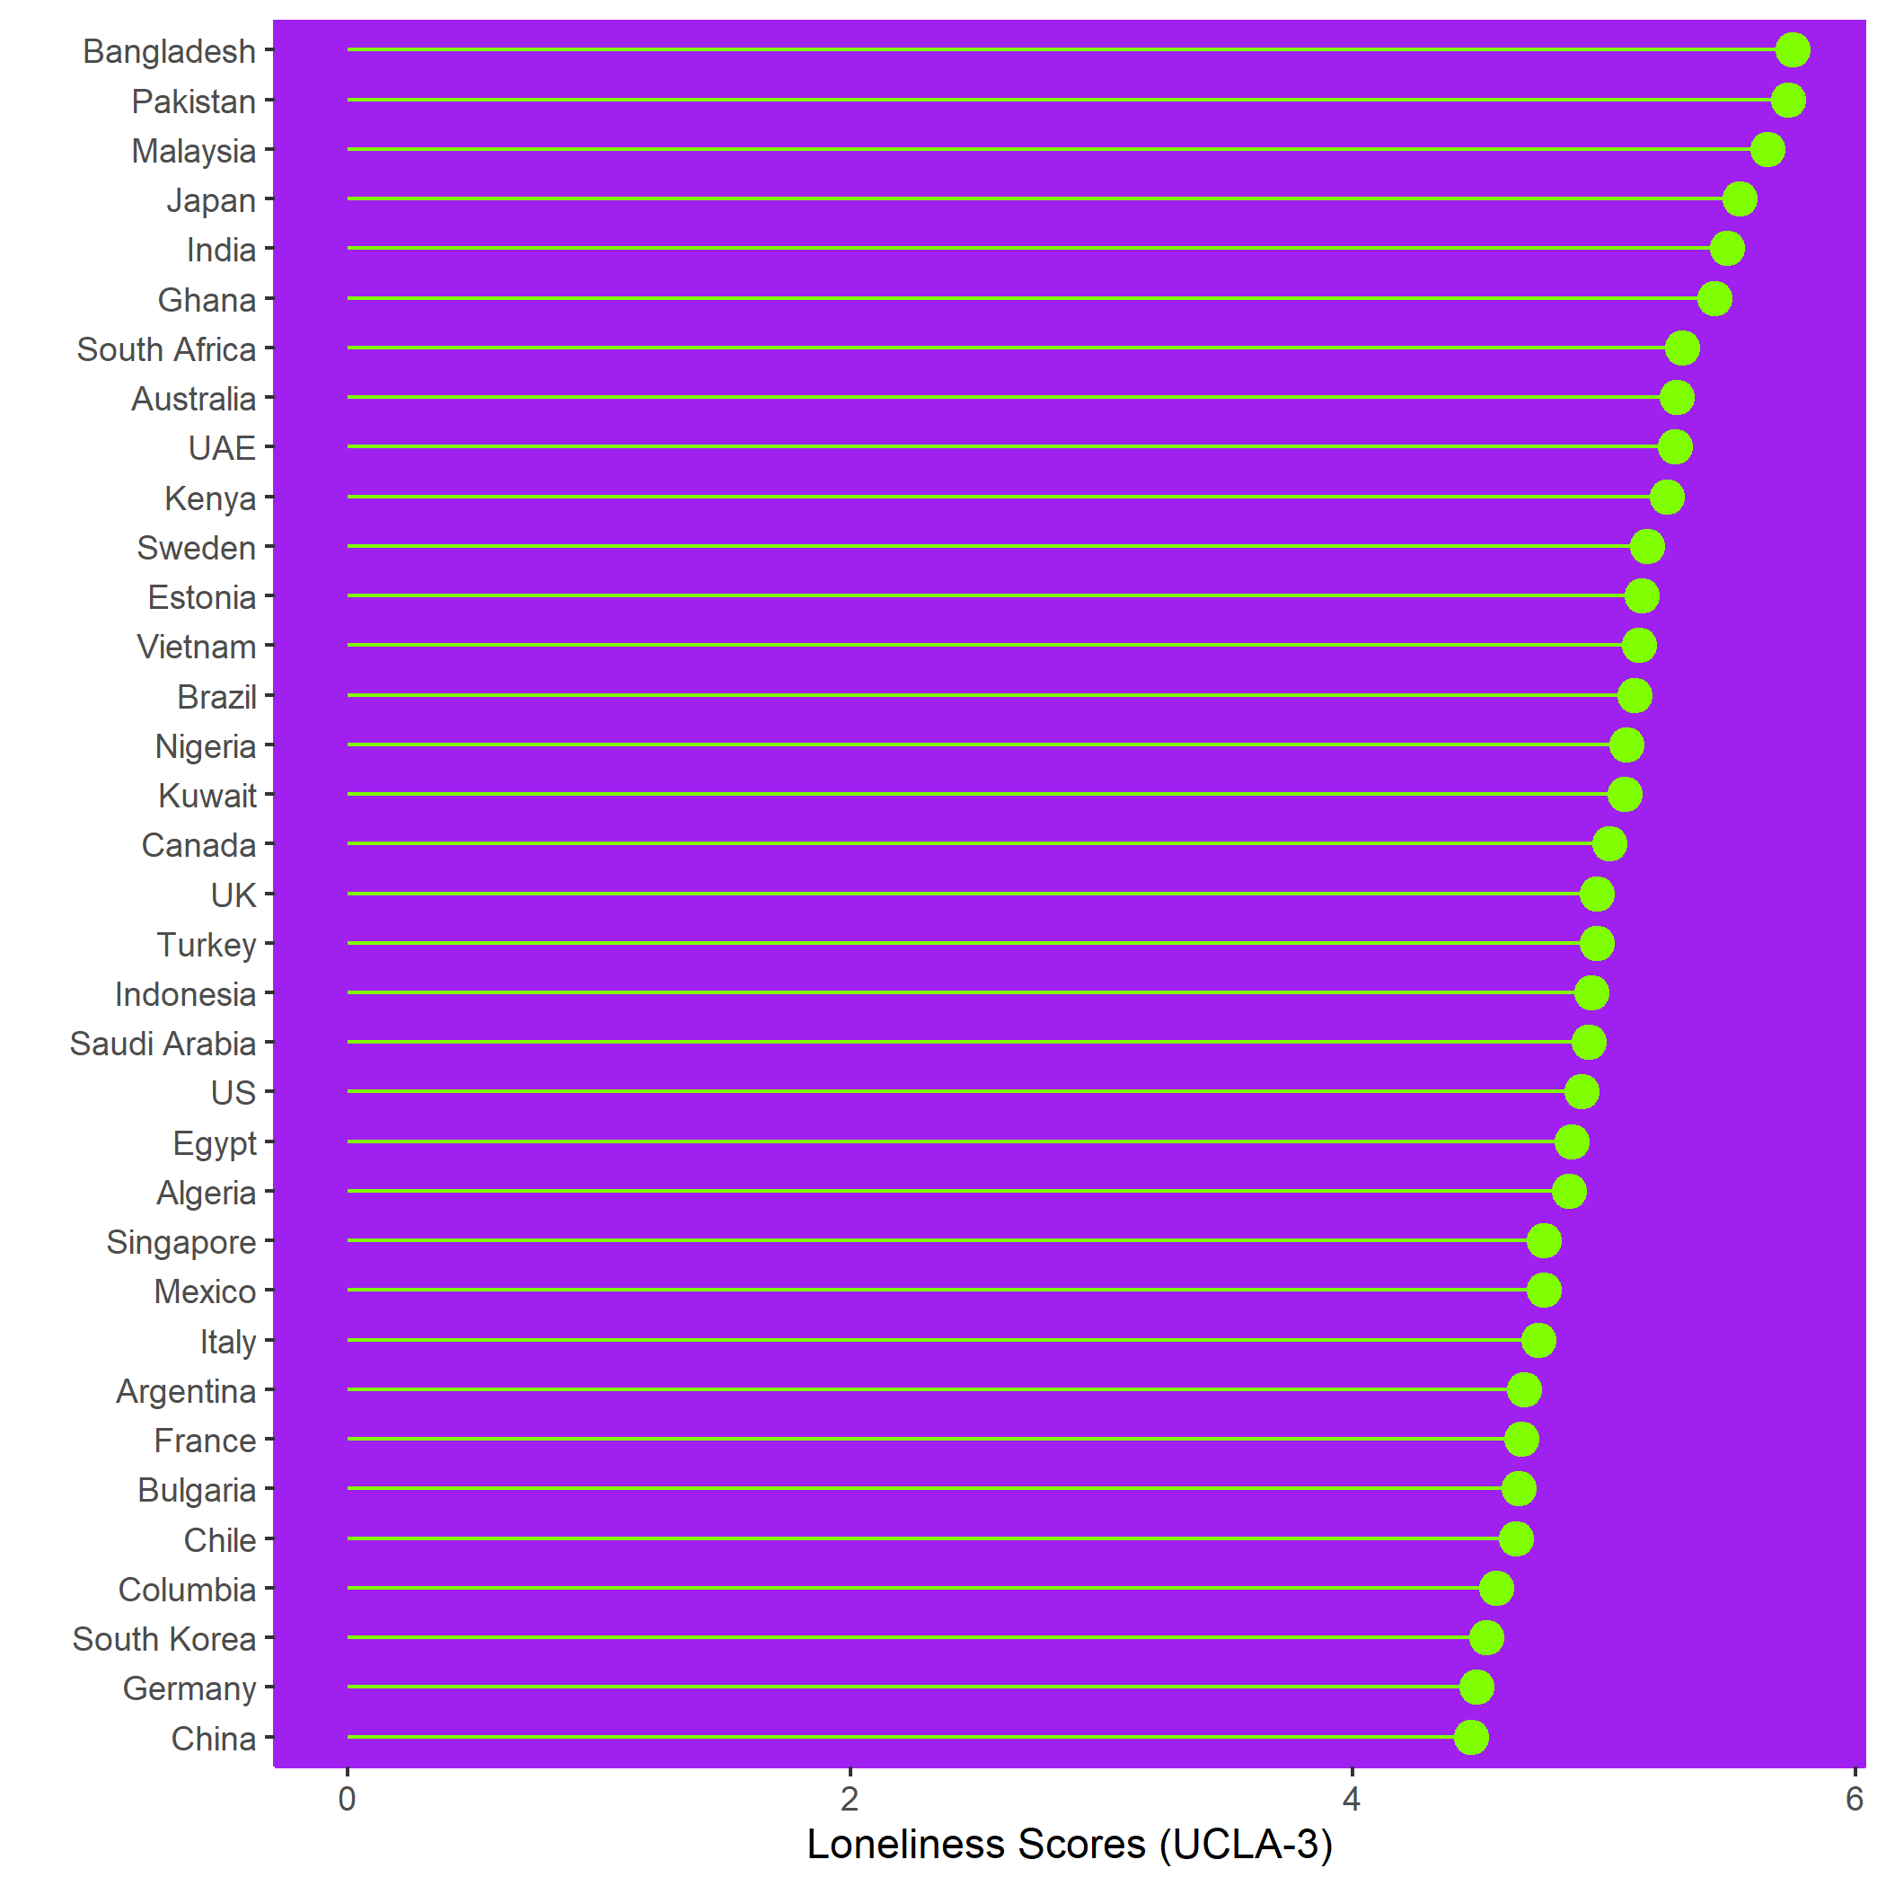

Adjusted Marginal Means

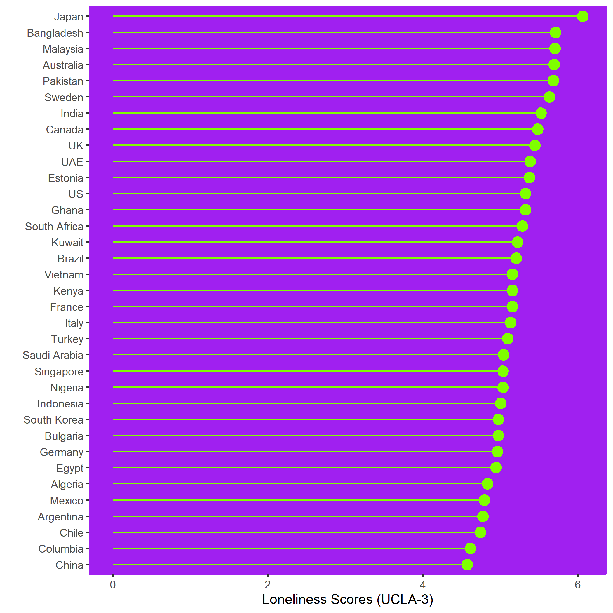

Figure A3: Estimated marginal means on the UCLA-3 loneliness scale after controlling for associated demographic variables (gender, age, education, employment and parental status). Post Hoc Tukey test reveals that Japan has significantly higher levels of loneliness compared with all other countries, p = <.001

