Figure S1. Random meta-analysis for the prevalence of obesity in patients with COVID-19

Figure S2. Random meta-analysis for the association of obesity with susceptibility to COVID-19

Figure S3. Random meta-analysis for the association of obesity with COVID-19 severity

Figure S4. Random meta-analysis for the association of obesity with odds of COVID-19 hospitalization

Figure S5. Random meta-analysis for the association of obesity with need for mechanical ventilation in COVID-19

Figure S6. Random meta-analysis for the association of obesity with odds of ICU admission in COVID-19 patients

Figure S7. Random meta-analysis for the association of obesity with death due to COVID-19

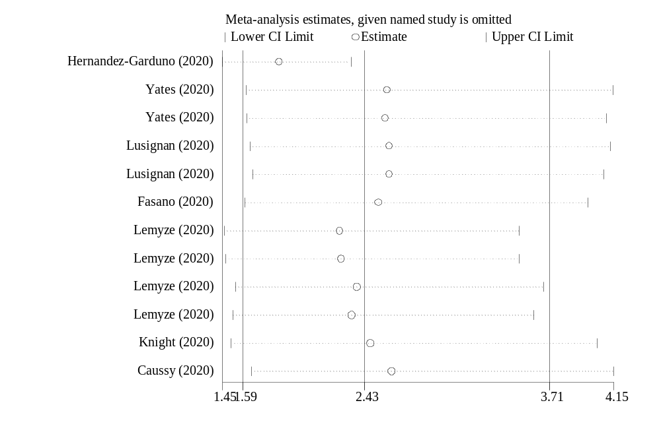
Figure S8. Sensitivity analysis in studies investigating the association of obesity with the risk of COVID-19

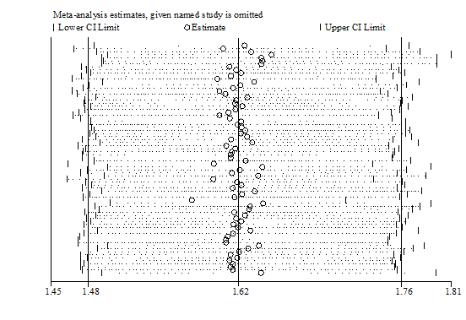

Figure S9. Sensitivity analysis in studies investigating the association of obesity with COVID-19 severity

Figure S10. Funnel plots for publication bias. A) COVID-19 risk, B) COVID-19 severity, C) Death, D) Hospitalization, E) ICU admission, F) Mechanical ventilation

Table S1. Subgroup analysis for the association between obesity and risk of susceptibility to COVID-19.

 |  |  |  |  |  |  |  | Effect sizes (n) | I² (%) | P-_{heterogeneity} | OR (95%CI)
 | Overall |  |  |  |  |  |  | 12 | 93.0 | ≤0.001 | 2.42 (1.58 -3.70)
 | Obesity degree
 |  |  | Obesity |  |  |  |  | 3 | 90.1 | ≤0.001 | 2.34 (1.27 -4.31)
 |  |  | Class I |  |  |  |  | 2 | 82.3 | 0.01 | 3.14 (0.61 -16.08)
 |  |  | Class I/Sever obesity |  |  |  |  | 1 | - | - | 1.41 (1.04 -1.91)
 |  |  | Sever obesity |  |  |  |  | 2 | 19.5 | 0.26 | 1.77 (0.95 -3.31)
 |  |  | Morbid obesity |  |  |  |  | 2 | 63.8 | 0.09 | 2.39 (0.43 -13.31)
 |  |  | Not reported |  |  |  |  | 2 | 95.4 | ≤0.001 | 3.53 (0.90 -13.80)
 | Study design
 |  |  |  | Cohort |  |  |  | 3 | 77..4 | 0.01 | 1.84 (1.33 -2.57)
 |  |  |  | Non-cohort |  |  |  | 9 | 94.4 | ≤0.001 | 2.91 (1.52 -5.55)
 | Age category
 |  |  |  | ≥ 50 years |  |  |  | 9 | 54.8 | 0.02 | 1.81 (1.38 -2.38)
 |  |  |  | ˂ 50 years |  |  |  | 1 | - | - | 6.92 (5.54 -8.65)
 |  |  |  | Not reported |  |  |  | 2 | 0.93 | ≤0.001 | 1.83 (1.00 -3.35)
 | Adjustment for covariates
 |  |  |  | Adjusted effect size |  |  |  | 7 | 44.0 | 0.12 | 1.85 (1.06-3.23)
 |  |  |  | Non-adjusted effect size |  |  |  | 5 | 56.1 | ≤0.001 | 4.26 (2.25-8.06)

Table S2. Subgroup analysis for the association between obesity and COVID-19 severity.
 |  |  |  |  |  |  |  | Effect sizes (n) | I² (%) | P _{for}  _{heterogeneity} | OR (95%CI)
 | Overall |  |  |  |  |  |  | 76 | 66.8 | 0.05 | 1.62 (1.48 -1.76)
 | Obesity degree
 |  |  | Obesity |  |  |  |  | 31 | 59.3 | ≤0.001 | 1.68 (1.42 -1.98)
 |  |  | Class I |  |  |  |  | 7 | 51.8 | 0.05 | 1.64 (1.001 -2.70)
 |  |  | Class I/Sever obesity |  |  |  |  | 8 | 67.9 | 0.003 | 1.29 (1.009 -1.66)
 |  |  | Sever obesity |  |  |  |  | 9 | 46.3 | 0.6 | 3.14 (2.03 -4.85)
 |  |  | Morbid obesity |  |  |  |  | 14 | 57.9 | 0.003 | 1.88 (1.43 -2.48)
 |  |  | Not reported |  |  |  |  | 7 | 32.7 | 0.17 | 1.30 (1.21 -1.39)
 | Study design
 |  |  |  | Cohort |  |  |  | 55 | 66.9 | ≤0.001 | 1.63 (1.44 -1.87)
 |  |  |  | Non-cohort |  |  |  | 21 | 62.7 | ≤0.001 | 1.54 (1.36 -1.74)
 | Ethnicity
 |  |  |  | Caucasian |  |  |  | 66 | 68.3 | ≤0.001 | 1.59 (1.46 -1.74)
 |  |  |  | East-Asian |  |  |  | 10 | 54.1 | 0.02 | 2.02 (1.26 -3.26)
 | Age category
 |  |  |  | ≥ 50 years |  |  |  | 53 | 61.5 | ≤0.001 | 1.53 (1.36 -1.72)
 |  |  |  | ˂ 50 years |  |  |  | 20 | 76.5 | ≤0.001 | 1.74 (1.50 -2.02)
 |  |  |  | Not reported |  |  |  | 3 | 0.0 | 0.97 | 1.96 (1.47 -2.60)
 | Adjustment for covariates
 |  |  |  | Adjusted effect size |  |  |  | 46 | 70.9 | ≤0.001 | 1.81 (1.58-2.07)
 |  |  |  | Non-adjusted effect size |  |  |  | 30 | 56.1 | ≤0.001 | 1.42 (1.28-1.59)

Table S3. overall and subgroup analysis for the association between obesity and poor outcomes of COVID-19.

 |  |  |  |  |  |  |  |  |  | Effect sizes (n) |  |  |  | I² (%) | P _{for}  _{heterogeneity} | OR (95%CI)
 | Death | Overall |  |  |  |  |  |  |  | 24 |  |  | 60.6 |  | ≤0.001 | 1.23 (1.06 -1.41)
 |  | Obesity degree
 |  |  |  |  | Obesity |  |  |  |  | 9 |  |  | 51.8 |  | 0.03 | 1.21 (0.98 -1.50)
 |  |  |  |  | Class I |  |  |  |  | 1 |  |  | - |  | - | 0.26 (0.05 -1.36)
 |  |  |  |  | Class I/Sever obesity |  |  |  |  | 3 |  |  | 0.0 |  | 0.41 | 1.06 (0.89 -1.25)
 |  |  |  |  | Sever obesity |  |  |  |  | 2 |  |  | 47.5 |  | 0.16 | 2.31 (0.68 -7.84)
 |  |  |  |  | Morbid obesity |  |  |  |  | 5 |  |  | 78.7 |  | 0.001 | 1.29 (0.61-2.71)
 |  |  |  |  | Not reported |  |  |  |  | 4 |  |  | 56.5 |  | 0.07 | 1.41 (0.83 -2.40)
 |  | Study design
 |  |  |  |  |  | Cohort |  |  |  | 19 |  |  | 64.5 |  | ≤0.001 | 1.21 (1.01 -1.45)
 |  |  |  |  |  | Non-cohort |  |  |  | 5 |  |  | 47.5 |  | 0.10 | 1.54 (0.68 -3.51)
 |  | Ethnicity
 |  |  |  |  |  | Caucasian |  |  |  | 22 |  |  | 63.1 |  | ≤0.001 | 1.22 (1.04 -1.42)
 |  |  |  |  |  | East-Asian |  |  |  | 2 |  |  | 5.4 |  | 0.30 | 1.29 (0.83 -2.02)
 |  | Age category
 |  |  |  |  |  |  | ≥ 50 years |  |  | 18 |  |  |  | 57.0 | 0.002 | 1.12 (0.93 -1.36)
 |  |  |  |  |  |  | ˂ 50 years |  |  | 6 |  |  |  | 72.4 | 0.003 | 1.54 (1.10 -2.15)
 |  | Adjustment for covariates
 |  |  |  |  |  |  | Adjusted effect size |  |  | 14 |  |  |  | 67.6 | ≤0.001 | 1.27 (1.04-1.55)
 |  |  |  |  |  |  | Non-adjusted effect size |  |  | 10 |  |  |  | 50.5 | 0.03 | 1.13 (0.83-1.54)
 | ICU admission | Overall |  |  |  |  |  |  |  | 14 |  |  |  | 74.0 | ≤0.001 | 1.75 (1.38 -2.22)
 |  | Obesity degree
 |  |  |  |  |  |  | Obesity |  |  | 6 |  |  |  | 67.8 | 0.008 | 1.68 (1.11 -2.54)
 |  |  |  |  |  |  | Class I |  |  | 3 |  |  |  | 47.6 | 0.14 | 1.47 (0.96 -2.27)
 |  |  |  |  |  |  | Sever obesity |  |  | 3 |  |  |  | 77.8 | 0.01 | 2.68 (1.27 -5.65)
 |  |  |  |  |  |  | Morbid obesity |  |  | 1 |  |  |  | - | - | 2.0 (1.07-3.72)
 |  |  |  |  |  |  | Not reported |  |  | 1 |  |  |  | - | - | 1.30 (1.16 -1.45)
 |  | Study design
 |  |  |  |  |  |  | Cohort |  |  | 8 |  |  |  | 70.7 | 0.001 | 1.83 (1.29 -2.60)
 |  |  |  |  |  |  | Non-cohort |  |  | 6 |  |  |  | 71.0 | 0.004 | 1.64 (1.17 -2.30)
 |  | Ethnicity
 |  |  |  |  |  |  | Caucasian |  |  | 13 |  |  |  | 75.7 | ≤0.001 | 1.79 (1.40 -2.29)
 |  |  |  |  |  |  | East-Asian |  |  | 1 |  |  |  | 5.4 | 0.30 | 1.03 (0.42 -2.53)
 |  | Age category
 |  |  |  |  |  |  | ≥ 50 years |  |  | 10 |  |  |  | 56.9 | 0.01 | 1.60 (1.19 -2.15)
 |  |  |  |  |  |  | ˂ 50 years |  |  | 3 |  |  |  | 92.7 | 0.003 | 2.00 (1.07 -3.74)
 |  |  |  |  |  |  | Not reported |  |  | 1 |  |  |  | - | - | 2.05 (1.24 -3.40)
 |  | Adjustment for covariates
 |  |  |  |  |  |  | Adjusted effect size |  |  | 4 |  |  |  | 64.4 | 0.03 | 2.35 (1.44-3.85)
 |  |  |  |  |  |  | Non-adjusted effect size |  |  | 10 |  |  |  | 73.9 | ≤0.001 | 1.57 (1.20-2.06)
 | Hospitalization | Overall |  |  |  |  |  |  |  | 8 |  |  |  | 73.3 | ≤0.001 | 1.75 (1.47 -2.09)
 |  | Obesity degree
 |  |  |  |  |  |  | Obesity |  |  | 2 |  |  |  | 81.5 | 0.02 | 1.67 (1.22 -2.29)
 |  |  |  |  |  |  | Class I/Sever obesity |  |  | 2 |  |  |  | 0.0 | 0.43 | 1.84 (1.51 -2.23)
 |  |  |  |  |  |  | Morbid obesity |  |  | 3 |  |  |  | 41.0 | 0.18 | 2.15 (1.47-3.15)
 |  |  |  |  |  |  | Not reported |  |  | 1 |  |  |  | - | - | 1.35 (1.21 -1.50)
 |  | Study design
 |  |  |  |  |  |  | Cohort |  |  | 6 |  |  |  | 61.5 | 0.02 | 1.90 (1.56 -2.31)
 |  |  |  |  |  |  | Non-cohort |  |  | 2 |  |  |  | 0.0 | 0.54 | 1.36 (1.23 -1.51)
 |  | Age category
 |  |  |  |  |  |  | ≥ 50 years |  |  | 5 |  |  |  | 63.4 | 0.02 | 1.80 (1.50 -2.15)
 |  |  |  |  |  |  | ˂ 50 years |  |  | 3 |  |  |  | 72.4 | 0.003 | 1.94 (1.06 -3.55)
 |  | Adjustment for covariates
 |  |  |  |  |  |  | Adjusted effect size |  |  | 7 |  |  |  | 54.9 | 0.03 | 1.85 (1.55-2.21)
 |  |  |  |  |  |  | Non-adjusted effect size |  |  | 1 |  |  |  | - | - | 1.46 (1.30-1.63)
 | Mechanical ventilation | Overall |  |  |  |  |  |  |  | 18 |  |  |  | 48.5 | 0.01 | 2.24 (1.70 -2.94)
 |  | Obesity degree
 |  |  |  |  |  |  | Obesity |  |  | 4 |  |  |  | 0.0 | 0.56 | 1.82 (1.34 -2.47)
 |  |  |  |  |  |  | Class I |  |  | 3 |  |  |  | 0.0 | 0.66 | 3.43 (1.42 -8.30)
 |  |  |  |  |  |  | Class I/Sever obesity |  |  | 2 |  |  |  | 0.0 | 0.64 | 1.51 (0.92 -2.49)
 |  |  |  |  |  |  | Sever obesity |  |  | 4 |  |  |  | 0.0 | 0.78 | 5.0 (2.52 -9.92)
 |  |  |  |  |  |  | Morbid obesity |  |  | 4 |  |  |  | 0.0 | 0.61 | 2.67 (1.70-4.21)
 |  |  |  |  |  |  | Not reported |  |  | 1 |  |  |  | - | - | 1.34 (1.20 -1.49)
 |  | Study design
 |  |  |  |  |  |  | Cohort |  |  | 15 |  |  |  | 2.0 | 0.42 | 2.06 (1.63 -2.61)
 |  |  |  |  |  |  | Non-cohort |  |  | 3 |  |  |  | 79.2 | 0.008 | 2.22 (1.06 -4.67)
 |  | Ethnicity
 |  |  |  |  |  |  | Caucasian |  |  | 17 |  |  |  | 51.4 | 0.008 | 2.32 (1.74 -3.10)
 |  |  |  |  |  |  | East-Asian |  |  | 1 |  |  |  | - | - | 1.34 (0.46 -3.93)
 |  | Age category
 |  |  |  |  |  |  | ≥ 50 years |  |  | 15 |  |  |  | 10.9 | 0.33 | 2.27 (1.77 -2.91)
 |  |  |  |  |  |  | ˂ 50 years |  |  | 3 |  |  |  | 23.6 | 0.27 | 1.64 (0.87 -3.07)
 |  | Adjustment for covariates
 |  |  |  |  |  |  | Adjusted effect size |  |  | 10 |  |  |  | 21.7 | 0.24 | 2.29 (1.71-3.05)
 |  |  |  |  |  |  | Non-adjusted effect size |  |  | 8 |  |  |  | 31.9 | 0.17 | 2.05 (1.26-3.34)

Table S4. quality of evidence based on the GRADE scale

 |  |  | Effect |  |  | No of patients |  |  |  |  |  |  |  |  |  |  |  |  |  |  | Quality assessment
Importance | Quality |  | Absolute | Relative  OR (95% CI) |  | NO of patients |  | Other considerations |  |  | Imprecision | Indirectness |  | Inconsistency |  | Risk of bias |  | Design |  |  | No of studies
 |  |  |  |  |  |  |  |  |  |  |  |  |  |  |  |  |  |  | Obesity and risk of COVID-19
Critical | Moderate |  | - | 2.42 (1.58 -3.70 |  | 14,669 |  |  | None | No serious |  | No serious | Serious ª |  | No serious risk  of bias |  | Observational study |  | 7
 |  |  |  |  |  |  |  |  |  |  |  |  |  |  |  |  |  |  | Obesity and COVID-19 severity
Critical | Low |  | - | 1.62 (1.48 -1.76) |  | 479,052 |  |  | None | No serious |  | No serious | Serious ª |  | Serious risk  of bias |  | Observational study |  | 37
 |  |  |  |  |  |  |  |  |  |  |  |  |  |  |  |  |  |  | Obesity and death
Critical | Low |  | - | 1.23 (1.06 -1.41) |  | 78,260 |  |  | None | Serious ^{b} |  | No serious | Serious ª |  | No serious risk  of bias |  | Observational study |  | 18
 |  |  |  |  |  |  |  |  |  |  |  |  |  |  |  |  |  |  | Obesity and ICU admission
Critical | Low |  | - | 1.75 (1.38 -2.22) |  | 58,055 |  |  | None | Serious ^{b} |  | No serious | Serious ª |  | No serious risk  of bias |  | Observational study |  | 10
 |  |  |  |  |  |  |  |  |  |  |  |  |  |  |  |  |  |  | Obesity and hospitalization
Critical | Very low |  | - | 1.75 (1.47 -2.09) |  | 447,595 |  |  | None | Serious ^{b} |  | No serious | Serious ª |  | Serious risk  of bias |  | Observational study |  | 6
 |  |  |  |  |  |  |  |  |  |  |  |  |  |  |  |  |  |  | Obesity and need for mechanical ventilation
Critical | Low |  | - | 2.24 (1.70 -2.94) |  | 54,459 |  |  | None | No serious |  | No serious | Serious ª |  | Serious risk  of bias |  | Observational study |  | 11

ª significant heterogeneity; ^{b} wide confidence interval and low sample size.

.

