Appendix A
The supplementary data for this article includes superimposed plasma plume images captured using a CMOS camera in Fig. S1.

Appendix - A
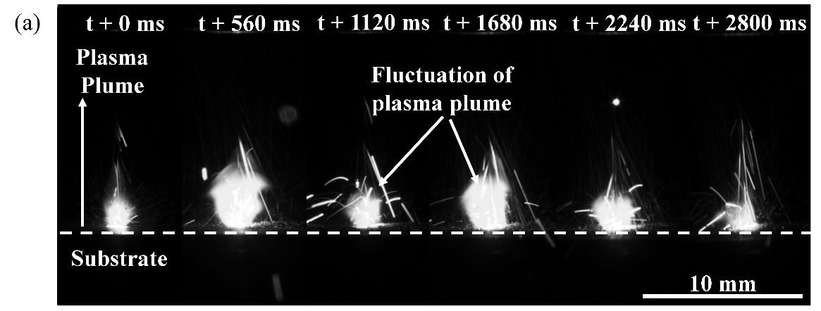
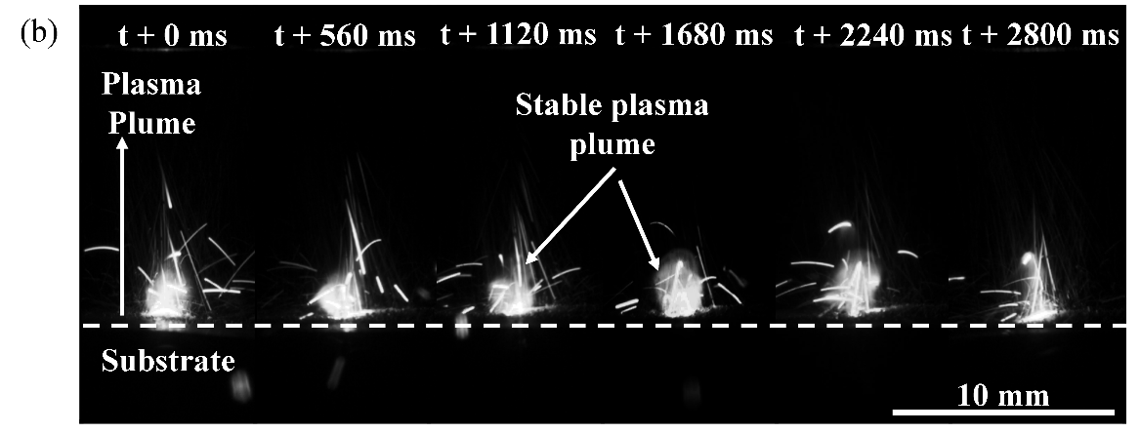
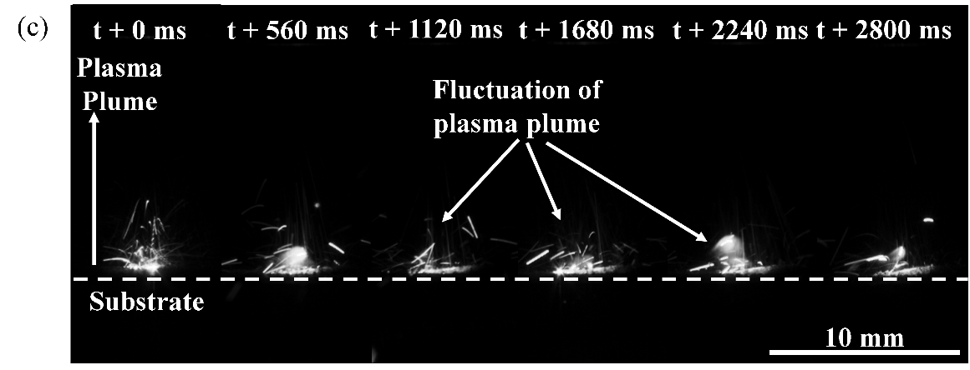
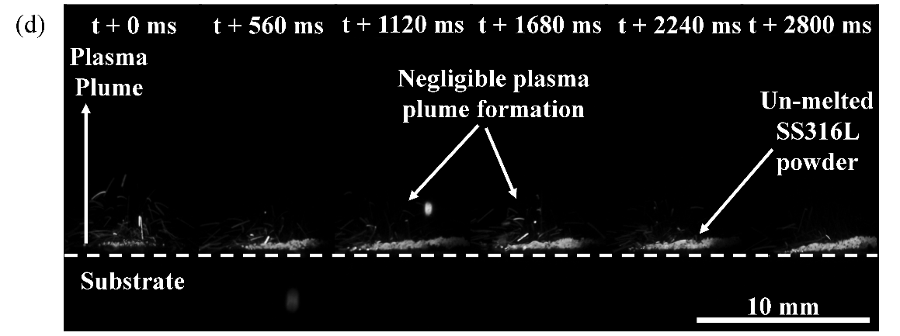
Fig. S1. Superimposed images of plasma plume SS316L clad deposition at different spot diameter (a) 0.8 mm, (b) 1.3mm, (c) 2.1mm, (d) 3.5mm.

