Supplementary Fig. 1
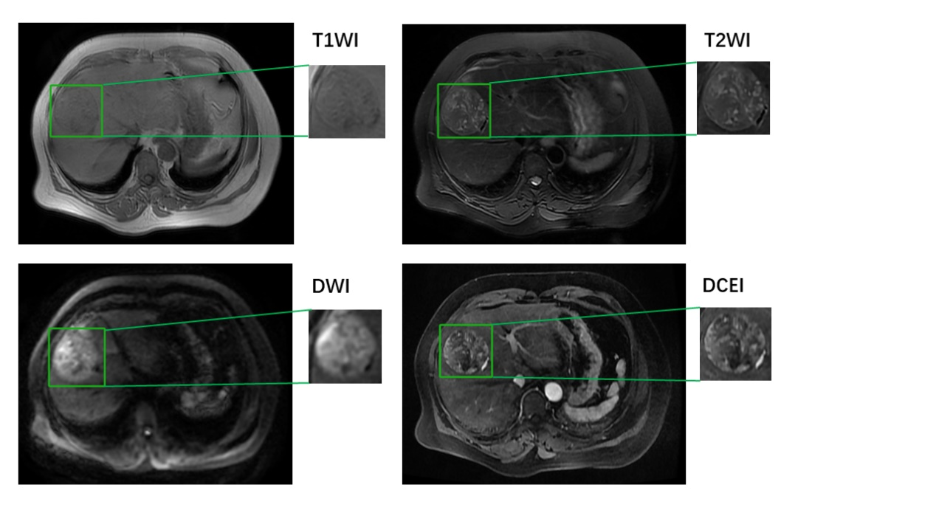

Supplementary Fig. 2
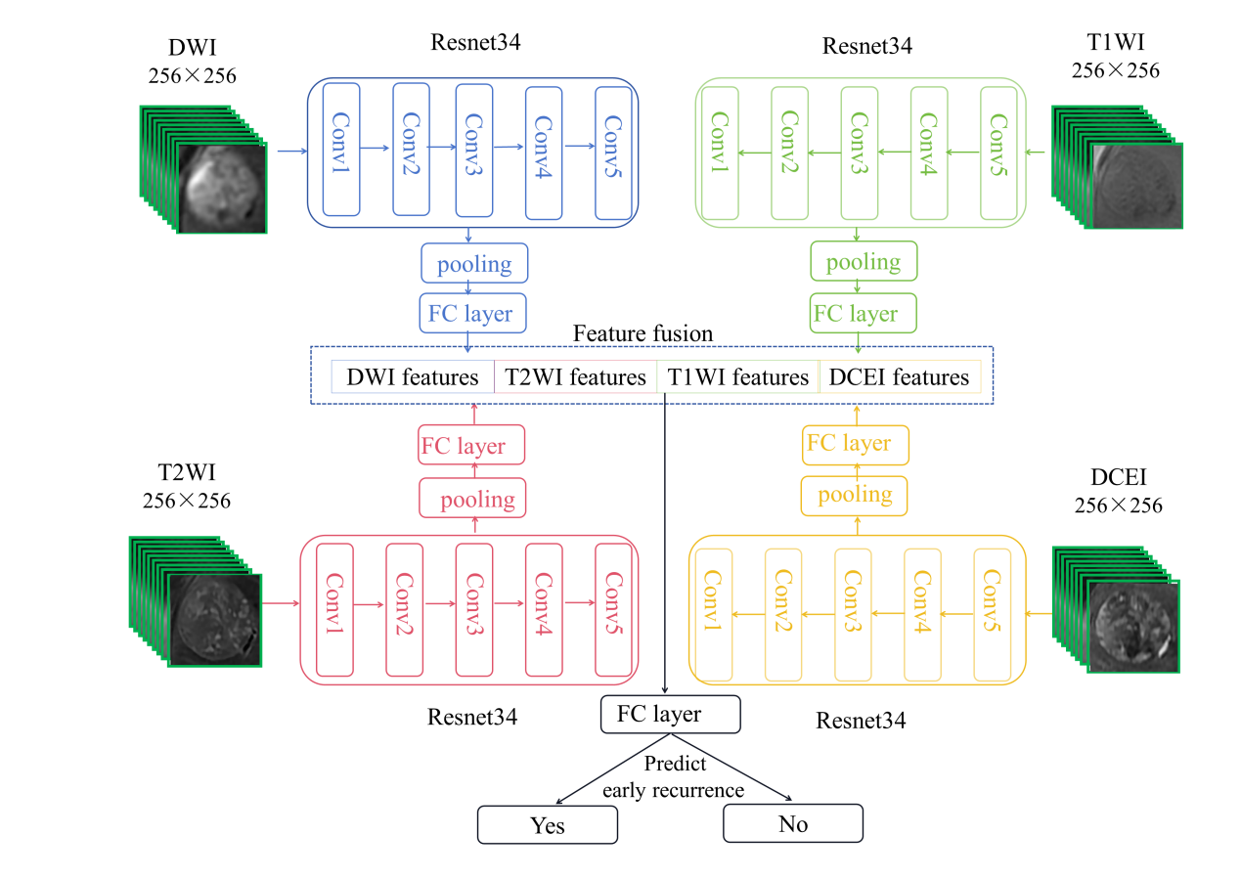

Supplementary Fig. 3
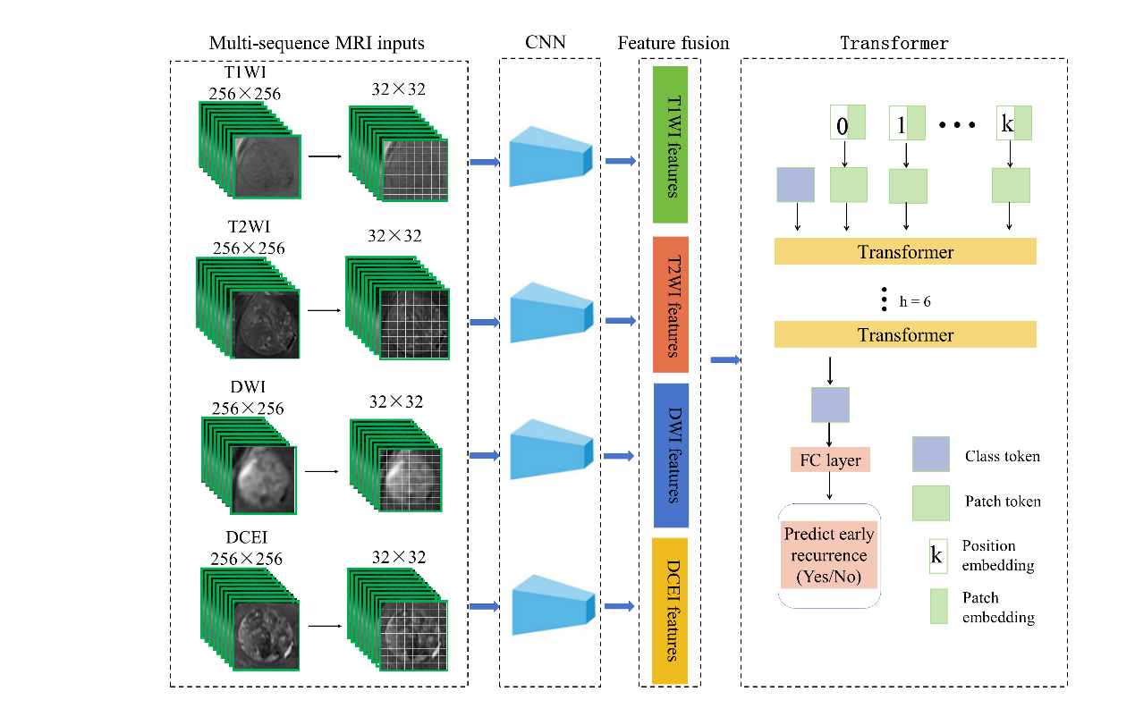

Supplementary Fig. 4

Supplementary Fig. 5

Supplementary Fig. 6
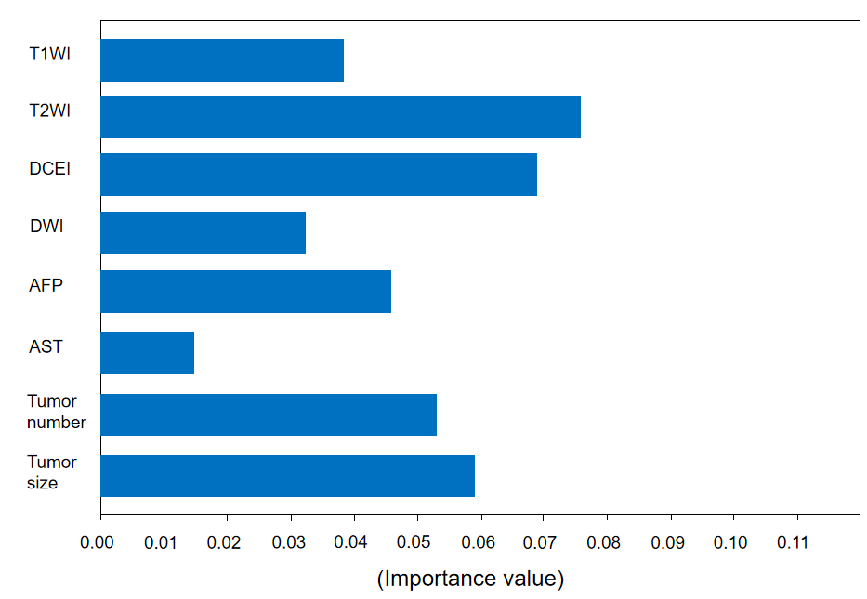

Supplementary Figure legends
Supplementary Fig. 1 Tumors were contoured manually on the images of T1WI, T2WI, DWI and DCEI at arterial phase.
Supplementary Fig. 2 The flowchart of Resnet34-based model. The feature extractors for multi-sequence MRI images were used in Resnet34. MRI input images were selected to include eight consecutive layers where the ROI was located, and they were cropped to a size of 256×256×8. The output of the features for each sequence was fused, and a fully connected layer of the prediction for early recurrence was used.
Supplementary Fig. 3 The flowchart of Transformer-based model. Image size was split to 32 × 32 in the form of slices, then these small parts were input into CNN (Resnet34). CNN was used as a feature extractor and generated a sequence of patch embeddings. The input includes a variety of embeddings and tokens, which are patch embedding, position embedding, patch token, and class token. The class token was attached to patch tokens before the input layer of transformers, passed through the transformer layer, and then output from the fully connected layer to predict early recurrence status.
Supplementary Fig. 4 Decision curve analysis for mMRI_R, mMRI_T and mMRI+C_R models. The gray dotted line represents the assumption that all patients are high risk, the green dotted line represents the assumption that no patients are high risk.
Supplementary Fig. 5 Decision curve analysis for T1WI, T2WI, DWI, DCEI and T2WI+C models. The gray dotted line represents the assumption that all patients are high risk, the green dotted line represents the assumption that no patients are high risk.
Supplementary Fig. 6 A higher positive SHAP value for a feature indicates a stronger positive association with early recurrence, with the color bar representing the magnitude of each feature's contribution.

Supplementary Table 1. Scan parameter of the multi-sequence MRI
Parameter | TR (ms) | TE (ms) | FOV (mm) | Flip Angle | Matrix size | Section thickness | intersection gap
T1WI | 3.5-4.0 ms | 1.5-2.0 ms | 300 × 400 mm | 10° | 256 × 256 | 6-7 mm | 1-2 mm
T2WI | 2500 ms | 90 ms | 300 × 400 mm | 20° | 384 × 256 | 6-7 mm | 1-2 mm
DWI | 2600 ms | 59.5 ms | 300 × 400 mm | 90° | 128 × 128 | 6-8 mm | 1-2 mm
DCEI | 3.5-4.0 ms | 1.5-2.0 ms | 300 × 400 mm | 10° | 256 × 256 | 6-7 mm | 1-2 mm
MRI magnetic resonance imaging, T1WI T1-weighted imaging, T2WI T2-weighted imaging, DWI diffusion-weighted imaging, DCEI dynamic contrast-enhanced imaging, TR repetition time, TE echo time, FOV field of view

Supplementary Table 2. Configuration of key parameters in Resnet34 and Transformer framework
Parameter Name | Parameter Value
num_classes | 2
optimizer | Adam
base_learning rate | 0.001
learning rate strategy | MultiStepLR
milestones | [20, 40, 60]
gamma | 0.1
loss function | FocalLoss
batch_size | 8
verbose | 1
Iters | 4800
Epoch | 100

Supplementary Table 3. Performance comparisons of multi-sequence MRI models
Model | Num_params | Num_iters | Total Training Time/s | Convergence Time/s | Loss value
mMRI+C_R | 87,257,296 | 100 | 29,268 | 20,500 | 0.38
mMRI_R | 87,256,272 | 100 | 29,196 | 19,850 | 0.43
mMRI_T | 159,236,944 | 100 | 46,944 | 35,299 | 0.55

Supplementary Table 4. Performance comparisons of single-sequence MRI models
Model | Num_params | Num_iters | Total Training Time/s | Convergence Time/s | Loss value
T2WI+C | 21,815,092 | 100 | 18,900 | 12,300 | 0.52
T2WI | 21,814,068 | 100 | 18,432 | 11,610 | 0.7
T1WI | 21,814,068 | 100 | 18,108 | 9,960 | 0.89
DCEI | 21,814,068 | 100 | 17,964 | 10,420 | 0.89
DWI | 21,814,068 | 100 | 18,036 | 8,296 | 0.8

