Table 3. Comparison of clinical characteristics between NOTCH1 mutation group and wild-type group.
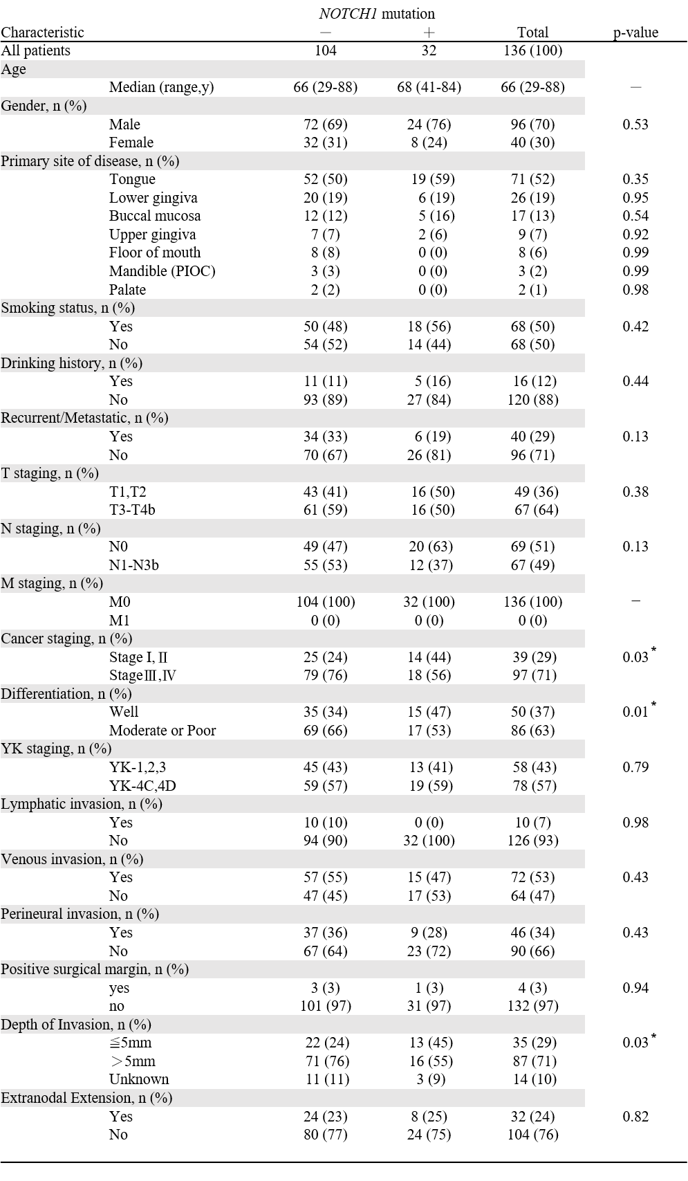
PIOC; primary intraosseous carcinoma
YK; Yamamoto-Kohama
*Significant at p<0.05

