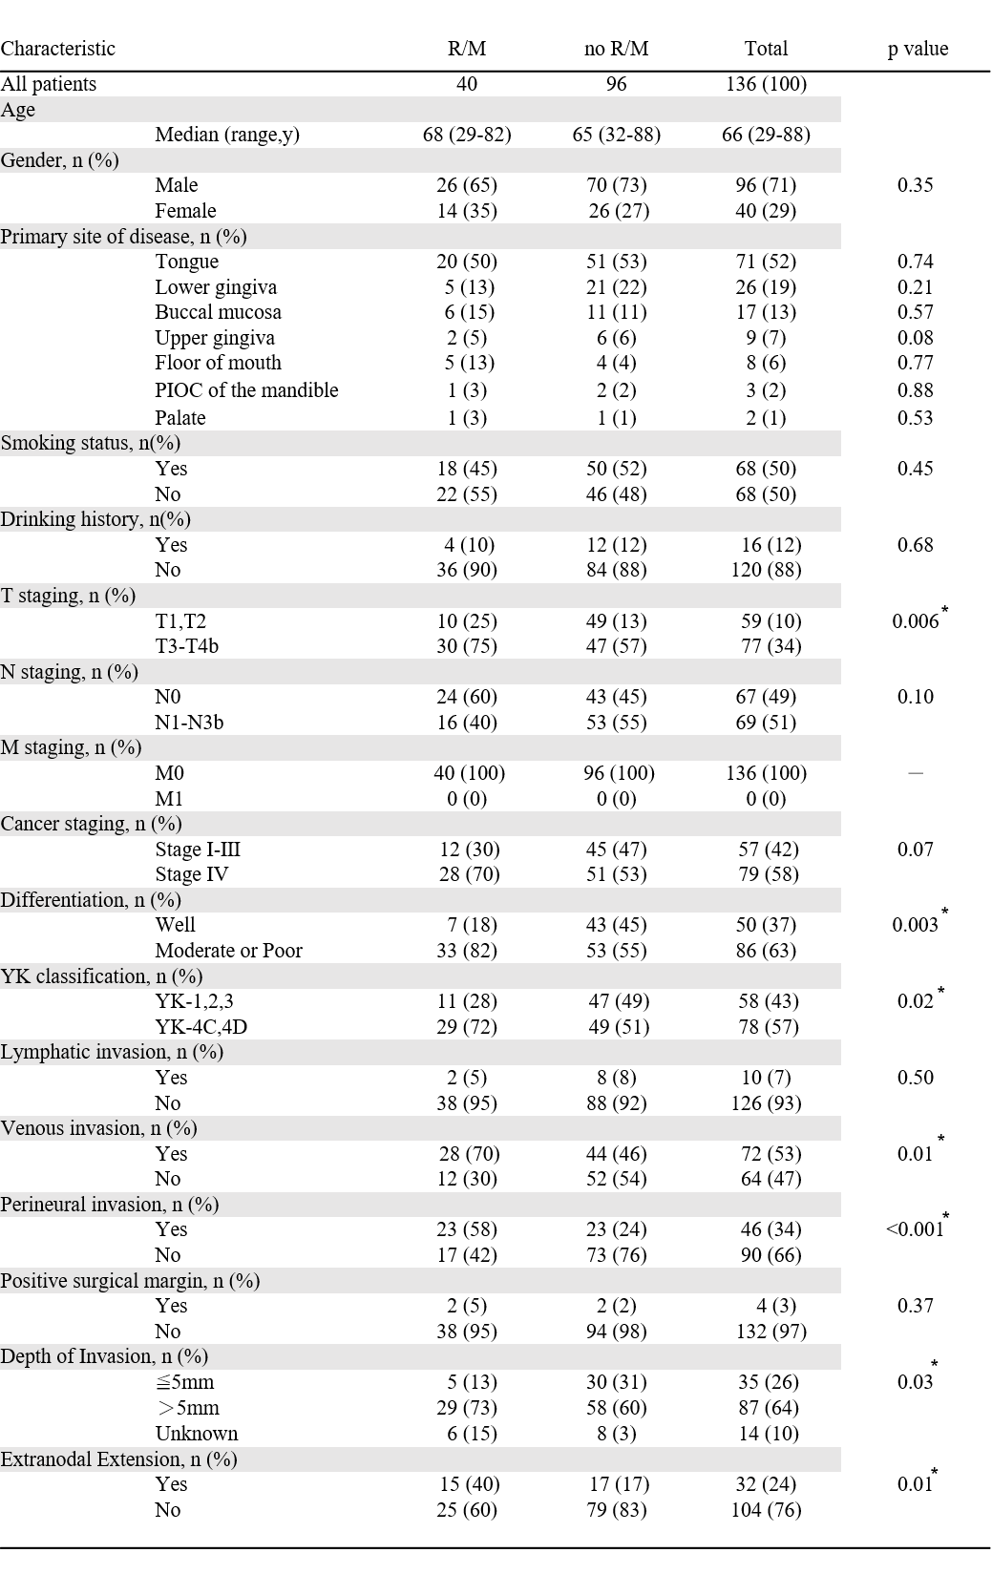
Table 1. Clinical characteristics.
R/M; recurrence or metastasis
PIOC; primary intraosseous carcinoma
YK; Yamamoto-Kohama
*Significant at p<0.05

