Table 2. Univariable and multivariable analyses for Relapse-Free Survival.
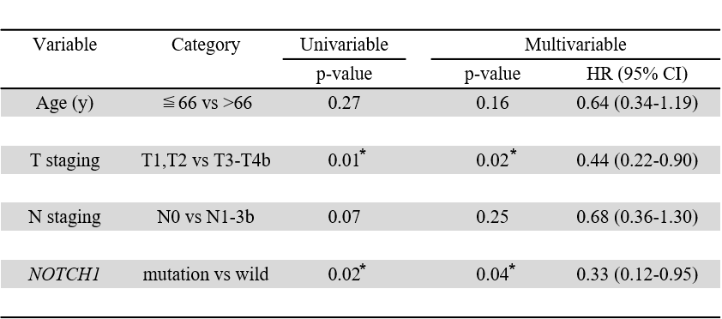
HR; hazard ratio
*Significant at p<0.05

