A Single Concussion in Juvenile Mice Leads to Sex Specific Acute Cerebral Vascular Dysfunction and Blood-brain Border Dysfunction

Jiamin Yan¹, Nathan Nguyen², Terese Garcia², Adam Godzik², Greer Cisneros², Amandine Jullienne², Junuen Alvarado², Rojina Pad², Jerome Badaut^{3,4*}, Andre Obenaus^{1,2*}

Supplimental Table and Figures

Supplemental Table 1: Number of Replicates Used in the Study

 | 1hpi |  | 6hpi |  | 1dpi |  | 3dpi |  | 7dpi
 | M | F | M | F | M | F | M | F | M | F
Sham* | 5 | 4 | N/A | N/A | 6 | 3 | N/A | N/A | 7 | 6
CHI | 7 | 5 | 8 | 8 | 10 | 11 | 8 | 10 | 10 | 9

* - Sham mice were not significantly different across time and were thus aggregated
hpi – hours post injury, dpi – days post injury

Supplemental Table 2: Feature Related Module Definitions for Statistical Modeling

Module Name | Included Features
Vascular Axial | - axial_surface_vessel_percentage  - axial_surface_total_vessel_length_mm  - axial_surface_average_vessel_length_mm  - axial_surface_junction_per_mm2
Vascular Coronal | - coronal_vessel_percentage  - coronal_total_vessel_length_mm  - coronal_average_vessel_length_mm  - coronal_junction_per_mm2
Local Fractal Dimension* | - surface_lfd_value_at_max_frequency  - surface_lfd_skewness  - surface_lfd_kutosis  - lfd_area_under_the_curve
Leakage Evans Blue | - axial_surface_evans_blue_extravasation_area_mm2  - axial_surface_evans_blue_integrated_density  - coronal_surface_evans_blue_integrated_density  - axial_surface_number_of_evans_blue_extravasation (count)

* - Fractal metrics often co-vary, and combining them enhanced signal-to-noise

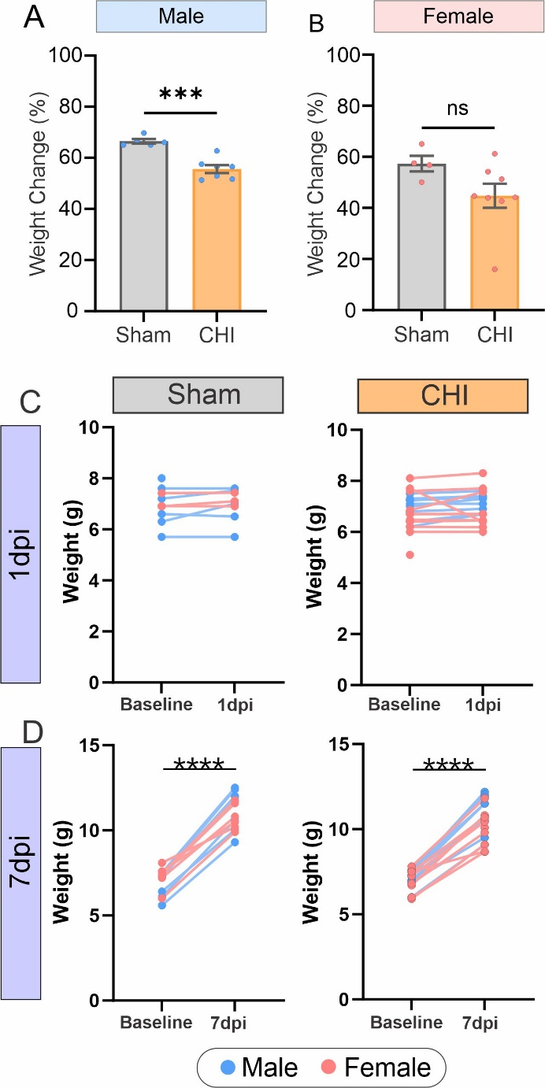

Supplemental Figure 1. Sex dependent weight changes. (A) Male CHILD mice at 7dpi exhibited significant reductions in weight. (B) Female CHILD mice also had weight reductions, but these were not significantly different from sham mice at 7dpi. *** p<0.0001 unpaired t-test. (C) Paired weight changes following CHILD found no significant weight differences were observed between baseline (pre-CHI) and 1dpi in either sham or CHI groups. (D) CHI and sham mice exhibited a significant increase in body weight at 7dpi compared to the baseline (*p≤0.05, paired t-test).

Supplemental Figure 2. Sex differences in brain volumes and extravascular bleeding after CHILD. (A) CHILD males exhibited significantly reduced cerebrum volumes compared to sham males and CHILD females (*p≤0.05, unpaired t-test). Female CHILD mice did not display cerebrum volume differences compared to shams. (B) Representative susceptibility weighted imaging (SWI) from 1dpi in either sham or CHILD mice. CHILD mice exhibited visible signs of bleeding at the cortex injury site (*) and within the corpus callosum (red arrows). (C) Pie charts demonstrate that 75% of CHILD males and 41.67% of CHILD females had visible signs of bleedings on SWI MRI.

Supplemental Figure 3. Representative 10X images of hyperacute and acute vascular leakage. (A-D) Representative CHILD mice that exhibit Evans Blue extravasation on the axial brain surface at 1hpi and 1dpi. This illustrates blood–brain border (BBB) disruption after CHILD as Evans Blue leaks from the vessels into the adjacent brain tissues. (Calibration bar is identical for all microphotographs).

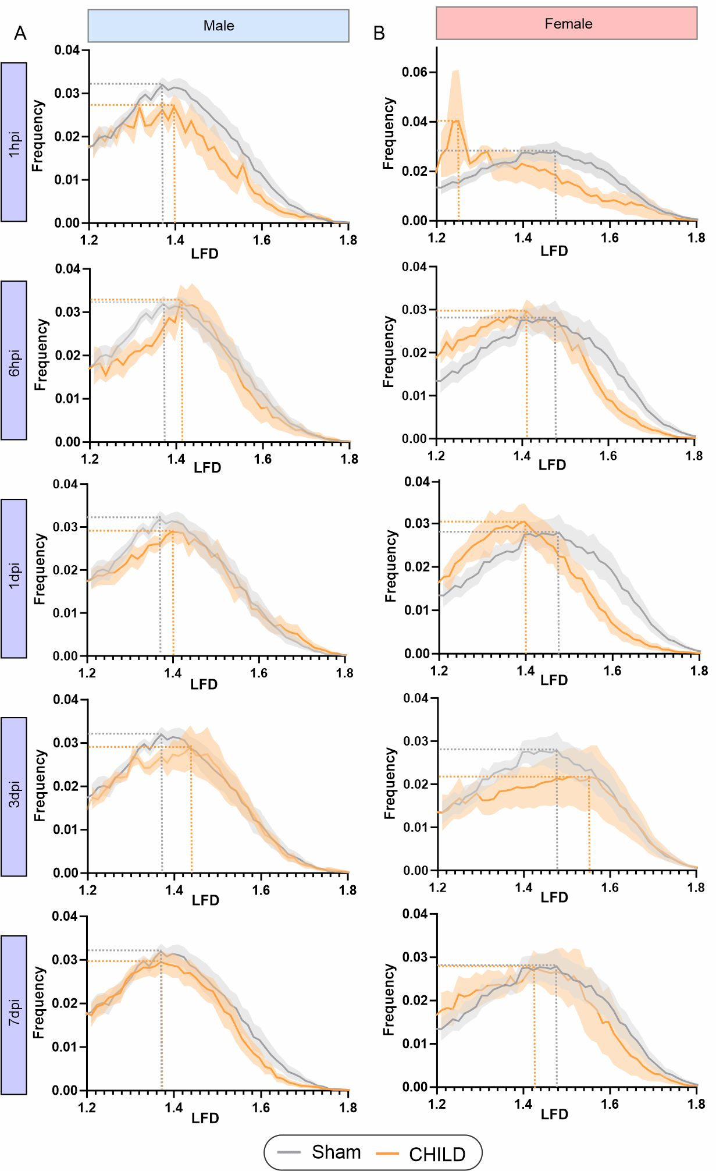
Supplemental Figure 4. Temporal evolution of local fractal dimensions (LFD) histograms, (A) Male CHILDLFD curves were initially reduced in amplitude with a rightward shift relative to shams that increased overtime but returned to baseline by 7dpi. (B) Female CHILD LFD curves exhibited an opposite leftward shift relative to shams over time consistent with decreased vessel complexity but like males returned to sham values by 7dpi.

Supplemental Figure 5. Quantification of vascular density and complexity from LFD histograms. (A) Area under the curve, indicative of the relative number of vessels, did not differ between sham and CHILD mice at 1, 3, or 7dpi, regardless of sex. (B) LFD peak values at the peak frequency which represents vessel complexity, revealed no significant differences between sham and CHILD mice at 1, 3, or 7dpi. No sex differences were observed. However, at 1dpi there was a trend toward reduced LFD value at peak frequency in female CHILD mice (p=0.075, unpaired t-test).

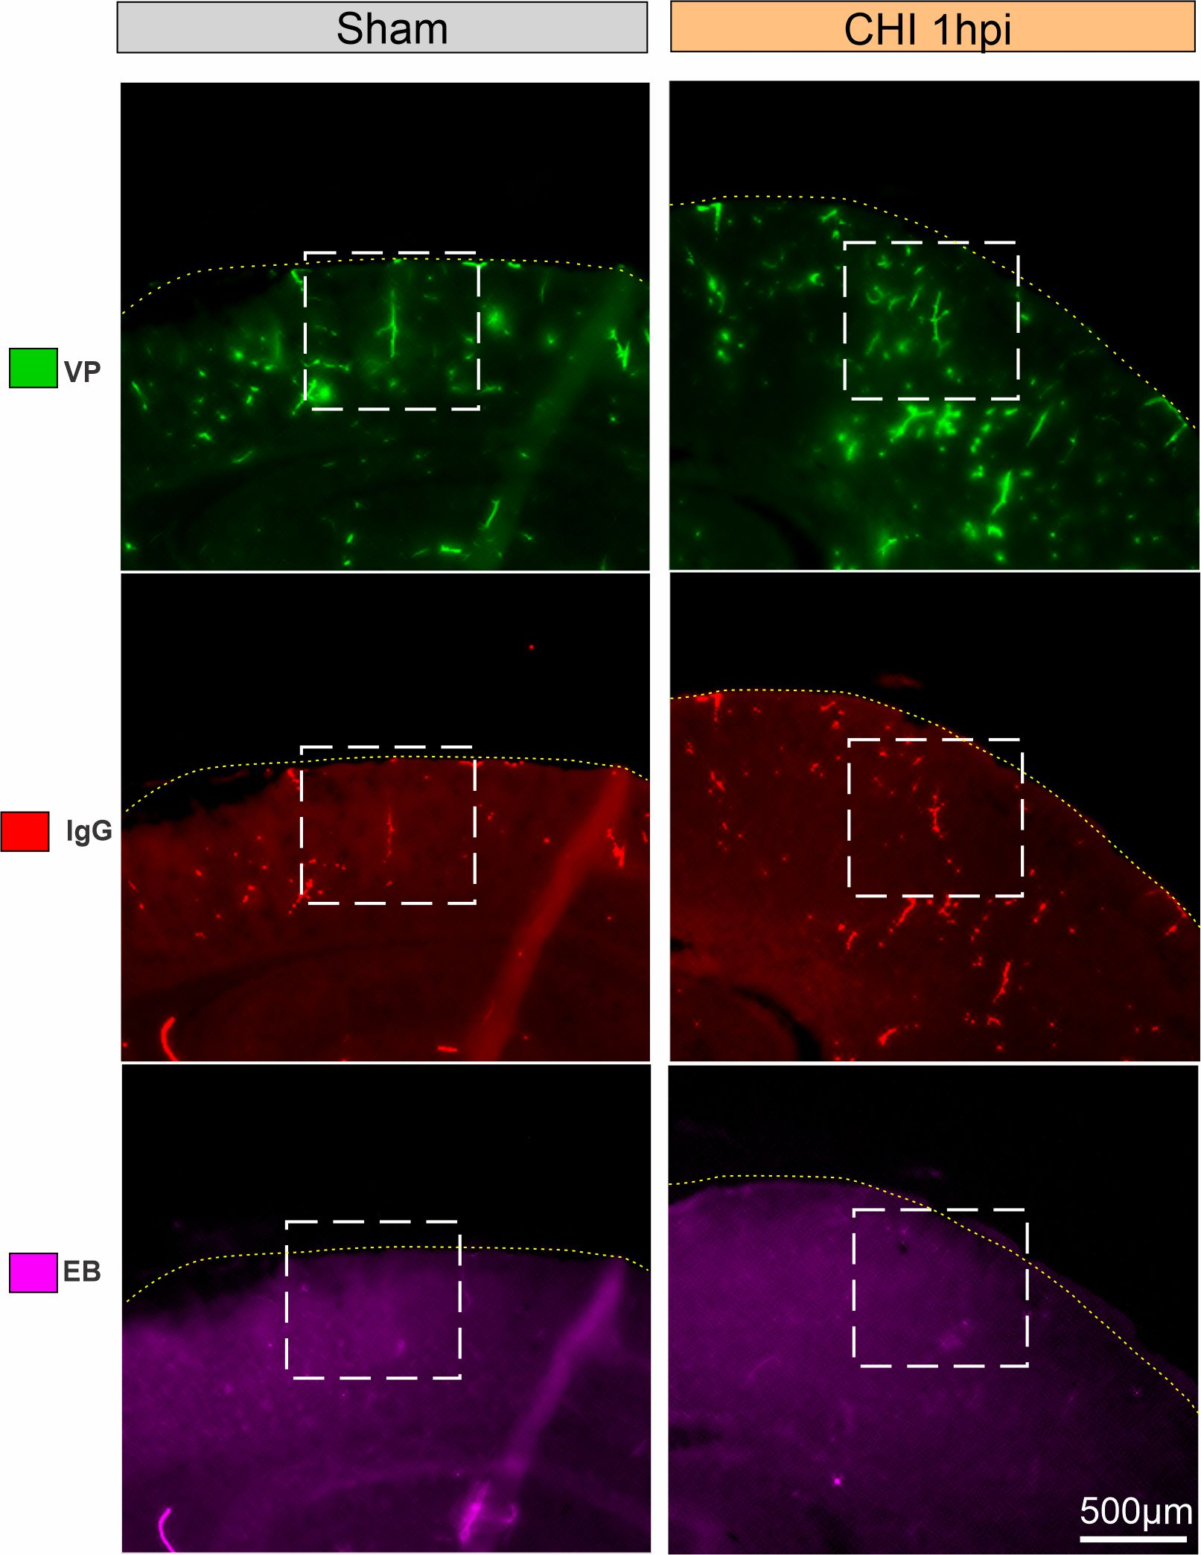
Supplemental Figure 6. Low-magnification fluorescent images showing IgG deposition after CHILD. Representative 2X fluorescent images from exemplar sections stained for vessel painting (VP, green), IgG (red), and Evans blue (EB, purple). White box indicates the region shown in higher magnification and 3D reconstruction in Figure 6, highlighting vascular structures and leakage sites. Dotted yellow line demarcates the cortical surface.

