Supplementary Information for Ran, et al., “Terahertz response of monolayer and few layer WTe₂ at the nanoscale”
Supplementary Note 1: Comparison between topography and near-field images
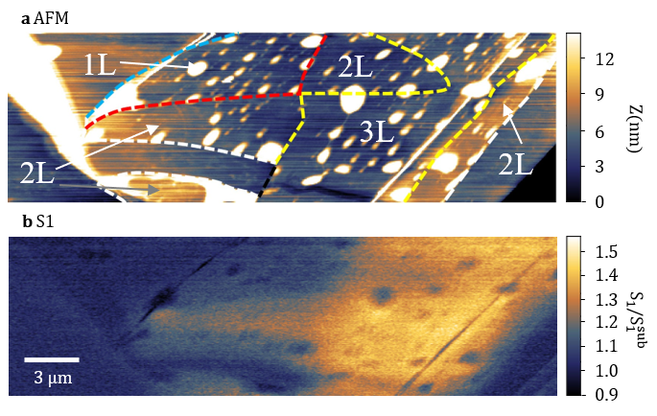
Supplementary Figure 1|Comparison between topography and near-field images. a The topography image of the field-of-view shown in Fig. 1b and c of the main text. The dashed lines, indicating the boundaries between different regions, are determined by topographical contrast of monolayer (1L), bilayer (2L) and trilayer (3L) regions. b The near-field S₁ image taken simultaneously with the topography image.
A side-by-side comparison between topography and near-field images helps better locate different regions on the sample surface. The micrometer-sized white dots in topography images, corresponding to the black dots in the near-field images, result from bubbles between WTe₂ sample and hBN encapsulation layers. Because the existence of the top layer hBN and bubbles, locating different regions in atomic force microscopy (AFM) images is challenging. Nevertheless, we can still track the boundary by taking line-cuts and compare with the near-field image and the optical inspection image.
Supplementary Note 2. Spatial resolution and approach Curve of S1 and S2 near-field signal
To illustrate how localized the signal is above the sample surface, we measured the dependence of near-field signal on the tip-sample distance. In the Fig. S2, S₂ signal is much more localized than S₁. More than 90% of S₂ signal is contributed within 150nm above the sample surface. For S₁ signal, this length scale of signal decay is ~700nm. In terms of full width half maximum, the decay length scale for S₁ and S₂ signal are <100nm and <50nm. The in-plane length scale of E-field localization of near-field signal equals that of out-of-plan [1]. Hence, the resolution of S₁ (S₂) image is no larger than 200nm (100nm).
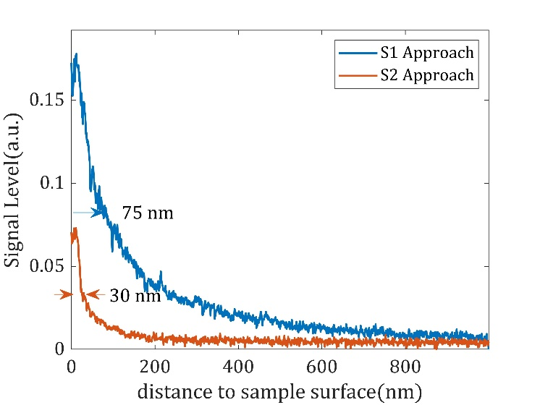
Supplementary Figure 2|Near-field Approach Curve of S₁ and S₂ signal. The approach curve is measured by varying the tip-sample distance. S₁ signal is mainly contributed by E field within 700nm above the sample surface, whereas S₂ signal is confined within 150nm above the sample surface.

Supplementary Note 3: Zoomed-in images of monolayer WTe₂
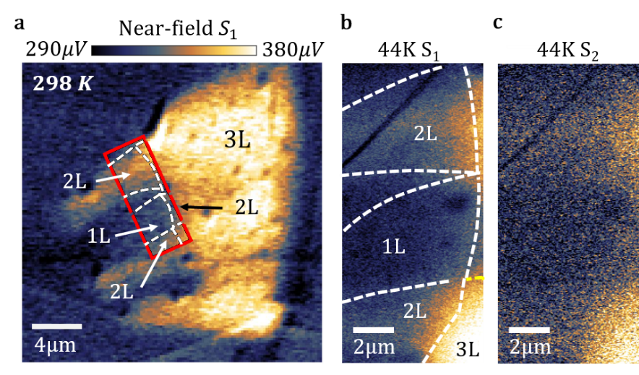
Supplementary Figure 3|Zoomed-in images of monolayer WTe₂. a THz near-field S₁ image of the whole sample area at room temperature. We mark the boundaries of terraces with different number of WTe₂ layers (1L, 2L, 3L) with dashed lines. The red frame indicates the area where the monolayer images are taken. b Zoomed-in S₁ image around monolayer region. c Zoomed-in S₂ image around monolayer region.

Monolayer WTe₂ is confirmed to support quantum spin Hall state below 100K [2] [3] [4] [5] [6] [7] with edge conduction channels. At the lowest temperature of the experiment 44K, THz response near images around monolayer WTe₂ was measured in more detail (Fig. S3). The location of the zoomed-in field-of-view is indicated in Fig. S3a with a red frame. In this field-of-view, we can see the boundaries between monolayer WTe₂ and substrate and between monolayer and bi-layer WTe₂. With our current signal to noise ratio, no clear feature arising from the topological edge state is observed, despite previous observation of the edge state at DC [8] and microwave frequencies [3]. It is possible that the increase of conductivity due to edge state does not extend to THz range. However, the low conductivity [8] of the edge state is also challenging for nano-THz technology.

Supplementary Note 4: The influence of in-plane anisotropy of WTe₂ on near-field modeling.
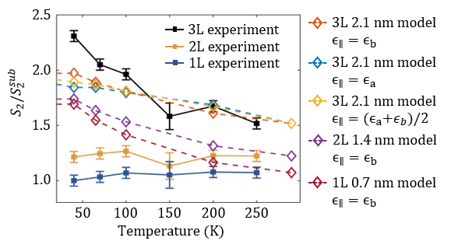
Supplementary Figure 4|Temperature dependent normalized S₂ from experiment and modeling. Experimental data points are indicated with solid squares. Near-field modeling are indicated with empty diamonds. Three different sets of parameters: $ϵ_{∥}=ϵ_{b}$, $ϵ_{∥}=ϵ_{a}$ and $ϵ_{∥}=(ϵ_{a}+ϵ_{b})/2$ are configured for 3L WTe₂ modeling. Bi-layer and monolayer results are achieved by setting the thickness of WTe₂ to 1.4 nm and 0.7 nm.
The near-field modeling mainly follows the procedure described in Ref. [1]. One assumption is that the material can be treated as isotropic or uniaxial material with a unique out-of-plane axis. On the contrary, WTe₂ reveals notable in-plane anisotropy with distinct plasma frequencies between a and b axes within the WTe₂ plane [9] [10]. We assumed that tri-layer WTe₂ can be reasonably described as a uniaxial material with its in-plane relative permittivity represented by that of b-axis of bulk WTe₂. Nevertheless, the finite in-plane anisotropy is evident only at much higher frequencies (~12 THz) [9] and gives rise to minor quantitative change in the observed near-field response, as demonstrated below. We first performed calculations with both a purely a-axis response and an effective dielectric function averaging between a-axis and b-axis data. In Fig. S4, three different configurations are displayed. Modeling with $ϵ_{∥}=ϵ_{b}$ has the highest increase of near-field signal at low temperature. The increase is lower in $ϵ_{∥}=(ϵ_{b}+ϵ_{a})/2$ and the lowest in $ϵ_{∥}=ϵ_{a}$, despite the overall differences are small enough to neglect.
We also performed modeling to see whether bi-layer and monolayer results can be explained. We tuned the thickness of WTe₂ down from 2.1 nm 1.4 nm to 0.7 nm. As is shown in Fig. S4, as long as the bulk conductivity is used in the modeling, the near-field signal always increases significantly at low temperature due to the existence of SPPs. Therefore, the conductivity of bi- and monolayer WTe₂ cannot be characterized by bulk conductivity.

Supplementary Note 5: Mid-IR response of monolayer and few layer WTe2 at the nanoscale.
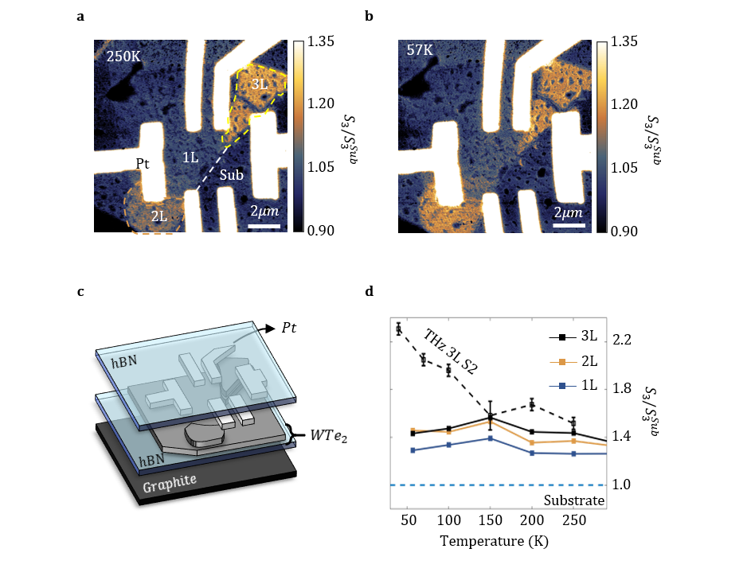
Supplementary Figure 5|Near-field nano-imaging on multi-terraced encapsulated WTe₂ micro-crystal in the mid-infrared. Image of the normalized near-field $S_{3}$ signal (ω=27 THz) at a 250 K and b 57K. c Layout of the sample measured in the mid-IR near-field experiments. d Temperature dependence of mid-IR near-field signal for regions with different number of layers.
For completeness, we also acquired near-field data in the frequency range higher than the plasma frequency of bulk WTe₂. The experiment is carried out in the mid-IR range with a 27 THz CO₂ laser. Here, a third (S₃) or higher harmonic of the near-field signal must be measured to suppress the far-field contribution [11]. The WTe₂-based structure investigated in this experiment shares common elements with the devices in the main text Fig.1a. The major difference is that there is another layer of graphite in between the SiO₂/Si substrate and bottom layer hBN. This latter architecture is only suitable for mid-IR experiments: the graphite beneath the sample saturates the near-field signal in THz range but not in mid-IR range. Images acquired at 250K and 57K are shown in Fig. S4a&b. The temperature dependence of nano-IR signals is plotted in Fig. S4d. WTe₂ shows a much weaker nano-IR signal compared to the signal produced by the platinum electrodes. Regions with more WTe₂ layers show systematically higher mid-IR signal levels and the temperature dependence for all layers is insignificant (Fig. S4d). This temperature independent behavior is well explained by our model result shown in the main text Fig. 3d.

Supplementary Note 5: Near-field electrodynamics of thermally activated carriers of bi-layer WTe₂

In calculating the near-field signal of bi-layer WTe₂, we mainly consider the Drude response of its thermally activated carriers. The carrier density is computed assuming WTe₂ has quadratic bands with effective electron mass at the conduction and valence band edge:
$$n_{2D}=\int_{E_{C}-E_{F}}^{∞}{{2f}_{FD}\left(E\right)g_{2D}\left(E\right)dE}=\frac{2kTm_{C}^{*}}{πℏ^{2}}ln⁡(e^{-\frac{E_{C}-E_{F}}{kT}}+1)$$
$$p_{2D}=\int_{{|E}_{D}-E_{F}|}^{∞}{{2f}_{FD}\left(E\right)g_{2D}\left(E\right)dE}=\frac{2kTm_{V}^{*}}{πℏ^{2}}ln⁡(e^{-\frac{{|E}_{V}-E_{F}|}{kT}}+1)$$
Here, $m_{C}^{*}$ and $m_{V}^{*}$ are the effective electron mass at the band edge of conduction and valence band. $E_{C}$, $E_{V}$ and $E_{F}$ are the energy of conduction band edge, valence band edge and Fermi energy of bi-layer WTe₂. The Fermi energy is determined by the neutrality condition $n_{2D}=p_{2D}$ of the investigated system. The permittivity of the model bi-layer:
$$ϵ=ϵ_{∞}-\frac{ω_{P}^{2}}{ω(ω-iγ)}$$
Here $ω_{P}$ is the plasma frequency determined by the thermally activated carrier density:
$$ω_{p,n}=\sqrt{\frac{n_{2d}e^{2}}{{dm}^{*}ϵ_{0}}}=\sqrt{\frac{2e^{2}kT}{{dπℏ}^{2}ϵ_{0}}ln⁡(e^{-\frac{E_{C}-E_{F}}{kT}}+1)}$$
$$ω_{p,p}=\sqrt{\frac{p_{2d}e^{2}}{{dm}^{*}ϵ_{0}}}=\sqrt{\frac{2e^{2}kT}{{dπℏ}^{2}ϵ_{0}}ln⁡(e^{-\frac{{|E}_{V}-E_{F}|}{kT}}+1)}$$
Here d = 1.4 nm, $n_{bulk}$ and $ω_{P}$ are the carrier density and the plasma frequency of the bulk WTe₂. The scattering rate γ of the model bi-layer is assumed to be the average of the two scattering rate of two Drude components in the bulk [12] $γ={(γ}_{1}+γ_{2})/2$.

Supplementary Note 6: Real-space near-field modeling of SPP structures

To generate predicted real-space images shown in the main text, we apply a semi-analytic method that approximates the near-field scattering signal from a 2D material as proportionate (to first-order) by the z-polarization of a polarizable dipole raster-scanned (at a height $z=z_{dp}$) some tens of nanometers over the surface of a sample (at $z=0$):
$S\left(ρ_{dp}\right) \sim p_{z}≈αE_{ref, z }(ρ_{dp},z=z_{dp})$. (S1)
Here $α$ denotes the dipole polarizability, $E_{ref, z }$denotes the z-component of the electric near-field reflected by the sample in response to the incident dipole field, and $ρ_{dp}$ denotes evaluation at the in-plane coordinate of the probe. Although this expression represents only the first term in a Born expansion of the full self-consistent dipole polarization [13] a similar conceptual treatment was previously shown to faithfully replicate the polaritonic near-field response of two-dimensional materials as measured by scanning near-field optical microscopy [14]. Here we summarize the key points enabling our calculation of Eq. S1 in the quasi-electrostatic approximation, and defer more detailed discussion to forthcoming work.
We recast Eq. S1 in a form reminiscent of the local photonic density of states [15] measured at the location $r_{dp}=(ρ_{dp},z_{dp})$ of our dipole probe:
$S\left(ρ_{dp}\right) \sim \int_{z>0}^{ }{dV} {\hat{j}}_{dp}⋅{\vec{E}}_{ref}=\int_{z>0}^{ }{dV} ∇⋅{\hat{j}}_{dp} Φ_{ref}∝\int_{z>0}^{ }{dV} {-ϱ}_{dp}⋅Φ_{ref}$ (S2)
Here ${\hat{j}}_{dp}$ denotes the unit vector oriented along the direction of the point dipole current, $ϱ_{dp}$ denotes the instantaneous charge distribution associated with the dipole, and $Φ_{ref}$ is the electrostatic potential for the reflected field given by ${\vec{E}}_{ref}=-∇Φ_{ref}$. Now $S\left(ρ_{dp}\right)$ can be evaluated entirely in the plane $z=0$ by identifying the “incident” electrostatic potential generated by the dipole through $ϱ_{dp}=-\frac{1}{4π}∇^{2}Φ_{dp}$ and integrating Eq. S2 by parts, yielding:
$$\int_{z>0}^{ }{dV} {-ϱ}_{dp}⋅Φ_{ref}=\frac{1}{4π}\left[\int_{z=0^{+}}^{ }{dA} (-\hat{z}⋅∇Φ_{dp} )Φ_{ref}-\int_{z>0}^{ }{dV}∇Φ_{dp}⋅∇Φ_{ref}\right]$$$=\frac{1}{4π}\int_{z=0^{+}}^{ }{dA} \left(Φ_{dp}∂_{z}Φ_{ref}-∂_{z}Φ_{dp}Φ_{ref}\right)$. (S3)
Here we have applied the source-free condition $∇^{2}Φ_{ref}=0$ in the volume $z>0$. Eq. (S3) represents an approximation for the signal $S\left(ρ_{dp}\right)$ when $Φ_{dp}$ is produced from a dipole-like probe at $r_{dp}$. Further simplification is admitted by the fact that $Φ_{ref}=-\hat{R}Φ_{dp}≡-Φ_{R}$, with $\hat{R}$ a generalized reflection operator. Moreover, for scalar potentials $Φ_{1,2}$ harmonic (viz. source-free) in the plane of integration, $\int{dA}Φ_{1}∂_{z}Φ_{2}=±\int{d^{2}q{ \left|q\right| \tilde{Φ}}_{1}{\tilde{Φ}}_{2}}$, where tilde quantities represent in-plane Fourier transforms with respect to the momentum$q$, and $±$ correspond to the cases where $Φ_{2}$ is sourced from $z>0$ or $z<0$, respectively. With these considerations, Eq. (S3) reduces to:
$S\left(ρ_{dp}\right)\sim \frac{1}{2π}\int{d^{2}q{ \left|q\right| \tilde{Φ}}_{dp}{\tilde{Φ}}_{R}}$= $\frac{1}{2π}$ $\int{dA}(q*Φ_{dp})\hat{R}Φ_{dp}$ (S4)
where $(q*Φ_{dp})$ represents the incident scalar potential spatially convolved at $z=0^{+}$ with a sharpening function with Fourier kernel $\left|q\right|$. Eq. (S4) represents a norm of the function $Φ_{dp}$ in the plane $z=0$ with respect to the composite reflection operator $q* \hat{R}$. By way of demonstration, we can consider cases where the reflected field is given by ${\tilde{Φ}}_{R}=r_{p}(q){\tilde{Φ}}_{dp}(q)$, with $r_{p}$ the momentum-resolved Fresnel coefficient for e.g. a layered medium with in-plane translational invariance. Applying the in-plane Fourier transform of the dipole potential ${\tilde{Φ}}_{dp}\left(q\right)=e^{-qz_{dp}}$ at $z=0$, for such cases Eq. S4 evaluates to $S∝\int{dq r_{p}\left(q\right) q^{2}e^{-2qz_{dp}}}$. This is indeed the first-order term in a Born series expansion of the point dipole model widely used to predict near-field observables in the case of multilayered systems [16] [17]. Meanwhile, whereas the real-space counterpart that we present in Eq. S4 remains underreported, it provides a powerful means to predict images recorded by scanning near-field optical microscopy.
We now briefly describe our method for evaluating $\hat{R}Φ_{dp}$ in the case of a spatially inhomogeneous 2D material at $z=0$ described by a (piecewise) optical conductivity $σ_{2D}(ρ)$ upon a substrate with isotropic reflectivity $β_{subs}$. We first consider the integro-differential equation for the scalar potential $Φ_{ref}$ generated by $σ_{2D}$ in response to the potential $Φ_{dp}$ of our quasi-dipolar probe [18], in absence of a substrate:
 | $\left[1+V*\sum_{m }{\frac{1}{2πq_{p,m}}∇⋅{\overline{σ}}_{m}\left(ρ\right) ∇}\right]Φ\left(ρ\right)=Φ_{dp}\left(ρ\right), with Φ=Φ_{dp}+Φ_{ref}$. | (S5)
Here $m$ indexes the piecewise homogeneous domains of our 2D material (i.e. in our case domains of mono-, bi-, and tri-layer WTe₂), $q_{p,m}$ denotes the complex plasmon wavevector associated with each domain, and ${\overline{σ}}_{m}\left(ρ\right)$ are piecewise homogeneous functions equal to zero or 1 marking the lateral regions $ρ∈Ω_{m}$ occupied by each domain. Meanwhile, $V(r,r^{'})=1/|r-r^{'}|$ is the Coulomb kernel, and the asterisk ($*$) denotes spatial convolution over the in-plane coordinate $ρ=(x,y)$. We solve Eq. S5 by expanding $Φ_{ref}(ρ)=\sum_{mn}{ϕ_{mn}^{ref}Φ_{mn}(ρ)}$ into an orthonormal basis of eigenfunctions specified on the domains $∂Ω_{m}$ by $∇⋅{\overline{σ}}_{m}\left(ρ\right) ∇Φ_{mn}\left(ρ\right)=-q_{mn}^{2}Φ_{mn}\left(ρ\right)$ and subject to the “zero current” boundary conditions $\hat{n}⋅∇Φ_{mn}$ on the domain edges ${∂Ω}_{m}$. These functions are obtained with the finite element solver FEniCs [19] after meshing the experimentally relevant domain configurations shown in Figure 5a of the main text.

Values for the plasmon wave-vectors are inferred from the respective layer thicknesses $d_{m}$ and complex in-plane optical permittivities $ε_{m}$ of each domain in $Ω_{m}$according to $q_{p,m}=2{\left(1-ε_{m}\right)}^{-1}{ d}_{m}^{-1}$; see Supplementary Table 1 for the values used in our simulations. Although WTe₂ is known to exhibit biaxial in-plane permittivity, for simplicity in our simulations we apply an isotropic approximation as earlier discussed in this supplement.

Domain  (indexed $m$) | Thickness $d_{m}$ (nm) | Optical permittivity  $ε_{m}$ ($ω≈1$ THz) | Plasmon wave-vector  $q_{p,m}$ (cm⁻¹)
Monolayer (70 K) | 0.7 | 41 | -710000
Monolayer (295 K) | 0.7 | 41 | -710000
Bilayer (70 K) | 1.4 | -1056+1056i | 6764+6758i
Bilayer (295 K) | 1.4 | -223+1482i | 1424+9424i
Trilayer (70 K) | 2.1 | -28265+28265i | 168.47+168.47i
Trilayer (295 K) | 2.1 | -1226+6146i | 296.5+1490i
Supplementary Table 1| Parameters for modeling real-space near-field images of WTe₂ monolayer, bilayer, and trilayer domains at 70 K and 295 K. Layer thickness and the complex-valued optical permittivity ε=ε₁+iε₂ determines the plasmon wave-vector. Permittivities are estimated according to discussion in the main test.
Assembling the expansion coefficients $ϕ_{mn}^{ref}$ into a vector $ϕ_{ref}$ (taking $mn$ as a composite index), we solve Eq. (S5) by the matrix equation:
$$ϕ_{ref}=-\left[\frac{-V\sum_{m}{q_{m}^{2}}/(2πq_{p,m})}{1-V\sum_{m}{q_{m}^{2}}/(2πq_{p,m})}\right]ϕ_{dp}$$
(S6)
As with $ϕ_{ref}$, here $ϕ_{dp}$ represents the vector of expansion coefficients for $Φ_{dp}(ρ)$. Meanwhile, each $q_{m}^{2}$ denotes a diagonal matrix of eigenvalues $q_{mn}^{2}$ acting in the vector subspace spanned by $\left\{Φ_{mn} ∀n\right\}$ at fixed domain index $m$, and $V$ is the coulomb matrix whose elements are given by $V_{kl,mn}=\int_{z=0}^{ }{dA Φ_{kl}\left(ρ\right) V*Φ_{mn}\left(ρ\right)}$. The term in brackets in Eq. (S6) represents the generalized reflection operator $R$ for the system in the $Φ_{mn}$ basis. (The denominator is understood in the sense of a matrix inverse applied before pre-multiplication by the numerator.) While we defer the derivation to forthcoming work, this reflection operator generalizes to the case of our 2D materials upon a substrate with isotropic reflectivity $β_{subs}$ as follows:
$$R=\frac{β_{subs}-V\sum_{n}{q_{n}^{2}}/(2πκq_{p,n})}{1-V\sum_{n}{q_{n}^{2}}/(2π{κq}_{p,n})}$$
(S7)
Here $κ=(ε_{subs}+1)/2$ and $β_{subs}=(ε_{subs}-1)/(ε_{subs}+1)$, with $ε_{subs}$ the substrate permittivity; in this work the substrate includes 20nm hBN and bulk SiO₂.
We also define a symmetric matrix $Q$ in the $Φ_{mn}$ basis corresponding to the spatial convolution in Eq. S4, with elements given by $Q_{kl,mn}=\int_{z=0}^{ }{dA Φ_{kl}\left(ρ\right) q*Φ_{mn}\left(ρ\right)}$. Since the $Φ_{mn}$ are orthonormal, Eq. S4 reduces to:
$S(ρ_{dp})\sim \frac{1}{2π}ϕ_{dp}{(ρ_{dp})}^{T} QR ϕ_{dp}(ρ_{dp})$. (S8)
This represents a vector norm of $ϕ_{dp}$ with respect to the matrix $QR$.
In summary, after computing eigenfunctions $Φ_{mn}$ associated with our sample geometry, we compute symmetric matrices $V$ and $Q$ and the generalized reflectance operator $R$. Then, in order to predict a spatial map $S(ρ_{dp})$, we simply project the incident potential emitted by our quasi-dipolar probe at each location $ρ_{dp}$ into the $Φ_{nm}$ basis by evaluating the vector of coefficients $ϕ_{dp,mn}(ρ_{dp})=\int{dA Φ_{dp}(ρ)Φ_{mn}(ρ)}$ and successively applying Eq. S8. Although the eigenbasis $\{Φ_{mn}\}$ is of infinite size, projections into $ϕ_{dp}$ decay exponentially with $n$ when $Φ_{mn}$ are sorted by increasing eigenvalue $q_{mn}^{2}$, so a truncated basis of size $N≈{10}^{3}$is in our case sufficient for a converged map of near-field scattering amplitude |$S\left(ρ_{dp}\right)|$. In this way, the observables of near-field microscopy can be predicted entirely by evaluating functions in the plane of the sample ($z=0$). This computational method may be suitable for qualitative and quantitative modeling of near-field response of other spatially inhomogeneous 2D heterostructures. Such applications and details of their unique numerical implementation will be reported elsewhere.

References

[1] | A. S. McLeod, P. Kelly, M. D. Goldflam, Z. Gainsforth, A. J. Westphal, G. Dominguez, M. H. Thiemens, M. M. Fogler and D. N. Basov, "Model for quantitative tip-enhanced spectroscopy and the extraction of nanoscale-resolved optical constants," Physical Review B, vol. 90, p. 085136, 2014.
[2] | Z. Fei, M. D. Goldflam, J.-S. Wu, S. Dai, M. Wagner, A. S. McLeod, M. K. Liu, K. W. Post, S. Zhu, G. C. A. M. Janssen and others, "Edge and surface plasmons in graphene nanoribbons," Nano letters, vol. 15, p. 8271–8276, 2015.
[3] | Y. Shi, J. Kahn, B. Niu, Z. Fei, B. Sun, X. Cai, B. A. Francisco, D. Wu, Z.-X. Shen, X. Xu and others, "Imaging quantum spin Hall edges in monolayer WTe2," Science advances, vol. 5, p. eaat8799, 2019.
[4] | L. Peng, Y. Yuan, G. Li, X. Yang, J.-J. Xian, C.-J. Yi, Y.-G. Shi and Y.-S. Fu, "Observation of topological states residing at step edges of WTe 2," Nature communications, vol. 8, p. 659, 2017.
[5] | S. Tang, C. Zhang, D. Wong, Z. Pedramrazi, H.-Z. Tsai, C. Jia, B. Moritz, M. Claassen, H. Ryu, S. Kahn and others, "Quantum spin Hall state in monolayer 1T'-WTe 2," Nature Physics, vol. 13, p. 683, 2017.
[6] | S. Wu, V. Fatemi, Q. D. Gibson, K. Watanabe, T. Taniguchi, R. J. Cava and P. Jarillo-Herrero, "Observation of the quantum spin Hall effect up to 100 kelvin in a monolayer crystal," Science, vol. 359, p. 76–79, 2018.
[7] | X. Qian, J. Liu, L. Fu and J. Li, "Quantum spin Hall effect in two-dimensional transition metal dichalcogenides," Science, vol. 346, p. 1344–1347, 2014.
[8] | Z. Fei, T. Palomaki, S. Wu, W. Zhao, X. Cai, B. Sun, P. Nguyen, J. Finney, X. Xu and D. H. Cobden, "Edge conduction in monolayer WTe 2," Nature Physics, vol. 13, p. 677, 2017.
[9] | A. J. Frenzel, C. C. Homes, Q. D. Gibson, Y. M. Shao, K. W. Post, A. Charnukha, R. J. Cava and D. N. Basov, "Anisotropic electrodynamics of type-II Weyl semimetal candidate WTe 2," Physical Review B, vol. 95, p. 245140, 2017.
[10] | C. Wang, S. Huang, Q. Xing, Y. Xie, C. Song, F. Wang and H. Yan, "Van der Waals thin films of WTe 2 for natural hyperbolic plasmonic surfaces," Nature communications, vol. 11, p. 1–9, 2020.
[11] | A. J. Sternbach, J. Hinton, T. Slusar, A. S. McLeod, M. K. Liu, A. Frenzel, M. Wagner, R. Iraheta, F. Keilmann, A. Leitenstorfer and others, "Artifact free time resolved near-field spectroscopy," Optics Express, vol. 25, p. 28589–28611, 2017.
[12] | C. C. Homes, M. N. Ali and R. J. Cava, "Optical properties of the perfectly compensated semimetal WTe 2," Physical Review B, vol. 92, p. 161109, 2015.
[13] | R. Hillenbrand, B. Knoll and F. Keilmann, "Pure optical contrast in scattering-type scanning near-field microscopy," Journal of microscopy, vol. 202, p. 77–83, 2001.
[14] | A. Y. Nikitin, P. Alonso-González, S. Vélez, S. Mastel, A. Centeno, A. Pesquera, A. Zurutuza, F. Casanova, L. E. Hueso, F. H. L. Koppens and others, "Real-space mapping of tailored sheet and edge plasmons in graphene nanoresonators," Nature Photonics, vol. 10, p. 239–243, 2016.
[15] | L. Novotny and B. Hecht, Principles of nano-optics, Cambridge university press, 2012.
[16] | Z. Fei, G. O. Andreev, W. Bao, L. M. Zhang, A. S. McLeod, C. Wang, M. K. Stewart, Z. Zhao, G. Dominguez, M. Thiemens and others, "Infrared nanoscopy of Dirac plasmons at the graphene–SiO2 interface," Nano letters, vol. 11, p. 4701–4705, 2011.
[17] | J. Aizpurua, T. Taubner, F. J. G. de Abajo, M. Brehm and R. Hillenbrand, "Substrate-enhanced infrared near-field spectroscopy," Optics Express, vol. 16, p. 1529–1545, 2008.
[18] | B. Rejaei and A. Khavasi, "Scattering of surface plasmons on graphene by a discontinuity in surface conductivity," Journal of Optics, vol. 17, p. 075002, 2015.
[19] | M. Alnæs, J. Blechta, J. Hake, A. Johansson, B. Kehlet, A. Logg, C. Richardson, J. Ring, M. E. Rognes and G. N. Wells, "The FEniCS project version 1.5," Archive of Numerical Software, vol. 3, 2015.

