Supplementary information

Carbon stocks in natural forests of Colombia

Miguel A. Peña¹*, Claudia P. Olarte², Sebastián González-Caro³, Sebastián Ramírez¹, Juan D. León-Peláez¹, Jorge A Rodríguez², Oscar F Merchán², Rubén D. Jurado², Alvaro Duque¹

¹ Departamento de Ciencias Forestales, Universidad Nacional de Colombia Sede Medellín, Medellín, Colombia
² Instituto de Hidrología Meteorología y Estudios Ambientales IDEAM, Bogotá, Colombia
³ Instituto de Biología, Universidad de Antioquia, Medellín, Colombia
Corresponding author: Miguel A. Peña mapenah@unal.edu.co

Supplementary methods
Allometric models for height estimation
Tree height (H, in m) was measured for approximately 40% of the individuals within each cluster using a clinometer (Sunto). We estimated the heights of all trees based on regional allometric relationships between height and diameter at breast height (DBH) (Table S2). For the Amazonia region, an H:DBH allometric regression model was fitted using the data from 16,863 individuals and the modelHD function available in the BIOMASS package for R (Réjou-Méchain et al., 2017). The Weibull model was selected as the one that best describes the H:DBW relationship (Table S2) and was also applied to estimate tree height in the Orinoquia region. For the Andes and Caribe regions, height estimates were based on the allometric model developed by Phillips et al. (2019), which incorporates field measurements of H and DBH collected along an elevational gradient on the Amazonia flank of the Eastern Cordillera in southern Colombia. For the Pacific region, we used the models fitted by Duque et al. (2017) (Table S2).

Wood debris carbon stocks
The carbon stored in the wood debris in each cluster was obtained by summing the dry mass stored in fallen trees and branches, categorized as fallen coarse wood debris (FCWD) and fallen fine wood debris (FFWD), as well as, standing coarse wood debris (SCWD), and multiplying by a factor of 0.456 (Martin et al., 2018).
Fallen wood debris were categorized as fallen coarse wood debris (FCWD) and fallen fine wood debris (FFWD), and were tallied using the line cross‐section mass method (Larjavaara & Muller‐Landau, 2011). To quantify the mass of FCWD, logs with a diameter ≥ 20 cm were tallied in eight transects of 30 m each (240 m in total), which were divided into sections of 10 m each, and located in the subplots 2 and 4 of each cluster (Figure S1A,C).
We used a caliper to measure D at the intersection point of the FCWD and the transect. In addition, we recorded the direction of each piece as well as its inclination angle in relation to the transect line ($γ$), using a SUNTO clinometer. The hardness of the wood of FCWD was measured at the D measurement point using a dynamic penetrometer (Larjavaara and Muller-Landau 2011). The penetration depth (P_{i}, in cm) of the 20 cm pin after 20 strikes was measured; in those cases where the pin completely penetrated the piece (P_{i} = 20 cm), the number of strikes was registered. The wood samples of FCWDs encountered in each transect were weighed and packed in plastic bags, and the associated oven-dry weight and wood density (WD; g cm⁻³) were determined in the laboratory of the Universidad Nacional de Colombia, in Medellin.
To calculate WD, we dried the samples at 65 ºC to constant weight (in g). The volume of each piece (in cm³) was calculated by water displacement. WD of FCWD (g cm⁻³) was obtained by dividing the dry weight of the piece by its volume. We fitted a piecewise regression between the WD of WDFC and the P_{i}, using the data from 815 samples collected in all the country. The selected model was WD = 0.1813 – 0.2170 ln(P < 0.6) + 0.2597 – 0.0101 ln(P ≥ 0.6) ($r_{Adj.}^{2}$ = 0.62, p < 0.001). The fitted model was employed to estimate the WD of those pieces of FCWD for which we only had a value of P_{i}.
The cross-section area (c_{a}, in m²) of each piece of FCWD was estimated from D assuming a circular cross-section. When $γ$ >0°, a correction was applied dividing c_{a} by the cosine of the angle (cos $γ$). The cross-section mass (c_{i}, in kg m⁻¹) of each FCWD was calculated as the product of c_{a} and WD of each FCWD. The mass per area (M, in kg m⁻²) in FCWD in each cluster was calculated as $M= \frac{π}{2L} \sum{c_{i}}$, where $L$ is the total length of the transects (in m).
The mass of FFWD (2 cm ≤ D < 20 cm) was also calculated using the c_{i} method (Larjavaara and Muller-Landau, 2011), as for FCWD. In this case, a subsection of 1-m located at the beginning of each section of 10 m along each transect of 30 m was measured (24 sections of 1 m in each circular plot, 48 by cluster) (Figure S1C). The D of each FFWD was registered as well as the distance at which it was found along each transect. For each FFWD, samples were collected, weighed and packed into plastic bags to estimate WD, which was obtained following the standard protocol mentioned above.
Standing coarse wood debris (SCWD), defined as all standing dead trees and stumps with a diameter (D) ≥ 10 cm, were censused within each cluster. In the case of tree stumps with H < 1.30 m, the diameter was measured in the middle of the piece. H of SCWD was measured with either a clinometer (Sunto) or Hastings telescopic fiberglass rods. The volume of each SCWD was obtained using the equation for the volume of a cylinder (in m³). WD of SCWD was estimated employing the P_{i} data applied to the regression model fitted for FCWD. Pi was measured at the diameter point at an angle of 45º with respect to the axis of the stump. The total dry mass (in Mg) stored in each SCWD was calculated by multiplying the volume by WD.

References
Duque, A., Saldarriaga, J., Meyer, V., Saatchi, S., 2017. Structure and allometry in tropical forests of Chocó, Colombia. For Ecol Manage 405, 309–318. https://doi.org/10.1016/j.foreco.2017.09.048
Larjavaara, M., Muller-Landau, H.C., 2011. Cross-section mass: an improved basis for woody debris necromass inventory. Silva Fennica 45.
Martin, A.R., Doraisami, M., Thomas, S.C., 2018. Global patterns in wood carbon concentration across the world’s trees and forests. Nat Geosci 11, 915–920. https://doi.org/10.1038/s41561-018-0246-x
Phillips, J., Ramirez, S., Wayson, C., Duque, A., 2019. Differences in carbon stocks along an elevational gradient in tropical mountain forests of Colombia. Biotropica 51, 490–499. https://doi.org/10.1111/btp.12675
Réjou-Méchain, M., Tanguy, A., Piponiot, C., Chave, J., Hérault, B., 2017. biomass: an r package for estimating above-ground biomass and its uncertainty in tropical forests. Methods Ecol Evol 8, 1163–1167. https://doi.org/10.1111/2041-210X.12753

Table S1. Total and forest area for each natural region in Colombia, and the number of clusters (plots) of the National Forest Inventory included in this study. The area of natural forest by biogeographic region was obtained in the 2016 forest cover map produced by IDEAM (https://ideam.gov.co/nuestra-entidad/ecosistemas-e-informacion-ambiental/sistema-monitoreo-bosques-carbono)
Region | Total area  (ha) | Forest area  (ha) | Number of  clusters
Amazonia | 45,858,171 | 39,661,290 | 139
Andes | 29,196,574 | 10,549,240 | 52
Caribe | 15,450,155 | 1,723,966 | 33
Orinoquia | 16,832,618 | 2,144,514 | 24
Pacific | 6,721,969 | 5,233,267 | 17
Country | 114,059,487 | 59,312,277 | 265

Table S2. Allometric models are employed to estimate tree height (H) based on diameter at breast height (DBH).
Region | Model | reference
Amazonia  Orinoquia | H = 37.76 × (1 −exp( −(DBH/31.35)^{0.78})) | This study
Andes  Caribe | H = 39.90 × (1 −exp( −0.07 × DBH^{0.62})) | Phillips et al. (2019)
Pacific  Trees | ln(H)=0.27 + 1.48×ln(DBH) − 0.25×ln(DBH)² + 0.02×ln(DBH)³ | Duque et al. (2017)
Pacific  Palms | ln(H)= −15.33 + 19.81×ln(DBH) – 7.45×ln(DBH)² + 0.95×ln(DBH)³ | Duque et al. (2017)

Table S3. Loads of the main ordination axes obtained from a principal component analysis (PCA) applied to climatic and soil variables. Climate variables: mean annual temperature (MAT), temperature seasonality (TS), mean annual precipitation (MAP), precipitation seasonality (PS), cloud area fraction (CLT), vapour pressure deficit (VPD), and potential evapotranspiration (PET). Soil variables: pH, phosphorus (P), aluminum (Al), calcium (Ca), magnesium (Mg), potassium (K), and cation exchange capacity (CEC).
Climate | PC1 | PC2
MAT | -1.53 | 1.71
TS | -1.87 | 0.31
MAP | 1.03 | 2.08
PS | -1.73 | -1.18
CLT | 2.05 | -0.20
PET | -2.28 | -0.34
VPD | -2.10 | 0.63
Soil | PC1 | PC2
pH | 1.93 | 0.87
P | 1.46 | -0.02
Al | -0.73 | -2.23
Ca | 2.14 | -0.07
Mg | 1.76 | -0.25
K | 1.65 | -0.67
CEC | 2.22 | -0.71

Figure S1. Sampling design of the Colombian National Forest Inventory. A Cluster layout with five circular plots, red numbers indicate the plot sequence. Soil sampling points are shown within each plot (orange squares). B Layout of concentric circular plots of different radii for tree measurement. C Layout of woody debris sampling in the circular plots 2 and 4.

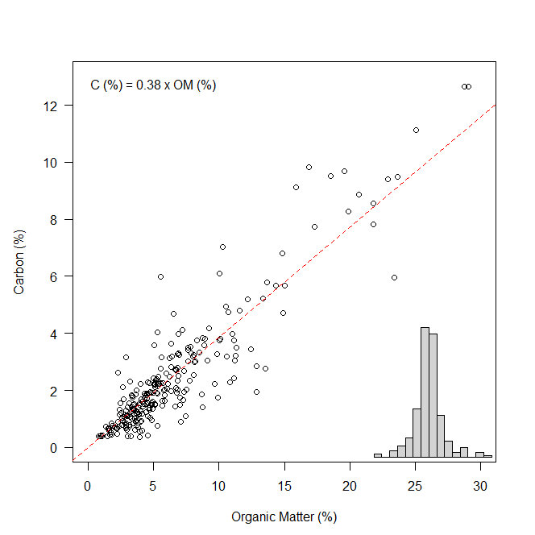
Figure S2. Regression model used to estimate soil carbon concentration from organic matter (OM) content determined by the loss on ignition (LOI) method (C = 0.38 × OM; R² = 0.94). The dotted red line represents the regression line. The histogram in the lower right corner displays the distribution of the model residuals.

