Sustained global greening driven by continuous CO₂ fertilization

Supplementary Information
S1. Remaining issues in the long-term satellite LAI datasets
Uncertainties in global long-term satellite leaf area index (LAI) products derived from Advanced Very High-Resolution Radiometer (AVHRR) observations have led to various conclusions in seasonal to decadal global vegetation changes¹. For example, several studies reported inconsistent seasonal patterns and magnitudes of AVHRR-based LAI in tropical forests ^{2,3}, which were caused by seasonal changes in satellite observation geometry, affecting surface reflectance and downstream vegetation products^{4–6}. Global long-term trends of LAI were also inconsistent among different products due to uncertainties in the input data from spectral reflectance and vegetation indices^{7–9}. For instance, Global Inventory Modeling and Mapping Studies (GIMMS) LAI3g showed stalled global trends from the 2000s to the 2010s caused by the AVHRR sensor degradation and orbital drifting effect of National Oceanic and Atmospheric Administration (NOAA) satellites in GIMMS3g NDVI data¹⁰. These divergent conclusions in leaf area dynamics underscore the urgent need to resolve uncertainties in long-term LAI products to ensure more consistent and reliable monitoring of ecosystem dynamics.
Temporal inconsistencies among different satellites and directional artifacts introduced by variations in sun-target-sensor geometry form the major sources of uncertainties in generating reliable long-term LAI data. The sources of temporal inconsistencies include discrepant bias of spectral reflectance among different AVHRR sensors, orbital drift of NOAA satellites, and incomplete harmonization with other reference satellite data, all of which collectively can increase uncertainties in satellite LAI estimation^{9,11}. Several studies reported a notable discontinuity in NIR and red reflectance between the AVHRR-2 and AVHRR-3 sensors ^{12,13}. Previous works also identified the influence of orbital drift on spectral reflectance and vegetation indices at multiple pseudo-invariant calibration sites or at the global scale^{8,14,15}. In addition, incomplete harmonization of AVHR-derived vegetation indices data with other reference satellite data can introduce further uncertainties in global trends and interannual variability ^{9,16}. Moreover, insufficient consideration for Bi-directional Reflectance Distribution Function (BRDF) effects in spectral reflectance could lead to directional artifacts in vegetation index and LAI estimations ¹⁷. Those directional effects could introduce considerable artifacts in LAI estimations^{18,19}.
Although many studies have attempted to address uncertainties in long-term LAI data, comprehensive strategies remain insufficient. For example, GIMMS LAI4g mainly used PKU GIMMS NDVI, which aimed to address sensor degradation and orbit drifting issues in GIMMS3g NDVI by integrating NOAA satellite information (e.g. NOAA satellite numbers and years after launch) into the training of a back propagation neural network model¹⁰. Although PKU GIMMS NDVI showed an enhanced temporal consistency compared to GIMMS3g NDVI, a clearer theoretical basis for addressing each source of uncertainty is still needed. In addition, PKU GIMMS NDVI used a biome-specific neural network model with a randomly sampled training dataset, which predominantly learns spatial relationships between NDVI and other variables²⁰. Consequently, the trained neural network might be inadequate to address issues such as sensor changes, degradation, and orbital drift, which are time-dependent processes^{8,9}. GEOV2-AVHRR LAI relied on pre-trained neural networks using SPOT-4/5 and Moderate Resolution Imaging Spectroradiometer (MODIS) LAI product²¹. It used the benchmark MODIS LAI derived from MODIS Collection 5 surface reflectance data, which version had a sensor degradation issue²², and deployed the inconsistent versions of Long-Term Data Record (LTDR) reflectance data^{23–25}.
S2. AVHRR LTDR LAI
To evaluate SNU LAI using the original LTDR V5 surface reflectance-based LAI, we use the LTDR V5 LAI (AVH15C1) from 1982 to 2021, acquired from the NOAA online archive²⁶. The LTDR team provided daily temporal resolution and 0.05º spatial resolution global LAI data based on the AVH09C1 surface reflectance product. The LTDR LAI algorithm used artificial neural networks trained with monthly MODIS LAI during the NOAA-16 periods from 2001 to 2007. They used normalized NDVI, NIR reflectance, red reflectance, and the cosine of solar zenith angle derived from AVH09C1 during the training, and tested the predicted LAI compared to MODIS LAI in each biome classified by the MODIS land cover product. We average the original daily LTDR LAI data into a monthly interval, after filtering out cloud, cloud-shadow, and snow pixels using the quality flag of AVH15C1.
S3. GIMMS LAI4g
To evaluate SNU LAI using the recently updated long-term LAI dataset, we use the GIMMS LAI4g dataset. GIMMS LAI4g provided spatiotemporally consistent LAI from 1982 to 2020 with bi-weekly temporal resolution and 1/12º spatial resolution¹⁰. By training a biome-specific neural network model based on high-quality Landsat LAI and PKU GIMMS NDVI²⁰, they generated GIMMS LAI4g from 1982 to 2015. Then they consolidated the GIMMS LAI4g with a reprocessed MODIS LAI using a pixel-wise linear regression on the overlapping period data for 2004–2015. The final output of GIMMS LAI4g consists of the consolidated GIMMS LAI4g data (1982–2003) and the reprocessed MODIS LAI data (2004–2020).
S4. GIMMS LAI3g
To evaluate SNU LAI using a widely used long-term LAI dataset, we adapt the GIMMS LAI3g data. This dataset has been applied extensively in global vegetation studies, including the Intergovernmental Panel on Climate Change (IPCC) Sixth Assessment Report (AR6)²⁷, to assess vegetation changes and evaluate Earth system model simulations. GIMMS LAI3g provided bi-weekly temporal resolution and 1/12º spatial resolution global LAI, which is based on the GIMMS NDVI3g and MODIS LAI²⁸. The feed-forward neural networks were trained on monthly MODIS LAI and GIMMS NDVI3g data spanning from 2000 to 2009²⁹. Subsequently, the trained model was used to generate GIMMS LAI3g for the entire period of the GIMMS NDVI3g dataset. We average the original bi-weekly GIMMS LAI3g data into a monthly interval and spatially resample it from a 1/12º to a 0.05º resolution using the nearest neighbor approach. The global monthly GIMMS LAI3g spanning from 1982 to 2015 is used in this study.
S5. Ground truth data
To evaluate the SNU LAI across ecosystems, we use the Committee on Earth Observation Satellites (CEOS) DIRECT 2.1 dataset, which provides a global network of LAI reference data (https://calvalportal.ceos.org/lpv-direct-v2.1)³⁰. CEOS DIRECT 2.1 provided averaged LAI values over a 3 km×3 km area by upscaling the original ground measurements with high spatial resolution satellite imagery. We exclude sites that had only a single observation across the entire study period. A total of 28 sites and 166 measurements are used, including croplands (CRO), deciduous broadleaf forests (DBF), mixed forests (MF), needleleaf forests (NF), and shrublands (SHR). The detailed sampling scheme and measurement strategy were described in the CEOS LPV subgroup (http://lpvs.gsfc.nasa.gov/).

S6. Nutrient datasets
We use global atmospheric nitrogen and phosphorus deposition data from 1980–2013³¹. The original dataset generates monthly global gridded rates of reactive N and total P deposition, combining both dry and wet pathways. Data are generated by the Laboratoire de Météorologie Dynamique Zoom general circulation model (LMDZ) coupled with the Interactive Chemistry and Aerosols module (INCA), aggregated from monthly outputs, and include bias corrections based on global observation networks. We obtain the processed annual global gridded nitrogen and phosphorus dataset from the publicly accessible repository (https://figshare.com/s/898e5d6c4f0982674ae3)³².
S7. Comparison of global trends among different long-term satellite LAI datasets
To examine the trends in different regions, we used the same criteria to separate the high-latitude Northern Hemisphere (NH) (50–90°N), temperate NH (25–50°N), tropical region (25°S–25°N), and extratropical Southern Hemisphere (SH) (25–90°S). In the tropical region, we have separated it into Tropical America (25–125°W), Tropical Africa (25°W–75°E), and Tropical Asia (75–180°E). We considered actual pixel areas to calculate global or regional values. Since each satellite LAI dataset has different data periods, we matched the data periods according to the purpose of the analysis. For the intercomparison of SNU LAI, LTDR LAI, LAI4g, and LAI3g, we separate the data into three different periods including 1982–1999, 2000–2015, and 1982–2015. To compare the temporal consistency in each season, we calculate the LAI trends in January–March, April–June, July–September, and October–December during the periods 1982–1999 and 2000–2015.
S8. Machine learning-based attribution analysis
To examine the consistency of estimated contributions of individual climate drivers to LAI trends, we apply a machine learning–based attribution approach that combines an extreme gradient boosting (XGBoost) model³³ with Shapley value³⁴. The model is trained to predict standardized LAI trends from four standardized climate driver trends: atmospheric CO₂ concentration, 2-m air temperature, precipitation, and shortwave radiation. To ensure sufficient training samples, we use all 0.05° grid-cell data within each 0.25° block (5×5 grid cells). For each block, the model is trained on 70% of randomly selected samples and tested on the remaining 30%. To obtain an attribution coefficient for each driver, we regress the SHAP values against the corresponding standardized driver values. The resulting slope (γ) represents the sensitivity of predicted standardized LAI to unit changes in the standardized climate variable. To estimate the contribution of each driver to the long-term LAI trend, we multiply γ by the raw linear trend of the corresponding driver and by the block-level standard deviation of LAI, yielding absolute contributions in units of m² m^{–2}decade^{–1}.
S9. Relationship between nutrient availability and CFE
The dominant CFE on global greening persists between 1982–2001 and 2002–2021, but its regional shifts may reflect spatially heterogeneous changes in nutrient availability (Supplementary Fig. 17)^{35,36}. In temperate and continental regions, increases in nitrogen and phosphorus availability significantly enhance the contribution of CO₂ to LAI trends (Supplementary Figs. 18–19). This finding is supported by evidence from the Duke Free-Air CO₂ Enrichment (FACE) site, where elevated CO₂ increased leaf area duration under nitrogen-enriched conditions³⁷, but additional nitrogen did not further enhance LAI once the canopy was closed³⁸. Consistent results from other FACE experiments further support that CO₂-induced increases in leaf area are limited by low nitrogen availability³⁹. While water availability strongly constrains LAI responses to elevated CO₂ in dry regions^{40,41}, nutrient limitation can dampen CO₂-induced increases in LAI⁴². Tropical regions show only a weak link between nutrient availability and CO₂-driven LAI trends, yet interpretation remains limited by the absence of comprehensive experiments in tropical rainforests, and forthcoming AmazonFACE is expected to provide a crucial reference for this relationship^{43,44}.
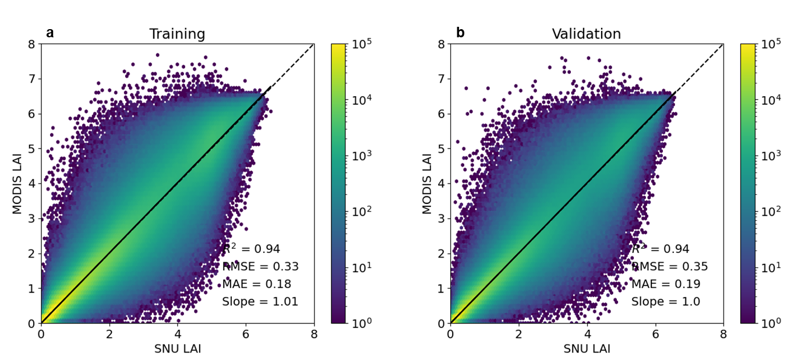
Figure S1. a, Training and b, validation of annual mean SNU LAI predictions against benchmark annual mean MODIS LAI. Black lines indicate a linear regression slope, and the dotted lines indicate a 1:1 line. The color bar represents the point density.

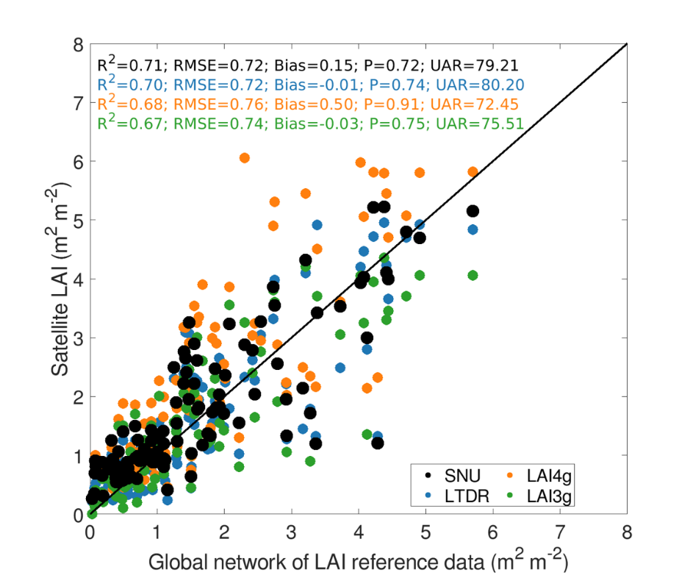
Figure S2. Evaluation of satellite LAI datasets using global network of LAI reference data (CEOS DIRECT 2.1). Each color indicates different satellite LAI products, including SNU (black), LTDR (blue), LAI4g (orange), and LAI3g (green). The black line is a 1:1 line.

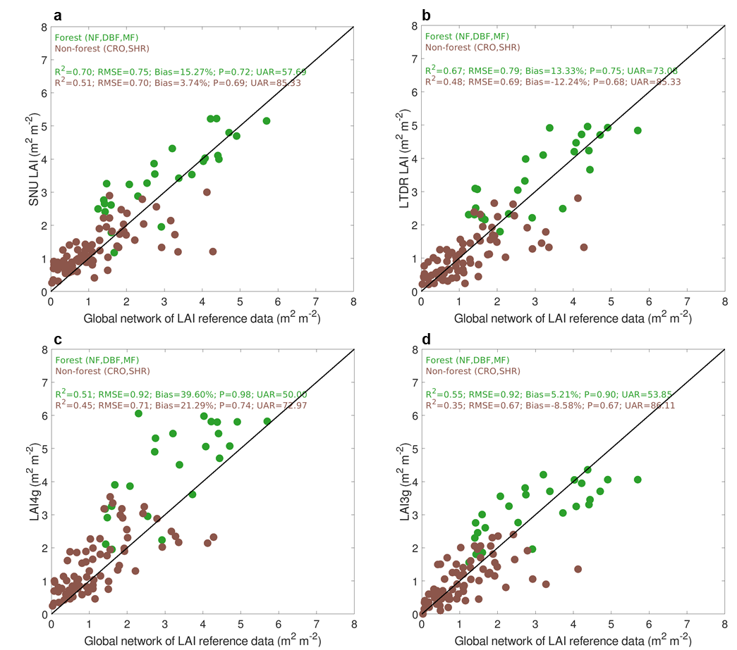
Figure S3. Evaluation of SNU LAI, LTDR LAI, LAI4g, and LAI3g using a global network of LAI reference data (CEOS DIRECT 2.1). Each panel indicates a, SNU LAI, b, LTDR LAI, c, LAI4g, and d, LAI3g. Green dots are forest (NF, DBF, and MF) and brown dots are non-forest (CRO, SHR) LAI values. The black line is a 1:1 line.
Figure S4. Global distribution of Köppen climate zones at 1° spatial resolution. The map shows four major climate categories: Tropical (green), Dry (yellow), Temperate (blue), and Continental (red).
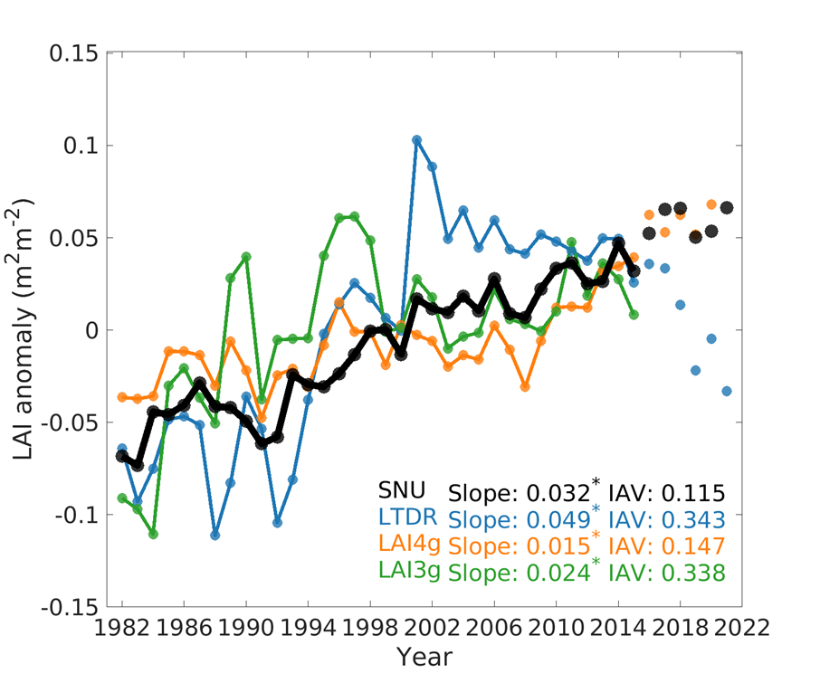
Figure S5. Temporal dynamics of the global growing season mean LAI anomaly during 1982–2021. Global LAI anomalies are computed by subtracting the multi-year growing season mean of the area-weighted global growing season mean LAI from the corresponding value in each year. Slope and interannual variability are calculated for the period from 1982 to 2015. Each color indicates different satellite LAI products, including SNU (black), LTDR (blue), LAI4g (orange), and LAI3g (green).
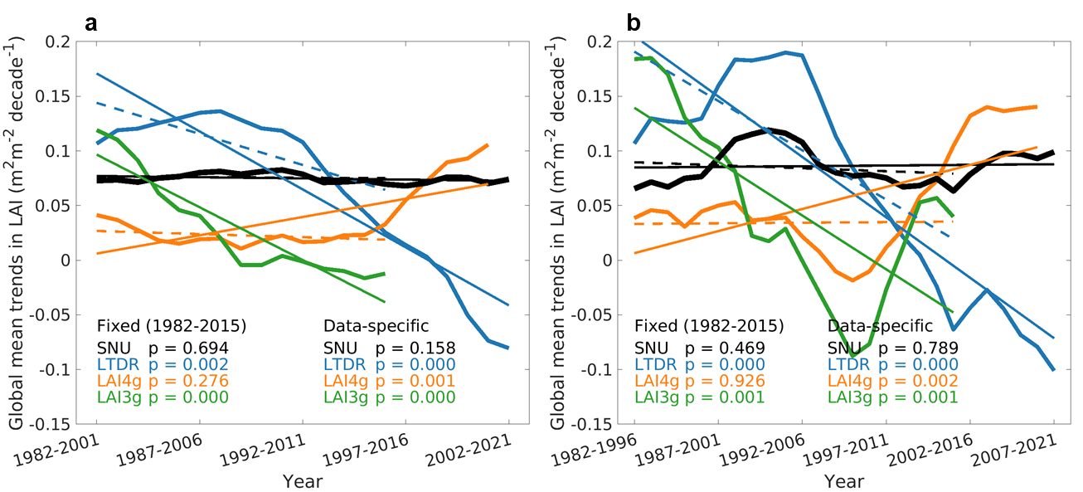
Figure S6. Global growing season mean LAI trends. For different periods, global LAI trends are calculated by selecting statistically significant pixels (Mann–Kendall test, P < 0.1) within each a, 20-year moving window and b, 15-year moving window. Colors represented different datasets: SNU (black), LTDR (blue), LAI4g (orange), and LAI3g (green).
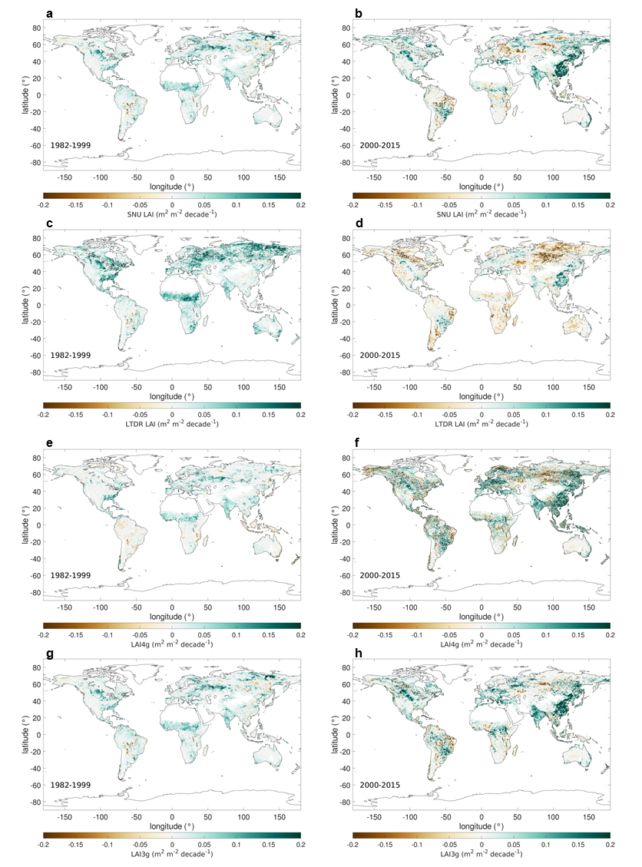
Figure S7. Spatial pattern of global LAI trends in long-term satellite products. Each column indicates different periods (Left: 1982–1999; Right: 2000–2015). Each row showed a different LAI dataset: a,b, SNU LAI, c,d, LTDR LAI, e,f, LAI4g, and g,h, LAI3g. Statistically significant pixels were colored (Mann–Kendall test, P < 0.1), and insignificant pixels were grey in color.
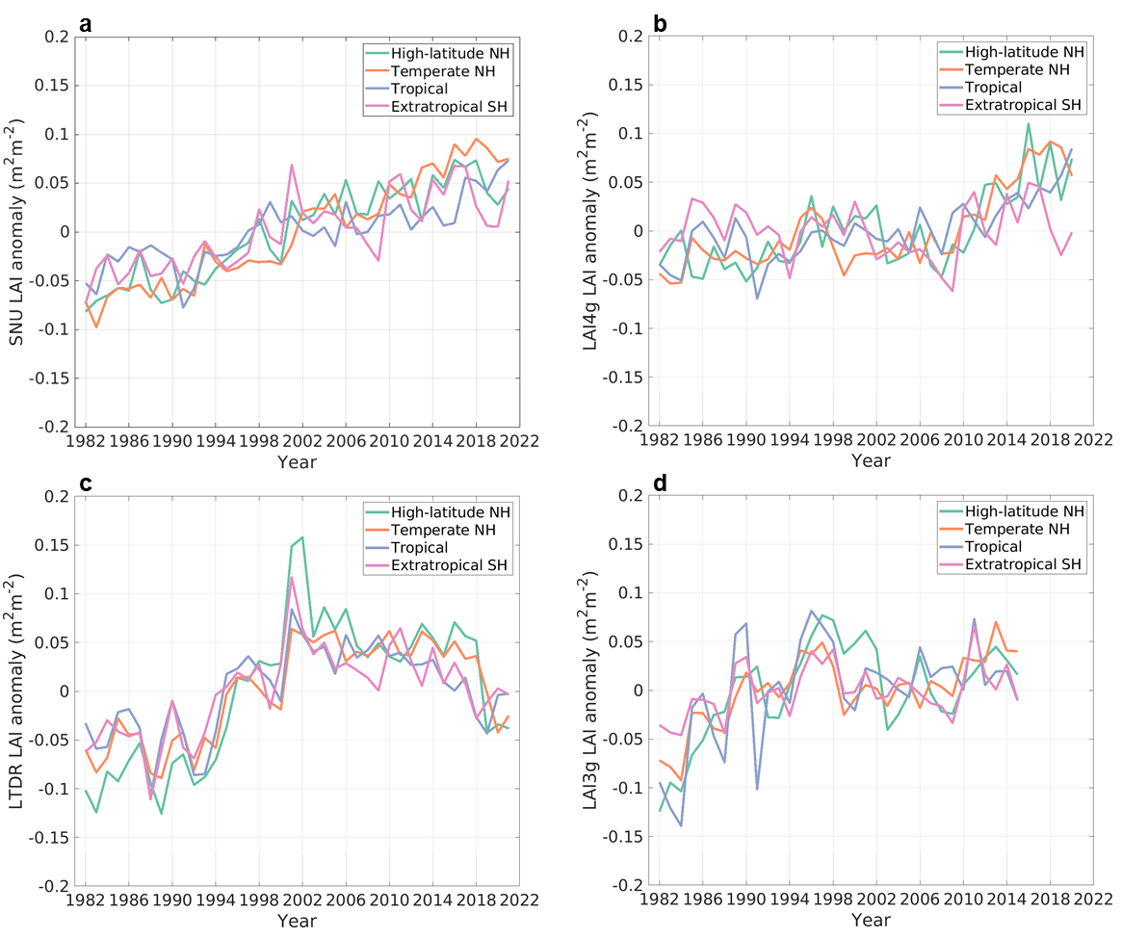
Figure S8. Temporal dynamics of the annual growing season mean LAI anomaly over high-latitude Northern Hemisphere (NH), temperate NH, tropical, and extratropical Southern Hemisphere (SH) regions. The LAI anomaly is computed by the difference between the annual growing season mean LAI and the multi-year growing season mean value of each pixel. Regional values were calculated considering the actual pixel area. Each panel shows a different LAI product: a, SNU LAI, b, LTDR LAI, c, LAI4g, and d, LAI3g.

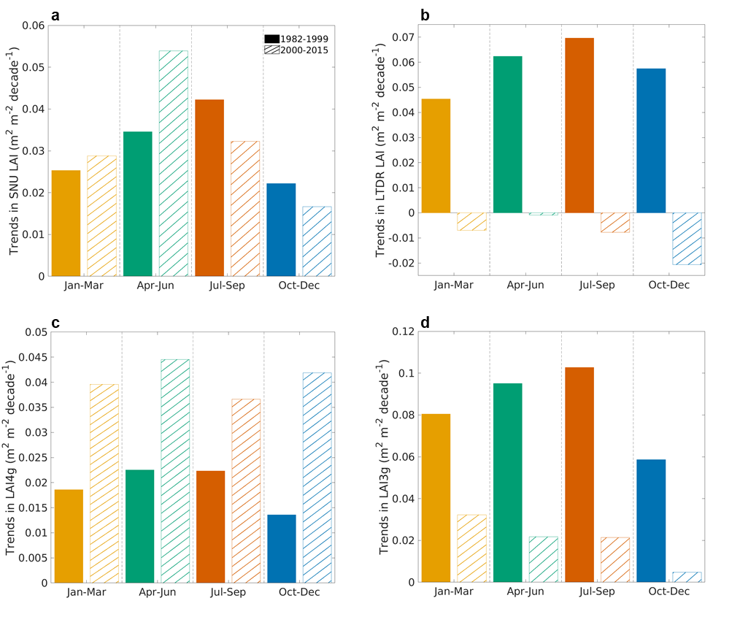Figure S9. Trends in a, SNU LAI, b, LTDR LAI, c, LAI4g, and d, LAI3g for each season during 1982–1999 and 2000–2015. Each color indicates a different season, including January-March (Dark yellow), April-June (Dark green), July-September (Dark orange), and October-December (Dark blue). The filled bars represent the period 1982–1999, and the dashed bars represent the period 2000–2015. The LAI anomaly is computed by the difference between the mean LAI in each season and the multi-year mean value of each pixel. Global values were calculated considering the actual pixel area.
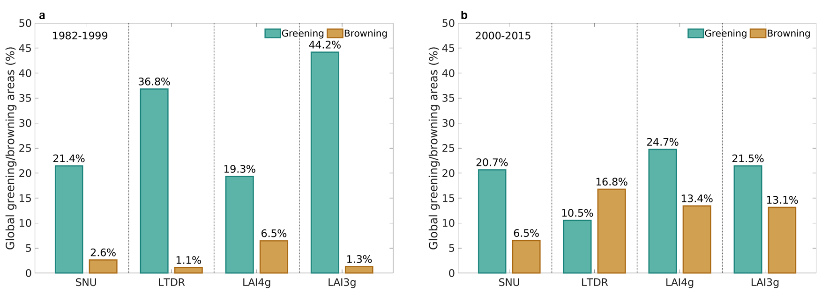
Figure S10. Global greening and browning areas (%) for SNU LAI considering the actual pixel area. Each panel represents a different period (a: 1982–1999; b: 2000–2015). Using the growing season mean LAI trend, we calculated global greening and browning areas, where a positive LAI trend indicates greening, while a negative LAI trend indicates browning. Statistically significant trends (Mann–Kendall test, P < 0.1) were only used.

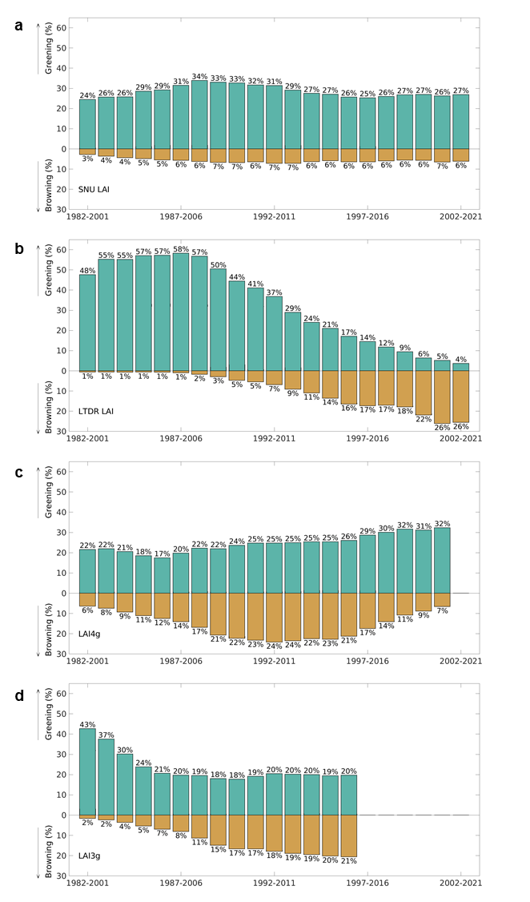
Figure S11. Global greening and browning areas (%) within each 20-year moving window in satellite LAI datasets: a, SNU LAI, b, LTDR LAI, c, LAI4g, and d, LAI3g. Green bars indicated the percentage of significant (Mann–Kendall test, P < 0.1) greening pixels, and brown bars represented significant browning pixels across different periods.
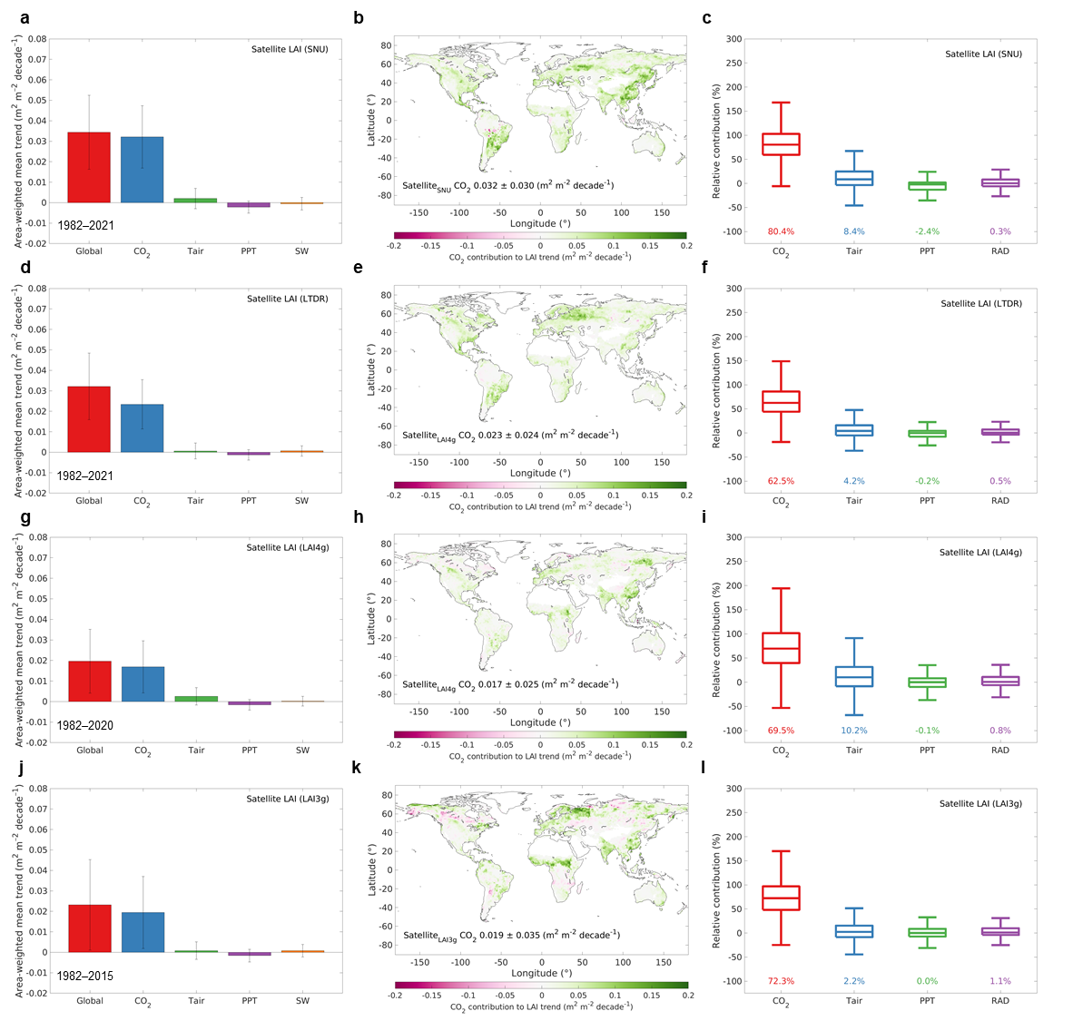
Figure S12. Attribution of global leaf area index (LAI) trends to climate drivers during 1982–2021. Each row indicates different satellite datasets, including SNU LAI (a–c), LTDR LAI (d–f), LAI4g (g–i), and LAI3g (j–l). Area-weighted mean LAI trends attributed to atmospheric CO2 concentration, air temperature (Tair), precipitation (PPT), and shortwave radiation (SW) from satellite observations and the TRENDY ensemble are shown. Error bars represent the spatial standard deviation across vegetated land surfaces. Box plots represent the relative contribution of climate-driven LAI trends, where each value is the median relative contribution (%) of each driver. Each map is a spatial distribution of contributions from atmospheric CO2 concentration for different satellite LAI datasets. White indicates non-vegetated regions, and grey indicates areas of high multicollinearity. The latter are defined as grid cells where the maximum variance inflation factor among the four predictors is > 10. Pink and green colors denote negative and positive contributions, respectively.
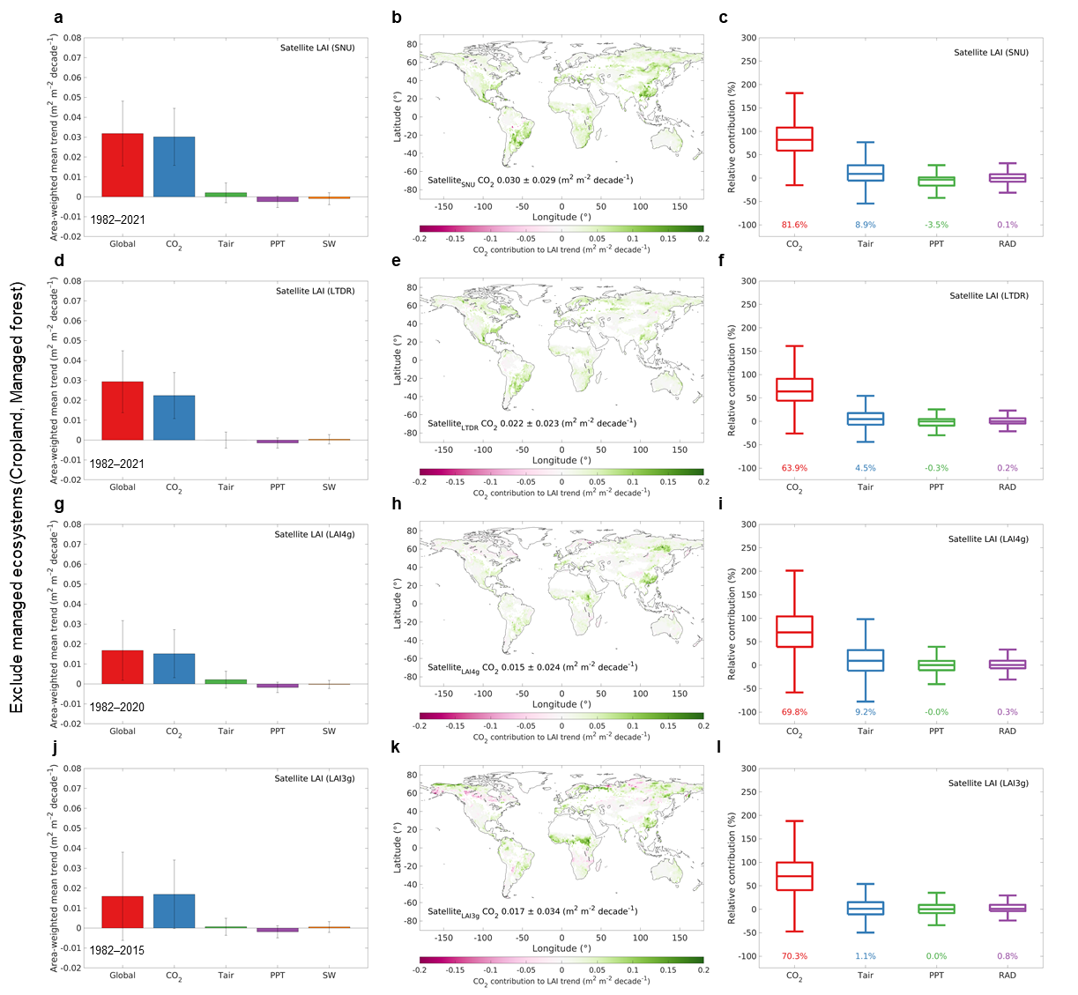
Figure S13. Same as Fig. S12, but excluding managed ecosystems. Cropland and managed forest areas are masked using a fixed land-cover map derived from the MODIS annual land cover product (2001–2021), by assigning each pixel the most frequently occurring land-cover class over the period. Managed forests are defined as MODIS forest pixels excluding intact forest areas, which are identified using the global forest map³⁵.
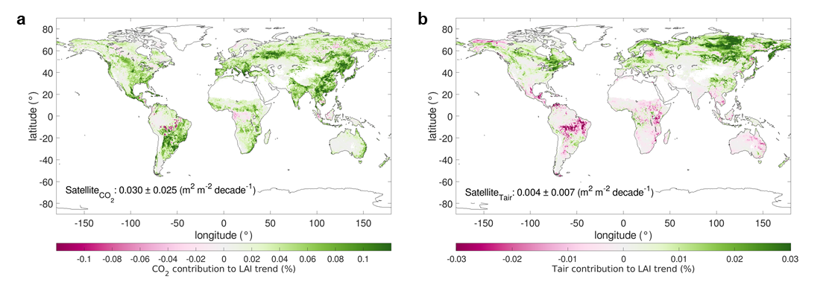
Figure S14. Attribution of global leaf area index (LAI) trends to climate drivers during 1982–2021. a,b, Spatial distributions of contributions from atmospheric CO₂ concentration (CO₂) and air temperature (Tair) for satellite-derived LAI trends. White indicates non-vegetated regions, and grey indicates areas of high multicollinearity (The maximum variance inflation factor among the four predictors is > 10). Pink and green colors denote negative and positive contributions, respectively.
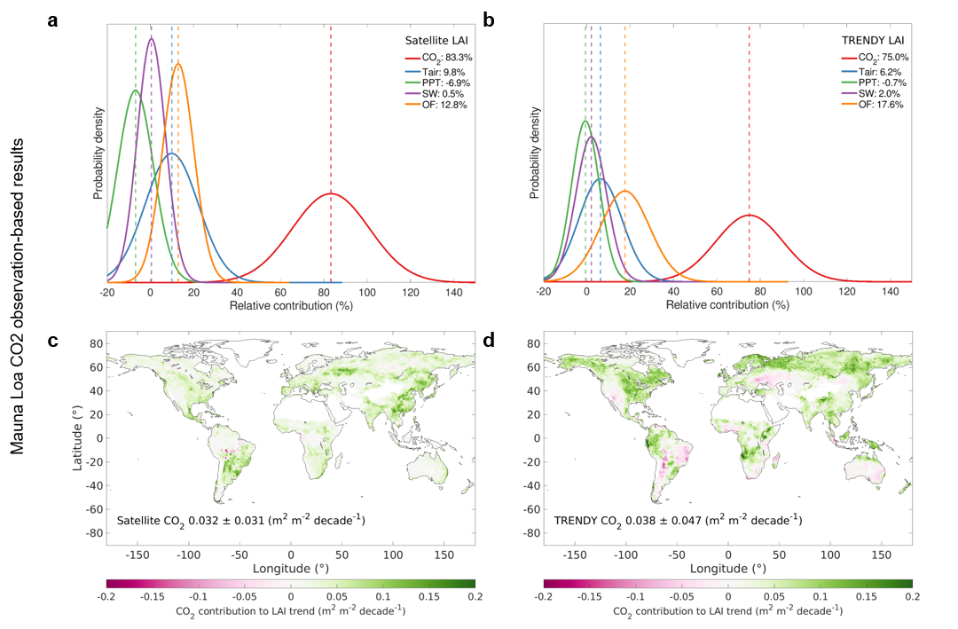
Figure S15. Same as Fig. 2, but using Mauna Loa atmospheric CO₂ observations (https://gml.noaa.gov/ccgg/trends/) uniformly across all global pixels.
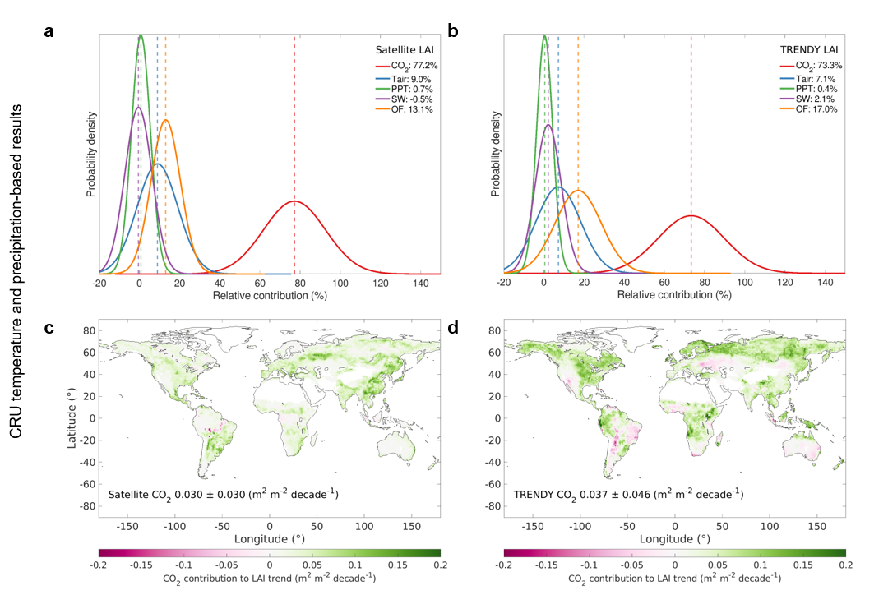
Figure S16. Same as Fig. 2, but using Climate Research Unit (CRU) 4.06 temperature and precipitation product (https://data.ceda.ac.uk/badc/cru/data/cru_ts/cru_ts_4.06).

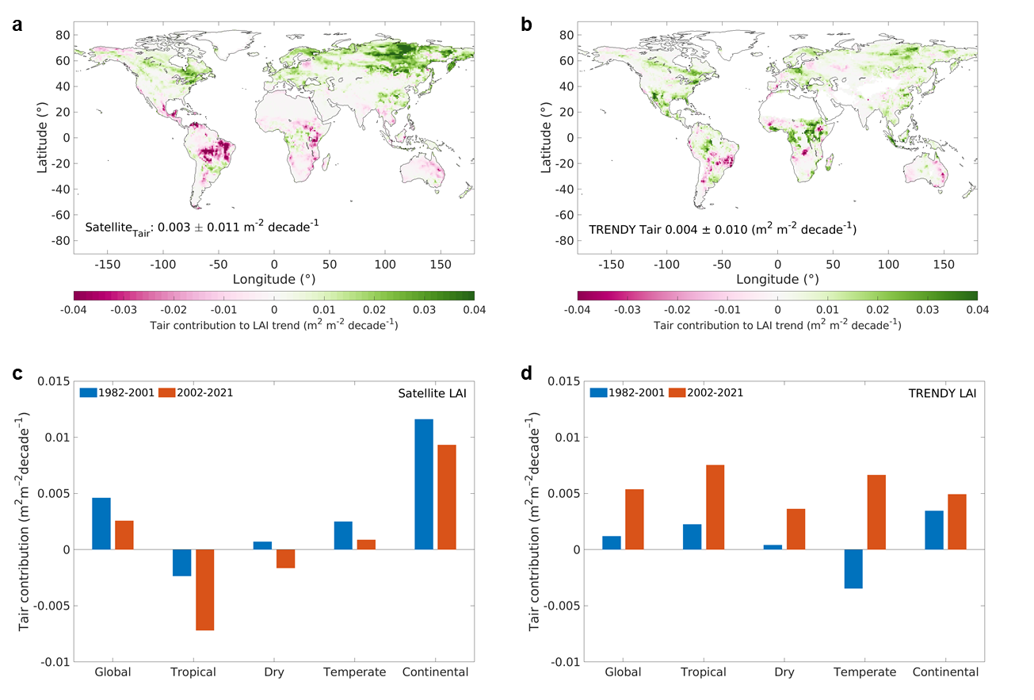
Figure S17. Attribution of global leaf area index (LAI) trends to climate drivers during 1982–2021. a,b, Spatial distributions of contributions from air temperature for satellite and TRENDY ensemble LAI trends. White indicates non-vegetated regions, and grey indicates areas of high multicollinearity (The maximum variance inflation factor among the four predictors is > 10). Pink and green colors denote negative and positive contributions, respectively.
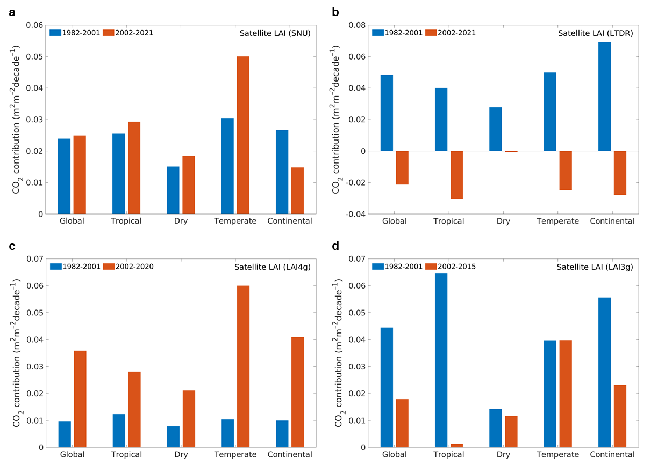Figure S18. Area-weighted CO₂ contributions to leaf area index (LAI) trends, shown globally and by climate zone. Each panel represents a different satellite LAI dataset.
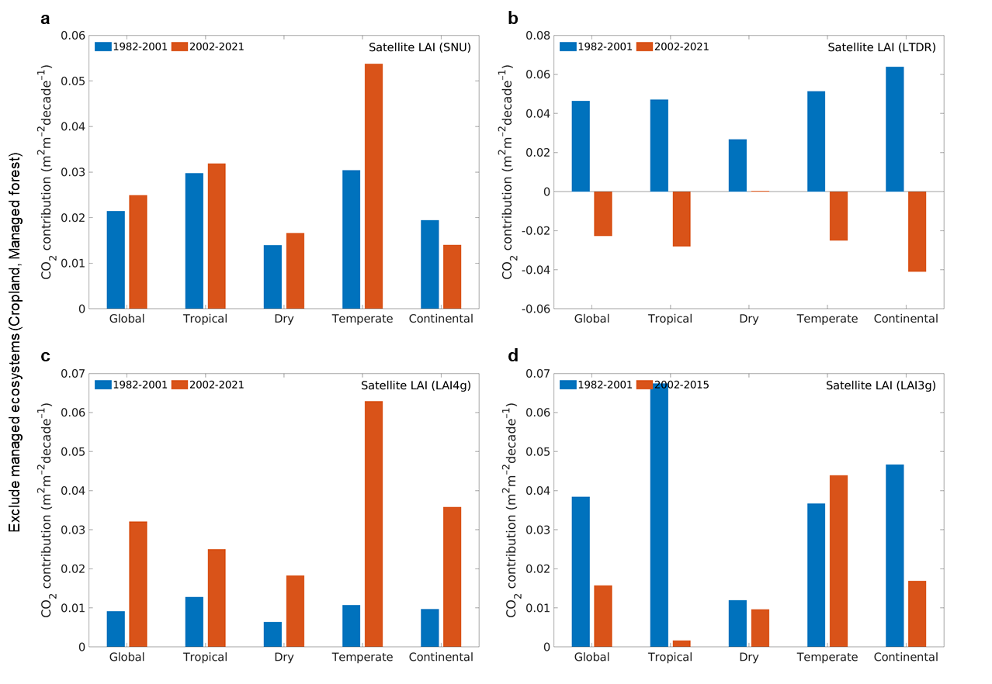Figure S19. Same as Fig. S18, but excluding managed ecosystems. Cropland and managed forest areas are masked using a fixed land-cover map derived from the MODIS annual land cover product (2001–2021)³⁶, by assigning each pixel the most frequently occurring land-cover class over the period. Managed forests are defined as MODIS forest pixels excluding intact forest areas, which are identified using the global forest map³⁵.
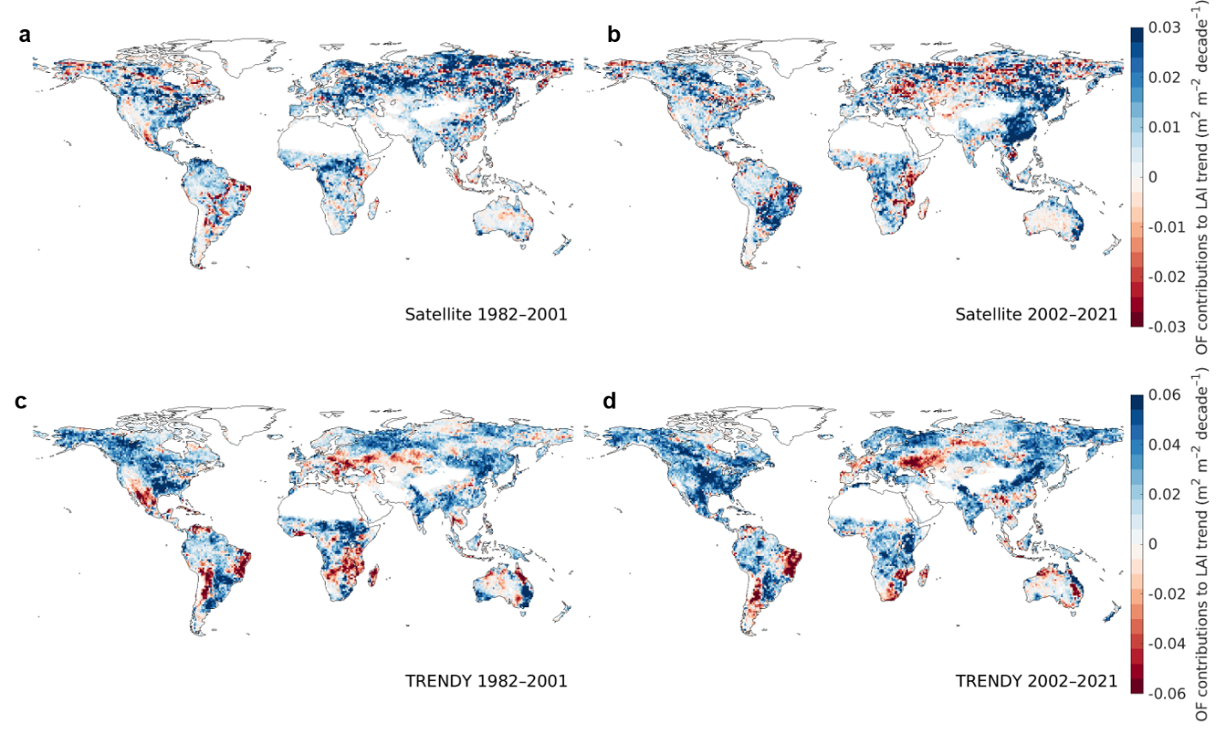 Figure S20. Decadal changes of other factors (OF) contributions to LAI trends and associated agricultural drivers. a,b OF contributions to satellite-derived LAI (SNU LAI) trend during 1982–2001 and 2002–2021. c,d OF contributions to the TRENDY ensemble LAI trend over the same periods. OF contributions are defined as the difference between the observed LAI trend and the combined contributions of four climate drivers: atmospheric CO₂ concentration, vapor pressure deficit, soil moisture, and shortwave radiation.
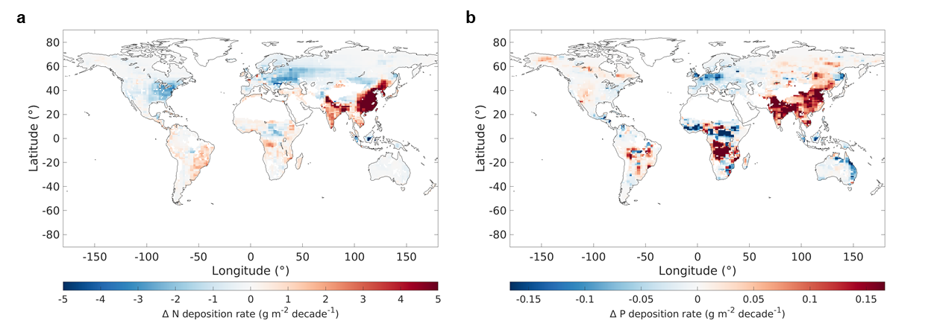
Figure S21. Changes in global atmospheric nitrogen (N) and phosphorus (P) deposition rates. Decadal deposition changes are calculated as the difference between mean annual deposition rates for 2002–2013 and 1980–2001.
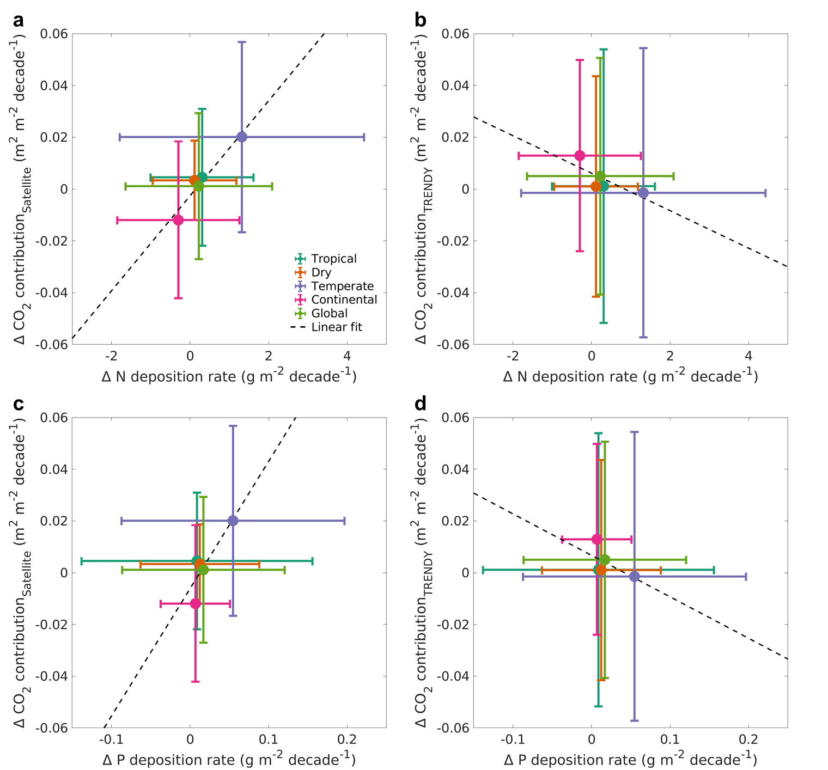
Figure S22. Relationship between decadal changes in nitrogen (N) and phosphorus (P) deposition rate and the CO₂ contribution to leaf area index (LAI) trends, estimated from a,c, satellite-derived LAI and c,d, the TRENDY ensemble LAI. Decadal deposition changes are calculated as the difference between mean annual deposition rates for 2002–2013 and 1980–2001. Changes in CO₂ contributions to LAI trends are calculated as the difference between 2002–2021 and 1982–2001. Colored symbols indicate area-weighted means for each climate zone: tropical (green), dry (orange), temperate (purple), continental (magenta), and global (olive). Error bars represent ±1 standard deviation across pixels within each climate zone. Dashed lines show linear regression fits based on the four individual climate zones.
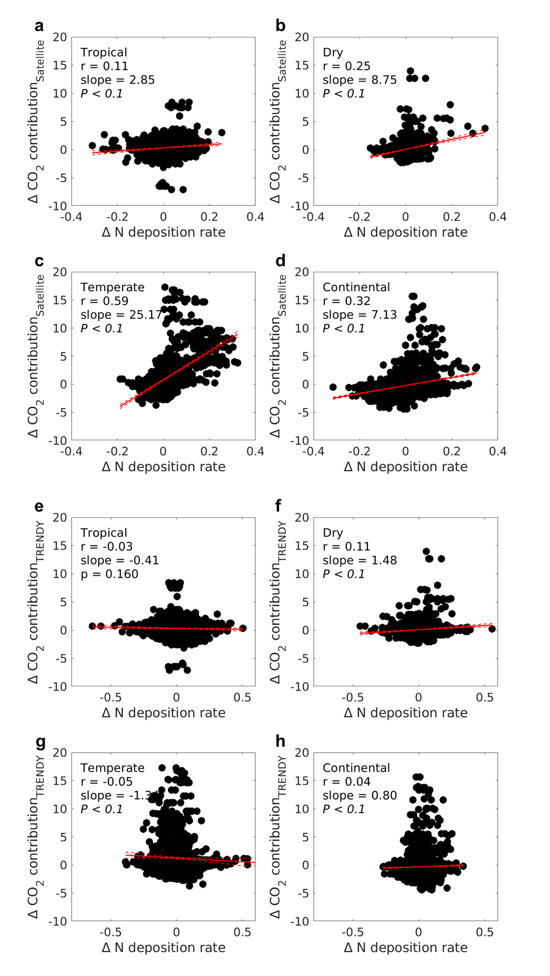
Figure S23. Relationship between decadal changes in nitrogen (N) deposition rate and the CO₂ contribution to leaf area index (LAI) trends, estimated from a–d, SNU LAI, and e–h, the TRENDY ensemble LAI. Decadal deposition changes are calculated as the difference between mean annual deposition rates for 2002–2013 and 1980–2001. Changes in CO₂ contributions to LAI trends are calculated as the difference between 2002–2021 and 1982–2001.

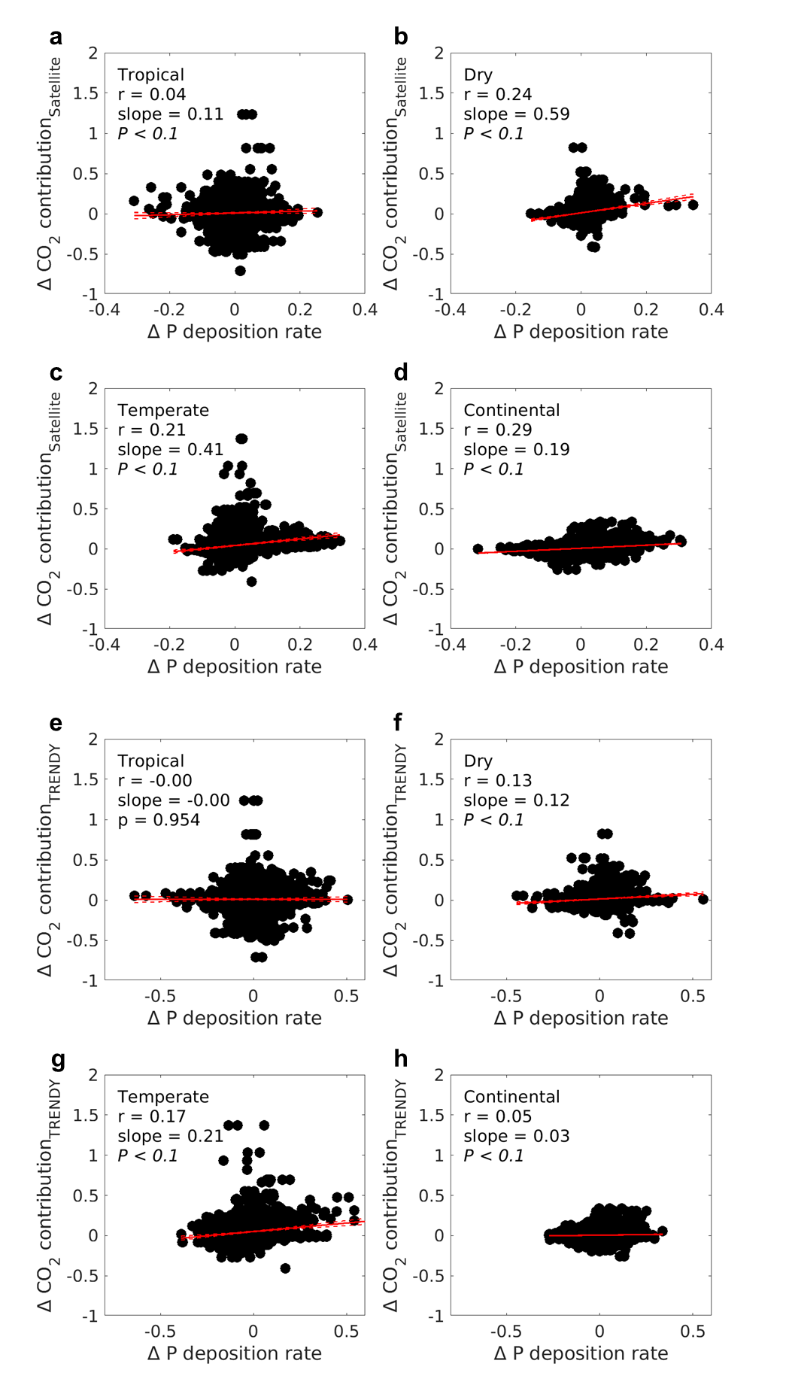
Figure S24. Relationship between decadal changes in phosphorus (P) deposition rate and the CO₂ contribution to leaf area index (LAI) trends, estimated a–d, SNU LAI, and e–h, the TRENDY ensemble LAI. Decadal deposition changes are calculated as the difference between mean annual deposition rates for 2002–2013 and 1980–2001. Changes in CO₂ contributions to LAI trends are calculated as the difference between 2002–2021 and 1982–2001.
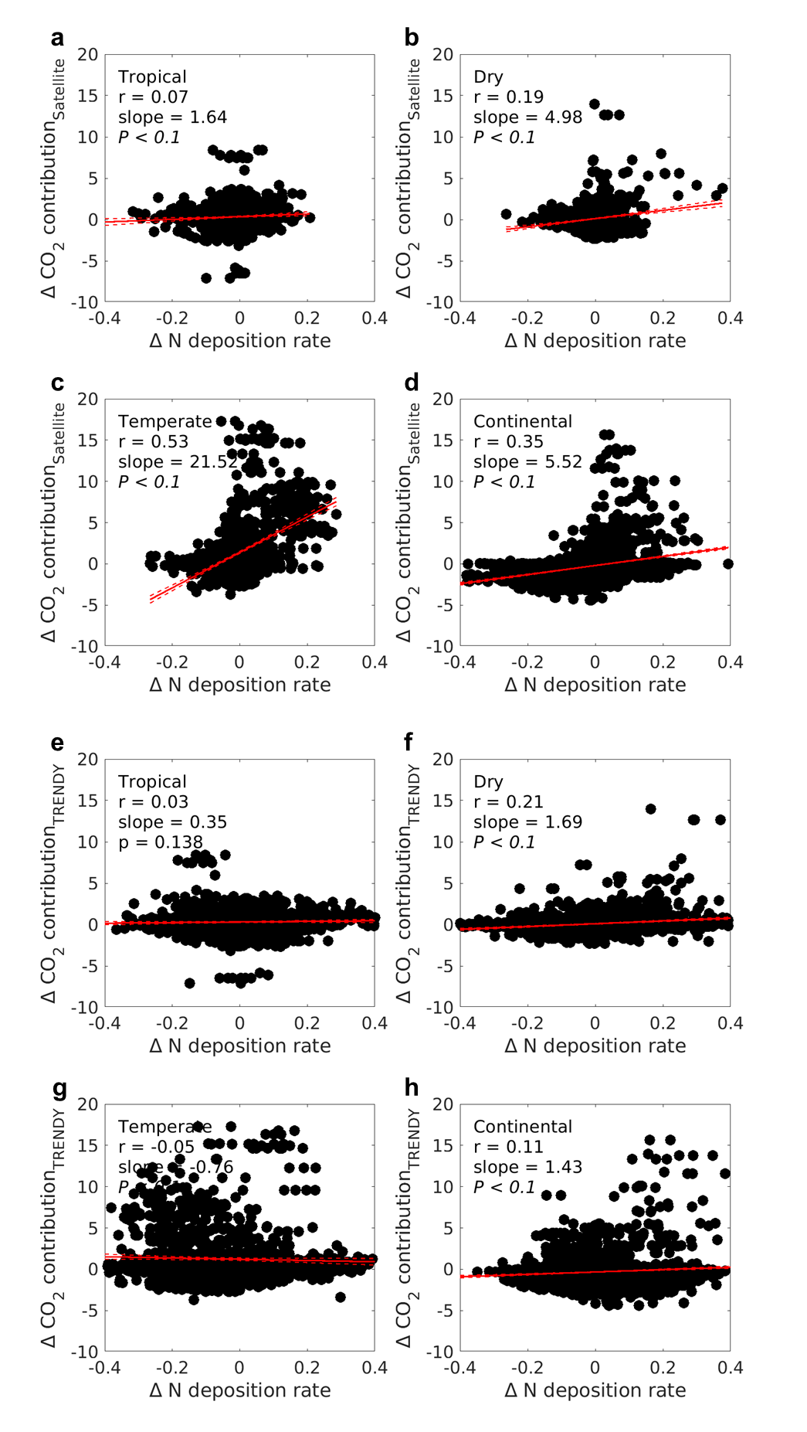
Figure S25. Relationship between decadal changes in nitrogen (N) deposition rate and the CO₂ contribution to leaf area index (LAI) trends, estimated from a–d, SNU LAI, and e–h, the TRENDY ensemble LAI. Decadal deposition changes are calculated as the difference between mean annual deposition rates for 2002–2013 and 1980–2001. Changes in CO₂ contributions to LAI trends are calculated as the difference between 2002–2013 and 1982–2001.
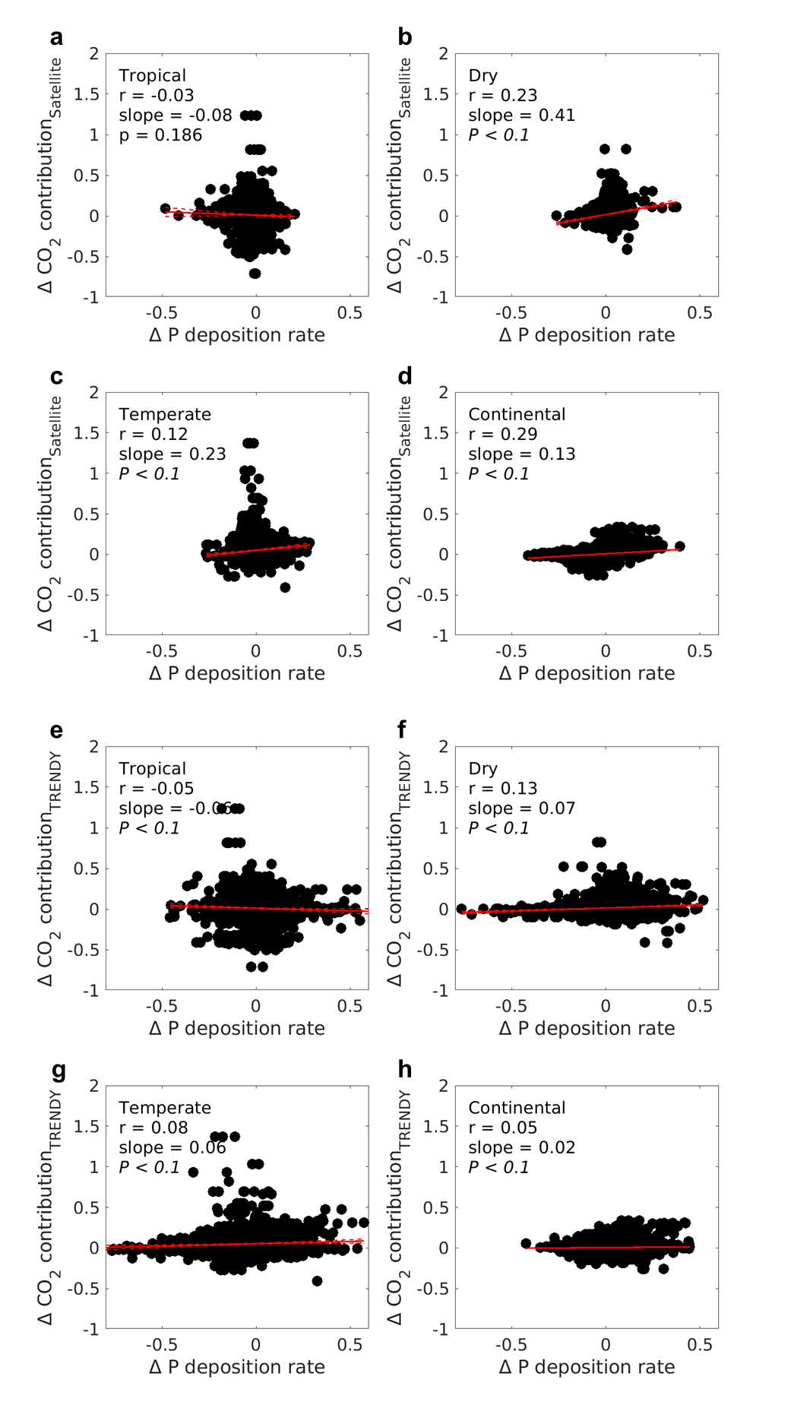
Figure S26. Relationship between decadal changes in phosphorus (P) deposition rate and the CO₂ contribution to leaf area index (LAI) trends, estimated from a–d, SNU LAI, and e–h, the TRENDY ensemble LAI. Decadal deposition changes are calculated as the difference between mean annual deposition rates for 2002–2013 and 1980–2001. Changes in CO₂ contributions to LAI trends are calculated as the difference between 2002–2013 and 1982–2001.
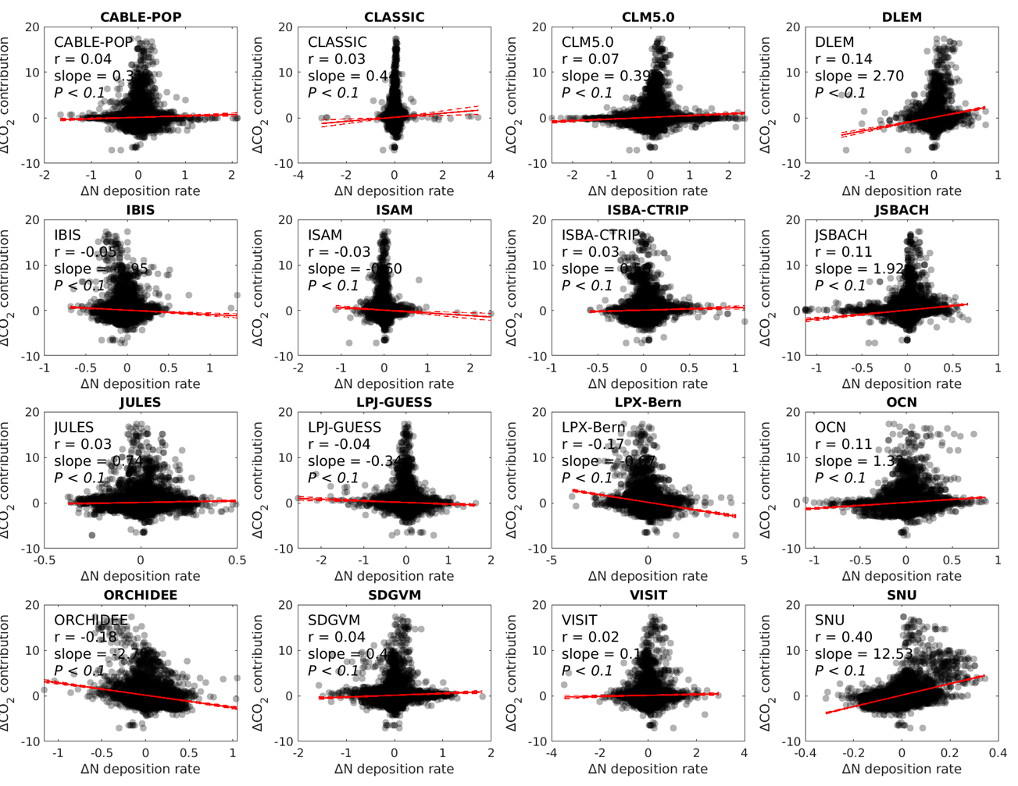
Figure S27. Relationship between decadal changes in nitrogen (N) deposition rate and the CO₂ contribution to leaf area index (LAI) trends, estimated from 15 Earth system models in TRENDY v12 and SNU LAI. Decadal deposition changes are calculated as the difference between mean annual deposition rates for 2002–2021 and 1980–2001. Changes in CO₂ contributions to LAI trends are calculated as the difference between 2002–2021 and 1982–2001.
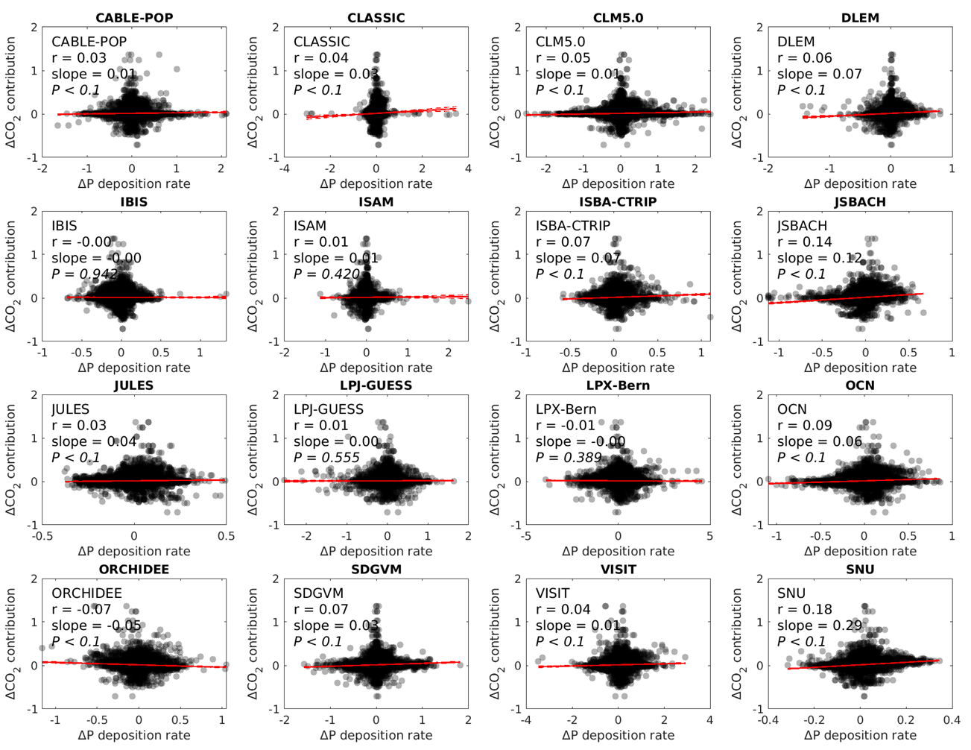
Figure S28. Relationship between decadal changes in phosphorus (P) deposition rate and the CO₂ contribution to leaf area index (LAI) trends, estimated from 15 Earth system models in TRENDY v12 and SNU LAI. Decadal deposition changes are calculated as the difference between mean annual deposition rates for 2002–2021 and 1980–2001. Changes in CO₂ contributions to LAI trends are calculated as the difference between 2002–2021 and 1982–2001.
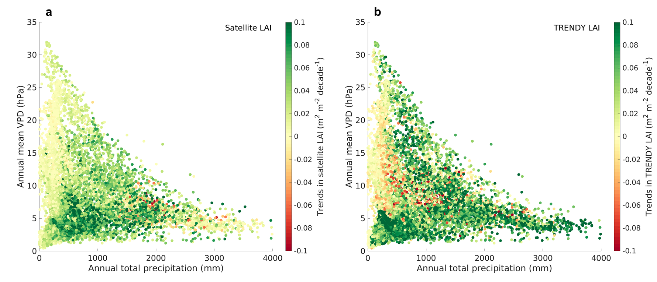
Figure S29. Trends in SNU LAI and TRENDY LAI across climate space defined by climatological annual total precipitation and annual mean vapor pressure deficit during 1982–2021.
Table S1. Performance of LAI predictions in each ecosystem. Needleleaf forests (NF), Evergreen Broadleaf Forests (EBF), Deciduous Broadleaf Forests (DBF), Mixed Forests (MF), Shrublands (SHR), Savanna (SAV), Grasslands (GRA), and Croplands (CRO).
 | R² | RMSE (m² m⁻²) | MAE (m² m⁻²)
NF | 0.88 | 0.33 | 0.24
EBF | 0.82 | 0.49 | 0.34
DBF | 0.93 | 0.39 | 0.25
MF | 0.93 | 0.40 | 0.33
SHR | 0.91 | 0.28 | 0.32
SAV | 0.89 | 0.23 | 0.14
GRA | 0.90 | 0.43 | 0.29
CRO | 0.91 | 0.32 | 0.19

Table S2. List of selected sites from the global network of LAI reference dataset (https://calvalportal.ceos.org/lpv-direct-v2.1).
Site ID | Latitude | Longitude | Land cover type
HARV  Barrax  Fundulea  Gourma  Hirsikangas  Jarvselja  Laprida  Nezer  Rovaniemi  Turco2  Wisconsin  Dahra_South  Tessekre_South  Tessekre_North  Utiel  Mongu  Harth Forest  Pshenichne  Merguellil  SouthWest_1  SouthWest_2  Barrax-LasTiesas  Albufera  Ottawa  Collelongo  Capitanata  Wielkopolska  Moncada | 42.53°N  39.07°N  44.41°N  15.32°N  62.64°N  58.30°N  36.99°S  44.57°N  66.46°N  18.24°S  45.80°N  15.41°N  15.82°N  15.90°N  39.58°N  15.44°S  47.81°N  50.08°N  35.57°N  43.55°N  43.45°N  39.05°N  39.27°N  45.31°N  41.85°N  41.46°N  52.06°N  39.52°N | 72.17°W  2.10°W  26.58°E  1.55°W  27.01°W  27.26°W  60.55°E  1.04°W  25.35°E  68.19°W  90.08°W  15.43°W  15.06°W  15.06°W  1.26°W  23.25°E  7.45°E  30.23°E  9.91°E  1.09°E  1.15°E  2.10°W  0.32°W  75.77°W  13.59°E  15.49°E  16.80°E  0.39°W | MF  CRO  CRO  SHR  NF  MF  CRO  NF  NF  SHR  MF  SHR  SHR  SHR  CRO  SHR  DBF  CRO  CRO  CRO  CRO  CRO  CRO  CRO  DBF  CRO  CRO  CRO

Table S3. Spatial correlations between SNU LAI trends and simulated LAI trends from 15 Earth system models during 1982–2021, quantified using Spearman ρ and Kendall τ. Reported P values indicate the statistical significance of the correlations.
Model | Spearman ρ | P value | Kendall τ | P value
'CABLE-POP' | 0.085 | < 0.001 | 0.06 | < 0.001
'CLASSIC' | 0.086 | < 0.001 | 0.063 | < 0.001
'CLM5.0' | 0.151 | < 0.001 | 0.104 | < 0.001
'DLEM' | 0.253 | < 0.001 | 0.176 | < 0.001
'IBIS' | 0.147 | < 0.001 | 0.098 | < 0.001
'ISAM' | 0.127 | < 0.001 | 0.085 | < 0.001
'ISBA-CTRIP' | 0.238 | < 0.001 | 0.163 | < 0.001
'JSBACH' | 0.236 | < 0.001 | 0.161 | < 0.001
'JULES' | 0.125 | < 0.001 | 0.087 | < 0.001
'LPJ-GUESS' | 0.202 | < 0.001 | 0.137 | < 0.001
'LPX-Bern' | 0.159 | < 0.001 | 0.109 | < 0.001
'OCN' | 0.242 | < 0.001 | 0.165 | < 0.001
'ORCHIDEE' | 0.248 | < 0.001 | 0.176 | < 0.001
'SDGVM' | 0.21 | < 0.001 | 0.143 | < 0.001
'VISIT' | 0.107 | < 0.001 | 0.073 | < 0.001

Reference
1. Jiang, C. et al. Inconsistencies of interannual variability and trends in long‐term satellite leaf area index products. Glob. Change Biol. 23, 4133–4146 (2017).
2. Garrigues, S. et al. Validation and intercomparison of global Leaf Area Index products derived from remote sensing data. J. Geophys. Res. Biogeosciences 113, 2007JG000635 (2008).
3. Xiao, Z., Liang, S. & Jiang, B. Evaluation of four long time-series global leaf area index products. Agric. For. Meteorol. 246, 218–230 (2017).
4. Doughty, C. E. & Goulden, M. L. Seasonal patterns of tropical forest leaf area index and CO₂ exchange. J. Geophys. Res. Biogeosciences 113, 2007JG000590 (2008).
5. Galvão, L. S. et al. On intra-annual EVI variability in the dry season of tropical forest: A case study with MODIS and hyperspectral data. Remote Sens. Environ. 115, 2350–2359 (2011).
6. Wu, J. et al. Biological processes dominate seasonality of remotely sensed canopy greenness in an Amazon evergreen forest. New Phytol. 217, 1507–1520 (2018).
7. Giglio, L. & Roy, D. P. On the outstanding need for a long-term, multi-decadal, validated and quality assessed record of global burned area: Caution in the use of Advanced Very High Resolution Radiometer data. Sci. Remote Sens. 2, 100007 (2020).
8. Frankenberg, C., Yin, Y., Byrne, B., He, L. & Gentine, P. Comment on “Recent global decline of CO₂ fertilization effects on vegetation photosynthesis”. Science 373, eabg2947 (2021).
9. Jeong, S. et al. Persistent global greening over the last four decades using novel long-term vegetation index data with enhanced temporal consistency. Remote Sens. Environ. 311, 114282 (2024).
10. Cao, S. et al. Spatiotemporally consistent global dataset of the GIMMS leaf area index (GIMMS LAI4g) from 1982 to 2020. Earth Syst. Sci. Data 15, 4877–4899 (2023).
11. Chen, C. et al. China and India lead in greening of the world through land-use management. Nat. Sustain. 2, 122–129 (2019).
12. Latifovic, R., Pouliot, D. & Dillabaugh, C. Identification and correction of systematic error in NOAA AVHRR long-term satellite data record. Remote Sens. Environ. 127, 84–97 (2012).
13. Li, C. et al. Post calibration of channels 1 and 2 of long-term AVHRR data record based on SeaWiFS data and pseudo-invariant targets. Remote Sens. Environ. 150, 104–119 (2014).
14. Giglio, L. & Roy, D. P. Assessment of satellite orbit-drift artifacts in the long-term AVHRR FireCCILT11 global burned area data set. Sci. Remote Sens. 5, 100044 (2022).
15. Fang, J. et al. A long-term reconstruction of a global photosynthesis proxy over 1982–2023. Sci. Data 12, 372 (2025).
16. Zhu, Z. et al. Comment on “Recent global decline of CO₂ fertilization effects on vegetation photosynthesis”. Science 373, eabg5673 (2021).
17. Hasegawa, K., Matsuyama, H., Tsuzuki, H. & Sweda, T. Improving the estimation of leaf area index by using remotely sensed NDVI with BRDF signatures. Remote Sens. Environ. 114, 514–519 (2010).
18. Zeng, Y. et al. Optical vegetation indices for monitoring terrestrial ecosystems globally. Nat. Rev. Earth Environ. 3, 477–493 (2022).
19. Gao, S. et al. Evaluating the saturation effect of vegetation indices in forests using 3D radiative transfer simulations and satellite observations. Remote Sens. Environ. 295, 113665 (2023).
20. Li, M. et al. Spatiotemporally consistent global dataset of the GIMMS Normalized Difference Vegetation Index (PKU GIMMS NDVI) from 1982 to 2022. Earth Syst. Sci. Data 15, 4181–4203 (2023).
21. Verger, A., Weiss, M. & Baret, F. Geov2-Avhrr: Continuous and Consistent Time Series of Global Leaf Area Index and Fraction Absorbed Par from 1981 to 2022. Preprint at https://doi.org/10.2139/ssrn.5012713 (2024).
22. Zhang, Y., Song, C., Band, L. E., Sun, G. & Li, J. Reanalysis of global terrestrial vegetation trends from MODIS products: Browning or greening? Remote Sens. Environ. 191, 145–155 (2017).
23. Nagol, J., Vermote, E. & Prince, S. Quantification of Impact of Orbital Drift on Inter-Annual Trends in AVHRR NDVI Data. Remote Sens. 6, 6680–6687 (2014).
24. Franch, B. et al. A 30+ Year AVHRR Land Surface Reflectance Climate Data Record and Its Application to Wheat Yield Monitoring. Remote Sens. 9, 296 (2017).
25. Santamaria-Artigas, A., Vermote, E. F., Franch, B., Roger, J.-C. & Skakun, S. Evaluation of the AVHRR surface reflectance long term data record between 1984 and 2011. Int. J. Appl. Earth Obs. Geoinformation 98, 102317 (2021).
26. Claverie, M., Matthews, J. L., Vermote, E. F. & Justice, C. O. A 30+ Year AVHRR LAI and FAPAR Climate Data Record: Algorithm Description and Validation. Remote Sens. 8, 263 (2016).
27. Intergovernmental Panel On Climate Change (Ipcc). Climate Change 2021 – The Physical Science Basis: Working Group I Contribution to the Sixth Assessment Report of the Intergovernmental Panel on Climate Change. (Cambridge University Press, 2023). doi:10.1017/9781009157896.
28. Zhu, Z. et al. Global Data Sets of Vegetation Leaf Area Index (LAI)3g and Fraction of Photosynthetically Active Radiation (FPAR)3g Derived from Global Inventory Modeling and Mapping Studies (GIMMS) Normalized Difference Vegetation Index (NDVI3g) for the Period 1981 to 2011. Remote Sens. 5, 927–948 (2013).
29. Yuan, H., Dai, Y., Xiao, Z., Ji, D. & Shangguan, W. Reprocessing the MODIS Leaf Area Index products for land surface and climate modelling. Remote Sens. Environ. 115, 1171–1187 (2011).
30. Brown, L. A. et al. Fiducial Reference Measurements for Vegetation Bio-Geophysical Variables: An End-to-End Uncertainty Evaluation Framework. Remote Sens. 13, 3194 (2021).
31. Wang, R. et al. Global forest carbon uptake due to nitrogen and phosphorus deposition from 1850 to 2100. Glob. Change Biol. 23, 4854–4872 (2017).
32. Wang, S. et al. Recent global decline of CO2 fertilization effects on vegetation photosynthesis. Science 370, 1295–1300 (2020).
33. Chen, T. & Guestrin, C. XGBoost: A Scalable Tree Boosting System. in Proceedings of the 22nd ACM SIGKDD International Conference on Knowledge Discovery and Data Mining 785–794 (ACM, San Francisco California USA, 2016). doi:10.1145/2939672.2939785.
34. Lundberg, S. M. & Lee, S.-I. A Unified Approach to Interpreting Model Predictions. in Advances in Neural Information Processing Systems vol. 30 (Curran Associates, Inc., 2017).
35. Wang, R. et al. Global forest carbon uptake due to nitrogen and phosphorus deposition from 1850 to 2100. Glob. Change Biol. 23, 4854–4872 (2017).
36. Piao, S. et al. Detection and attribution of vegetation greening trend in China over the last 30 years. Glob. Change Biol. 21, 1601–1609 (2015).
37. McCarthy, H. R., Oren, R., Finzi, A. C. & Johnsen, K. H. Canopy leaf area constrains [CO2]-induced enhancement of productivity and partitioning among aboveground carbon pools. Proc. Natl. Acad. Sci. 103, 19356–19361 (2006).
38. Palmroth, S. et al. Increased leaf area index and efficiency drive enhanced production under elevated atmospheric [CO2] in a pine-dominated stand showing no progressive nitrogen limitation. Glob. Change Biol. 30, e17190 (2024).
39. Norby, R. J. & Zak, D. R. Ecological Lessons from Free-Air CO2 Enrichment (FACE) Experiments. Annu. Rev. Ecol. Evol. Syst. 42, 181–203 (2011).
40. Jiang, M., Kelly, J. W. G., Atwell, B. J., Tissue, D. T. & Medlyn, B. E. Drought by CO2 interactions in trees: a test of the water savings mechanism. New Phytol. 230, 1421–1434 (2021).
41. Morgan, J. A. et al. C4 grasses prosper as carbon dioxide eliminates desiccation in warmed semi-arid grassland. Nature 476, 202–205 (2011).
42. Jiang, M. et al. Low phosphorus supply constrains plant responses to elevated CO2: A meta-analysis. Glob. Change Biol. 26, 5856–5873 (2020).
43. Lapola, D. et al. AmazonFACE: Assessing the effects of increased atmospheric CO2 on the ecology and resilience of the Amazon forest - 2025-2030 Science Plan. Preprint at https://doi.org/10.5281/ZENODO.13693335 (2024).
44. Fleischer, K. et al. Amazon forest response to CO2 fertilization dependent on plant phosphorus acquisition. Nat. Geosci. 12, 736–741 (2019).
45. Potapov, P. et al. The last frontiers of wilderness: Tracking loss of intact forest landscapes from 2000 to 2013. Sci. Adv. 3, e1600821 (2017).
46. Friedl, M. & Sulla-Menashe, D. MODIS/Terra+Aqua Land Cover Type Yearly L3 Global 0.05Deg CMG V061. NASA EOSDIS Land Process. Distrib. Act. Arch. Cent. DAAC Data Set MCD12C1.061 (2022) doi:10.5067/MODIS/MCD12C1.061.

