Supplementary information

Content
Supplementary Method 1. The inclusion and exclusion criteria of participants.
Supplementary Method 2. Network analysis
Supplementary Method 3. Quality control and imputation of genotype data.
Supplementary Method 4. Selection of pathways and cell types for calculating polygenic risk score.
Supplementary Result 1. Comparison of two-cluster solution and three-cluster solution.
Supplementary Result 2. Network comparison tests results among three subtypes.
Supplementary Table 1. The sample information of cases and controls in discovery and replication stages.
Supplementary Table 2. Correlations of PANSS items with Age and Sex.
Supplementary Table 3. GWAS summary statistics used in this study.
Supplementary Table 4. Gene sets for neurotransmitter pathways and single cell types included in this analysis.
Supplementary Table 5. Characteristic and clinical information among three subtypes of the discovery dataset.
Supplementary Table 6. Characteristic and clinical information among three subtypes of the replication dataset.
Supplementary Table 7. Network comparison test results.
Supplementary Table 8. Replication of significant loci identified in previous EAS GWAS
Supplementary Table 9. eQTL mapping results.
Supplementary Figure 1. Comparison of two-cluster (k=2) and three-cluster (k=3) solutions.
Supplementary Figure 2. Network analysis results in the discovery dataset.
Supplementary Figure 3. Stability and accuracy of edge weight estimates for the symptom networks.
Supplementary Figure 4. Stability analysis of centrality measure of the symptom networks.
Supplementary Figure 5. PCA of our samples and samples from the 1000 Genomes project.
Supplementary Figure 6. Risk allele ORs in SCZ and SCZ subtypes.
Supplementary Figure 7. Regional plot of rs2836330.
Supplementary Figure 8. Regional plot of rs9876206.
Supplementary Figure 9. Regional plot of rs3767295.
Supplementary Figure 10. Regional plot of rs970115.

Supplementary Method 1. The inclusion and exclusion criteria of participants.
All the cases underwent a comprehensive clinical evaluation using the Structured Clinical Interview for Mental Disorder (SCID), and met the criteria for schizophrenia in DSM-V. Individuals with other severe mental disorders, organic mental disorder, a history of alcohol or substance abuse, or severe physical diseases were excluded. Exclusion criteria for healthy controls included a personal or family history of mental illness, head injuries, epilepsy, or learning disabilities. For healthy controls, individuals with a family history of mental illness, head injuries, substance induced psychosis, epilepsy and learning disabilities were excluded.

Supplementary Method 2. Network analysis
Networks were estimated using the graphical Least Absolute Shrinkage and Selection Operator (glasso) with the extended Bayesian Information Criterion (EBIC) for model selection, implemented in the bootnet R package. This regularization technique minimizes spurious edges by shrinking small partial correlations to zero. Node strength centrality, reflecting the relative influence of each node, was computed with the R package “qgraph”. The stability of edge weights and centrality estimates was evaluated using non-parametric and case-dropping bootstrap procedures. A correlation stability coefficient (CS-coefficient) of ≥0.25 was considered acceptable. ¹
To formally compare networks across subtypes, we performed a Network Comparison Test (NCT) with 5,000 iterations using the R package “NetworkComparisonTest”. The test evaluated differences in overall network structure, global strength, and individual edge strength.

Supplementary Method 3. Quality control and imputation of genotype data.
First, SNPs and individuals with a missing rate exceeding 20% were excluded to filter SNPs and individuals with very high level missingness². Subsequently, sample screening was performed. Samples were removed if the genotype call rate was less than 96% or if their genotype sex was inconsistent with recorded sample information. Heterozygosity rates were calculated, and samples with values exceeding 6 standard deviations were excluded from the further analysis. Additionally, relatedness among samples were assessed using identify-by-descent estimates. Relatedness was assessed using identity-by-descent (IBD) estimates. For pairs of genetically related individuals (PI_HAT > 0.2), the one with the lower call rate was excluded. For the variants screening, SNPs were removed if their call rate was below 98%, minor allele frequency (MAF) was less than 0.01, or Hardy-Weinberg equilibrium (HWE) P-value was below 1×10⁻⁶. Principal component analyses (PCA) were performed to assess population structure. Subjects deviating by more than 6 standard deviations from the central cluster of the PCA plot were excluded following visual inspection. Genotype imputation after QC was performed with the ChinaMAP reference panel. This reference panel was constructed based in-depth whole genome sequencing data of 10,155 unrelated Chinese individuals and exhibited significant improvement in terms of precision and sensitivity for Chinese population 3. After imputation, variants with imputation quality (INFO score) < 0.8, MAF < 0.01, or HWE P < 1×10-6 were excluded from the further analysis. To confirm the genetic ancestry of our participants, we also performed PCA by co-analyzing our sample genotypes with those from the 1000 Genomics project reference panel⁴.

Supplementary Method 4. Selection of psychiatric disorders, pathways and cell types for calculating polygenic risk score.

We used a cross-ancestry polygenic prediction tool, PRS-CSx, to calculated genome-wide polygenic risk score (gPRS) and pathway-based PRS (pPRS) and cell-type-specific PRS (ctPRS).

For gPRS, we downloaded summary statistics for three common psychiatric disorders from the Psychiatric Genomics Consortium (https://pgc.unc.edu/for-researchers/download-results/) as based data. Ancestry-specific GWAS summary statistics for schizophrenia⁵, bipolar disorder (BD)⁶, Major depressive disorder (MDD)^{7,8}.

For four neurotransmitter pathways, genes were identified by querying Gene Ontology (GO) pathways in the MsigDB database (). Neurotransmitter-specific keywords (e.g. “dopamine” or “dopaminergic”) were used for pathway selection. All pathways corresponding to a given neurotransmitter were subsequently merged to construct a single gene set.

When defined the gene sets of 6 brain cell types, we only included differentially expressed genes (DEGs) that stratified an FDR < 0.05 in a meta-analysis of two cohorts and exhibited consistent effect directions across both cohorts⁹. Notably, while the original study further divided excitatory and inhibitory neurons into multiple subpopulations, we merged the DGEs from their respective subpopulations to create unified excitatory and inhibitory gene sets, thereby simplifying the categorization for our analysis.

Supplementary Result 1. Comparison of two-cluster solution and three-cluster solution.

When patients were grouped into two clusters, one cluster was characterized by generally low symptom severity, while the other showed high severity across all five symptom dimensions. The Jaccard similarity coefficients for these two subtypes were 0.86 and 0.88, indicating a highly stable clustering structure.

When patients were classified into three clusters, a new subgroup emerged that was characterized primarily by elevated negative and disorganized symptoms, while the other symptom dimensions remained relatively mild. The Jaccard coefficients for three clusters were 0.79, 0.79, and 0.85, suggesting a relatively stable cluster structure, albeit slightly less stable than the two-cluster solutions. Notably, 82.5% of patients in the low-symptom cluster from the two-cluster solution remained in the low-symptom cluster under the three-cluster solution, indicating strong consistence. Among those originally classified as high-symptom in the two-cluster model, 39.0% remained in the high-symptom group, while most of the remaining patients transitioned into the newly identified third cluster.

Supplementary Result 2. Network comparison tests results among three subtypes.

The network comparison tests were applied to compare symptom structures of three subtypes.

The analysis revealed significant differences in the overall network structure between Cluster-S and Cluster-N (M = 0.284, P = 0.006), between Cluster-S and Cluster-L (M = 0.264, P = 0.003), and between Cluster-N and Cluster-L (M = 0.185, P = 0.002). No significant difference was found in global connectivity strength across the subtypes. More details were shown in Supplementary Table 7.

Although Cluster-N exhibited the most severe negative symptoms, the centrality indices of the negative symptom nodes was lower in this subtype compared to the others (Strength: Cluster-N vs Cluster-L, P = 0.029; Expected Influence: Cluster-N vs Cluster-S, P = 0.002; Cluster-N vs Cluster-L, P = 0.011). This indicates that negative symptoms, while prominent, were less interconnected with other symptoms within the Cluster-N network. A similar pattern was observed for disorganized symptoms, whose centrality was lower in Cluster-N than in Cluster-S, despite comparable high severity in both subtypes (Strength: Cluster-N vs Cluster-S, P = 0.009; Expected Influence: Cluster-N vs Cluster-S, P = 0.013).

Reference

1. Epskamp S, Borsboom D, Fried EI. Estimating psychological networks and their accuracy: A tutorial paper. Behav Res Methods 2018; 50(1): 195-212.
2. Marees AA-O, de Kluiver H, Stringer S, et al. A tutorial on conducting genome-wide association studies: Quality control and statistical analysis. (1557-0657 (Electronic)).
3. Li L, Huang P, Sun X, et al. The ChinaMAP reference panel for the accurate genotype imputation in Chinese populations. Cell Res 2021; 31(12): 1308-10.
4. Auton A, Brooks LD, Durbin RM, et al. A global reference for human genetic variation. Nature 2015; 526(7571): 68-74.
5. Trubetskoy V, Pardiñas AF, Qi T, et al. Mapping genomic loci implicates genes and synaptic biology in schizophrenia. Nature 2022; 604(7906): 502-8.
6. O'Connell KS, Koromina M, van der Veen T, et al. Genomics yields biological and phenotypic insights into bipolar disorder. Nature 2025; 639(8056): 968-75.
7. Trans-ancestry genome-wide study of depression identifies 697 associations implicating cell types and pharmacotherapiesMolecular and genetic evidence for abnormalities in the nodes of Ranvier in schizophrenia. Cell 2025; 188(3): 640-52.e9.
8. Giannakopoulou O, Lin K, Meng X, et al. The Genetic Architecture of Depression in Individuals of East Asian Ancestry: A Genome-Wide Association Study. JAMA Psychiatry 2021; 78(11): 1258-69.
9. Ruzicka WB, Mohammadi S, Fullard JF, et al. Single-cell multi-cohort dissection of the schizophrenia transcriptome. Science 2024; 384(6698): eadg5136.

Supplementary Table 1. The sample information of cases and controls in discovery and replication stages.
 | Discovery dataset |  | Replication dataset |  | Between SZ (Discovery vs Replication) | SZ vs HC (Discovery dataset) | SZ vs HC (Replication dataset)
 | SZ (n=2416) | HC (n=2240) | SZ (n=480) | HC (n=739) | P | P | P
Age | 46.2 ± 11.8 | 28.2 ± 6.9 | 45.4 ± 11.5 | 28.3 ± 8.1 | 0.213 | <0.001 | <0.001
Gender (female %) | 35.2% | 55.2% | 35.2% | 51.4% | 1.000 | <0.001 | <0.001
Age at Onset | 28.0 ± 9.9 | - | 28.8 ± 10.0 | - | 0.116 | - | -
Duration of illness | 18.3 ± 10.4 | - | 17.3 ± 10.1 | - | 0.058 | - | -
PANSS total | 57.7 ± 16.7 | - | 57.4 ± 15.4 | - | 0.702 | - | -
PANSS-Positive | 11.6 ± 5.4 | - | 11.4 ± 5.4 | - | 0.391 | - | -
PANSS-Negative | 16.4 ± 8.0 | - | 17.0 ± 7.1 | - | 0.131 | - | -
PANSS-Disorganization | 10.8 ± 4.4 | - | 10.4 ± 4.4 | - | 0.061 | - | -
PANSS-Depression/Anxiety | 6.2 ± 2.3 | - | 6.2 ± 2.2 | - | 0.958 | - | -
PANSS-Hostility | 6.0 ± 2.8 | - | 6.0 ± 2.9 | - | 0.791 | - | -
HAMA | 2.1 ± 3.3 | - | 3.1 ± 3.8 | - | <0.001 | - | -
HAMD | 6.0 ± 5.3 | - | 7.0 ± 5.3 | - | <0.001 | - | -
YMRS | 7.3 ± 6.3 | - | 7.2 ± 6.5 | - | 0.812 | - | -
SDSS | 1.0 ± 0.6 | - | 1.0 ± 0.4 | - | 0.980 | - | -
Abbreviations: SZ: schizophrenia; HC: healthy control; PANSS: Positive and Negative Syndrome Scale; HAMA: Hamilton Rating Scale for Anxiety; HAMD: Hamilton Rating Scale for Depression; YMRS: Young Mania Rating Scale; SDSS: Social Disability Screening Schedule.

Supplementary Table 2. Correlations of PANSS items with Age and Sex
 | Age |  | Sex
 | r | P | F | P
P1 | -0.107 | <0.001 | 59.360 | <0.001
P2 | -0.029 | 0.150 | 57.220 | <0.001
P3 | -0.107 | <0.001 | 27.750 | <0.001
P4 | -0.124 | <0.001 | 2.062 | 0.151
P5 | -0.013 | 0.523 | 8.674 | 0.003
P6 | -0.081 | <0.001 | 51.230 | <0.001
P7 | -0.127 | <0.001 | 10.420 | 0.001
N1 | 0.169 | <0.001 | 11.290 | <0.001
N2 | 0.169 | <0.001 | 22.150 | <0.001
N3 | 0.166 | <0.001 | 4.194 | 0.041
N4 | 0.167 | <0.001 | 20.500 | <0.001
N5 | 0.111 | <0.001 | 2.123 | 0.145
N6 | 0.141 | <0.001 | 4.301 | 0.038
N7 | 0.059 | 0.004 | 0.358 | 0.550
G1 | 0.014 | 0.492 | 1.632 | 0.202
G2 | -0.071 | <0.001 | 0.009 | 0.925
G3 | -0.058 | 0.004 | 2.701 | 0.100
G4 | -0.096 | <0.001 | 0.099 | 0.754
G5 | -0.068 | <0.001 | 0.006 | 0.936
G6 | -0.081 | <0.001 | 0.200 | 0.655
G7 | 0.148 | <0.001 | 2.988 | 0.084
G8 | -0.102 | <0.001 | 3.329 | 0.068
G9 | -0.101 | <0.001 | 106.1 | <0.001
G10 | 0.028 | 0.167 | 0.226 | 0.635
G11 | 0.060 | 0.003 | 0.064 | 0.800
G12 | -0.046 | <0.001 | 14.270 | <0.001
G13 | 0.115 | <0.001 | 11.420 | <0.001
G14 | -0.143 | <0.001 | 0.291 | 0.589
G15 | 0.028 | 0.175 | 11.730 | <0.001
G16 | 0.048 | 0.018 | 14.870 | <0.001

Supplementary Table 3. GWAS summary statistics used in this study.
Disorder | Ancestry | DOI | N_total | N_cases | N_controls | Link
SCZ | EUR | 10.1038/s41586-022-04434-5 | 130,644 | 53,386 | 77,258 | https://figshare.com/articles/dataset/scz2022/19426775?file=34517828
SCZ | EAS | 10.1038/s41586-022-04434-5 | 30,761 | 14,004 | 16,757 | https://figshare.com/articles/dataset/scz2022/19426775?file=34517804
BD | EUR | 10.1038/s41586-024-08468-9 | 59,287 | 781,022 | 840,309 | https://figshare.com/articles/dataset/bip2024/27216117?file=49760772
BD | EAS | 10.1038/s41586-024-08468-9 | 4,479 | 75,725 | 80,204 | https://figshare.com/articles/dataset/bip2024/27216117?file=49760769
MDD | EUR | 10.1016/j.cell.2024.12.002 | 2,000,702 | 412,305 | 1,588,397 | https://figshare.com/articles/dataset/GWAS_summary_statistics_for_major_depression_PGC_MDD2025_/27061255?file=51487019
MDD | EAS | 10.1001/jamapsychiatry.2021.2099 | 169,805 | 13,893 | 155,912 | https://figshare.com/articles/dataset/mdd2021asi/16989442?file=31424374

Supplementary Table 4. Gene sets for neurotransmitter pathways and single cell types included in this analysis.
Pathways/Cell types | N (genes)
Glutamate | 600
GABA | 143
Dopamine | 142
Serotonin | 65
Astrocytes (Ast) | 626
Ex (Excitatory Neurons) | 7593
In (Inhibitory Neurons) | 3127
Mic (Microglia) | 88
Oli (Oligodendrocytes) | 596
OPC (Oligodendrocyte Progenitor Cells) | 364

Supplementary Table 5. Characteristic and clinical information among three subtypes of the discovery dataset.
 | Cluster-S  (n=306) | Cluster-N  (n=711) | Cluster-L  (n=1399) | F/X2 | P | Pairwise test
Age | 44.12 [12.12] | 47.66 [11.09] | 45.96 [11.97] | 10.95 | <0.001 | S<L<N
Gender  (female %) | 99 (31.7%) | 274 (38.6%) | 478 (34.3%) | 5.731 | 0.057 | -
Age at Onset | 27.3 [10.0] | 28.0 [9.8] | 28.2 [10.0] | 1.083 | 0.339 | -
Duration of years | 17.1 [10.5] | 19.8 [10.3] | 17.7 [10.3] | 11.34 | <0.001 | N>[S=L]
Medication  Clozapine (%)  More than two medications (%) | 16.2%  9.6% | 20.5%  10.1% | 20.7%  4.5% | 3.187  24.209 | 0.203  <0.001 | -  L>[S=N]
PANSS total | 80.10 [16.87] | 67.56 [12.27] | 47.67 [8.91] | 1443 | <0.001 | L<N<S
PANSS negative | 19.49 [6.92] | 24.91 [6.10] | 11.39 [4.27] | 1622 | <0.001 | L<S<N
PANSS positive | 16.70 [4.61] | 10.05 [4.46] | 11.25 [5.29] | 202.2 | <0.001 | N<L<S
PANSS disorganized | 15.41 [4.47] | 13.94 [4.26] | 8.28 [2.10] | 1077 | <0.001 | L<N<S
PANSS depression/anxiety | 10.39 [3.32] | 5.76 [1.30] | 5.53 [1.10] | 1193 | <0.001 | L<N<S
PANSS hostility | 10.50 [3.51] | 5.50 [1.93] | 5.25 [1.96] | 741.8 | <0.001 | L<N<S
HAMA | 4.8 [5.7] | 2.3 [3.0] | 1.4 [2.3] | 147.2 | <0.001 | S>N>L
HAMD | 9.5 [7.9] | 6.5 [5.3] | 5.0 [4.1] | 101.9 | <0.001 | S>N>L
YMRS | 10.4 [7.8] | 7.0 [5.8] | 6.8 [6.0] | 41.76 | <0.001 | S>[N=L]
SDSS | 1.34 [0.41] | 1.37 [0.47] | 0.75 [0.50] | 369.8 | <0.001 | L<[N=S]
Abbreviations: PANSS, Positive and Negative Syndrome Scale; HAMA, Hamilton Rating Scale for Anxiety; HAMD, Hamilton Rating Scale for Depression; YMRS, Young Mania Rating Scale; SDSS, Social Disability Screening Schedule.

Supplementary Table 6. Characteristic and clinical information among three subtypes of the replication dataset.
 | Cluster-L  (n=213) | Cluster-S  (n=96) | Cluster-N  (n=171) | F/X2 | P | Pairwise test
Age | 45.4 [11.3] | 45.4 [10.2] | 45.5 [12.5] | 0.002 | 0.998 | -
Gender  (female %) | 76 (35.7%) | 22 (22.9%) | 71 (41.5%) | 9.366 | 0.009
Age at Onset | 28.5 [10.0] | 30.2 [9.7] | 28.4 [10.0] | 1.222 | 0.296 | -
Duration of years | 17.9 [10.5] | 15.6 [9.1] | 17.5 [10.2] | 1.624 | 0.198 | -
Medication
PANSS total | 46.8 [9.0] | 77.8 [13.3] | 59.0 [9.4] | 313.3 | <0.001 | S>N>L
PANSS negative | 11.0 [3.2] | 21.1 [6.8] | 22.1 [4.8] | 312.8 | <0.001 | [S=N]>L
PANSS positive | 11.2 [5.4] | 16.24 [4.3] | 8.9 [3.9] | 77.12 | <0.001 | S>L>N
PANSS disorganized | 8.3 [2.6] | 14.3 [5.6] | 11.0 [3.7] | 89.81 | <0.001 | S>N>L
PANSS depression/anxiety | 5.4 [1.1] | 9.2 [2.8] | 5.5 [1.1] | 213.9 | <0.001 | S>[L=N]
PANSS hostility | 5.4 [2.1] | 9.6 [3.7] | 4.9 [1.4] | 139.8 | <0.001 | S>[L=N]
SDSS | 0.9 [0.3] | 1.2 [0.3] | 1.1 [0.3] | 22.68 | <0.001 | [S=N]>L
HAMA | 1.7 [2.6] | 7.1 [4.4] | 1.9 [2.2] | 104.7 | <0.001 | S>[L=N]
HAMD | 4.9 [4.2] | 12.8 [5.2] | 5.5 [3.4] | 113.3 | <0.001 | S>[L=N]
YMRS | 6.0 [6.2] | 13.1 [6.5] | 4.6 [3.9] | 66.86 | <0.001 | S>[L=N]
Abbreviations: PANSS, Positive and Negative Syndrome Scale; HAMA, Hamilton Rating Scale for Anxiety; HAMD, Hamilton Rating Scale for Depression; YMRS, Young Mania Rating Scale; SDSS, Social Disability Screening Schedule.

Supplementary Table 7. Network comparison test results.
 |  | S vs N | S vs L | N vs L
 |  | Test statistic (P) | Test statistic (P) | Test statistic (P)
Network Structure Difference |  | 0.284 (0.006) | 0.264 (0.003) | 0.185 (0.002)
Global Strength Difference |  | 0.571 (0.506) | 0.015 (0.988) | 0.587 (0.091)
Edge Differences | Neg-Pos | 0.136 (0.297) | 0.232 (0.028) | 0.096 (0.160)
Edge Differences | Neg-Dis | 0.284 (0.007) | 0.264 (0.002) | 0.020 (0.731)
Edge Differences | Pos-Dis | 0.021 (1.000) | 0.027 (1.000) | 0.006 (1.000)
Edge Differences | Neg-D/A | 0.116 (0.297) | 0.106 (0.284) | 0.010 (0.607)
Edge Differences | Pos-D/A | 0.049 (0.733) | 0.059 (0.497) | 0.010 (0.975)
Edge Differences | Dis--D/A | 0.000 (1.000) | 0.065 (0.664) | 0.065 (0.160)
Edge Differences | Neg-Hos | 0.089 (0.383) | 0.156 (0.030) | 0.067 (0.025)
Edge Differences | Pos-Hos | 0.008 (1.000) | 0.049 (0.749) | 0.041 (0.607)
Edge Differences | Dis-Hos | 0.059 (0.683) | 0.015 (1.000) | 0.073 (0.189)
Edge Differences | D/A-Hos | 0.000 (1.000) | 0.000 (1.000) | 0.000 (1.000)
Edge Differences | Neg-Man | 0.010 (1.000) | 0.070 (0.532) | 0.080 (0.038)
Edge Differences | Pos-Man | 0.021 (1.000) | 0.205 (0.002) | 0.185 (0.002)
Edge Differences | Dis-Man | 0.017 (1.000) | 0.000 (1.000) | 0.018 (0.251)
Edge Differences | D/A-Man | 0.143 (0.383) | 0.037 (1.000) | 0.106 (0.189)
Edge Differences | Hos-Man | 0.233 (0.073) | 0.071 (0.749) | 0.162 (0.013)
Edge Differences | Neg-Dep | 0.053 (0.683) | 0.016 (1.000) | 0.038 (0.607)
Edge Differences | Pos-Dep | 0.0007 (1.000) | 0.009 (1.000) | 0.008 (0.975)
Edge Differences | Dis-Dep | 0.028 (1.000) | 0.028 (1.000) | 0.000 (1.000)
Edge Differences | D/A-Dep | 0.036 (0.393) | 0.079 (0.284) | 0.043 (0.694)
Edge Differences | Hos-Dep | 0.122 (0.102) | 0.106 (0.089) | 0.016 (0.351)
Edge Differences | Man-Dep | 0.075 (0.433) | 0.00001 (1.000) | 0.075 (0.189)
Edge Differences | Neg-Anx | 0.000 (1.000) | 0.000 (1.000) | 0.000 (1.000)
Edge Differences | Pos-Anx | 0.001 (0.525) | 0.000 (1.000) | 0.001 (0.434)
Edge Differences | Dis-Anx | 0.067 (0.107) | 0.073 (0.124) | 0.006 (0.975)
Edge Differences | D/A-Anx | 0.019 (1.000) | 0.045 (1.000) | 0.025 (0.865)
Edge Differences | Hos-Anx | 0.000 (1.000) | 0.020 (1.000) | 0.020 (0.898)
Edge Differences | Man-Anx | 0.182 (0.126) | 0.088 (0.525) | 0.094 (0.164)
Edge Differences | Dep-Anx | 0.243 (0.007) | 0.209 (0.004) | 0.034 (0.659)
Edge Differences | Neg-SDSS | 0.183 (0.034) | 0.204 (0.002) | 0.021 (0.694)
Edge Differences | Pos-SDSS | 0.128 (0.218) | 0.000 (1.000) | 0.128 (0.002)
Edge Differences | Dis-SDSS | 0.103 (0.200) | 0.103 (0.149) | 0.000 (1.000)
Edge Differences | D/A-SDSS | 0.002 (1.000) | 0.092 (0.189) | 0.089 (0.009)
Edge Differences | Hos-SDSS | 0.015 (0.639) | 0.009 (0.638) | 0.024 (0.287)
Edge Differences | Man-SDSS | 0.133 (0.073) | 0.009 (1.000) | 0.124 (0.002)
Edge Differences | Dep-SDSS | 0.097 (0.073) | 0.135 (1.000) | 0.038 (0.607)
Edge Differences | Anx-SDSS | 0.043 (0.201) | 0.111 (0.031) | 0.068 (0.189)
Node Differences |  | P (Strength/expectedInfluence) | P (Strength/expectedInfluence) | P (Strength/expectedInfluence)
Node Differences | Neg | 0.613/0.002 | 0.817/0.002 | 0.029/0.011
Node Differences | Pos | 0.339/0.782 | 0.181/0.623 | 0.588/0.350
Node Differences | Dis | 0.009/0.013 | 0.004/0.047 | 0.269/0.107
Node Differences | D/A | 0.621/0.313 | 0.943/0.004 | 0.269/0.031
Node Differences | Hos | 0.105/0.105 | 0.425/0.107 | 0.029/0.347
Node Differences | Man | 0.782/0.007 | 0.406/0.051 | 0.242/0.145
Node Differences | Dep | 0.140/0.621 | 0.276/0.296 | 0.604/0.588
Node Differences | Anx | 0.782/0.621 | 0.978/0.406 | 0.604/0.795
Node Differences | SDSS | 0.013/0.002 | 0.068/0.002 | 0.029/0.347
Notes: This table presents the results of the network comparison test for three pairwise comparisons: Cluster-S vs Cluster-N, Cluster-S vs Cluster-L, Cluster-N vs Cluster-L. the tests assess for significant differences in overall Network Structure, Global Strength (total network connectivity), individual Edge weights, and individual Node centrality (Strength and Expected Influence).
Abbreviations: Pos, Positive symptoms (PANSS); Neg, Negative symptoms (PANSS); Dis, Disorganized symptoms (PANSS); D/A, Depression/Anxiety (PANSS); Hos, Hostility symptoms (PANSS); Anx, Anxiety (HAMA); Dep, Depression (HAMD); Man, Mania (YMRS); SDSS, social disability screening schedule.

Supplementary Table 8. Replication of significant loci identified in previous EAS GWAS
SNP | All |  | Cluster L |  | Cluster S |  | Cluster N
SNP | OR | P | OR | P | OR | P | OR | P
rs4660761 | 0.943 | 0.336 | 1.010 | 0.896 | 0.800 | 0.048 | 0.945 | 0.507
rs17592552 | 0.928 | 0.347 | 0.884 | 0.182 | 0.935 | 0.606 | 1.010 | 0.919
rs848293 | 0.881 | 0.026 | 0.890 | 0.078 | 0.899 | 0.263 | 0.837 | 0.016
rs10935182 | 1.124 | 0.100 | 1.083 | 0.328 | 1.252 | 0.048 | 1.031 | 0.739
rs13096176 | 0.949 | 0.505 | 0.974 | 0.773 | 0.857 | 0.246 | 0.932 | 0.489
rs2073499 | 0.921 | 0.175 | 0.974 | 0.711 | 0.765 | 0.011 | 0.929 | 0.357
rs4856763 | 0.975 | 0.657 | 0.985 | 0.819 | 1.064 | 0.504 | 0.970 | 0.675
rs76442143 | 1.005 | 0.938 | 0.996 | 0.963 | 0.993 | 0.953 | 0.975 | 0.792
rs13142920 | 0.906 | 0.091 | 0.840 | 0.011 | 0.978 | 0.822 | 0.966 | 0.645
rs6832165 | 0.854 | 0.016 | 0.808 | 0.006 | 0.889 | 0.276 | 0.838 | 0.038
rs320696 | 0.996 | 0.944 | 1.057 | 0.428 | 1.002 | 0.982 | 0.967 | 0.673
rs11986274 | 0.866 | 0.014 | 0.905 | 0.146 | 0.941 | 0.541 | 0.751 | 2.85E-04
rs2612614 | 0.986 | 0.850 | 0.946 | 0.524 | 1.054 | 0.666 | 1.098 | 0.327
rs4147157 | 0.910 | 0.097 | 0.933 | 0.302 | 0.766 | 0.007 | 0.903 | 0.177
rs10861879 | 0.894 | 0.048 | 0.900 | 0.109 | 0.992 | 0.930 | 0.850 | 0.030
rs1984658 | 1.125 | 0.045 | 1.157 | 0.035 | 1.252 | 0.022 | 1.036 | 0.643
rs9567393 | 0.797 | 2.24E-04 | 0.796 | 0.002 | 0.750 | 0.006 | 0.757 | 7.39E-04
rs11665111 | 0.952 | 0.387 | 0.994 | 0.930 | 0.880 | 0.177 | 0.947 | 0.452
rs55642704 | 0.957 | 0.439 | 0.994 | 0.929 | 0.837 | 0.061 | 0.966 | 0.636

Supplementary Table 9. eQTL mapping results.
SNP | Database | Tissue | Gene | P | FDR | Risk Allele
rs9876206 | PsychENCODE | DLPFC | MYNN | 8.26E-05 | 7.13E-03 | C
rs9876206 | PsychENCODE | DLPFC | LRRIQ4 | 4.95E-25 | 3.76E-22 | C
rs9876206 | PsychENCODE | DLPFC | SAMD7 | 5.80E-05 | 5.23E-03 | C
rs9876206 | PsychENCODE | DLPFC | LRRC34 | 6.23E-15 | 2.30E-12 | C
rs3767295 | PsychENCODE | DLPFC | CNTN2 | 3.43E-04 | 2.42E-02 | G
rs2836330 | GTEx | Whole Blood | KCNJ15 | 1.17E-06 | 2.11E-27 | G
rs970115 | GTEx | Whole Blood | KCNJ15 | 6.36E-07 | 2.11E-27 | C
Notes: eQTL mapping was performed using the FUMA platform to identify potential causal genes for the genome-wide significant loci. The analysis utilized eQLT data from the DLPFC provided by PsychENCODE, and from 13 brain tissues and whole blood provided by GTEx (v8). The table displays only genes with a significant eQTL association.
Abbreviations: eQTL, expression quantitative trait loci; FDR, False Discovery Rate; DLPFC, dorsolateral prefrontal cortex.

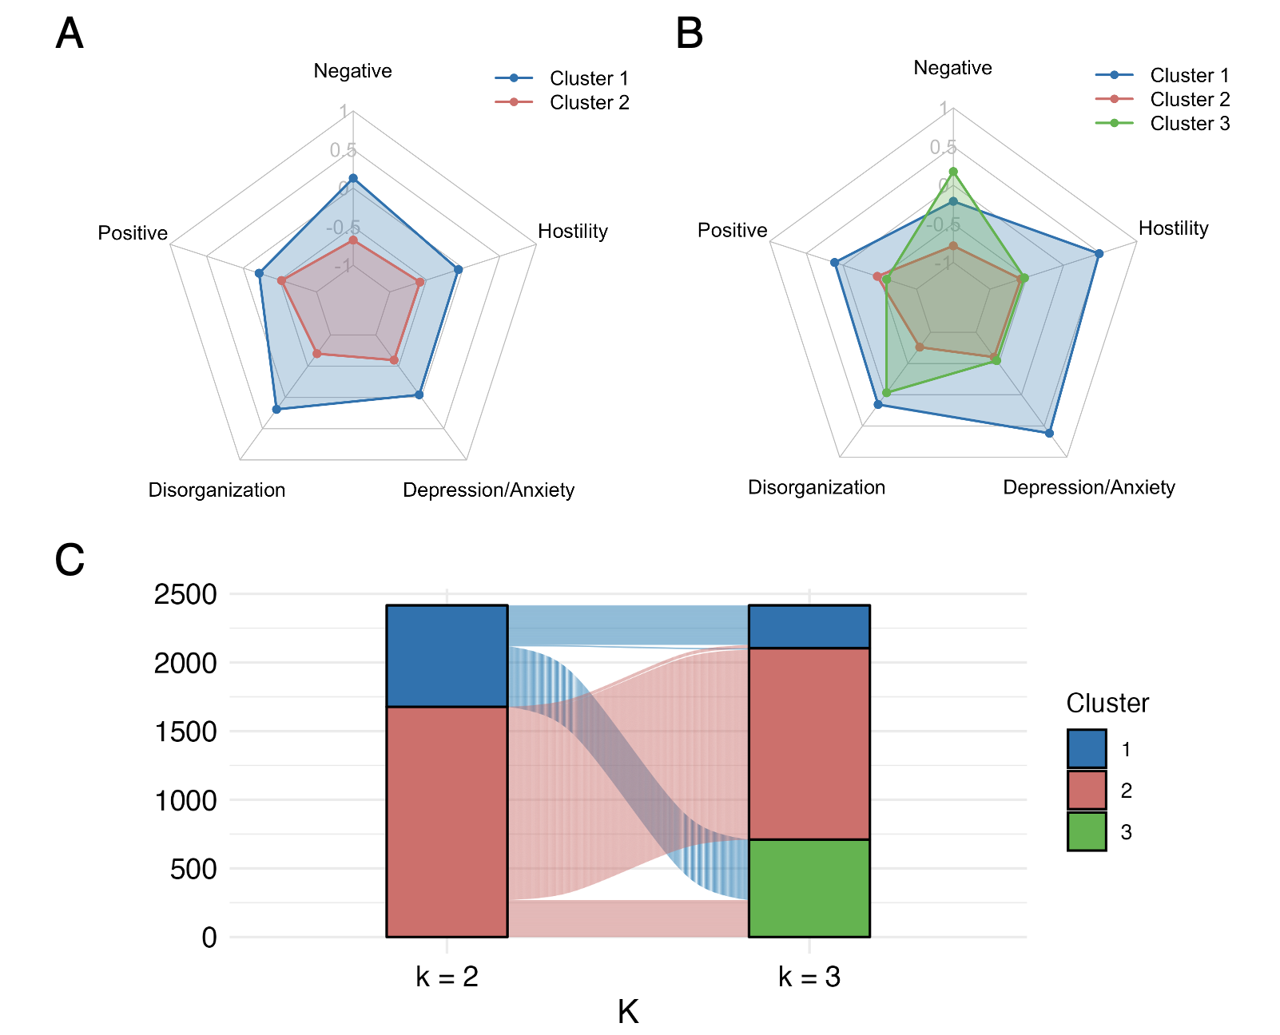
Supplementary Figure 1. Comparison of two-cluster (k=2) and three-cluster (k=3) solutions. Symptom profiles for the (A) two-cluster and (B) three-cluster solutions are shown as z-scores on five symptom dimensions. (C) An alluvial plot illustrates the re-assignment of patients from the k=2 solution to the k=3 solution, demonstrating the relationship between the two models.

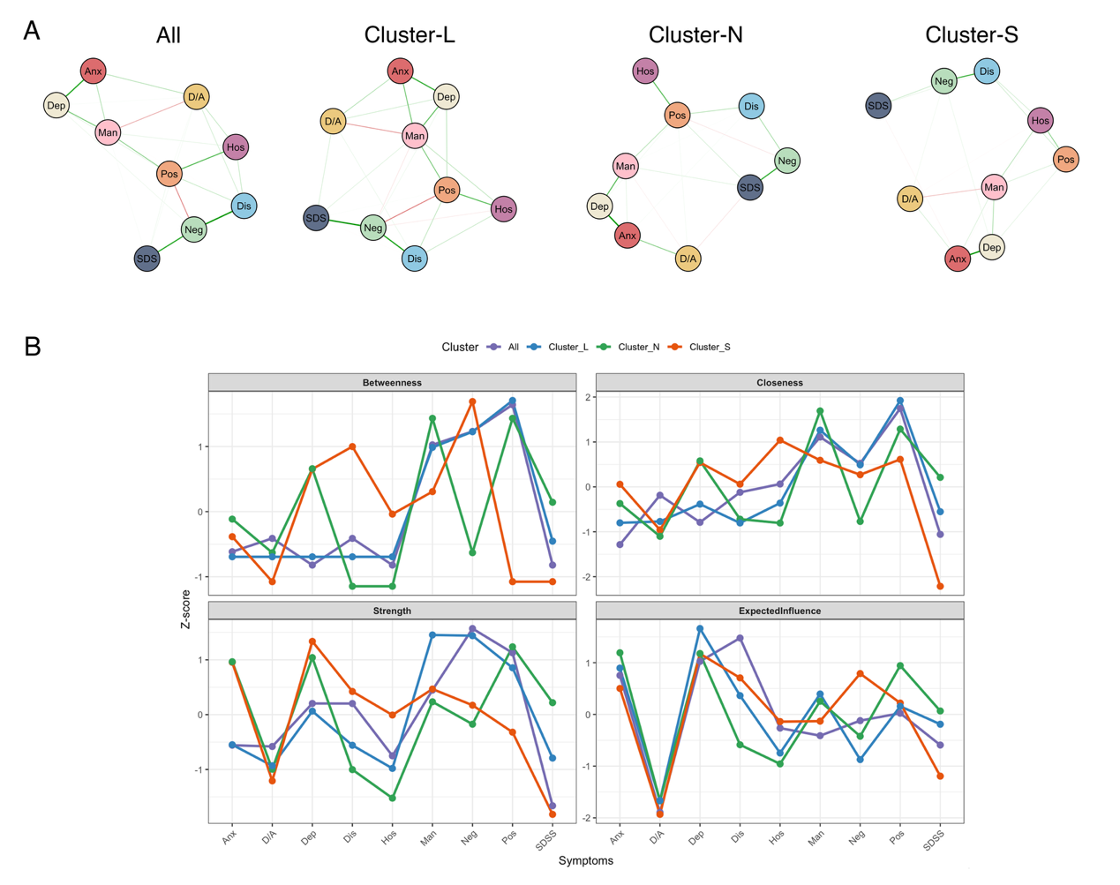
Supplementary Figure 2. Network analysis results in the discovery dataset. (A) Symptom network structures for the overall patient group and each subtype; Nodes represent the symptom factors, while edges represent partial correlations (green for positive, red for negative), with edge thickness indicating correlation strength. (B) Centrality indices for the overall patient group and subtype-specific network.
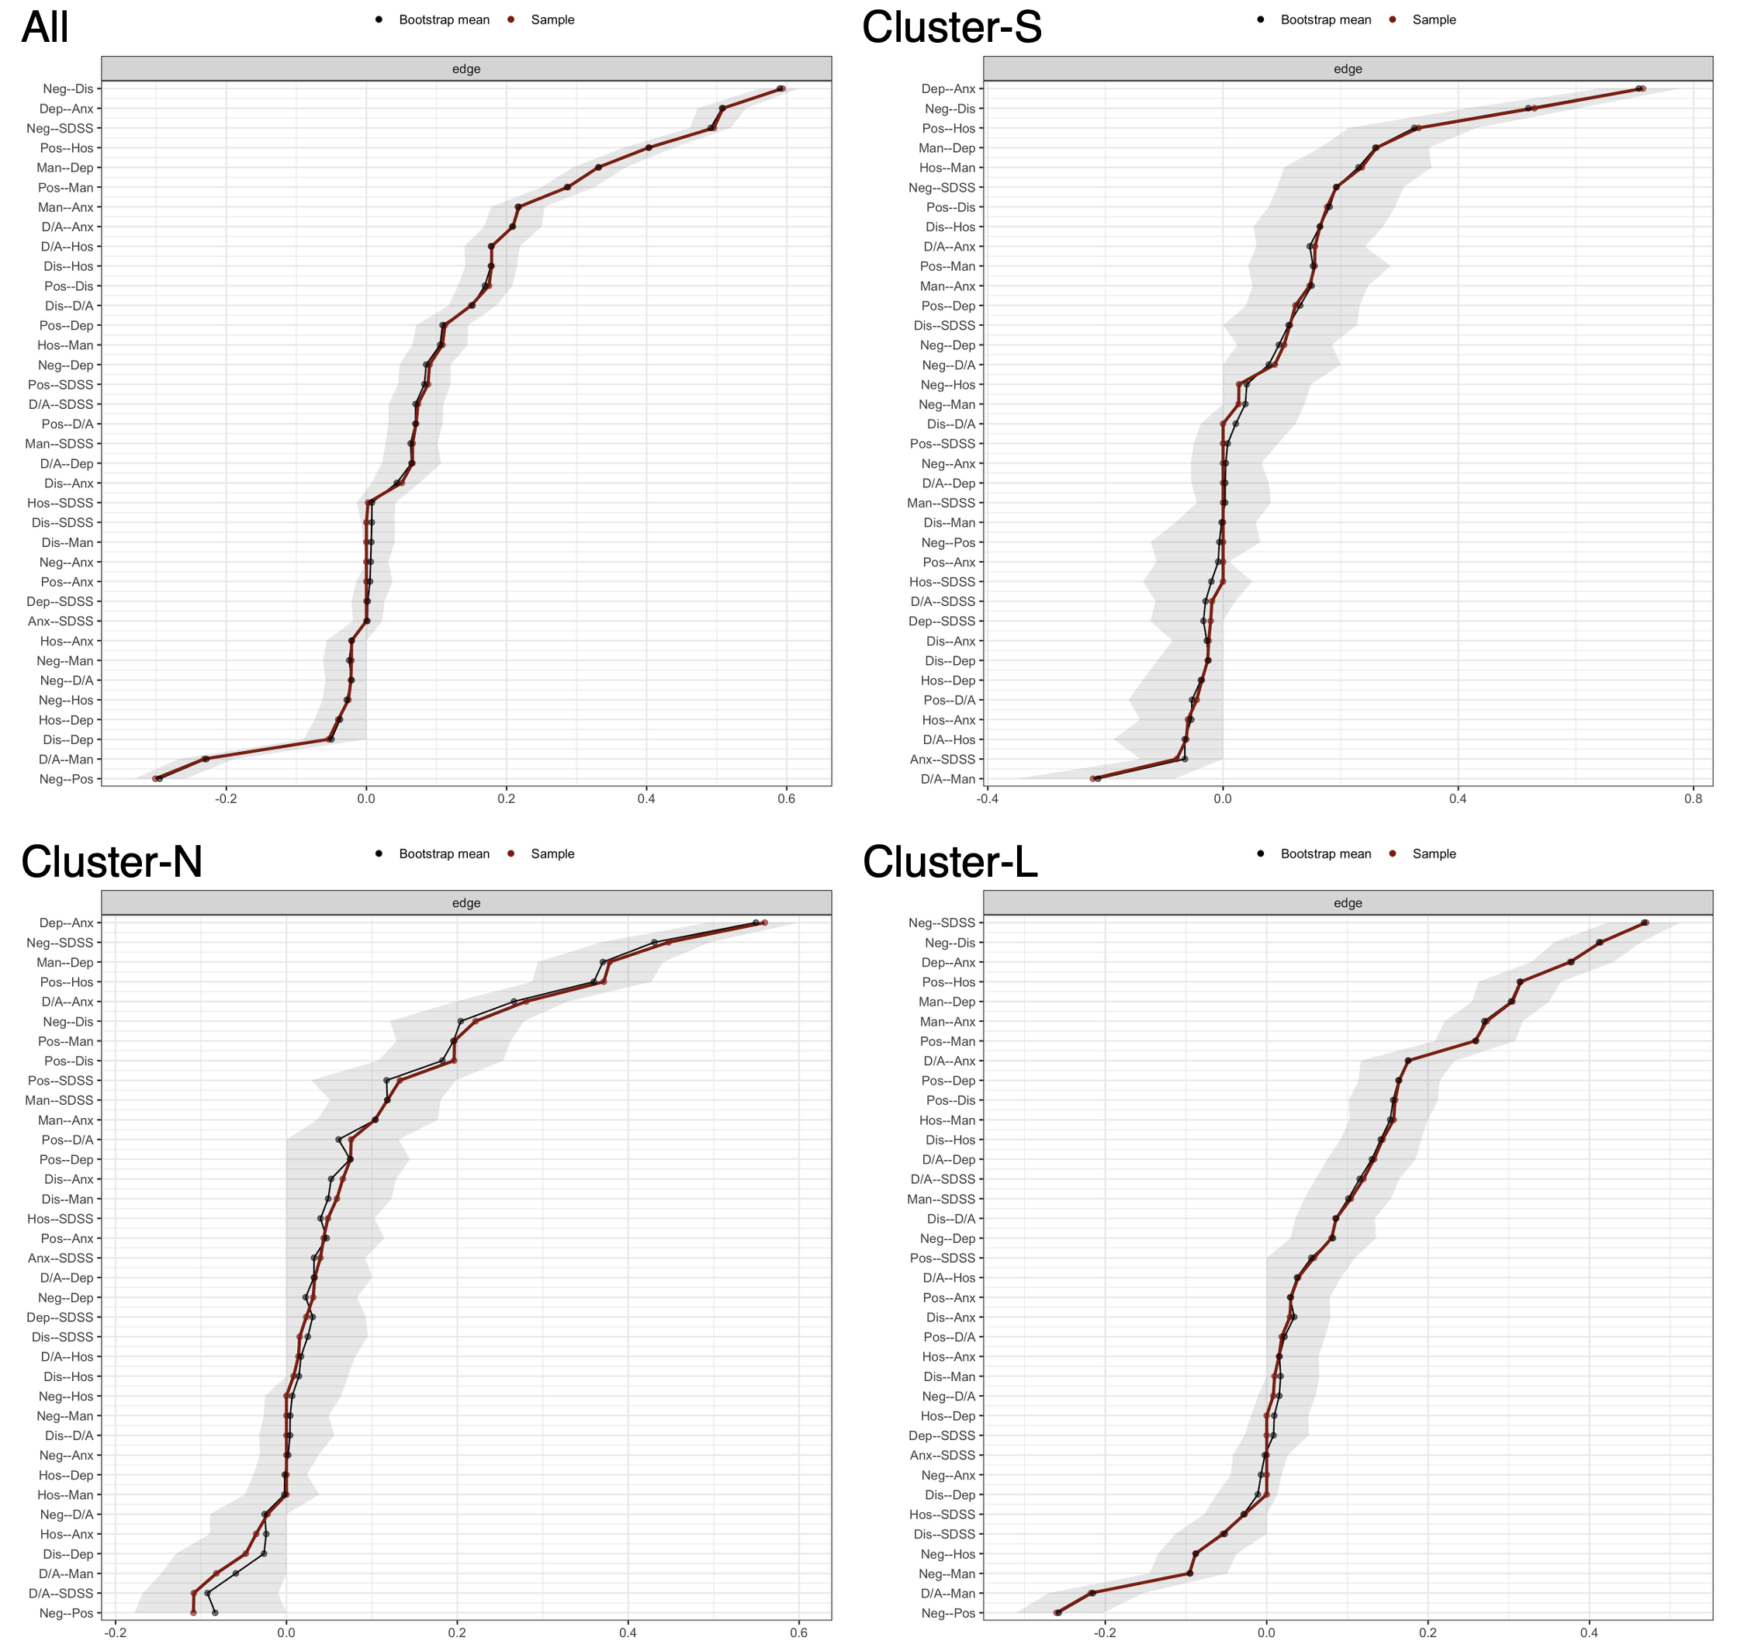
Supplementary Figure 3. Stability and accuracy of edge weight estimates for the symptom networks. This figure presents the results of a bootstrapping analysis assessing the stability of edge-weight estimates for the networks of the entire cohort (All) and the three subtypes. The red line represents edge weights from the original sample, the black line represents bootstrapped means, and the grey area indicates bootstrapped 95% confidence intervals. Narrower intervals suggest more stable and precise of edge-weight estimates.

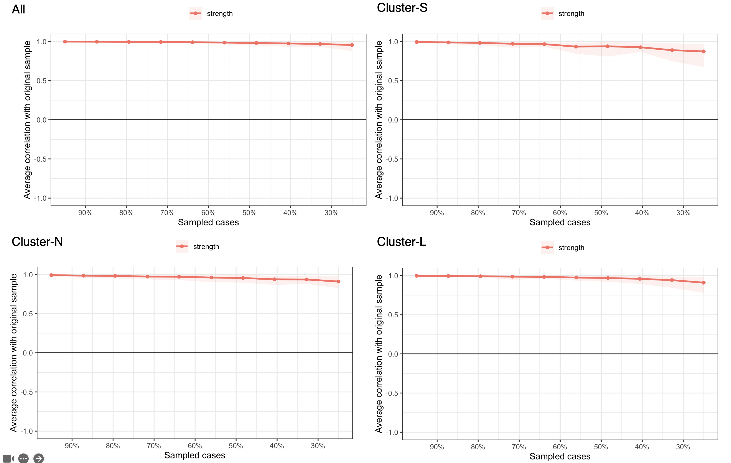
Supplementary Figure 4. Stability analysis of centrality measure of the symptom networks. This figure displays the results of a case-dropping bootstrap results assessing the stability of the ‘strength’ centrality estimates for all four networks. The Y-axis shows the average correlation between the strength values from the full sample and those from subsets containing the percentage of cases indicated on the x-axis. The high correlation when dropping a substantial portion of the sample indicates that the strength centrality estimates are highly robust.

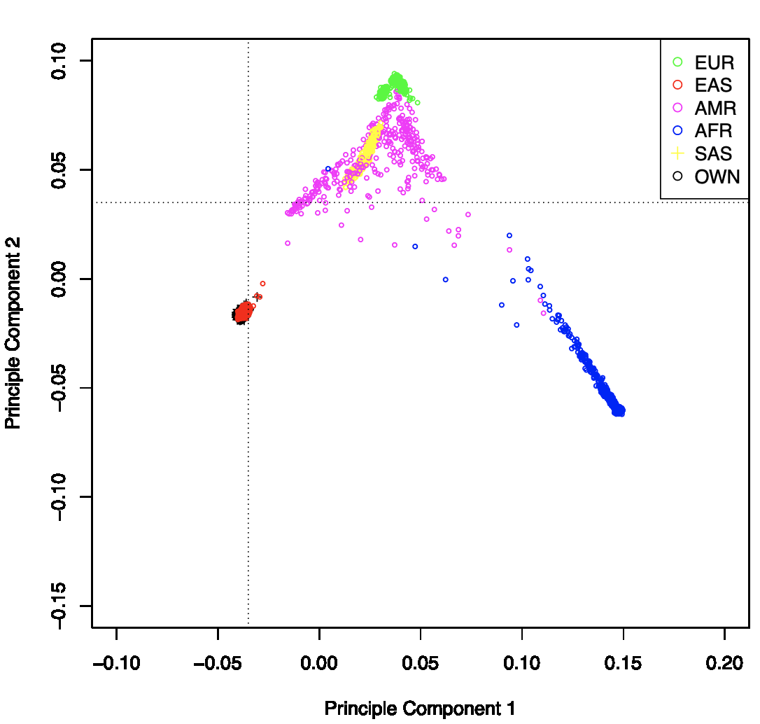
Supplementary Figure 5. PCA of our samples and samples from the 1000 Genomes project

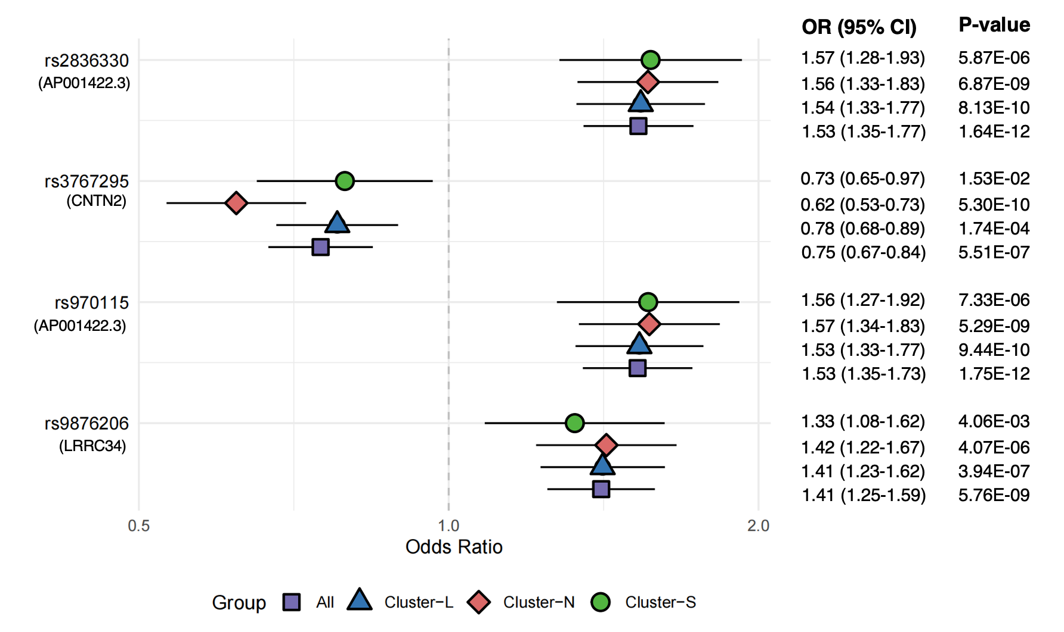
Supplementary Figure 6. Risk allele ORs in SCZ and SCZ subtypes. ORs with 95% CIs and associated P-value from the meta-analyses are shown.
Abbreviations: OR, Odds Ratio; CI, confidence intervals.

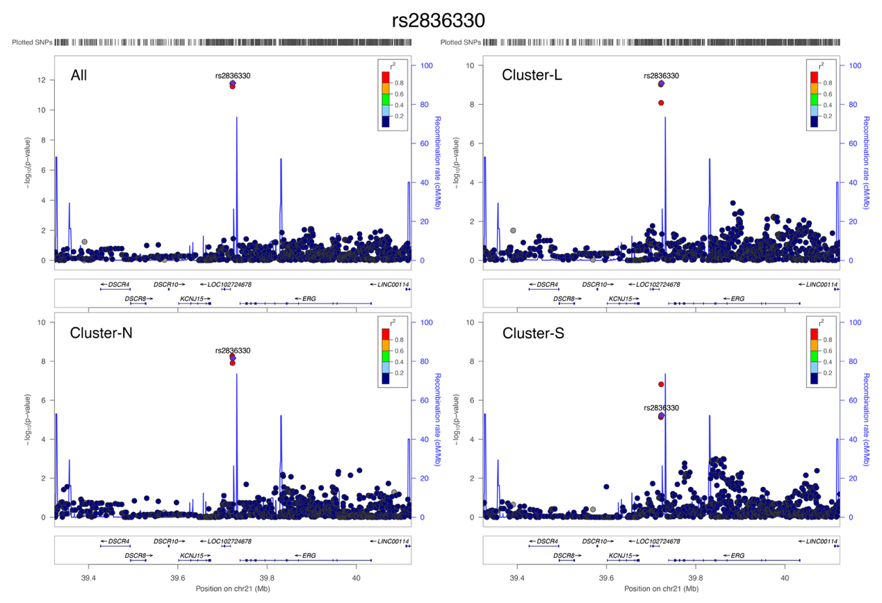
Supplementary Figure 7. Regional plot of rs2836330.

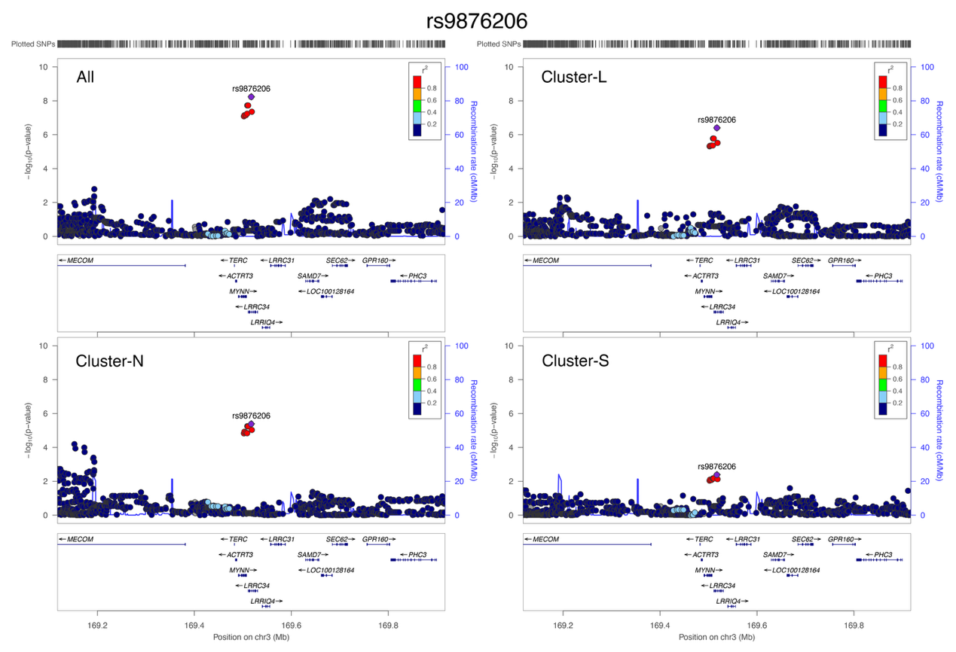
Supplementary Figure 8. Regional plot of rs9876206.

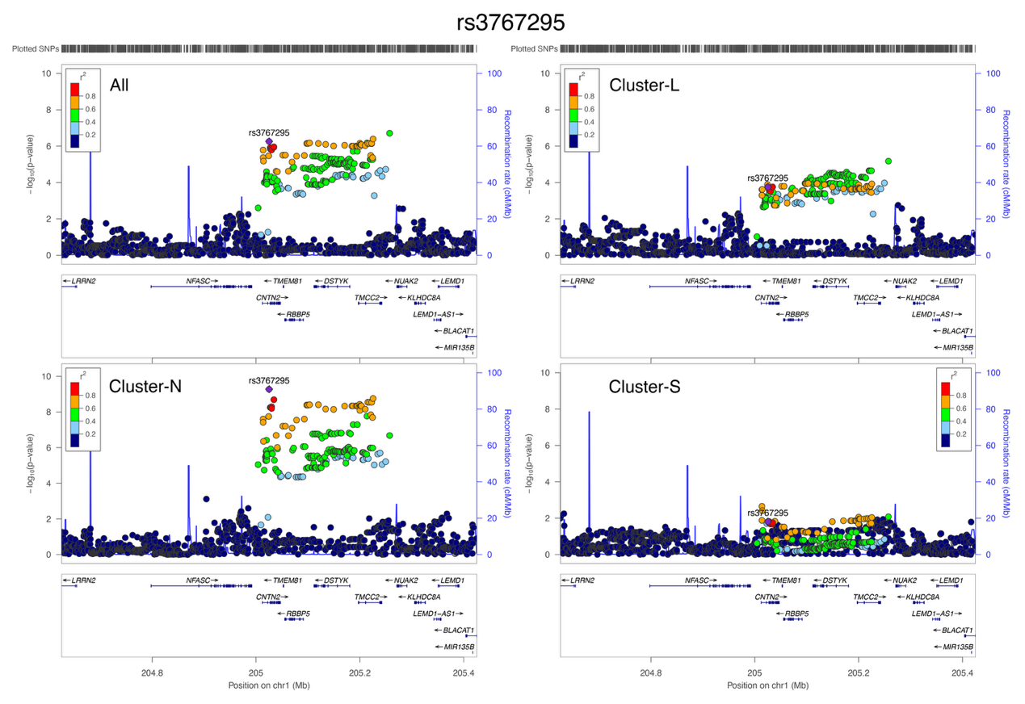
Supplementary Figure 9. Regional plot of rs3767295.

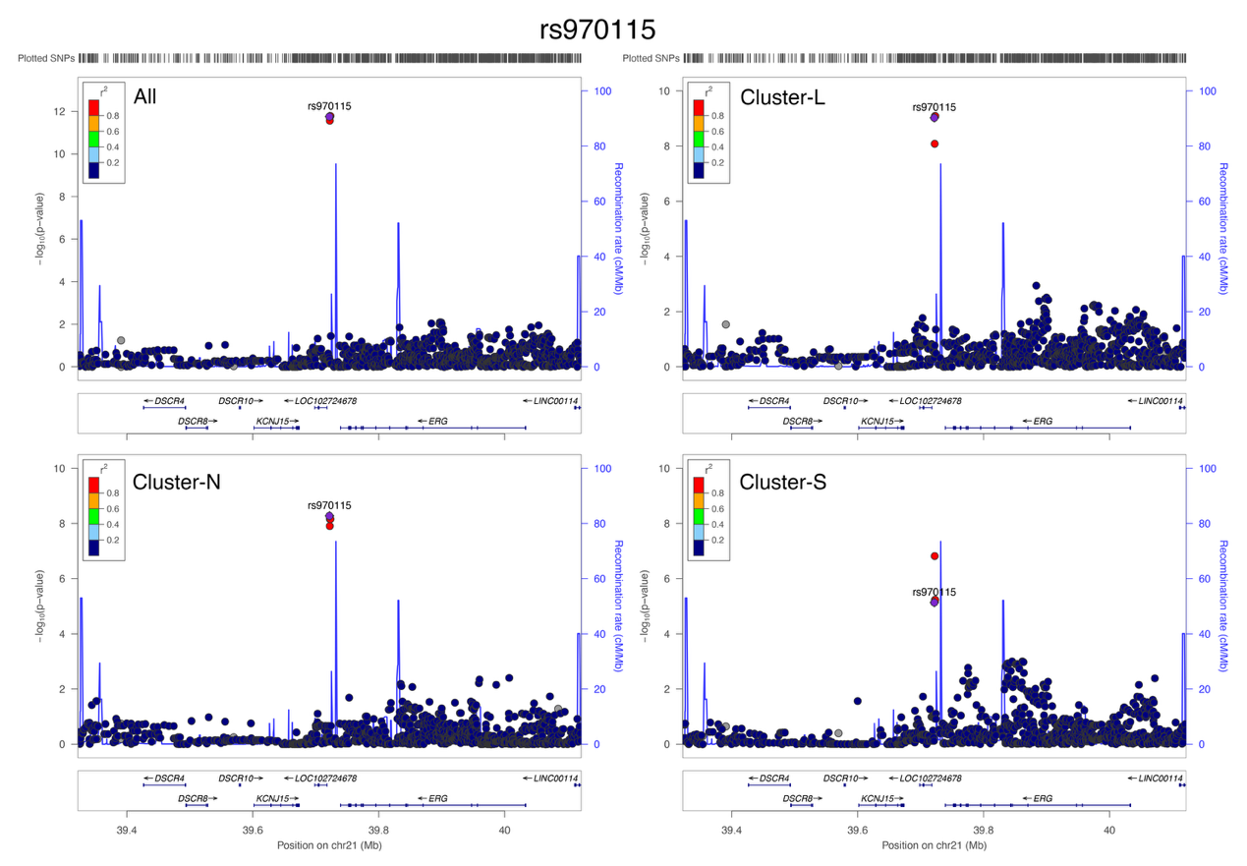
Supplementary Figure 10. Regional plot of rs970115.

